Character-based Understanding

Topics:

Protagonist Emotion, Sentiment State

Main Character Pair Relationship Structure

**(Arxiv 21) CHARET: Character-centered Approach to Emotion Tracking in Stories - Carvalho et al.**

Make **Commonsense** inference -> classify **emotional state** of character

Plutchik basic emotions:

surprise, disgust, sadness, joy, anger, fear, trust, anticipation

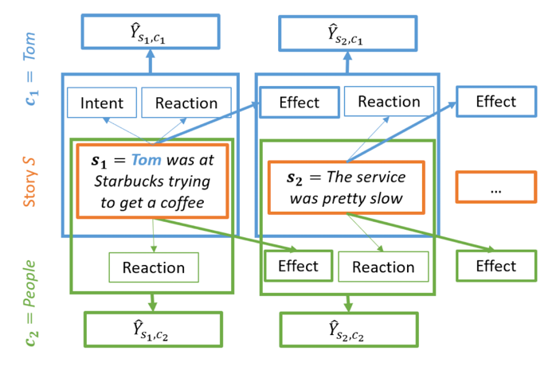

Inferenced Unstated Events (through COMET)

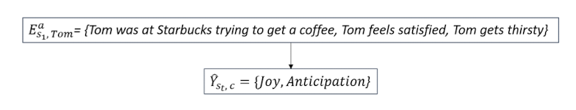

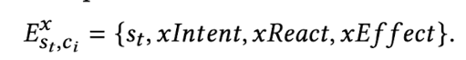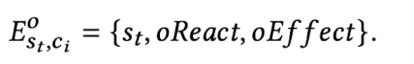

Left: If character is actor, Right: If character is object

Dataset: StoryCommonsense (Character mental state annotated)

**(*SEM 20) “where is this relationship going?”: Understanding Relationship Trajectories in Narrative Text - You et al.**

2 Tasks: Outlook (4th sentence), Resolution (5th sentence) Prediction

**Social Narrative Tree (5 Stage - Freytag's Pyramid)**

Seed -> Build Up -> Climax -> [ Resolution -> Outlook ]

2 Protagonists

각 단계 조합당 가능한 몇개 AMT 사람이 직접 가능한 문장 작성

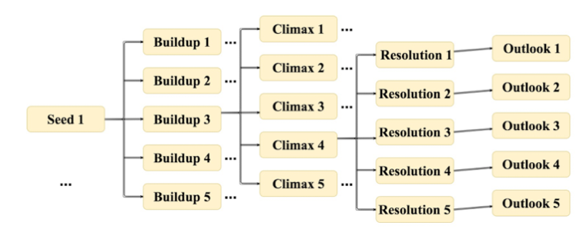

NLTK Extract, Lemmatize, Remove Stop Words

Predicate Connecting Protagonist in *Seed* Stage

**Active**: asked, invited / **Passive**: receive / **Neutral**: realized, were, went to

**(SIGDIAL 17) Modelling Protagonist Goals and Desires in First-Person Narrative - Rahimtorohi et al.**

DesireDB**: First- person** Narratives with annotations for **desires & fullfillment**

(Blogs)

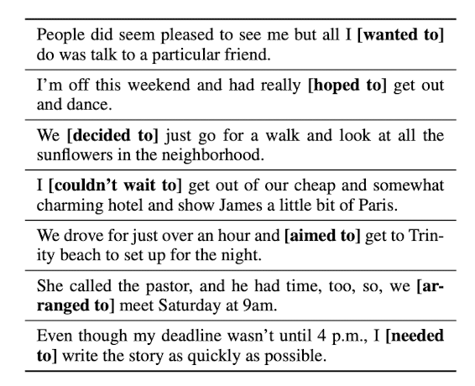

FrameNet - select frames that likely contains lexical units specifying desires

(Desiring, Needing, Purpose, Request)

Select only verbal lexical units -> verbs likely to introduce goals

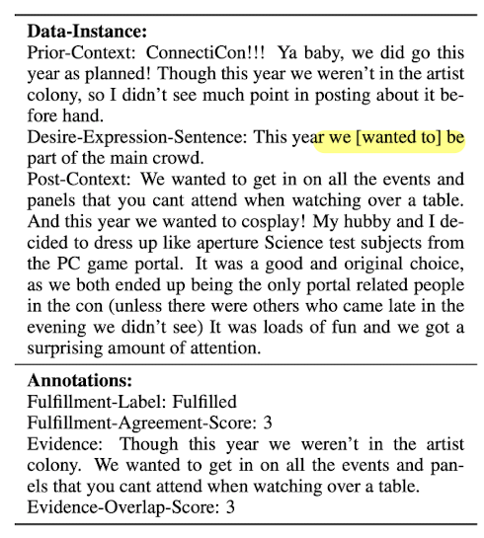

**(ACL 17) Modeling Naive Psychology of Characters in Simple Commonsense Stories - Rashkin et al. (Yejin Choi)**

Annotated ROC -> **Story Commonsense** Dataset

Explain Naive psychology of story characters as fully-specified chains of mental states

Motivations (Pre-condition) : Maslow (5 Coarse) -> Reiss (19 Fine)

Emotional Reactions (Post-condition) : Plutchik Wheel of emotions (8)

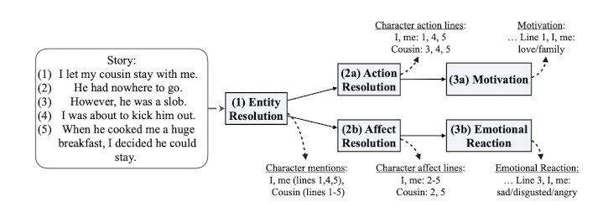

3 Tasks

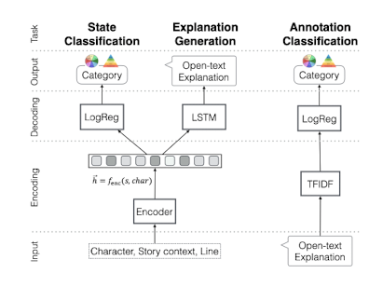

State Classification: Categorize psychological states given line (+preceding context)

Binary label for each Maslow, Reiss, Plutchik

Annotation Classification: Predict label given **emotional reaction** or **motivation explanation**

Explanation Generation: Generate free text state representation (emotional or motivation)

**(AAAI 17) Unsupervised Learning of Evolving Relationships Between Literary Characters - Chaturvedi et al.**

Unsupervised, Character-pair 단위

Relationship을 Latent Variable Sequence로 표현

Character Pair 가 함께 나타나는 문장을 선택 -> 4가지 word set 피쳐 이용

Actions / Surrogate Actions (Consider for being implicit) / Lexical / Frame-Semantic

위 4개 set을 union후 모든 단어 임베딩 avg를 sentence embedding으로 이용

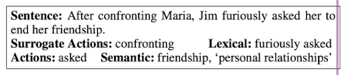

English novel-summary dataset **(SparkNotes)**

BookNLP (Bamman 14) Pipeline 으로 처리 (major character 판단까지)

같이 5문장 이상 나타나는 이야기 고름

**(AAAI 16) Inferring Interpersonal Relations in Narrative Summaries - Srivastava et al.**

Inferring Cooperative / Adversarial Relationships (Structured Prediction) - Relationship Binary Label

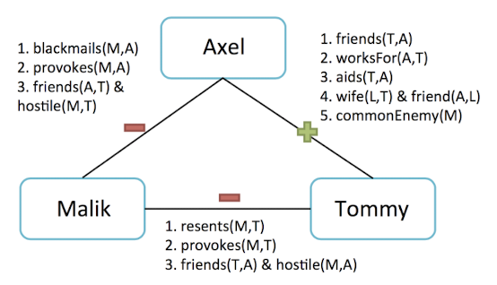

Use indirect structural cues: 서로 직접적 관계 뿐만 아니라 남과의 관계도 고려

Assumption: Relation is **fixed**

Relationship Structure 예측

Text-based Features

Structural Inferences Features: Triadic Structural Features (# of config in assignment?)

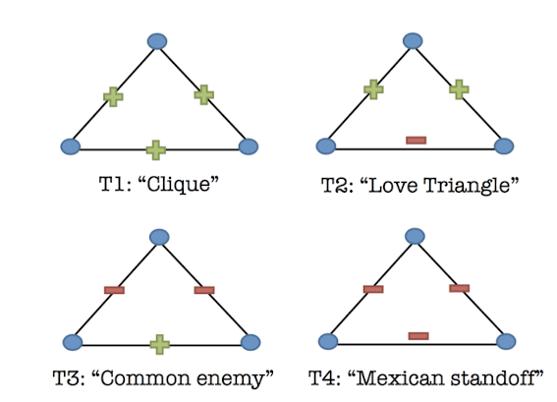

Narrative Type 고려 -> Clustering (ex. Mexican Standoffs -- revenge/gangster, Family-relation -- children story)

Incorporate description of narrative text to infer regularities (**content**-based)

Features

Text-based Cues

**Polarity** of Interaction between character mentions **(lexical, phrasal-level polarity)**

**Semantic connotations** of actions (does to other / share as agent,patient / act as team)

Character co-occurence in **semantic frames** that evokes +,-,or social relationship

Character **Similarity** (similar **adjectives / adverbs**)

Existence of Familial Relations

Structural Inferences

# of config in assignment (?)

Entity-tracking with Stanford CoreNLP

NER, Dependency Parse

CMU Movie Summary Corpus

**Annotate Directed** Relationship: [Hostile, Adversarial], Neutral, [Cooperative, Friendly]

Hostile, Adversarial: 42%

Cooperative & Friendly: 58%