ECN 511 · ECONOMICS FOR MANAGERS · GROUP 8
Building stadiums, building capability
Use stadium procurement to leave the Kingdom with qualified people and suppliers.
King Salman Stadium, Riyadh — a planned FIFA World Cup 2034 venue.
Sector 8, Construction and Infrastructure · Topic B, the multiplier effect of public capital spending and where the money leaks.
Presented 7 November 2026 · Prepared for Dr Rhea Elizabeth George, MBSC
Group 8: Salman · Abdulaziz · Nada · Mohammed · Haifa · Abdulmajed · Abdulrahman

This document reproduces the content of the group’s presentation — every heading, figure and source line — without the three‑dimensional staging. The charts are the ones used on screen.

Part 1 · The sector
Planned speaking time: about 1 minute 15 seconds
PART 1 · THE SECTOR

A construction programme, read as an economic decision
92,760  planned gross capacity, King Salman Stadium  Verified [R01] | 7.5%  construction share of nominal GDP, Q2 2026  Verified [R04] | 15  venues proposed across five cities  Verified [R01]

Our focus is where imports concentrate: electrical systems, ventilation and controls.
FIFA, Bid Evaluation Report, 29 November 2024, pp. 46–51 [R01] — the 2024 evaluated bid, not a 2026 delivery census. GASTAT, Quarterly GDP, Q2 2026, sheet 1.3 [R04] — provisional, current prices.
PART 1 · WHO BUYS AND WHO SUPPLIES

Public owners, an international delivery chain
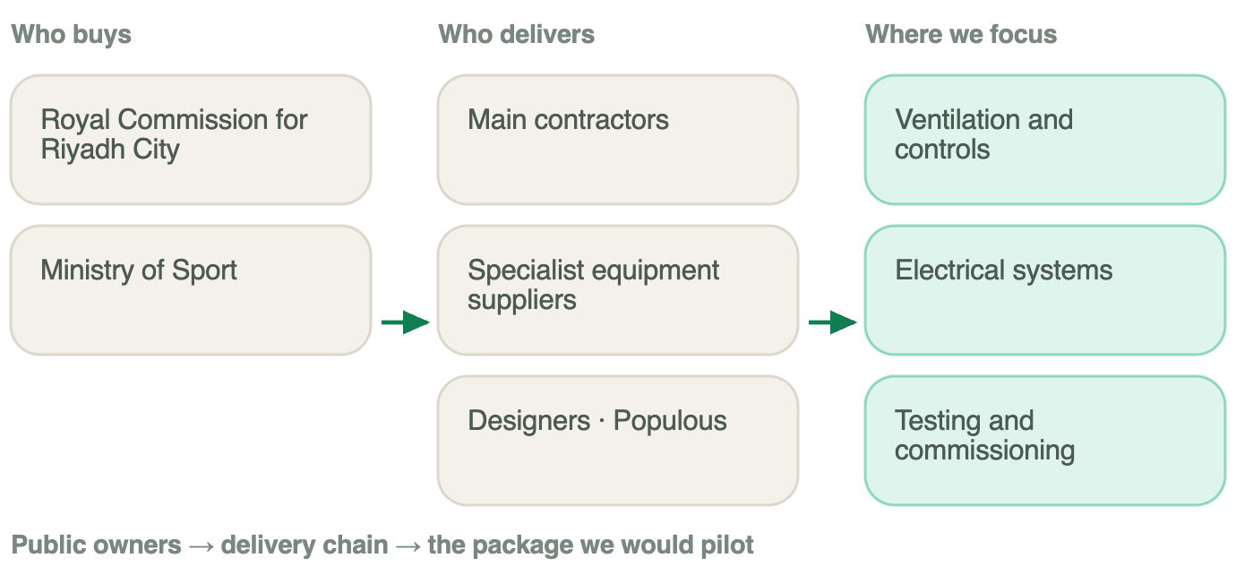
Ministry of Sport prequalification invitations: main works 25 November 2025 [R02], preliminary works 7 April 2026 [R03]. Documented evidence of procurement stage — not of award, value or construction start. Designer identity: Populous, 18 November 2024 [S06].
PART 1 · HOW IMPORT-DEPENDENT IT IS

The inputs a stadium needs most are the ones the Kingdom imports most
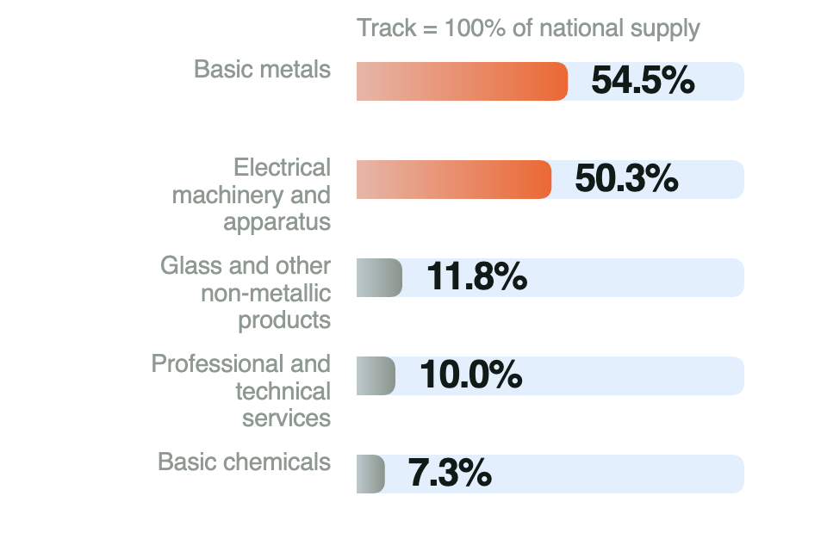
GASTAT Supply and Use tables, 2023, sheet 6.1 (cells AA/AB). National ratios — they cannot be treated as construction or stadium import shares.
GASTAT, Supply and Use / Input–Output tables by sections, 2023, sheet 6.1 [R05]. Imports as a share of national supply — a screen for where to ask for contract data, not a measurement of this project.

Part 2 · The economics topic
Planned speaking time: about 3 minutes
PART 2 · THE ECONOMICS TOPIC

In 2034 the stadium is finished. Our question starts earlier.
When the Kingdom pays to build it, how much production happens inside the Kingdom — and what capability remains?
Topic B · the spending multiplier and where it leaks
PART 2 · WHAT THE KINGDOM KEEPS TODAY

Measured, not assumed: just over half of construction output is Saudi value added
Saudi construction, 2023 — output, bought-in inputs, value added Verified [R05]
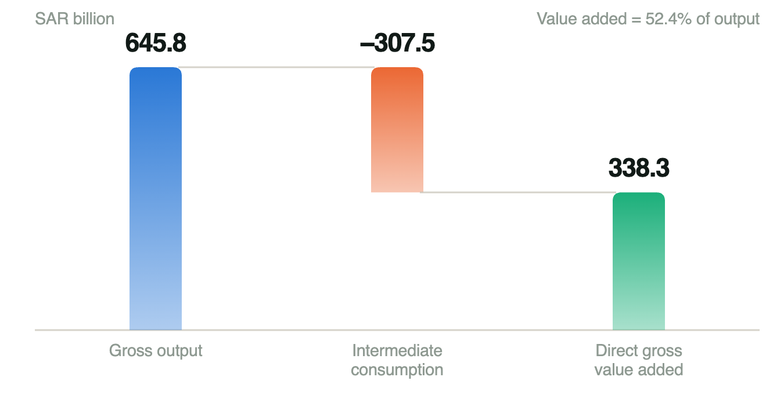
GASTAT Supply & Use / Input–Output tables by sections, 2023. An accounting share, not a multiplier and not an LCGPA local-content score.
Of every SAR 100 the sector produces, SAR 52.40 is value created here and SAR 47.60 buys inputs. That is the baseline the multiplier works on — and the share procurement can move.
GASTAT, Supply and Use / Input–Output tables by sections, 2023 [R05]. SAR billion.
PART 2 · FOLLOW THE MONEY

One payment, then round after round
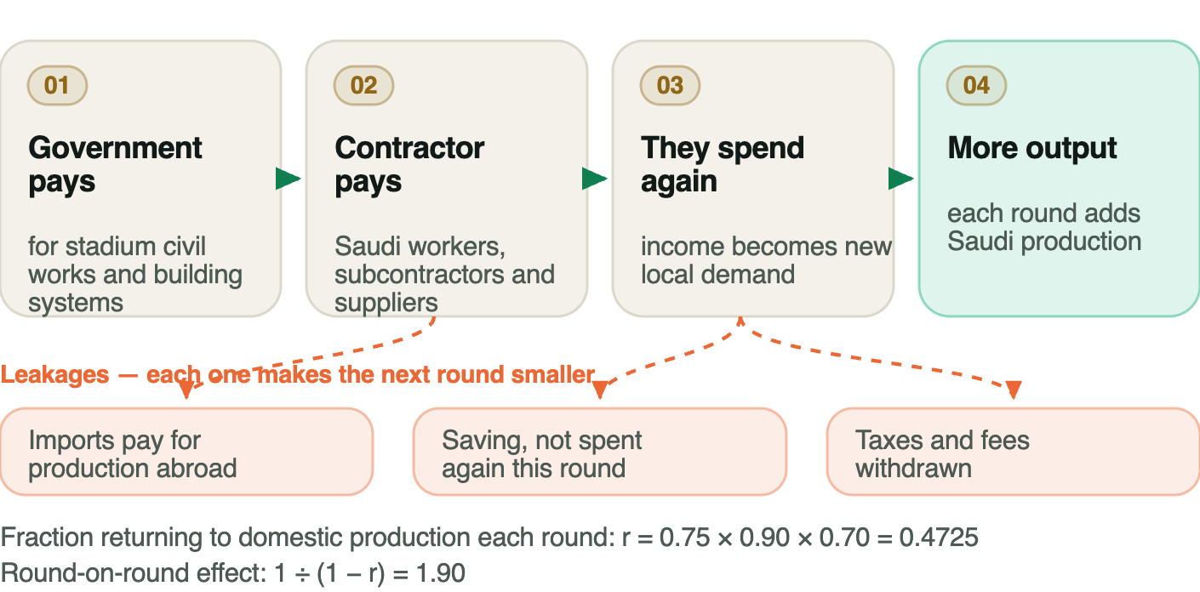
Illustrative spending model — group assumptions. Not a measured Saudi or stadium multiplier.
PART 2 · THE LEAKS

Every leak makes the next round smaller
Leak 1 — Imports: The payment buys production abroad.
Leak 2 — Saving: Income not spent again this round.
Leak 3 — Taxes and fees: Withdrawn before the next round.

Returning to domestic production each round: r = 0.4725 · effect per riyal of domestic impulse 1.90.
Illustrative · teaching assumptions
PART 2 · ROUND BY ROUND

The first round is the one procurement controls
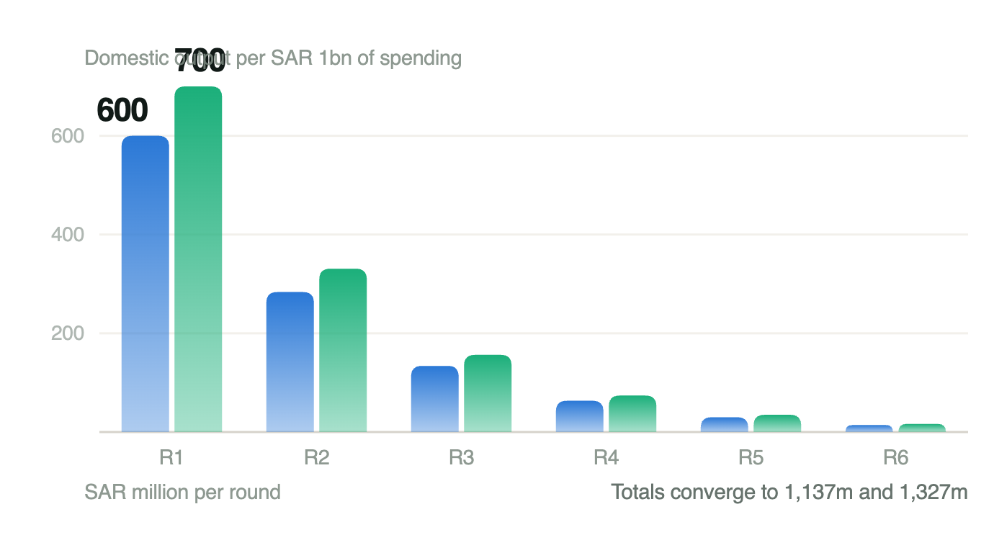
Group calculation. Round 1 = local share × SAR 1,000m; each later round = previous × r, r = 0.75 × 0.90 × 0.70 = 0.4725. Illustrative teaching assumptions, not measured parameters.
Totals converge to SAR 1,137m and SAR 1,327m per SAR 1bn of spending.
group calculation, illustrative.
PART 2 · MOVE TEN POINTS, HOLD EVERYTHING ELSE

Where an illustrative SAR 1 billion goes
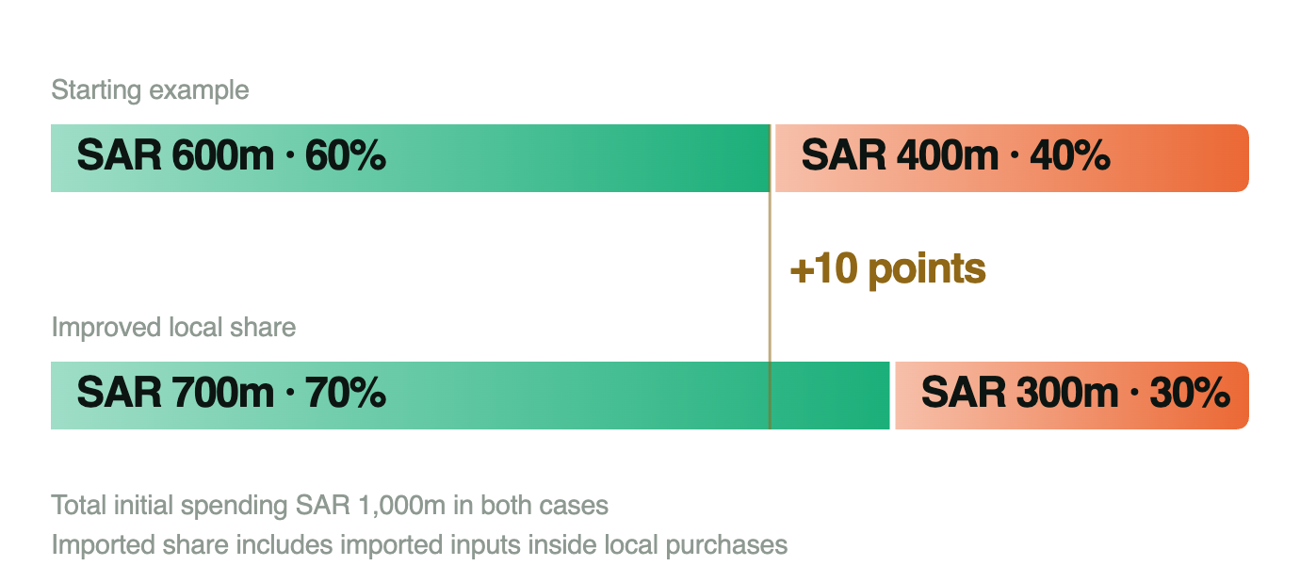
Group assumptions. Illustrative shares, not King Salman Stadium procurement data.
group assumptions, illustrative.
PART 2 · THE RESULT

+SAR 190m
of extra domestic output per SAR 1bn, from ten percentage points more local share in the first round.
SAR 1,137m → SAR 1,327m. The size depends on real procurement, capacity and cost. This is the lever, not a forecast.
PART 2 · THE REALITY CHECK

Spending alone is a weak lever — which is exactly our argument
Saudi capital-spending multiplier on non-oil growth Verified [R08]
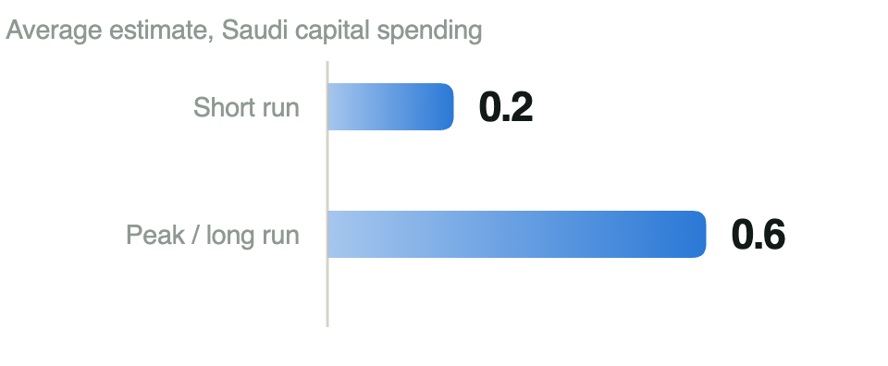
IMF, Saudi Arabia Article IV (2024), Box 1 — average of reviewed estimates. Not a stadium forecast.
The IMF puts the average at 0.2 in the short run and 0.6 at peak. When capacity is tight, extra riyals bid up prices instead of adding output. So the lever is not how much is spent — it is how much of it can be produced here. That is a capability question, and it is what the EPP is for.
IMF, Saudi Arabia 2024 Article IV, Country Report 24/280, Box 1, printed p. 10 [R08]. An average of reviewed estimates — not a stadium forecast, and not a calibration of our illustration.

Part 3 · The EPP and localisation
Planned speaking time: about 2 minutes 30 seconds
PART 3 · THE CURRENT SITUATION

The policy exists. Its use on a stadium is not on the public record.
The policy — Published: A SAR 100m imported-value gate and a 35% obligation, with seven credit categories [R09].
This sector — No evidence found: No EP agreement, credit factor or imported-value figure is published for any Saudi stadium.
The project — Notices only: Main works invited 25 November 2025, preliminary works 7 April 2026 [R02][R03].

Where the dependence sits. In the equipment — basic metals and electrical machinery are 54.5% and 50.3% imported as a share of national supply [R05] — and in the people who commission it. Testing, controls set-up and fault diagnosis are routinely flown in.
Searched 13–22 October 2026: LCGPA's training material and portal [R09], the April 2026 consultation notice [R11], Ministry of Sport notices and the main-contractor questionnaire [R02][R03], FIFA's bid evaluation [R01]. Absence from the public record is not proof that no agreement exists — it is the limit of what we could verify.
PART 3 · THE EPP AND LOCALISATION IN OUR SECTOR

The gate: SAR 100m of imported goods and services
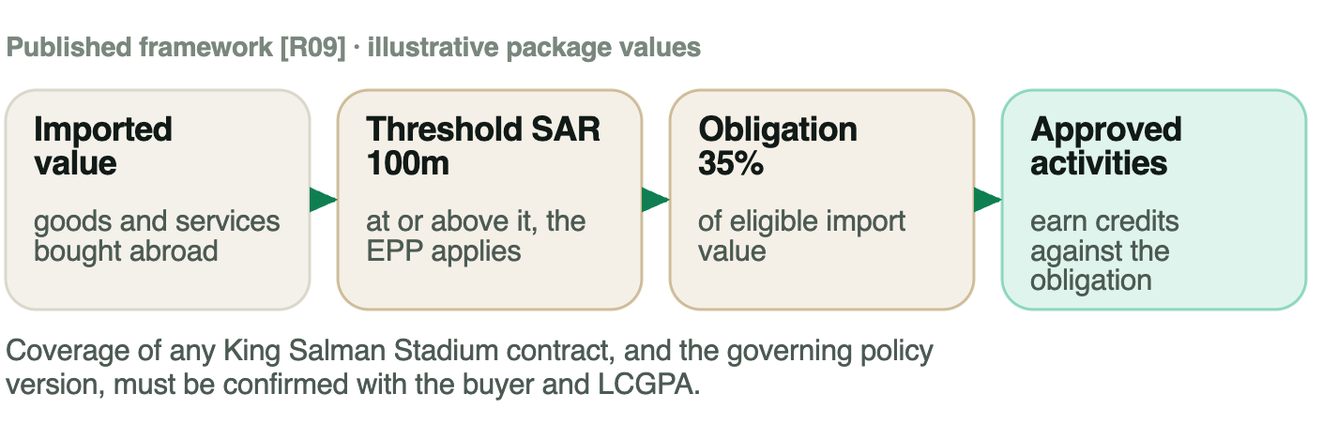
LCGPA, Economic Participation Policy, Unit 7 training document, printed pp. 4–5 and 12 [R09]. Published training baseline — legal commencement not established.
PART 3 · WHAT THE OBLIGATION IS WORTH

35% of eligible import value
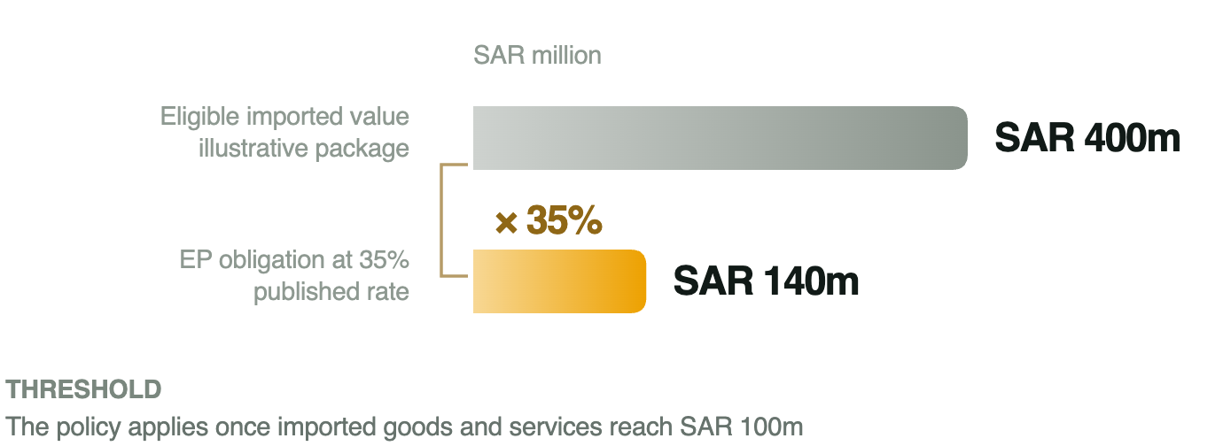
LCGPA, Economic Participation Policy, Unit 7, pp. 4–5 and 12 [R09]. The 35% applies to eligible imported value, never to whole contract value; the SAR 400m package is illustrative.
PART 3 · WHICH EP CATEGORIES AND MULTIPLIERS MATTER

Seven categories, and the multiplier decides what a riyal of effort is worth
Fits our pilot — Knowledge transfer: ×0.5–2
Fits our pilot — Localisation of industry or services: ×0.5–2
Phase two — Technology transfer: ×0.5–3
Highest value — Research and development: ×3
Highest value — Export promotion: ×0.5–3
Capital — Investment: ×1–3
Lowest value — Subcontracting: ×1

Buying from a local firm earns the floor. Teaching people and moving capability earn more. That is why our pilot is built as knowledge transfer and service localisation, not as a purchase order.
LCGPA, Economic Participation Policy, Unit 7, pp. 14–15 [R09] — the seven categories and their multiplier ranges are stated there verbatim. The policy says a multiplier is “determined by the value added to the national economy” (p. 21), but publishes no criteria for where inside a range a project lands — a gap the April 2026 draft does not close [S11].
PART 3 · WHERE VALUE LEAKS OUT, HERE

Ventilation and controls — the package we would pilot
Proposed first — Ventilation and controls: Skills transfer to many building types, not only stadiums.
Candidate — Pumps and panels: Recurring demand, heavier manufacturing step.
Candidate — Testing before handover: Service work that is currently flown in.

Do the work here first — testing, installation, fault diagnosis — then components. A Saudi reseller invoice is not Saudi production.
What localisation would change: it lifts the first-round local share — the lever worth +SAR 190m per SAR 1bn in Part 2 — and, unlike a one-off purchase, leaves people and suppliers who can serve the next venue.
PART 3 · THE TRAP IN THE WORD "MULTIPLIER"

A credit factor is not the spending multiplier
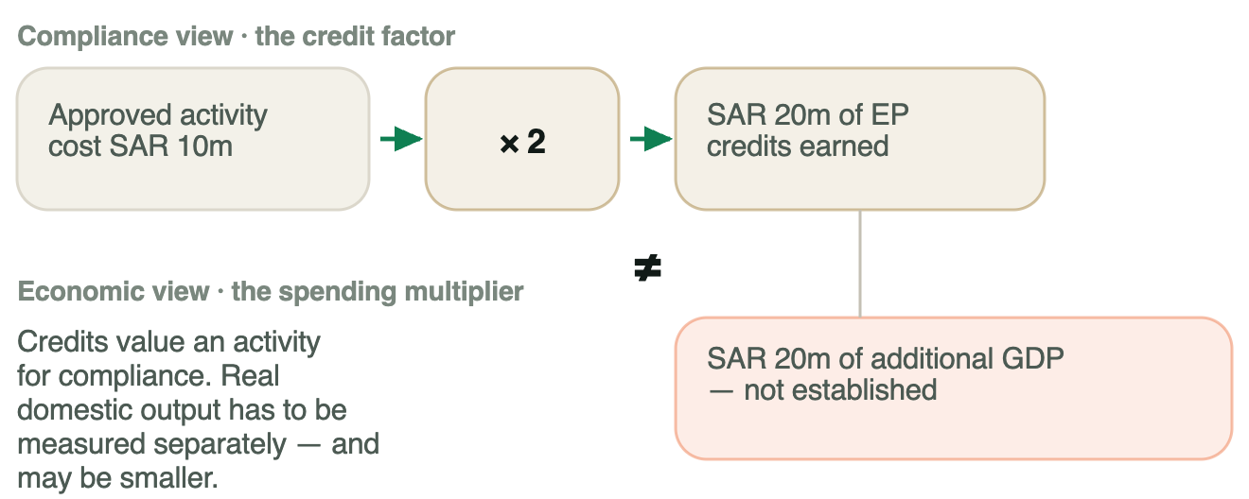
Group illustration of the credit mechanism [R09][S11]. Credits are a compliance measure — neither cash nor GDP.
PART 3 · BENCHMARK

London 2012 tied skills to real venue construction — and under-enforced it
3,000+  training places for work on the Olympic Park and other construction sites  Verified [R12] | 408  apprentices enabled to work on the project  A separate measure — do not add

✓ Worked: Skills tied to real site work before a fixed deadline.
▲ Weaker: Targets were encouraged, not binding [R13, §§1.2 and 5.1].

Lesson: write mentoring, skills tests and reporting into the delivery plan — and count awarded work, not advertised opportunities [S14].
PART 3 · CHALLENGES AND RISKS

Six ways this fails — and the three that would decide it
Critical — The deadline: An unready supplier can delay safe delivery of a 2034 venue. Train early; release critical work only after independent qualification.
Serious — Tools and rights: Training cannot replace foreign expertise without the means of doing the work. Put software, manuals, diagnostic tools and licences inside the EP agreement.
Serious — Demand after 2034: Skills disappear when one project ends. Choose transferable building skills and secure a second customer before handover.

Three more we would watch: cost and quality against the equipment's life, routine work counted as new, and imports hidden inside local invoices. All six sit in the appendix with the safeguard we would write into the contract.
Group risk assessment. The safeguards are our proposals, not existing LCGPA requirements.

Part 4 · Our recommendation
Planned speaking time: about 1 minute 20 seconds
PART 4 · WHAT WE RECOMMEND

Pilot one package: an academy that trains its own trainers
Phase 1: Ventilation and controls, inside an existing technical institute, with the stadium as the workplace.
Phase 2: Qualify Saudi makers of brackets and enclosures once quality and demand are proven.

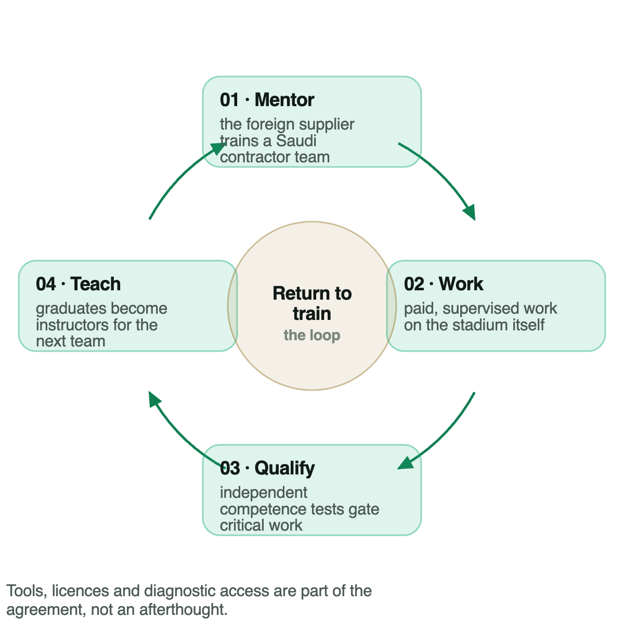
group proposal.
PART 4 · EXPECTED BENEFITS

What this is worth — now, and after 2034
While it is built — A bigger first round: Work done here instead of imported lifts the local share of the first round — the lever Part 2 values at +SAR 190m per SAR 1bn for ten percentage points. Saudi teams are on live commissioning work rather than watching it.
After handover — Something still standing: People who passed an independent test and are training the next team. Suppliers qualified to serve the next venue. A cost and quality baseline the next tender can price against.

We claim no exact monetary figure. The Part 2 number is an illustration under stated assumptions, not a forecast of this project. What we would commit to is measurement: test pass rates during construction, employment retained at 12 and 24 months, and production net of imported inputs across future projects.
Group proposal. The +SAR 190m figure is the illustrative model from Part 2, not a projected return on this pilot.
PART 4 · THE CLOSING ARGUMENT

What we would tell LCGPA
In 2034 the stadium will be finished either way. The question this project answers is what else is still standing afterwards.
Thank you — questions welcome.
A stadium is a deadline, not a market. The credit system will be satisfied long before any Saudi capability exists, unless the policy counts people who passed an independent test and production net of imported inputs — and keeps counting them two years after handover. Fund one package, verify it, then scale.
Group 8
Salman · Abdulaziz · Nada · Mohammed · Haifa · Abdulmajed · Abdulrahman

Appendix · for questions
Planned speaking time: not presented — held for questions
APPENDIX · FOR QUESTIONS

What Saudi construction produced and bought in, 2023
Output, inputs, value added Verified [R05]
What construction consumed Verified [R05]
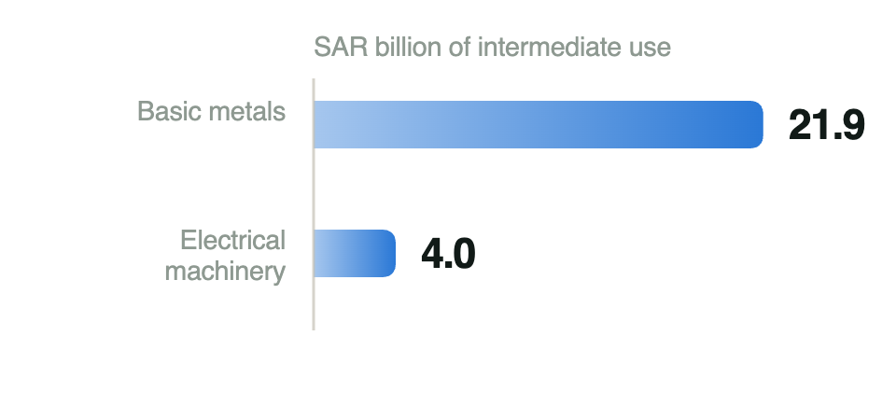
Imported share of that supply Verified [R05]
GASTAT Supply & Use tables, 2023 — construction sector intermediate consumption.
GASTAT Supply and Use tables, 2023, sheet 6.1 (cells AA/AB). National ratios — they cannot be treated as construction or stadium import shares.
GASTAT Supply & Use / Input–Output tables, 2023. Value added is 52.4% of output — an accounting share, not a multiplier. The import ratios are national: a screen for where to request contract data, not a measurement of this project.
APPENDIX · FOR QUESTIONS

EP categories, and what the April 2026 draft leaves open
Highest fit — Training and knowledge transfer: Mentoring a Saudi team through installation, controls and fault diagnosis on live work.
Highest fit — Service localisation: Testing and commissioning performed here rather than flown in.
Phase two — Technology transfer · new subcontracting: Qualifying local makers of brackets, enclosures and assemblies.
Reserved — R&D and export activity: Higher multipliers, but only where adoption and buyers are demonstrable.

In the April 2026 draft [S11]: the official notice announced a 22 April 2026 closing date [R11]; no record of closure, adoption or commencement was retrieved. The topline obligation falls from 35% to 25% and becomes tiered — 25% on the first tier (SAR 75–300m by competition value, SAR 100–300m cumulative), 20% on SAR 300–500m, 15% above SAR 500m. Multipliers rise from 0.5–3 to 1–4, with a bonus of 1–2 (maximum 5–6). Article 10 adds an impact-based alternative track above SAR 500m, extendable to smaller contracts at LCGPA's discretion. Also: proactive and surplus credits, quarterly reporting, and a 2% administrative fee counted toward the obligation. Separately — already practice, not a draft change — DGA reports some government bodies negotiating to cascade obligations to subcontractors rather than the main contractor; for stadium work that decides who actually carries the obligation. DGA notes the draft still does not say how a multiplier is set within a category.
APPENDIX · FOR QUESTIONS

Six ways this goes wrong, and the safeguards we would write in
Risk | Level | Why it matters | Safeguard we would write in
Fixed event deadline | Critical | An unready supplier can delay safe delivery of a 2034 venue. | Train early; release critical work only after independent qualification.
Tools and technical rights | Serious | Training cannot replace foreign expertise without access to the means of doing the work. | Agree access to software, manuals, diagnostic tools and licences inside the EP agreement.
Weak demand after handover | Serious | Skills can disappear when one project ends. | Use transferable building skills and secure a second customer before handover.
Higher costs or poor quality | Watch | Localisation can reduce value if execution is inefficient. | Pilot one package; compare quality and cost across the equipment’s life, not at purchase.
Routine work counted as new | Watch | Credits may reward activity that would have happened anyway. | Record the pre-programme baseline and demonstrate additional capability.
Imports inside local invoices | Watch | Local spending can be overstated, or counted twice. | Trace production origin and imported inputs; audit one consistent ledger.

APPENDIX · FOR QUESTIONS

A documented gap is a finding, not a weakness
- Where we looked: LCGPA's training material and portal [R09]; the April 2026 consultation notice [R11] and DGA's analysis [S11]; Ministry of Sport notices and the main-contractor prequalification questionnaire [R02][R03]; GASTAT's supply-and-use and quarterly GDP tables [R04][R05]; Ministry of Finance budget reports [R07]; FIFA's bid evaluation [R01]; the Ministry of Finance construction tender template [R16].
The wider localisation toolkit: LCGPA mechanisms: the mandatory products list; the national product price preference; local content weighting inside financial evaluation; preference for local SMEs.

Construction has no single IKTVA — that is the finding. Several public owners each set their own local-content schedule, so a contractor may face both an owner requirement and an EP obligation.
- Any statement that a stadium contract crosses the EPP threshold.
- Contract-level imported value for any package.
- A published EP agreement or credit factor for a sports venue.
- A construction-specific credit-factor table from LCGPA.
APPENDIX · FOR QUESTIONS

The full recommendation, and how we would measure it
To LCGPA
- Publish clearer credit-factor criteria, so a bidder can price the obligation before signing.
- Enable joint training programmes across qualifying contracts.
- Measure competence and real Saudi production separately from credits.
- Require independent quality and cost assessment before scale-up.
To a supplier or contractor
- Confirm buyer, policy version, imported amount and responsible EP party first.
- Record the baseline before training starts.
- Agree activity, rights, partner, cost, factor and milestones with LCGPA.
- Document real work and independent test results.
- Review retention and value — change or stop what fails.
During construction
- Test pass rates, fewer defects, safe on-time handover.
After handover
- Employment retained at 12 and 24 months; graduates training others.
Across future projects
- Production net of imported inputs; repeat orders.
APPENDIX · FOR QUESTIONS

Where each question is answered
1 · Sector: Part 1. Construction and infrastructure, through one venue: King Salman Stadium, a planned 2034 World Cup site.
2 · Economic concept: Part 2. The spending multiplier and its leakages, applied with Saudi supply-and-use data and anchored to the IMF's Saudi estimate.
3 · Current situation: Part 3, opening. The policy is published; no stadium EP agreement is on the public record. Import and foreign-expertise dependence quantified from GASTAT.
4 · Benchmark: Part 3. London 2012 — what worked, what was under-enforced, and the contracting lesson for Saudi Arabia.
5 · Challenges: Part 3, closing, with all six risks and safeguards in this appendix. No procurement interviews were used; everything cited is public.
6 · Innovative proposal: Part 4. An academy where graduates return as instructors — mentoring that compounds instead of ending with the contract.
7 · Expected benefits: Part 4. Value during construction and after handover, with the measures we would be judged on. No exact monetary figure is claimed.
Evidence rule: Verified facts, verified calculations, illustrations and group proposals are labelled separately on every slide.

APPENDIX · SOURCES RE-VERIFIED TO 22 OCTOBER 2026

Primary sources

[R01] FIFA, 29 November 2024 — Bid Evaluation Report — p. 46: “15 stadiums across five proposed host cities”; p. 48 venue table and p. 50: “planned gross capacity of 92,760”, construction to commence 2025 and “be completed by 2030”. Describes the 2024 evaluated bid, not a 2026 delivery census.
https://digitalhub.fifa.com/m/51d8a13714827f1d/original/FIFA-World-Cup-2034-Bid-Evaluation-Report.pdf
[R02] Ministry of Sport, 25 November 2025 — Main-works prequalification invitation, King Salman Stadium; stated submission deadline 16 February 2026. A notice, not an award.
https://www.mos.gov.sa/en/media/news/2025/11/25/king-salman-stadium
[R03] Ministry of Sport, 7 April 2026 — Preliminary-works prequalification invitation; stated deadline 28 April 2026.
https://www.mos.gov.sa/en/media/news/2026/04/07/king-salman-stadium
[R04] GASTAT — Quarterly time series of GDP, Q2 2026, provisional — sheet 1.3, cells BQ14/BQ24: 94,524 / 1,263,831 = 7.48%, shown as 7.5%. Current prices.
https://www.stats.gov.sa/documents/20117/2435267/GDP_Q2_2026_EN+%282%29.xlsx/c83d0a5f-e2e1-2cac-a477-f1ad8529f202?t=1788844506153
[R05] GASTAT — Supply and Use & Input–Output tables by sections, 2023 — sheet 6.2 cells H89/H90/H97 and H45–H75; sheet 6.1 cells AA/AB, same rows.
https://www.stats.gov.sa/documents/20117/2435267/SUT_and_IO_By_Sections_-En.xlsx_fixed_3036245/91b73a34-05e8-0e49-46e8-eda783beae16?t=1746090703771
[R06] GASTAT, updated 29 April 2025 — Methodology and quality report for the supply-and-use and input–output tables — concepts, valuation, units, time coverage 2018–2023.
https://www.stats.gov.sa/en/w/methodology-and-quality-report-for-supply-and-use-tables-and-the-input-output-table
[R07] Ministry of Finance — Quarterly budget performance report, Q2 FY2026 — PDF p. 10, non-financial assets (capex) row: Q2 SAR 46.226bn, H1 SAR 89.660bn, cash basis. Government-wide, not construction-only.
https://www.mof.gov.sa/en/financialreport/2026/Documents/Q2%20Eng%202026%20V10.pdf
[R08] IMF, September 2024 — Saudi Arabia 2024 Article IV, Country Report 24/280 — Box 1, printed p. 10 / PDF p. 15: the average of capital-spending multipliers on non-oil growth is 0.2 in the short run and 0.6 at peak and in the long run. A literature average, not a forecast.
https://www.imf.org/en/Publications/CR/Issues/2024/09/03/Saudi-Arabia-2024-Article-IV-Consultation-Press-Release-Staff-Report-and-Informational-Annex-554530
[R09] LCGPA — Economic Participation Policy, Unit 7 training document — p. 4 and p. 5: the policy applies where imported goods and services reach SAR 100 million, giving obligations of “35% of the imported goods and services’ value”; p. 11 principles; p. 12 scope; pp. 14–15 categories and factors; p. 21 credits; pp. 33–35 evidence and approval. Published training baseline; legal commencement not established.
https://lcgpa.futurex.sa/pluginfile.php/2095/mod_folder/content/0/pdf%20E/Economic%20Participation%20Policy%20%281%29.pdf?forcedownload=1
[R10] Ministry of Finance, via Umm Al-Qura, 19 January 2024 — Model terms and specifications for performance-based operation and maintenance — section 9, clauses 75–77 (local-content measures) and section 10. Distinct from EP credits.
https://www.uqn.gov.sa/details?p=24374
APPENDIX · SOURCES RE-VERIFIED TO 22 OCTOBER 2026

Further sources and declarations

[R11] Umm Al-Qura / National Competitiveness Center, 14 April 2026 — Istitlaa consultation announcement, second paragraph — the updated Economic Participation Policy among sixteen projects. The notice announced a 22 April 2026 closing date; no closure or adoption record was retrieved.
https://www.uqn.gov.sa/news/reports/4000737
[R12] UK Department for Culture, Media and Sport, 20 May 2012 — 2012 Games construction workforce update — more than 3,000 training places for work on the Olympic Park and other construction sites; 408 apprentices enabled to work on the project.
https://www.gov.uk/government/news/2012-games-construction-on-track-thanks-to-12-000-strong-workforce
[R13] Crossrail Learning Legacy — Eldred and Blin, 17 August 2018 — Implementing contractual skills and employment targets — §§1.2 and 5.1: the Olympic programme relied on encouragement and persuasion rather than contractually binding targets.
https://learninglegacy.crossrail.co.uk/documents/implementing-contractual-skills-and-employment-targets/
[R14] Expenditure and Projects Efficiency Authority, 18 August 2021 — National Manual of Assets and Facilities Management, vol. 5 ch. 1, document EOM-ZO0-GL-000001 Rev 001 (18 August 2021) — §6.6 mechanical systems and §6.7 electrical systems operations, pp. 8–9.
https://expro.gov.sa/api/uploads/Operations%20Management%20Introduction%20Guideline.pdf
[R15] MBSC — Dr Rhea Elizabeth George, 30 September 2026 — Assessment guidelines, ECN 511 Economics for Managers — sector 8, topic B; the four assessed parts; permission to supplement the EPP with other LCGPA mechanisms and to report an evidence gap as a finding.
[R16] Ministry of Finance template, hosted by King Faisal University — Model Terms and Specifications Booklet (General Construction), version two — Section Ten, p. 49 of 59: the section may be deleted below SAR 100 million, and where a local agent subcontracts several foreign companies the threshold applies to each subcontractor separately.
https://www.kfu.edu.sa/ar/Departments/Purchases/Documents/pages/assets/pdf/Approved-booklet-templates/Sample-Terms-Specifications-Booklet-General-Construction.pdf
[S06] Populous, 18 November 2024 · secondary — Design announcement — evidence of designer identity only. Not a source for capacity, cost or import values.
https://populous.com/article/populous-designed-king-salman-stadium-set-to-become-global-sporting-icon
[S11] DGA Group, April 2026 · secondary — Analysis of the updated EPP issued for public consultation, pp. 4–8 — scope, obligations, credits, alternative track. The draft text itself was not retrieved and adoption is not public.
https://dgagroup.com/wp-content/uploads/2026/04/DGA-ASG-Analysis-Updated-Version-of-Saudi-Economic-Participation-Policy-Issued-for-Public-Consultation-1.pdf
[S14] Australian Department of Industry, Science and Resources, August 2023 · secondary — Australian Industry Participation Policy impact evaluation — Finding 20, printed p. 24 / PDF p. 28, on measuring outcomes rather than opportunities.
https://www.industry.gov.au/sites/default/files/2024-08/australian-industry-participation-policy-impact-evaluation-report_0.pdf
How these numbers were checked. Every figure traces to a cell or page in the group's final verification register (19 October 2026): GASTAT values to named worksheet cells, the IMF anchor to Box 1 of Country Report 24/280. Facts, verified calculations, illustrations and group proposals are labelled separately throughout. National import ratios are national — they are a screen for where to request contract data, not a measurement of this stadium.
AI use statement (draft): AI assistance supported source discovery, draft organisation, the illustrative calculations and the visuals; the group verified accuracy and sources and takes responsibility for the submission. Policy version analysed: the published LCGPA training baseline, with notes on the April 2026 consultation draft. Views are the group's own, not DGA Group's or LCGPA's.

