ECN 511 · ECONOMICS FOR MANAGERS · GROUP 8
Building stadiums, building capability
How World Cup 2034 stadium procurement could leave the Kingdom with qualified people and suppliers
Group report · Economic Participation Policy in Saudi construction
Case: King Salman Stadium, Riyadh
Prepared for Dr Rhea Elizabeth George, MBSC
Group 8: Salman · Abdulaziz · Nada · Mohammed · Haifa · Abdulmajed · Abdulrahman
Sources verified to 22 October 2026
Evidence standard used throughout. Verified facts, verified calculations, illustrations and group proposals are labelled separately. Every figure carries a source identifier and a precise locator — a worksheet cell, a page, or a numbered section. Where a primary source could not be reached, this report says so rather than softening the claim.

1. Executive summary
Saudi Arabia will build or refurbish fifteen stadiums across five cities for the 2034 FIFA World Cup [R01]. Construction is already 7.5% of nominal GDP [R04], and government capital spending reached SAR 89.660bn in the first half of 2026, 32% above the same period in 2025 [R07]. The question this report addresses is not whether the money will be spent. It is how much of it is produced inside the Kingdom, and what capability remains once the tournament ends.
Three findings shape our recommendation.
- The sector already retains just over half of what it produces. Saudi construction had gross output of SAR 645.8bn in 2023 against SAR 307.5bn of bought-in inputs, leaving SAR 338.3bn of direct value added — 52.4% of output [R05]. The share procurement can move is the other half.
- The leak is concentrated in exactly the inputs a stadium needs. Imports are 54.5% of national supply of basic metals and 50.3% of electrical machinery and apparatus, against 7.3% for basic chemicals [R05]. The dependence extends to people: testing, controls set-up and fault diagnosis are routinely flown in.
- Spending alone will not fix it. The IMF puts the average capital-spending multiplier for Saudi Arabia at 0.2 in the short run and 0.6 at peak and in the long run [R08]. When capacity is tight, extra riyals raise prices rather than output. The lever is supply-side capability, which is what the Economic Participation Policy exists to build.
The Economic Participation Policy (EPP) applies to government procurement where imported goods and services reach SAR 100 million, creating an obligation worth 35% of that imported value, discharged through seven categories of qualifying activity carrying multipliers from 0.5 to 3 [R09]. We could not find any published evidence that the policy has been applied to a Saudi stadium — no EP agreement, no credit factor, no contract-level imported value. We treat that documented gap as a finding, not as proof of absence.
We propose one pilot rather than a programme: a ventilation-and-controls academy attached to an existing technical institute, using the stadium itself as the workplace, built so that graduates return as instructors for the next intake. It is claimed under knowledge transfer and localisation of industry or services, not under subcontracting, because buying from a local firm earns the multiplier floor while teaching people and moving capability earn more [R09].
We claim no exact monetary figure. Our illustrative model suggests that moving ten percentage points of first-round local share is worth about SAR 190m of additional domestic output per SAR 1bn of spending, under stated assumptions. That is a lever, not a forecast.

2. Scope, method and evidence standard
This report covers Sector 8, construction and infrastructure, examined through a single venue: King Salman Stadium in Riyadh, proposed by the bidder as the opening-match and final venue, with a planned gross capacity of 92,760, construction due to commence in 2025 and to be completed by 2030 [R01].

What we did
- Opened every source at the publisher rather than relying on secondary summaries. Sixteen primary references and three secondary ones were retrieved and read between 13 and 22 October 2026.
- Recalculated every national-accounts figure from the GASTAT workbook cells, and checked the accounting identity: intermediate consumption plus gross value added equals gross output exactly.
- Separated four kinds of statement — verified fact, verified calculation, illustration, and group proposal — and labelled each wherever it appears.

What we did not do
- No procurement interviews were conducted. Everything cited is public. No confidential or commercially sensitive information is used.
- No claim is made that the EPP has or has not been applied to any specific contract. We report what the public record shows and where it is silent.
A note on national ratios. The import shares in this report are national: imports as a share of total national supply of a product group. They are a screen showing where to request contract data. They are not, and cannot be read as, the import share of this stadium or of the construction sector [R05, R06].

3. Current situation

3.1 The sector and the programme
Construction contributed 7.5% of nominal GDP in the second quarter of 2026 — SAR 94,524m of SAR 1,263,831m, provisional, at current prices [R04]. The 2034 bid proposed fifteen stadiums across five host cities, of which eight were planned new builds [R01].
For King Salman Stadium the documented procurement evidence is two prequalification invitations from the Ministry of Sport: main construction works announced 25 November 2025 with a submission deadline of 3:00 p.m. on 16 February 2026 [R02], and preliminary works announced 7 April 2026 with a deadline of 2:00 PM on 28 April 2026 [R03]. These establish the stage reached. They do not establish an award, a contract value, or a construction start.

3.2 Does the EPP already apply in this sector?
The policy itself is published and unambiguous. It applies to all government procurements where the value of imported goods and services equals or exceeds SAR 100 million, producing obligations of 35% of the imported goods and services’ value [R09]. The Ministry of Finance general-construction tender template carries this as Section Ten, which a government entity may delete only where the estimated competition cost falls below SAR 100 million [R16].
Two features of that template matter for a stadium. First, the obligation reaches a local agent or local company that subcontracts to a foreign supplier, and where several foreign companies are engaged, the threshold is applied to each subcontractor separately [R16]. A main contract that looks domestic can therefore carry EP obligations through its supply chain. Second, economic participation is a distinct mechanism from local-content procurement, which sits in Section Nine — the mandatory list, local-content weighting in financial evaluation, and price preference [R10]. Credits earned under one are not the other.
What we could not establish is whether any stadium contract has crossed the threshold. We searched LCGPA’s training material and portal [R09], the April 2026 consultation notice [R11], the Ministry of Sport notices and the main-contractor prequalification questionnaire [R02, R03], and FIFA’s bid evaluation [R01]. We found no published EP agreement for a sports venue, no credit factor, no contract-level imported value, and no construction-specific credit-factor table.
This is a documented evidence gap, and we present it as a finding. Absence from the public record is not proof that no agreement exists — it is the limit of what can be verified from outside the procurement process. It is also, in itself, an argument for publishing more.

3.3 A policy in transition
On 14 April 2026 the National Competitiveness Center opened sixteen projects for public consultation on the Istitlaa platform, among them an update to the Economic Participation Policy by LCGPA. The notice announced that consultation on that project would close on 22 April 2026 [R11]. We retrieved no record of closure, adoption, or a commencement instrument.
Secondary analysis of the draft describes a material redesign: the headline obligation falling from 35% to a tiered 25% / 20% / 15%, multipliers rising from 0.5–3 to 1–4 with a bonus of 1–2, an impact-based alternative track under Article 10 for contracts above SAR 500 million, proactive and surplus credits, quarterly reporting, a 2% administrative fee counted toward the obligation, and the performance bond reduced from 15% to 10% of contract value [S11]. We did not retrieve the draft text itself, so this is reported as secondary and unconfirmed.
For a bidder this is the live risk: which version of the policy governs a contract signed in 2026 or 2027 is not publicly settled.

4. Import dependence and reliance on foreign expertise
Saudi construction produced SAR 645.8bn of gross output in 2023. It bought in SAR 307.5bn of intermediate inputs and generated SAR 338.3bn of direct gross value added — 52.4% of output [R05]. The two components reconcile to the total exactly, which is the check that the figures are being read correctly.
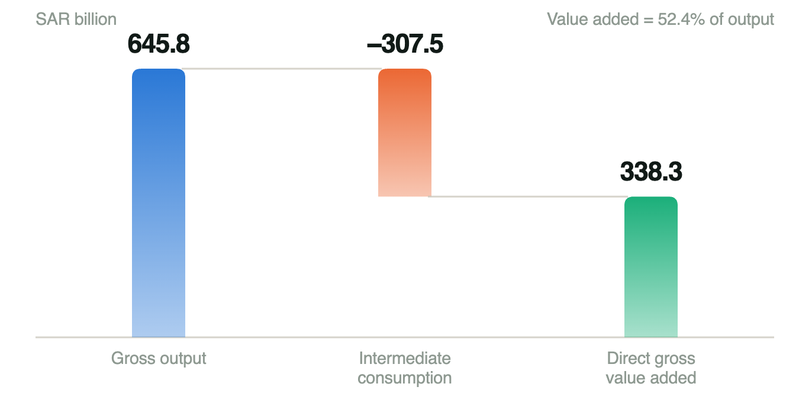
Saudi construction, 2023 — gross output, bought-in inputs and direct value added. Source: GASTAT supply and use tables, sheet 6.2, cells H97, H89 and H90 [R05].
Direct value added of 52.4% is an accounting ratio. It is not a multiplier, and it is not an LCGPA local-content score. Upstream Saudi value added embedded in those bought-in inputs is recorded in other industries, so 52.4% understates the full domestic contribution while saying nothing about how much of the remainder leaves the country.

4.1 Where the imported share concentrates
Screening construction’s product inputs against national import ratios shows the dependence is not spread evenly. It sits in precisely the equipment a modern stadium is full of.
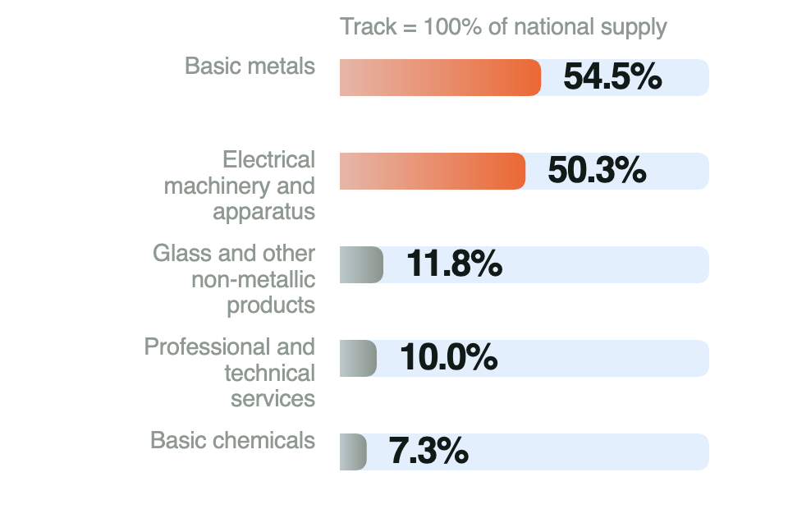
Imports as a share of national supply, 2023, by product group. Source: GASTAT supply and use tables, sheet 6.1, columns AA and AB [R05].
Product group | Construction use (SAR bn) | Imports / national supply
Basic metals | 21.9 | 54.5%
Electrical machinery and apparatus | 4.0 | 50.3%
Glass and other non-metallic products | 41.9 | 11.8%
Professional and technical services | 1.0 | 10.0%
Basic chemicals | 59.0 | 7.3%
The pattern is the argument. Chemicals and glass are consumed in volume but largely supplied domestically. Basic metals and electrical machinery are the two groups where roughly half of national supply is imported — and they are the structural steel, the switchgear, the motors, the control panels and the building-management systems. A stadium is unusually intensive in exactly these.

4.2 The dependence that does not appear in the trade data
Goods are only part of it. Commissioning a building’s mechanical, electrical and control systems is a specialist activity in its own right — the national facilities-management manual treats mechanical systems operations and electrical systems operations as distinct disciplines [R14]. In practice this work, together with controls set-up, performance testing and fault diagnosis, is routinely performed by teams flown in for the purpose and flown out afterwards.
That matters because it is the part of the spend most easily localised without a factory. It requires people and accreditation rather than capital plant, and the skills transfer to hospitals, airports, campuses and data centres — not only to stadiums.
Limit of this screen. These ratios are national and are measured at different valuations from the construction-use column beside them. No construction-specific imported-input matrix was identified in the published GASTAT workbook [R05]. The screen tells us where to ask for contract data. It does not measure this project.

5. Benchmarking
We examined two national programmes that attached industry-participation obligations to large public construction, both with published retrospective evaluations. We chose them because each failed in a different, instructive way.

5.1 London 2012 — real work, weak enforcement
The Olympic Delivery Authority tied skills and employment commitments to the construction of the venues themselves. By May 2012 the programmes had delivered more than 3,000 places training people to work on the Olympic Park and other construction sites, and enabled 408 apprentices to work on the project [R12].
Two things are worth noting about those numbers. They are separate measures and should not be added. And the training places explicitly extended beyond the Olympic Park to other construction sites — the programme was designed to build sector capability, not just to staff one project.
The weakness was enforcement. Crossrail’s retrospective review records that while the ODA imposed public commitments on itself, it “mostly relied on encouragement and persuasion, rather than contractually binding targets, to secure contractors’ cooperation”, and that with hindsight the ODA “accepted that this absence of targets had made it more difficult to achieve its skills and employment objectives than might have been the case otherwise” [R13].
What transfers: tie the obligation to work that is actually being built, and write the commitment into the contract rather than into a memorandum of intent.

5.2 Australia’s AIP Policy — obligations without measurement
Australia has required Australian Industry Participation plans on major projects for years. Its own impact evaluation concluded, at Finding 20, that “the lack of a monitoring and evaluation framework and fit-for-purpose data system make it difficult to clearly establish the extent to which AIP policy is achieving its policy outcomes”, and recommended that such a framework be finalised and implemented as a priority [S14].
This is the more uncomfortable benchmark. The Australian policy was not obviously badly designed; it simply could not demonstrate what it had achieved, because measurement was never built into it. A credit system that counts approved activity rather than realised capability is exposed to the same verdict.
What transfers: decide what will be measured, and who will measure it, before the first obligation is signed — not after the programme needs defending.

5.3 Taken together
London shows that attaching skills obligations to live construction works. Australia shows that obligations which are not measured cannot be proven to work. The Saudi opportunity is to take the first and avoid the second: contractual commitments tied to real venue work, with outcome measurement defined at signature.
Further comparators we did not verify. Malaysia’s Industrial Collaboration Programme and Brazil’s local-content regime are frequently cited in this literature. We did not retrieve their primary documents within this review and therefore make no claim about them.

6. Challenges and risks
Six risks would determine whether a localisation pilot on a World Cup venue creates capability or merely creates paperwork. The safeguards in the right-hand column are our proposals, not existing LCGPA requirements.
Risk | Level | Why it matters | Safeguard we would write in
Fixed event deadline | Critical | An unready supplier can delay safe delivery of a 2034 venue. | Train early; release critical work only after independent qualification.
Tools and technical rights | Serious | Training cannot replace foreign expertise without access to the means of doing the work. | Agree access to software, manuals, diagnostic tools and licences inside the EP agreement.
Weak demand after handover | Serious | Skills disappear when one project ends. | Use transferable building skills and secure a second customer before handover.
Higher costs or poor quality | Watch | Localisation can reduce value if execution is inefficient. | Pilot one package; compare quality and cost across the equipment’s life, not at purchase.
Routine work counted as new | Watch | Credits may reward activity that would have happened anyway. | Record the pre-programme baseline and demonstrate additional capability.
Imports inside local invoices | Watch | Local spending can be overstated, or counted twice. | Trace production origin and imported inputs; audit one consistent ledger.
Two of these deserve emphasis because they are structural rather than operational.
The deadline problem is real and asymmetric. A tournament venue has a date that cannot move, which makes any public owner risk-averse about unproven suppliers precisely when the localisation opportunity is largest. This is why we propose qualification gates rather than quotas: capability is released into critical work only once it has been independently tested.
The additionality problem is the one that decides whether the policy means anything. If credits can be earned for training that would have happened anyway, or for purchases from a local reseller who imports the goods, the scheme generates compliance without capability. A Saudi reseller invoice is not Saudi production.

7. Proposed reinvestment
Our proposal is deliberately narrow: one package, one venue, designed so that the capability outlives the contract. Everything in this section is a group proposal, not an approved or existing programme.

7.1 Why ventilation and controls
We would pilot on building ventilation and control systems rather than on structural steel or façade. Three reasons. The electrical and controls group is where the imported share is highest at 50.3% of national supply [R05]. The work is skills-intensive rather than capital-intensive, so a pilot does not require a factory. And the resulting capability is transferable — the same competence serves hospitals, airports and campuses, which answers the demand-after-2034 risk directly.

7.2 The mechanism: an academy that trains its own trainers
The core idea is a loop rather than a course. A foreign supplier mentors a Saudi contractor team; that team performs paid, supervised work on the stadium itself; independent competence tests gate their access to critical work; and graduates then become instructors for the next intake. The obligation is discharged by teaching, and the teaching compounds.
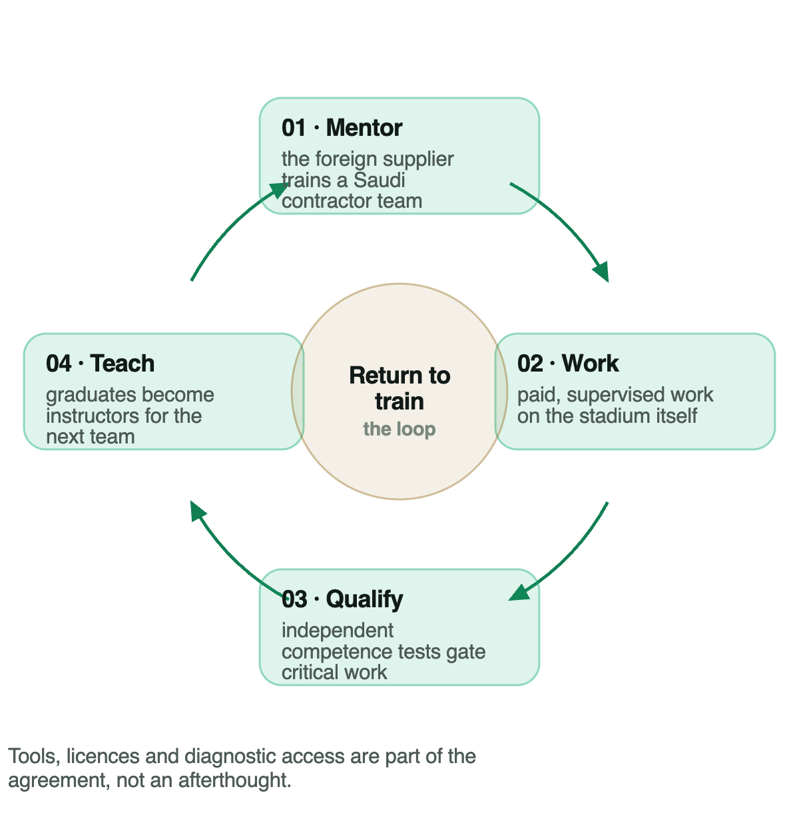
The reinvestment loop: mentor, work, qualify, teach. Group proposal.
Delivery would sit inside an existing technical institute rather than a new entity, with the stadium as the workplace. Phase two — qualifying Saudi makers of brackets, enclosures and assemblies — begins only once quality and demand are proven.

7.3 Five economic-participation activities we would claim
Each is mapped to a published category and its multiplier range [R09]. The category determines what a riyal of effort is worth, which is why the design matters.
- Mentored installation and commissioning training — knowledge transfer (×0.5–2). The mentoring loop itself, evidenced by independent test results rather than attendance.
- In-Kingdom testing and commissioning — localisation of industry or services (×0.5–2). Work currently flown in, performed here.
- Technical-rights package — technology transfer (×0.5–3). Software, manuals, diagnostic tools and licences transferred with the training, without which the training does not survive the mentor’s departure.
- Qualification of local component makers — localisation, moving to subcontracting (×1) once routine. Phase two only.
- Pooled training across qualifying contracts — knowledge transfer. One cohort serving several obligors, which requires an LCGPA rule change (see section 9).
Why not subcontracting. Buying from a local firm is a legitimate qualifying activity, but its multiplier is fixed at 1 — the floor of the schedule [R09]. Knowledge transfer and localisation carry 0.5 to 2, and technology transfer up to 3. A design that teaches is worth more under the policy than a design that merely purchases, and it is also the only one that leaves anything behind.

7.4 Five gates before scale-up
- Verified leakage: contract-level imported value established, not assumed.
- Technical rights: access to tools, software and licences agreed in writing.
- Lifecycle cost: quality and cost compared across the equipment’s life, not at purchase.
- Safe qualification: independent competence tests passed before critical work is released.
- Repeat customer: a second paying customer identified beyond 2034.

8. Expected benefits and how we would measure them
We claim no exact monetary figure, and the brief does not require one. What follows separates an illustration from a commitment.

8.1 The illustration
A simple spending model shows the shape of the prize. Taking SAR 1,000m of spending, a domestic share of 60% rising to 70%, a marginal propensity to consume of 0.75, taxes and fees of 0.10 and an import share of consumption of 0.30, the fraction returning to domestic production each round is r = 0.75 × 0.90 × 0.70 = 0.4725. Total domestic output is then SAR 1,137.44m at 60% and SAR 1,327.01m at 70% — a difference of SAR 189.57m, about SAR 190m per SAR 1bn, from ten percentage points of first-round local share.
These are teaching assumptions, not Saudi estimates, and the multiplier of 1.90 applies to the domestic impulse, not to total project expenditure. The IMF’s literature average for Saudi capital spending is 0.2 in the short run and 0.6 at peak [R08] — which does not calibrate this model and does not establish a stadium multiplier. The illustration shows direction and order of magnitude. It is not a forecast of this project.

8.2 Benefits during construction
- A larger first-round domestic share, which is the only part of the multiplier procurement actually controls.
- Saudi teams performing commissioning work on live systems rather than observing it.
- A documented cost and quality baseline for the same package on the next venue.

8.3 Benefits after handover
- Technicians who have passed an independent competence test and are training the next intake.
- Suppliers qualified to serve the remaining venues and the wider building stock.
- Reduced dependence on flown-in commissioning for hospitals, airports and campuses — demand that does not end in 2034.

8.4 What we would be measured on
Because the Australian evaluation shows that unmeasured obligations cannot be defended [S14], we would commit to three measures at signature rather than at review.
Horizon | Measure | Why this one
During construction | Independent test pass rates; defect rates; safe on-time handover | Competence, not attendance
At 12 and 24 months | Employment retained; graduates who have become instructors | Whether the loop closed
Across future projects | Production net of imported inputs; repeat orders | Real capability, not relabelled imports

9. Recommendations to LCGPA
Four changes would make a pilot of this kind investable for a contractor and provable for the Authority.
1. Publish the criteria for setting a multiplier within a category. The policy states that a multiplier is “determined by the value added to the national economy” and gives a range of 0.5 to 3 [R09], but publishes no criteria for where inside that range a project lands. A bidder therefore cannot price the obligation before signing. The April 2026 draft does not appear to close this gap [S11].
2. Enable joint training programmes across qualifying contracts. Stadium packages are individually too small to sustain a training institution, but collectively are not. Allowing several obligors to fund one accredited cohort would raise quality and lower unit cost, and would make the capability outlast any single contract.
3. Measure competence and real production separately from credits. Credits are a compliance measure; they are neither cash nor GDP. Reporting people who passed an independent test, and production net of imported inputs, alongside credit totals would let the Authority demonstrate outcomes rather than activity — the failure Australia documented [S14].
4. Require independent quality and cost assessment before scale-up. A pilot that is not compared against the imported alternative across the equipment’s life cannot tell the Authority whether localisation added value or simply added cost.

10. Limitations and open questions
- No contract-level data. Imported value for any stadium package is not public; our screen uses national ratios, which cannot be read as project shares [R05, R06].
- Policy version unresolved. Whether a 2026 or 2027 contract falls under the published baseline or the consultation draft is not publicly established [R09, R11, S11].
- Obligor unidentified. We could not establish which party would carry an EP obligation on this project, or whether the funding route brings it into scope [R02, R03].
- Draft text not retrieved. The April 2026 changes are reported from secondary analysis only [S11].
- Model is illustrative. Parameters are teaching assumptions with no Saudi empirical estimate behind them; the result is not a projected return.
- Absence is not proof. Our failure to find a published stadium EP agreement does not establish that none exists.

11. References
R01 FIFA, 29 November 2024 — FIFA World Cup 2034 Bid Evaluation Report — p. 46: “15 stadiums across five proposed host cities”; p. 48 venue table and p. 50: “planned gross capacity of 92,760”, construction to commence 2025 and “be completed by 2030”. https://digitalhub.fifa.com/m/51d8a13714827f1d/original/FIFA-World-Cup-2034-Bid-Evaluation-Report.pdf
R02 Ministry of Sport, 25 November 2025 — Main-works prequalification invitation, King Salman Stadium; deadline 3:00 p.m. on 16 February 2026. https://www.mos.gov.sa/en/media/news/2025/11/25/king-salman-stadium
R03 Ministry of Sport, 7 April 2026 — Preliminary-works prequalification invitation; deadline 2:00 PM on 28 April 2026. https://www.mos.gov.sa/en/media/news/2026/04/07/king-salman-stadium
R04 GASTAT — Quarterly time series of GDP, Q2 2026, provisional, current prices — sheet 1.3, cells BQ14 / BQ24: 94,524 / 1,263,831 = 7.48%, shown as 7.5%. https://www.stats.gov.sa/documents/20117/2435267/GDP_Q2_2026_EN+%282%29.xlsx/c83d0a5f-e2e1-2cac-a477-f1ad8529f202?t=1788844506153
R05 GASTAT — Supply and Use & Input–Output Tables by Sections, 2023 — sheet 6.2 column H (“F / Construction”, thousands of SAR), cells H89 / H90 / H97 and H45–H75; sheet 6.1 columns AA (“Total imports”) and AB (“Supply at basic prices”), same rows. https://www.stats.gov.sa/documents/20117/2435267/SUT_and_IO_By_Sections_-En.xlsx_fixed_3036245/91b73a34-05e8-0e49-46e8-eda783beae16?t=1746090703771
R06 GASTAT, updated 29 April 2025 — Methodology and quality report for the supply-and-use and input–output tables — concepts, valuation, units, coverage 2018–2023. https://www.stats.gov.sa/en/w/methodology-and-quality-report-for-supply-and-use-tables-and-the-input-output-table
R07 Ministry of Finance — Quarterly budget performance report, Q2 FY2026 — PDF p. 10, “Non-financial Assets (CAPEX)”: Q1 43,433, Q2 46,226, H1 89,660 SAR million, cash basis; p. 12 shows H1 2025 of 67,695 (+32%). https://www.mof.gov.sa/en/financialreport/2026/Documents/Q2%20Eng%202026%20V10.pdf
R08 IMF, September 2024 — Saudi Arabia 2024 Article IV, Country Report 24/280 — Box 1, printed p. 10 / PDF p. 15: “the average of capital spending multipliers on non-oil growth is 0.2 in the short run and 0.6 at peak and in the long run”. A literature average, not a forecast. https://www.imf.org/en/Publications/CR/Issues/2024/09/03/Saudi-Arabia-2024-Article-IV-Consultation-Press-Release-Staff-Report-and-Informational-Annex-554530
R09 LCGPA — Economic Participation Policy, Unit 7 training document — p. 4 and p. 5: applies where imported goods and services reach SAR 100 million, giving obligations of “35% of the imported goods and services’ value”; pp. 14–15 the seven categories and multiplier ranges; p. 21 credits and the 0.5–1 bonus. Published training baseline; legal commencement not established. https://lcgpa.futurex.sa/pluginfile.php/2095/mod_folder/content/0/pdf%20E/Economic%20Participation%20Policy%20%281%29.pdf?forcedownload=1
R10 Ministry of Finance, via Umm Al-Qura, 19 January 2024 — Model terms and specifications, performance-based operation and maintenance, Ministerial Decision 832 — Section Nine (local content, clause 75 onward) and Section Ten (economic participation) are separate mechanisms. https://www.uqn.gov.sa/details?p=24374
R11 Umm Al-Qura / National Competitiveness Center, 14 April 2026 — Istitlaa consultation announcement, second paragraph — the updated Economic Participation Policy among sixteen projects; consultation announced to close 22 April 2026. https://www.uqn.gov.sa/news/reports/4000737
R12 UK Department for Culture, Media and Sport, 20 May 2012 — “delivered more than 3,000 places training people to work on the Olympic Park and other construction sites, and enabled 408 apprentices to work on the project”. https://www.gov.uk/government/news/2012-games-construction-on-track-thanks-to-12-000-strong-workforce
R13 Crossrail Learning Legacy — Eldred and Blin, 17 August 2018 — Implementing Contractual Skills and Employment Targets, §1.2: the ODA “mostly relied on encouragement and persuasion, rather than contractually binding targets” and “accepted that this absence of targets had made it more difficult to achieve its skills and employment objectives”. https://learninglegacy.crossrail.co.uk/documents/implementing-contractual-skills-and-employment-targets/
R14 Expenditure and Projects Efficiency Authority, Rev 001, 18 August 2021 — National Manual of Assets and Facilities Management, vol. 5 ch. 1, EOM-ZO0-GL-000001 — §6.6 mechanical systems and §6.7 electrical systems operations. https://expro.gov.sa/api/uploads/Operations%20Management%20Introduction%20Guideline.pdf
R15 MBSC — Dr Rhea Elizabeth George, 30 September 2026 — Assessment guidelines, ECN 511 Economics for Managers — sector 8, topic B; the assessed questions; permission to report an evidence gap as a finding.
R16 Ministry of Finance template, hosted by King Faisal University — Model Terms and Specifications Booklet (General Construction), version two — Section Ten, p. 49 of 59: deletable below SAR 100 million; where a local agent subcontracts to several foreign companies the threshold applies to each subcontractor separately. https://www.kfu.edu.sa/ar/Departments/Purchases/Documents/pages/assets/pdf/Approved-booklet-templates/Sample-Terms-Specifications-Booklet-General-Construction.pdf
S06 Populous, 18 November 2024 · secondary — Design announcement — designer identity only; not a source for capacity, cost or import values. https://populous.com/article/populous-designed-king-salman-stadium-set-to-become-global-sporting-icon
S11 DGA Group, April 2026 · secondary — Analysis of the updated EPP issued for public consultation, pp. 4–8 — tiers, multipliers, Article 10, administrative fee, reporting. Draft text not retrieved; adoption not public. https://dgagroup.com/wp-content/uploads/2026/04/DGA-ASG-Analysis-Updated-Version-of-Saudi-Economic-Participation-Policy-Issued-for-Public-Consultation-1.pdf
S14 Australian Department of Industry, Science and Resources, August 2023 · secondary — Australian Industry Participation (AIP) Policy Impact Evaluation Report — Finding 20 (PDF p. 28): “the lack of a monitoring and evaluation framework and fit-for-purpose data system make it difficult to clearly establish the extent to which AIP policy is achieving its policy outcomes”. https://www.industry.gov.au/sites/default/files/2024-08/australian-industry-participation-policy-impact-evaluation-report_0.pdf

Appendix A. Calculations
Every figure below was recalculated from the publisher’s own file. Cell references are to the GASTAT workbooks named in R04 and R05.
Quantity | Cells | Arithmetic | Result
Construction gross output 2023 | 6.2 H97 | 645,815,815 thousand SAR ÷ 1,000,000 | SAR 645.8bn
Intermediate consumption 2023 | 6.2 H89 | 307,541,082 ÷ 1,000,000 | SAR 307.5bn
Direct gross value added 2023 | 6.2 H90 | 338,274,733 ÷ 1,000,000 | SAR 338.3bn
Accounting identity | 6.2 | 307,541,082 + 338,274,733 = 645,815,815 | Exact
Value added / output | 6.2 H90 ÷ H97 | 338,274,733 ÷ 645,815,815 | 52.379444% → 52.4%
Basic metals import ratio | 6.1 AA51 ÷ AB51 | 72,399,573 ÷ 132,727,383 | 54.547578% → 54.5%
Electrical machinery import ratio | 6.1 AA56 ÷ AB56 | 27,829,535 ÷ 55,326,438 | 50.300609% → 50.3%
Construction share of GDP, Q2 2026 | 1.3 BQ14 ÷ BQ24 | 94,524 ÷ 1,263,831 | 7.479165% → 7.5%
Illustrative leakage factor | — | r = 0.75 × 0.90 × 0.70 | 0.4725
Multiplier on domestic impulse | — | 1 ÷ (1 − 0.4725) | 1.8957
Output at 60% local share | — | 600 ÷ 0.5275 | SAR 1,137.44m
Output at 70% local share | — | 700 ÷ 0.5275 | SAR 1,327.01m
Difference | — | 1,327.01 − 1,137.44 | SAR 189.57m
Rows one to eight are verified calculations from official statistics. Rows nine to thirteen are an illustration built on group assumptions, with no Saudi empirical estimate behind the parameters.

