안건하-전소영-고효진-오예진

Github: <https://github.com/Hyojinko/2021_datascience.git>

#end-to-end process

|  |  |
| --- | --- |
|  | Import warnings  warnings.filterwarnings("ignore") |
|  | import numpy as np |
|  | import pandas as pd |
|  | import matplotlib.pyplot as plt |
|  | import seaborn as sns |
|  | from sklearn import preprocessing |
|  | from sklearn.neighbors import KNeighborsRegressor |
|  | from sklearn.model_selection import train_test_split |
|  | from sklearn.ensemble import BaggingRegressor |
|  | from sklearn.ensemble import RandomForestRegressor |
|  | from sklearn.linear_model import LinearRegression |
|  | from sklearn.preprocessing import PolynomialFeatures |
|  | from sklearn.cluster import KMeans |
|  | from sklearn.ensemble import BaggingClassifier |
|  | from sklearn.neighbors import KNeighborsClassifier |
|  | from sklearn.ensemble import RandomForestClassifier |
|  | from sklearn.model_selection import GridSearchCV |
|  | from sklearn.tree import DecisionTreeRegressor |
|  |  |
|  | pd.set_option('display.max_row', 100) |
|  | pd.set_option('display.max_columns', 100) |
|  |  |
|  | # Read csv |
|  | df = pd.read_excel('IT_3.xlsx') |
|  | df.fillna(axis=0, method='ffill', inplace=True) |
|  |  |
|  | df1 = pd.DataFrame(df) |
|  | # # Drop 5 columns |
|  | df1 = df1.drop(['Miles_driven_annually', 'Years_Experience', 'EngineHP', 'credit_history'], axis=1) |
|  | # Drop rows with Nan |
|  |  |
|  | # Fill missing values |
|  | df1['annual_claims']=df1['annual_claims'].astype(np.int64) |
|  | df1['annual_claims']=df['annual_claims'].astype('category') |
|  |  |
|  |  |
|  |  |
|  |  |
|  |  |
|  |  |
|  | # #make target to category |
|  | # targets = df['annual_claims'].astype(np.int64) |
|  | # targets = targets.astype('category') |
|  |  |
|  |  |
|  | df_ordinal = df1.copy() |
|  | df_oneHot = df1.copy() |
|  | df_label = df1.copy() |
|  |  |
|  | # Convert 'Marital_Status' feature to numeric values using ordinalEncoder |
|  | ordinalEncoder = preprocessing.OrdinalEncoder() |
|  | X = pd.DataFrame(df1['Marital_Status']) |
|  | ordinalEncoder.fit(X) |
|  | df_ordinal['Marital_Status'] = pd.DataFrame(ordinalEncoder.transform(X)) |
|  |  |
|  | # Convert 'Marital_Status' feature to numeric values using labelEncoder |
|  | labelEncoder = preprocessing.LabelEncoder() |
|  | labelEncoder.fit(df_label['Marital_Status']) |
|  | df_label['Marital_Status'] = labelEncoder.transform(df_label['Marital_Status']) |
|  |  |
|  |  |
|  | # Convert 'Vehical_type' feature to numeric values using ordinalEncoder |
|  | ordEnc = preprocessing.OrdinalEncoder() |
|  | X = pd.DataFrame(df1['Vehical_type']) |
|  | ordEnc.fit(X) |
|  | df_ordinal['Vehical_type'] = pd.DataFrame(ordEnc.transform(X)) |
|  |  |
|  | # Convert 'Vehical_type' feature to numeric values using labelEncoder |
|  | labelEnc = preprocessing.LabelEncoder() |
|  | labelEnc.fit(df1['Vehical_type']) |
|  | df_label['Vehical_type'] = pd.DataFrame(labelEnc.transform(df1['Vehical_type'])) |
|  |  |
|  |  |
|  | # Convert 'Gender' features to numeric values using ordinalEncoder |
|  | X = pd.DataFrame(df1['Gender']) |
|  | ordEnc.fit(X) |
|  | df_ordinal['Gender'] = pd.DataFrame(ordEnc.transform(X)) |
|  |  |
|  | # Convert 'Gender' features to numeric values using labelEncoder |
|  | labelEnc.fit(X) |
|  | df_label['Gender'] = pd.DataFrame(labelEnc.transform(X)) |
|  |  |
|  |  |
|  | # Convert 'State' features to numeric values using ordinalEncoder |
|  | X = pd.DataFrame(df1['State']) |
|  | ordEnc.fit(X) |
|  | df_ordinal['State'] = pd.DataFrame(ordEnc.transform(X)) |
|  |  |
|  | # Convert 'State' features to numeric values using labelEncoder |
|  | labelEnc.fit(df1['State']) |
|  | df_label['State'] = pd.DataFrame(labelEnc.transform(df1['State'])) |
|  |  |
|  |  |
|  | # Convert 'Age_bucket' features to numeric values using ordinalEncoder |
|  | X = pd.DataFrame(df1['Age_bucket']) |
|  | ordEnc.fit(X) |
|  | df_ordinal['Age_bucket'] = pd.DataFrame(ordEnc.transform(X)) |
|  |  |
|  | # Convert 'Age_bucket' features to numeric values using labelEncoder |
|  | labelEnc.fit(df1['Age_bucket']) |
|  | df_label['Age_bucket'] = pd.DataFrame(labelEnc.transform(df1['Age_bucket'])) |
|  |  |
|  |  |
|  | # Convert 'EngineHP_bucket' features to numeric values using ordinalEncoder |
|  | X = pd.DataFrame(df1['EngineHP_bucket']) |
|  | ordEnc.fit(X) |
|  | df_ordinal['EngineHP_bucket'] = pd.DataFrame(ordEnc.transform(X)) |
|  |  |
|  | # Convert 'EngineHP_bucket' features to numeric values using labelEncoder |
|  | labelEnc.fit(df1['EngineHP_bucket']) |
|  | df_label['EngineHP_bucket'] = pd.DataFrame(labelEnc.transform(df1['EngineHP_bucket'])) |
|  |  |
|  |  |
|  | # Convert 'Years_Experience_bucket' features to numeric values using ordinalEncoder |
|  | X = pd.DataFrame(df1['Years_Experience_bucket']) |
|  | ordEnc.fit(X) |
|  | df_ordinal['Years_Experience_bucket'] = pd.DataFrame(ordEnc.transform(X)) |
|  |  |
|  | # Convert 'Years_Experience_bucket' features to numeric values using labelEncoder |
|  | labelEnc.fit(df1['Years_Experience_bucket']) |
|  | df_label['Years_Experience_bucket'] = pd.DataFrame(labelEnc.transform(df1['Years_Experience_bucket'])) |
|  |  |
|  |  |
|  | # Convert 'Miles_driven_annually_bucket' features to numeric values using ordinalEncoder |
|  | X = pd.DataFrame(df1['Miles_driven_annually_bucket']) |
|  | ordEnc.fit(X) |
|  | df_ordinal['Miles_driven_annually_bucket'] = pd.DataFrame(ordEnc.transform(X)) |
|  |  |
|  | # Convert 'Miles_driven_annually_bucket' features to numeric values using labelEncoder |
|  | labelEnc.fit(df1['Miles_driven_annually_bucket']) |
|  | df_label['Miles_driven_annually_bucket'] = pd.DataFrame(labelEnc.transform(df1['Miles_driven_annually_bucket'])) |
|  |  |
|  |  |
|  | # Convert 'credit_history_bucket' features to numeric values using ordinalEncoder |
|  | X = pd.DataFrame(df1['credit_history_bucket']) |
|  | ordEnc.fit(X) |
|  | df_ordinal['credit_history_bucket'] = pd.DataFrame(ordEnc.transform(X)) |
|  |  |
|  | # Convert 'credit_history_bucket' features to numeric values using labelEncoder |
|  | labelEnc.fit(df1['credit_history_bucket']) |
|  | df_label['credit_history_bucket'] = pd.DataFrame(labelEnc.transform(df1['credit_history_bucket'])) |
|  |  |
|  | print("=======isNan") |
|  | print(df_label.isnull().sum()) |
|  | # 인코딩 거치면 null 값이 생깁니다.. |
|  | df_label = df_label.dropna() |
|  |  |
|  | df_oneHot['annual_claims']=df_oneHot['annual_claims'].astype(np.int64) |
|  |  |
|  | # Getting all the categorical variables in a list |
|  | categoricalColumn = df1.columns[df1.dtypes == np.object].tolist() |
|  | # Convert categorical features to numeric values using oneHotEncoder |
|  | for col in categoricalColumn: |
|  | if(len(df_oneHot[col].unique()) == 2): |
|  | df_oneHot[col] = pd.get_dummies(df_oneHot[col], drop_first=True) |
|  |  |
|  | df_oneHot = pd.get_dummies(df_oneHot) |
|  |  |
|  | df1['annual_claims']=df1['annual_claims'].astype('category') |
|  | y = df1['annual_claims'] |
|  | y2 = df1['annual_claims'] |
|  | # Split the dataset |
|  |  |
|  | X1 = df_ordinal.drop(['annual_claims'], 1) |
|  | X2 = df_label.drop(['annual_claims'], 1) |
|  | X3 = df_oneHot.drop(['annual_claims'], 1) |
|  |  |
|  |  |
|  |  |
|  | X1_train, X1_test, y1_train, y1_test = train_test_split(X1, y, random_state=0) |
|  | X2_train, X2_test, y2_train, y2_test = train_test_split(X2, y, random_state=0) |
|  | X3_train, X3_test, y3_train, y3_test = train_test_split(X3, y, random_state=0) |
|  |  |
|  |  |
|  |  |
|  | # Normalizing the ordinalEncoded dataset using MaxAbsScaler |
|  | scaler = preprocessing.MaxAbsScaler() |
|  | df_ordinal_maxAbs_train = scaler.fit_transform(X1_train) |
|  | df_ordinal_maxAbs_train = pd.DataFrame(df_ordinal_maxAbs_train, columns=X1_train.columns) |
|  |  |
|  | df_ordinal_maxAbs_test = scaler.fit_transform(X1_test) |
|  | df_ordinal_maxAbs_test = pd.DataFrame(df_ordinal_maxAbs_test, columns=X1_test.columns) |
|  | print(df_ordinal_maxAbs_train.head(10)) |
|  |  |
|  |  |
|  |  |
|  | # Normalizing the oneHotEncoded dataset using MaxAbsScaler |
|  | scaler = preprocessing.MaxAbsScaler() |
|  | df_oneHot_maxAbs_train = scaler.fit_transform(X3_train) |
|  | df_oneHot_maxAbs_train = pd.DataFrame(df_oneHot_maxAbs_train, columns=X3_train.columns) |
|  |  |
|  | df_oneHot_maxAbs_test = scaler.fit_transform(X3_test) |
|  | df_oneHot_maxAbs_test = pd.DataFrame(df_oneHot_maxAbs_test, columns=X3_test.columns) |
|  | print(df_oneHot_maxAbs_test.head(10)) |
|  |  |
|  |  |
|  |  |
|  | # Normalizing the labelEncoded dataset using MaxAbsScaler |
|  | scaler = preprocessing.MaxAbsScaler() |
|  | df_label_maxAbs_train = scaler.fit_transform(X2_train) |
|  | df_label_maxAbs_train = pd.DataFrame(df_label_maxAbs_train, columns=X2_train.columns) |
|  |  |
|  | df_label_maxAbs_test = scaler.fit_transform(X2_test) |
|  | df_label_maxAbs_test = pd.DataFrame(df_label_maxAbs_test, columns=X2_test.columns) |
|  | print(df_label_maxAbs_test.head(10)) |
|  |  |
|  |  |
|  | # Normalizing the ordinalEncoded dataset using RobustScaler |
|  | scaler = preprocessing.RobustScaler() |
|  | df_ordinal_robust_train = scaler.fit_transform(X1_train) |
|  | df_ordinal_robust_train = pd.DataFrame(df_ordinal_robust_train, columns=X1_train.columns) |
|  |  |
|  | df_ordinal_robust_test = scaler.fit_transform(X1_test) |
|  | df_ordinal_robust_test = pd.DataFrame(df_ordinal_robust_test, columns=X1_test.columns) |
|  | print(df_ordinal_robust_test.head(10)) |
|  |  |
|  |  |
|  |  |
|  | # Normalizing the oneHotEncoded dataset using RobustScaler |
|  | scaler = preprocessing.RobustScaler() |
|  | df_oneHot_robust_train = scaler.fit_transform(X3_train) |
|  | df_oneHot_robust_train = pd.DataFrame(df_oneHot_robust_train, columns=X3_train.columns) |
|  |  |
|  | df_oneHot_robust_test = scaler.fit_transform(X3_test) |
|  | df_oneHot_robust_test = pd.DataFrame(df_oneHot_robust_test, columns=X3_test.columns) |
|  | print(df_oneHot_robust_test.head(10)) |
|  |  |
|  |  |
|  |  |
|  | # Normalizing the labelEncoded dataset using RobustScaler |
|  | scaler = preprocessing.RobustScaler() |
|  | df_label_robust_train = scaler.fit_transform(X2_train) |
|  | df_label_robust_train = pd.DataFrame(df_label_robust_train, columns=X2_train.columns) |
|  |  |
|  | df_label_robust_test = scaler.fit_transform(X2_test) |
|  | df_label_robust_test = pd.DataFrame(df_label_robust_test, columns=X2_test.columns) |
|  | print(df_label_robust_test.head(10)) |
|  |  |
|  |  |
|  |  |
|  | # Normalizing the ordinalEncoded dataset using MinMaxScaler |
|  | scaler = preprocessing.MinMaxScaler() |
|  | df_ordinal_minMax_train = scaler.fit_transform(X1_train) |
|  | df_ordinal_minMax_train = pd.DataFrame(df_ordinal_minMax_train, columns=X1_train.columns) |
|  |  |
|  |  |
|  | df_ordinal_minMax_test = scaler.fit_transform(X1_test) |
|  | df_ordinal_minMax_test = pd.DataFrame(df_ordinal_minMax_test, columns=X1_test.columns) |
|  | print(df_ordinal_minMax_test.head(10)) |
|  |  |
|  | # Normalizing the oneHotEncoded dataset using MinMaxScaler |
|  | scaler = preprocessing.MinMaxScaler() |
|  | df_oneHot_minMax_train = scaler.fit_transform(X3_train) |
|  | df_oneHot_minMax_train = pd.DataFrame(df_oneHot_minMax_train, columns=X3_train.columns) |
|  |  |
|  | df_oneHot_minMax_test = scaler.fit_transform(X3_test) |
|  | df_oneHot_minMax_test = pd.DataFrame(df_oneHot_minMax_test, columns=X3_test.columns) |
|  | print(df_oneHot_minMax_test.head(10)) |
|  |  |
|  | # Normalizing the labelEncoded dataset using MinMaxScaler |
|  | scaler = preprocessing.MinMaxScaler() |
|  | df_label_minMax_train = scaler.fit_transform(X2_train) |
|  | df_label_minMax_train = pd.DataFrame(df_label_minMax_train, columns=X2_train.columns) |
|  |  |
|  | df_label_minMax_test = scaler.fit_transform(X2_test) |
|  | df_label_minMax_test = pd.DataFrame(df_label_minMax_test, columns=X2_test.columns) |
|  | print(df_label_minMax_test.head(10)) |
|  |  |
|  | # Normalizing the ordinalEncoded dataset using StandardScaler |
|  | scaler = preprocessing.StandardScaler() |
|  | df_ordinal_stand_train = scaler.fit_transform(X1_train) |
|  | df_ordinal_stand_train = pd.DataFrame(df_ordinal_stand_train, columns=X1_train.columns) |
|  |  |
|  | df_ordinal_stand_test = scaler.fit_transform(X1_test) |
|  | df_ordinal_stand_test = pd.DataFrame(df_ordinal_stand_test, columns=X1_test.columns) |
|  | print(df_ordinal_stand_test.head(10)) |
|  |  |
|  | # Normalizing the oneHotEncoded dataset using StandardScaler |
|  | scaler = preprocessing.StandardScaler() |
|  | df_oneHot_stand_train = scaler.fit_transform(X3_train) |
|  | df_oneHot_stand_train = pd.DataFrame(df_oneHot_stand_train, columns=X3_train.columns) |
|  |  |
|  | df_oneHot_stand_test = scaler.fit_transform(X3_test) |
|  | df_oneHot_stand_test = pd.DataFrame(df_oneHot_stand_test, columns=X3_test.columns) |
|  | print(df_oneHot_stand_test.head(10)) |
|  |  |
|  | # Normalizing the labelEncoded dataset using StandardScaler |
|  | scaler = preprocessing.StandardScaler() |
|  | df_label_stand_train = scaler.fit_transform(X2_train) |
|  | df_label_stand_train = pd.DataFrame(df_label_stand_train, columns=X2_train.columns) |
|  |  |
|  | df_label_stand_test = scaler.fit_transform(X2_test) |
|  | df_label_stand_test = pd.DataFrame(df_label_stand_test, columns=X2_test.columns) |
|  | print(df_label_stand_test.head(10)) |
|  |  |
|  |  |
|  |  |
|  |  |
|  | #bar graph of target |
|  | sns.countplot(df['target']) |
|  | plt.show() |
|  |  |
|  | #bar graph of Gender |
|  | sns.countplot(df['Gender']) |
|  | plt.show() |
|  |  |
|  | #bar graph of annual_claims |
|  | sns.countplot(df['annual_claims']) |
|  | plt.show() |
|  |  |
|  | #bar graph of Marital_Status |
|  | sns.countplot(df['Marital_Status']) |
|  | plt.show() |
|  |  |
|  | #bar graph of Vehical_type |
|  | sns.countplot(df['Vehical_type']) |
|  | #plt.show() |
|  |  |
|  |  |
|  | #bar graph of size_of_family |
|  | sns.countplot(df['size_of_family']) |
|  | #plt.show() |
|  |  |
|  | #bar graph of State |
|  | sns.countplot(df['State']) |
|  | plt.show() |
|  |  |
|  | #Two variable plots |
|  | df_f = pd.DataFrame(df[df['Gender']=='F']) |
|  | df_m = pd.DataFrame(df[df['Gender']=='M']) |
|  |  |
|  |  |
|  | #EngineHP histogram by Gender |
|  | plt.hist(df_f['EngineHP'], bins=10) |
|  | plt.title('Female') |
|  | plt.xlabel('EngineHP') |
|  | plt.ylabel('Frequency') |
|  | plt.show() |
|  |  |
|  | plt.hist(df_m['EngineHP'], bins=10) |
|  | plt.title('Male') |
|  | plt.xlabel('EngineHP') |
|  | plt.ylabel('Frequency') |
|  | plt.show() |
|  |  |
|  | #credit history histogram by Gender |
|  | plt.hist(df_m['credit_history'], bins=10) |
|  | plt.title('Male') |
|  | plt.xlabel('credit_history') |
|  | plt.ylabel('Frequency') |
|  | plt.show() |
|  |  |
|  | plt.hist(df_f['credit_history'], bins=10) |
|  | plt.title('Female') |
|  | plt.xlabel('credit_history') |
|  | plt.ylabel('Frequency') |
|  | plt.show() |
|  |  |
|  |  |
|  | #years experience histogram by Gender |
|  |  |
|  | plt.hist(df_f['Years_Experience'], bins=10) |
|  | plt.title('Female') |
|  | plt.xlabel('Years_Experience') |
|  | plt.ylabel('Frequency') |
|  | plt.show() |
|  |  |
|  | plt.hist(df_m['Years_Experience'], bins=10) |
|  | plt.title('Male') |
|  | plt.xlabel('Years_Experience') |
|  | plt.ylabel('Frequency') |
|  | plt.show() |
|  |  |
|  | #annual claims histogram by Gender |
|  |  |
|  |  |
|  | plt.hist(df_m['annual_claims'], bins=10) |
|  | plt.title('Male') |
|  | plt.xlabel('annual_claims') |
|  | plt.ylabel('Frequency') |
|  | plt.show() |
|  |  |
|  | plt.hist(df_f['annual_claims'], bins=10) |
|  | plt.title('Female') |
|  | plt.xlabel('annual_claims') |
|  | plt.ylabel('Frequency') |
|  | plt.show() |
|  | #Miles driven annually histogram by Gender |
|  |  |
|  | plt.hist(df_f['Miles_driven_annually'], bins=10) |
|  | plt.title('Female') |
|  | plt.xlabel('Miles_driven_annually') |
|  | plt.ylabel('Frequency') |
|  | plt.show() |
|  |  |
|  | plt.hist(df_m['Miles_driven_annually'], bins=10) |
|  | plt.title('Male') |
|  | plt.xlabel('Miles_driven_annually') |
|  | plt.ylabel('Frequency') |
|  | plt.show() |
|  |  |
|  | #Size of family histogram by Gender |
|  |  |
|  | plt.hist(df_f['size_of_family'], bins=10) |
|  | plt.title('Female') |
|  | plt.xlabel('size_of_family') |
|  | plt.ylabel('Frequency') |
|  | plt.show() |
|  |  |
|  | plt.hist(df_m['size_of_family'], bins=10) |
|  | plt.title('Male') |
|  | plt.xlabel('size_of_family') |
|  | plt.ylabel('Frequency') |
|  | plt.show() |
|  |  |
|  | #State histogram by Gender |
|  |  |
|  | plt.hist(df_f['State'], bins=10) |
|  | plt.title('Female') |
|  | plt.xlabel('State') |
|  | plt.ylabel('Frequency') |
|  | plt.show() |
|  |  |
|  | plt.hist(df_m['State'], bins=10) |
|  | plt.title('Male') |
|  | plt.xlabel('State') |
|  | plt.ylabel('Frequency') |
|  | plt.show() |
|  |  |
|  |  |
|  | #Pie chart of vehicle type |
|  | car = pd.DataFrame(df[df['Vehical_type']=='Car']) |
|  | van = pd.DataFrame(df[df['Vehical_type']=='Van']) |
|  | truck = pd.DataFrame(df[df['Vehical_type']=='Truck']) |
|  | utility = pd.DataFrame(df[df['Vehical_type']=='Utility']) |
|  |  |
|  | langs = ['Car','Van','Truck','Utility'] |
|  | vehicle_level = [len(car), len(van), len(truck),len(utility)] |
|  | plt.pie(vehicle_level,labels=langs,autopct='%1.2f%%') |
|  | plt.show() |
|  |  |
|  | #Pie chart of annual_claim |
|  | ann_0 = pd.DataFrame(df[df['annual_claims']==0]) |
|  | ann_1 = pd.DataFrame(df[df['annual_claims']==1]) |
|  | ann_2 = pd.DataFrame(df[df['annual_claims']==2]) |
|  | ann_3 = pd.DataFrame(df[df['annual_claims']==3]) |
|  | ann_4 = pd.DataFrame(df[df['annual_claims']==4]) |
|  |  |
|  | langs = ['0','1','2','3','4'] |
|  | claim_level = [len(ann_0), len(ann_1), len(ann_2),len(ann_3),len(ann_4)] |
|  | plt.pie(claim_level,labels=langs,autopct='%1.2f%%') |
|  | plt.title('annual claim levels') |
|  | plt.show() |
|  |  |
|  |  |
|  | #Pie chart of size of family |
|  | fam1 = pd.DataFrame(df[df['size_of_family']==1]) |
|  | fam2 = pd.DataFrame(df[df['size_of_family']==2]) |
|  | fam3 = pd.DataFrame(df[df['size_of_family']==3]) |
|  | fam4 = pd.DataFrame(df[df['size_of_family']==4]) |
|  | fam5 = pd.DataFrame(df[df['size_of_family']==5]) |
|  | fam6 = pd.DataFrame(df[df['size_of_family']==6]) |
|  | fam7 = pd.DataFrame(df[df['size_of_family']==7]) |
|  | fam8 = pd.DataFrame(df[df['size_of_family']==8]) |
|  |  |
|  |  |
|  | langs = ['1','2','3','4','5','6','7','8'] |
|  | family_level = [len(fam1), len(fam2), len(fam3),len(fam4),len(fam5),len(fam6),len(fam7),len(fam8)] |
|  | plt.pie(family_level,labels=langs,autopct='%1.2f%%') |
|  | plt.title('famliy size levels') |
|  | plt.show() |
|  |  |
|  | #EngineHP and crdit history scatter plot divided by Gender |
|  |  |
|  | plt.scatter(df_f['EngineHP'], df_f['credit_history'],color='r') |
|  | plt.scatter(df_m['EngineHP'], df_m['credit_history'],color='b') |
|  | plt.xlabel('EngineHP') |
|  | plt.ylabel('Credit history') |
|  | plt.title('Scatter plot divided by Gender') |
|  | plt.show() |
|  |  |
|  | #Years_Experience and annual claims scatter plot divided by Gender |
|  |  |
|  | plt.scatter(df_f['Years_Experience'], df_f['annual_claims'],color='r') |
|  | plt.scatter(df_m['Years_Experience'], df_m['annual_claims'],color='b') |
|  | plt.xlabel('Years_Experience') |
|  | plt.ylabel('Annual claims ') |
|  | plt.title('Scatter plot divided by Gender') |
|  | plt.show() |
|  |  |
|  | df['annual_claims']=df1['annual_claims'].astype(np.int64) |
|  | #Boxplot of annual claims divided by gender |
|  | sns.boxplot(df['Gender'],df['annual_claims']) |
|  | plt.show() |
|  |  |
|  | #Boxplot of EngineHP divided by gender |
|  | sns.boxplot(df['Gender'],df['EngineHP']) |
|  | plt.show() |
|  |  |
|  |  |
|  | #Boxplot of Years Experience divided by gender |
|  | sns.boxplot(df['Gender'],df['Years_Experience']) |
|  | plt.show() |
|  |  |
|  | #Boxplot of size of family divided by gender |
|  | sns.boxplot(df['Gender'],df['size_of_family']) |
|  | plt.show() |
|  |  |
|  | #heatmap-pearson |
|  | sns.heatmap(df.corr(method='pearson')) |
|  | plt.title("pearson") |
|  | plt.show() |
|  |  |
|  | # Correlation of all features |
|  | plt.figure(figsize=(15,15)) |
|  | sns.heatmap(df.corr(method='pearson'), annot=True, fmt='.2f', linewidths=5, cmap='Blues') |
|  | plt.title("Correlation of all features") |
|  | plt.show() |
|  |  |
|  |  |
|  |  |
|  | # # Rename 'target' and 'annual_claims' features |
|  | # df2.rename(columns = {'target':'claim_prediction', 'annual_claims':'target'}, inplace=True) |
|  |  |
|  | # Drop 'ID' feature |
|  |  |
|  |  |
|  | X_train = df_label_stand_train |
|  | X_test = df_label_stand_test |
|  | y_train = y2_train |
|  | y_test = y2_test |
|  |  |
|  | print(X_test) |
|  | print(X_train) |
|  | # |
|  |  |
|  |  |
|  |  |
|  | """ |
|  | model = BaggingClassifier() #grid search 해야함 |
|  | params = {'n_estimators': [100,125,150], |
|  | 'max_features': [0.1,0.4, 0.5,1], |
|  | 'max_samples':[0.1, 0.2, 0.3,0.5,1] |
|  | }; |
|  |  |
|  | print("\n---------- Bagging classifier grid search ----------") |
|  | model_gscv = GridSearchCV(model,param_grid = params,cv=5,scoring='accuracy') |
|  | model_gscv.fit(X_train,y_train) |
|  | print("Best param : ",model_gscv.best_params_) |
|  | print("Best score : ",model_gscv.best_score_) |
|  | prediction = model_gscv.predict(X_test) |
|  | print(model_gscv.score(X_test,y_test)) |
|  |  |
|  |  |
|  | # Using KNN algorithm |
|  | # Create and train a KNN classifier |
|  | knn = KNeighborsClassifier(n_neighbors=5) |
|  | knn.fit(X_train, y_train) |
|  |  |
|  | y_prec = knn.predict(X_test) |
|  | print("\n---------- KNN classifier ----------") |
|  | print(y_prec[0:100]) |
|  | print("Score: %.2f" % knn.score(X_test, y_test)) |
|  |  |
|  |  |
|  | rfModel = RandomForestClassifier() |
|  | params = {'n_estimators': [100,125,150], |
|  | 'max_depth': [2,4,6,8], |
|  | 'max_features': [0.1,0.4, 0.5,1], |
|  | 'max_samples':[0.1, 0.2, 0.3,0.5,1] |
|  | }; |
|  | print("\n----------Random Forest classifier grid search ----------") |
|  | rfModel_gscv = GridSearchCV(rfModel,params,scoring = 'r2') |
|  | rfModel_gscv.fit(X_train,y_train) |
|  | y_predict = rfModel_gscv.predict(X_test) |
|  | print("Best param : ",rfModel_gscv.best_params_) |
|  | print("Best score : ",rfModel_gscv.best_score_) |
|  | print(rfModel_gscv.score(X_test,y_test)) |
|  | print("\n\n\n") |
|  |  |
|  | """ |
|  | y_test = y_test.astype(np.int64) |
|  | y_train = y_train.astype(np.int) |
|  | """ |
|  | models = BaggingRegressor() |
|  | params = {'n_estimators': [100,125,150], |
|  | 'max_features': [0.1,0.4, 0.5,1], |
|  | 'max_samples':[0.1, 0.2, 0.3,0.5,1] |
|  | }; |
|  |  |
|  | print("\n---------- Bagging regressor grid search ----------") |
|  | models_gscv = GridSearchCV(models,param_grid = params,cv=5,scoring='r2') |
|  | models_gscv.fit(X_train,y_train) |
|  | print("Best param : ",models_gscv.best_params_) |
|  | print("Best score : ",models_gscv.best_score_) |
|  | print(models_gscv.score(X_test,y_test)) |
|  |  |
|  |  |
|  | # Using KNN algorithm |
|  | # Create and train a KNN classifier |
|  | knnR = KNeighborsRegressor(n_neighbors=5) |
|  | knnR.fit(X_train, y_train) |
|  | print("\n---------- KNN regressor----------") |
|  | print("Score: %.2f" % knnR.score(X_test, y_test)) |
|  |  |
|  |  |
|  | rfModelR = RandomForestRegressor() |
|  | params = {'n_estimators': [100,125,150], |
|  | 'max_depth': [2,4,6,8], |
|  | 'max_features': [0.1,0.4, 0.5,1], |
|  | 'max_samples':[0.1, 0.2, 0.3,0.5,1] |
|  | }; |
|  | print("\n----------Random Forest regressor grid search ----------") |
|  | rfModelR_gscv = GridSearchCV(rfModelR,params,scoring = 'r2') |
|  | rfModelR_gscv.fit(X_train,y_train) |
|  | print("Best param : ",rfModelR_gscv.best_params_) |
|  | print("Best score : ",rfModelR_gscv.best_score_) |
|  | print(rfModelR_gscv.score(X_test,y_test)) |
|  | print("\n\n\n") |
|  | """ |
|  | # # LinearRegression |
|  | line_reg = LinearRegression(); |
|  | line_reg.fit(X_train, y_train) |
|  | y_predict = line_reg.predict(X_test) |
|  | print("\n---------- LinearRegression ----------") |
|  | print("y_predict: \n", y_predict) |
|  | print("Score: %.2f" % line_reg.score(X_test, y_test)) |
|  | # |
|  | # # Polynomial Regression |
|  | poly_reg = PolynomialFeatures(degree=2) |
|  | X_poly_train = poly_reg.fit_transform(X_train) |
|  | X_poly_test = poly_reg.fit_transform(X_test) |
|  | pol_reg = LinearRegression() |
|  | pol_reg.fit(X_poly_train, y_train) |
|  | y_predict = line_reg.predict(X_test) |
|  | print("\n---------- Polynomial algorithm ----------") |
|  | print("y_predict: \n", y_predict) |
|  | print("Score: %.2f" % pol_reg.score(X_poly_test, y_test)) |
|  |  |
|  |  |
|  |  |
|  | X = X2 |
|  | y = y2 |
|  |  |
|  | X_train,X_test,y_train,y_test = train_test_split(X, y, random_state=0) |
|  |  |
|  | X_train2 = np.array(X_train) |
|  | X_test2 = np.array(X_test) |
|  | y_test2 = np.array(y_test) |
|  |  |
|  | #kmeans cluster |
|  | kmeans = KMeans(n_clusters=2) |
|  | kmeans.fit(X_train2) |
|  | correct = 0 |
|  | for i in range(len(X_test2)): |
|  | predict_me = np.array(X_test2[i].astype(float)) |
|  | predict_me = predict_me.reshape(-1,len(predict_me)) |
|  | prediction = kmeans.predict(predict_me) |
|  | if(prediction[0]==y_test2[i]): |
|  | correct += 1 |
|  | print("Score: %.2f" % (correct/len(X_test2))) |
|  |  |
|  |  |
|  | #Make own module to predict |
|  | def process_module(df, targetName): |
|  |  |
|  | # Split the dataset |
|  | y = df[targetName] |
|  | X = df.drop([targetName], 1) |
|  | X_train, X_test, y_train, y_test = train_test_split(X, y, random_state=0) |
|  |  |
|  |  |
|  | # Normalization with 4 Scaling methods |
|  | maxAbsScaler = preprocessing.MaxAbsScaler() |
|  | minmaxScaler = preprocessing.MinMaxScaler() |
|  | robustScaler = preprocessing.RobustScaler() |
|  | standardScaler = preprocessing.StandardScaler() |
|  |  |
|  | df_maxAbs_scaled_train = maxAbsScaler.fit_transform(X_train) |
|  | df_maxAbs_scaled_train = pd.DataFrame(df_maxAbs_scaled_train, columns=X_train.columns) |
|  | df_maxAbs_scaled_test = maxAbsScaler.fit_transform(X_test) |
|  | df_maxAbs_scaled_test = pd.DataFrame(df_maxAbs_scaled_test, columns=X_test.columns) |
|  |  |
|  | df_minMax_scaled_train = minmaxScaler.fit_transform(X_train) |
|  | df_minMax_scaled_train = pd.DataFrame(df_minMax_scaled_train, columns=X_train.columns) |
|  | df_minMax_scaled_test = minmaxScaler.fit_transform(X_test) |
|  | df_minMax_scaled_test = pd.DataFrame(df_minMax_scaled_test, columns=X_test.columns) |
|  |  |
|  | df_robust_scaled_train = robustScaler.fit_transform(X_train) |
|  | df_robust_scaled_train = pd.DataFrame(df_robust_scaled_train, columns=X_train.columns) |
|  | df_robust_scaled_test = robustScaler.fit_transform(X_test) |
|  | df_robust_scaled_test = pd.DataFrame(df_robust_scaled_test, columns=X_test.columns) |
|  |  |
|  | df_standard_scaled_train = standardScaler.fit_transform(X_train) |
|  | df_standard_scaled_train = pd.DataFrame(df_standard_scaled_train, columns=X_train.columns) |
|  | df_standard_scaled_test = standardScaler.fit_transform(X_test) |
|  | df_standard_scaled_test = pd.DataFrame(df_standard_scaled_test, columns=X_test.columns) |
|  |  |
|  |  |
|  | # Alogirthm |
|  | print("\n------------------------- Using maxAbs scaled dataset -------------------------") |
|  | max_score_maxAbs = algorithm_module(df_maxAbs_scaled_train, df_maxAbs_scaled_test, y_train, y_test) |
|  | print("\n------------------------- Using minMax scaled dataset -------------------------") |
|  | max_score_minMax = algorithm_module(df_minMax_scaled_train, df_minMax_scaled_test, y_train, y_test) |
|  | print("\n------------------------- Using robust scaled dataset -------------------------") |
|  | max_score_robust = algorithm_module(df_robust_scaled_train, df_robust_scaled_test, y_train, y_test) |
|  | print("\n------------------------- Using standard scaled dataset -------------------------") |
|  | max_score_standard = algorithm_module(df_standard_scaled_train, df_standard_scaled_test, y_train, y_test) |
|  |  |
|  |  |
|  | # Result |
|  | max_score_result = max(max_score_maxAbs, max_score_minMax, max_score_robust, max_score_standard) |
|  | print("\n\n============================== Result ==============================") |
|  | print("Final maximum score: %.6f" % max_score_result) |
|  |  |
|  |  |
|  | def algorithm_module(X_train, X_test, y_train, y_test): |
|  |  |
|  | # Linear Regression |
|  | line_reg = LinearRegression() |
|  | line_reg.fit(X_train, y_train) |
|  | y_prec_linear = line_reg.predict(X_test) |
|  | score_linear = line_reg.score(X_test, y_test) |
|  | print("\ny_predict_linear: \n", y_prec_linear[0:50]) |
|  | print("Score: %.6f" % score_linear) |
|  |  |
|  | # Polynomial Regression |
|  | poly_reg = PolynomialFeatures(degree=2) |
|  | X_poly_train = poly_reg.fit_transform(X_train) |
|  | X_poly_test = poly_reg.fit_transform(X_test) |
|  | pol_reg = LinearRegression() |
|  | pol_reg.fit(X_poly_train, y_train) |
|  | y_prec_poly = line_reg.predict(X_test) |
|  | score_poly = pol_reg.score(X_poly_test, y_test) |
|  | print("\ny_predict_poly: \n", y_prec_poly[0:50]) |
|  | print("Score: %.6f" % score_poly) |
|  |  |
|  | # KNN algorithm |
|  | knn = KNeighborsRegressor(n_neighbors=5) |
|  | knn.fit(X_train, y_train) |
|  | y_prec_knn = knn.predict(X_test) |
|  | score_knn = knn.score(X_test, y_test) |
|  | print("\ny_predict_KNN: \n", y_prec_knn[0:50]) |
|  | print("Score: %.6f" % score_knn) |
|  |  |
|  | # Random Forest |
|  | random_forest = RandomForestRegressor(max_depth=4, random_state=0) |
|  | random_forest.fit(X_train, y_train) |
|  | y_predict_rf = random_forest.predict(X_test) |
|  | score_rf = random_forest.score(X_test, y_test) |
|  | print("\ny_predict_RF: \n", y_predict_rf[0:50]) |
|  | print("Score: %.6f" % score_rf) |
|  |  |
|  | max_score = max(score_linear, score_poly, score_knn, score_rf) |
|  | return max_score |
|  |  |
|  |  |
|  | # Test our model using the ordinal encoded dataset |
|  | df_test_model = df_ordinal.copy() |
|  | print("\n\n============================== Using own module ==============================") |
|  | process_module(df_test_model, 'annual_claims') |
|  | # process_module(df_test_model, 'target') |

Result

#Graph

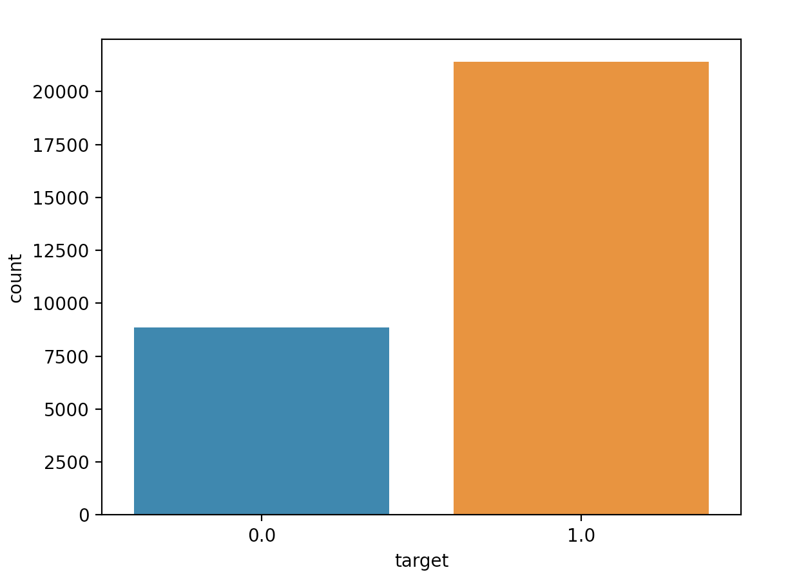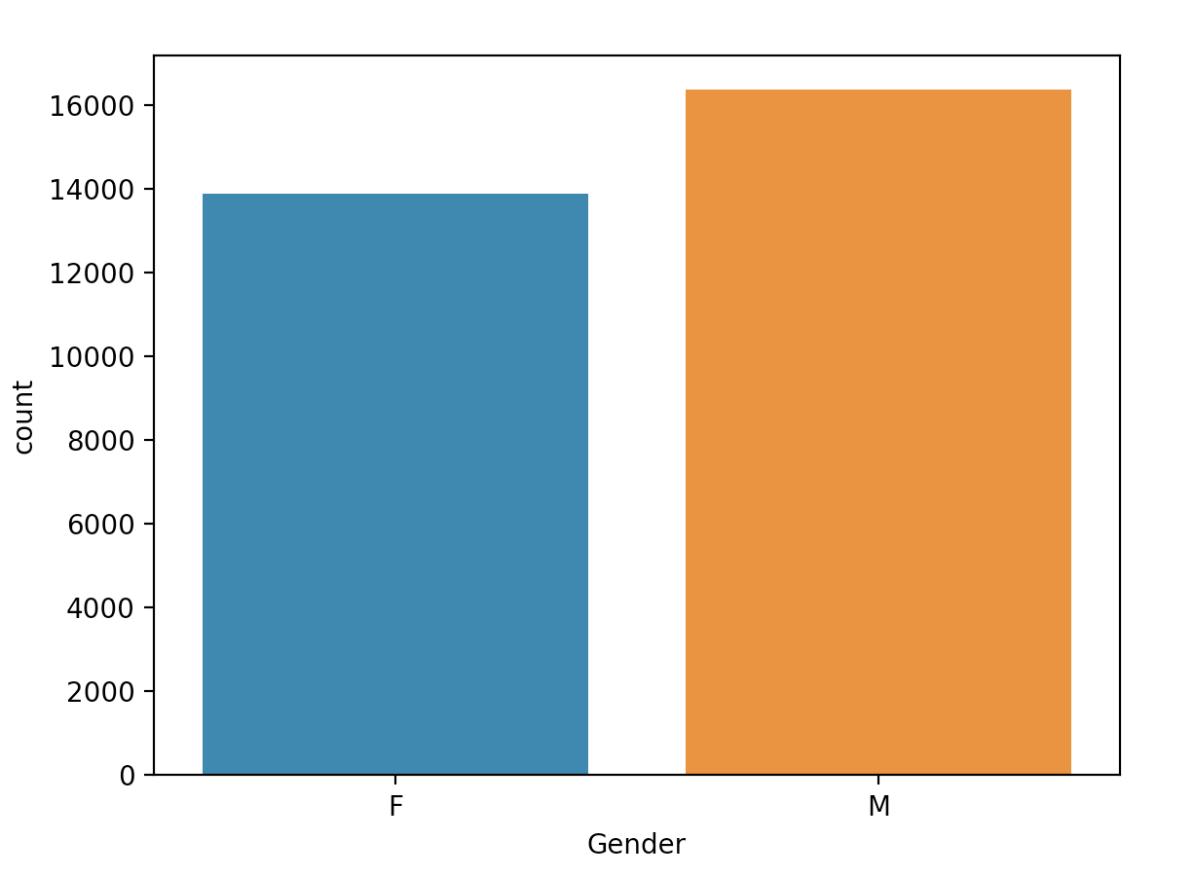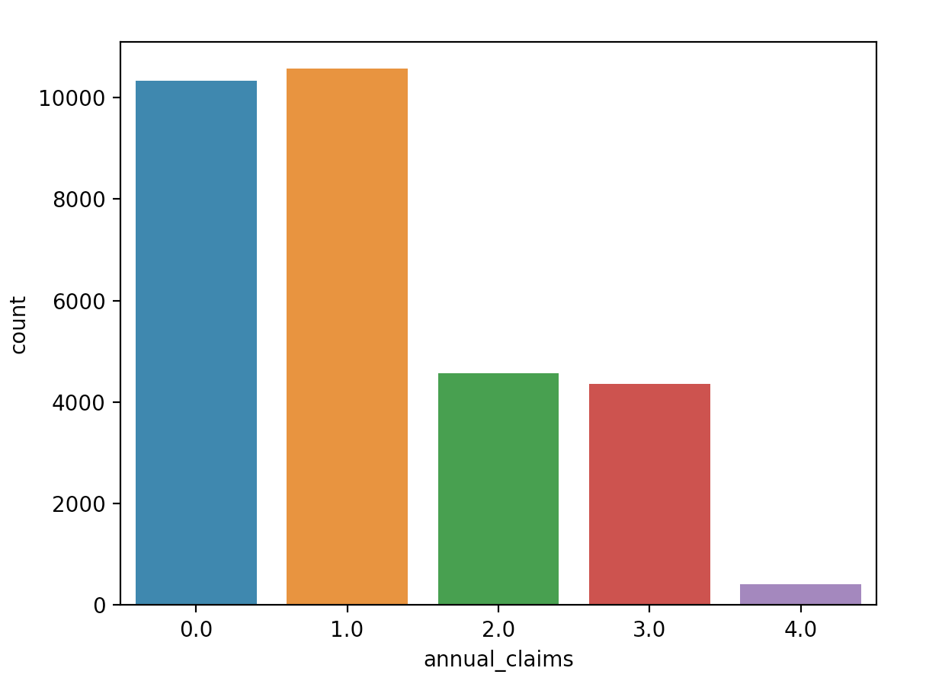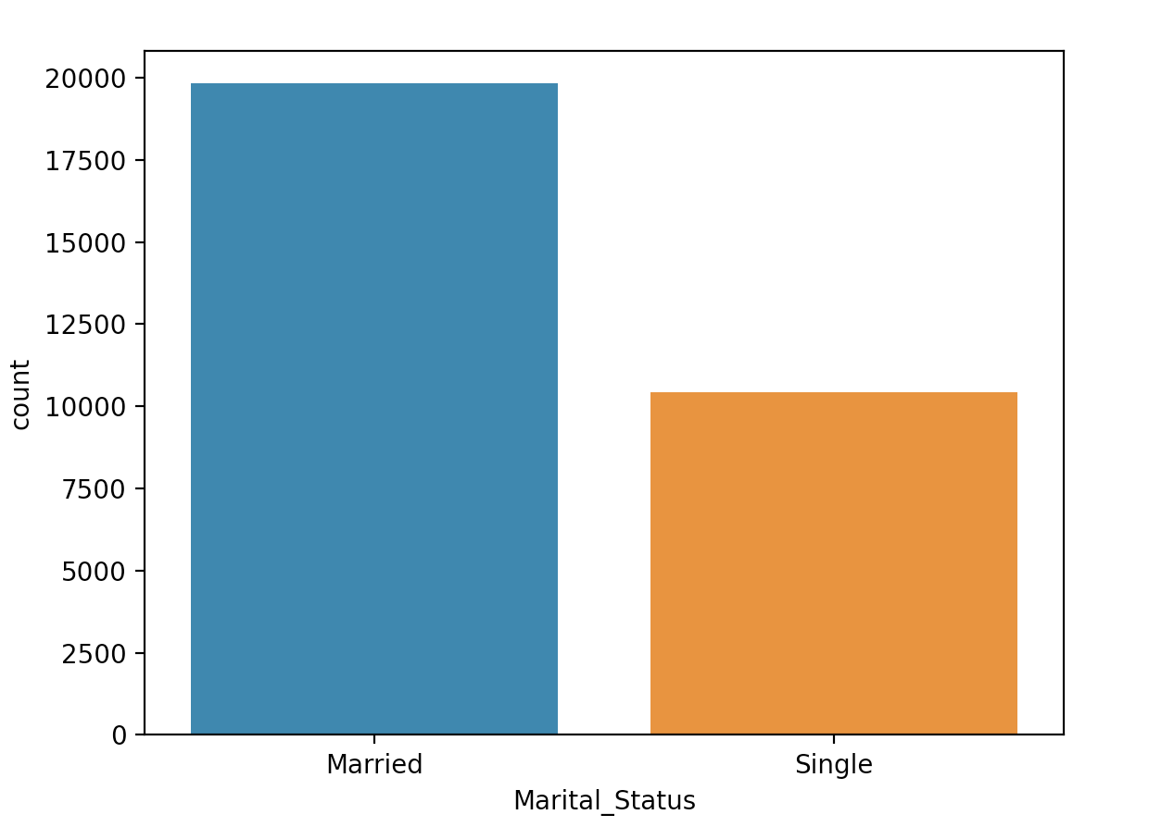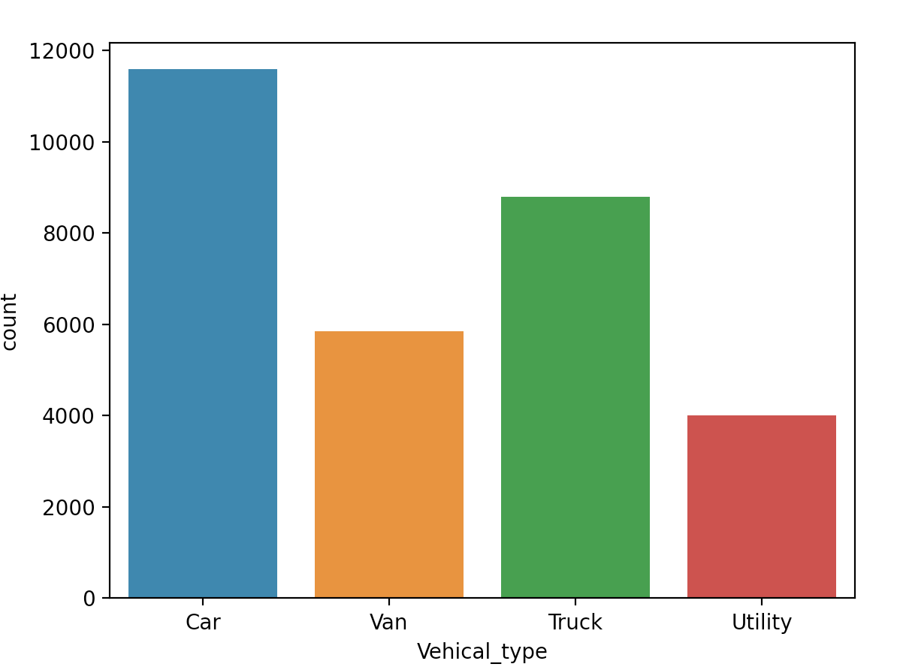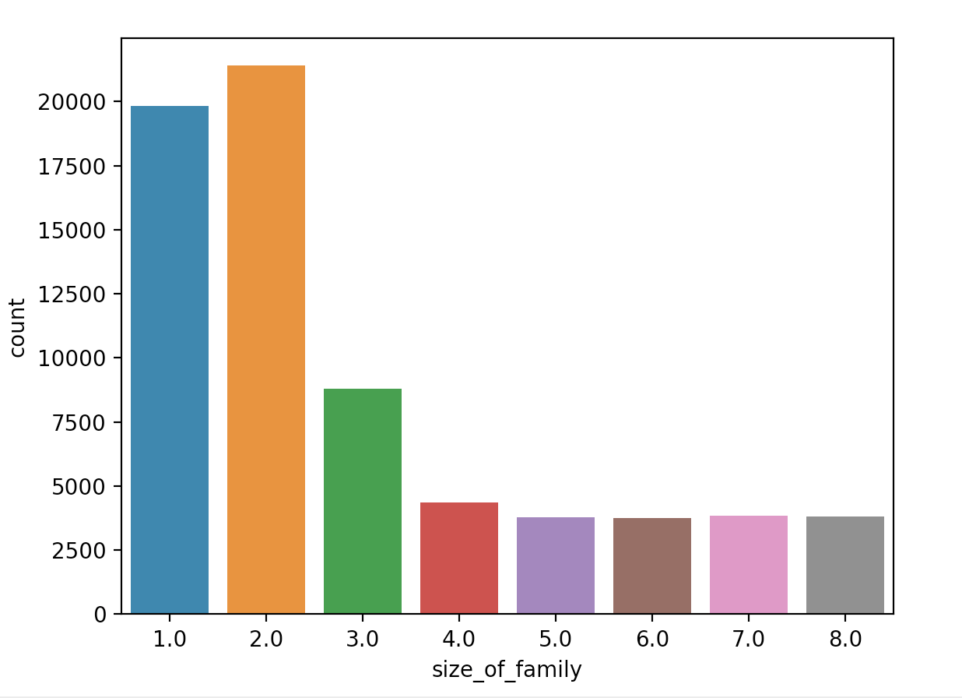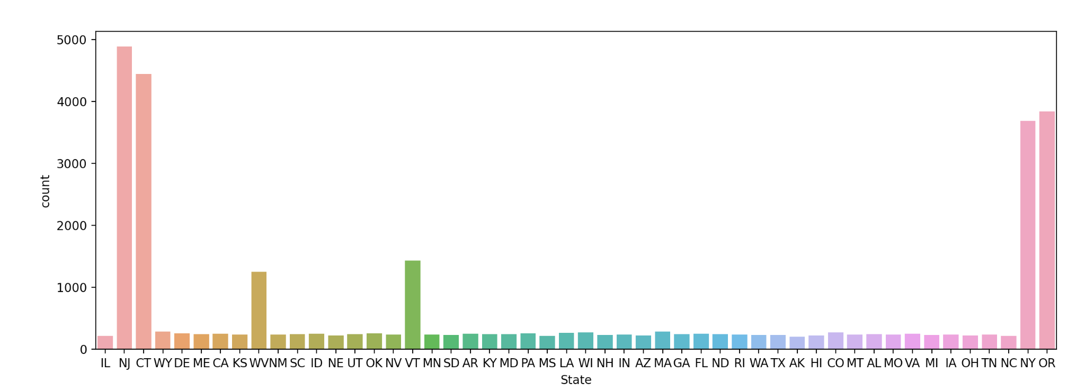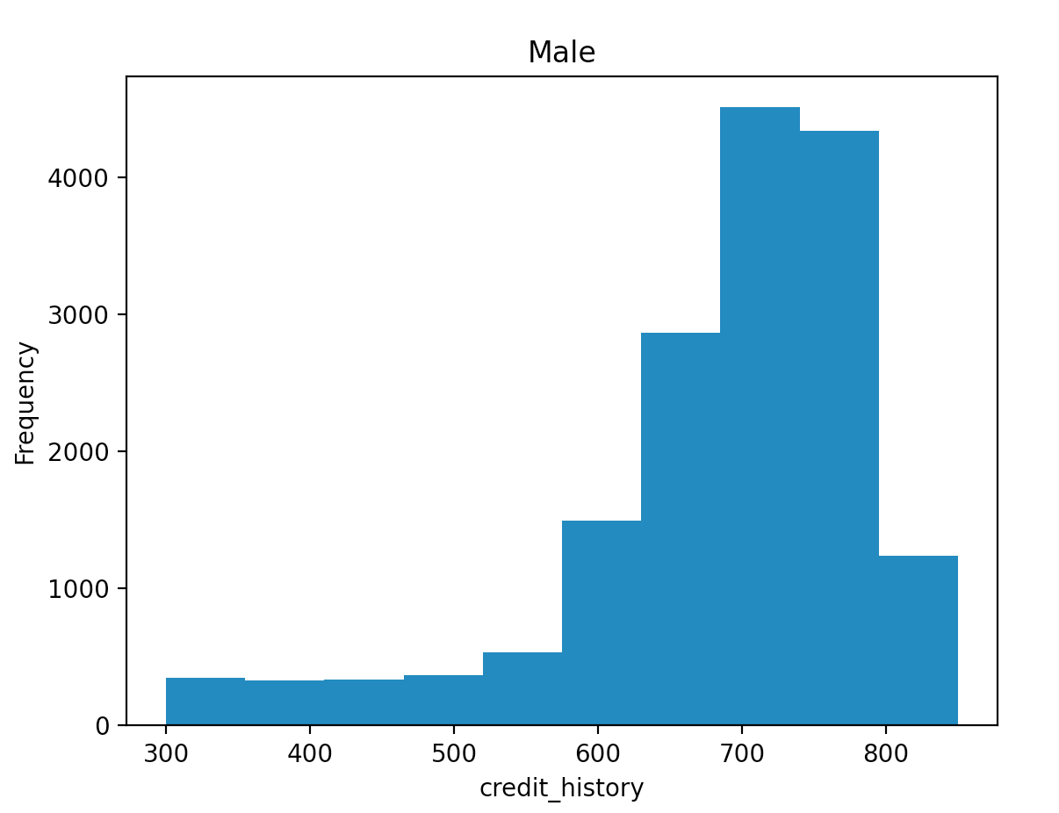

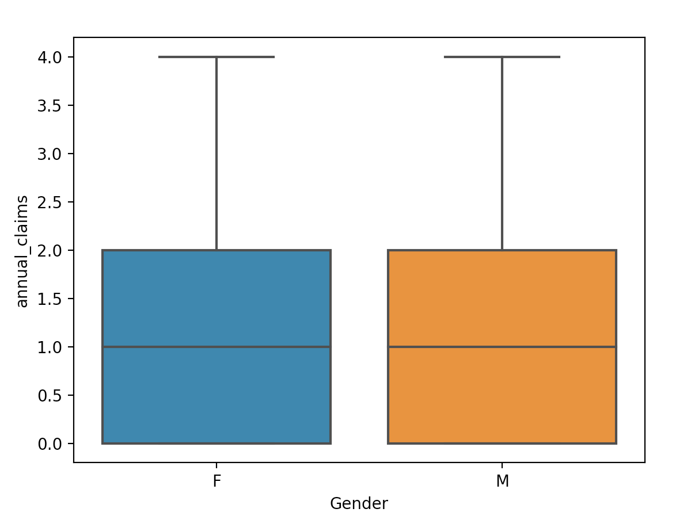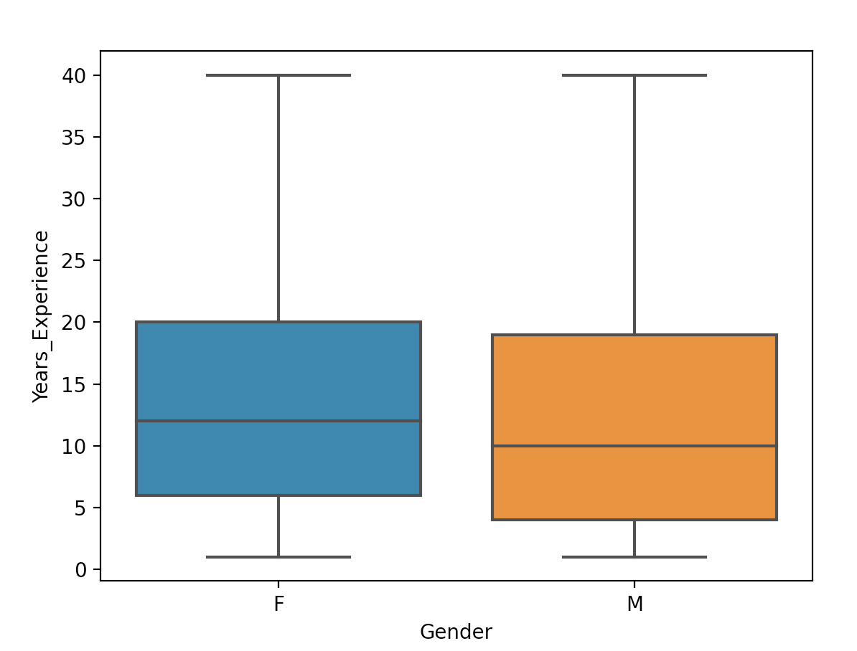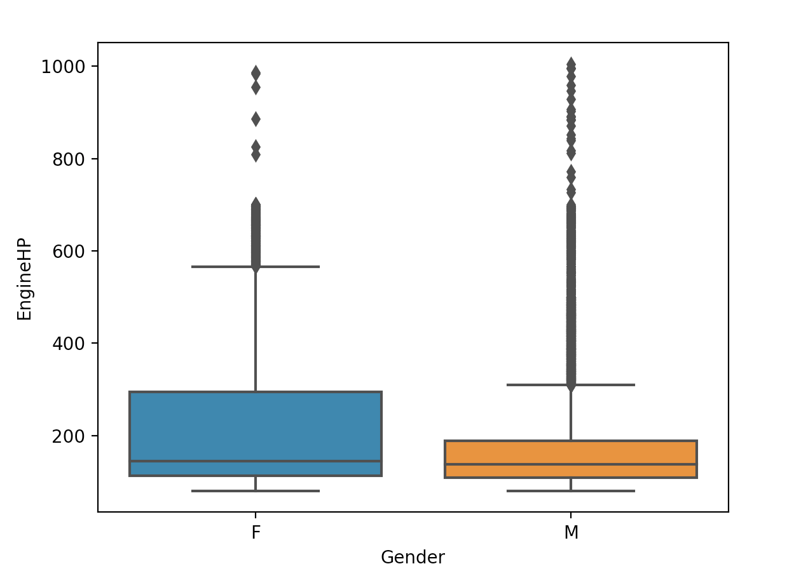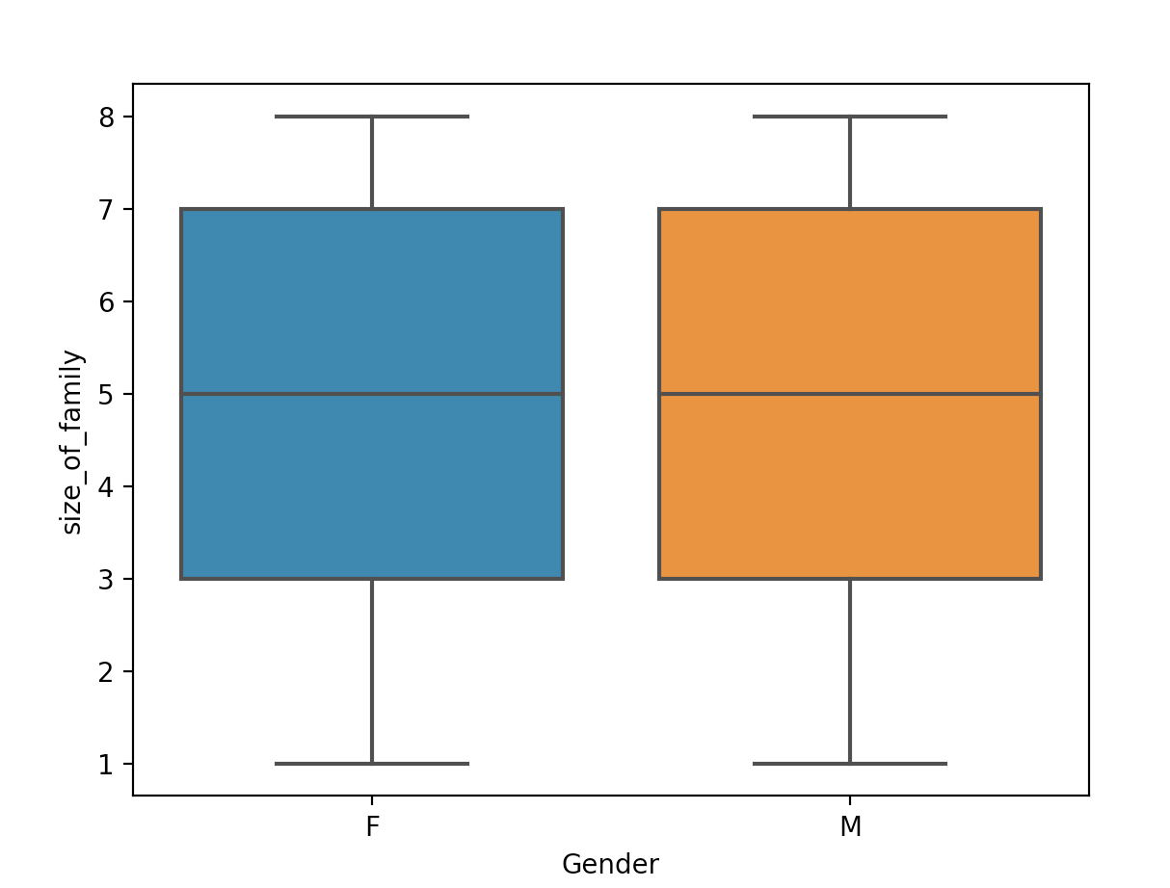

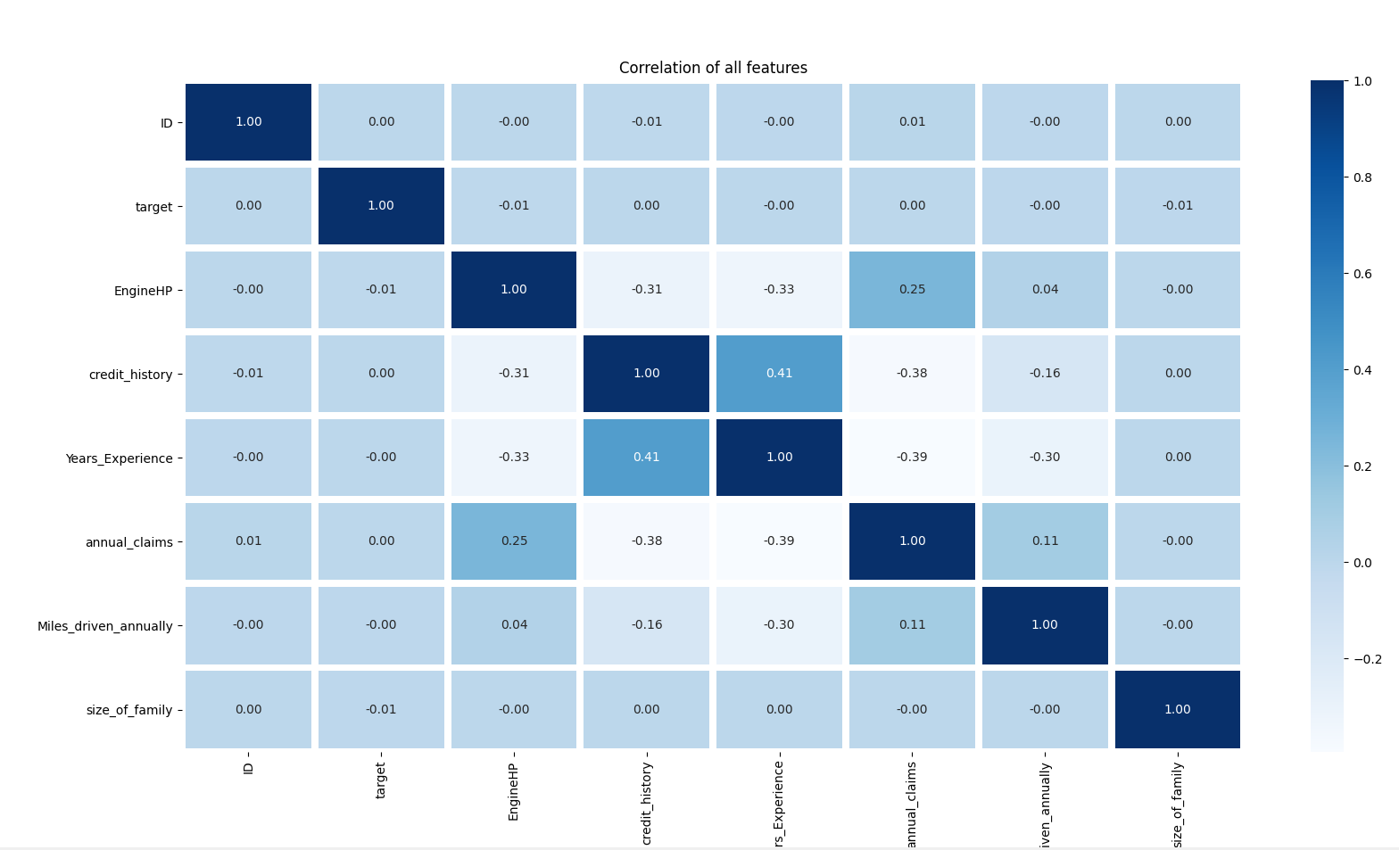

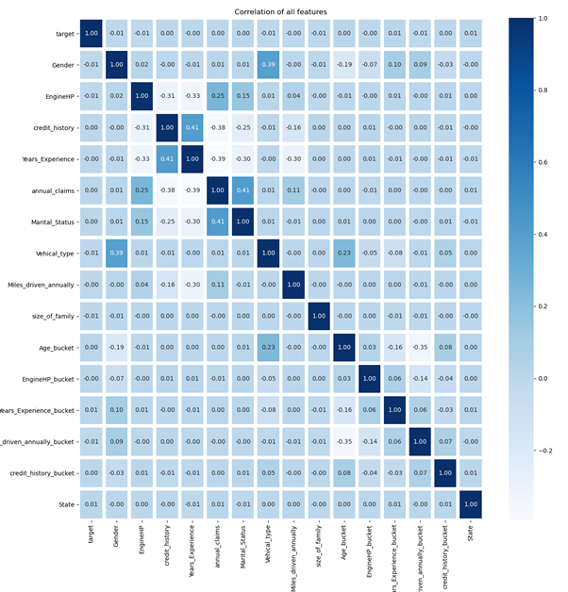

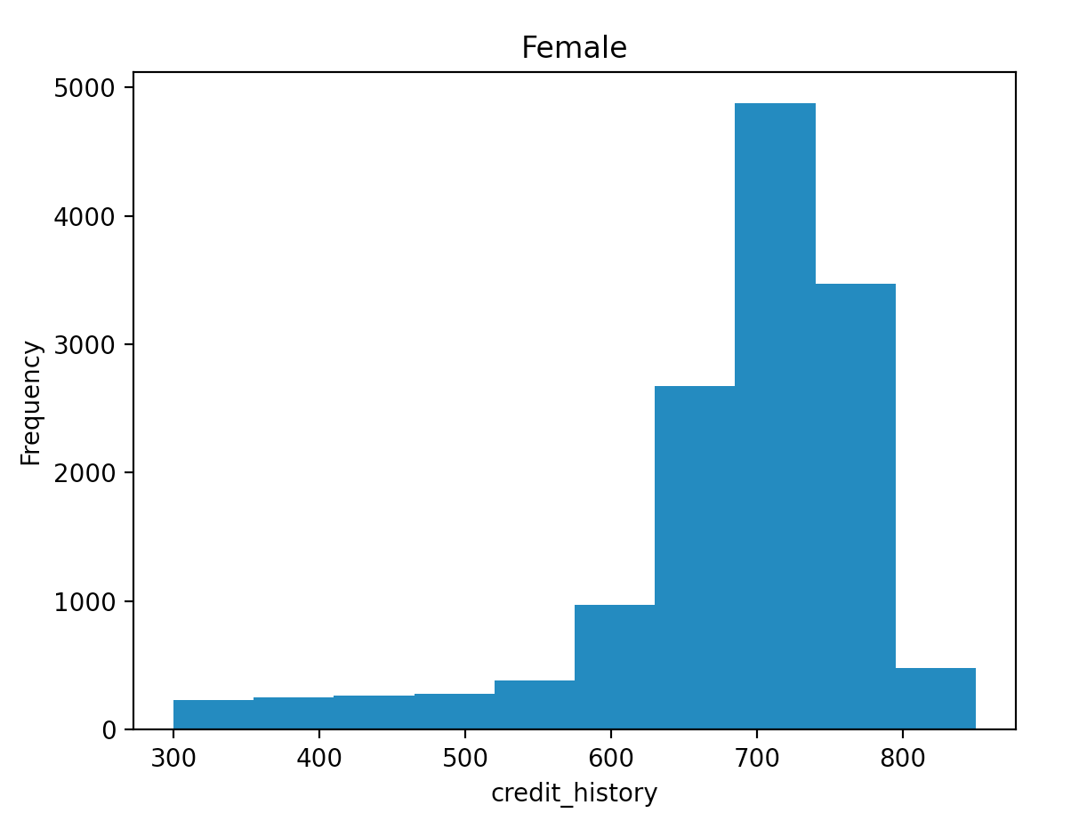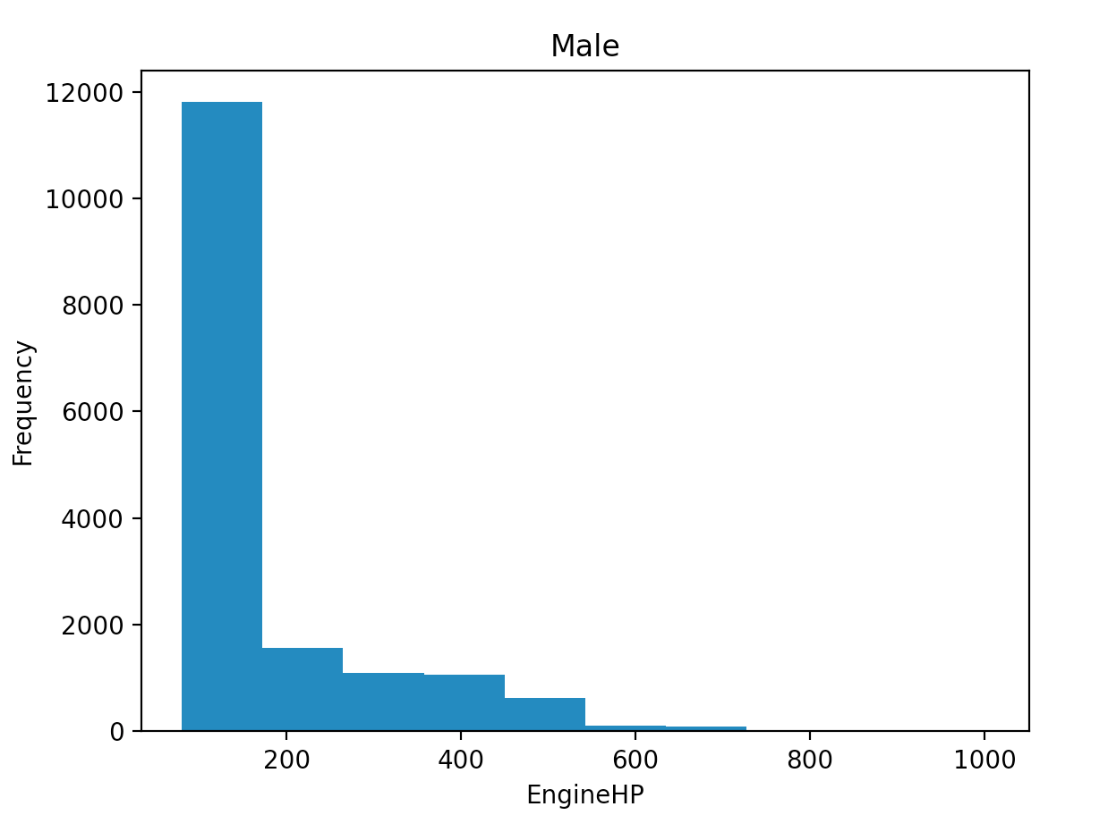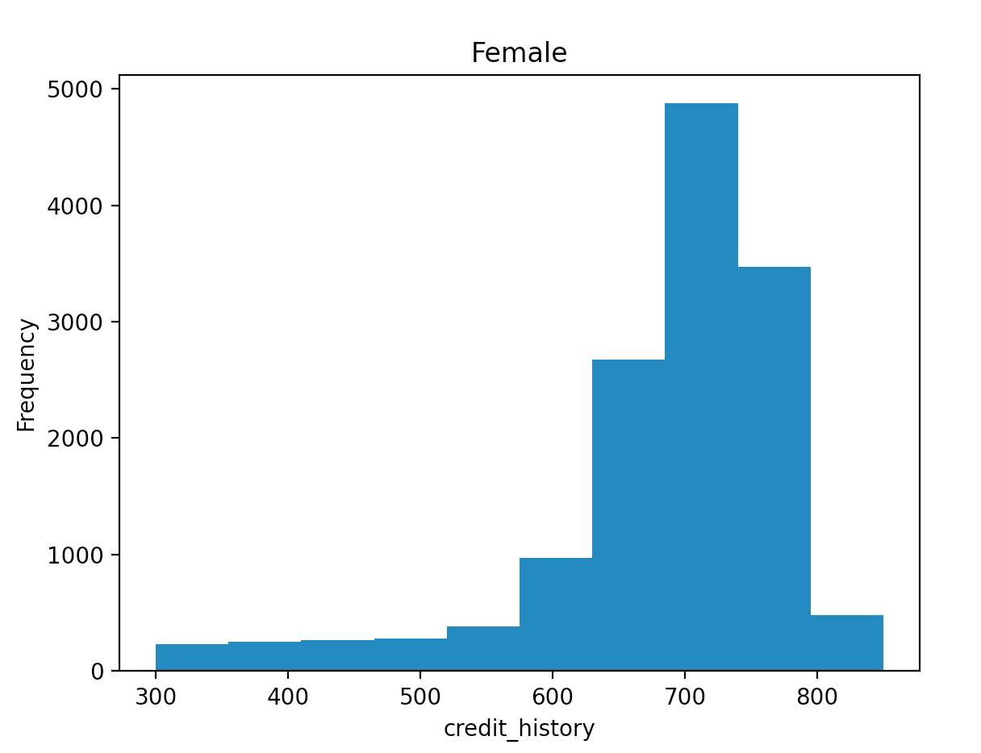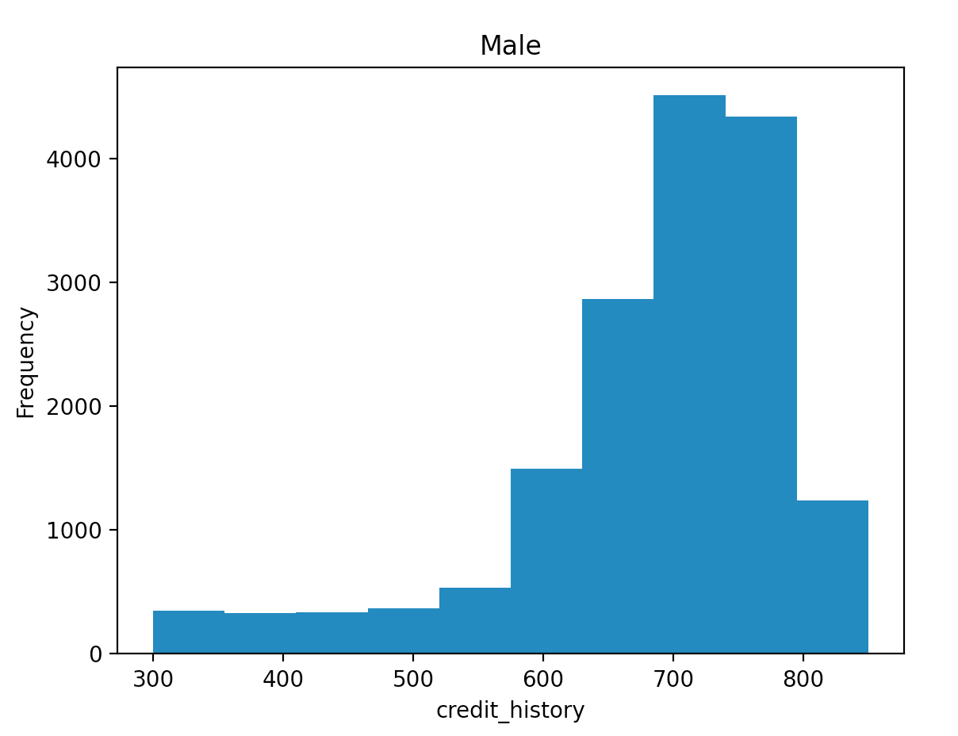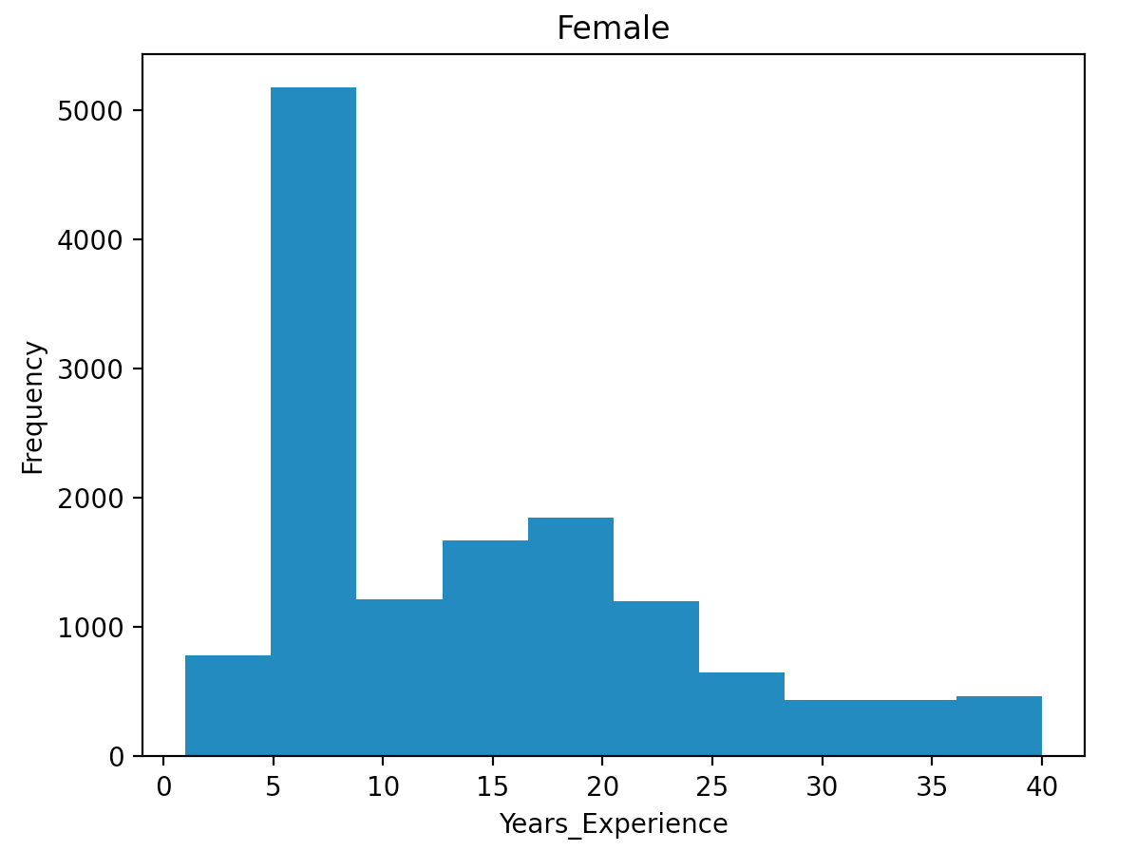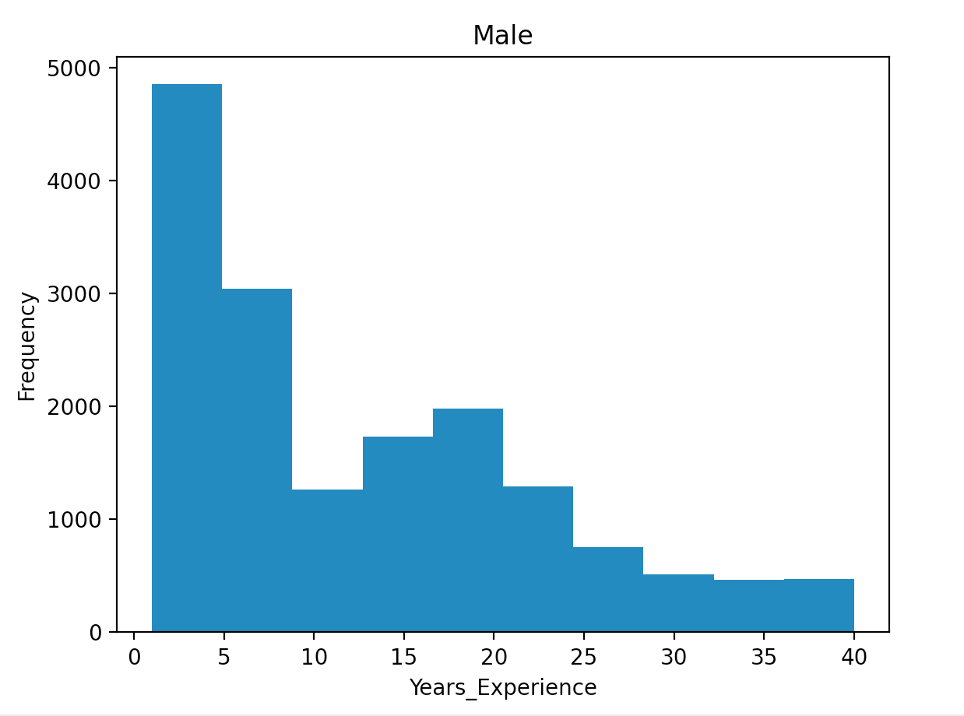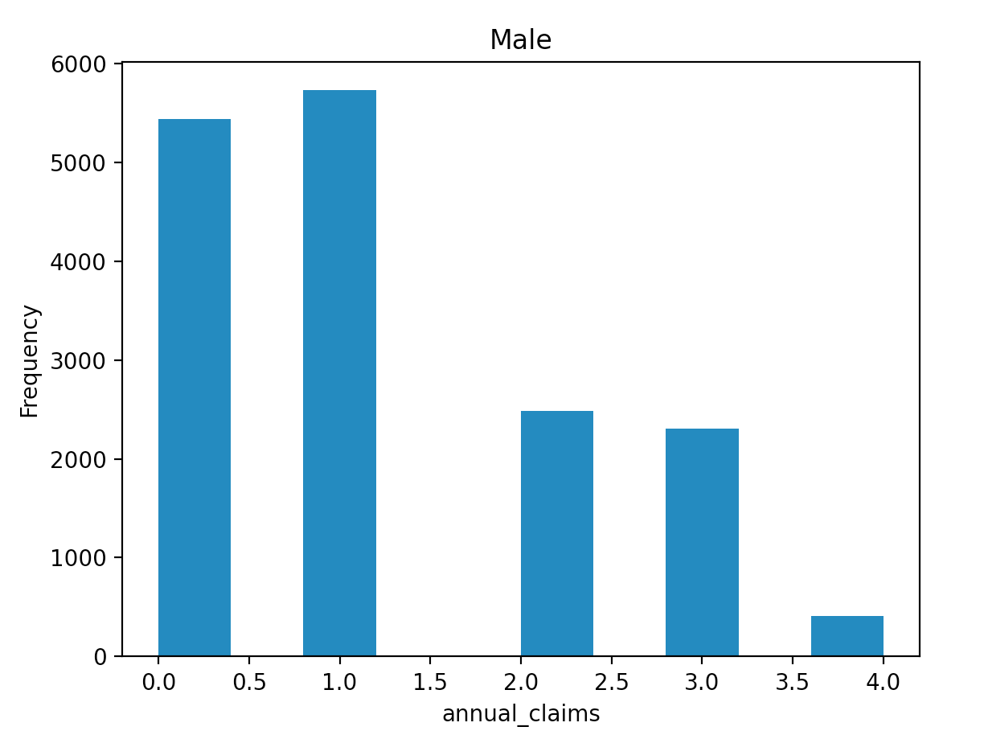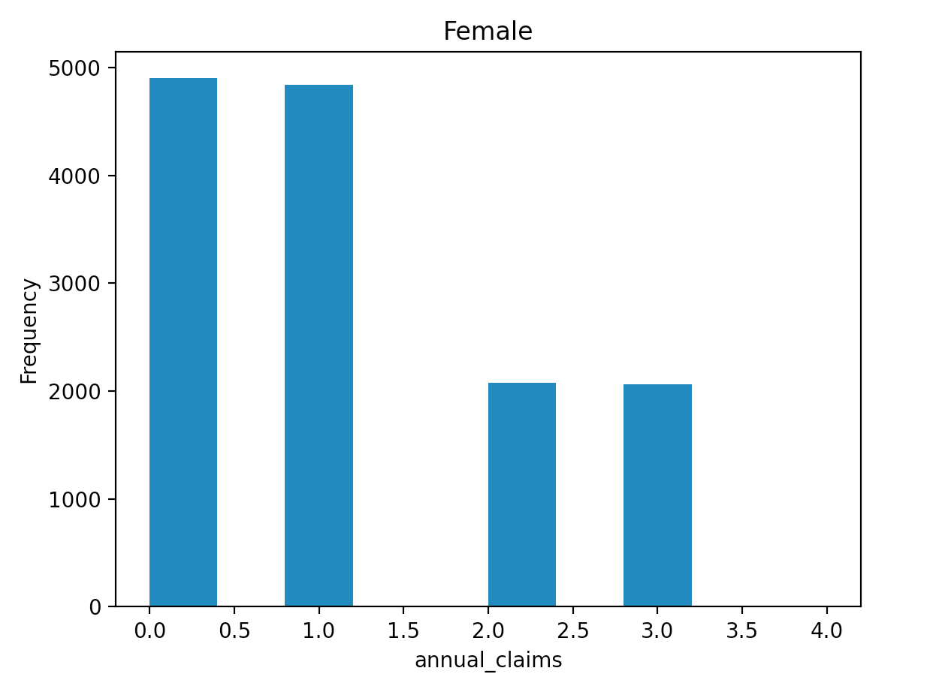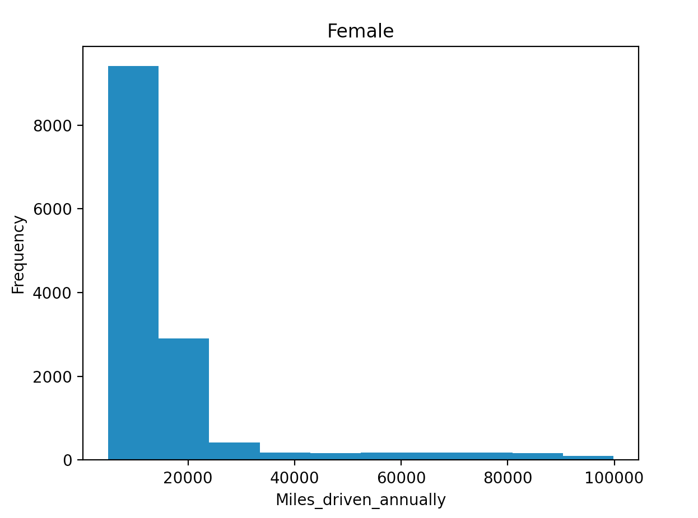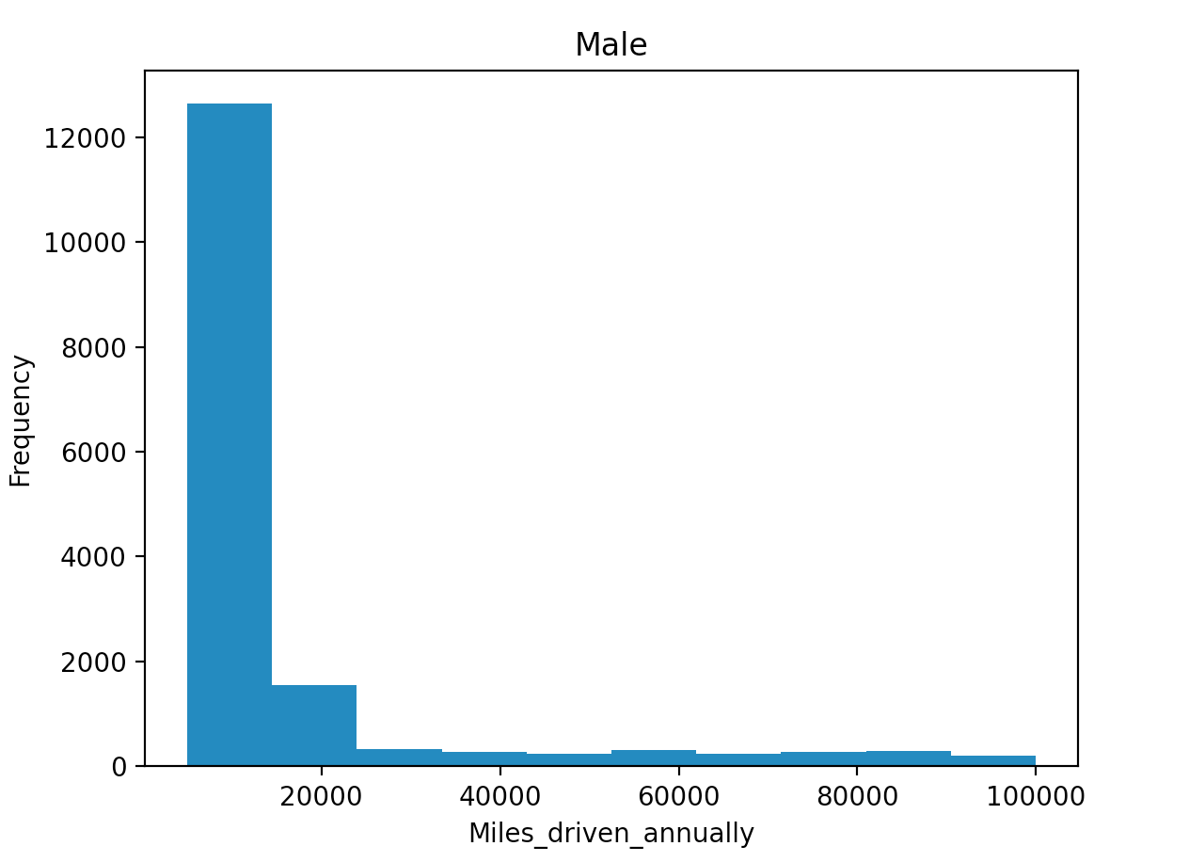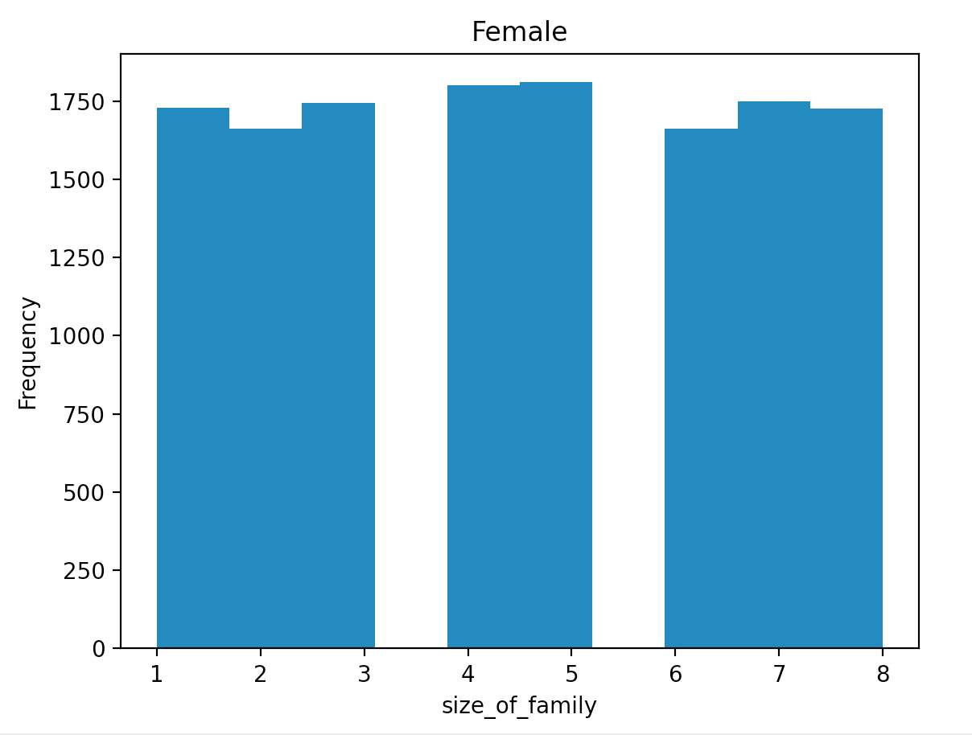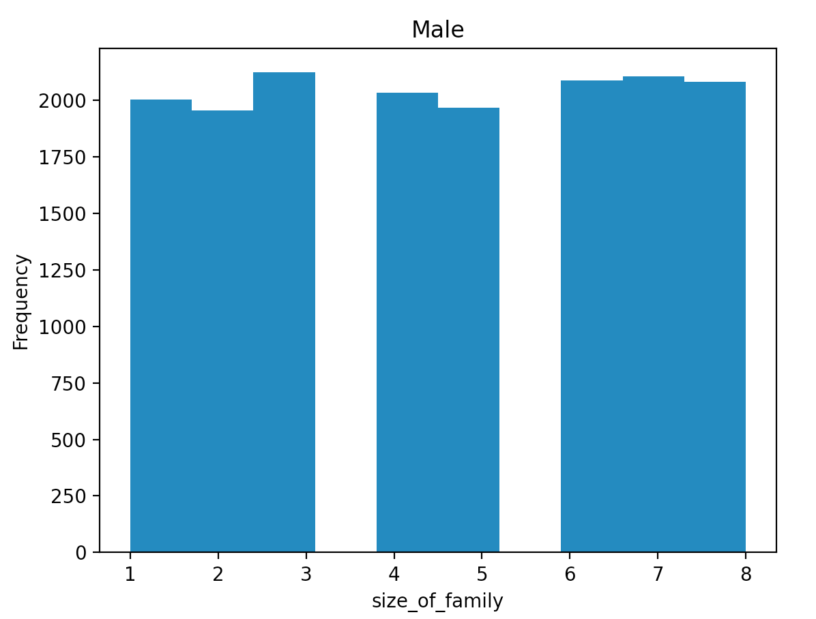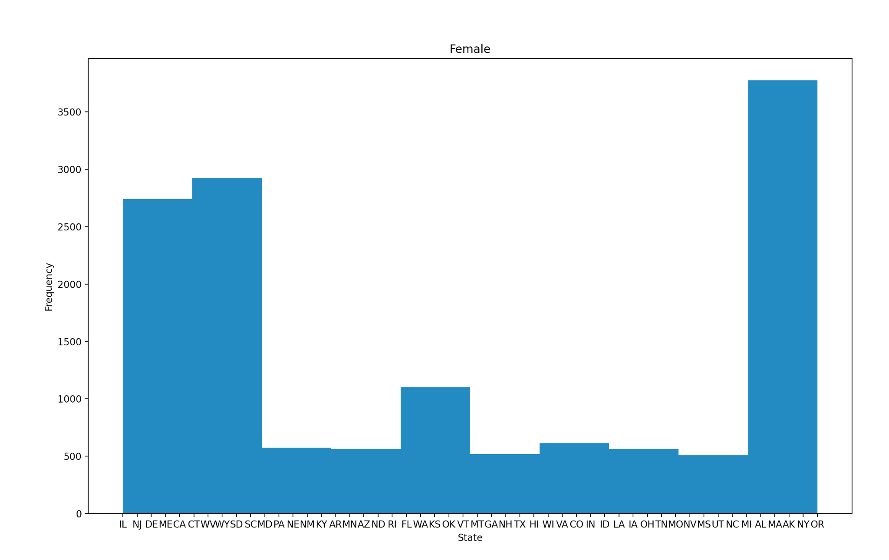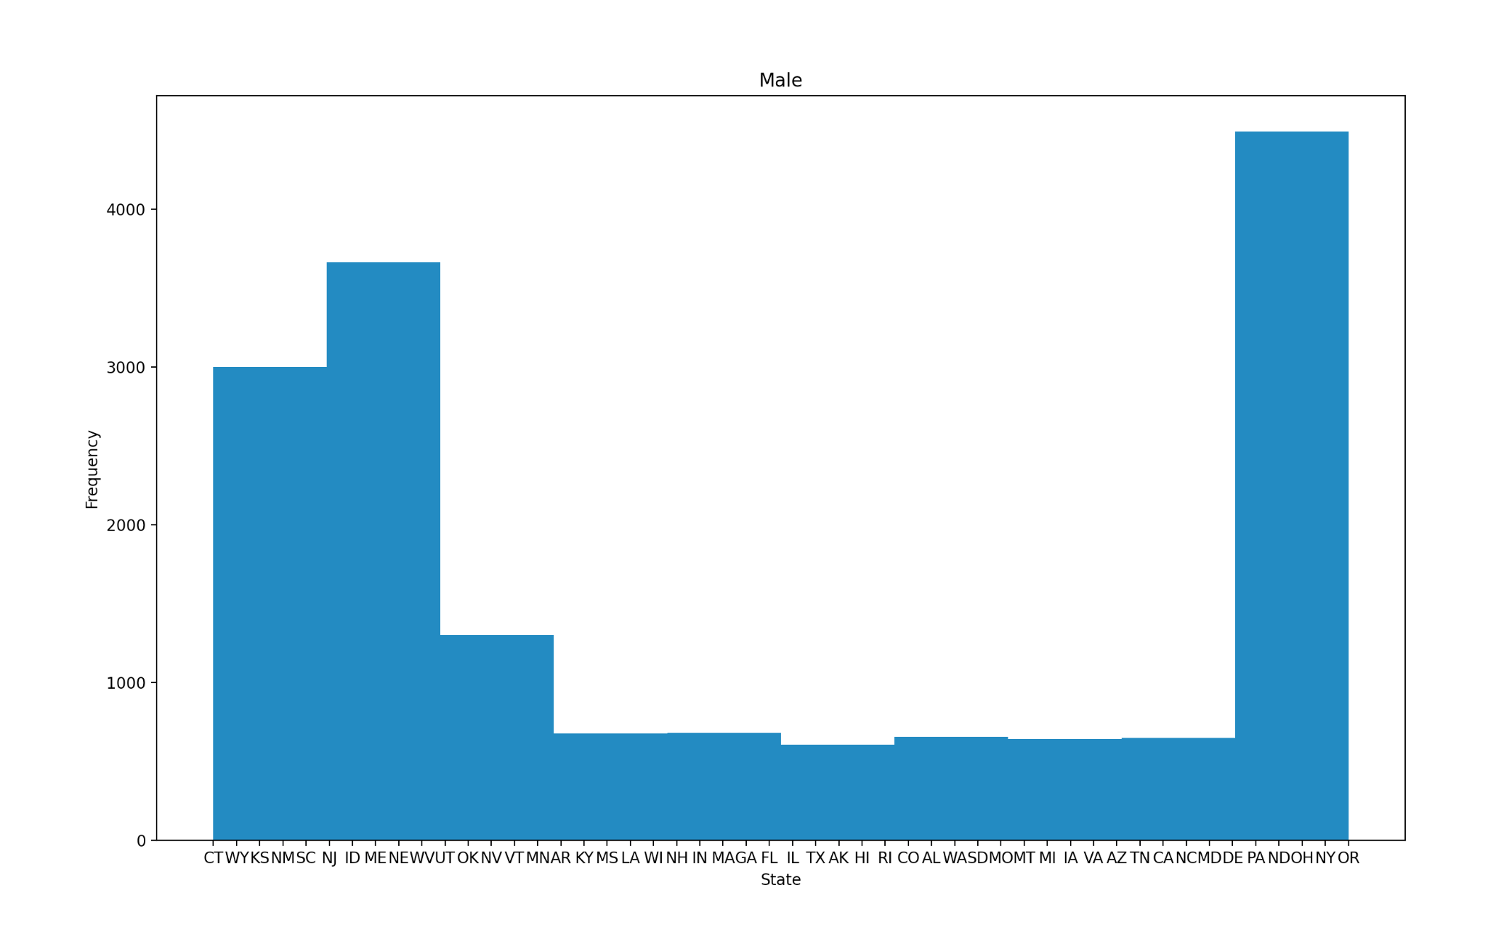

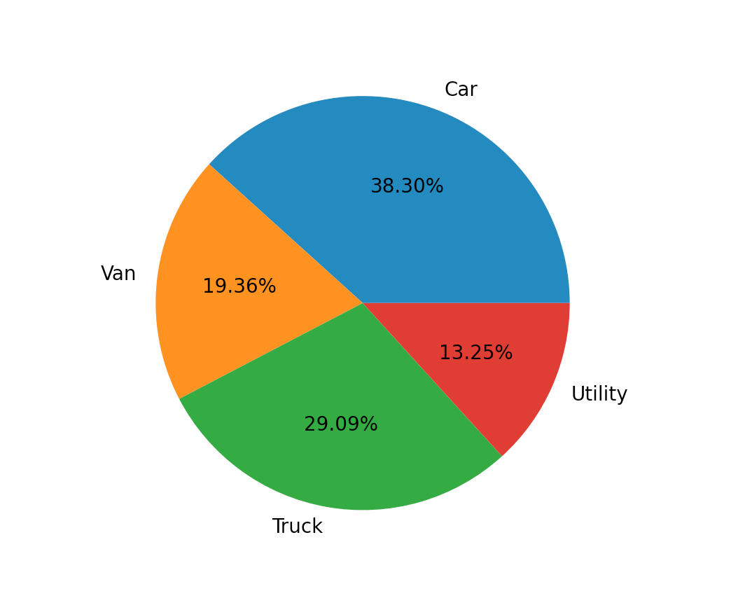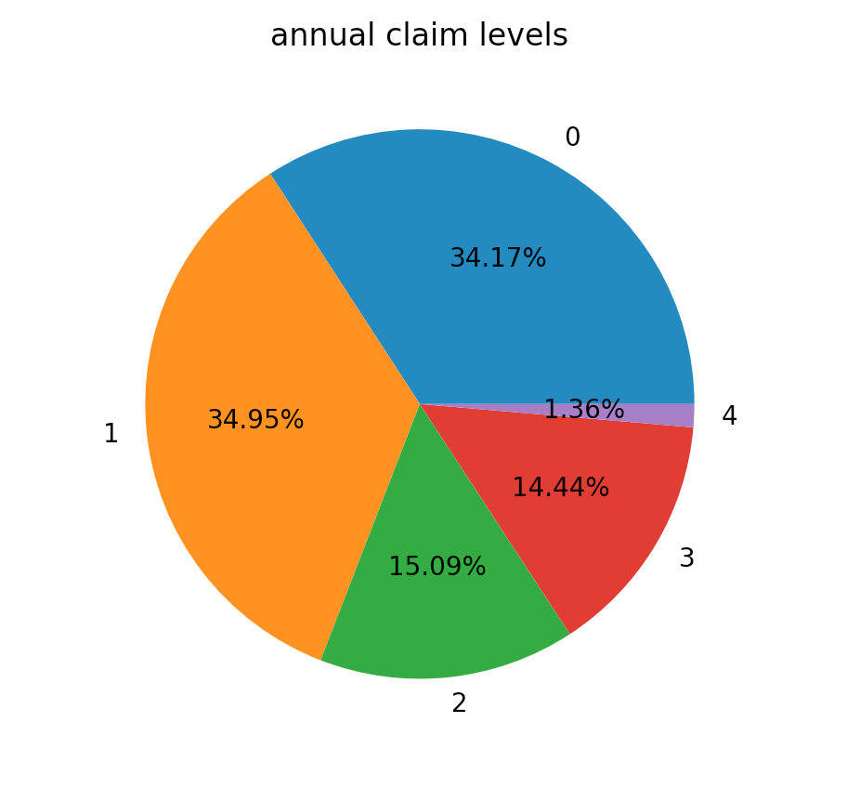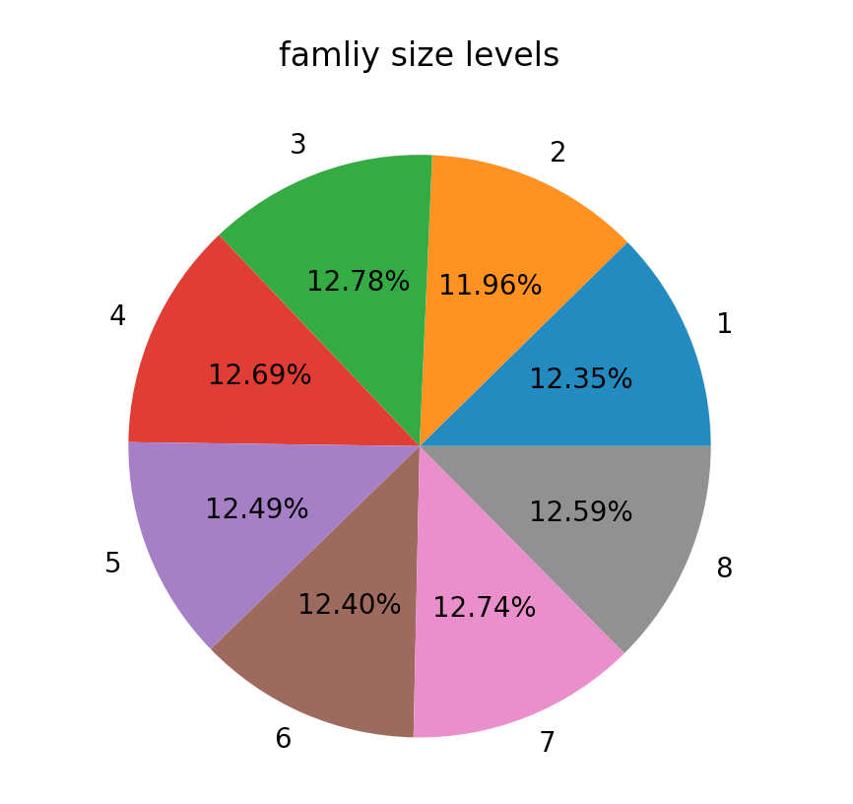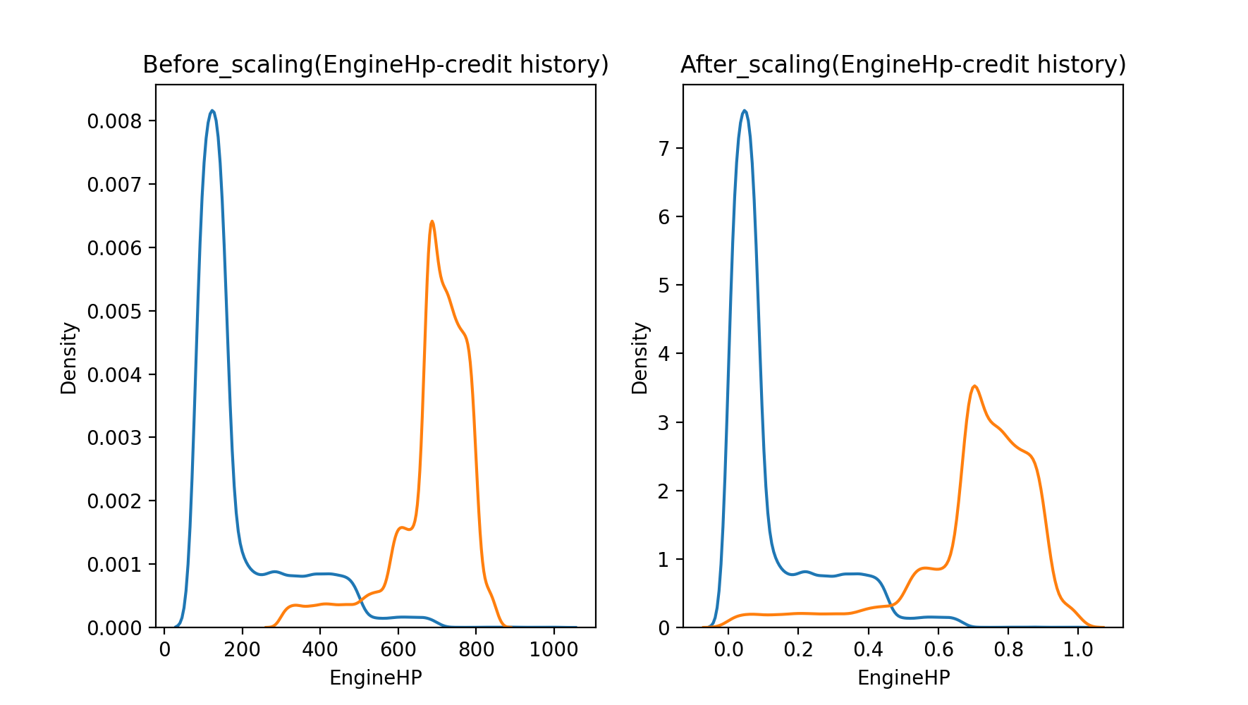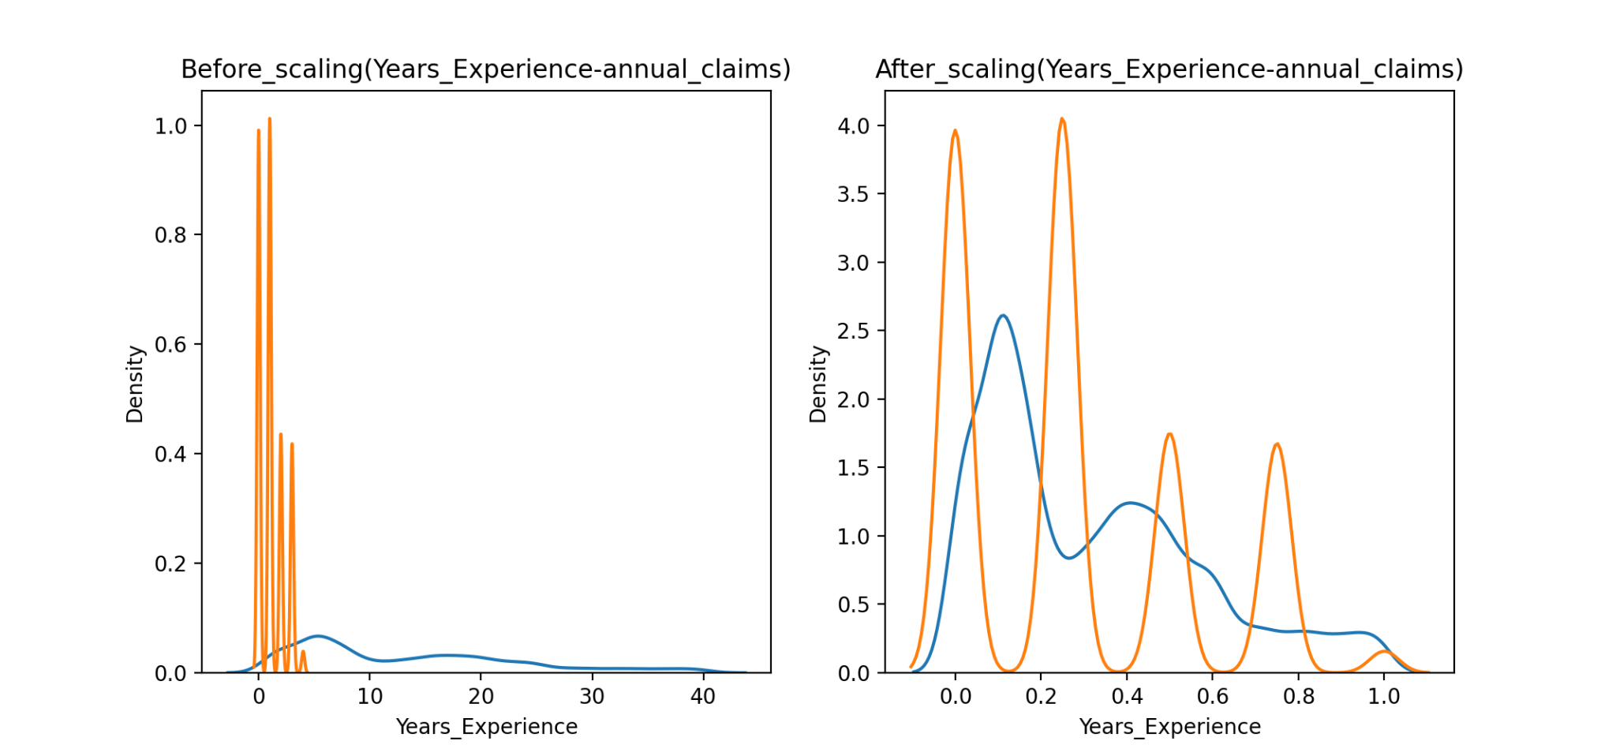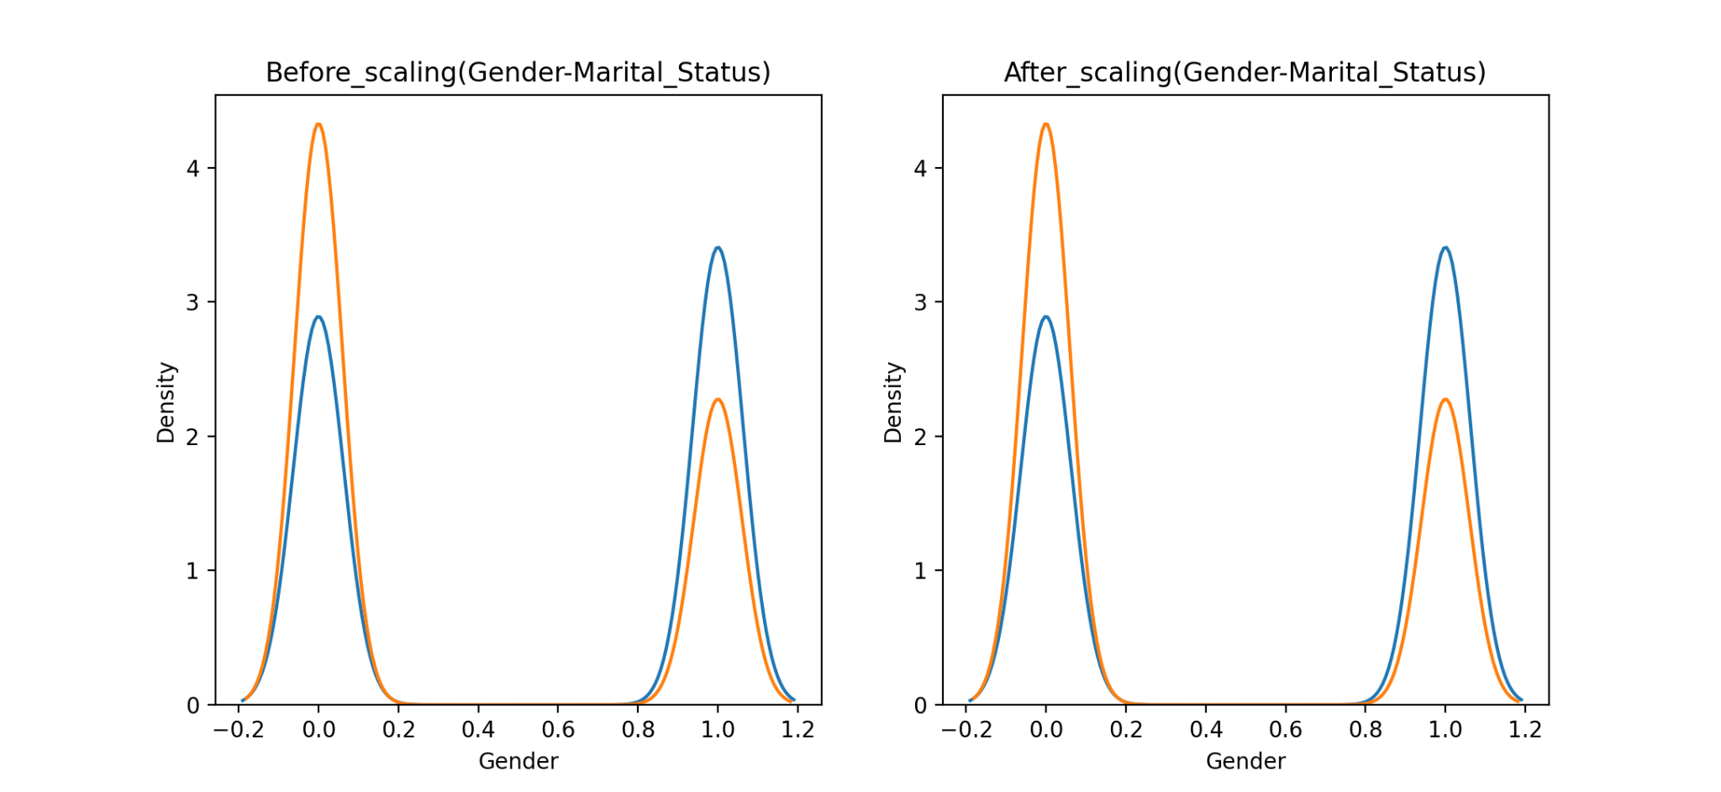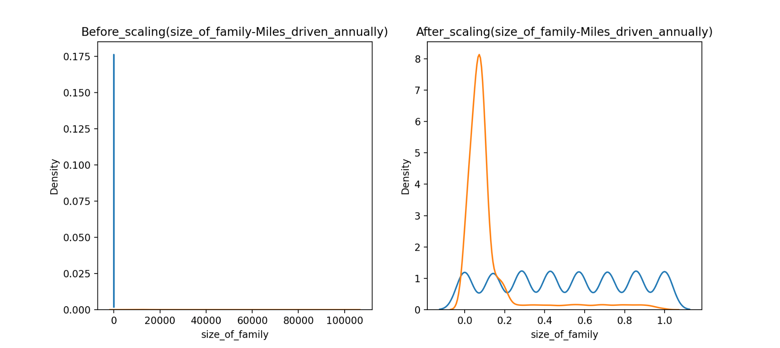

#Bagging regressor (grid search)

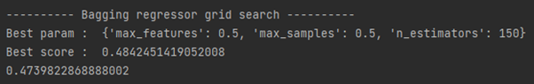

#Random forest regressor (grid search)

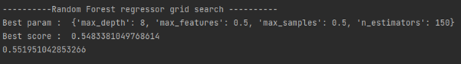

#Knn regressor

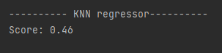

#Linear regressor

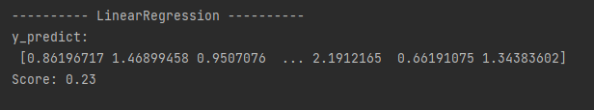

#Polynomial regressor

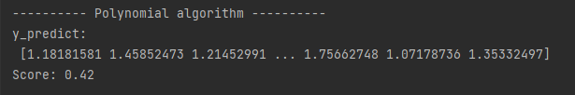

#K-mean clustering



#Bagging classifier (grid search)

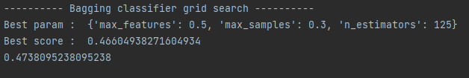

#Random forest classifier

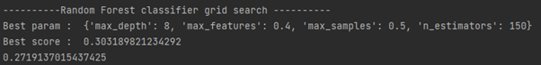

#Knn classifier

