Space Ball Roller DRAFT

Joonho Kim  
CS 6491 Fall 2017  
11/14/2017

# Problem Statement

We are given two horizontal planes called the floor and ceiling each with a set of balls (sites). Our assignment is to find the Delaunay Tetrahedralization created from edges between the floor and ceiling.

*• A clear, concise, complete, and concrete* ***problem statement*** *formulated in your own words using mathematical concepts learned in class and assisted by images produced by your program*

# Contributions and Level of Completion

We currently have the Delaunay Triangulation of the floor and ceiling running in O(n­­3). This is acceptable because it’s simple and there aren’t that many balls per plane.

Next we need to find the Delaunay Tetrahedralization. This we have yet to do.

*• A precise statement of your contributions and the level of completion of your solution: Have you solved the problem? If not, what is missing and why? If yes, characterize your results (asymptotic complexity, measured time average per ball, assumed restrictions on the input (such as for example that balls must be pairwise disjoint or that you need at least 3 balls on each plane, or that you assume a ‘general configuration’ where specific spatial alignments are forbidden), and comments on how*

*reliable your solution is (does it crash and if so how often).*

# Solution Outline

We first find the Delaunay Triangulation of both the floor and ceiling.

*• A clear, but high level* ***outline*** *of the nature of your solution/approach. This should target a senior researcher in this field.*

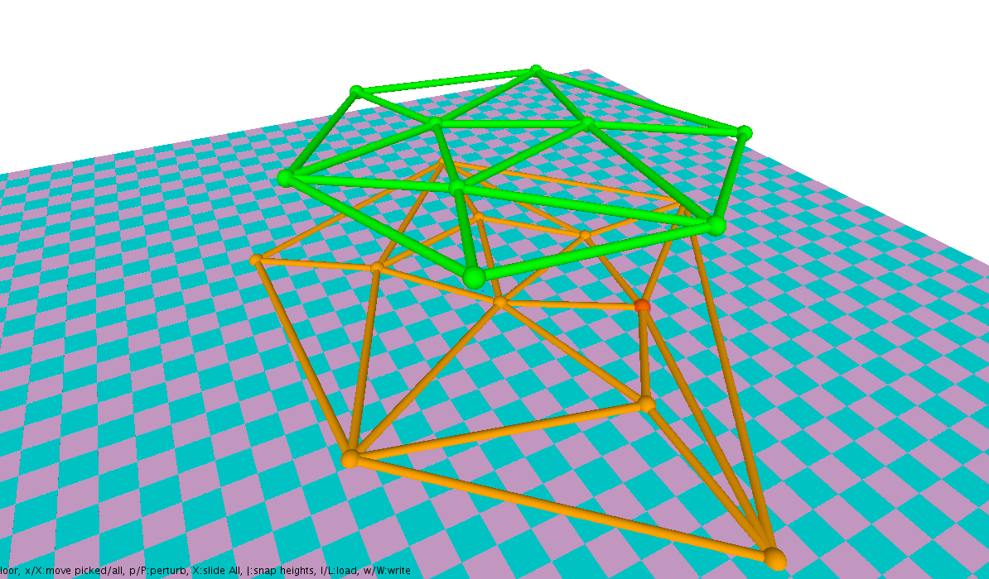

# Prior Art

I read the Delaunay Triangulation page on Wikipedia to understand what the topic is. I use the Incremental Bowyer-Watson algorithm to create the triangulation. I found it interesting that the algorithm online starts with a “super” triangle as part of the triangulation and then removes triangles connected with the super triangle. It seems inefficient, but I used it and it creates a nice triangulation. I’ll probably rewrite the code to remove it, but for now it’s just a draft. The triangulation idea does seem very simple and intuitive.

*• A brief review of the most relevant prior art that you have found. Do not merely cite the work or include a section of their abstract. Instead, show that you have read the paper and that you were able to extract the parts that are relevant to this project. Discuss whether you have followed any of the ideas suggested in prior art or how your solution relates to them.*

# Step-by-Step Guideline

*We assume that you are given the base code from the assignment.*

We first find the Delaunay triangulation for the floor and the ceiling. The Delaunay triangulation of a set of points is the triangulation in which each circumcircle created by a triplet of points (triangle) does not contain any other point inside of it.

We use the Bowyer-Watson triangulation algorithm on both planes. The Bowyer-Watson algorithm starts off with a “super” triangle enclosing the entire set of points as the base triangulation and then inserts each point one-by-one while flipping triangles whose circumcircle encloses the new point. To find the circumcircle, we find the circumcenter C of the 3 points (A, B, C) with a radius d(C,A).

*• A step-by-step guideline for a junior developer charged to implement this from scratch.*