CS4400 Database Project:
Atlanta Pet Adoption Consortium
Summer 2013

Project Overview
The purpose of this project is to analyze, specify, design, implement, document, and demonstrate a database management information system called Atlanta Pet Adoption Consortium (APAC). The project will proceed in three phases as outlined in the Classical Methodology for Database Development: Analysis & Specification, Design, and Implementation & Testing. The system should be implemented using a Database Management System (DBMS) that supports standard SQL queries. Class administrators will provide you with information about how to access a college-managed MySQL server in order to implement your database. Your professor must approve alternative implementations. Under no circumstances may you use a tool that automatically generates SQL or automatically maps programming objects into the database.
The three phases of the project cover the following work-processes from the Classical Methodology for Database Development. The due dates for each phase appear in the table below.

Phase | Phase Description | Due Date
I | Analysis & Specification | June 4
II | Design | June 27
III | Implementation & Testing | July 24
 | Demonstration | July 25-26

Groups
Project groups must have 2 or 3 members. A group may remove a member from further participation in the group when phase I is turned in or when phase II is turned in. A written notification must be provided to the professor at that time.

Phase I – Analysis & Specification
The phase I deliverables include:
- A cover page including the name, class section, email address, and T-Square username of each group member.
- A list of contributions of each team member.
- An Information Flow diagram showing the primary documents and tasks of the system and the flow of data among them. An example of this deliverable can be found in Appendix B – Sample EER Diagram.
- The data model for your system in the form of an Enhanced Entity Relationship (EER) diagram. The EER diagram must capture the constraints of the system as fully as possible. For example, all relationship types should have cardinality constraints, all keys should be identified, and total participation constraints should appear where applicable. An example of this deliverable can be found in Appendix B – Sample EER Diagram.
- A list of business constraints that will be enforced. Do not include any constraints that can be shown in the EER diagram, but rather business logic related constraints that cannot be expressed in EER. The constraints should be written in terms of the Entity Types, Relationship Types and Attributes of your EER diagram. An example of this deliverable can be found in Appendix C – Sample Constraints.
- A list of any assumptions made, including explanations. You are allowed to make up additional reasonable assumptions and constraints as long as they do not conflict with the specified constraints and requirements. If possible, those additional assumptions and constraints should be included in the EER diagram.

Phase II – Design
The phase II deliverables include:
- A coverpage including the name, class section, email address, and T-Square username of each group member.
- A list of contributions of each team member.
- An updated copy of the EER diagram and Information Flow diagram including any corrections made since phase I. Alternatively, the group may choose to adopt the EER diagram and Information Flow diagram from the sample solution.
- A relational schema diagram with primary and foreign keys identified and referential integrity shown by arrows. An example of this deliverable can be found in Appendix D – Sample Relational Model Diagram.
- CREATE TABLE SQL statements, including domain constraints, integrity constraints, primary keys, and foreign keys. An example of this deliverable can be found in Appendix E – Sample CREATE TABLE Statements.
- SQL statements and abstract code for each task. An example of this deliverable can be found in Appendix F – Example Abstract Code + SQL.
Multiple SQL statements may be required in order to complete one task. However, in such cases, the last SQL statement should show the output according to the specification as much as possible. If mentioned, the returned tuples must be ordered according to the specification. Views and nested queries may be used to support the tasks. Complex queries should be broken down into views to make the query more readable.

Phase III – Implementation & Testing
There are two options for phase III: lightweight and heavyweight. The lightweight option requires a demonstration of working SQL statements that could be used to perform all tasks specified in the project description (i.e., the set of tasks identified in the Information Flow diagram). The queries will be executed against a database created by each group and pre-populated with sample data. A query interface such as phpMyAdmin or the MySQL Query Browser will be used to execute your queries.
The heavyweight option is to implement a working application including a graphical user interface (GUI) with all functionality described in the project description. Under this option, the SQL statements will be embedded in a host language, such as PHP or Python.
For both lightweight and heavyweight options, you will need to generate sample data for your database, which will be used for your demo.
The deliverables for phase III include:
- A coverpage including the name, class section, email address, and T-Square username of each group member.
- A list of contributions of each team member.
- A copy of the relational schema diagram from phase II, including any revisions.
- A copy of the CREATE TABLE statements from phase II, including any revisions.
- A relational database pre-populated with sample data.
- A set of working SQL statements for all tasks (lightweight option).
- A functional application with embedded SQL statements (heavyweight option).

Grading
Phase I and Phase II of the project are each worth 10% of your final grade. Credit for phase III depends on the implementation option you choose: the heavweight option counts for 20% of your final grade and the lightweight option counts for 5%.
In addition, when phase 3 is submitted, each group member will need to sign and submit the following statement:
I certify that I have contributed XX% of effort to the overall project and I agree to be graded accordingly.
Signed:______________
The XX value should ideally be the same for all members of the project, however if one or more of you do not pull your weight during the project you should list an accordingly smaller
percentage.
Overview of Atlanta Pet Adoption Consortium
The Atlanta Pet Adoption Consortium (APAC) is a simple application for managing and sharing information about pets that are up for adoption by various animal shelters in the Atlanta area.
The Atlanta area has several independent animal shelters that have combined their efforts to provide more useable and up to date information about adoptable pets. These animal shelters, known as the Atlanta Pet Adoption Consortium, have engaged us to design and implement an information management system and user interface to achieve their goals. The basic information that the system will store includes shelter, pet and adoptee information.
- Shelters are independent organizations that have one director and multiple employees. Included will be basic information about each shelter such as location and operating hours. Additional information will be pictured in the user interface documents. Shelters also encourage and solicit donations from people and companies in the community. Shelters also host fund raising events in addition to their pet adoption events held at pet stores throughout greater Atlanta.
- Typical pet information for animals housed at the shelter includes type (the shelters only take in dogs and cats for adoption), breed, age, etc. In addition, some pets may be temporarily placed in foster homes.
- People who adopt an animal must supply necessary information in an application.
The following sections contain a functional description of the APAC application along with some screen mockups. We should note that we will not implement a complete real-world system for this application but rather a subset of the system that is described in this document. The user interfaces depicted in this project description merely serve as examples to guide your thinking. Your project’s interface may look completely different and that is fine—even encouraged! For example, you might choose to split up some interfaces we have shown on a single screen into multiple screens. You might choose to use popup windows instead of refreshing the page. A complete reorganization of the user interface is acceptable as long as your application supports the same functionality as described below. If you choose the heavyweight option, you may implement the project as a traditional standalone application (e.g., using Python or Java GUIs) or as a web application (e.g., using a web scripting language like PHP). Your project is not graded on its aesthetic appeal, but on its functionality as it relates to the application requirements.

Logging In
The APAC login screen is shown in Figure 1. All employees are uniquely identified by his or her employee number within a given animal shelter. After an employee selects the shelter they work for via a drop down box, he/she must provide a valid employee number and password combination for logging into the system. If invalid login credentials are input then an error message should be displayed and the user should be asked to retry. Employees have update/insert/delete privileges. If a user is a guest (i.e., someone wanting to adopt a pet) then they do not need to provide any login credentials. In which case, access to the system is limited to read only access, such as searching for a shelter location or type of pet available for adoption. These options will be detailed in later screen shots.

Atlanta | Pet Adoption Consortium
 | 
Guest | Login
Employee | ↓
 | Shelter Name
 | EmpNum
 | Password
 | Login

Figure 1 – General APAC Login Screen

Guest Access
After a guest logs in to APAC, he or she is directed to the Guest Menu. The Guest Menu gives the user two options for searching. The first option allows guests to find a shelter(s) based on zip code. An appropriate search screen will be displayed with a search box as shown in Figure 2. A sample query result is shown in Figure 3. The output is ordered by Shelter name.
Atlanta | Pet Adoption Consortium
Shelter | Search
Enter Zipcode
30332
 | Submit

Figure 2 – Shelter Search Screen

The second option allows guests to search for a particular pet based on one or more search conditions such as type (dog or cat), breed, age and gender over all shelters or for some subset of shelters. The conditions specified are all ANDed together for the query. An appropriate search screen will be displayed with search boxes as shown in Figure 4. We should note that the dropdown box BREED will be populated based on the selection in the dropdown box TYPE. That is, the breed depends on whether we are interested in a dog or a cat. The output is ordered by Shelter name and Pet ID as shown in Figure 5. The pets listed for a shelter also include pets that are currently staying in a foster home associated with the shelter.

Atlanta Pet Adoption Consortium
Shelter Search Results for Zipcode 30332
Name | Address | Phone | Days Open | Hours Open
ARC | 111 Broad St, Atlanta, GA 30332 | 404-456-1122 | M, W, F | 10am – 4pm
Best Pets | 75 Marietta St, Atlanta GA 30332 | 404-444-3355 | T, Th, S | 11am – 5pm
Safe Haven | 4422 MLK Dr, Atlanta GA 30332 | 404-456-7777 | M, T, W | 9am – 5pm
Return to Menu

Figure 3 – Shelter Search Results Screen

Atlanta | Pet Adoption Consortium
Pet | Search
Zipcode
30332
Type
Dog
↓

Breed
Irish Setter
↓

Gender
Female
↓

Age
Young
↓

 | Submit

Figure 4 – Pet Search Screen

Atlanta | Pet Adoption Consortium
 | Pet Search Results For
Zipcode | Type | Breed | Gender | Age
30332 | Dog | Irish Setter | Female | Young

Shelter Name | Address | Phone | PetID | Pet Name
ARC | 111 Broad St, Atlanta, GA 30332 | 404-456-1122 | 101 | Chloe
 |  |  | 105 | Amy
 |  |  | 106 | Amy
Best Pets | 75 Marietta St, Atlanta GA 30332 | 404-444-3355 | 100 | Bella
 |  |  | 101 | Abby
Safe Haven | 4422 MLK Dr, Atlanta GA 30332 | 404-456-7777 | 100 | Grace

 | Return to Menu

Figure 5 – Pet Search Results Screen

Employee Access
After an employee logs in to APAC, he or she is directed to the Employee Menu. The Employee Menu gives the user seven options. The first option allows employees to add a new pet to the shelter where they work. An appropriate GUI will be displayed as shown in Figure 6. We should note that the employee will not have to assign a PetID or a Date. Both values will be determined by the database system and will be stored along with the information input from the GUI.

Atlanta | Pet Adoption Consortium
 | Add New Pet for Shelter ARC
Type
Dog
↓

Breed
Irish Setter
↓

Gender
Female
↓

Age
Young
↓

Submit | Samantha  Pet Name

Figure 6 – Add New Pet Screen
The second option allows employees to add new events to the database but just for the shelter the employee works for. An appropriate GUI will be displayed as shown in Figure 7. This assumes that the employee works for the ARC shelter. Also, there are only two types of events: adoption and fundraising. Multiple events may be hosted on the same day but not at the same location. Each event will have a short and informative description about it.

Atlanta Pet Adoption Consortium
Add new Events for Shelter ARC
Type | Location | Date | Description
Adoption
↓

300 North Side Dr, Atlanta, GA 30332
May-30-2013
AJC sponsored event at Turner Field
Adoption
Fundraising
300 North Side Dr, Atlanta, GA 30332
↓

June-30-2013
505 Peachtree St,, Atlanta, GA 30303
↓

June-10-2013

AJC sponsored event at Turner Field
Buckhead Junior Leaders sponsored event at Buckhead Diner

↓

Submit

Figure 7 – Add New Events Screen
The third option allows employees to run a summary report about largest monthly donations to their shelter for the current year. The report is ordered by Month. An appropriate GUI will be displayed as shown in Figure 8. It shows some of the necessary information about donors that needs to be stored in our system. We can assume that the combination of name and phone will allow us to uniquely identify a specific donor. Also, we may assume that every donor will have a different email address.

Atlanta Pet Adoption Consortium
Largest Monthly Donations for Shelter ARC May 25, 2013
Month | Name | Email | Phone | City | Amount
January | John Smith | js@gmail.com | 404-231-1111 | Atlanta | 250
 | Sally Brown | sbrown@yahoo.com | 404-455-2233 | Atlanta | 250
February | Peter Green | pg2@gmail.com | 404-554-5544 | Atlanta | 500
March | Mike Bloom | mb@yahoo.com | 770-923-1122 | Marietta | 200
April | Eric Black | eblack@hotmail.com | 770-923-4466 | Marietta | 100
May | Jeff Beck | Jb777@gmail.com | 404-999-1234 | Sandy Springs | 700
Return to Menu

Figure 8 – Largest Monthly Donations Screen

The fourth option allows employees to run a detailed report about adoptions on a given date for their shelter. An appropriate GUI will be displayed as shown in Figure 9 where the output is ordered by Pet ID. This shows some of the information that people submit when adopting a pet. Additional information to be stored includes income and employer name. We can assume that the combination of name and phone will allow us to uniquely identify a specific person who adopts a pet.

Atlanta Pet Adoption Consortium
May 10, 2013
Enter Date
Adoptions for Shelter ARC
Name | Date of Birth | Phone | Address | Pet ID | Type
Jay Bauer | May-10-1990 | 404-111-1111 | 1 Main St, Atlanta GA 30333 | 101 | Dog
May Ames | June-17-1980 | 404-222-2233 | 2 Main St, Atlanta GA 30333 | 105 | Dog
Pete Short | June-22-1975 | 404-222-5544 | 3 Main St, Atlanta GA 30333 | 110 | Cat
Dave Mims | April-10-1993 | 776-999-1122 | 7 Pin St, Marietta GA 30366 | 116 | Cat
Eric Banks | March-1-1960 | 776-999-4466 | 7 Oak St, Marietta GA 30366 | 120 | Dog
Dave Bauer | May-24-1950 | 776-999-1234 | 9 Main St, Atlanta GA 30333 | 127 | Cat
Return to Menu

Figure 9 – Detailed Adoptions Screen for a specific shelter

The fifth option gives an employee the capability to assign a pet from their shelter to a foster home associated with their shelter. This activity will be done when the shelter is reaching its capacity or when a specific pet needs extra care. An appropriate GUI will be displayed as shown in Figure 10. As we know, two pets from the same shelter cannot have the same petid. We can assume that foster homes are identifiable by the combination of the person’s name and phone number who operates the home. Foster homes will also have an associated address.
Atlanta Pet Adoption Consortium
Assign Pet from Shelter ARC to a Foster Home
PetID | Name-Phone

↓

↓

Submit

Figure 10 – Foster Home Assignment
The sixth option allows employees to run a summary report about current year pet adoptions by month for their shelter. From this report, we see that some pets may stay in the shelter and other pets associated with the shelter may be staying in a temporary foster home. An appropriate GUI will be displayed as shown in Figure 11.

Atlanta Pet Adoption Consortium .
Current Year Pet Adoptions Summary for Shelter ARC May 25, 2013
Month | Dogs Adopted | New Dogs | Dogs in shelter | Dogs in Foster Homes | Cats Adopted | New Cats | Cats in shelter | Cats in Foster Homes
January | 3 | 5 | 23 | 10 | 5 | 2 | 10 | 10
February | 2 | 0 | 24 | 7 | 0 | 4 | 14 | 10
March | 5 | 0 | 24 | 2 | 6 | 0 | 14 | 4
April | 6 | 3 | 22 | 1 | 4 | 4 | 18 | 0
May | 5 | 1 | 17 | 2 | 7 | 0 | 10 | 1
Year To Date | 21 | 9 |  |  | 22 | 10
Return to Menu

Figure 11 – Current Year Pet Adoptions Summary Screen

The seventh option allows employees to run the current quarterly (3 month) report containing cumulative information by month and shelter. The appropriate quarterly report is determined by the current date. In Figure 10, the current date is May 25, 2013, so we want the second quarter report. This is the only report that cuts across all shelters. An appropriate GUI will be displayed as shown in Figure 12 (a) and (b).

Atlanta Pet Adoption Consortium
Current Quarterly Report May 25, 2013
April 2013
Shelter | No. of Sponsored Events | Total Donations | Total Pet Adoptions | Total Pets Received
Arc | 2 | 1000 | 12 | 5
Best Pets | 3 | 1500 | 10 | 4
Pet Finder | 1 | 400 | 3 | 7
Pet Max | 0 | 500 | 3 | 3
Safe Haven | 2 | 700 | 5 | 0
May 2013
Shelter | No. of Sponsored Events | Total Donations | Total Pet Adoptions | Total Pets Received
Arc | 1 | 400 | 5 | 3
Best Pets | 0 | 150 | 6 | 1
Pet Finder | 1 | 200 | 3 | 2
Pet Max | 1 | 500 | 4 | 3
Safe Haven | 0 | 600 | 6 | 1

Return to Menu
Next Page

Figure 12(a) – Current Quarterly Report Screen
Atlanta Pet Adoption Consortium
Current Quarterly Report May 25, 2013
June 2013
Shelter | No. of Sponsored Events | Total Donations | Total Pet Adoptions | Total Pets Received
Arc
Best Pets
Pet Finder
Pet Max
Safe Haven
Return to Menu

Figure 12(b) – Current Quarterly Report Screen

Appendix A – Sample Information Flow Diagram

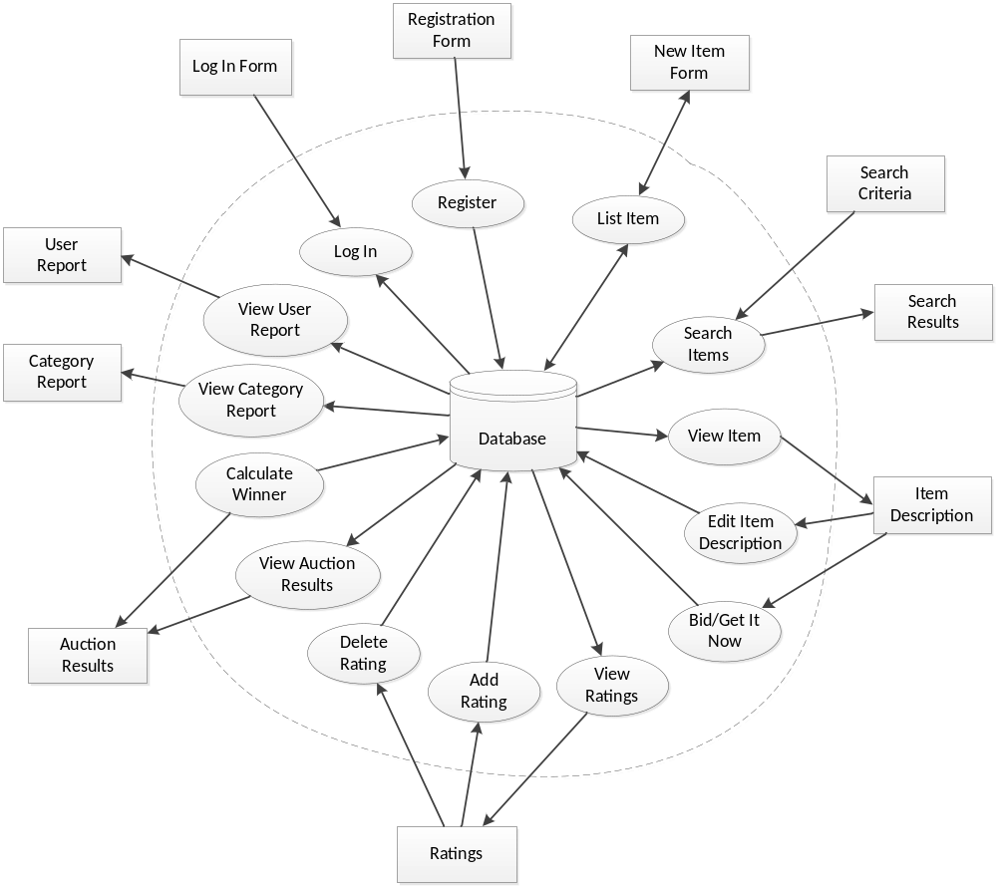

Appendix B – Sample EER Diagram

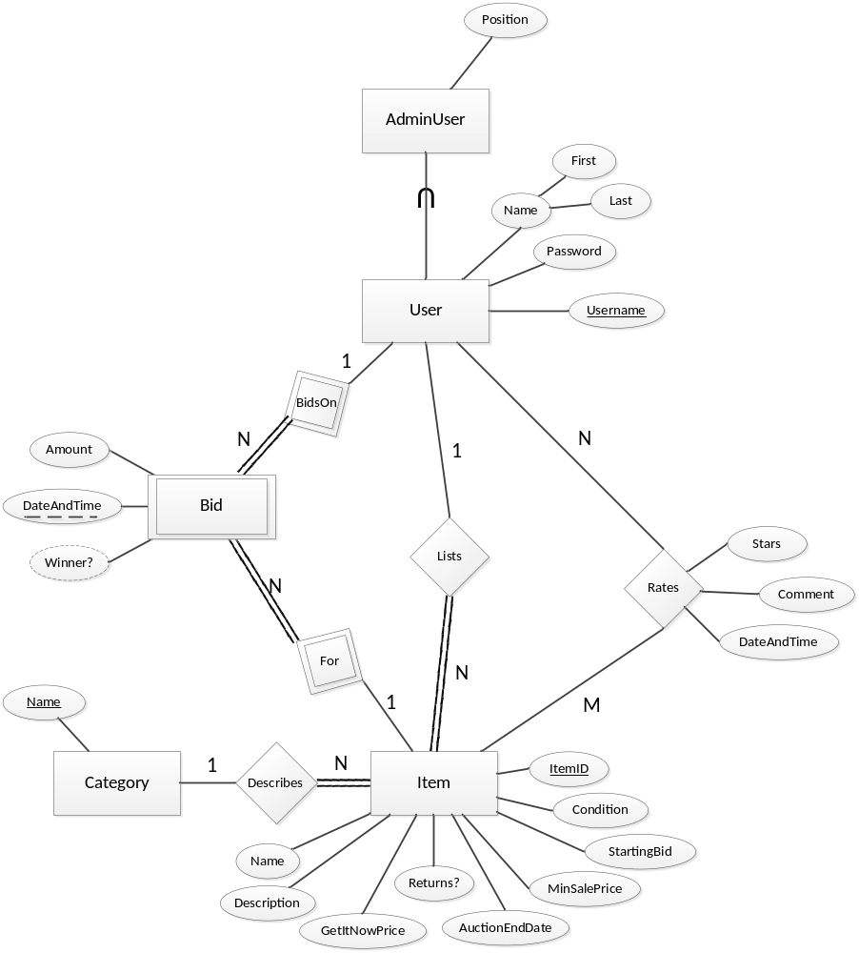

Appendix C – Sample Constraints

No. | Entity Types, Relationship Types, and Attributes involved | Constraint Definition
1 | Item.StartingBid, Item.GetItNowPrice | Item.StartingBid < Item.GetItNowPrice
2 | Lists, User, Item, BidsOn, Bid, For | The user who lists an item cannot also bid on the same item.
3 | Bid.Amount, Bid.DateAndTime | For any two Bids B1 and B2 on the same item, if B1.DateAndTime > B2.DateAndTime then B1.Amount > B2.Amount  (Later bids must be for a greater amount than prior bids.)
4 | Rates.Stars | 1 <= Rates.Stars <= 5
5 | Lists, User, Rates, Item | A user cannot rate an item that he or she lists.

Appendix D – Sample Relational Model Diagram

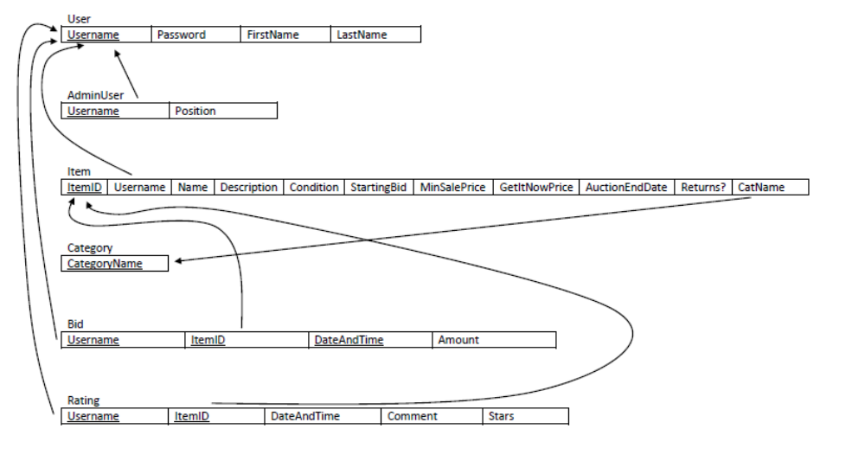

Appendix E – Sample CREATE TABLE Statements

CREATE TABLE User (
Username VARCHAR(30) PRIMARY KEY,
Password VARCHAR(30) NOT NULL,
FirstName VARCHAR(50) NOT NULL,
LastName VARCHAR(50) NOT NULL
)

CREATE TABLE AdminUser (
Username VARCHAR(30) PRIMARY KEY,
Position VARCHAR(50) NOT NULL,
FOREIGN KEY (Username) REFERENCES User(Username)
)

CREATE TABLE Category (
CategoryName VARCHAR(30) PRIMARY KEY
)

CREATE TABLE Item (
ItemID INT AUTO_INCREMENT PRIMARY KEY,
Username VARCHAR(30) NOT NULL,
Name VARCHAR(250) NOT NULL,
Description VARCHAR(4000) NOT NULL,
Condition INT NOT NULL,
StartingBid DECIMAL(10,2) NOT NULL,
MinSalePrice DECIMAL(10,2) NOT NULL,
GetItNowPrice DECIMAL(10,2),
AuctionEndDate DATETIME NOT NULL,
Returns? BIT NOT NULL,
CatName VARCHAR(30) NOT NULL,
FOREIGN KEY (Username) REFERENCES User(Username),
FOREIGN KEY (CatName) REFERENCES Category(CategoryName)
)

CREATE TABLE Bid (
Username VARCHAR(30) NOT NULL,
ItemID INT NOT NULL,
DateAndTime DATETIME NOT NULL,
Amount DECIMAL(10,2) NOT NULL,
PRIMARY KEY (Username, ItemID, DateAndTime),
FOREIGN KEY Username REFERENCES User(Username),
FOREIGN KEY ItemID REFERENCES Item(ItemID)
)

CREATE TABLE Rating (
Username VARCHAR(30) NOT NULL,
ItemID INT NOT NULL,
DateAndTime DATETIME NOT NULL,
Comment VARCHAR(4000) NOT NULL,
Stars INT NOT NULL,
PRIMARY KEY (Username, ItemID),
FOREIGN KEY Username REFERENCES User(Username),
FOREIGN KEY ItemID REFERENCES Item(ItemID)
)

Appendix F – Example Abstract Code + SQL

Task: List New Item
//show category listing on new item form
SELECT CategoryName FROM Category ORDER BY CategoryName

//read in parameters from form
$ItemName = read(“ItemName”)
$ItemDescription = read(“ItemDescription”)
$Category = read(“Category”)
$Condition = read(“Condition”)
$StartingBid = read(“StartingBid”)
$MinSalePrice = read(“MinSalePrice”)
$AuctionDuration = read(“AuctionDuration”)
$GetItNowPrice = read(“GetItNowPrice”)
$Returns = read(“Returns?”)

//validate form data
if ($StartingBid > $GetItNowPrice) then
error(“Starting Bid must be lower than Get It Now price.”)
return to form
end if

if ($MinSalePrice > $GetItNowPrice) then
error(“Minimum Sale Price must be lower than Get It Now price.”)
return to form
end if

//calculate end date
$AuctionEndDate = Now() + $AuctionDuration

//insert new item
INSERT INTO Item (Username, Name, Description, Condition, StartingBid,
MinSalePrice, GetItNowPrice, AuctionEndDate, Returns?, CatName)
VALUES ($Username, $ItemName, $ItemDescription, $Condition,
$StartingBid, $MinSalePrice, $GetItNowPrice, $AuctionEndDate, $Returns, $Category)

Document Version Info

Version | Notes | Date
1.1 | my modified version | 5/16/2013
1.2 | Sham’s comments included | 5/20/2013

Constraint definition may be described in plain English or written using basic logic and mathematical operators.
The notation XXX.YYY means that YYY is an Attribute of the Entity Type XXX or Relationship Type XXX.

