Outage project notes (April 3rd)

1. Logic Complexity & Dependency Chains
The outage schedule isn't just a list of tasks — it's a web of thousands of interdependencies. Steam generator inspections can't start until the reactor head is lifted. Reactor head lift can't happen until reactor coolant system pressure is below threshold. Some dependency chains are 10–20 activities deep, and a single incorrect logic tie can cascade into days of delay. I maintain these manually in Primavera P6, and even small scope changes can require re-logic of hundreds of activities.
2. Resource Contention — The Hardest Problem
This is where I spend most of my time. Consider a single outage involves:
- Radiation workers with dose limits (10 CFR 20)
- Licensed operators required for certain evolutions
- Specialized crafts — pipe welders, scaffold builders, rigging crews, NDE technicians
- Vendor specialists — often only 1–2 teams available nationally (e.g., reactor vessel inspection crews)
These resources are shared across activities, and many activities compete for the same crew at the same time. The critical path often shifts not because of technical logic but because I can't staff two critical activities simultaneously.
3. The Parallel vs. Sequential Tension
Some work must be sequential (safety interlocks, physical access constraints). But I'm always trying to maximize parallelism to compress the schedule. The problem is:
- Running too much in parallel overloads supervisory capacity
- Radiation work areas have physical occupancy limits
- Parallel welding in confined spaces creates atmospheric hazards
Deciding which activities to parallelize and in what order to release work packages is a judgment call I make based on experience — and it's where I know I leave time on the table.
4. Real-Time Replanning
Outages never go to plan. Common disruptions include:
- Unexpected equipment degradation found during disassembly (e.g., cracked nozzles found during ISI)
- Regulatory hold points that extend beyond estimated duration
- Craft absenteeism on night shifts
- Parts delivery delays
When this happens at 3 AM on Day 8, I need to resequence hundreds of activities within minutes, knowing the impact on the critical path, near-critical paths, and resource loading — all at once.
5. Activity Priority — The Hidden Bottleneck
When I have 40 activities eligible to start on Day 5 and only resources for 25, which 25 do I pick? This is almost entirely intuition-based today. I use rules of thumb like:
- Total float (prioritize zero-float activities)
- Downstream resource demand (avoid starving a critical chain later)
- Regulatory deadline sensitivity
- Crew fatigue and dose accumulation
But these heuristics conflict with each other constantly, and I know my prioritization decisions aren't optimal. I just don't have the computational tools to prove it either way.
6. Regulatory & Safety Constraints as Hard Constraints
Unlike commercial construction, many of my constraints are non-negotiable:
- Technical Specification action levels (e.g., reactor must be in cold shutdown within X hours)
- Surveillance test windows that cannot be moved
- ALARA dose goals per worker per outage
- Fire watch requirements during hot work in certain zones
These aren't preferences — they're hard schedule constraints that many general-purpose scheduling tools don't handle well.

Where Your RCPSP + GP Tool Fits In
Here's my honest assessment of where your approach would make a real difference:
My Problem | How Your Tool Helps
Resource contention across 1,500+ activities | RCPSP explicitly models resource availability — this is the core of the problem
Parallel vs. serial sequencing decisions | SGS (serial/parallel) lets me explore both strategies systematically
Activity priority under resource constraints | GP-derived priority rules — this is the breakthrough. Instead of my gut feel, data-driven priority
Near-critical path awareness | CP method surfaces float consumption across all paths, not just one
What-if replanning at 3 AM | Rapid re-solve with updated constraints — game changing for live outage management
Regulatory hard constraints | These can be encoded as resource constraints or precedence constraints in RCPSP
The GP Component — Why It Matters Most to Me
The genetic programming piece is what excites me most. My prioritization heuristics are essentially rules — but they're rules I've never been able to validate or optimize. If GP can evolve priority rules trained on historical outage data that outperform my intuition, that addresses the single biggest source of suboptimality in my schedules.
Specifically, I'd want to know:
- Can the GP rules generalize across different outage scopes (mini-outage vs. full RFO)?
- Can they incorporate regulatory constraints as part of the fitness function?
- How do they perform when scope changes mid-outage — do the rules degrade gracefully?

My Bottom Line as a Scheduler
The gap in the industry today is not in tracking tools (P6 handles that) or in critical path math. The gap is in intelligent, constraint-aware prioritization and real-time replanning. Your RCPSP+GP framework is attacking exactly the right problem. The validation I'd need before trusting it operationally is proof that it handles hard regulatory constraints as inviolable and that its solutions are explainable enough that I can defend the schedule to plant management and the NRC.

Architecture Diagram 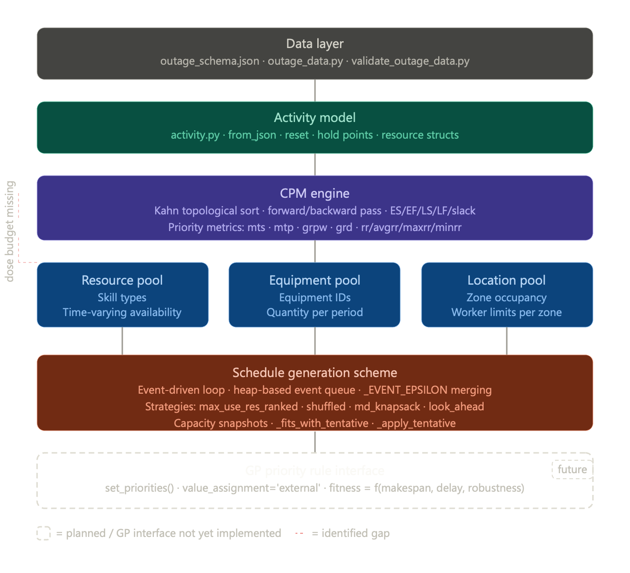

Pert class challenges
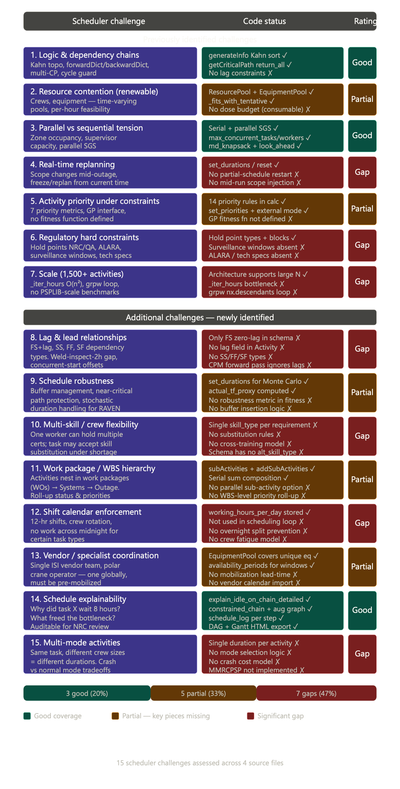
Challenge 1 — Logic Complexity & Dependency Chains
This is the strongest area of the code. The Kahn topological sort in generateInfo() handles arbitrarily deep dependency chains correctly. The forwardDict/backwardDict dual representation makes predecessor checking O(1) per activity. The cycle guard in _build_graph_from_outage_data() when processing hold point edges is a smart defensive measure. The getCriticalPath(return_all=True) capability that surfaces all zero-slack paths — not just one — is exactly what I'd want as a scheduler, since near-critical paths are where surprises come from.
What's still missing: Lag relationships. Real outage schedules use finish-to-start lags (e.g. "weld inspection can start 2 hours after weld completes") and sometimes start-to-start constraints ("scaffold erection and equipment staging can start together but staging must follow erection by 4 hours"). Your model only handles pure finish-to-start with zero lag. This eliminates an entire class of real outage constraints.

Challenge 2 — Resource Contention
The ResourcePool with time-varying availability_periods and the per-hour _fits_with_tentative check handle the renewable resource problem correctly. The equipment pool adds a second resource dimension that most academic RCPSP tools omit entirely.
The critical gap: As I noted in the code review — radiation dose is consumable, not renewable. A mechanic who has absorbed 800 mRem this outage has only 1,200 mRem remaining regardless of how many shifts are left. Your model has no mechanism to track this. Every scheduler's priority call in a high-dose environment is partly a dose-budget call. Without it, the tool will schedule tasks in optimal makespan order that a real HP technician would immediately override.
The second gap: Shift calendars. working_hours_per_day is stored in OutageData but never referenced inside calculateScheduleWithResources(). The resource pool availability periods can encode this — but nothing prevents the scheduler from starting a 12-hour task at hour 11 of a 12-hour shift window and having it run silently into the next period with potentially zero staff.

Challenge 3 — Parallel vs Sequential Tension
This is well-handled. The max_concurrent_tasks and max_concurrent_workers per location per time period directly model zone occupancy. The _schedule_generation_scheme() offering both serial (max_use_res_ranked) and parallel-style (md_knapsack, look_ahead) strategies gives the GP meaningful choices to compare. The tentative capacity decrement (_apply_tentative) correctly prevents double-booking within a single scheduling step.

Challenge 4 — Real-Time Replanning
This is the most operationally painful gap. The code supports pre-run re-configuration (set_durations(), set_priorities()) but not mid-run replanning. At 3 AM on Day 8, when an ISI team finds cracked nozzles and needs to add 6 new tasks with their own resources and dependencies, I need to:
- Inject new activities into the live graph
- Freeze the start times of already-completed activities
- Re-run CPM from the current time forward only
- Get a new schedule for remaining activities within seconds
None of this is currently supported. reset() wipes all scheduling state. There's no concept of a "frozen" activity or a "current time" from which to re-plan forward. This is architecturally the hardest feature to add, but operationally the most valuable.

Challenge 5 — Activity Priority Under Constraints
The infrastructure is there: seven priority metrics in infoDict, set_priorities() for external GP input, and value_assignment='external' in the candidate selection logic. This is the GP coupling point and it's correctly designed.
What's missing is the other side of the interface — the fitness function. The GP needs to be told what "better" means. Currently there's no composite objective, no robustness metric, no penalty for regulatory constraint proximity. The metrics (grpw, rr, grd, etc.) are the inputs to the GP's evolved rules, but the output evaluation is undefined. Without this, GP cannot be trained.

Challenge 6 — Regulatory Hard Constraints
Hold points with NRC/QA/Engineering/Operations typing and blocks_tasks enforcement is a good start. But the nuclear regulatory constraint set goes much further:
Regulatory Constraint | Status in Code
NRC/QA hold points | ✅ Modeled
Surveillance test fixed windows | ❌ Absent
Technical Specification action levels (time-to-cold-shutdown) | ❌ Absent
ALARA dose goals per worker | ❌ Absent
Fire watch requirements during hot work | ❌ Absent
Minimum staffing for nuclear safety functions | ❌ Absent
Surveillance tests in particular are hard constraints that have fixed windows — they can't start before a certain time and must complete before another. They're not precedence constraints; they're time-window constraints. Your schema and activity model have no field for this.

Challenge 7 — Scale
The architecture can represent a 1,500-activity outage. Whether it can solve it in useful time is another question. Two specific bottlenecks:
The _iter_hours loop inside _fits_with_tentative iterates hour by hour for every candidate at every scheduling event. For a 720-hour outage with 100 candidates per event and 500 events, this is potentially 36 million individual get_availability() lookups. The calculate_greatest_rank_position_weight method calls nx.descendants() in a loop over all activities — O(n²) on the network. Neither has been benchmarked at outage scale.
Challenge 8 — Lag & Lead Relationships
In Primavera P6, the relationship types I use every single day are: Finish-to-Start with lag (FS+2h: "inspection starts 2 hours after weld completion"), Start-to-Start (SS: "concrete pour and vibration must start together"), Finish-to-Finish (FF: "commissioning test finishes when startup procedure finishes"), and Start-to-Finish (SF, rare). In your code, the schema only captures successors as a plain list of task IDs — pure FS zero-lag. The forward pass in generateInfo() only does es[v] = max(ef[u]), with no lag term anywhere. This is a significant modelling limitation. A realistic outage schedule uses lag relationships on perhaps 20–30% of its links.
Challenge 9 — Schedule Robustness
This is a strength area worth acknowledging more fully than I did previously. The actual_tf_proxy, the augmented graph construction in _build_augmented_graph(), and the constrained_chain_list concept are genuinely sophisticated — these are post-schedule analytics that most academic RCPSP implementations simply don't have. The set_durations() / RAVEN coupling for Monte Carlo duration sampling is the right architecture for stochastic robustness assessment. What's missing is the forward-looking robustness side: the ability to insert time buffers on near-critical paths before scheduling (proactive robustness), and a fitness function component that rewards schedule stability across duration scenarios.
Challenge 10 — Multi-Skill / Crew Flexibility
Every mechanic at our plant holds multiple qualifications — they're a licensed RO, a qualified rigger, and a basic radiation worker simultaneously. When I'm short on one skill type, I can sometimes substitute a cross-trained worker. The schema enforces {"skill_type": "MECHANIC", "crew_count": 4} — one rigid type per requirement. There's no alternative_skill_types list, no substitution priority, and no worker-level tracking that distinguishes one mechanic from another. This means the scheduler will hit artificial infeasibilities when a task requiring 4 "SENIOR_MECHANIC" units could feasibly be staffed by 2 senior and 2 journeyman mechanics.
Challenge 11 — Work Package / WBS Hierarchy
The subActivities mechanism in Activity exists and addSubActivities() computes duration as a serial sum. However, I discovered that the composition is hardcoded to serial — there's no parallel composition option even though subActivities is the right abstraction for it. More importantly, there's no WBS-level priority roll-up. In outage scheduling, work orders (WOs) belong to systems, systems belong to trains, trains belong to the critical path. When a system's aggregate float hits zero, all its constituent WOs need their priorities elevated simultaneously. The current model treats every activity as independent.
Challenge 12 — Shift Calendar Enforcement
I found the smoking gun in the code. working_hours_per_day is stored in OutageData and printed in print_summary(), but searching the entire pert.py — including calculateScheduleWithResources(), calculateSerialScheduleWithResources(), _select_candidate_activities(), and _fits_with_tentative() — it is never referenced. The scheduler will happily start a 16-hour task at hour 20 of a 24-hour period, letting it run through what would be a shift boundary. In practice, many nuclear tasks cannot be interrupted mid-execution and must be staffed continuously by a single crew. This is not just a performance issue — it's a schedule validity issue.
Challenge 13 — Vendor / Specialist Coordination
The EquipmentPool with availability_periods can model a vendor team's mobilization window — if you encode the team as a piece of "equipment." But there's no concept of mobilization lead time (the ISI vendor needs 72 hours' notice before their team can be on-site) or demobilization cost (sending them away and calling them back costs $500K). The schema has no mobilization_lead_hours field, and the scheduler has no mechanism to ensure that activities requiring specialized vendors are sequenced to minimize their total on-site time.
Challenge 14 — Schedule Explainability
This is the most impressive feature in the codebase beyond the core CPM engine. The explain_idle_on_chain_detailed() method does something genuinely valuable — for each gap between consecutive activities on the resource-constrained chain, it identifies specifically which resource, equipment, or location constraint caused the wait, and which other activities were consuming that capacity. Combined with the plot_activity_dag() with augmented resource-flow edges and the three-color Gantt chart (red = constrained chain, orange = zero actual TF, blue = normal), this is a coherent explainability story. As a scheduler, I could use this to defend a schedule to plant management. However, one limitation: irsm, wcs, and acs priority rules in priority_calculation() are listed but raise IOError("Not yet implemented!") — these are precisely the dynamic priority rules most relevant to GP and most useful for explainability.
Challenge 15 — Multi-Mode Activities
This one emerged from reading calculateSerialScheduleWithResources() carefully. Each activity has exactly one duration. In real outage scheduling, I frequently make mode decisions: crash the valve replacement from 24 hours to 16 hours by assigning 8 mechanics instead of 4, at higher cost. This is the Multi-Mode RCPSP (MMRCPSP), which is strictly more general than what's implemented. Without it, the optimizer cannot explore the time-cost tradeoff space that makes up a significant part of my daily scheduling decisions.

Summary
The code solves the academic RCPSP problem well. It would perform competitively on PSPLIB benchmark instances. For nuclear outage scheduling specifically, it covers roughly the first layer of complexity — dependency logic and renewable resource allocation — but the layers that make outage scheduling genuinely hard (consumable resources, regulatory time windows, shift calendars, live replanning) are mostly absent.
The good news: The architecture is correctly designed to receive these additions. The pool pattern, the schema, the event-driven loop, and the set_priorities() interface are all built in ways that can be extended without restructuring. You're not building on a wrong foundation — you're building on an incomplete one.
The GP coupling point is correct but incomplete. The feature vectors that GP will evolve rules over (grpw, rr, slack, etc.) are computed. The mechanism to inject evolved priority rules (set_priorities, value_assignment='external') is in place. What's missing is the fitness evaluation loop and the composite objective function. That's the next critical development step.
Additional Code Findings
The addActivity() bug: When a new activity is added mid-schedule via addActivity(), its infoDict entry is initialized with only 6 keys (duration, es, ef, ls, lf, slack) but generateInfo() later reads 12 keys including mts, mtp, grpw, grd, rr, avgrr, maxrr, minrr. This will throw a KeyError if addActivity() is called after generateInfo() has run. The resetInfo() method initializes all 12 keys, but addActivity() calls its own minimal initialization block instead of resetInfo().
The _weight_function is non-intuitive: The sigmoid 1.0 - 1.0 / (1 + exp(5.0 - slack)) centers at slack=5 hours. An activity with 4.9 hours of float gets weight ~0.73; one with 5.1 hours gets ~0.27. This cliff means two activities with very similar float values can get radically different priorities. For a 720-hour outage, this threshold should scale with project duration, not be hardcoded.
The irsm, wcs, acs stub: Three priority rules are listed in priority_calculation() and documented in the docstring but raise IOError. These are important: IRSM (Improved Resource Scheduling Method) is a dynamic priority rule that accounts for downstream resource pressure — exactly what a GP-evolved rule should try to replicate. Their absence means the most sophisticated baseline comparators for GP are missing.
The MDKnapsackScheduler ignores location constraints: In its _get_capacities() and _get_resource_consumption() methods, the knapsack optimizer only considers resource and equipment dimensions. Location constraints (max_concurrent_tasks, max_concurrent_workers) are not part of the knapsack capacity vector. The subsequent _fits_with_tentative re-validation will catch violations, but the initial greedy selection may produce a poor activity set if location is the binding constraint — which in high-radiation zones it often is.
print() calls inside calculateScheduleWithResources(): Lines 1264–1272 contain a block of bare print() statements inside the main scheduling loop that will execute on every iteration in production use. At 500+ events, this is substantial console I/O that will slow execution and is not guarded by any verbosity flag. These should be converted to logging.debug() calls.

Prioritized Development Roadmap
Based on this full analysis, here is how I would sequence the remaining work as a practitioner:
Immediate (blocks GP coupling): Define the composite fitness function with makespan + delay + robustness components. Implement irsm/wcs/acs as GP baseline comparators. Remove the hardcoded _weight_function cliff.
High priority (correctness): Fix the addActivity() infoDict initialization gap. Enforce shift calendar in the scheduling loop. Add lag relationship support to the schema and forward pass.
Medium priority (domain completeness): Add consumable resource type for dose budgets. Implement skill substitution rules. Make MDKnapsackScheduler location-aware. Scale _weight_function to project duration.
Longer term (advanced capability): Mid-run replanning with frozen activities. Multi-mode activity support. WBS-level priority roll-up. Mobilization lead-time constraints.

