BACKGROUND OF EMRALD FOR DPRA
Event Modeling Risk Assessment using Linked Diagrams (EMRALD) is a Dynamic Probabilistic Risk Assessment (DPRA) tool developed at Idaho National Laboratory (INL) and has been used for many lab and academic research projects along with commercial endeavors. To expand for wider industry use, continued feedback from users is used for development. Based on feedback, verification methods have been added. These tests were put together at INL by a PRA student Priyanka Pandit as part of an internship. The green highlighted items have been added to the user testing suite the red ones are still to be added.
Name - Priyanka Pandit
Email - ppandit@ncsu.edu

EMRALD VERIFICATION WORK

Verification Framework
EMRALD has a testing project named “Testing” that is part of the source code. The tests were added to the user testing folders available for external users to provide validation cases. References specifying the section of this document are in the test cases.
Testing->UserValidationTests.cs – This is where the tests are defined and are included in the automatic testing.
Testing->TestinFiles/UserValidationModels/[modelName] – All the models for testing were placed here.

Dynamic vs. Static Evaluation Cases
Part of the validation was to verify that the simulation-based results are equivalent to static PRA calculations using SAPHIRE and demonstrate the modeling in EMRALD. The following subsections go over the test cases performed where SAPHIRE was used along with analytical calculations to validate EMRALD results. The results of these validation test cases are summarized in Table 1 and denote the failure rate of a component as λ, the repair rate as $μ$, the availability as $A\left(t\right)$, the mission time as $t$, and $P\left(f\right)$as the failure probability.
Table 1. Summary of dynamic vs. static evaluation cases.
Model # | Model Name | Test # | SAPHIRE Results | EMRALD Results
2.2.1 | Single Component Failure | 1 | P(f) = $1×{10}^{0}$ | P(f) =$9.9995×{10}^{-1}$
 |  | 2 | P(f) = $6.3129×{10}^{-1}$ | P(f) = $6.3129×{10}^{-1}$
 |  | 3 | MTTF = 364.11 days | MTTF = 365 days
2.2.2 | Single Component Failure and Repair | 1 | A(t) = $1.88172×{10}^{-2}$ | A(t) = $1.888×{10}^{-2}$
 |  | 2 | P(f) = $2.733×{10}^{-3}$ | P(f) = $2.84×{10}^{-3}$
2.2.3 | Two Identical Components in Parallel Fail | 1 | P(f) = $9.9995×{10}^{-1}$ | P(f) = $1×{10}^{0}$
 |  | 2 | P(f) = $3.9728×{10}^{-1}$ | P(f) = $3.9728×{10}^{-1}$
 |  | 3 | MTTF = 547 days | MTTF = 547.5 days
2.2.4 | Two Identical Components in Series Fail | 1 | MTTF = 5 days | MTTF = 5 days
 |  | 2 | P(f) = $8.638×{10}^{-1}$ | P(f) = $8.638×{10}^{-1}$
 |  | 3 | MTTF = 178 days | MTTF = 182.5 days
2.2.5 | Two Identical Components in Parallel Fail with Common Cause Failure | 1 | P(f) = 0.5861  (Beta Factor Model) | P(f) = 0.7461
2.2.6 | Initiating Event | 1 | $$f_{0}=0.005/year$$ | $$f_{0}=0.00494/year$$
2.2.7 | Initiating Event with One Engineering Safety Feature | 1 | $$f_{CD}=3.160×{10}^{-3}$$ | $$f_{CD}=3.101×{10}^{-3}$$
2.2.8 | Initiating Event with Engineering Safety Feature 1 | 1 | $$f_{CD}=2.008×{10}^{-3}$$ | $$f_{CD}=1.986×{10}^{-3}$$
2.2.9 | Initiating Event with Engineering Safety Feature 2 | 1 | $$f_{CD}=4.32×{10}^{-3}$$ | $$f_{CD}=4.51×{10}^{-3}$$

Single Component Failure
We can test the failure probability and mean time to failure (MTTF) of a single component given the mission time and failure rate. The SAPHIRE model and EMRALD model for the system are given in Figure 2 and Figure 3. The equation to calculate the MTTF is given in (1). We use a range of failure rates and mission times as shown in Table 2.
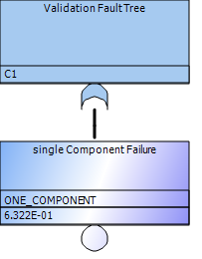
Figure 2. Fault tree in SAPHIRE for single component failure.
$$MTTF=\frac{1}{λ}$$ | (1)

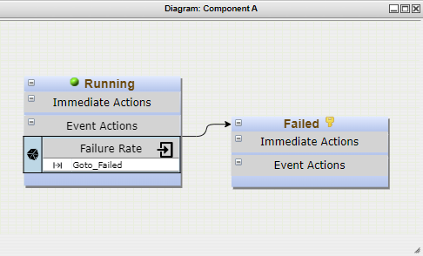
Figure 3. EMRALD model for failure of a single component.
Table 2. Data for validating the failure of a single component.
Test Number | Failure Rate | Mission Time | Number of Runs |  | EMRALD Failure Probability |  |  | SAPHIRE Failure Probability | EMRALD Mean Time to Failure | Analytical Mean Time to Failure
1 | $$\frac{1}{10 days}$$ | 100 days |  | 100,000 |  | $$P(f) = 9.9995×{10}^{-1}$$ | $$P(f) = 1×{10}^{0}$$ |  | MTTF = 10 days | MTTF = 10 days
2 | $$\frac{1}{365 days}$$ | 365 days | 100,000 |  | $$P(f) = 6.3129×{10}^{-1}$$ |  |  | $$P(f) = 6.3129×{10}^{-1}$$ | - | -
3 | $$\frac{1}{365 days}$$ | 10000 days |  | 100,000 |  | $$P(f) = 1×{10}^{0}$$ | $$P(f) = 1×{10}^{0}$$ |  | MTTF = 364.11 days | MTTF = 365 days
The MTTF is not compared in test 2 because the mission time is not large enough to simulate enough failures to get an accurate result. The mission time was increased in test 3 and compare the MTTF.

Single Component Failure and Repair
We can test the failure and repair of a single component given the failure rate, repair rate or time, and mission time. Using the repair rate, we can form a Markov model as shown in Figure 4 and calculate the unavailability of the system using Equation (2). Using the repair time, we can use SAPHIRE to calculate the failure probability as shown in Figure 5. Finally, using the Markov model and SAPHIRE results, we can verify the EMRALD results as shown in Figure 6 and Table 3.

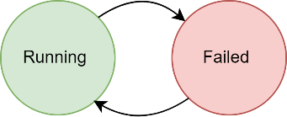
Figure 4. Markov model for single component failure and repair.
$$A\left(t\right)={(μ+λ)}^{-1}∙\{μ+λ∙e^{[-(μ+λ)∙t]}\}$$ | (2)
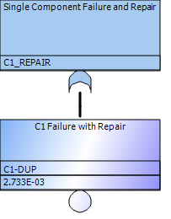
Figure 5. SAPHIRE model for the failure and repair of a single component.
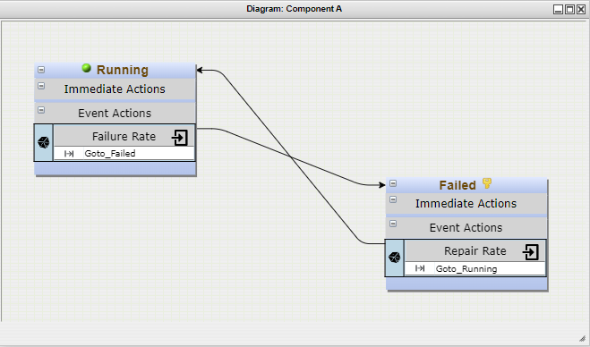
Figure 6. EMRALD model for the failure and repair of a single component.
Table 3. Data for validating the failure of a single component.
Test Number | Failure Rate | Repair Rate/ Time | Mission Time | Number of Runs | EMRALD Unavailability/ Failure Probability | Analytical Unavailability/ SAPHIRE Failure Probability
1 | $$\frac{7}{365 days}$$ | $$1 day$$ | 1,000 days | 100,000 | $$A(t) = 1.888×{10}^{-2}$$ | $$A(t) = 1.88172×{10}^{-2}$$
2 | $$\frac{7}{365 days}$$ | 1 day | 365 days | 100,000 | $$P(f) = 2.84×{10}^{-3}$$ | $$P(f) = 2.733×{10}^{-3}$$

Two Identical Components in Parallel Fail
To test the failure probability and MTTF of two identical components in parallel in EMRALD, as shown in Figure 7, we can use SAPHIRE as shown in Figure 8 and analytical calculations as given in Equation (3). The results are tabulated in Table 4.
$$MTTF=\frac{2}{3∙λ}$$ | (3)

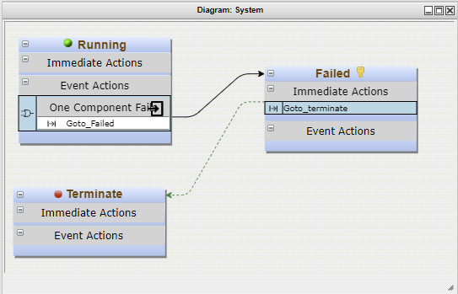  - System Diagram | 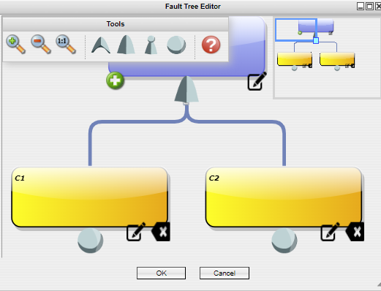  - Failure Tree
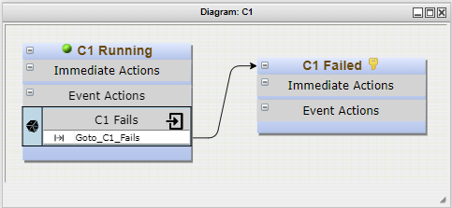  - Component 1 | 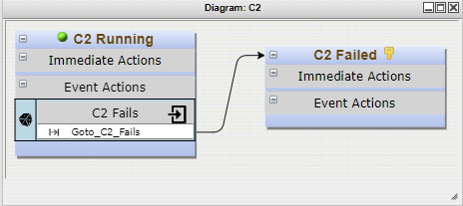  - Component 2
Figure 7. EMRALD model for the failure of two identical components in parallel.

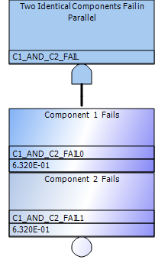
Figure 8. SAPHIRE model for the failure of two identical components in parallel.
Table 4. Data for validating the failure of two identical components in parallel.
Test Number | Failure Rates of Both Components | Mission Time | Number of Runs | EMRALD Failure Probability | SAPHIRE Failure Probability | EMRALD Mean Time to Failure | Analytical Mean Time to Failure
1 | $$\frac{1}{10 days}$$ | 100 days | 100,000 | $$P(f) = 9.9995×{10}^{-1}$$ | $$P(f) = 1×{10}^{0}$$ | MTTF = 15 days | MTTF = 15 days
2 | $$\frac{1}{365 days}$$ | 365 days | 100,000 | $$P(f) = 3.9728×{10}^{-1}$$ | $$P(f) = 3.997×{10}^{-1}$$ | - | -
3 | $$\frac{1}{365 days}$$ | 10,000 days | 100,000 | $$P(f) = 1×{10}^{0}$$ | $$P(f) = 1×{10}^{0}$$ | MTTF = 547 days | MTTF = 547.5 days
The MTTF is not compared in test 2, because the mission time is not large enough to simulate enough failures to get an accurate result. The mission time was increased in test 3 and compare the MTTF.

Two Identical Components in Series Fail
To test the failure probability and MTTF of two identical components in series in EMRALD, as shown in Figure 9, we can use SAPHIRE as shown in Figure 10 and analytical calculations as given in Equation (4). The results are tabulated in Table 5.
  - System Diagram | 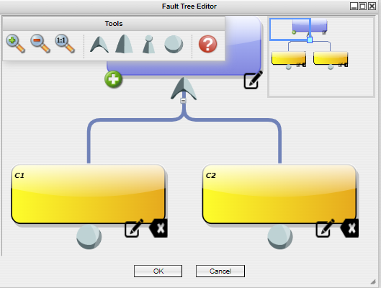  - Failure Tree
  - Component 1 |   - Component 2
Figure 9. EMRALD model for the failure of two identical components in series.
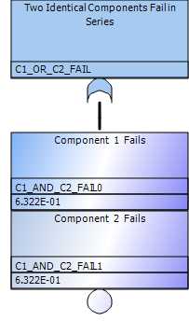
Figure 10. SAPHIRE model for the failure of two identical components in series.
$$MTTF=\frac{1}{2∙λ}$$ | (4)

Table 5. Data for validating the failure of two identical components in series.
Test Number | Failure Rates of Both Components | Mission Time | Number of Runs | EMRALD Failure Probability | SAPHIRE Failure Probability | EMRALD Mean Time to Failure | Analytical Mean Time to Failure
1 | $$\frac{1}{10 days}$$ | 100 days | 100,000 | $$P(f) = 1×{10}^{0}$$ | $$P(f) = 1×{10}^{0}$$ | MTTF = 5 days | MTTF = 5 days
2 | $$\frac{1}{365 days}$$ | 365 days | 100,000 | $$P(f) = 8.638×{10}^{-1}$$ | $$P(f) = 8.647×{10}^{-1}$$ | - | -
3 | $$\frac{1}{365 days}$$ | 10,000 days | 100,000 | $$P(f) = 9.9573×{10}^{-1}$$ | $$P(f) = 1×{10}^{0}$$ | MTTF = 178 days | MTTF = 182.5 days
The MTTF is not compared in test 2, because the mission time is not large enough to simulate enough failures to get an accurate result. The mission time was increased in test 3 and compare the MTTF.

Two Identical Components in Parallel Fail with Common Cause Failure
We can calculate the failure probability of two components in parallel with common cause failure using the equation of the beta factor model given in Equation (5). The beta factor denoted by $β, is considered$to be 0.1. Figure 11 shows the EMRALD model for depicting common cause failure, and Table 6 gives the analytical and modeling results.
$$P\left(f\right)=2e^{-λt}-e^{-(2-β)λt}$$ | (5)

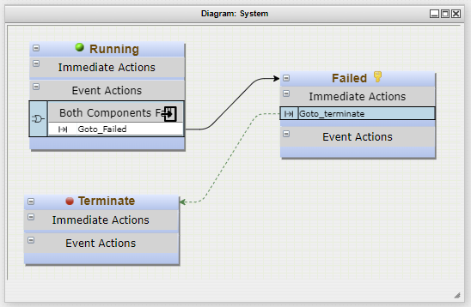  - System Diagram | 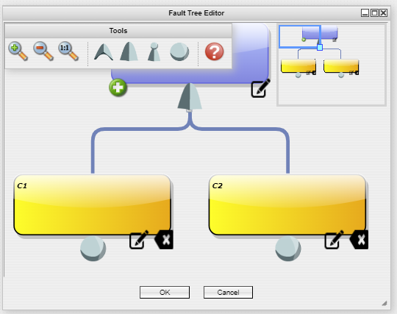  - Failure Tree
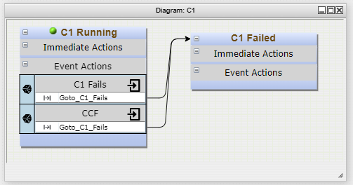  - Component 1 | 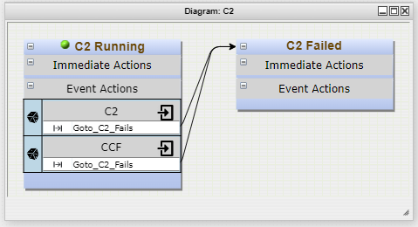  - Component 2
Figure 11. EMRALD model for the failure and repair of two components in series, one repairperson available.

Table 6. Data for validating the failure and repair of a two components in series, repaired one at a time.
Test Number | Failure Rate | Beta Factor | Mission Time | Number of Runs | EMRALD Failure Probability | Analytical Failure Probability
1 | $$\frac{1}{100 days}$$ | 0.1 | 100 days | 100,000 | $$P(f) = 7.461×{10}^{-1}$$ | $$P(f) = 5.861×{10}^{-1}$$

Initiating Event with One Engineering Safety Feature
We can verify the results of an event tree model, with one component as the engineering safety feature, in EMRALD. Figure 12 gives the EMRALD model of an event tree that has one component as the engineering safety feature along with an initiating event. Figure 13 shows the SAPHIRE model of the same system, and Equation (6) gives the failure frequency of the core damage state. Table 7 gives the results of the EMRALD and SAPHIRE models.
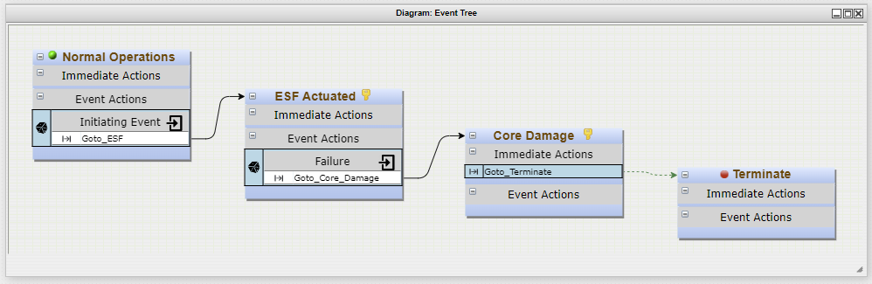
Figure 12. EMRALD model of an event tree with one component as the engineering safety feature.
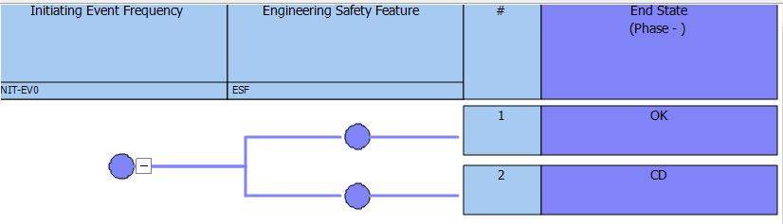
Figure 13. SAPHIRE model of an event tree with one component as the engineering safety feature.

$$Core Damage Frequency \left(f_{CD}\right)=Initiating Event Frequency(F_{0})*Engineering Safety Feature Failure Probability$$  $$f_{CD}= F_{0}∙(1-e^{-\int_{0}^{t}{λ∙dt}})$$  $$f_{CD}= \frac{0.005}{year}∙(1-e^{-\int_{0}^{365}{\frac{1}{365}∙dt}})$$  $$f_{CD}= \frac{0.005}{year}∙(1-e^{-\frac{1}{365}\int_{0}^{365}{dt}})$$  $$f_{CD}= \frac{0.005}{year}∙(1-e^{-\frac{1}{365}\left[365-0\right]})$$  $$f_{CD}= \frac{0.005}{year}∙\left(1-e^{-\frac{1}{365}∙365}\right)$$  $$f_{CD}= \frac{0.005}{year}∙0.6321$$  $$f_{CD}= 0.0031606/year$$ | (6)

Table 7. Data for validation of failure frequency of an event tree with one component as the engineering safety feature.
Test Number | Initiating Event Frequency | Failure Rate | Mission Time | Number of Runs | EMRALD Failure Frequency | Analytical Failure Frequency
1 | $$\frac{0.005}{365 days}$$ | $$\frac{1}{365 days}$$ | 365 days | 10,000,000 | $$f_{CD}=3.101×{10}^{-3}$$ | $$f_{CD}=3.160×{10}^{-3}$$

Initiating Event with Engineering Safety Feature 1
We can verify the results of an event tree model with an engineering safety feature that has two component sin parallel, in EMRALD. Figure 14 gives the EMRALD model, and Figure 15 shows the SAPHIRE model of the same system, and Equation (7) gives the failure frequency of the core damage state. Table 8 gives the results from the EMRALD and SAPHIRE models.
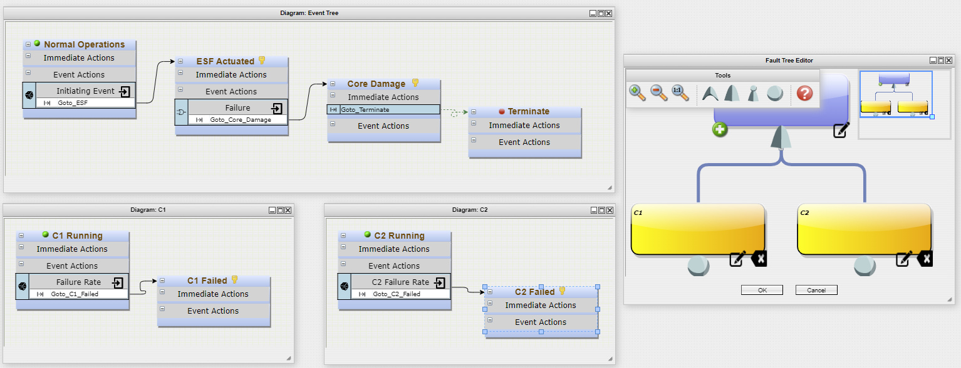
Figure 14. EMRALD model of an event tree with two components in parallel as the engineering safety feature.
 | 
Figure 15. SAPHIRE model of an event tree with two components in parallel as the engineering safety feature.
$$CD= \frac{0.005}{year}∙0.39728$$  $$CD= 0.0019864/year$$ | (7)
Table 8. Data for validating the failure frequency of an event tree with two components in parallel as the engineering safety feature.
Test Number | Initiating Event Frequency | Failure Rate | Mission Time | Number of Runs |  | EMRALD Failure Frequency | Analytical Failure Frequency
1 | $$\frac{0.005}{365 days}$$ | $$\frac{1}{365 days}$$ | 365 days | 10,000,000 | $$f_{CD}=2.008×{10}^{-3}$$ |  | $$f_{CD}=1.986×{10}^{-3}$$

Initiating Event with Engineering Safety Feature 2
We can verify the results of an event tree model with an engineering safety feature that has two components in series, in EMRALD. Figure 16 gives the EMRALD model and Figure 17 shows the SAPHIRE model of the same system.
Table 9 gives the results from the EMRALD and SAPHIRE models.
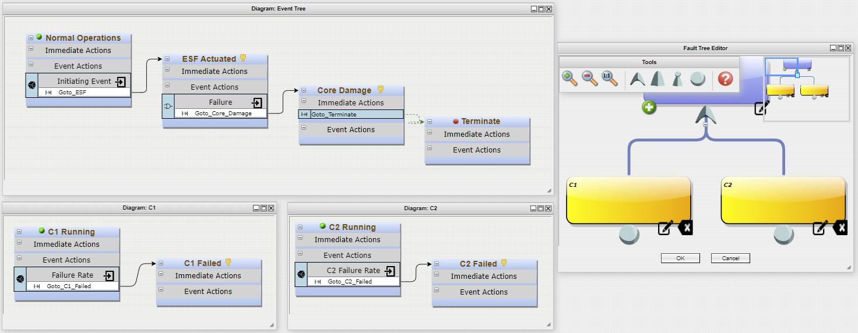
Figure 16. EMRALD model of an event tree with two components in series as the engineering safety feature.

 | 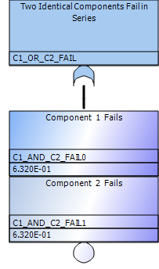
Figure 17. SAPHIRE model of an event tree with two components in series as the engineering safety feature.
Table 9. Data for validating the failure frequency of an event tree with two components in series as the engineering safety feature.
Test Number | Initiating Event Frequency | Failure Rate | Mission Time | Number of Runs | EMRALD Failure Frequency | Analytical Failure Frequency
1 | $$\frac{0.005}{365 days}$$ | $$\frac{1}{365 days}$$ | 365 days | 10,000,000 | $$f_{CD}=4.51×{10}^{-3}$$ | $$f_{CD}=4.32×{10}^{-3}$$

Dynamic Model Numerical Evaluation Cases
Many simple dynamic cases can be evaluated numerically to verify the EMRALD results. This section evaluates several of those cases. Many of these test cases are compared against the unavailability time calculation. The standard output of EMRALD is the probability of a key state, typically a failure or success state, and time statistics to failure for success. To compare the availability time, a cumulative variable is used to determine the time in the OK states or the inverse. This is summed and averaged for the scenario runs. The results of these validation test cases are summarized in Table 10Table 10.
Table 10. Summary of dynamic vs. static evaluation cases.
Mode # | Model Name |  | Test # |  | Availability Results |  | SAPHIRE  Results |  | EMRALD Results
2.3.1 | Two Identical Components in Active Parallel Fail and Get Repaired: One Repairperson Available |  | 1 |  | A(t) = $1×{10}^{-3}$ |  |  |  | A(t) = $8.264×{10}^{-3}$
 |  |  | 2 |  | A(t) = $1.6×{10}^{-2}$ |  |  |  | A(t) = $1.6×{10}^{-2}$
2.3.2 | Two Identical Components in Active Parallel Fail and Get Repaired: Two Repairpersons Available |  | 1 |  | A(t) = 8.235$×{10}^{-3}$ |  |  |  | A(t) = $8.2644628×{10}^{-3}$
 |  |  | 2 |  | A(t) = $8.275×{10}^{-3}$ |  |  |  | A(t) = $8.2644628×{10}^{-3}$
 |  |  | 3 |  |  |  | P(f) = $8.263×{10}^{-3}$ |  | P(f) = $8.025×{10}^{-3}$
2.3.3 | Two Identical Components, One Active and One in Standby Fail and Get Repaired, One Repairperson Available |  | 1 |  | A(t) = $5.5×{10}^{-2}$ |  |  |  | A(t) = $9.009×{10}^{-3}$
 |  |  | 2 |  | A(t) = $8.985×{10}^{-3}$ |  |  |  | A(t) = $9.009×{10}^{-3}$
2.3.4 | Two Identical Components, One Active and One in Standby Fail and Get Repaired, Two Repairpersons Available |  | 1 |  | A(t) = $4.541×{10}^{-3}$ |  |  |  | A(t) = $4.5248×{10}^{-3}$
 |  |  | 2 |  | A(t) = $4.524×{10}^{-3}$ |  |  |  | A(t) = $4.5248×{10}^{-3}$
2.3.5 | Two Identical Components in Series Fail and Get Repaired: One Repairperson Available |  | 1 |  | A(t) = $0.0123×{10}^{-1}$ |  |  |  | A(t) = $1.8033×{10}^{-1}$
 |  |  | 2 |  | A(t) = $1.8001×{10}^{-1}$ |  |  |  | A(t) = $1.8033×{10}^{-1}$
2.3.6 | Two Identical Components in Series Fail and Get Repaired: Two Repairpersons Available |  | 1 |  | A(t) = $1.624×{10}^{-1}$ |  |  |  | A(t) = $1.735×{10}^{-1}$
 |  |  | 2 |  | A(t) = 1.735$×{10}^{-1}$ |  |  |  | A(t) = $1.735×{10}^{-1}$
 |  |  | 3 |  |  |  | P(f) = 1.622 $×{10}^{-1}$ |  | P(f) = 1.711 $×{10}^{-1}$
Model # |  | Model Name |  | Test # |  | SAPHIRE Results |  | EMRALD Results
2.3.1 |  | Two Identical Components in Active Parallel Fail and Get Repaired, One Repairperson Available |  | 1 |  | A(t) = $1×{10}^{-3}$ |  | A(t) = $8.264×{10}^{-3}$
 |  |  |  | 2 |  | A(t) = $1.6×{10}^{-2}$ |  | A(t) = $1.6×{10}^{-2}$
2.3.2 |  | Two Identical Components in Active Parallel Fail and Get Repaired, Two Repairpersons Available |  | 1 |  | A(t) = 8.235$×{10}^{-3}$ |  | A(t) = $8.2644628×{10}^{-3}$
 |  |  |  | 2 |  | A(t) = $8.275×{10}^{-3}$ |  | A(t) = $8.2644628×{10}^{-3}$
 |  |  |  | 3 |  | P(f) = $8.263×{10}^{-3}$ |  | P(f) = $8.025×{10}^{-3}$
2.3.3 |  | Two Identical Components, One Active and One in Standby Fail and Get Repaired, One Repairperson Available |  | 1 |  | A(t) = $5.5×{10}^{-2}$ |  | A(t) = $9.009×{10}^{-3}$
 |  |  |  | 2 |  | A(t) = $8.985×{10}^{-3}$ |  | A(t) = $9.009×{10}^{-3}$
2.3.4 |  | Two Identical Components, One Active and One in Standby Fail and Get Repaired, Two Repairpersons Available |  | 1 |  | A(t) = $4.541×{10}^{-3}$ |  | A(t) = $4.5248×{10}^{-3}$
 |  |  |  | 2 |  | A(t) = $4.524×{10}^{-3}$ |  | A(t) = $4.5248×{10}^{-3}$
2.3.5 |  | Two Identical Components in Series Fail and Get Repaired, One Repairperson Available |  | 1 |  | A(t) = $0.0123×{10}^{-1}$ |  | A(t) = $1.8033×{10}^{-1}$
 |  |  |  | 2 |  | A(t) = $1.8001×{10}^{-1}$ |  | A(t) = $1.8033×{10}^{-1}$
2.3.6 |  | Two Identical Components in Series Fail and Get Repaired, Two Repairpersons Available |  | 1 |  | A(t) = $1.624×{10}^{-1}$ |  | A(t) = $1.735×{10}^{-1}$
 |  |  |  | 2 |  | A(t) = 1.735$×{10}^{-1}$ |  | A(t) = $1.735×{10}^{-1}$
 |  |  |  | 3 |  | P(f) = 1.622 $×{10}^{-1}$ |  | P(f) = 1.711 $×{10}^{-1}$

Two Identical Components in Active Parallel Fail and Get Repaired, One Repairperson Available
We can calculate the availability of two components in parallel that fail and can be repaired one at a time using a Markov model as shown in Figure 18, whose availability equation is given in Equation (8) [22]. The EMRALD model for the system is given in Figure 19. However, its results are significantly higher when compared to the analytical calculations as shown in Table 11, Test 1. Therefore, another EMRALD model was developed which evaluates a more standard Markov model of the system rather than decomposing the system into separate components, as shown in Figure 20. The results of the second EMRALD model are close to the analytical unavailability as shown in Table 12, Test 2. Further investigation needs to be done as to why the first model used was not equivalent.
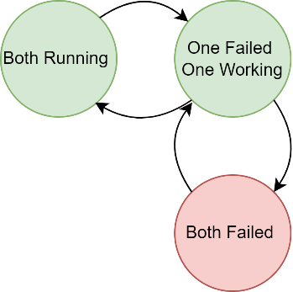
Figure 18. Markov model for failure of two components in parallel, one repairperson available.
$$A\left(t\right)=\frac{μ^{2}+2μλ}{μ^{2}+2λμ+{2λ}^{2}}-\frac{{2λ}^{2}\left\{s_{2}e^{{(s}_{1}t)}-s_{1}e^{{(s}_{2}t)}\right\}}{s_{1}s_{2}(s_{1}{-s}_{2})};$$  $$s_{1}=-0.5\left(2μ+3λ+\sqrt{4λμ+λ^{2}}\right); s_{2}=-0.5\left(2μ+3λ-\sqrt{4λμ+λ^{2}}\right)$$ |  | (8)
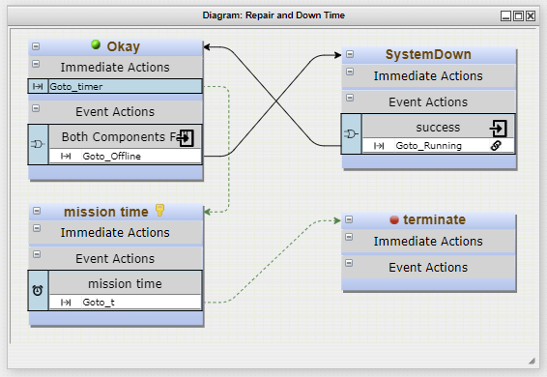  - System Diagram |   - Failure Tree
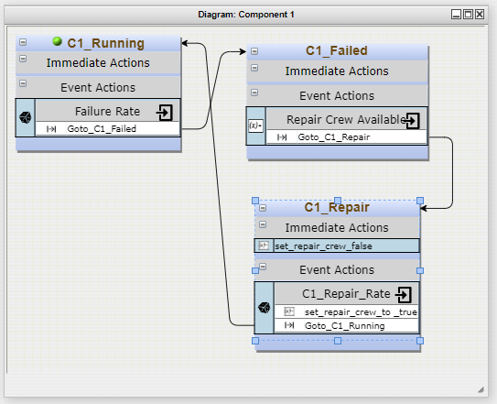  - Component 1 | 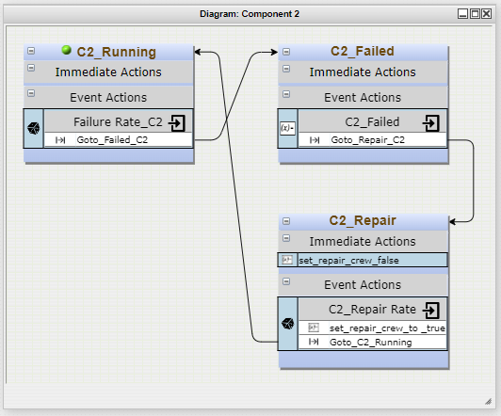  - Component 2
Figure 19. EMRALD model for the failure and repair of two components in parallel, one repairperson available.
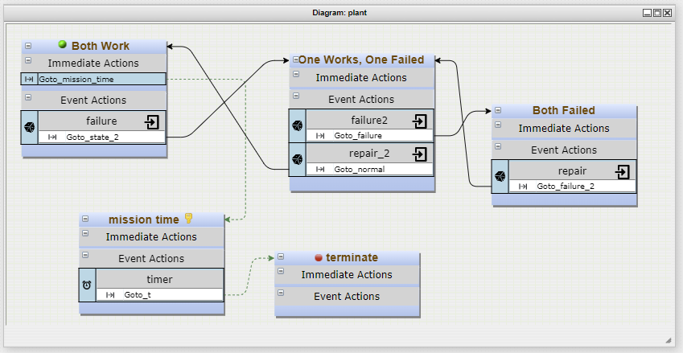
Figure 20. EMRALD model of the Markov model for the failure and repair of two components in parallel, one repairperson available.
Table 11. Data for validating the failure and repair of two components in parallel, repaired one at a time.
Test Number | Failure Rate | Repair Rate/Time | Mission Time | Number of Runs | EMRALD Unavailability | Analytical Unavailability
1 | $$\frac{1}{10 days}$$ | $$\frac{1}{ day}$$ | 1,000 days | 100,000 | A(t) = $1×{10}^{-3}$ | A(t) = $8.264×{10}^{-3}$
2 | $$\frac{1}{10 days}$$ | $$\frac{1}{ day}$$ | 1,000 days | 100,000 | A(t) = $1.6×{10}^{-2}$ | A(t) = $0.8264×{10}^{-2}$

Two Identical Components in Active Parallel Fail and Get Repaired, Two Repairpersons Available
The availability of two components in parallel that fail and can be repaired simultaneously can be calculated using the failure and repair rate and a Markov model, as shown in Figure 21. The availability equation is given in Equation (9). The EMRALD model for the system is given in Figure 22, and another EMRALD model, which evaluates a more standard Markov model of the system, rather than the decomposition of the system into separate components, is shown in Figure 23. The results of the second EMRALD model are close to the analytical unavailability as shown in Table 12, Test 2, versus the results of the first EMRALD model given in Table 12, Test 1. We can also compare the results of a SAPHIRE model and the corresponding EMRALD model when the failure rates and repair duration are considered. The SAPHIRE model is shown in Figure 24, and the EMRALD model is the same as Figure 21 other than the repair events being of the timer type instead of a rate.


Figure 21. Markov model for failure of two components in parallel, two repairpersons available.
$$A\left(t\right)=\frac{μ^{2}+2μλ}{μ^{2}+2λμ+λ^{2}}-\frac{{2λ}^{2}\left\{s_{2}e^{{(s}_{1}t)}-s_{1}e^{{(s}_{2}t)}\right\}}{s_{1}s_{2}(s_{1}{-s}_{2})};$$  $$s_{1}=-2\left(μ+λ\right); s_{2}=-\left(μ+λ\right)$$ | (9)

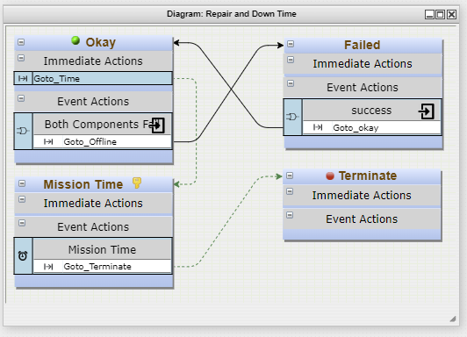  - System Diagram |   - Failure Tree
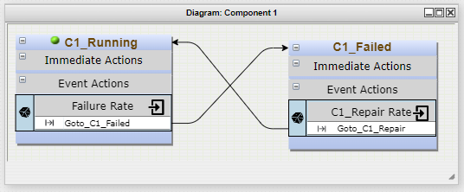  - Component 1 | 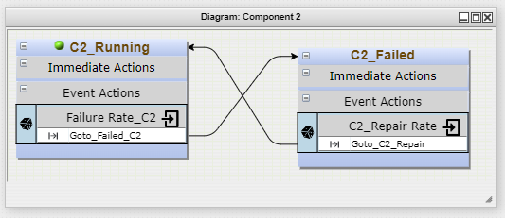  - Component 2
Figure 22. EMRALD model for the failure and repair of two parallel components, two repairpersons available.

Figure 23. EMRALD model of the Markov model for the failure and repair of two parallel components, two repairpersons available.
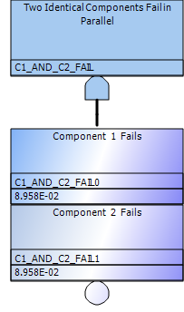
Figure 24. SAPHIRE model for failure of two identical components in parallel, which can be repaired simultaneously.
Table 12. Data for validating the failure and repair of two components in parallel, repaired simultaneously.
Test Number | Failure Rate | Repair Rate/ Time | Mission Time | Number of Runs | EMRALD Unavailability/ Failure Probability | Analytical Unavailability/ SAPHIRE Failure Probability
1 | $$\frac{1}{ 10 days}$$ | $$\frac{1}{ day}$$ | 1,000 days | 100,000 | A(t) = 8.235$×{10}^{-3}$ | A(t) = $8.2644628×{10}^{-3}$
2 | $$\frac{1}{ 10 days}$$ | $$\frac{1}{ day}$$ | 1,000 days | 100,000 | A(t) = $8.275×{10}^{-3}$ | A(t) = $8.2644628×{10}^{-3}$
3 | $$\frac{1}{ 10 days}$$ | 1 day | 1,000 days | 100,000 | P(f) = $8.263×{10}^{-3}$ | P(f) = $8.025×{10}^{-3}$

Two Identical Components, One Active and One in Standby, Fail and Get Repaired, One Repairperson Available
The availability of two components, one active and one in standby, that fail and can be repaired one at a time can be calculated using a Markov model as shown in Figure 25, whose availability equation is given in Equation (10) [22]. The EMRALD model for the system is given in Figure 29, and another EMRALD model, which evaluates a more standard Markov model of the system rather than the decomposition of the system into separate components, is shown in Figure 27. Table 13 gives a comparison of the analytical and EMRALD results.

Figure 25. Markov model for failure of two components, one active and one in standby, one repairperson available.
$$A\left(t\right)=\frac{μ^{2}+μλ}{μ^{2}+λμ+λ^{2}}-\frac{λ^{2}\left\{s_{2}e^{{(s}_{1}t)}-s_{1}e^{{(s}_{2}t)}\right\}}{s_{1}s_{2}(s_{1}{-s}_{2})};$$  $$s_{1}=-\left(μ+λ+\sqrt{2λμ}\right); s_{2}=-\left(μ+λ-\sqrt{2λμ}\right)$$ | (10)

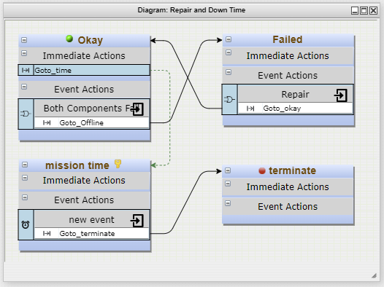  - System Diagram |   - Failure Tree
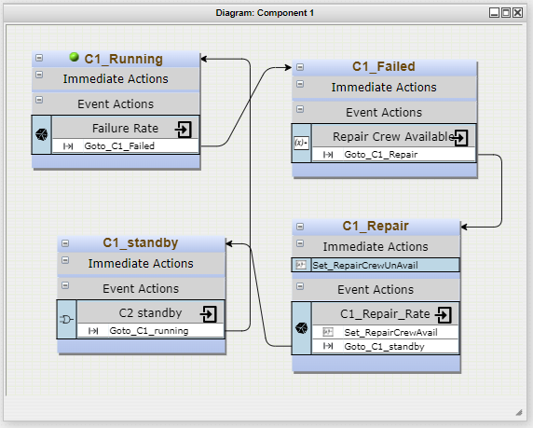  - Component 1 | 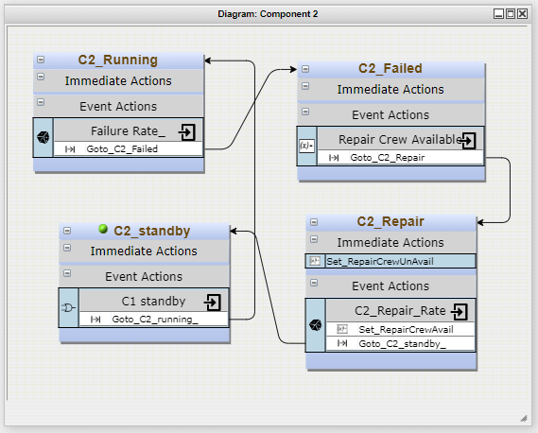  - Component 2
Figure 26. EMRALD model for the failure and repair of one active and one standby component, one repairperson available.
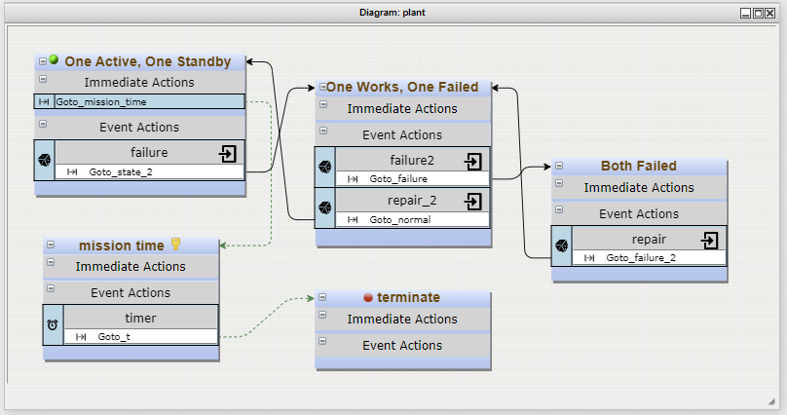
Figure 27. EMRALD model of Markov model for the failure and repair of one active and one standby component, one repairperson available.
Table 13. Data for validating the failure and repair of two components, one active and one in standby, repaired one at a time.
Test Number | Failure Rate | Repair Rate/ Time | Mission Time | Number of Runs | EMRALD Unavailability/ Failure Probability | Analytical Unavailability/ Failure Probability
1 | $$\frac{1}{ 10 days}$$ | $$\frac{1}{ day}$$ | 1,000 days | 100,000 | A(t) = $8.979 ×{10}^{-3}$ | A(t) = $9.009×{10}^{-3}$
2 | $$\frac{1}{ 10 days}$$ | $$\frac{1}{ day}$$ | 1,000 days | 100,000 | A(t) = $8.985×{10}^{-3}$ | A(t) = $9.009×{10}^{-3}$

Two Identical Components, One Active and One in Standby, Fail and Get Repaired, Two Repairpersons Available
The availability of two components, one active and one in standby, that fail and can be repaired simultaneously can be calculated using a Markov model as shown in Figure 28, whose availability equation is given in Equation (11) [22]. The EMRALD models for the system are given in Figure 29 and Figure 30, where the first model includes all the components and their states while the second model is the Markov model representation of the system. Table 14 gives a comparison of the analytical and EMRALD results.

Figure 28. Markov model for failure of two components, one active and one in standby, two repairpersons available.
$$A\left(t\right)=\frac{{2μ}^{2}+2μλ}{2μ^{2}+2λμ+λ^{2}}-\frac{λ^{2}\left\{s_{2}e^{{(s}_{1}t)}-s_{1}e^{{(s}_{2}t)}\right\}}{s_{1}s_{2}(s_{1}{-s}_{2})};$$  $$s_{1}=-0.5\left(3μ+2λ+\sqrt{4λμ+μ^{2}}\right); s_{2}=-0.5\left(3μ+2λ-\sqrt{4λμ+μ^{2}}\right)$$ | (11)

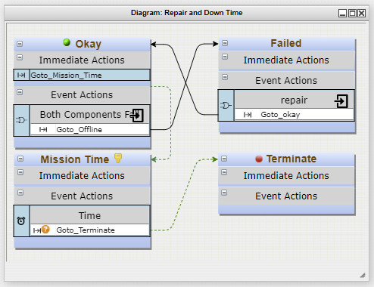  - System Diagram |   - Failure Tree
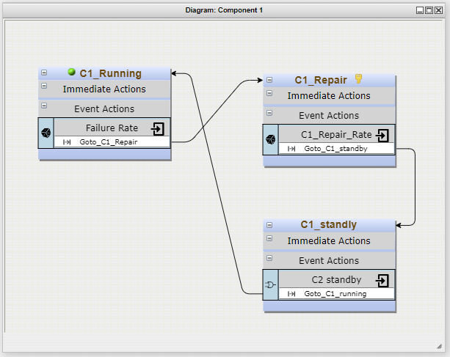  - Component 1 | 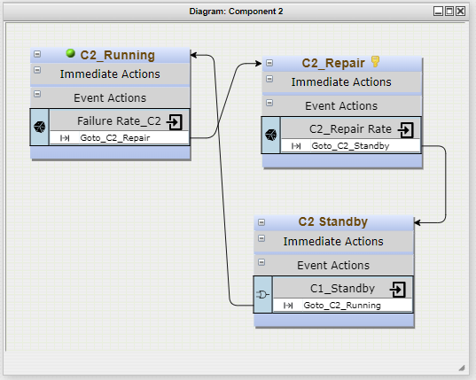  - Component 2
Figure 29. EMRALD model for the failure and repair of one active and one standby component, two repairpersons available.

Figure 30. EMRALD model of Markov model for the failure and repair of one active and one standby component, two repairpersons available.

Table 14. Data for validating the failure and repair of two components, one active and one in standby, repaired simultaneously.
Test Number | Failure Rate | Repair Rate/ Time | Mission Time | Number of Runs | EMRALD Unavailability/ Failure Probability | Analytical Unavailability/ Failure Probability
1 | $$\frac{1}{ 10 days}$$ | $$\frac{1}{ day}$$ | 1,000 days | 100,000 | A(t) = $4.5155 ×{10}^{-3}$ | A(t) = $4.5248×{10}^{-3}$
2 | $$\frac{1}{ 10 days}$$ | $$\frac{1}{ day}$$ | 1,000 days | 100,000 | A(t) = $4.524×{10}^{-3}$ | A(t) = $4.5248×{10}^{-3}$

Two Identical Components in Series Fail and Get Repaired, One Repairperson Available
The availability of two components in series that fail and can be repaired one at a time can be calculated using a Markov model as shown in Figure 31, whose availability equation is given in Equation (12) [22]. The EMRALD models for the system are given in Figure 32 and Figure 33, where the first model includes all the components and their states while the second model is the Markov model representation of the system. Table 15 gives a comparison of the analytical and EMRALD results.
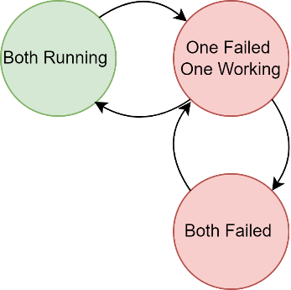
Figure 31. Markov model for the failure and repair of two components in series, one repairperson available.
$$A\left(t\right)= \frac{e^{s_{1}t}(s_{1}\left(2μ+λ\right)+s_{1}^{2}+μ^{2})}{s_{1}(s_{1}-s_{2})}+\frac{e^{s_{2}t}(s_{2}\left(2μ+λ\right)+s_{2}^{2}+μ^{2})}{s_{1}(s_{1}-s_{2})}+\frac{μ^{2}}{s_{1}s_{1}}$$ | (12)

  - System Diagram | 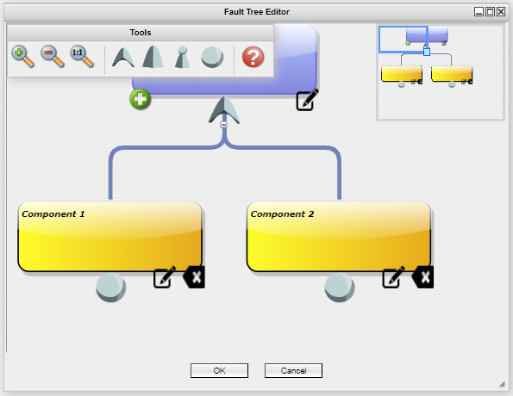  - Failure Tree
  - Component 1 |   - Component 2
Figure 32. EMRALD model for the failure and repair of two components in series, one repairperson available.

Figure 33. EMRALD model of Markov model for the failure and repair of two components in series, one repairperson available.
Table 15. Data for validating the failure and repair of two components in series, repaired one at a time.
Test Number | Failure Rate | Repair Rate/ Time | Mission Time | Number of Runs | EMRALD Unavailability/ Failure Probability | Analytical Unavailability/ Failure Probability
1 | $$\frac{1}{10 days}$$ | $$\frac{1}{ day}$$ | 1000 days | 100000 | A(t) = 1.7995$×{10}^{-1}$ | A(t) = $1.8033×{10}^{-1}$
2 | $$\frac{1}{10 days}$$ | $$\frac{1}{ day}$$ | 1000 days | 100000 | A(t) = $1.8001×{10}^{-1}$ | A(t) = $1.8033×{10}^{-1}$

Two Identical Components in Series Fail and Get Repaired, Two Repairpersons Available
The availability of two components in series that fail and can be repaired one at a time can be calculated using a Markov model as shown in Figure 34, whose availability equation is given in Equation (13) [22]. The EMRALD models for the system are given in Figure 35 and Figure 36, where the first model includes all the components and their states while the second model is the Markov model representation of the system. Table 16 gives a comparison of the analytical and EMRALD results. The results of both the first and second EMRALD models are close to the analytical unavailability as shown in Table 16, Test 1 and Test 2, respectively. The components, with a failure rate and repair time, can be modeled in SAPHIRE as shown in Figure 37. The results are compared to the corresponding EMRALD model as shown in Table 16, Test 3.

Figure 34. Markov model for the failure and repair of two components in series, one repairperson available.
$$A\left(t\right)= \frac{e^{s_{1}t}(s_{1}\left(3μ+λ\right)+s_{1}^{2}+{2μ}^{2})}{s_{1}(s_{1}-s_{2})}+\frac{e^{s_{2}t}(s_{2}\left(3μ+λ\right)+s_{2}^{2}+2μ^{2})}{s_{1}(s_{1}-s_{2})}+\frac{{2μ}^{2}}{s_{1}s_{1}}$$ | (13)

  - System Diagram |   - Failure Tree
  - Component 1 |   - Component 2
Figure 35. EMRALD model for the failure and repair of two components in series, one repairperson available.

Figure 36. EMRALD model of Markov model for the failure and repair of two components in series, one repairperson available.
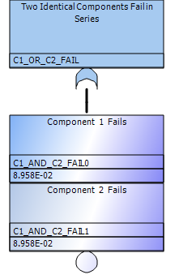
Figure 37. SAPHIRE model for the failure of two identical components in series, which can be repaired one a time.
Table 16. Data for validating the failure and repair of two components in series, repaired one at a time.
Test Number | Failure Rate | Repair Rate/Time | Mission Time | Number of Runs | EMRALD Unavailability/  Failure Probability | Analytical Unavailability/  Failure Probability
1 | $$\frac{1}{10 days}$$ | $$\frac{1}{ day}$$ | 1,000 days | 100,000 | A(t) = $1.732×{10}^{-1}$ | A(t) = $1.735×{10}^{-1}$
2 | $$\frac{1}{10 days}$$ | $$\frac{1}{ day}$$ | 1,000 days | 100,000 | A(t) = 1.735$×{10}^{-1}$ | A(t) = $1.735×{10}^{-1}$
3 | $$\frac{1}{10 days}$$ | 1 day | 1,000 days | 100,000 | P(f) = 1.622 $×{10}^{-1}$ | P(f) = 1.711 $×{10}^{-1}$

