**Introduction**

**Objectives:** Participants will become familiar with HERON and other tools within the FORCE framework. Participants will use HERON to learn about system optimization and the financial and technical implications of different component sizes within an IES system.

**Outcomes:** Participants will be able to describe the benefits of integrated energy systems.

**Report:** Participants will describe the results from running the code and answer the accompanying discussion questions.

**Acronyms:** integrated energy system (IES), net present value (NPV), Autoregressive moving average (ARMA)

**Assignment #1: Simple IES System**

1. Complete the code using the HERON user guide and the table below:

|  |  |  |  |
| --- | --- | --- | --- |
| Component | Type | Dispatch Type | Capacity |
| Natural Gas Combined Cycle (NGCC) | Producer | Independent | Optimize from 30-50 GW |
| Import | Producer | Independent | Very large (100 GW) |
| Grid | Consumer | Fixed | Based on ARMA input |

1. Run the HERON code in “opt mode”
   1. How many runs were required to find the optimal design?
   2. What is the optimal size of the NGCC?
   3. What is the NPV of the optimal system?
2. Change the code to “sweep mode.” Run the code to sweep over 5 NGCC capacities. One of these capacities should be the optimal value from step 2. Two capacities should be below the optimal value and 2 should be higher than the optimal value.
3. Using the results of step 3, graph the NGCC capacity (x-axis) vs. NPV (y-axis). Describe the shape of the graph and where the optimal NGCC capacity is located
   1. What does this show about the importance of optimization algorithms?
   2. What is a situation in which the optimal design might include a few MWh of expensive import throughout the year? (hint: think capital costs vs. variable costs)

**Assignment #2: Full IES System**

1. Complete the code using the HERON user guide and the information below.

|  |  |
| --- | --- |
| **Project Lifetime** | 3 Years |
| **Discount Rate** | 8% |
| **Tax Rate** | 30% |
| **Inflation Rate** | 6% |
| **ARMA Samples** | 25 |

|  |  |  |  |
| --- | --- | --- | --- |
| **Component** | **Capacity** | **Capital Expenditure** | **Fixed O&M** |
| Nuclear Power Plant (NPP) | 25, 50 | -$12,800,000 / MW | N/A |
| Wind Turbine (wind) | 5, 10 | -$1,300,000 / MW | -$15,000 / MW |
| Steam Turbine (turbine) | 40 | N/A | N/A |
| High Temperature Steam Electrolysis (HTSE) | 10, 15 | -$1,900,000 | -$131,333 |
| Hydrogen Storage | 0.2 | -$1,200,000 | N/A |

|  |  |
| --- | --- |
| **Component** | **Sales Price** |
| Energy Grid Market | $100 / MW |
| Hydrogen Market | $8 / Kg |

1. Run the case in “sweep” mode (Line 13: <mode>sweep</mode>).
2. When the run completes, navigate to sweep.csv.
   1. What system configuration provides the highest NPV?
   2. What system configuration provides the lowest NPV?
   3. Discuss the results. Why do you think these configurations were the best or worst?
3. Modify the code to answer the following questions. Document your modifications along with the answer.
   1. Change the capacity for each component to the optimal configuration from step 3 (keep it in sweep mode). What is the NPV for a 20-year project lifetime?
   2. Does adding a lithium battery improve the NPV over 20 years? (sweep singular capacity values for your other components for faster processing time).

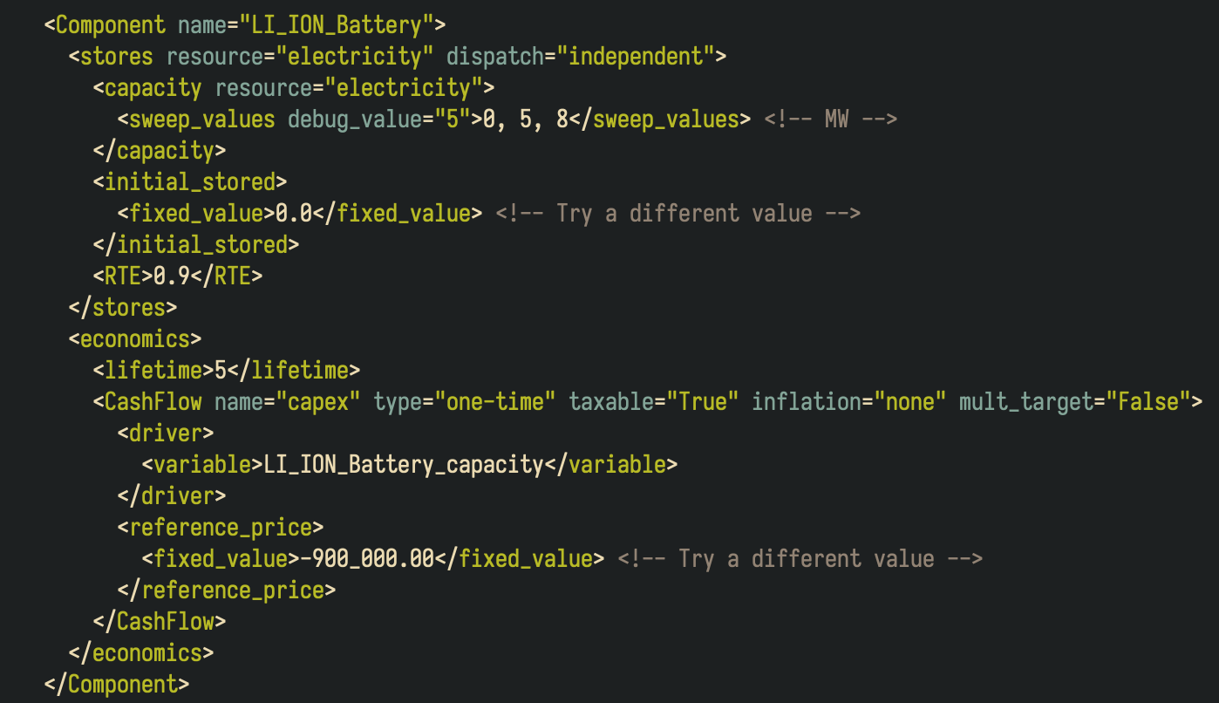

1. IF TIME ALLOWS: run the original system configuration in “opt” mode. Choose the opt bounds based on the most profitable system configuration from step 2. Note the optimal capacity for each component to maximize NPV.

**Assignment #1: Simple IES System**

Can a clean grid system meet demand using only wind?

What factors lead to the economic balance between clean, firm energy sources and clean, variable energy sources?

Why does the system configuration in Assignment 2 include so many different energy sources and components? What is beneficial about this “all of the above” solution to decarbonization?