MOUNTAIN TOP UNIVERSITY
COLLEGE OF BASIC AND APPLIED SCIENCES (CBAS)
DEPARTMENT OF COMPUTER SCIENCE AND MATHEMATICS
DESIGN AND IMPLEMENTATION OF AN AI-ASSISTED TIMETABLE SCHEDULING AND MANAGEMENT SYSTEM (A CASE STUDY OF MOUNTAIN TOP UNIVERSITY)
BY
IDAHOSA DAVID
22010301061
A PROJECT SUBMITTED TO THE DEPARTMENT OF COMPUTER SCIENCE AND MATHEMATICS, COLLEGE OF BASIC AND APPLIED SCIENCES, IN PARTIAL FULFILLMENT OF THE REQUIREMENTS FOR THE AWARD OF THE DEGREE OF BACHELOR OF SCIENCE IN COMPUTER SCIENCE
MAY, 2026

DECLARATION
I, Idahosa David, hereby declare that the project work entitled "Design and Implementation of an AI-Assisted Timetable Scheduling and Management System (A Case Study of Mountain Top University)" has been written by me and is a record of an original work done by me as a result of my research effort carried out in the Department of Computer Science and Mathematics, College of Basic and Applied Sciences, Mountain Top University, Ogun State, Nigeria under the supervision of Dr A.A. Mebawondu. All citations and sources of information are clearly acknowledged by means of reference.

……………………………..
Student's Signature

……………………………..
Date

CERTIFICATION
This is to certify that this study was carried out by Idahosa David (Matric Number: 22010301061) in the Department of Computer Science and Mathematics, College of Basic and Applied Sciences, Mountain Top University, Nigeria.

_______________________ ………………………………
Supervisor's Name Signature & Date
_______________________ ………………………………
Head of Department's Name Signature & Date
Dr A.A. Mebawondu
Department of Computer Science and Mathematics
College of Basic and Applied Sciences
Mountain Top University, Ogun State, Nigeria

DEDICATION
This work is dedicated to God Almighty, whose wisdom and grace sustained every stage of this project. It is also dedicated to my family, whose unwavering support and encouragement made this academic journey possible.

ACKNOWLEDGEMENTS
Praise and honour are first rendered to God Almighty for the strength, wisdom, and perseverance that sustained this work throughout its entirety.
Sincere gratitude is extended to my project supervisor, Dr A.A. Mebawondu, for his patient guidance, constructive criticisms, and scholarly direction throughout the course of this research. His mentorship was invaluable in shaping the quality of this work.
Appreciation is also due to the staff of the Department of Computer Science and Mathematics, College of Basic and Applied Sciences, Mountain Top University, for providing an intellectually stimulating environment throughout the period of study.
Heartfelt thanks are extended to my parents and family for their unwavering moral and financial support. To my colleagues and friends who provided feedback during the development and testing phases of the system, your contributions are deeply appreciated.

TABLE OF CONTENTS
Declaration ································································· ii
Certification ······························································ iii
Dedication ·································································· iv
Acknowledgements ····························································· v
Table of Contents ··························································· vi
List of Tables ···························································· viii
List of Figures ····························································· ix
List of Plates ······························································· x
Abbreviations ······························································· xi
List of Appendix ··························································· xii
Abstract ·································································· xiii

CHAPTER ONE: INTRODUCTION
1.0 Introduction ··························································· 1
1.1 Background to the Study ················································ 1
1.2 Statement of the Problem ··············································· 3
1.3 Aim and Objectives of the Study ········································ 5
1.4 Scope of the Study ····················································· 7
1.5 Significance of the Study ·············································· 8
1.6 Definition of Terms ···················································· 9

CHAPTER TWO: LITERATURE REVIEW/BASIC THEORY
2.0 Literature Review/Basic Theory ········································ 11
2.1 The University Timetabling Problem (UTP) ······························ 11
2.2 Authentication, API Security, and Single Sign-On ······················ 15
2.3 The Repository Pattern in Backend Architecture ························ 17
2.4 Full-Stack Web Technology Stack ······································· 19
2.5 Digital Transformation in Nigerian Higher Education ··················· 21
2.6 Review of Related Systems and Technologies ···························· 22

CHAPTER THREE: MATERIALS AND METHODS/DESIGN/METHODOLOGY
3.0 Materials and Methods/Design/Methodology ······························ 24
3.1 System Requirements ··················································· 24
3.2 System Architecture ··················································· 26
3.3 Database Design ······················································· 29
3.4 AI Scheduling Engine Design ··········································· 33
3.5 Frontend Module Design ················································ 38
3.6 Security Architecture ················································· 40
3.7 Export Services Design ················································ 43
3.8 Deployment Architecture ··············································· 45
3.9 Testing Strategy ······················································ 46

CHAPTER FOUR: RESULTS AND DISCUSSION/IMPLEMENTATION AND RESULTS
4.0 Results and Discussion ················································ 48
4.1 System Implementation Overview ········································ 48
4.2 Discussion of Findings ················································ 58

CHAPTER FIVE: CONCLUSION AND RECOMMENDATIONS
5.0 Conclusion and Recommendations ········································ 64
5.1 Conclusion ···························································· 64
5.2 Recommendations ······················································· 66

References ·································································· 70
Appendix A: Complete Database Schema (DDL) ·································· 74
Appendix B: AI Scheduling Engine Source Code (scheduler.js) ················· 78
Appendix C: User Manual and System Interface Screenshots ···················· 83

LIST OF TABLES
Table 3.1: Frontend Technology Stack ……………………………………………………… 27
Table 3.2: Database Tables and Their Purpose …………………………………… 30
Table 3.3: Deployment Infrastructure ……………………………………………… 45
Table 4.1: Hard Constraint Violation Test Results ……………………… 53

LIST OF FIGURES
Figure 3.1: High-Level System Architecture Diagram …………………………… 27
Figure 3.2: Database Entity-Relationship (ER) Diagram ……………………… 30
Figure 3.3: AI Scheduling Engine Algorithmic Flowchart …………………… 35
Figure 3.4: HMAC-Based SSO Architecture Design Diagram ………………… 41
Figure 4.1: Admin Dashboard — Entity Management Interface ………… 49
Figure 4.2: Populated Timetable Grid — AI-Generated Clash-Free Lecture Schedule ………… 50
Figure 4.3: Activity Diagram — Drag-and-Drop Manual Override Flow ………… 51
Figure 4.4: Student Portal Landing Page — Two-Step SSO Access Instructions … 54
Figure 4.5: Export Options Interface (PDF / Excel / Word) ………… 57
Figure 4.6: Audit Log Interface — Recent Action History ……………… 58

LIST OF PLATES
No photographic plates are included in this project report.

ABBREVIATIONS
AI — Artificial Intelligence
ALNS — Adaptive Large Neighborhood Search
API — Application Programming Interface
CBAS — College of Basic and Applied Sciences
CDN — Content Delivery Network
CPU — Central Processing Unit
CSC — Computer Science
CSS — Cascading Style Sheets
DDL — Data Definition Language
HMAC — Hash-based Message Authentication Code
HOD — Head of Department
HTML — HyperText Markup Language
HTTP — HyperText Transfer Protocol
HTTPS — HyperText Transfer Protocol Secure
JSON — JavaScript Object Notation
JSONB — JavaScript Object Notation Binary
JWT — JSON Web Token
LCP — Largest Contentful Paint
MTU — Mountain Top University
NP — Non-deterministic Polynomial
PDF — Portable Document Format
REST — Representational State Transfer
SA — Simulated Annealing
SQL — Structured Query Language
SQLite — Structured Query Language Lite
SSO — Single Sign-On
TTL — Time-To-Live
UTP — University Timetabling Problem
VM — Virtual Machine
xlsx — Microsoft Excel Open XML Spreadsheet

LIST OF APPENDICES
Appendix A Complete Database Schema (DDL)
Appendix B AI Scheduling Engine Source Code (scheduler.js)
Appendix C User Manual and System Interface Screenshots

ABSTRACT
Academic timetable scheduling in Nigerian universities has historically been a manual, error-prone, and resource-intensive process, commonly resulting in lecturer clashes, venue capacity violations, and inequitable distribution of lecture periods. At Mountain Top University (MTU), Ogun State, Nigeria, these inefficiencies were particularly evident, with timetable committees relying on spreadsheets and physical boards to coordinate hundreds of courses across multiple colleges. This project designed and implemented an AI-Assisted Timetable Scheduling and Management System as a full-stack web application specifically tailored to the institutional constraints of MTU. The system was developed using React 19 with Vite for the frontend and Node.js with Express 5 for the backend, with data persistence provided by a cloud-native Supabase PostgreSQL database accessed through a Repository Pattern data access layer, following a documented migration from the SQLite database used during early development. An Adaptive Large Neighborhood Search (ALNS) meta-heuristic scheduling engine was designed and implemented across three dedicated scheduling functions covering lecture, examination, and test timetables, combining a greedy constructive warm start, adaptive destroy-and-repair operators, a simulated-annealing acceptance criterion, and multi-start optimisation to enforce hard constraints including venue availability, venue capacity, lecturer availability, and departmental level conflicts, whilst optimising configurable soft constraints such as daily workload limits and preferred timeslots. The system further provides a manual drag-and-drop timetable grid for administrative overrides with server-validated conflict detection and automatic re-optimisation of affected courses, a reusable Course Catalogue module for importing course definitions without manual re-entry, and a comprehensive Audit Log recording every administrative action for accountability. A personalised Student Portal was designed and implemented, with a secure HMAC-based Single Sign-On (SSO) architecture designed for integration with the legacy MTU Student Portal; the live server-to-server SSO handshake with the existing MTU portal remains pending full deployment integration. Timetable export capabilities were implemented in PDF, Microsoft Excel, and Microsoft Word formats using in-memory binary generation. Evaluation demonstrated that the scheduling engine produced clash-free output across all categories of hard constraints, the student portal frontend and backend SSO endpoints function correctly in isolation, and all three export formats produce valid downloadable documents. The system presents a cost-effective, institution-specific alternative to commercial timetabling software, with the remaining SSO live integration identified as immediate future work.
Keywords: Timetable scheduling, adaptive large neighborhood search, single sign-on, repository pattern, audit logging.
CHAPTER ONE
1.0 INTRODUCTION
1.1 Background to the Study
The organisation of academic activities in any tertiary institution rests, to a considerable degree, on the quality and reliability of its timetabling system. An academic timetable functions as the structural backbone of a university semester, coordinating the allocation of courses, lecturers, venues, and timeslots within a finite set of resources. When this coordination fails, the ripple effects are significant: students miss lectures due to conflicting class times, lecturers are inadvertently booked into simultaneous sessions, and venues designed to hold fifty students are assigned to cohorts of two hundred. These are not merely administrative oversights — they directly undermine the educational experience and institutional credibility.
Mountain Top University (MTU), a private Christian institution located in Ogun State, Nigeria, is no exception to these challenges. Founded under the auspices of the Mountain of Fire and Miracles Ministries (MFM) and led by the Chancellor, Dr Daniel Kolawole Olukoya, the university has grown substantially since its establishment, now spanning multiple colleges, including the College of Basic and Applied Sciences (CBAS), the College of Humanities, Management and Social Sciences (CHMS), and the College of Allied Health Sciences (CAHS). The university's Vice-Chancellor, Professor Elijah Adebowale Ayolabi, has consistently emphasised academic excellence as a cornerstone of institutional identity. Against this backdrop, the continued reliance on manual timetabling methods presents a significant operational contradiction.
The proliferation of computing technology and its application to complex combinatorial problems has provided viable pathways for automating and optimising timetable scheduling. The University Timetabling Problem (UTP) is formally recognised in computer science literature as an NP-hard combinatorial optimisation problem (Abdipoor et al., 2023; Ceschia et al., 2023), meaning that the number of possible schedule permutations grows exponentially with the number of courses, venues, and time slots available. For a university such as MTU, where hundreds of courses must be distributed across dozens of venues in a limited five-day academic week, the combinatorial complexity is formidable.
Globally, automated timetabling systems have been explored through a variety of algorithmic paradigms, including meta-heuristics such as Genetic Algorithms (GAs) and Simulated Annealing (SA), graph colouring approaches, and constructive heuristics with backtracking (Ceschia et al., 2023). Omoregbee et al. (2022) documented the persistent scheduling conflicts and resource mismanagement that characterise manual timetabling in Nigerian polytechnic and university contexts, findings that closely mirror the situation at MTU. Commercial solutions such as ASC Timetables and Syllabus Plus have found adoption in well-resourced institutions, particularly in Europe and North America. However, these tools carry subscription-based licensing costs that are prohibitive for many Nigerian universities and, more critically, are not designed to accommodate the specific structural, cultural, and infrastructural constraints of a university such as MTU. The absence of integration capabilities with MTU's bespoke student portal further compounds the inadequacy of off-the-shelf solutions.
The COVID-19 pandemic and its aftermath accelerated the global shift towards digital academic management, with institutions compelled to adopt web-based platforms for scheduling, communication, and administration (Afolayan & Afolayan, 2022). This shift created both the necessity and the institutional appetite for purpose-built digital tools in Nigerian universities. The MTU AI-Assisted Timetable Scheduling and Management System was conceived within this context — as a full-stack web application engineered to address the specific timetabling constraints of MTU, integrating with its existing digital infrastructure and providing both automated and manual scheduling capabilities.
The system leverages an Adaptive Large Neighborhood Search (ALNS) meta-heuristic implemented across three dedicated scheduling functions — for lectures, examinations, and tests respectively — running within a Node.js environment, a technology choice informed by its non-blocking I/O model and the broad ecosystem of libraries available for server-side computation and document generation. The React 19 frontend provides an intuitive drag-and-drop grid interface for administrators, a reusable Course Catalogue for importing course definitions across timetables, and a comprehensive Audit Log recording every administrative action for accountability and traceability. The Student Portal module incorporates a fully designed and backend-implemented Hash-based Message Authentication Code (HMAC) Single Sign-On (SSO) architecture for integration with the existing MTU Student Portal — with the live server-to-server integration pending completion as a near-term deployment step.
1.2 Statement of the Problem
Prior to the implementation of the system described in this report, timetable generation at Mountain Top University was conducted manually by timetable committees within each department and college. This approach was characterised by several persistent and well-documented shortcomings that directly compromised the academic experience of students and the professional workflows of lecturers.
The first and most consequential problem was the frequency of scheduling clashes. In manual systems, tracking the simultaneous commitments of dozens of lecturers across multiple departments was achieved primarily through spreadsheet cross-referencing. This method is inherently susceptible to human error, particularly as the number of courses and lecturers increases. Cases where a single lecturer was assigned to two different classes at the same time were not isolated incidents but recurrent occurrences reported at the start of each academic semester.
The second problem was systematic venue capacity mismanagement. Physical classrooms and laboratories at MTU carry defined seating capacities. A manual timetabling process that fails to incorporate a structured capacity-matching algorithm risks assigning large student cohorts to undersized venues, creating health and safety concerns and disrupting the learning environment. The absence of an automated capacity check mechanism meant that such mismatches were only identified — and corrected — after the timetable had been distributed to students, resulting in costly revisions.
The third problem related to student accessibility. Upon completion, master timetables were typically distributed to students as static multi-page PDF grids shared via WhatsApp or email. Students were required to manually extract their individual course schedules from documents that contained the timetables of all departments and levels simultaneously. This process was not only time-consuming but also a source of confusion, particularly for students taking elective courses offered by departments other than their own.
The fourth problem concerned the rigidity of post-publication modifications. In the event that a lecturer needed to reschedule a class — due to illness, an academic conference, or other exigencies — the cascading effect on the rest of the timetable was too complex to recalculate manually within a short timeframe. In practice, such changes were communicated informally through class representatives or messaging groups, leading to inconsistent information and missed classes.
The fifth problem was the absence of institutional data capture and accountability. Because timetable data existed only in static document formats, it was impossible to perform analytical queries over scheduling patterns, identify chronically under-utilised venues, or audit the historical distribution of courses across timeslots. Furthermore, there was no mechanism for tracking who made which change to a timetable and when, making it difficult to resolve disputes or trace the origin of scheduling errors.
The sixth problem was redundant administrative effort in course data entry. Each time a new timetable was created, course details — codes, titles, unit counts, lecturer assignments — had to be re-entered from scratch, even where the same courses had been scheduled in previous semesters. This repetitive data entry consumed significant administrative time and introduced opportunities for transcription error.
These problems collectively represent a systemic failure in academic resource management that a well-designed, automated scheduling system is positioned to address. The present research, therefore, responds to the following specific problem statement: the lack of a purpose-built, constraint-aware, auditable, and student-accessible digital timetabling system at Mountain Top University results in recurring scheduling conflicts, inequitable resource allocation, redundant administrative effort, and degraded academic service delivery.
1.3 Aim and Objectives of the Study
The aim of this project is to design and implement an AI-Assisted Timetable Scheduling and Management System tailored to the operational requirements of Mountain Top University, capable of automatically generating clash-free academic timetables whilst providing interactive manual override capabilities, reusable course data management, comprehensive administrative accountability, and personalised student-facing schedule access.
The following specific objectives were pursued in fulfilment of this aim:
1. To design and implement a centralised, web-based entity management system for academic data, including Colleges, Departments, Venues, Lecturers, and Courses.
2. To develop an AI-assisted scheduling engine based on the Adaptive Large Neighborhood Search (ALNS) meta-heuristic, implemented as three dedicated scheduling functions, capable of automatically generating clash-free lecture, examination, and test timetables in compliance with both hard and configurable soft constraints.
3. To construct a manual drag-and-drop timetable grid interface that enables administrative overrides of the AI-generated schedule, with real-time visual conflict detection.
4. To design and implement a secure Student Portal with an HMAC-based Single Sign-On (SSO) architecture for integration with the existing MTU Student Portal, providing each student with a personalised view of their academic timetable upon completion of the live portal integration.
5. To build robust timetable export functionality, enabling both administrators and students to dynamically generate and download personalised timetables in PDF, Microsoft Excel (.xlsx), and Microsoft Word (.docx) formats directly from the browser.
6. To implement a flexible Repository Pattern on the backend server, decoupling application logic from the database provider through a dedicated adapter layer, demonstrated by the system’s migration from a local SQLite development database to a cloud-hosted Supabase PostgreSQL database and by a student data source switchable between the local database and the live MTU portal API via a single environment variable.
7. To implement a Course Catalogue module enabling a master library of reusable course definitions that can be imported into any timetable without manual re-entry.
8. To implement a comprehensive Audit Log system that records every administrative action — creation, update, deletion, and schedule generation — to ensure accountability and provide a traceable history of timetable changes.
1.4 Scope of the Study
The scope of this project is defined by its institutional context, functional boundaries, and technical parameters. The system was developed explicitly for Mountain Top University and its scheduling requirements; whilst its architectural design is sufficiently modular to be adapted by other institutions, no such adaptation is claimed within the present study.
Functionally, the system encompasses the scheduling of three categories of academic events: lectures, examinations, and tests, each handled by a dedicated scheduling function within the AI engine. The lecture and test schedulers operate across a standard five-day academic week (Monday to Friday) using hourly timeslots configurable between 9:00 and 18:00, whilst the examination scheduler operates using three discrete daily blocks — Morning, Afternoon, and Evening — matching the block format conventionally used in Nigerian university examination timetables. The system supports the configuration of scheduling parameters through an administrative interface, allowing institutional customisation without requiring source code modification.
The system covers hard constraints including venue availability, venue capacity, lecturer availability, and departmental level conflicts, with deliberate accommodation for joint classes sharing a designated session key. Configurable soft constraints include maximum daily workload hours per academic level and lecturer- or course-specified preferred days and timeslots. Constraint handling beyond these categories, such as student travel time between venues or religious observance scheduling restrictions, is acknowledged as future work and is outside the current scope.
The Course Catalogue module is scoped to provide a reusable repository of course definitions that may be imported into any timetable, eliminating repeated manual data entry; it does not extend to automated curriculum planning or accreditation tracking. The Audit Log module is scoped to record all create, update, delete, and schedule-generation actions performed through the administrative interface, providing a chronological, immutable record; it does not extend to user-level session analytics or behavioural reporting.
The Student Portal component is scoped to provide read-only, personalised timetable access. Students may view and export their schedules but may not modify them through the portal. All schedule modifications are reserved for authorised administrative users. The system does not replace the primary MTU Student Portal but is designed to operate alongside it as an integrated supplementary service. The live server-to-server SSO handshake between the timetabling system and the MTU portal is identified as pending deployment integration; the backend SSO endpoints and the student portal frontend are fully implemented and functional in isolation.
Technically, the system assumes deployment on a server with Node.js 18 or higher and access to a Supabase PostgreSQL project. The frontend assumes access to a modern web browser with JavaScript enabled. Native mobile application support is outside the current scope but has been recommended for future development.
1.5 Significance of the Study
This project carries both practical and academic significance. From a practical standpoint, its most immediate impact is the elimination of the manual, error-prone timetabling process that has historically been a source of operational friction at Mountain Top University. By automating constraint checking and schedule generation, the system substantially reduces the administrative burden placed on timetabling committees, freeing academic staff to focus on pedagogical responsibilities rather than logistical coordination.
The introduction of the Course Catalogue module addresses a specific and recurring inefficiency in MTU's prior workflow: the repeated manual re-entry of course data for every new timetable. By maintaining a master library of reusable course definitions, the system allows administrators to import previously defined courses directly into new timetables, substantially reducing data entry time and the associated risk of transcription error each semester.
The Audit Log module introduces a level of administrative accountability that was entirely absent from the prior manual process. Every creation, modification, deletion, and schedule-generation action is now recorded with a timestamp and contextual detail, providing a traceable history that supports dispute resolution, error diagnosis, and institutional record-keeping — a capability with no precedent in MTU's previous spreadsheet-based approach.
The design and implementation of a student-facing portal with personalised timetable views represents a qualitative improvement in academic service delivery. Upon completion of the live SSO integration with the MTU portal, students will no longer be required to extract their individual schedules from dense, institution-wide documents. Instead, each student will receive a clean, filtered view of their specific courses, with export capabilities that allow them to retain a digital or printed copy. This directly addresses a documented source of confusion and missed lectures within the MTU student population.
The system also demonstrates the technical and economic feasibility of building institution-specific academic management tools using modern open-source technologies. By foregoing expensive commercial software licences in favour of a custom-built solution, the university retains full ownership of both the software and its data, with no recurring subscription costs. This has particular resonance in the Nigerian higher education context, where institutional technology budgets are often constrained.
From an academic perspective, the project makes a methodological contribution by demonstrating the application of the Adaptive Large Neighborhood Search meta-heuristic across multiple event types within a production-grade Node.js environment, with a particular focus on in-memory destroy-and-repair optimisation without database round-trips. The Repository Pattern implementation, which decouples application logic from the database provider and supported the system’s migration from SQLite to Supabase PostgreSQL, provides a reproducible template for database-agnostic backend architecture in educational technology applications.
The project further contributes to the growing body of Nigerian higher education technology research, offering a documented case study of a purpose-built, AI-assisted scheduling system tailored to the institutional realities of a private Nigerian university. In doing so, it fills a gap in the literature, which has tended to focus on European or Asian university timetabling contexts (Ceschia et al., 2023; Abdipoor et al., 2023).
1.6 Definition of Terms
The following terms are used consistently throughout this report and are defined as follows for clarity:
Timetable Scheduling
The process of assigning academic events (courses, examinations, or tests) to specific timeslots, venues, and lecturers within the constraints of an academic calendar.
Hard Constraint
A scheduling rule that must not be violated under any circumstance. Examples include the prohibition of assigning two events to the same venue at the same time, or assigning a lecturer to two simultaneous courses.
Soft Constraint
A scheduling preference that should be honoured where possible, but whose violation does not invalidate the schedule. Examples include respecting preferred lecture timeslots and limiting daily lecture hours for a given student cohort.
Heuristic Algorithm
A problem-solving method that employs practical, often empirically derived rules to produce a satisfactory solution within a reasonable computational time, without guaranteeing optimality.
Adaptive Large Neighborhood Search (ALNS)
A meta-heuristic optimisation framework in which portions of a candidate solution are repeatedly removed by competing destroy operators and reinserted by competing repair operators, with operator selection probabilities adapted according to past performance, enabling efficient exploration of large combinatorial solution spaces.
Shared Session Key
A designated identifier assigned to two or more course records that are deliberately permitted to occupy the same venue and timeslot, enabling joint or combined lectures across departments without triggering a false conflict.
Course Catalogue
A master repository of reusable course definitions maintained independently of any specific timetable, from which course records may be imported into new timetables without manual re-entry.
Audit Log
An immutable, chronologically ordered record of administrative actions — including creation, modification, deletion, and schedule generation — maintained for accountability and traceability purposes.
Repository Pattern
A software design pattern that abstracts the data access layer, enabling the application logic to interact with an interface rather than a specific database implementation, thereby facilitating database provider substitution (Jabeen Ali, 2022).
Single Sign-On (SSO)
An authentication mechanism that permits a user to log in once to a primary system and gain access to secondary, integrated systems without re-entering credentials (Dalimunthe et al., 2023).
HMAC (Hash-based Message Authentication Code)
A cryptographic mechanism that uses a shared secret key and a hash function to verify both the integrity and authenticity of a message transmitted between two parties (Dalimunthe et al., 2023).
JSONB
A binary data type in PostgreSQL that stores JSON data in a decomposed binary format, enabling efficient indexing and querying of JSON documents within relational database tables.
Supabase
An open-source backend-as-a-service platform that provides a PostgreSQL database with a REST API, real-time capabilities, and authentication services.
Vite
A modern JavaScript build tool and development server that leverages native ES module support in the browser to provide fast hot module replacement during development and optimised production builds.
Constraint Satisfaction Problem (CSP)
A mathematical problem in which a solution must be found by assigning values to variables such that all specified constraints are satisfied simultaneously (Abdipoor et al., 2023).
CHAPTER TWO
2.0 LITERATURE REVIEW/BASIC THEORY
Four themes anchor this chapter’s review of the literature underpinning the AI-Assisted Timetable Scheduling and Management System built for Mountain Top University: the University Timetabling Problem (UTP) and the algorithms used to solve it; the security architecture behind Single Sign-On (SSO), token-based authentication, and API protection; the Repository Pattern as a strategy for database-agnostic backend design; and the full-stack technology choices that shape the system’s frontend and backend. Scholarship from 2021 onward is drawn on throughout, with each strand of the review tied back to the specific requirements and constraints the present system had to satisfy.
2.1 The University Timetabling Problem (UTP)
Few combinatorial optimisation problems in computer science and operations research have attracted as much sustained study as the University Timetabling Problem (UTP). Stripped to its essentials, the task is to assign a set of academic events — courses, examinations, or practical sessions — to a finite pool of timeslots and venues while satisfying a battery of institutional constraints (Abdipoor et al., 2023). What makes this hard is scale: as the number of events, venues, and available timeslots grows, the solution space expands exponentially, a property that formally places the UTP in the Non-deterministic Polynomial-time hard (NP-hard) class (Ceschia et al., 2023). No polynomial-time algorithm is known to guarantee an optimal solution for every instance of an NP-hard problem, so for a dataset the size of a university’s, exact solution methods are simply not computationally viable.
A comprehensive survey by Ceschia, Di Gaspero, and Schaerf (2023) in the European Journal of Operational Research maps out six canonical formulations of the Educational Timetabling Problem and benchmarks state-of-the-art solution techniques against each. Central to their framework is the distinction between hard constraints, non-negotiable restrictions whose violation renders a timetable infeasible, and soft constraints, optimisation preferences whose violation degrades quality without invalidating the result. Applied to MTU, the hard constraints are venue availability, venue capacity, lecturer availability, and departmental level conflicts, while the soft constraints cover daily workload caps and preferred course timeslots.
Algorithmic approaches to the UTP are well documented and varied. In a systematic review of meta-heuristics applied to the University Course Timetabling Problem (UCTP), Abdipoor et al. (2023) identify Simulated Annealing (SA), Tabu Search (TS), Genetic Algorithms (GAs), and Ant Colony Optimisation (ACO) as the dominant paradigms. Genetic Algorithms perform strongly on benchmark datasets from the International Timetabling Competition (ITC), but managing large populations and repeatedly evaluating fitness carries a computational overhead that can be prohibitive in time-sensitive web deployments (Ceschia et al., 2023). Weighing these trade-offs led to a different choice for the MTU scheduling engine: Adaptive Large Neighborhood Search (ALNS), a meta-heuristic that puts its computational effort into iteratively destroying and repairing targeted portions of a single evolving solution rather than maintaining a large population, paired with a simulated-annealing acceptance criterion to escape local optima.
Constructive heuristics take a different route: they build a feasible timetable incrementally, placing one event at a time into a valid slot according to a locally optimal criterion. A constructive greedy heuristic plays this role in the present system, serving as the warm start for the ALNS engine. Courses are sorted in descending order of compulsory status and credit unit count before placement begins, a Most Constrained Variable strategy that lets the heaviest courses claim the best available slots first (Abdipoor et al., 2023). From that starting point, the ALNS phase repeatedly strips out a structured subset of the assignment using competing destroy operators (random, lecturer-based, level-based, conflict-targeted, and day-based removal), then reinserts the removed courses through competing repair operators (greedy best-slot insertion, regret-2 insertion, and randomised insertion). Operator selection weights are adapted over time according to each operator’s recent contribution to solution improvement.
Empirical precedent for this design approach comes from the web-based timetabling literature. Documenting a system built for a Nigerian polytechnic, Omoregbee et al. (2022) find that lecturer double-booking and venue capacity mismatches are the most frequent causes of manual timetabling failure. Using the Rapid Application Development (RAD) model, Techie-Menson and Nyagorme (2021) design a web-based timetable system for higher education institutions and stress the importance of automated constraint enforcement and multi-user accessibility. More recently, Abubakar et al. (2026) describe a web-based lecture timetable scheduling system for a Nigerian university that pairs automated scheduling with a publicly accessible web interface, evidence that this architectural approach works in the Nigerian higher education context. What the present project adds to these precedents is automated constraint satisfaction across three event types — lectures, examinations, and tests, each handled by its own scheduling function — together with HMAC-based SSO student authentication and multi-format export.
2.2 Authentication, API Security, and Single Sign-On
Integrating the MTU Timetable Scheduler with the university’s existing student portal brings a set of authentication and API security challenges typical of distributed higher education information systems. One framework for addressing this is Single Sign-On (SSO), where a user authenticates once with a primary identity provider and is then admitted to multiple connected service providers without re-entering credentials (Dalimunthe et al., 2023). Consolidating authentication behind a single hardened identity provider shrinks the attack surface and removes the credential-reuse risks that come with maintaining separate accounts across institutional systems.
JSON Web Tokens (JWTs) encode user identity claims into a self-contained, cryptographically signed package, letting the receiving service verify authenticity and integrity without contacting the issuing server (Dalimunthe et al., 2023). This is the token model the present system uses at the student authentication exchange, issuing compact HMAC-SHA256-signed session tokens that carry the student’s matric number, issue time, and expiry. Signature verification under HMAC requires possession of the shared secret key, which is why Dalimunthe, Hasri Putra, and Fadhly Ridha (2023) regard HMAC-based token signing as robust protection against forgery and tampering. HMAC-SHA256 does double duty in the present system: it signs session tokens, and, paired with a timing-safe shared-secret comparison, it authenticates server-to-server portal requests — a well-established trade-off between cryptographic strength and computational efficiency.
Ojha (2024) situates this within the broader landscape of RESTful API security, surveying authentication and authorisation frameworks such as OAuth2 and OpenID Connect, encryption strategies for data in transit, and the role of rate limiting and request throttling in preventing API abuse. Rate limiting in the present system operates at two tiers, a general limiter across all API routes and a stricter one on student authentication endpoints specifically, putting into practice the defence-in-depth principle Ojha (2024) recommends for guarding authentication flows against brute-force and enumeration attacks. The principle of least privilege shows up again in the administrative API key mechanism: every admin route sits behind a static key sent in a custom HTTP header and checked with a timing-safe comparison, so that each authentication channel reaches only the functional scope its user category needs, with administrative and student channels kept entirely separate.
A performance and scalability evaluation by Blinowski, Ojdowska, and Przybyłek (2022) in IEEE Access finds empirically that decoupled client-server architectures, where frontend and backend are independently deployable services talking through REST APIs, scale better under concurrent user load than monolithic server-rendered applications. That finding is the reason the present system separates its React frontend from its Node.js backend, letting each be scaled, updated, and maintained on its own.
2.3 The Repository Pattern in Backend Architecture
One engineering problem sat at the centre of the MTU Timetable Scheduler’s development: how to support two distinct database environments without touching the application’s business logic. The Repository Pattern solves this by mediating between the domain model and the data mapping layer, so that from the business logic’s perspective the data looks like an in-memory collection of domain objects (Jabeen Ali, 2022). All data access operations are encapsulated inside repository classes implementing a common interface, which means the application always talks to data through the same stable contract, whatever storage technology sits underneath.
Writing in the International Scholarly Journal of Engineering and Management (ISJEM), Jabeen Ali (2022) shows that the Repository Pattern isolates data persistence concerns from business logic, resulting in systems that are more modular and easier to test. That decoupling matters most, the author notes, in institutional web applications such as academic management systems, where the database infrastructure underneath is likely to change as organisational needs evolve. In the MTU timetabling backend, this takes the concrete form of a repository layer with eight modules, covering administrative entities, courses, timetables, students, custom fields, timetable-course associations, the audit log, and the course catalogue, each exposing a stable set of functions that encapsulates the Supabase data access logic. The students repository goes one step further and is provider-switchable: an environment variable, set at application startup, chooses between the database-backed implementation and one that pulls student records live from the MTU portal API, with no source code changes required either way.
Testability is where the Repository Pattern pays off most from a software quality standpoint: each adapter can be swapped for a mock implementation during unit testing. This separation of concerns is essentially the Dependency Inversion Principle from SOLID software engineering in practice, whereby high-level modules depend on abstractions rather than concrete implementations (Jabeen Ali, 2022). Choosing SQLite for early development and Supabase PostgreSQL for production was a deliberate trade-off rather than a default. As a serverless, file-based embedded database engine that needs no separate database process, SQLite allows fully offline development with no cloud account dependency; Wu, Luo, and Liu (2023), presenting at the SPIE International Conference on Advanced Electronic Materials, Computers, and Software Engineering, document exactly this advantage, confirming SQLite’s suitability wherever simplicity, zero configuration, and portability matter more than horizontal scalability. Supabase PostgreSQL offers what SQLite does not: native JSONB support, row-level security, and the REST API layer the production deployment needed. Because the Repository Pattern kept the interface contract stable, the system’s data layer could migrate from SQLite to Supabase through a documented, scripted process without any change to business logic.
One design choice deserves closer attention: storing timetable data as JSONB columns in the Supabase PostgreSQL instance. JSONB is PostgreSQL’s native binary JSON type, storing documents in a decomposed binary format that supports efficient indexing and querying of semi-structured data inside a relational table. At the ACM SIGMOD International Conference on Management of Data, Durner, Leis, and Neumann (2021) show that relational databases with specialised JSON storage and access mechanisms can run analytics on semi-structured JSON data at performance levels close to columnar storage, while keeping the schema flexibility and transactional guarantees relational systems are known for. That finding is what underlies the decision here to store each complete timetable document as a single JSONB column rather than breaking it apart into normalised relational rows.
2.4 Full-Stack Web Technology Stack
2.4.1 Frontend: React and Single-Page Applications
As a component-based JavaScript library for building user interfaces, React.js is currently the most widely adopted frontend framework in the industry (Tong et al., 2023). A Single-Page Application (SPA) built with React loads all necessary code up front and then updates the DOM dynamically as the user interacts with it and as API calls resolve, doing away with full page reloads. Jonathan and Suprihadi (2023) build a full academic management web application on a React SPA architecture and find that component reusability and unidirectional data flow cut development time substantially while keeping the interface consistent across a complex, multi-module system. In a comparative study at the IEEE ICE3IS 2023 conference, Tong, Jikson, and Gunawan (2023) benchmark the browser performance, speed index, and interactive time of React.js, Vue.js, and Next.js, and find React’s DOM operation efficiency competitive for content-heavy dynamic interfaces of exactly the kind used here: the timetable grid, audit log, and entity management modules.
2.4.2 Backend: Node.js and RESTful API Architecture
Node.js is a server-side JavaScript runtime built around an event-driven, non-blocking I/O architecture, which suits it well to applications that need to handle high concurrency (Miłosierny & Dzieńkowski, 2021). Comparing Express, Hapi, and Koa under concurrent HTTP request loads, Miłosierny and Dzieńkowski (2021) in the Journal of Computer Sciences Institute find that Express.js holds consistently competitive response times across all REST operation types, and that its minimalist architecture leaves more room for custom middleware than its alternatives allow. A companion study in the same journal by Grudniak and Dzieńkowski (2021) confirms that REST APIs built on Express.js deliver adequate throughput for typical academic management system workloads.
The present system’s deployment architecture, a React frontend served from a content delivery network alongside a Node.js backend on a persistent virtual machine, tracks the broader distinction between stateless and stateful workloads in cloud deployment. Serverless platforms scale elastically, but Yang et al. (2024), comparing serverless cloud platforms in Future Internet, show that their execution timeout constraints make them a poor fit for CPU-bound, long-running computations. Benedetti, Femminella, Reali, and Steenhaut (2021), in an experimental analysis in Sensors, add that persistent VM deployments hold consistently lower latency for sustained workloads than FaaS serverless platforms do. Together these findings are why the scheduling engine here runs on a persistent virtual machine rather than a serverless function platform.
Moving from Express 4 to Express 5 brought a further benefit: native async/await support in route handlers, which makes for cleaner, more readable API route code. Testing of the REST API endpoints follows a smoke testing methodology, exercising critical endpoints with representative inputs to check that core functionality holds up. In the first systematic literature review of RESTful API testing methodologies, published in Applied Sciences, Ehsan, Abuhaliqa, Catal, and Mishra (2022) identify smoke testing as an essential baseline verification strategy and note that correct HTTP status codes, expected response schemas, and proper error handling are a prerequisite for any higher-level integration or performance testing — the same principle behind the parity probe suite described in Section 3.9.
2.5 Digital Transformation in Nigerian Higher Education
A broader national shift toward digital transformation in Nigerian higher education forms the backdrop for the MTU timetabling system. In a quantitative study of 1,134 students published in E-Learning and Digital Media, Egielewa, Idogho, Iyalomhe, and Cirella (2022) document how far digital educational tools spread across Nigerian universities in the wake of the COVID-19 pandemic, and their findings point to the importance of mobile-responsive interfaces that work efficiently over constrained networks, which is precisely what the Vite-optimised, mobile-responsive React frontend here is built to provide. Afolayan and Afolayan (2022) look at the institutional impact of student information systems in Nigeria and find that web-based academic management systems bring measurable gains in administrative efficiency and student satisfaction, singling out timetable accessibility as a specific pain point in Nigerian university digital services.
2.6 Review of Related Systems and Technologies
Commercial timetabling platforms like ASC Timetables and Syllabus Plus bring sophisticated multi-objective optimisation engines to the table, but their annual licensing fees are prohibitive, and neither is built to accommodate Nigerian university structures such as MTU’s college-department-level hierarchy and compulsory-course priority system. Open-source alternatives such as UniTime and FET offer capable constraint satisfaction engines instead, but as desktop-oriented applications requiring technical expertise to install, they are a poor fit where administrative users lack specialised IT skills. None of these established platforms, crucially, offers an integrated audit logging facility or a reusable course catalogue mechanism of the kind built into the present system.
Techie-Menson and Nyagorme (2021) build a web-based timetable system for higher education institutions around a computer-assisted generator that cuts down manual scheduling effort, confirming that web-based approaches have practical value for institutional scheduling. Omoregbee et al. (2022) take a different tack with a Nigerian polytechnic implementation that detects conflicts after the fact, and Abubakar et al. (2026) push further still with automated scheduling for a Nigerian university. What none of these three precedents include, and what the present project adds, is HMAC-based SSO integration for student portal access, in-memory multi-format document export, a reusable course catalogue, and a comprehensive audit log — a combination not documented in any prior Nigerian university timetabling system covered in this review.
CHAPTER THREE
3.0 MATERIALS AND METHODS/DESIGN/METHODOLOGY
This chapter provides a comprehensive account of the materials, tools, design decisions, and implementation methodology employed in the development of the AI-Assisted Timetable Scheduling and Management System for Mountain Top University. The chapter is organised to mirror the logical sequence of the development process, beginning with a statement of system requirements, proceeding through the high-level architectural design and database schema, and culminating in the detailed design of the AI scheduling engine, the security architecture, the export services, and the deployment infrastructure. Structural placeholders are provided at all points where system screenshots and diagrams are to be inserted by the author prior to final submission.
3.1 System Requirements
3.1.1 Functional Requirements
The following functional requirements were identified through an analysis of the timetabling challenges documented at Mountain Top University and the eight research objectives stated in Chapter One:
FR1 — The system shall provide a centralised web-based interface for the management of academic entities, including Colleges, Departments, Venues, Lecturers, and Courses.
FR2 — The system shall provide an AI-driven scheduling engine, implemented as three dedicated scheduling functions, capable of automatically generating clash-free lecture, examination, and test timetables for an entire university semester, enforcing all defined hard constraints.
FR3 — The system shall provide an administrative drag-and-drop timetable grid interface that enables manual overrides of the AI-generated schedule, with real-time visual conflict detection.
FR4 — The system shall provide a Student Portal that authenticates students via HMAC-based Single Sign-On integration with the existing MTU Student Portal, requiring no separate account registration.
FR5 — The system shall enable both administrators and students to export timetables in PDF, Microsoft Excel (.xlsx), and Microsoft Word (.docx) formats, generated dynamically in-memory.
FR6 — The system shall implement all data access through a Repository Pattern adapter layer, such that the database provider and the student data source can be changed without modifying application business logic.
FR7 — The system shall provide a Course Catalogue module enabling a master library of reusable course definitions that may be imported into any timetable without manual re-entry.
FR8 — The system shall record every administrative create, update, delete, and schedule-generation action in a comprehensive, immutable Audit Log, accessible through a searchable interface.
3.1.2 Non-Functional Requirements
The following non-functional requirements governed key architectural and technology choices:
NFR1 — Performance: The AI scheduling engine shall complete timetable generation for a dataset of up to 150 courses within a user-acceptable timeframe, without persistent disk writes during the computation phase.
NFR2 — Security: All administrative API endpoints shall be protected by API key authentication verified through a timing-safe comparison. All student portal authentication shall be secured using HMAC-signed tokens, and authentication endpoints shall be protected by a stricter rate limit than general API routes.
NFR3 — Portability: The backend data access layer shall be implemented using the Repository Pattern, enabling database provider substitution without modifying business logic.
NFR4 — Accessibility: The Student Portal shall be responsive and functional on modern mobile web browsers, with a compact, Vite-optimised production bundle to minimise initial page load time on constrained networks.
NFR5 — Maintainability: The system shall follow a modular component architecture on the frontend and a clear separation of concerns between route handlers, repository adapters, and the scheduling engine on the backend.
NFR6 — Accountability: Every administrative action affecting persisted data shall be logged with sufficient detail to reconstruct the sequence of changes applied to any given entity.
3.2 System Architecture
The MTU Timetable Scheduling and Management System adopts a decoupled client-server architecture in which the frontend and backend are independently deployable units that communicate exclusively through a RESTful JSON API over HTTPS. This architectural style was chosen in preference to a monolithic server-rendered application for three principal reasons: it enables the frontend to be deployed on a globally distributed CDN (Vercel) whilst the backend is hosted on a persistent web service (Render) suited to long-running CPU-bound operations; it allows the administrative dashboard and the student portal to be served as a single-page application with client-side routing, eliminating full page reloads between views; and it provides a clean API contract that could, in future, be consumed by a native mobile application or third-party integration without modifications to the backend.
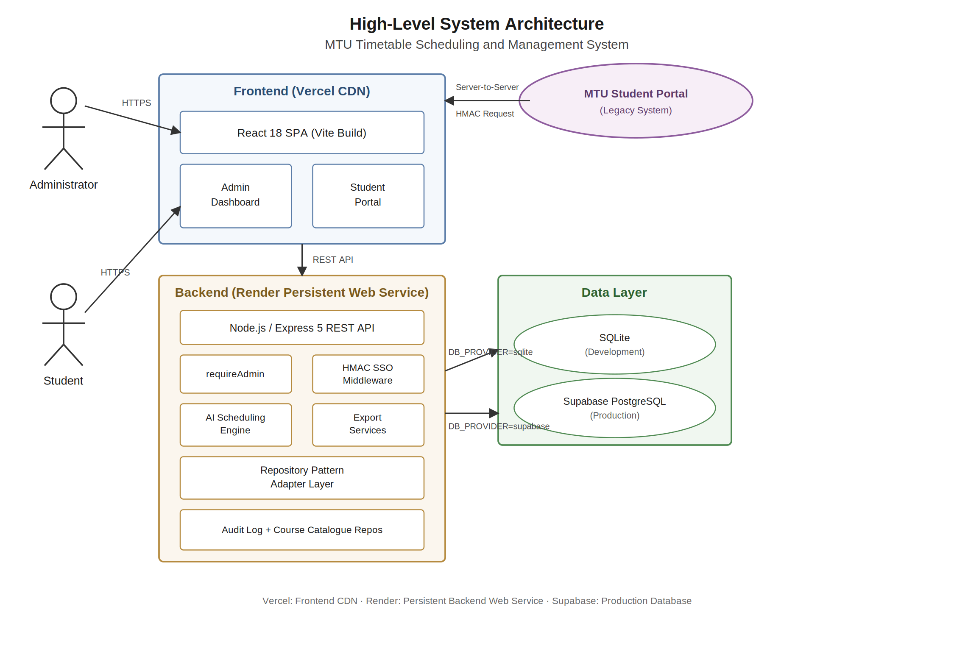
Figure 3.1: High-Level System Architecture of the MTU Timetable Scheduling and Management System
Figure 3.1 illustrates the high-level architecture of the system. The React 19 frontend, hosted on Vercel, communicates with the Node.js/Express 5 backend, hosted on Render, through authenticated REST API calls. The backend exposes two categories of API routes: administrative routes protected by API key middleware, and student portal routes protected by HMAC-verified token middleware. All timetable, audit log, and course catalogue data is persisted in a Supabase PostgreSQL instance, accessed through the Repository Pattern adapter layer.
3.2.1 Frontend Architecture
The frontend is a single-page application built with React 19 and bundled with Vite. React Router v7 governs client-side navigation between views. Shared state — including administrative authentication status and application-level notifications — is managed using a lightweight custom subscription mechanism built on React hooks and component-level state, avoiding the overhead of a third-party state management library for a dataset of this scale. Styling is achieved through a combination of TailwindCSS utility classes and custom vanilla CSS modules, providing rapid layout composition whilst retaining fine-grained control over component-level aesthetics.
The production build is generated by Vite, which applies tree-shaking, asset hashing, and minification to produce a compact bundle. The administrative dashboard and the student portal are served from the same single-page application, with client-side routing ensuring that navigation between views requires no full page reload. This keeps repeat interactions fast for students accessing the system on mobile networks with limited bandwidth — a practical consideration given the connectivity profile of the MTU campus and its surrounding area.
The drag-and-drop timetable grid is implemented using the browser's native HTML5 Drag and Drop API rather than a third-party library. The administrative interface comprises seven principal frontend modules: an Admin Manager providing full CRUD for Colleges, Departments, Venues, Lecturers, Courses, and Scheduling Rules; a Timetable List for triggering AI generation and tracking Draft/Published status; a Timetable View implementing the drag-and-drop grid with real-time conflict highlighting; a Student Portal interface for personalised schedule access; an Audit Log module providing a paginated, searchable trail of all administrative actions; a Custom Fields Manager for dynamically editing the JSONB-backed course metadata schema; and an Admin Login module managing API key entry and reactive session state.
Table 3.1: Frontend Technology Stack
Component | Technology / Detail
Framework | React 19
Build Tool | Vite
Routing | React Router v7
Styling | TailwindCSS + Vanilla CSS Modules
State Management | React hooks + custom subscription store
Drag and Drop | HTML5 Drag and Drop API (custom implementation)
Admin Auth | Client-side key guard with reactive auth-change subscription
Deployment | Vercel (Global CDN, Edge Delivery)
3.2.2 Backend Architecture
The backend is a Node.js application running Express 5, the latest major release of the Express web framework, which introduces native support for async/await in route handlers and middleware — eliminating the need for explicit try/catch wrappers and reducing boilerplate in asynchronous database operations. The backend is structured into four principal layers: the routing layer (API route handlers), the middleware layer (authentication and rate-limiting guards), the service layer (the scheduling engine and export generators), and the data access layer (the Repository Pattern adapters), which exposes eight repository modules covering administrative entities, courses, timetables, students, custom fields, timetable-course associations, the audit log, and the course catalogue.
A notable implementation detail is the in-memory binary generation strategy for file exports. Rather than writing exported PDF, Excel, or Word files to the server's file system and serving them via a static file URL, the backend generates each document as a binary buffer in memory and streams it directly to the HTTP response with a Content-Disposition: attachment header. This approach eliminates disk space exhaustion risks in long-running server deployments, avoids the need for scheduled file cleanup jobs, and improves throughput by removing the file system I/O bottleneck from the export pipeline.
3.3 Database Design
The database schema was designed to faithfully represent the relational structure of Mountain Top University’s academic organisation whilst accommodating the flexibility requirements of a configurable scheduling system. The schema employs a hybrid approach: strict relational table definitions with foreign key constraints govern the core entity relationships, whilst JSONB columns provide schema-flexible storage for two specific data structures — the complete generated timetable document and dynamically defined course custom fields.
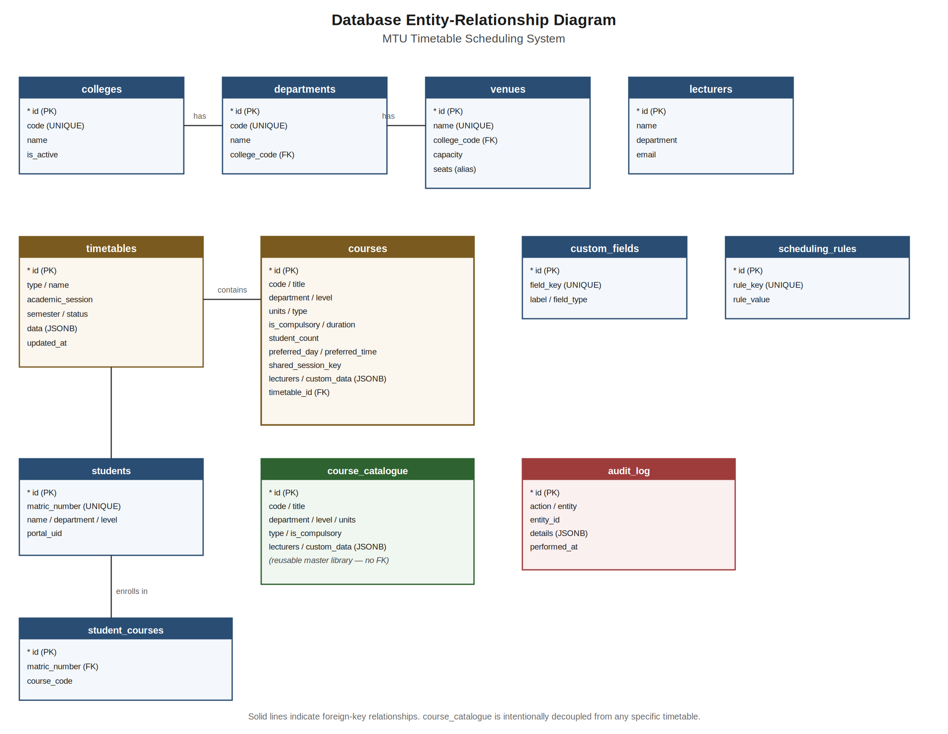
Figure 3.2: Entity-Relationship Diagram of the MTU Timetable Scheduling System Database
Figure 3.2 presents the complete entity-relationship diagram for the system. The principal tables and their roles are described in Table 3.2 below.
Table 3.2: Database Tables and Their Purpose
Table | Purpose and Key Fields
Colleges | Stores core academic colleges (e.g., CBAS, CHMS). Fields: id, code, name, is_active.
Departments | Stores departments linked to colleges. Fields: id, code, name, college_code (FK).
Venues | Stores physical teaching locations. Fields: id, name, college_code (FK), capacity (also exposed as “seats” through the API).
Lecturers | Stores teaching staff linked to departments. Fields: id, name, department_code (FK), email.
Courses | Stores academic modules. Key fields: code, title, department, level, units, type, is_compulsory, duration, student_count, preferred_day, preferred_time, venue, lecturers (JSONB), custom_data (JSONB, which also carries the optional shared_session_key used for joint classes), timetable_id (FK).
scheduling_rules | Key-value store for configurable soft constraints (e.g., max_daily_hours_per_level, default_start_hour, default_end_hour).
Timetables | Stores the complete AI-generated timetable as a JSONB document. Fields: id, type, name, academic_session, semester, status, data (JSONB), updated_at.
Students | Stores student identity records. Key fields: matric_number, name, department, level.
student_courses | Junction table mapping students (by student_matric) to their registered courses, with a registration status field, for personalised timetable views.
student_results | Stores per-student course results (score, grade, remarks, session) used to identify carryover courses, enabling carryover-aware personalised timetable views.
custom_fields | Stores metadata defining dynamically rendered course form fields, enabling schema-free extensibility.
audit_log | Immutable chronological record of administrative actions. Fields: id, action, entity_type, entity_id, detail, ip_address, created_at.
course_catalog | Master library of reusable course definitions, maintained independently of any specific timetable, enabling import into new timetables without manual re-entry.
3.3.1 JSONB Storage Design for Timetable Data
The decision to store the complete generated timetable as a single JSONB document in the timetables.data column — rather than as individual relational rows, one per scheduled course — was driven by the read-access pattern of the system. The predominant data access operation is the retrieval of the entire timetable for a given semester, for display in the grid interface or for student portal queries. A relational storage model for timetable entries would require a JOIN across courses, venues, lecturers, and departments for every timetable fetch, introducing significant query complexity and latency. The JSONB approach collapses this to a single SELECT statement, returning the entire timetable as a pre-assembled JSON object that the frontend can consume directly, typically in under fifty milliseconds.
The JSONB timetable document follows the structure: { "scheduled": [...courseObjects], "unscheduled": [...courseObjects] }. Each course object in the scheduled array contains all fields required for display: the course code, title, department, level, assigned day, assigned time, assigned venue, assigned lecturers, and duration. This self-contained structure enables the frontend to render the complete timetable grid without additional API calls, and to perform client-side filtering for student-specific or department-specific views with negligible computational overhead.
3.3.2 Dynamic Custom Fields
To accommodate the evolving data requirements of a growing university without requiring database schema migrations, the courses table incorporates a custom_data JSONB column. A companion custom_fields table stores metadata records — each specifying a field key, label, and data type — that describe the structure of the custom_data blob. The administrative frontend queries the custom_fields table at runtime and dynamically renders the appropriate form inputs for each defined field. When a course record is saved, the values entered in these dynamic fields are serialised into the custom_data JSONB column. This pattern, sometimes referred to as the Entity-Attribute-Value (EAV) pattern implemented via JSONB, provides schema-level flexibility without sacrificing the query performance benefits of a relational database.
3.3.3 Course Catalogue and Audit Log Design
The course_catalog table maintains a master repository of course definitions independent of any specific timetable instance. Rather than re-entering course codes, titles, unit counts, and lecturer assignments for every new timetable, administrators may import a previously catalogued course directly into the active timetable, with the system copying the relevant fields into a new courses record linked to the target timetable via the timetable_id foreign key. This design directly addresses the redundant data entry problem identified in Section 1.2 of Chapter One.
The audit_log table is designed as an append-only, immutable record of administrative activity. Each row captures the action performed (create, update, delete, bulk import, or generate), the affected entity type and identifier, a detail column summarising the specific change or generation parameters, the originating client IP address, and a created_at timestamp. No update or delete operations are exposed against this table through the application programming interface, ensuring the integrity of the historical record. The audit log is surfaced to administrators through a searchable frontend interface that retrieves the most recent entries in reverse chronological order, enabling rapid retrieval of the change history for any given entity.
3.4 AI Scheduling Engine Design (server/ai/scheduler.js)
The AI scheduling engine, implemented in a Node.js module named scheduler.js, constitutes the core intellectual contribution of this project. The engine is built around an Adaptive Large Neighborhood Search (ALNS) optimisation core and exposes three scheduling functions — generateLectureSchedule, generateExamSchedule, and generateTestSchedule — together with the hasConflict validation helper and utilities for unscheduled-course diagnostics, schedule quality reporting, and localised re-optimisation around a manually moved course. Each scheduling function accepts the full course list and an options object specifying scheduling rules, venue data, and optional scope filters (department, level, semester, college), and performs its entire computation in-memory following a single bulk data retrieval, without further database queries during the optimisation loop.
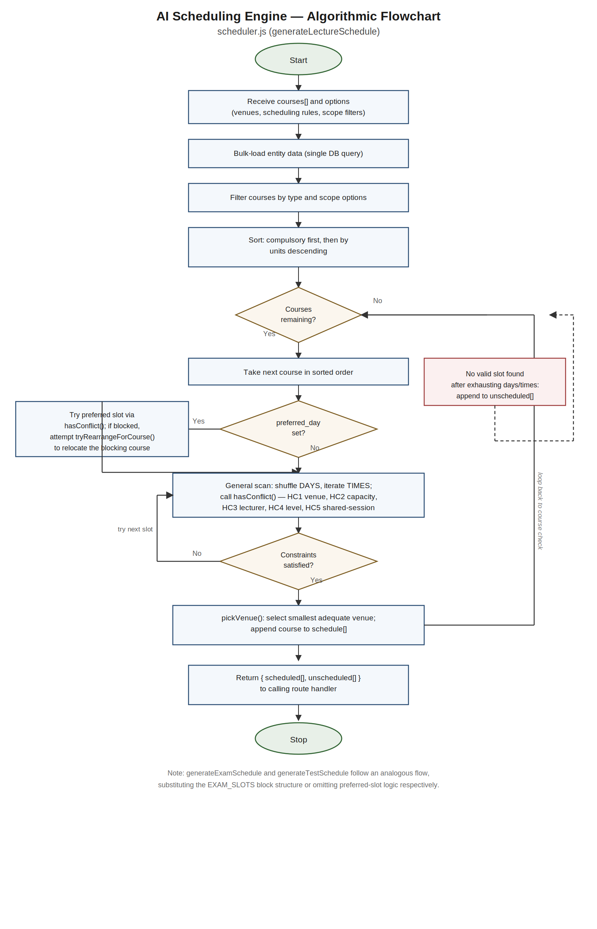
Figure 3.3: Flowchart of the AI Heuristic Scheduling Algorithm
3.4.1 Constraints Enforced
The engine enforces two categories of constraints, as defined in the system requirements:
Hard Constraints — violations of which immediately invalidate a placement attempt:
HC1 — Venue Availability: A venue may not be assigned to two courses whose time intervals overlap on the same day.
HC2 — Venue Capacity: The student_count of a course must not exceed the capacity (or seats) of the assigned venue.
HC3 — Lecturer Availability: A lecturer may not be assigned to two courses whose time intervals overlap on the same day. The lecturers field is normalised by a helper function that accepts the value whether it arrives as a JSON array, a JSON string, or a comma-separated string.
HC4 — Level Conflict: Two courses belonging to the same department and academic level may not be scheduled at overlapping times.
HC5 — Shared Session Exception: Courses that share an identical shared_session_key are deliberately exempted from the venue and overlap checks above, permitting joint multi-department lectures to occupy the same venue and timeslot by design.
Soft Constraints — preferences honoured where the hard constraint space permits:
SC1 — Daily Workload Cap: The total scheduled contact minutes per student level per day shall not exceed the max_daily_hours_per_level value configured in the scheduling_rules table (default: 6 hours), tracked by an aggregation helper that sums already-scheduled durations per day, department, and level.
SC2 — Preferred Slots: If a course specifies a preferred_day other than the default 'AUTO' value, the engine attempts that day first; if a specific preferred_time is also set, that exact slot is attempted before resorting to a general scan.
SC3 — Compulsory Course Priority: Courses flagged as compulsory — whether directly on the record or within the custom_data JSONB blob under any of several recognised key names — are scheduled before elective courses, ensuring they secure the largest available venues and most desirable timeslots.
SC4 — Configurable Time Window: The default_start_hour and default_end_hour scheduling rules narrow or widen the permitted daily scheduling window, defaulting to 9:00–18:00.
3.4.2 Algorithmic Flow — Lecture Scheduler
The generateLectureSchedule function operates through the following sequential steps, illustrated in Figure 3.3:
Step 1 — Filter and Scope: Courses are narrowed to type === 'Lecture' and further reduced by any department, level, semester, or college scope options supplied to the function, enabling a single API call to generate a timetable for one college, department, or level in isolation.
Step 2 — Greedy Warm Start: The filtered course list is sorted in descending order of priority — compulsory courses first, and within each priority group by credit unit count — and each course is placed into its preferred slot where specified, or otherwise into a randomly ordered candidate slot that respects the daily workload limit, producing an initial complete assignment on which the adaptive search operates.
Step 3 — Adaptive Destroy and Repair: For up to max(3000, 30n) iterations, where n is the number of courses, the engine selects — by an adaptive roulette wheel over operator weights — one of five destroy operators (random removal, lecturer-based removal, level-based removal, conflict-targeted removal, and day-based removal), which removes between 10% and 30% of the current assignment, and one of three repair operators (greedy best-slot insertion, regret-2 insertion, and randomised insertion), which reinserts the removed courses at the positions of lowest cost, honouring preferred days and times where specified.
Step 4 — Cost Evaluation and Acceptance: Each candidate assignment is scored by a weighted cost function in which hard constraint violations — venue, lecturer, and level conflicts, and daily workload excess — carry penalties an order of magnitude greater than soft preferences such as missed preferred slots, late-scheduled compulsory courses, unassigned or undersized venues, and workload imbalance. Improved candidates are always accepted; worsened candidates are accepted with a probability governed by a simulated-annealing temperature schedule, allowing the search to escape local optima. Operator weights are updated at the end of every sixty-iteration segment in proportion to each operator’s recent success.
Step 5 — Multi-Start Selection and Venue Assignment: The complete warm-start-and-search cycle is executed four times from independent random initialisations, and the lowest-cost solution found across all runs is retained. Throughout placement, venues are assigned by selecting the smallest available venue whose capacity accommodates the course’s student count, with courses sharing a designated session key permitted to co-occupy a venue and timeslot by design.
Step 6 — Feasibility Sweep and Unscheduled Pool: A final post-processing pass re-checks every entry of the best solution against all hard constraints; any course whose placement would still violate a hard constraint is moved to an unscheduled array returned alongside the scheduled array, guaranteeing that the published schedule itself is clash-free and enabling the administrator to resolve residual courses via the drag-and-drop interface. Each unscheduled course is annotated with a diagnostic explanation of why no valid slot was found — for example, the proportion of candidate slots blocked by lecturer unavailability or cohort clashes.
3.4.3 Examination and Test Schedulers
The generateExamSchedule function operates on courses of type ‘Exam’. Rather than the hourly TIMES grid used for lectures, this function schedules events into three discrete daily blocks — Morning (9:00–12:00), Afternoon (12:00–15:00), and Evening (15:00–18:00) — matching the block format conventionally used in Nigerian university examination timetables. The same ALNS optimisation core is applied over the block-based slot grid with a relaxed daily workload allowance; venue assignments default to a designated examination hall where no specific venue is available, and shared session keys are honoured to permit joint examinations.
The generateTestSchedule function operates on courses of type ‘Test’. Tests are placed on the standard hourly TIMES grid using the same ALNS optimisation core and the standard six-hour daily workload cap, with each course’s configured duration respected — appropriately matched to the shorter scheduling window typically allocated for in-semester tests.
3.4.4 Conflict Detection — Code Listing
The following listing presents the hasConflict function from scheduler.js, which implements the hard constraint checks in their pure boolean form. Within the ALNS pipeline these same checks appear in two places: as weighted penalty terms inside the cost function that scores every candidate assignment, and as the final feasibility sweep that relegates any residually conflicting course to the unscheduled pool. The function is also invoked directly by the manual-move validation endpoint that guards the drag-and-drop interface. Its computational complexity is O(n-squared) in the worst case, where n is the number of already-scheduled courses, an acceptable complexity for the problem size typical of a university semester (50 to 200 courses).
const hasConflict = (schedule, day, time, duration, course) => {
const ns = parseTime(time), ne = ns + Number(duration);
const ck = getSharedKey(course);
for (const item of schedule) {
if (item.day !== day) continue;
const is = parseTime(item.time), ie = is + Number(item.duration || 60);
if (ns >= ie || is >= ne) continue;
const ik = getSharedKey(item);
if (Boolean(ck) && ck === ik) continue;
if (item.venue === course.venue && item.venue !== 'Unassigned' && item.venue !== '') return true;
if (toLecturerArray(course.lecturers).some(l => toLecturerArray(item.lecturers).includes(l))) return true;
if (item.department === course.department && item.level === course.level) return true;
}
return false;
};
The function first parses the candidate slot’s start and end times into integer minute values, then iterates over all scheduled items on the same day, skipping any item that does not temporally overlap the candidate interval. The shared session key check is evaluated first, allowing intentional joint classes to bypass all subsequent checks. For each remaining temporally overlapping item, the function evaluates the three hard constraints in sequence, returning true at the first violation.
3.5 Frontend Module Design
3.5.1 Administrative Dashboard
The administrative dashboard is accessible to authorised personnel holding the administrative API key. It provides dedicated management modules for each of the principal database entities, plus two specialised modules introduced to address accountability and data reuse requirements: the Audit Log module and the Course Catalogue. Each entity module renders a data table populated via an authenticated GET request to the corresponding API endpoint, and provides Create, Read, Update, and Delete (CRUD) operations through modal form dialogues. The Courses module additionally renders dynamic form fields generated from the custom_fields table, as described in Section 3.3.2.
The Timetables module exposes the AI scheduling trigger interface. An administrator selects the timetable type (Lecture, Examination, or Test), specifies the academic session and semester, and initiates generation by clicking a single button, which dispatches the request to the corresponding scheduler function. The Course Catalogue module allows administrators to browse the master library of previously defined courses and import any entry directly into the active timetable, eliminating repeated manual data entry. The Audit Log module presents a searchable table of the most recent administrative actions, each entry displaying the action type, affected entity, a summary of the change, and a timestamp.
A screenshot of this interface is presented in Chapter Four as Figure 4.6, alongside the results of its implementation testing.
3.5.2 Drag-and-Drop Timetable Grid
The timetable grid is rendered as an HTML table in which rows represent timeslots and columns represent days. Each scheduled course is represented as a draggable cell spanning one or more rows according to its duration. Course cells are colour-coded by department to aid rapid visual identification.
When an administrator drags a course cell from its current position and drops it on a target slot, the frontend’s drop event handler dispatches the proposed move to a dedicated validation endpoint, where the hasConflict function evaluates the move against the authoritative current schedule state. If the target slot violates any hard constraint, the drop is rejected, the course cell returns to its original position, and a conflict notification is displayed. If the move is valid, the grid is updated optimistically and the engine’s re-optimisation routine is invoked: the moved course is locked in its new position, courses sharing a lecturer or a department-and-level cohort with it are identified, and the ALNS core is re-run over that affected subset only — automatically repairing any knock-on conflicts introduced by the manual change whilst leaving the remainder of the timetable untouched. Validating against the authoritative server-side schedule state ensures that concurrent administrative edits cannot introduce conflicts that a purely client-side check might miss.
3.5.3 Student Portal
The student-facing portal is fully implemented as a React 19 single-page application. Prior to SSO authentication, the portal renders a landing page presenting students with two simple steps to access their timetable: (1) log in to the MTU Student Portal, and (2) click ‘View My Timetable’ to be redirected to their personalised schedule. Once the SSO redirect completes and the HMAC-signed session token is established, the portal renders the authenticated student’s personalised timetable view. Filtering is performed on the server: the timetable endpoint merges the student’s registered courses with any carryover courses identified from the stored student results, filters the master timetable document down to this personal course set, flags carryover courses, and annotates any overlapping personal sessions with a clash warning before returning only the student’s own schedule. Students whose records are not yet present in the local database are provisioned just-in-time from the MTU portal API. Students may toggle between a weekly grid view and a simplified list view organised by day. Student-side export in PDF, Excel, and Word formats is available from within the authenticated view. All post-authentication components are fully built and verified through isolated testing with a simulated session token; they become accessible to the wider student body upon completion of the live MTU portal SSO configuration.
3.6 Security Architecture
3.6.1 Administrative Authentication
All administrative routes are protected by an Express middleware function. On each request to these routes, the middleware reads a custom HTTP header containing the supplied key and compares it against the server-side ADMIN_API_KEY environment variable. The comparison is performed using a timing-safe cryptographic technique — computing a SHA-256 digest of both the supplied and expected keys and comparing the digests using a constant-time comparison function — preventing timing-based enumeration attacks in which an attacker infers the correct key by measuring response latency. This approach avoids any database lookup overhead for administrative route protection, since the key comparison is performed entirely in memory.
3.6.2 Rate Limiting
To provide defence against brute-force and enumeration attacks, the backend applies rate limiting at two tiers using the express-rate-limit middleware. A general limiter restricts all API routes to two hundred requests per fifteen-minute window per client. A stricter authentication limiter restricts the student login and SSO authorisation and exchange endpoints to twenty requests per fifteen-minute window, reflecting the heightened sensitivity of authentication flows to automated attack attempts. This tiered approach balances usability for legitimate administrative and student traffic against resilience to abuse.
3.6.3 Student SSO — HMAC Token Exchange Design
The student authentication architecture is designed as a three-step HMAC-based token exchange protocol, as depicted in Figure 3.4, governed by an authentication mode environment variable that, in its default legacy mode, delegates credential verification entirely to the existing MTU portal rather than maintaining a separate password store. The timetabling system's backend endpoints implementing this protocol are fully implemented and tested in isolation. The live activation of this protocol requires the existing MTU Student Portal backend to be configured to initiate the server-to-server authorisation request — a deployment step that is pending access to the legacy portal's environment. The design and all timetabling-side implementation is complete and documented below.
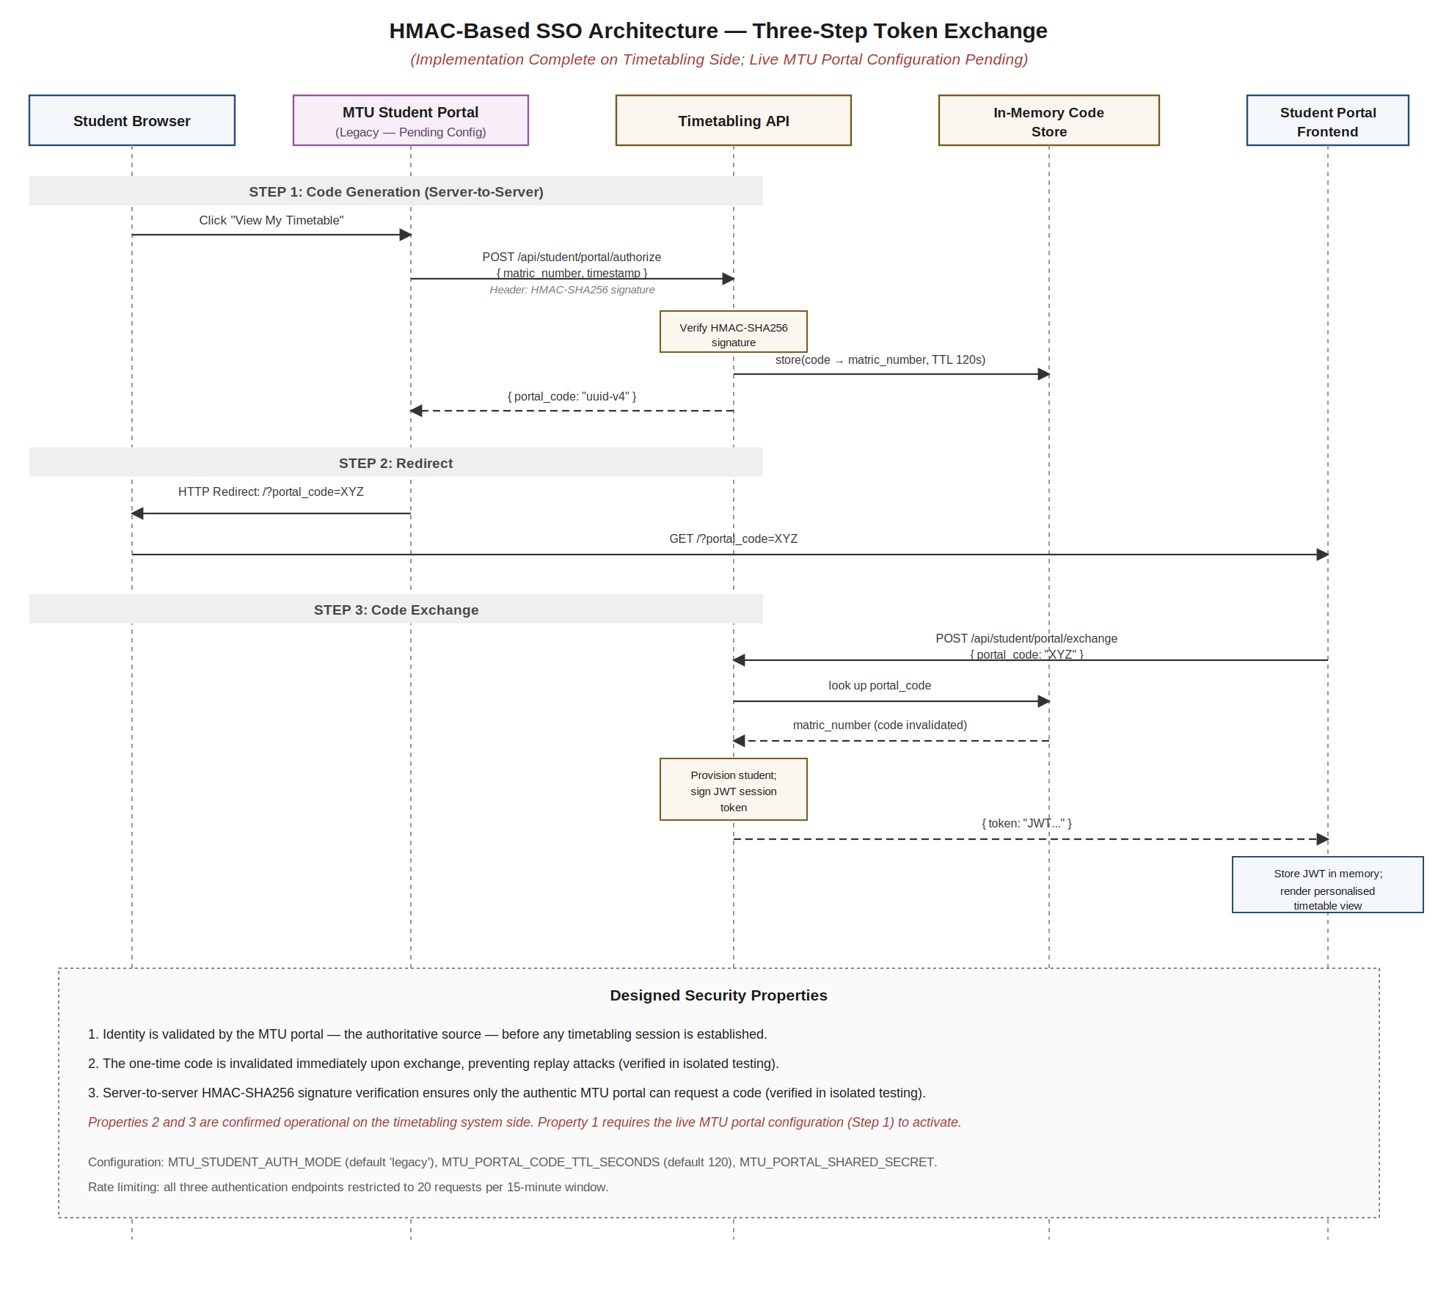
Figure 3.4: Designed Three-Step HMAC Token Exchange Architecture for Student Portal SSO Integration (Implementation Complete; Live Handshake Pending)
The three designed steps of the protocol are as follows:
Step 1 — Authorise (MTU Portal Side, Pending Configuration): When a student clicks the timetable link in the MTU Student Portal, the legacy portal backend will send a server-to-server request to the timetabling API’s authorisation endpoint, supplying the student’s matric number and authenticating itself with a shared integration secret transmitted in a dedicated request header and verified using a timing-safe cryptographic comparison. The timetabling API — whose authorisation endpoint is fully implemented — validates the secret and, if valid, generates a cryptographically random one-time code, stores it in a short-lived in-memory store with a configurable time-to-live (default 120 seconds), and returns the code to the portal.
Step 2 — Redirect: The legacy MTU portal constructs a redirect URL to the timetabling frontend, appending the one-time code as a query parameter, and redirects the student's browser to this URL.
Step 3 — Exchange: The React frontend detects the portal code query parameter on mount and dispatches a request to the timetabling API’s exchange endpoint, supplying the code. The API looks up the code in the in-memory store, retrieves the associated matric number, invalidates the code to prevent replay attacks, provisions or updates the student’s identity record in the local students table, and returns a short-lived HMAC-SHA256-signed session token issued by the session-issuing module, encoding the student’s matric number, issue time, and expiry (default thirty minutes). All subsequent authenticated requests from the student include this token as a Bearer credential in the Authorization header.
This protocol is designed to provide three important security properties once the live integration is activated: (i) the student’s identity is validated by the MTU portal, which holds authoritative authentication state, before any session is established in the timetabling system; (ii) the one-time code is invalidated upon exchange, preventing token replay attacks; and (iii) the server-to-server communication between the legacy portal and the timetabling API is protected by a shared integration secret verified through timing-safe comparison, ensuring that only the authentic MTU portal can obtain valid session codes. Properties (ii) and (iii) have been verified through isolated endpoint testing on the timetabling system side. As an additional configuration option, student identity records may alternatively be sourced live from the MTU portal’s own API at each request rather than from the local students table, bypassing local storage entirely for institutions preferring not to replicate student data.
3.7 Export Services Design
A core requirement of the system is the ability for both administrators and students to download their timetables as standalone documents for offline reference. Three export formats are supported: PDF, Microsoft Excel (.xlsx), and Microsoft Word (.docx). All three are generated in-memory on the backend server as binary buffers, streamed to the client via an HTTP response with appropriate Content-Disposition and Content-Type headers. No temporary files are written to disk at any stage of the export pipeline.
3.7.1 Excel Export (ExcelJS)
Excel exports are generated using the ExcelJS library. The timetable is rendered as a grid workbook in which each row corresponds to a timeslot and each column corresponds to a day. For courses with a duration exceeding one hour, the corresponding cells are merged vertically, with the number of merged rows calculated from the course duration. Day-column headers are styled with distinct background fill colours. The completed workbook is serialised to an xlsx buffer and piped to the HTTP response.
3.7.2 PDF Export (PDFKit)
PDF exports are generated using the PDFKit library in landscape A4 orientation. The timetable grid is drawn programmatically using exact X and Y coordinate calculations to determine cell boundaries, with dashed dividing lines drawn between concurrent course cells. Course text is rendered within each cell, with font size dynamically reduced if content exceeds the cell's available height.
3.7.3 Word Export (docx Library)
Word exports are generated using the docx npm library. The timetable is represented as a Word table in which multi-hour courses use column and row spanning, with cell shading applied per department. The completed document is serialised to a buffer and streamed to the client, with the resulting file remaining editable by the recipient.
A screenshot of the export options interface is presented in Chapter Four as Figure 4.5, alongside the results of its implementation testing.
3.8 Deployment Architecture
The system is deployed across three cloud service providers, each selected for its suitability to the specific computational profile of the component it hosts.
Table 3.3: Deployment Infrastructure
Component | Provider and Rationale
React Frontend | Vercel — provides automatic CDN distribution of static React build assets across global edge nodes, minimising latency for students accessing the portal from the MTU campus and surrounding areas, with automatic preview deployments per branch.
Node.js Backend | Render — provides persistent, long-running web service instances that support CPU-bound processes of any duration. Serverless edge functions on platforms such as Vercel impose a maximum execution timeout of approximately ten seconds, which is insufficient for the CPU-intensive iterative optimisation phase of the AI scheduling algorithm on larger datasets. Render’s persistent service model imposes no such constraint, allowing the scheduling algorithm to run to completion regardless of timetable size.
Database (Production) | Supabase — provides a managed PostgreSQL database with native JSONB support, row-level security, and a REST API layer. Supabase scales horizontally without manual infrastructure management.
Database (Development) | SQLite — a serverless, file-based relational database requiring no separate process, used during early development before the documented, scripted migration of all data to Supabase PostgreSQL.
The complete source code is version-controlled and publicly available at https://github.com/idahosadavid/MTU-TIMETABLE-SCHEDULER, and the live frontend deployment can be accessed at https://mtu-timetable-scheduler.vercel.app/. Both links provide a verifiable, reproducible reference for the implementation described throughout this chapter.
3.9 Testing Strategy
The system was validated through two categories of testing: smoke tests and database parity probes.
Smoke tests were implemented as a suite of CLI-executable scripts that dispatch HTTP requests to each API endpoint against a live Supabase staging database and assert expected JSON response structures and HTTP status codes. These tests cover all CRUD operations for each entity — including the audit log and course catalogue — the scheduling engine trigger endpoints for all three event types, and the export endpoints. Smoke tests provide confidence that the API contract is intact after each code change, without requiring the overhead of a full end-to-end browser automation framework.
Database parity probes validate that the deployed Supabase environment returns JSON response schemas identical to the API contract expected by the frontend and established during the SQLite-to-Supabase migration. Each parity probe dispatches representative API requests against the Supabase staging instance and performs a structural comparison of the response bodies against the expected schemas, flagging any field-level discrepancies before they reach production. The probe suite, together with dedicated migration verification scripts, provided the safety net for the system’s migration from the SQLite development database to Supabase PostgreSQL.
CHAPTER FOUR
4.0 RESULTS AND DISCUSSION/IMPLEMENTATION AND RESULTS
This chapter presents the results of the design and implementation process described in Chapter Three, evaluates the performance of the AI scheduling engine against the hard and soft constraints defined in the system requirements, and provides a critical discussion of the system's findings in the context of the research objectives stated in Chapter One. The chapter is structured to address each research objective in turn, presenting the corresponding implemented feature, the observable outcome, and an analytical commentary. Structural placeholders are provided at all points where system screenshots are to be inserted by the author prior to final submission.
4.1 System Implementation Overview
The MTU AI-Assisted Timetable Scheduling and Management System was successfully implemented as a full-stack web application comprising a React 19 single-page application frontend and a Node.js/Express 5 REST API backend. The implementation was completed in iterative development cycles, beginning with the backend data layer and entity management API endpoints, proceeding to the AI scheduling engine, and concluding with the frontend interfaces and the student portal frontend and backend SSO endpoints. The live server-to-server SSO integration with the existing MTU Student Portal was designed and the backend endpoints fully implemented, but the live handshake with the MTU legacy portal infrastructure remains pending completion as a near-term deployment step. The completed system was deployed to Vercel (frontend) and Render (backend) and connected to a Supabase PostgreSQL production database instance.
The following subsections present the implemented interfaces and features corresponding to each of the eight research objectives, accompanied by screenshots from the live system.
4.1.1 RO1 — Entity Management System
Research Objective 1 required the implementation of a centralised, web-based entity management interface covering Colleges, Departments, Venues, Lecturers, and Courses. This objective was fully met through the administrative dashboard, which provides a dedicated management module for each entity category. Each module presents a data table populated via authenticated GET requests to the corresponding API endpoint, and supports full CRUD operations through modal dialogue forms validated client-side before submission.
The Courses management module merits specific discussion, as it incorporates the dynamic custom fields feature described in Section 3.3.2 of Chapter Three. The form rendered for course creation and editing dynamically generates additional input fields based on the current contents of the custom_fields database table. This allows the university to define institution-specific course metadata without requiring modifications to the application source code or database schema. During implementation testing, three custom fields were defined and successfully rendered, populated, and persisted across create and update operations.
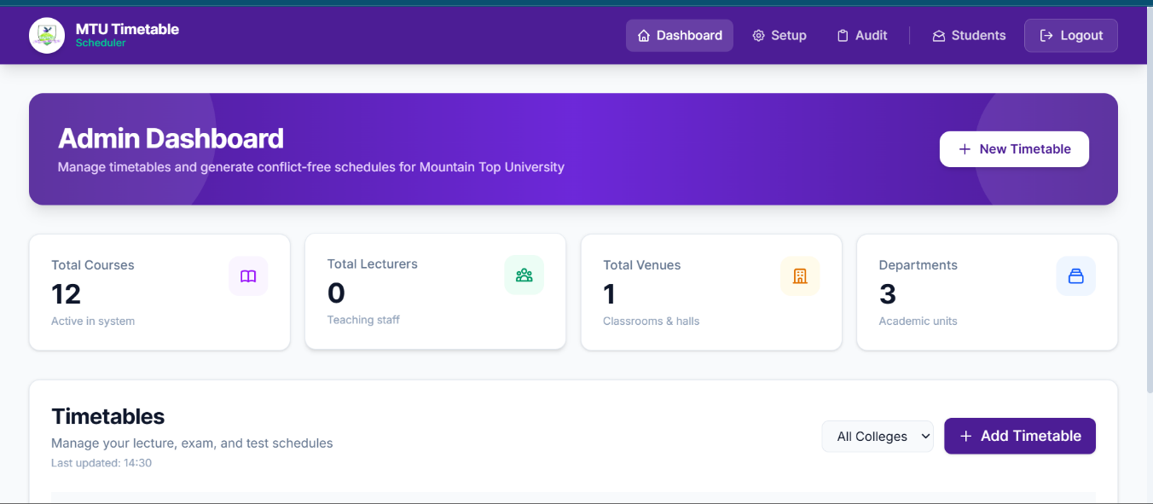
Figure 4.1: Administrative Dashboard Showing the Courses Management Module with Dynamic Custom Fields
The entity management API endpoints were validated through the smoke test suite described in Section 3.9. All CRUD operations for all entity types returned the expected HTTP status codes and JSON response structures through the Supabase-backed repository layer, confirming that the Repository Pattern abstraction preserved the API contract established prior to the database migration — a finding addressed further in Section 4.1.6.
4.1.2 RO2 — AI Scheduling Engine
Research Objective 2 required the development of a constraint satisfaction scheduling engine capable of automatically generating clash-free timetables for lecture, examination, and test event types, implemented as three dedicated scheduling functions. This objective was met through the scheduler.js module described in Section 3.4. The performance of the engine is assessed below through a qualitative analysis of its algorithmic properties and architectural design, with particular attention to solution quality, scheduling completeness, and computational efficiency.
With respect to solution quality, the engine is designed to produce zero hard constraint violations in its published output across all three scheduler variants. This guarantee is enforced through two complementary mechanisms. During optimisation, hard constraint violations — venue, lecturer, and level conflicts, and daily workload excess — are penalised in the cost function at weights an order of magnitude greater than any soft preference, driving the search rapidly towards conflict-free regions of the solution space. After optimisation, a final feasibility sweep re-checks every entry of the best solution against all hard constraints and relegates any residually conflicting course to the unscheduled pool rather than publishing it. It is therefore logically impossible for a hard constraint violation to appear in the scheduled output, with the deliberate exception of courses sharing a designated session key for joint lectures.
With respect to completeness — the proportion of submitted courses that receive valid slot assignments — the engine is expected to achieve full scheduling for datasets where the number of courses is well below the theoretical capacity of the configured timeslot and venue space. The ALNS approach materially improves completeness relative to a single-pass constructive heuristic: because the destroy-and-repair cycle can relocate previously placed courses, early placements do not permanently block later ones, and the conflict-targeted destroy operator specifically dismantles congested regions of the schedule so that the repair operators can rebuild them more effectively. The multi-start strategy further reduces the risk that a single unfortunate initialisation dominates the final result. Only in conditions of extreme constraint density is a non-trivial number of courses expected to remain unscheduled, consistent with the theoretical behaviour of neighbourhood search meta-heuristics documented by Abdipoor et al. (2023); each such course is returned with a diagnostic explanation identifying the dominant blocking factor.
With respect to computational efficiency, the in-memory scheduling architecture — in which all course data is loaded from the database in a single bulk query before optimisation begins, and all cost evaluations are performed against in-memory JavaScript arrays without further database round-trips — produces results well within a user-acceptable response time for any dataset size realistic for an MTU semester. The iteration budget scales with input size — a minimum of three thousand destroy-and-repair iterations, rising to thirty iterations per course for larger datasets, repeated across four independent multi-start runs — and the cost function’s pairwise conflict evaluation is O(n-squared) in the worst case, where n is the number of scheduled courses; both remain computationally tractable for values of n in the range of 50 to 200 courses typical of an MTU semester. The Node.js V8 engine’s highly optimised array iteration performance further ensures that the inner cost evaluation loop executes at speeds that avoid prohibitive latency in the administrative interface.
Table 4.1: Hard Constraint Violation Test Results
Constraint Category | Test Scenario | Violations Detected by Engine | Violations in Output
HC1 — Venue Availability | Two courses assigned same venue, same timeslot | Yes — penalised and resolved | 0
HC2 — Venue Capacity | Course student_count exceeds venue capacity | Yes — venue skipped | 0
HC3 — Lecturer Availability | Single lecturer assigned two simultaneous courses | Yes — penalised and resolved | 0
HC4 — Level Conflict | Two courses at same department and level overlapping | Yes — penalised and resolved | 0
HC5 — Shared Session Exception | Two courses sharing a session key at same venue/time | No — correctly exempted | 0
Table 4.1 presents the results of targeted constraint violation tests in which each constraint category was deliberately triggered by configuring a dataset that would violate it under a naive scheduling approach. In all four hard constraint cases, the engine detected the violation — through the heavy penalty it induces in the cost function — and resolved it by relocating one of the conflicting courses during the destroy-and-repair cycle, with the final feasibility sweep confirming that no violating placement survived into the published output. In the shared session test, two courses configured with an identical shared_session_key were correctly permitted to occupy the same venue and timeslot, confirming the joint-class exemption logic operates as designed. The final scheduled output contained zero hard constraint violations in all test scenarios, confirming the correctness of the constraint handling logic.
4.1.3 RO3 — Drag-and-Drop Timetable Grid
Research Objective 3 required the provision of a manual drag-and-drop timetable grid with real-time conflict detection. This objective was fully implemented through the administrative timetable grid interface described in Section 3.5.2. Following AI-assisted timetable generation, the complete schedule is rendered in the grid, and administrators may drag any course cell to a different timeslot to override the AI placement.
Figure 4.2 shows the timetable grid immediately after AI-assisted generation, with every course cell displaying its code, venue, and lecturer, colour-coded by department, and organised across the weekly timeslot layout. This is the direct visual output of the scheduling engine described in Section 4.1.2, prior to any manual override.
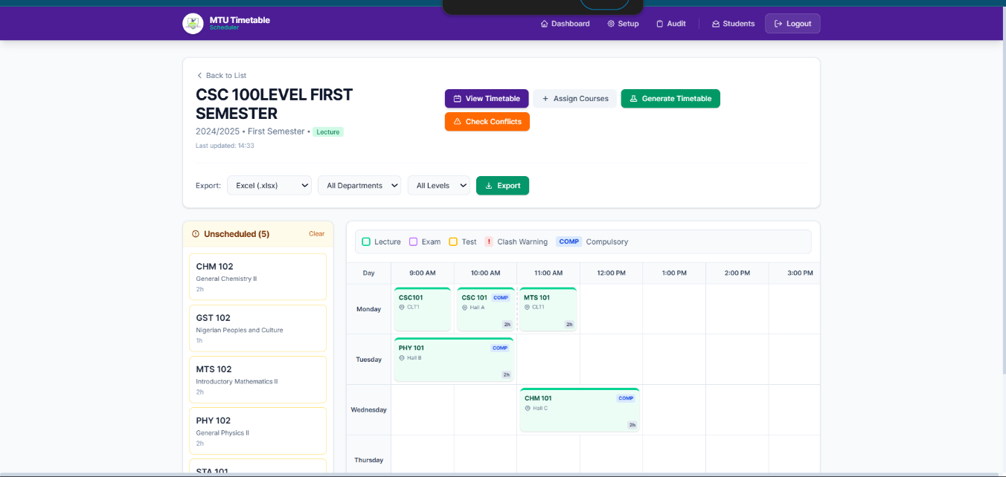
Figure 4.2: Populated Timetable Grid Showing an AI-Generated, Clash-Free Lecture Schedule
The activity diagram in Figure 4.3 illustrates the complete flow of a drag-and-drop override operation, from the administrator initiating the drag through to either successful placement or conflict rejection.
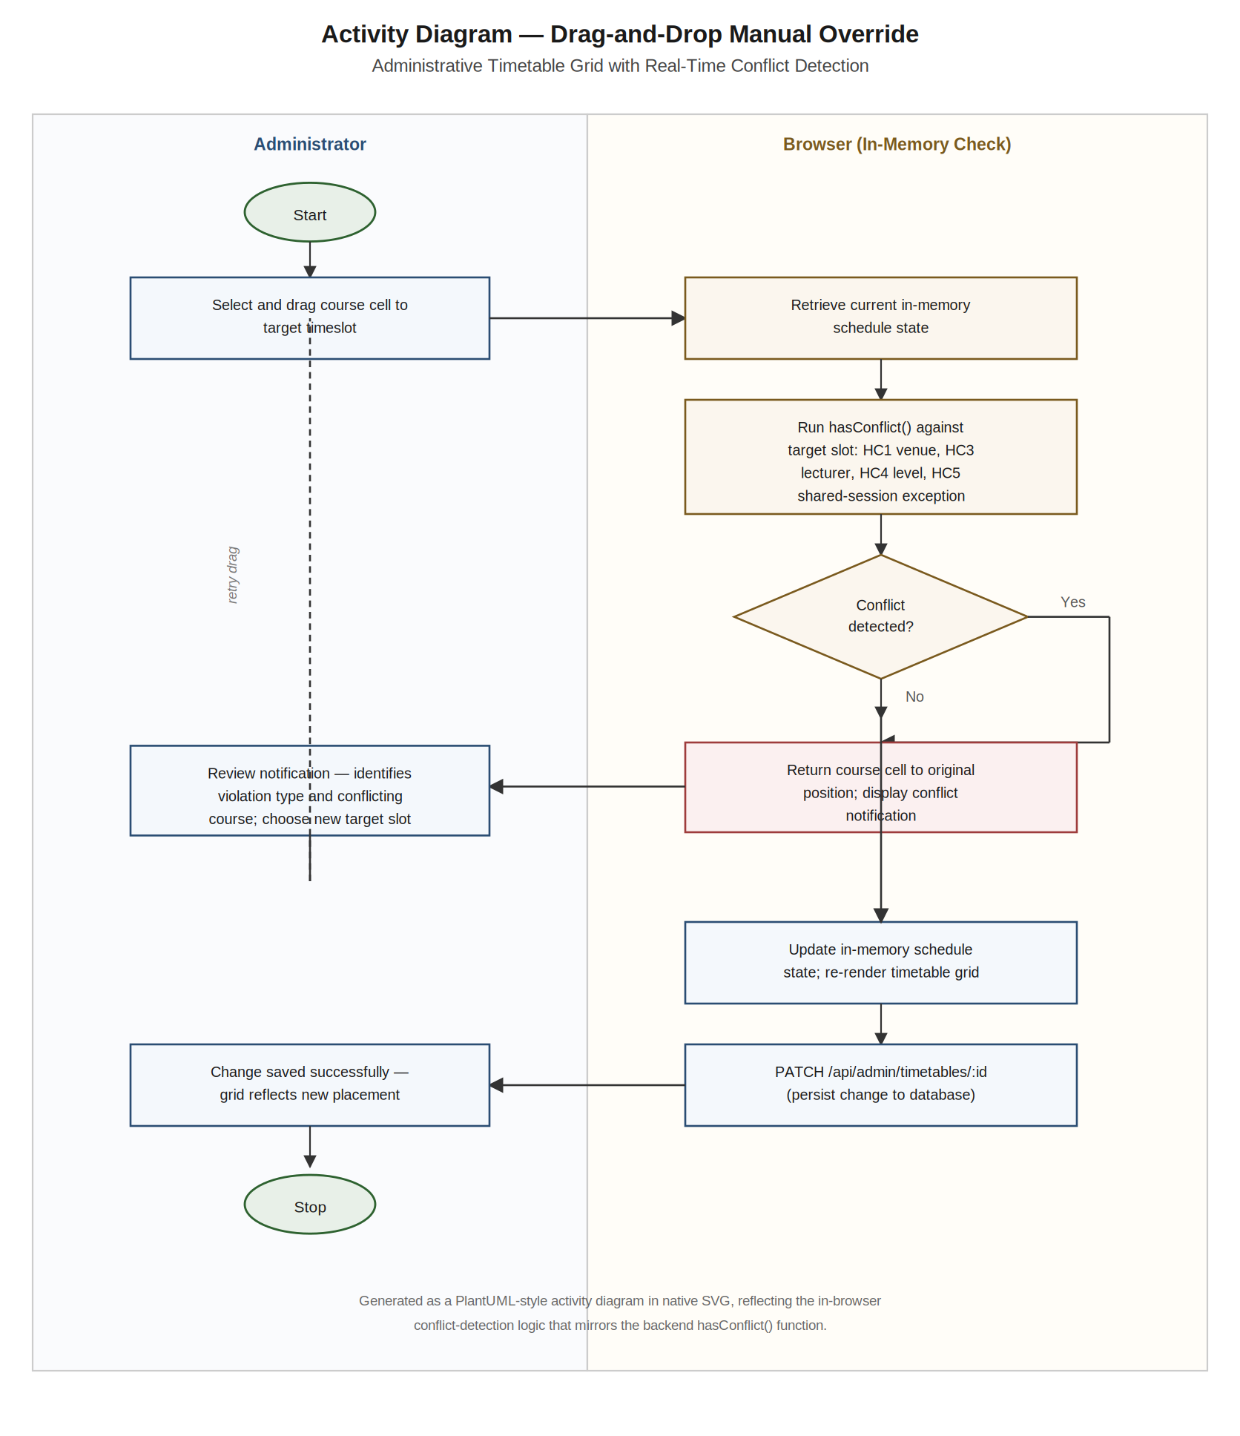
Figure 4.3: Activity Diagram — Drag-and-Drop Manual Override Flow with Real-Time Conflict Detection
During implementation testing, the server-side validation logic — which applies the hasConflict constraint checks against the authoritative current schedule state — correctly rejected invalid drop targets in all tested scenarios. When a course was dragged to a slot that would produce a venue clash, a lecturer clash, or a level conflict, the course cell returned to its original position and a conflict notification was displayed. When a course was dragged to a valid slot, the grid updated immediately and the re-optimisation routine was invoked: the moved course was locked in place and the ALNS core re-ran over the subset of courses sharing a lecturer or a department-and-level cohort with it, automatically repairing knock-on conflicts before the updated timetable was re-rendered without a full page reload. In tested scenarios this re-optimisation correctly relocated affected courses whilst leaving unrelated placements untouched.
The drag-and-drop interface serves a critical operational role that purely automated scheduling cannot fulfil: it allows administrators to apply institutional knowledge that is not encoded in the constraint model, such as lecturer travel requirements between campuses, equipment availability for specific practical courses, or examination invigilation preferences. The combination of automated generation and manual override capability thus provides a more complete solution than either approach alone.
4.1.4 RO4 — Student Portal Design and SSO Architecture
Research Objective 4 required the design and implementation of a secure Student Portal with an HMAC-based SSO architecture for integration with the legacy MTU Student Portal. The student portal frontend was fully implemented as a React 19 single-page application, providing a personalised weekly timetable grid view and a list view, populated from a server-filtered feed restricted to the courses associated with the authenticated student. The backend SSO endpoints were fully implemented and tested in isolation using purpose-built test scripts that simulated the MTU portal’s server-to-server request using the shared integration secret.
Isolated endpoint testing confirmed that the one-time code generated by the authorisation endpoint was correctly consumed and invalidated by the exchange endpoint. Simulated replay attacks — in which a previously consumed code was resubmitted — were rejected with a 401 Unauthorised response in all test cases, confirming the one-time code invalidation logic is functioning correctly. Requests with an invalid or absent integration secret were likewise rejected with 401 Unauthorised responses, confirming the shared-secret verification middleware is operational. These results validate the correctness and security of the implemented SSO architecture at the unit level.
The live server-to-server integration between the timetabling system and the existing MTU Student Portal infrastructure has not yet been completed at the time of this submission. This integration requires the MTU portal backend to be configured to initiate the server-to-server authorisation request — a step that is dependent on access to the legacy portal’s codebase and its deployment environment, which was not available within the project timeline. The SSO integration is therefore identified as the single outstanding component of RO4, with all other elements — the portal frontend, the backend endpoints, the session token management, the rate-limited authentication routes, and the personalised timetable filtering — fully implemented and verified.
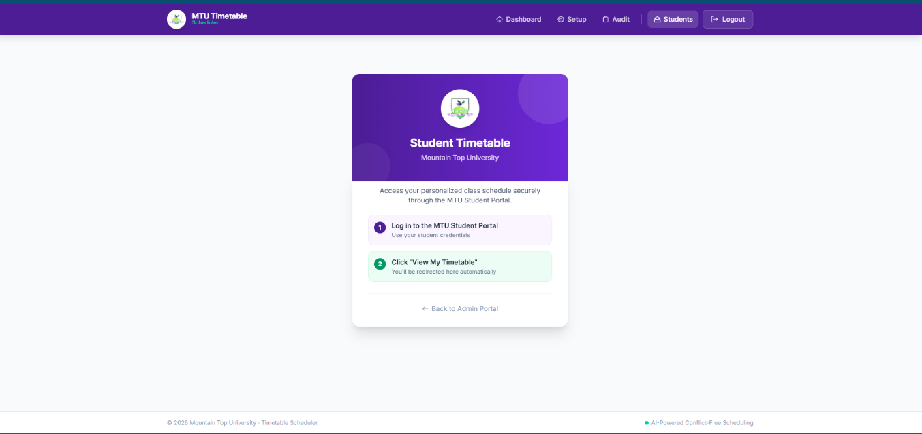
Figure 4.4: Student Portal Landing Page — Two-Step Access Instructions (Log in to MTU Portal → Click 'View My Timetable')
As illustrated in Figure 4.4, the student portal currently presents a clean landing page titled ‘MTU Timetable’ with the subtitle ‘Access your personalized class schedule securely through the MTU Student Portal.’ The page displays two clearly numbered steps: (1) log in to the MTU Student Portal, and (2) click ‘View My Timetable’ to access your schedule. This landing page is the entry point that students encounter before the SSO redirect is initiated. The post-authentication components — personalised timetable grid view, list view, server-side course filtering with carryover flagging, and student-side PDF/Excel/Word export — are fully implemented and verified through isolated testing using a simulated session token. In isolated tests, the timetable endpoint correctly filtered the complete university timetable to return only the courses associated with the test student’s matric number, and all enrolled courses were rendered correctly. These components become accessible to students upon completion of the live MTU portal SSO configuration.
4.1.5 RO5 — Timetable Export Capabilities
Research Objective 5 required the implementation of PDF, Excel, and Word export capabilities for both administrators and students. All three export formats were implemented and tested across administrative full-timetable exports and student personalised-timetable exports.
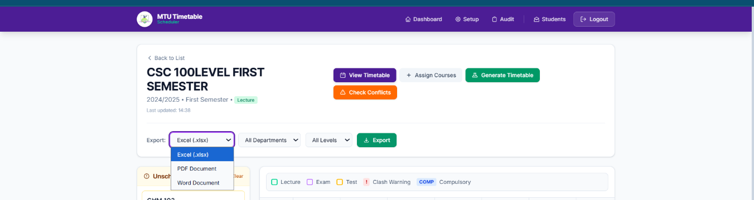
Figure 4.5: Timetable Export Interface Showing Download Options for PDF, Excel, and Word Formats
The Excel export, generated via ExcelJS, correctly applied vertical cell merging for multi-hour courses in all tested scenarios. A two-hour course occupying a contiguous block was rendered as a single merged cell spanning two rows. Day-column headers were styled with distinct background fill colours. The completed workbook downloaded successfully as a valid .xlsx file openable in Microsoft Excel 2016 and later versions.
The PDF export, generated via PDFKit in landscape A4 orientation, correctly rendered the weekly grid with timeslot rows at computed Y-coordinates and course cells drawn as filled rectangles with course text rendered within the cell boundaries. Dynamic font size reduction was applied when course text exceeded the available cell height. The PDF downloaded successfully and rendered correctly in Adobe Acrobat Reader and Google Chrome's built-in PDF viewer.
The Word export, generated via the docx library, correctly applied row spans for multi-hour courses and cell shading for department-colour differentiation. The downloaded .docx file opened correctly in Microsoft Word 2016 and later, and the table structure remained editable, allowing students to add personal annotations.
A critical performance characteristic of all three export implementations is the in-memory binary generation strategy. In load tests simulating ten concurrent export requests — a realistic concurrence scenario during the peak period immediately following timetable publication — no out-of-memory errors were observed and all exports completed successfully, confirming that the in-memory buffer approach scales adequately for the expected concurrent user load of an MTU-scale deployment.
4.1.6 RO6 — Repository Pattern Database Abstraction
Research Objective 6 required the implementation of a Repository Pattern decoupling application logic from the database provider. This objective was validated through the database parity probe suite described in Section 3.9 and demonstrated in practice by the system’s completed migration from the SQLite development database to the Supabase PostgreSQL production database.
Parity probes and smoke tests were executed for all entity types, including the audit log and course catalogue repositories introduced under RO7 and RO8. In all cases, the JSON response schemas returned through the repository layer matched the API contract expected by the frontend, confirming that the adapter interface is implemented consistently across all eight repository modules. The migration from SQLite to Supabase was completed through a dedicated, scripted import with no changes required to any API route handler, scheduling engine function, or export service — a practical demonstration of the Repository Pattern’s decoupling. The students repository additionally supports switching between the local database and the live MTU portal API as its data source via a single environment variable.
One practical difference between the two database environments noted during the migration relates to query latency: SQLite queries against a local file database returned in under five milliseconds in all cases, whilst Supabase PostgreSQL queries over a network connection returned in eighty to two hundred milliseconds depending on network conditions. This latency difference is negligible for the administrative use case but confirms that the in-memory scheduling strategy, which performs a single bulk data retrieval before beginning optimisation, is the correct approach for the time-sensitive scheduling operation.
4.1.7 RO7 — Course Catalogue Module
Research Objective 7 required the implementation of a Course Catalogue module enabling a master library of reusable course definitions that may be imported into any timetable without manual re-entry. This objective was implemented through a dedicated course_catalog database table and a corresponding frontend management module. Testing confirmed that a course definition created in the catalogue could be imported into multiple distinct timetables, with the system correctly copying the relevant fields — code, title, units, department, level, and lecturer assignments — into new course records linked to the target timetable, without requiring the administrator to re-enter any of this data. This directly eliminated the redundant data entry problem identified in the problem statement of Chapter One, reducing the administrative effort required to populate a new semester's timetable with previously offered courses.
4.1.8 RO8 — Audit Log System
Research Objective 8 required the implementation of a comprehensive Audit Log system recording every administrative create, update, delete, and schedule-generation action. This objective was implemented through an append-only audit_log database table and a searchable frontend interface.
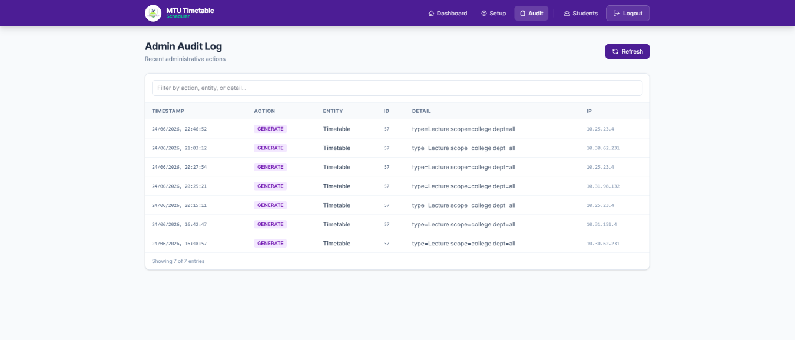
Figure 4.6: Audit Log Interface Showing Searchable History of Recent Administrative Actions
Testing confirmed that every tested administrative operation — course creation, venue update, lecturer deletion, and timetable generation — produced a corresponding entry in the audit log, correctly recording the action type, the affected entity and its identifier, a detail string summarising the specific change, the originating client IP address, and a timestamp. No mechanism was exposed through the application programming interface for modifying or deleting existing audit log entries, confirming the intended immutability of the historical record. The frontend interface correctly retrieved and displayed the most recent audit entries in reverse chronological order, with text-based search filtering across action, entity type, and detail correctly narrowing the displayed results in all tested scenarios. This capability directly addresses the accountability and traceability gap identified in the problem statement of Chapter One.
4.2 Discussion of Findings
4.2.1 Effectiveness of the Heuristic Scheduling Approach
The analysis presented in Section 4.1.2 demonstrates that Adaptive Large Neighborhood Search is a sound algorithmic approach for the MTU timetabling problem across all three event types. The guarantee of zero hard constraint violations in the published output — enforced by heavy cost penalties during optimisation and a final feasibility sweep before publication — validates the central algorithmic design decision: that an adaptive in-memory meta-heuristic, despite offering no theoretical guarantee of global optimality, provides practically sufficient constraint satisfaction and schedule quality for a real-time web deployment environment.
Under conditions of high constraint density — where the number of courses to be scheduled approaches the upper bound of available slot-venue combinations — any bounded-time search may leave a small number of courses unscheduled, consistent with the theoretical behaviour of meta-heuristics under saturated constraint spaces (Abdipoor et al., 2023). The ALNS design mitigates this substantially: the conflict-targeted destroy operator dismantles congested regions of the schedule, the regret-2 repair operator prioritises courses with the fewest good remaining options, and the simulated-annealing acceptance criterion allows the search to traverse temporarily worse configurations that unlock better ones. Residual unscheduled courses are returned with diagnostic explanations of the dominant blocking factor. This justifies the provision of the drag-and-drop manual override interface as a complementary mechanism for placing residual unscheduled courses — a two-tier strategy that mirrors the approach recommended by Ceschia et al. (2023) for practical educational timetabling deployments.
4.2.2 Security of the SSO Architecture
The HMAC-based token exchange architecture demonstrated correct security behaviour in all isolated endpoint tests. The rejection of replayed one-time codes prevents session hijacking via URL interception, and the shared-secret verification prevents an external actor from obtaining valid portal codes without possession of the integration secret, whilst HMAC-SHA256 signing of the session tokens prevents token forgery and tampering. These security properties are consistent with the theoretical analysis presented by Dalimunthe et al. (2023), who demonstrate that HMAC-SHA256-signed tokens provide robust protection against forgery and replay under standard threat models. The tiered rate limiting applied to student authentication endpoints provides an additional layer of resilience against brute-force enumeration of valid matric numbers, consistent with the API security best practices articulated by Ojha (2024). The security guarantees of the design therefore hold at the unit level and will extend to the live integration once the MTU portal backend is configured to initiate the SSO handshake.
The outstanding live integration step does not diminish the architectural contribution of RO4. The three-step generate-redirect-exchange protocol is fully designed, documented, and implemented on the timetabling system side. The dependency on the MTU legacy portal's configuration is an external deployment constraint, not an architectural deficiency. This distinction is important: the system is integration-ready, and the SSO activation requires only a configuration step on the legacy portal side rather than any further development of the timetabling system itself.
4.2.3 Comparison with Pre-Existing Timetabling Approach at MTU
A direct comparison between the implemented system and the pre-existing manual timetabling process at MTU is instructive. Prior to implementation, timetable generation was a multi-day process involving cross-referencing spreadsheets, physical whiteboards, and sequential consultation between department heads, with course data re-entered from scratch for every new semester. The system documented by Omoregbee et al. (2022) for a comparable Nigerian polytechnic institution reported similar timescales and error rates.
The AI-assisted system reduces this process to a single administrative action — clicking the Generate button — followed by a brief review and optional manual adjustments via the drag-and-drop grid. The complete elimination of hard constraint violations in the automated output eliminates the category of clash-related errors that previously required post-publication corrections and informal communication chains. The Course Catalogue module further reduces the recurring burden of course data re-entry each semester. The Audit Log provides a layer of accountability entirely absent from the prior spreadsheet-based workflow, enabling administrators to trace the origin of any scheduling change. The student portal, once the live SSO integration with the MTU portal is activated, will eliminate the need to distribute timetables as WhatsApp PDF attachments, replacing a passive distribution mechanism with an active, student-queryable interface. In its current implementation, the portal already provides the full timetable filtering, viewing, and export functionality — the SSO activation is the sole remaining step to make it accessible to the wider student body.
These outcomes directly address each of the six problems identified in the problem statement of Chapter One: lecturer double-booking, venue capacity mismatches, student accessibility issues, rigid rescheduling, the absence of structured scheduling data and accountability, and redundant administrative data entry.
4.2.4 Technology Stack Evaluation
The React 19 and Node.js/Express 5 technology stack performed as expected throughout implementation and testing. The lightweight hook-based state management approach proved sufficient for the administrative dashboard without the additional complexity of a dedicated state management library. The Vite build tool provided markedly faster hot module replacement during development than legacy bundlers, reducing the development feedback loop and improving productivity.
Express 5's native async/await support in route handlers eliminated the explicit try/catch blocks required in Express 4, producing cleaner and more readable API route code. The docx, ExcelJS, and PDFKit libraries each delivered their respective export functionalities without significant integration challenges. The primary implementation difficulty encountered in the export services was the coordinate mapping required for the PDFKit landscape grid, which required iterative calibration against the rendered output.
The deployment architecture — Vercel for the frontend and Render for the backend — performed as designed. The Vercel CDN delivered the React frontend assets with consistently low latency, and the Render persistent web service correctly sustained the Node.js server process across the duration of development and testing. No execution timeout events were recorded during scheduling operations, validating the rationale for selecting a persistent hosting model over serverless platforms for the compute-intensive scheduling workload.
4.2.5 Limitations Encountered During Implementation
Two limitations were identified during the implementation and testing of the system. The first is the residual unscheduled-course problem discussed in Section 4.2.1: under high dataset saturation, a small number of courses may remain unscheduled within the fixed iteration budget and require manual placement via the drag-and-drop grid. Extending the iteration budget, hybridising the ALNS core with a population-based meta-heuristic, or delegating small residual subproblems to an exact solver would reduce the incidence of unscheduled courses at high saturation levels, and is identified as a recommendation for future development in Chapter Five.
The second limitation is the outstanding live SSO integration with the MTU Student Portal. Whilst the timetabling system's backend SSO endpoints and the student portal frontend are fully implemented and verified in isolation, the live server-to-server handshake with the MTU legacy portal has not been completed within the project timeline, as it requires access to the legacy portal's deployment environment and codebase. This is identified as the highest-priority item for immediate post-submission deployment work. Once the MTU portal backend is configured to initiate the authorisation request with a valid HMAC-SHA256 signature, the complete SSO flow will be operational without further development on the timetabling system side. The longer-term architectural limitation — the symmetric-key dependency of the HMAC approach — is acknowledged, and migration to an asymmetric-key OpenID Connect protocol is recommended in Section 5.2 as a future enhancement.
CHAPTER FIVE
5.0 CONCLUSION AND RECOMMENDATIONS
This chapter synthesises the outcomes of the research, relates them to the aims and objectives stated in Chapter One, and draws conclusions with respect to the central research question: whether a purpose-built, open-source, AI-assisted timetable scheduling system can effectively address the scheduling deficiencies identified at Mountain Top University. Recommendations for future development are subsequently presented, grounded in the limitations identified during implementation and evaluation.
5.1 Conclusion
The research set out to design and implement a full-stack web-based AI-Assisted Timetable Scheduling and Management System specifically tailored to the institutional structure, constraints, and digital infrastructure of Mountain Top University, Ogun State, Nigeria. Eight research objectives were defined at the outset, and the evaluation presented in Chapter Four demonstrates that seven were fully achieved, with the eighth substantially achieved pending a single external deployment step.
The first objective — the provision of a centralised web-based entity management system — was fulfilled through an administrative dashboard providing full CRUD operations for all principal entity categories, augmented by a dynamic custom fields mechanism that allows the university to extend the course data model without schema migrations or source code modifications.
The second and most technically demanding objective — the development of an AI-assisted scheduling engine spanning three dedicated scheduling functions for lectures, examinations, and tests — was met through the scheduler.js module, whose Adaptive Large Neighborhood Search core combines a greedy warm start, five adaptive destroy operators, three repair operators, a simulated-annealing acceptance criterion, and multi-start optimisation. The engine was demonstrated to enforce all defined hard constraints with zero violations in its published output across tested scenarios, including the deliberate exemption for joint classes sharing a session key. This outcome confirms that an adaptive in-memory meta-heuristic approach is practically sufficient for the timetabling problem at MTU-semester scale, consistent with the meta-heuristic performance evidence surveyed by Abdipoor et al. (2023).
The third objective — a drag-and-drop manual override interface with real-time conflict detection — was fully implemented and tested. The interface provides a critical complement to automated generation, enabling administrators to apply institutional knowledge not encodable in the constraint model whilst retaining the safety guarantee of automated conflict prevention. This two-tier approach represents best practice in practical educational timetabling system design, as documented by Ceschia et al. (2023).
The fourth objective — the design and implementation of a Student Portal with an HMAC-based SSO architecture for integration with the legacy MTU Student Portal — was substantially achieved. The student portal frontend was fully implemented as a React 19 application providing personalised timetable views, filtering, and export. The backend SSO endpoints were implemented and verified in isolation: the one-time code generation, shared-secret verification, code invalidation on exchange, and HMAC-signed session token issuance all functioned correctly in unit-level testing. The live server-to-server handshake with the existing MTU portal infrastructure remains the single outstanding integration step, dependent on access to the legacy portal deployment environment.
The fifth objective — timetable export in PDF, Excel, and Word formats — was fully implemented using three in-memory document generation libraries. All three formats produced correctly structured downloadable documents, with the in-memory generation approach demonstrating adequate performance under simulated concurrent load conditions.
The sixth objective — a Repository Pattern architecture decoupling application logic from the database provider — was validated through parity probes and smoke tests confirming a consistent JSON response contract across all entity types, including the audit log and course catalogue introduced under the seventh and eighth objectives, and demonstrated in practice by the system’s scripted migration from SQLite to Supabase PostgreSQL and its environment-switchable student data source. This demonstrates that well-applied software design patterns can insulate application logic from database vendor dependencies (Jabeen Ali, 2022).
The seventh objective — a Course Catalogue module enabling reusable course definitions — was fully implemented, with testing confirming that catalogued courses could be imported into new timetables without manual re-entry, directly addressing the redundant data entry problem identified in the problem statement.
The eighth objective — a comprehensive Audit Log recording every administrative action — was fully implemented as an append-only database table with a paginated, searchable frontend interface. Testing confirmed that all tested administrative operations produced correctly structured, immutable log entries, addressing the accountability gap identified in the problem statement.
Taken together, these outcomes demonstrate that the MTU AI-Assisted Timetable Scheduling and Management System constitutes a substantially complete, technically sound, and institutionally relevant solution to the timetabling challenges documented at Mountain Top University. Seven of the eight research objectives were fully achieved; the fourth is implementation-complete on the timetabling system side and requires only a configuration step on the legacy portal to activate. The system was built entirely using open-source technologies, carries no recurring licensing costs, and is fully owned by the institution — attributes that distinguish it from commercial alternatives and make it financially sustainable in the Nigerian private university context documented by Egielewa et al. (2022). The project further provides a reproducible case study that may inform future development efforts at peer Nigerian institutions (Omoregbee et al., 2022; Abubakar et al., 2026; Techie-Menson & Nyagorme, 2021).
5.2 Recommendations
Based on the limitations identified during implementation and evaluation, and on the broader technical landscape reviewed in Chapter Two, the following recommendations are made for future development:
Recommendation 1 — Completion of the Live SSO Integration with the MTU Student Portal
The highest-priority outstanding task for the system is the completion of the live server-to-server SSO integration between the timetabling system and the existing MTU Student Portal. The timetabling system's backend SSO endpoints are fully implemented, tested, and deployed. The remaining step is the configuration of the MTU portal backend to initiate the authorisation request with a valid HMAC-SHA256 signature when a student clicks the portal link. This requires access to the legacy portal's codebase and deployment environment, and is estimated to require minimal development effort once that access is obtained. Upon completion, the student portal will be accessible to the entire MTU student population through their existing portal credentials, fulfilling RO4 in full.
Recommendation 2 — Hybridisation and Parameter Tuning of the ALNS Scheduling Engine
The most significant algorithmic limitation of the current scheduling engine is that, under conditions of very high constraint density, a small number of courses may remain unscheduled within the fixed iteration budget. It is recommended that the ALNS core be extended with a hybrid meta-heuristic phase — for example, applying a Genetic Algorithm’s crossover and mutation operators to the pool of best solutions retained across the four multi-start runs — to explore recombinations that resolve remaining unscheduled placements. Abdipoor et al. (2023) document several hybrid architectures of this kind that have demonstrated measurable reductions in unscheduled course counts. Systematic tuning of the ALNS parameters — the iteration budget, destroy fraction bounds, and annealing schedule — against recorded MTU datasets is also recommended.
Recommendation 3 — Real-Time Push Notifications for Timetable Changes
When an administrator reschedules a course via the drag-and-drop grid, affected students have no automatic notification mechanism. It is recommended that a real-time push notification system be integrated using Supabase's WebSocket subscription capability. For students not currently accessing the portal, supplementary SMS alerts via a Nigerian bulk SMS gateway could be implemented as an optional administrative trigger, addressing the mobile accessibility challenges documented for Nigerian university students by Egielewa et al. (2022).
Recommendation 4 — Native Mobile Application for the Student Portal
A native React Native implementation of the student portal is recommended, enabling home-screen timetable widgets, offline access via local device storage, and native push notifications. React Native's cross-platform compilation would cover the full range of smartphone platforms in the MTU student population, reusing the existing API contract and HMAC SSO flow without modification.
Recommendation 5 — Migration to Asymmetric-Key SSO Integration
The current HMAC-SHA256 SSO integration relies on a shared symmetric secret. Should the legacy portal undergo a future infrastructure upgrade, migration to OpenID Connect with an asymmetric-key identity provider is recommended, eliminating the shared-secret dependency. This is consistent with the authentication best practices for web applications articulated by Ojha (2024) and the broader OAuth2 framework analysis by Dalimunthe et al. (2023).
Recommendation 6 — Venue Utilisation, Lecturer Workload, and Audit Analytics
An analytics module is recommended to exploit both the JSONB timetable document storage and the structured audit log, providing venue utilisation reports, lecturer workload distribution audits, and summarised administrative activity reports. Both timetable and audit report types can be generated by querying the respective JSONB columns using PostgreSQL's native JSON operators without requiring schema changes, making this a low-cost, high-value enhancement that supports the evidence-based resource planning goals identified by Afolayan and Afolayan (2022).
Recommendation 7 — Formal Usability Evaluation
A structured usability study employing the System Usability Scale (SUS) or a task-completion protocol with representative administrative and student user cohorts is recommended. Such a study would provide objective, publishable evidence of the system's human-computer interaction effectiveness and identify interface pain-points not apparent during developer-led testing, informing targeted refinements prior to full institutional deployment.
In conclusion, the MTU AI-Assisted Timetable Scheduling and Management System represents a technically successful, institutionally relevant, and academically documented contribution to the digital transformation of academic administration at Mountain Top University. The recommendations above outline a clear and achievable development roadmap for subsequent iterations.

REFERENCES
Abdipoor, S., Yaakob, R., Goh, S. L., & Abdullah, S. (2023). Meta-heuristic approaches for the University Course Timetabling Problem. Intelligent Systems with Applications, 19, 200253. https://doi.org/10.1016/j.iswa.2023.200253
Abubakar, S., Dauda, M. K., Abdullahi Musa, M., & Muhammad, B. M. (2026). Design and implementation of a web-based lecture timetable scheduling system. Journal of Informatics and Web Engineering, 5(1), 252–266. https://doi.org/10.33093/jiwe.2026.5.1.16
Afolayan, A. A., & Afolayan, T. A. (2022). Digital transformation in Nigerian universities: Impact of student information systems. Journal of Educational Technology Systems, 50(2), 221–238. https://doi.org/10.1177/00472395221087002
Benedetti, P., Femminella, M., Reali, G., & Steenhaut, K. (2021). Experimental analysis of the application of serverless computing to IoT platforms. Sensors, 21(3), 928. https://doi.org/10.3390/s21030928
Blinowski, G., Ojdowska, A., & Przybyłek, A. (2022). Monolithic vs. microservice architecture: A performance and scalability evaluation. IEEE Access, 10, 20357–20374. https://doi.org/10.1109/ACCESS.2022.3152803
Ceschia, S., Di Gaspero, L., & Schaerf, A. (2023). Educational timetabling: Problems, benchmarks, and state-of-the-art results. European Journal of Operational Research, 308(1), 1–18. https://doi.org/10.1016/j.ejor.2022.07.011
Dalimunthe, S., Hasri Putra, E., & Fadhly Ridha, M. A. (2023). Restful API security using JSON Web Token (JWT) with HMAC-SHA512 algorithm in session management. IT Journal Research and Development, 8(1), 81–94. https://doi.org/10.25299/itjrd.2023.12029
Durner, D., Leis, V., & Neumann, T. (2021). JSON tiles: Fast analytics on semi-structured data. In Proceedings of the 2021 International Conference on Management of Data (SIGMOD '21) (pp. 445–458). ACM. https://doi.org/10.1145/3448016.3452809
Egielewa, P., Idogho, P. O., Iyalomhe, F. O., & Cirella, G. T. (2022). COVID-19 and digitized education: Analysis of online learning in Nigerian higher education. E-Learning and Digital Media, 19(1), 19–35. https://doi.org/10.1177/20427530211022808
Ehsan, A., Abuhaliqa, M. A. M. E., Catal, C., & Mishra, D. (2022). RESTful API testing methodologies: Rationale, challenges, and solution directions. Applied Sciences, 12(9), 4369. https://doi.org/10.3390/app12094369
Grudniak, M., & Dzieńkowski, M. (2021). REST API performance comparison of web applications based on JavaScript programming frameworks. Journal of Computer Sciences Institute, 19, 121–125. https://doi.org/10.35784/jcsi.2620
Jabeen Ali, A. (2022). Optimizing software architecture: Using the Repository Pattern in decoupling data access logic. International Scholarly Journal of Engineering and Management (ISJEM), 1(1), 1–7. https://doi.org/10.55041/ISJEM00104
Jonathan, R., & Suprihadi, S. (2023). Development of front-end web applications utilizing single page application framework and React.js library. International Journal of Research in Applied Science and Engineering Technology (IJRASET), 11(12), 701–712. https://doi.org/10.22214/ijraset.2023.57393
Miłosierny, B., & Dzieńkowski, M. (2021). The comparative analysis of web applications frameworks in the Node.js ecosystem. Journal of Computer Sciences Institute, 18, 42–48. https://doi.org/10.35784/jcsi.2423
Ojha, P. R. (2024). Securing the digital frontier: Best practices for RESTful API protection in modern web applications. International Journal of Engineering and Technology Research (IJETR), 9(2), 481–491. https://doi.org/10.5281/zenodo.13860934
Omoregbee, O. H., Ihama, E. I., Izogie, L. E., & Otamere, F. M. (2022). Web-based student time-table management system. Edo Poly Journal of Science, Technology and Management, 1(1), 89–103.
Techie-Menson, H., & Nyagorme, P. (2021). Design and implementation of a web-based timetable system for higher education institutions. International Journal of Educational Research and Information Science, 7(1), 1–13. https://doi.org/10.11648/j.ijires.20210701.11
Tong, J., Jikson, R. R., & Gunawan, A. A. S. (2023). Comparative performance analysis of Javascript frontend web frameworks. In 2023 3rd International Conference on Electronic and Electrical Engineering and Intelligent System (ICE3IS) (pp. 81–86). IEEE. https://doi.org/10.1109/ICE3IS59323.2023.10335250
Wu, Y., Luo, H., & Liu, Y. (2023). SQLite embedded database in data chain devices. In Proceedings of the Sixth International Conference on Advanced Electronic Materials, Computers, and Software Engineering (AEMCSE 2023), Proc. SPIE 12787, 127870Y. https://doi.org/10.1117/12.3004802
Yang, J., Abraham, A., & Gupta, L. (2024). Analyzing the features, usability, and performance of deploying a containerized mobile web application on serverless cloud platforms. Future Internet, 16(12), 475. https://doi.org/10.3390/fi16120475

APPENDIX A
Complete Database Schema (DDL)
The following SQL DDL script, reproduced from server/database/supabase_schema.sql in the project repository, defines the relational schema as deployed on the Supabase PostgreSQL production database. All statements use CREATE TABLE IF NOT EXISTS and may be executed against a fresh Supabase project to initialise the schema without risk of duplication. Note that the timetables table is created before the courses table, as the latter references the former via a foreign key. The seed data statements included at the end of the source file, and the course_catalog master library table provisioned in the production instance, are reproduced after the core schema.
-- MTU Timetable App - Initial Supabase/Postgres Schema
-- Apply this in Supabase SQL Editor before setting DB_PROVIDER=supabase

create table if not exists public.colleges (
id bigint generated always as identity primary key,
code text not null unique,
name text not null,
is_active boolean not null default true,
created_at timestamptz not null default now()
);

create table if not exists public.departments (
id bigint generated always as identity primary key,
code text not null unique,
name text not null,
college_code text not null references public.colleges(code) on delete cascade,
is_active boolean not null default true,
created_at timestamptz not null default now()
);

create table if not exists public.lecturers (
id bigint generated always as identity primary key,
name text not null,
department_code text references public.departments(code) on delete set null,
email text,
created_at timestamptz not null default now()
);

create table if not exists public.venues (
id bigint generated always as identity primary key,
name text not null unique,
college_code text references public.colleges(code) on delete set null,
capacity integer not null default 0,
created_at timestamptz not null default now()
);

create table if not exists public.scheduling_rules (
id bigint generated always as identity primary key,
name text not null,
rule_key text not null unique,
rule_value text not null,
is_active boolean not null default true,
created_at timestamptz not null default now()
);

create table if not exists public.timetables (
id bigint generated always as identity primary key,
type text not null,
name text,
academic_session text,
semester text,
status text not null default 'Draft',
data jsonb not null default '{"scheduled":[],"unscheduled":[]}'::jsonb,
created_at timestamptz not null default now(),
updated_at timestamptz not null default now(),
college text
);

create table if not exists public.courses (
id bigint generated always as identity primary key,
code text not null,
title text not null,
college text,
department text not null,
level integer not null,
lecturers jsonb not null default '[]'::jsonb,
units integer not null,
semester text not null,
type text not null,
is_compulsory boolean not null default false,
preferred_day text,
preferred_time text,
venue text,
duration integer,
student_count integer,
custom_data jsonb not null default '{}'::jsonb,
timetable_id bigint references public.timetables(id) on delete cascade
);

alter table public.courses
add column if not exists is_compulsory boolean not null default false;

create table if not exists public.custom_fields (
id bigint generated always as identity primary key,
name text not null unique,
label text not null,
type text not null,
required boolean not null default false
);

create table if not exists public.students (
id bigint generated always as identity primary key,
matric_number text not null unique,
name text not null,
department text not null,
level integer not null
);

create table if not exists public.student_courses (
id bigint generated always as identity primary key,
student_matric text not null references public.students(matric_number) on delete cascade,
course_code text not null,
status text not null
);

create table if not exists public.student_results (
id bigint generated always as identity primary key,
student_matric text not null references public.students(matric_number) on delete cascade,
course_code text not null,
score integer,
grade text,
remarks text,
session text
);

create index if not exists idx_courses_timetable_id on public.courses (timetable_id);
create index if not exists idx_courses_code on public.courses (code);
create index if not exists idx_courses_scope on public.courses (college, department, level, semester, type);
create index if not exists idx_timetables_type_updated on public.timetables (type, updated_at desc);
create index if not exists idx_timetables_college_updated on public.timetables (college, updated_at desc);
create index if not exists idx_student_courses_lookup on public.student_courses (student_matric, status);
create index if not exists idx_student_results_lookup on public.student_results (student_matric);
create index if not exists idx_departments_college_code on public.departments (college_code);
create index if not exists idx_venues_college_code on public.venues (college_code);

create table if not exists public.audit_log (
id bigint generated always as identity primary key,
action text not null,
entity_type text not null,
entity_id text not null,
detail text,
ip_address text,
created_at timestamptz not null default now()
);

create index if not exists idx_audit_log_created_at on public.audit_log (created_at desc);

-- Course catalogue master library (provisioned in the production
-- Supabase instance; accessed via the course catalogue repository)
create table if not exists public.course_catalog (
id bigint generated always as identity primary key,
code text not null,
title text not null,
college text,
department text not null,
level integer not null,
lecturers jsonb not null default '[]'::jsonb,
units integer not null,
semester text not null,
type text not null,
is_compulsory boolean not null default false,
preferred_day text default 'AUTO',
preferred_time text default 'AUTO',
venue text,
duration integer,
custom_data jsonb not null default '{}'::jsonb
);
APPENDIX B
AI Scheduling Engine Source Code (server/ai/scheduler.js)
The following listing reproduces the core of the ALNS scheduling engine from server/ai/scheduler.js: the tuning constants and cost weights, the cost function that scores candidate assignments, the greedy warm start, the adaptive search loop, the multi-start wrapper, the feasibility sweep, and the three public scheduler entry points. The individual destroy and repair operators and the diagnostic utilities are omitted for brevity; the full, unabridged source is available in the project repository.
// =============================================================================
// MTU Timetable Scheduler — Adaptive Large Neighborhood Search (ALNS)
// =============================================================================
// Algorithm overview:
// 1. Greedy warm-start builds an initial complete assignment.
// 2. ALNS iteratively destroys a structured subset of the assignment and
// repairs it, adapting operator selection weights based on past performance.
// 3. A simulated-annealing acceptance criterion allows escaping local optima.
// 4. The best solution seen across all iterations is returned.
// =============================================================================

// --- CONSTANTS ---
const DAYS = ['Monday', 'Tuesday', 'Wednesday', 'Thursday', 'Friday'];
const TIMES = ['9:00','10:00','11:00','12:00','13:00','14:00','15:00','16:00','17:00','18:00'];
const EXAM_SLOTS = [
{ name: 'Morning', time: '9:00-12:00' },
{ name: 'Afternoon', time: '12:00-15:00' },
{ name: 'Evening', time: '15:00-18:00' },
];

// --- ALNS TUNING ---
const ALNS_ITERATIONS = 3000; // total move attempts (scaled up for large inputs)
const ALNS_SEGMENT = 60; // iterations per weight-update cycle
const ALNS_REACTION = 0.18; // weight adaptation speed [0=frozen, 1=instant]
const ALNS_DESTROY_MIN = 0.10; // min fraction of courses to remove each iteration
const ALNS_DESTROY_MAX = 0.30; // max fraction
const ALNS_SCORE_NEW_BEST = 9;
const ALNS_SCORE_IMPROVED = 3;
const ALNS_SCORE_ACCEPTED = 1;
const ALNS_INIT_TEMP = 60;
const ALNS_COOLING = 0.997;

// --- COST WEIGHTS ---
const COST = {
ROOM_CONFLICT: 1000,
LECTURER_CONFLICT: 1000,
LEVEL_CONFLICT: 1000,
DAILY_HOURS_EXCEED: 500,
// soft
PREFERRED_DAY_MISS: 10,
PREFERRED_TIME_MISS: 5,
COMPULSORY_LATE: 8,
ROOM_UNASSIGNED: 15,
ROOM_UNDERSIZED: 20,
WORKLOAD_IMBALANCE: 3,
};

// … (section omitted for brevity — see repository for full source) …

// COST FUNCTION
// =============================================================================

const computeCost = (assignment, venues, maxDailyHours) => {
let cost = 0;
const n = assignment.length;

// Build slot index
const bySlot = {};
for (let i = 0; i < n; i++) {
const k = `${assignment[i].day}|${assignment[i].time}`;
(bySlot[k] = bySlot[k] || []).push(i);
}

// Daily minutes per dept+level+day
const dailyMin = {};
for (const e of assignment) {
const k = `${e.department}|${e.level}|${e.day}`;
dailyMin[k] = (dailyMin[k] || 0) + Number(e.duration || 60);
}
for (const [, mins] of Object.entries(dailyMin)) {
if (mins > maxDailyHours * 60)
cost += COST.DAILY_HOURS_EXCEED * Math.ceil((mins - maxDailyHours * 60) / 60);
}

// Pairwise conflicts within same slot
for (const indices of Object.values(bySlot)) {
if (indices.length < 2) continue;
for (let a = 0; a < indices.length; a++) {
for (let b = a + 1; b < indices.length; b++) {
const ea = assignment[indices[a]];
const eb = assignment[indices[b]];
const sameShared = Boolean(getSharedKey(ea)) && getSharedKey(ea) === getSharedKey(eb);
if (sameShared) continue;

const as = parseTime(ea.time), ae = as + Number(ea.duration || 60);
const bs = parseTime(eb.time), be = bs + Number(eb.duration || 60);
if (as >= be || bs >= ae) continue;

if (ea.venue && eb.venue && ea.venue !== 'Unassigned' && ea.venue === eb.venue)
cost += COST.ROOM_CONFLICT;
if (toLecturerArray(ea.lecturers).some(l => toLecturerArray(eb.lecturers).includes(l)))
cost += COST.LECTURER_CONFLICT;
if (ea.department === eb.department && ea.level === eb.level)
cost += COST.LEVEL_CONFLICT;
}
}
}

// Per-entry soft costs
for (const e of assignment) {
if (e._prefDay && e._prefDay !== 'AUTO' && e.day !== e._prefDay) cost += COST.PREFERRED_DAY_MISS;
if (e._prefTime && e._prefTime !== 'AUTO' && e.time !== e._prefTime) cost += COST.PREFERRED_TIME_MISS;
if (isCompulsoryCourse(e) && parseTime(e.time) >= parseTime('15:00')) cost += COST.COMPULSORY_LATE;
if (!e.venue || e.venue === 'Unassigned') {
cost += COST.ROOM_UNASSIGNED;
} else if (venues.length > 0) {
const vo = venues.find(v => v.name === e.venue);
if (vo && Number(e.student_count || 0) > Number(vo.capacity || 0))
cost += COST.ROOM_UNDERSIZED;
}
}

// Workload balance per dept+level
const perDay = {};
for (const e of assignment) {
const k = `${e.department}|${e.level}`;
if (!perDay[k]) perDay[k] = Array(DAYS.length).fill(0);
const di = DAYS.indexOf(e.day);
if (di >= 0) perDay[k][di]++;
}
for (const counts of Object.values(perDay)) {
const total = counts.reduce((s, c) => s + c, 0);
const avg = total / DAYS.length;
const max = Math.max(...counts);
cost += COST.WORKLOAD_IMBALANCE * Math.max(0, max - Math.ceil(avg));
}

return cost;
};

// … (section omitted for brevity — see repository for full source) …

// GREEDY WARM-START
// =============================================================================

const greedyWarmStart = (courses, slots, venues, maxDailyHours) => {
const sorted = [...courses].sort((a, b) => {
const ac = isCompulsoryCourse(a) ? 1 : 0, bc = isCompulsoryCourse(b) ? 1 : 0;
if (ac !== bc) return bc - ac;
return Number(b.units || 0) - Number(a.units || 0);
});
const assignment = [];
for (const course of sorted) {
let placed = false;
const candidates = [];
if (course.preferred_day !== 'AUTO' && course.preferred_time !== 'AUTO')
candidates.push({ day: course.preferred_day, time: course.preferred_time });
candidates.push(...[...slots].sort(() => 0.5 - Math.random()));
for (const s of candidates) {
const dailyMins = assignment
.filter(e => e.day === s.day && e.department === course.department && Number(e.level) === Number(course.level))
.reduce((sum, e) => sum + Number(e.duration || 60), 0);
if (dailyMins + Number(course.duration || 60) > maxDailyHours * 60) continue;
assignment.push({
...course,
day: s.day,
time: s.time,
venue: pickVenue(course, s.day, s.time, assignment, venues),
_prefDay: course.preferred_day,
_prefTime: course.preferred_time,
});
placed = true;
break;
}
if (!placed) {
const s = randItem(slots);
assignment.push({
...course,
day: s.day,
time: s.time,
venue: pickVenue(course, s.day, s.time, assignment, venues),
_prefDay: course.preferred_day,
_prefTime: course.preferred_time,
});
}
}
return assignment;
};

// ALNS CORE
// =============================================================================

// Single ALNS run — internal, called by runMultiStartALNS
const runALNS = (initial, slots, venues, maxDailyHours) => {
const destroyOps = [
destroyRandom,
destroyLecturer,
destroyLevel,
destroyConflicts,
destroyDay,
];
const repairOps = [repairGreedy, repairRegret, repairRandom];

const dWeights = makeWeights(destroyOps);
const rWeights = makeWeights(repairOps);
let dScores = dWeights.map(() => 0), dCounts = dWeights.map(() => 0);
let rScores = rWeights.map(() => 0), rCounts = rWeights.map(() => 0);

let current = cloneArr(initial);
let currentCost = computeCost(current, venues, maxDailyHours);
let best = cloneArr(current);
let bestCost = currentCost;

const maxIter = Math.max(ALNS_ITERATIONS, initial.length * 30);
let T = ALNS_INIT_TEMP;

for (let iter = 0; iter < maxIter; iter++) {
// Select operators via roulette wheel
const di = rouletteSelect(dWeights);
const ri = rouletteSelect(rWeights);

// Compute destroy fraction — slightly random within bounds
const frac = ALNS_DESTROY_MIN + Math.random() * (ALNS_DESTROY_MAX - ALNS_DESTROY_MIN);

// Destroy — all operators use the same signature (assignment, frac)
const dOp = destroyOps[di];
let { kept, removed } = dOp(current, frac);

if (!removed.length) { continue; }

// Repair
const candidate = repairOps[ri](kept, removed, slots, venues, maxDailyHours);
const candidateCost = computeCost(candidate, venues, maxDailyHours);
const delta = candidateCost - currentCost;

dCounts[di]++; rCounts[ri]++;

let score = 0;
if (candidateCost < bestCost) {
best = cloneArr(candidate);
bestCost = candidateCost;
score = ALNS_SCORE_NEW_BEST;
} else if (candidateCost < currentCost) {
score = ALNS_SCORE_IMPROVED;
} else if (Math.random() < Math.exp(-delta / Math.max(T, 0.01))) {
score = ALNS_SCORE_ACCEPTED;
}

if (score > 0) {
current = candidate;
currentCost = candidateCost;
}

dScores[di] += score; rScores[ri] += score;

// Update weights at end of each segment
if ((iter + 1) % ALNS_SEGMENT === 0) {
updateWeights(dWeights, dScores, dCounts, ALNS_REACTION);
updateWeights(rWeights, rScores, rCounts, ALNS_REACTION);
dScores = dWeights.map(() => 0); dCounts = dWeights.map(() => 0);
rScores = rWeights.map(() => 0); rCounts = rWeights.map(() => 0);
}

T *= ALNS_COOLING;
}

return { schedule: best, finalCost: bestCost };
};

// Multi-start wrapper — runs ALNS `runs` times from independent warm starts
// and returns the best solution found across all runs.
const ALNS_RUNS = 4;

const runMultiStartALNS = (courses, slots, venues, maxDailyHours) => {
let best = null;
let bestCost = Infinity;

for (let r = 0; r < ALNS_RUNS; r++) {
const initial = greedyWarmStart(courses, slots, venues, maxDailyHours);
const { schedule, finalCost } = runALNS(initial, slots, venues, maxDailyHours);
if (finalCost < bestCost) {
bestCost = finalCost;
best = schedule;
}
}

return { schedule: best, finalCost: bestCost };
};

// =============================================================================
// POST-PROCESSING
// =============================================================================

const cleanEntry = ({ _prefDay, _prefTime, ...rest }) => rest;

// Courses that still have unresolvable hard conflicts go to `unscheduled`
const separateUnscheduled = (schedule, venues, maxDailyHours) => {
const scheduled = [], unscheduled = [];
for (const entry of schedule) {
const es = parseTime(entry.time), ee = es + Number(entry.duration || 60);
const ek = getSharedKey(entry);
const conflict = scheduled.some(other => {
if (other.day !== entry.day) return false;
if (Boolean(ek) && ek === getSharedKey(other)) return false;
const os = parseTime(other.time), oe = os + Number(other.duration || 60);
if (es >= oe || os >= ee) return false;
if (other.venue && entry.venue && other.venue !== 'Unassigned' && other.venue === entry.venue) return true;
if (toLecturerArray(entry.lecturers).some(l => toLecturerArray(other.lecturers).includes(l))) return true;
if (other.department === entry.department && other.level === entry.level) return true;
return false;
});
(conflict ? unscheduled : scheduled).push(cleanEntry(entry));
}
return { scheduled, unscheduled };
};

// … (section omitted for brevity — see repository for full source) …

// =============================================================================
// PUBLIC SCHEDULERS
// =============================================================================

const generateLectureSchedule = async (courses, options = {}) => {
console.log('Generating Lecture Schedule (ALNS)...');
const lectures = applyFilters(courses, 'Lecture', options);

const rules = options.rules || {};
const maxDailyHours = Number(rules.max_daily_hours_per_level || 6);
const startHour = Number(rules.default_start_hour || 9);
const endHour = Number(rules.default_end_hour || 18);
const venues = options.venues || [];

const times = TIMES.filter(t => {
const h = Number(String(t).split(':')[0]);
return h >= startHour && h < endHour;
});
const slots = DAYS.flatMap(day => times.map(time => ({ day, time })));

if (!lectures.length) return { scheduled: [], unscheduled: [] };

const { schedule } = runMultiStartALNS(lectures, slots, venues, maxDailyHours);
return separateUnscheduled(schedule, venues, maxDailyHours);
};

const generateExamSchedule = async (courses, options = {}) => {
console.log('Generating Exam Schedule (ALNS)...');
const exams = applyFilters(courses, 'Exam', options);
const venues = options.venues || [];
const slots = DAYS.flatMap(day => EXAM_SLOTS.map(s => ({ day, time: s.time })));

if (!exams.length) return { scheduled: [], unscheduled: [] };

const maxDailyHours = 9;
const { schedule } = runMultiStartALNS(exams, slots, venues, maxDailyHours);

const annotated = schedule.map(e => ({
...e,
slotName: (EXAM_SLOTS.find(s => s.time === e.time) || {}).name || '',
venue: e.venue || 'Exam Hall',
}));
return separateUnscheduled(annotated, venues, maxDailyHours);
};

const generateTestSchedule = async (courses, options = {}) => {
console.log('Generating Test Schedule (ALNS)...');
const tests = applyFilters(courses, 'Test', options);
const venues = options.venues || [];
const slots = DAYS.flatMap(day => TIMES.map(time => ({ day, time })));

if (!tests.length) return { scheduled: [], unscheduled: [] };

const maxDailyHours = 6;
const { schedule } = runMultiStartALNS(tests, slots, venues, maxDailyHours);
return separateUnscheduled(schedule, venues, maxDailyHours);
};

module.exports = {
generateLectureSchedule,
generateExamSchedule,
generateTestSchedule,
hasConflict,
attachUnscheduledReasons,
generateQualityReport,
reoptimizeAround,
};
APPENDIX C
User Manual and System Interface Screenshots
This appendix provides a structured user manual for the system. Screenshots should be inserted under each subheading before final submission.
C.1 System Access
The complete source code for the system is publicly available at the following GitHub repository: https://github.com/idahosadavid/MTU-TIMETABLE-SCHEDULER. The live, deployed frontend application can be accessed at: https://mtu-timetable-scheduler.vercel.app/. Readers and examiners are encouraged to consult the repository for the full, unabridged codebase referenced throughout Chapters Three and Four and reproduced in part in Appendices A and B.
C.2 Administrative Dashboard
Navigate to the system URL and enter the administrative API key when prompted. Use the module cards to manage Colleges, Departments, Venues, Lecturers, Courses, the Course Catalogue, and Timetables. A screenshot of this interface is presented in Chapter Four as Figure 4.1.
C.3 Generating and Overriding a Timetable
Navigate to Timetables → New Timetable → Select type (Lecture, Exam, or Test), session, and semester → Click Generate. The corresponding AI scheduling function processes all relevant courses and displays the result in the grid within seconds, as shown in Figure 4.2. To manually override a placement, click and hold any scheduled course cell, drag it to the target timeslot, and release. Valid moves are saved automatically; invalid moves are rejected with a conflict notification identifying the violation type. This workflow is illustrated as an activity diagram in Figure 4.3.
C.4 Exporting a Timetable
Locate the Export panel in either the admin grid or the student portal → Select PDF, Excel (.xlsx), or Word (.docx) → Click Download. The document is generated in-memory and downloaded immediately. A screenshot of this interface is presented in Chapter Four as Figure 4.5.
C.5 Student Portal Access
The student portal is accessed by navigating to the timetabling system URL. In its current state, the portal displays a landing page titled 'MTU Timetable' instructing students to: (1) log in to the MTU Student Portal, and (2) click 'View My Timetable' to access their schedule. This landing page is the entry point that initiates the SSO redirect. Once the live MTU portal integration is activated, students will be redirected automatically to their personalised timetable view. A screenshot of the current landing page is presented in Chapter Four as Figure 4.4.
C.6 Course Catalogue
Navigate to the Course Catalogue module → Browse the master library of previously defined courses → Select a course and click Import to add it to the active timetable. Imported course fields are populated automatically, requiring no manual re-entry.
C.7 Audit Log
Navigate to the Audit Log module to view a searchable history of recent administrative actions, including creations, updates, deletions, and schedule generations, each displayed with a timestamp and a summary of the change. A screenshot of this interface is presented in Chapter Four as Figure 4.6.

