Demo Paper: Demonstrating Hybrid Provenance Queries from Script Runs

Yang Cao¹, Peter Slaughter⁵, Christopher Jones⁵, Matthew B. Jones⁵, Qiwen Wang², Duc Vu³, Priyaa Thavasimani⁴, Qian Zhang¹, Timothy McPhillips¹, Paolo Missier⁴, Lauren Walker⁵,
Dave Vieglais⁶, Bertram Ludäscher¹ ²
¹School of Information Sciences, University of Illinois at Urbana-Champaign
²Department of Computer Science, University of Illinois at Urbana-Champaign
³Department of Electrical and Computer Engineering, University of Illinois at Chicago
⁴School of Computing Science, Newcastle University, UK
⁵National Center for Ecological Analysis and Synthesis, UCSB, Santa Barbara, USA
⁶ University of Kansas, Lawrence, USA

Abstract
In this demo, we demonstrate prospective, retrospective, and hybrid provenances and queries with a prospective provenance tools -- YesWorkflow (YW) as example to answer provenance queries about provenance history. DataONE is a federated data network on earth and environmental science data and supports provenance storage, indexing and search. The demonstrated provenance capabilities can benefit earth researchers to understand the processing history of a derived products and verify them.

Introduction
Provenance from scripts and runs of scripts plays an important role in software debugging, testing, reliability and sharing. Such provenance traces consist of events that the user is interested in. A considerable amount of research has been done on investigating methods of harvesting provenance information from scripts and runs of scripts, ranging from conventional approaches, e.g. research compendium (folder layouts) and logging to recent provenance tools, e.g., YesWorkflow (YW) [6], noWorkflow (NW) [5], RDataTracker [8], Reprozip [9], RunManager [7, 10]. However, most existing tools focus on provenance harvesting and not enough attention has been paid to study provenance queries systematically. The work presented here is an attempt to fill the gap. In this demo, we demonstrate the provenance query capabilities for heterogeneous provenance tools.
Data provenance is metadata that describes the origin and processing history of a data artifact. In the computational and data sciences, we can distinguish two forms of data provenance, i.e., prospective and retrospective provenance. The former describes the general workflow by which data is produced, while the latter consists of runtime observables, e.g., names, locations, and contents of files read and written during a script run (coarse-grained observables). Fine-grained provenance can be captured as well, e.g., changes to individual data records, program variables, parameter settings, etc.
In this demo, YW is used as an example (extending earlier work [1]; see also [2]) will illustrate the variety of provenance information that we are able to capture, query, and visualize using a combination of tools for exposing both prospective and retrospective provenance. We show how prospective provenance can be expressed using YW annotations that reveal the retrospective provenance information recorded by
the DataONE Run Managers for MATLAB and R. More precisely, we aim to get the “best of both worlds”, by combining the detailed retrospective provenance, observed from a run of the script, with a conceptual view of the script itself, expressed using YW annotations. We refer to this as hybrid provenance: a graph containing an alternation of process steps, situated in the context of the entire process structure, and of the specific instances of data elements that have been generated and consumed by executions of those steps. The data elements can be instantiated to document the specific files used in a concrete workflow run.
Furthermore, we show how this model enables a longitudinal view of e-science experiments (i.e., studies over time), expressed by multi-run provenance. Since computational and data science experiments can often last days, weeks, or even months and often require the execution of multiple scripts or workflows with varying input datasets and parameters, some of these script runs appear as chained together implicitly via intermediate data files, i.e., the output of one script run was subsequently used as an input to another script run. In this way, larger ad-hoc dataflow graphs are generated as part of a data-driven, exploratory workflow. By multi-run provenance we are referring to those dataflow graphs that link individual script runs via intermediate data files.
To summarize, we demonstrate the usefulness of integrating prospective and retrospective provenance in this way with queries:

1. Prospective provenance queries in the context of a single script. This can expose and test data dependencies at the workflow-level.
2. Retrospective provenance queries in the context of a single run of a single script: captures actual input and output files of a script run and other runtime observables.
3. Hybrid provenance query in the context of a single script and single run: blends retrospective and prospective provenance, yielding new knowledge artifacts.
4. Provenance query in the context of multiple scripts and multiple runs: query and visualize data dependencies across multiple script runs.

Architecture & Provenance Query Capabilities
Figure 1 shows provenance query architecture. After a user annotates a script with YW tags a script (in Python, R, MATLAB, …), the dataflow graph implicit in the script can be revealed as a YW workflow model (left). System-recorded or user-provided runtime observables (right) can then be linked to the workflow model via suitable “bridge rules” (expressed e.g. as Prolog or SQL views), which in turn are used to generate new hybrid provenance graphs (center).
Figure 2 shows a code snippet from a MATLAB script with YW annotations: Here, the @begin and @end tags are used to mark code blocks (i.e., processing steps in the YW model); @in and @out tags are used to define the dataflow between blocks; and the @uri template (which is paired with an @in tag) is used to define a where the data file is located. Note that @uri templates define a metadata pattern via so-called template variables (here: {start_year}, {end_year}, and {month}). In this way, the script author can document the folder structure and file-naming conventions used by the script. When the script is run, concrete file- and folder-names are instantiated and can be harvested subsequently by YW to obtain runtime provenance information (even in the absence of a dedicated provenance recorder [4]). When combining this retrospective provenance information with the YW workflow model, hybrid provenance queries can be answered.
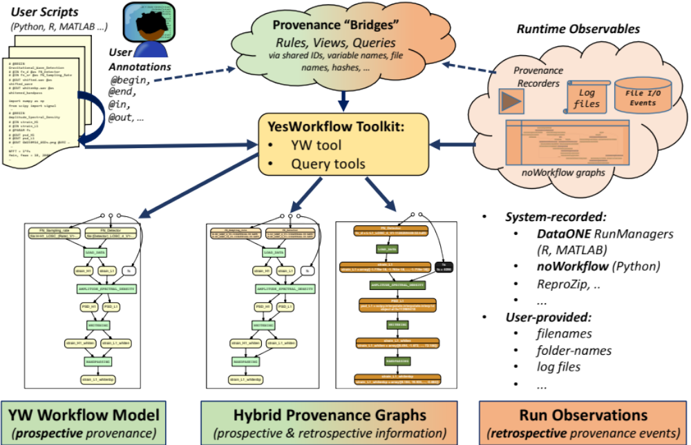

Figure 1 Provenance Query Architecture
Given the different aims of various retrospective provenance tools and the heterogeneous harvesting approaches they take, we find that each system supports different retrospective provenance queries. By combining YW prospective provenance with retrospective provenance, our hybrid queries can answer questions that neither approach could answer separately.
%% Load input: long-term monthly mean air temperature data
% @BEGIN fetch_monthly_mean_air_temperature_data
% @IN mean_airtemp
% @URI file:inputs/narr_air.2m_monthly/air.2m_monthly_{start_year}_{end_year}_mean.{month}.nc
% @OUT Tair @AS Tair_Matrix
Tair=zeros(ncols,nrows,12);
for m=1:12
tncid=netcdf.open(strcat('inputs/narr_air.2m_monthly/air.2m_monthly_2000_2010_mean.',
num2str(m),'.nc'),
'NC_NOWRITE');
tvid = netcdf.inqVarID(tncid, 'Tair_monthly_mean');
Tair(:,:,m) = netcdf.getVar(tncid,tvid);
netcdf.close(tncid)
end
% @END fetch_monthly_mean_air_temperature_data

Figure 2. A MATLAB code snippet for C3C4 example [1] with YesWorkflow annotations

Various Formats Provenance Tools and Methods

Table 1: Various Provenance Tools and Methods Breakdown
 | Language: Application / Implementation | Scope | Methods
YesWorkflow [6] | Any / Java | Prospective Provenance | Annotations added by users; language independent
URI-templates [4] | Any / Any | Retrospective Provenance | Templates matching with runtime file locations; language independent
Logging | Any /Any | User-defined Retrospective Provenance | Exported runtime variables/files provenance by users
noWorkflow [5] | Python / Python | Retrospective Provenance | Runtime function calls, variables, file inputs/outputs, execution environmental information
RunManager[7, 10] | R/ R  MATLAB/MATLAB | Retrospective Provenance | Runtime file inputs/outputs, execution environmental information

Table 1 lists a number of provenance tools. The provenance traces used for demonstration are harvested using a combination of the tools in Table 1. YesWorkflow is the only prospective provenance tool. It can query across these heterogeneous retrospective provenance traces to produce different types of artifacts.

Demo Provenance Queries and Results
To demonstrate different types of provenance queries, we have developed SQL queries as well as rule-based queries (implemented in XSB-Prolog) against different types of YW provenance facts. For example: What outputs does the workflow (script) have? Advanced provenance queries can take the form of regular path queries (RPQs), tree-structure queries, or graph queries and show the data lineage hidden in the provenance information. For example: (1) What are the ancestors or descendants of a given output in a prospective provenance graph? (2) What are the ancestors or descendants of a given output in a retrospective- or hybrid- provenance graph? (3) Which possible execution (i.e., dataflow) paths satisfy a given regular path expression? In this demo, we show each of these queries in action. The queries can be found at [1,12] as well as the use cases for IDCC practice paper.
Table 2. Concrete examples used in the demo

Domain | Demonstrated use case names  in example folder | Demonstrated provenance  methods
Astrophysics | LIGO [12] | YW+ (NW, ReproZip)
Social media | Twitter [12]  TwitterR [12] | YW+NW (Python)  YW (R)
Biodiversity data curation [13] | kurator-SPNHC16-YW-xsb [12] | YW+logging
Chemistry | simulate_data_collection [12] | YW+URI templates
Sociology / Ecology | OHIBC_Howe_Sound [12] | YW+RunManager (R)
Climate science | C3C4 [12] | YW+RunManager (MATLAB)

Querying YW Prospective Provenance. YW [6] provenance queries refer to workflow steps and data names declared via YW annotations. Example complete YW graph for the OHIBC_Howe_Sound example is pictured in Figure 3. This script written in R calculates the Ocean Health Index for Howe Sound, British Columbia.

Querying YW*noWorkflow (NW) Retrospective Provenance. YW*NW hybrid provenance queries refer to the YW model and the runtime input/output files exported from NW [5] generated provenance database by joining via URI templates and runtime file locations. Examples of complete reconstructed graph with all observables for the Twitter example is shown in Figure 4. The example script calculates contextual polarity of tweets.
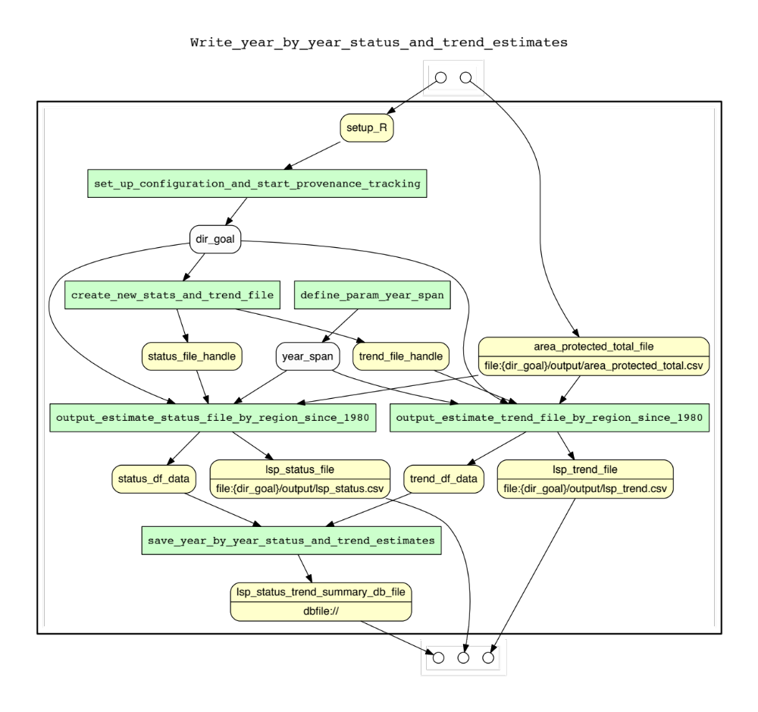
Figure 3. Complete YW prospective provenance graph for the OHIBC_Howe_Sound example

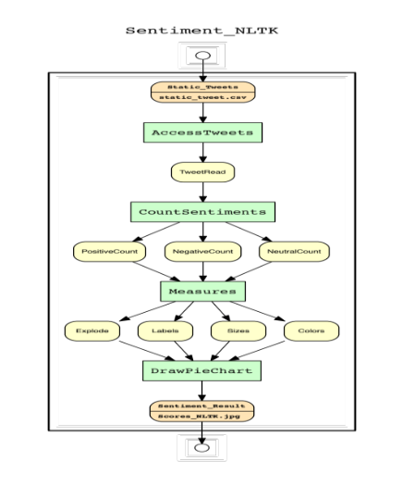
Figure 4. Complete reconstructed hybrid provenance graph for the Twitter example

Querying YW*URI-template-based Provenance. YW*URI-template-based provenance queries refer to YW model and provenance information contained in local file system layouts (research compendium) which has been documented in [4].

Querying YW*DataONE RunManager Retrospective Provenance. YW*DataONE RunManager hybrid provenance queries refer to YW model and runtime file-level retrospective provenance harvested by RunManager. Example is pictured in Figure 5 which is an enriched YW model graph with all file-level observables in a single run for a script. The example script (in MATLAB) produces Carbon 3/Carbon 4 (C3/C4) soil maps for North America using average rain and air temperature monthly data from year 2000 to 2010. Figure 6 shows a hybrid provenance graph for the OHIBC_Howe_Sound example (implemented in R).
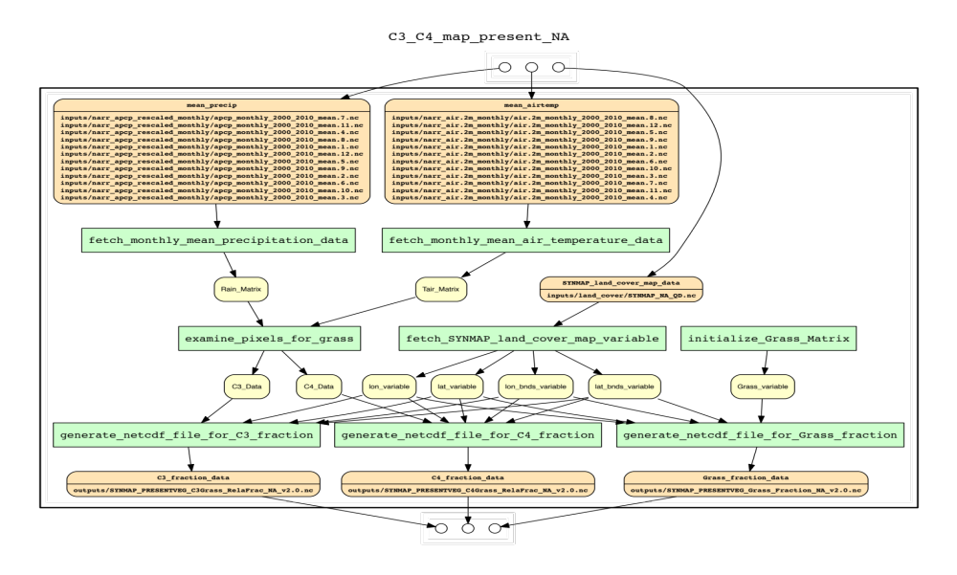
Figure 5. Complete reconstructed hybrid provenance graph for the C3C4 example (version 1) using YW and DataONE RunManager MATLAB client
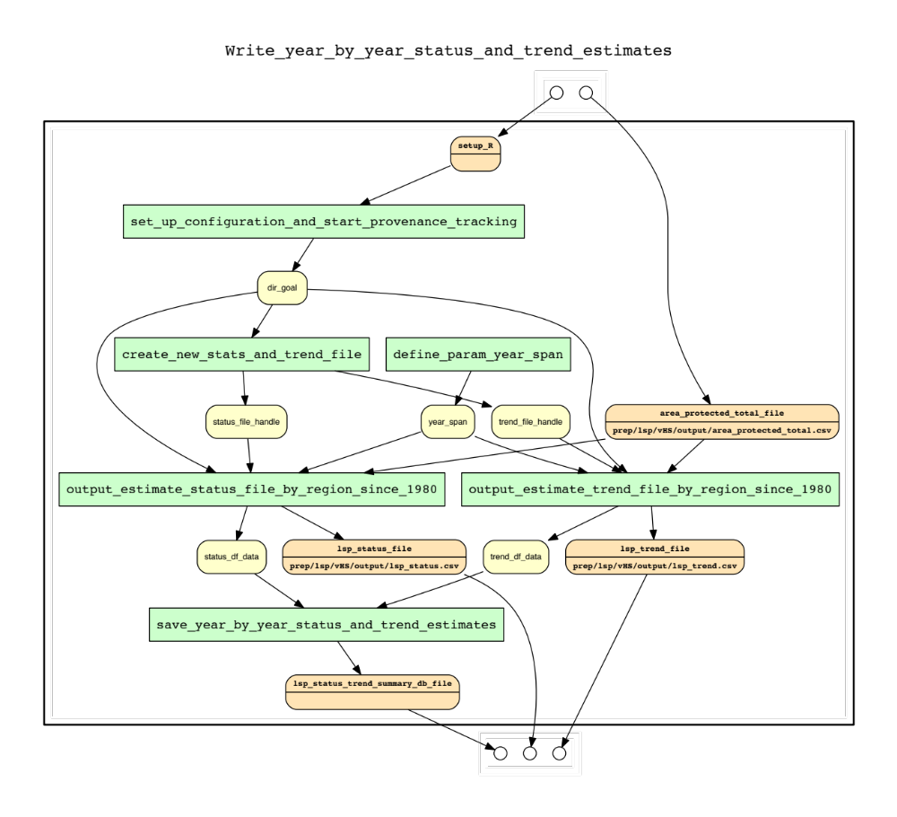
Figure 6. Complete reconstructed hybrid provenance graph for the OHIBC_Howe_Sound example using YW and DataONE RunManager R client

Querying DataONE RunManager Retrospective Provenance. RunManager [7,10] retrospective provenance queries refer to the runtime retrospective provenance obtained from executing multiple scripts, using RunManager. Since the scripts are logically connected through sharing some of their inputs and outputs, the corresponding provenance traces are also connected through shared data products. One example is pictured in Figure 7. The generated graph recorded a set of runs that consist of three scripts, five runs and the second script was run with two different parameter values (i.e., 2.5 and 5) twice. The example script set is called C3C4 example version 2.

Conclusions
Provenance is a useful component of the software development cycle, either to benefit researcher themselves or documenting and sharing code for use by future investigators. For the researcher, the quality of data produced by script runs can be assessed by identifying source data and verifying their quality.
Many provenance tools have been developed to capture, store, query and visualize the provenance produced by scripts and runs of scripts. But there is not enough investigation on what kind of provenance queries can be answered from the provenance information at prospective and retrospective provenance levels. Our research on prospective-, hybrid-, and retrospective- provenance queries allow researchers to use simple queries and a subset of advanced queries to query across YW model and various retrospective provenance to produce interesting provenance artifacts.
With our provenance query demo, we showcase our prospective-, retrospective-, and hybrid- query capabilities. We demonstrated that provenance queries across heterogeneous provenance can yield a more complete and comprehensible picture of data provenance.
The demonstration is available at: https://github.com/yesworkflow-org/yw-idcc-17 [12].

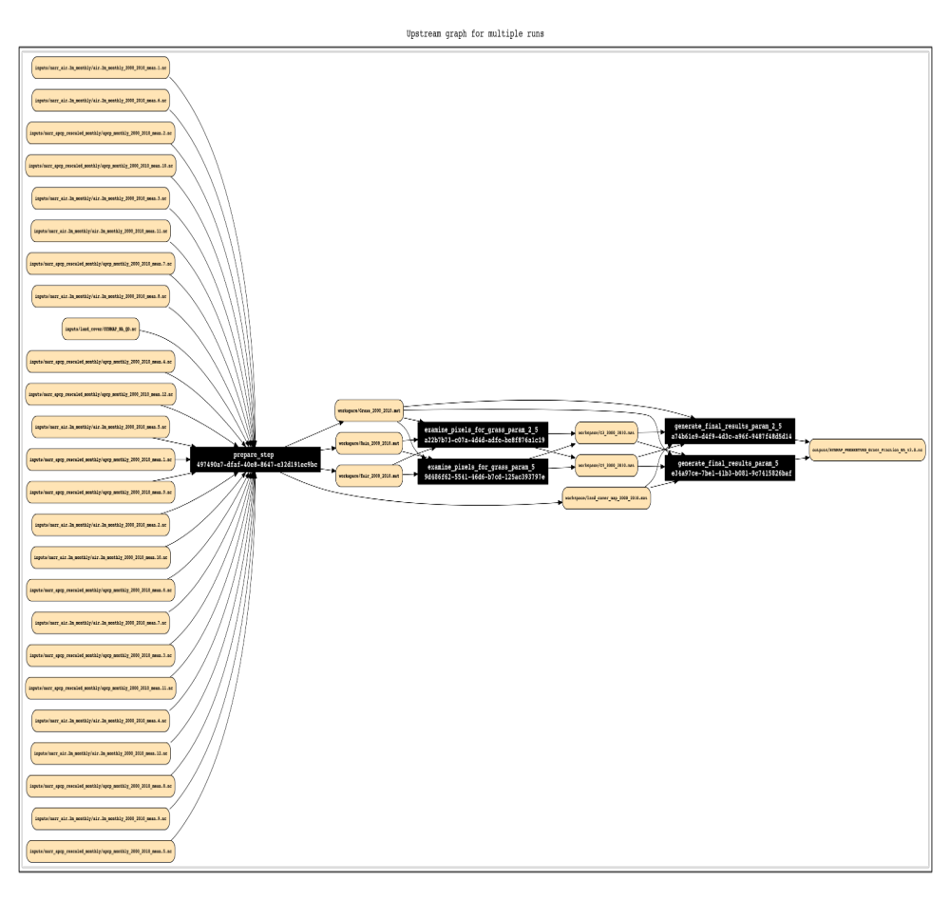
Figure 7 Upstream retrospective provenance subgraph (longitudinal view) recording multiple scripts and multiple runs for C3C4 (version 2) example

Acknowledgments. We thank DataONE for support of provenance research. DataONE [11] is a federated data network on earth and environmental science data. The demonstrated provenance capabilities can benefit the earth researchers to understand the processing history of a derived products and verify them. Work supported in part by NSF awards DBI-1356751 (Kurator), ACI-1430508 (DataONE), SMA-1637155 (SKOPE), and ACI-1541450 (Whole Tale).

References
[1] Y. Cao, D. Vu, Q. Wang, Q. Zhang, P. Thavasimani, T. McPhillips, P. Missier, B. Ludäscher
(2016). YW query demo site on Github: https://github.com/idaks/dataone-ahm-2016-poster.
[2] Zhang, Q., Cao, Y., Wang, Q., Vu, D., Thavasimani, P., McPhillips, T., Missier, P., Slaughter P., Jones C., Jones M.B., Ludäscher, B. (2017). Revealing the Detailed Lineage of Script Outputs Using Hybrid Provenance (Practice Paper track).
[3] Provenance demo queries. https://github.com/yesworkflow-org/yw-idcc-17/tree/master/queries
[4] McPhillips, T., Bowers, S., Belhajjame, K., Ludäscher, B. (2015). Retrospective Provenance Without a Runtime Provenance Recorder. 7th USENIX Workshop on the Theory and Practice of Provenance.
[5] noWorkflow GitHub Repository: https://github.com/gems-uff/noworkflow
[6] YesWorkflow GitHub Repository: https://github.com/yesworkflow-org/yw-prototypes
[7] DataONE RunManager (MATLAB client) GitHub Repository: https://github.com/DataONEorg/matlab-dataone
[8] RDatatracker GitHub Repository: https://github.com/End-to-end-provenance/RDataTracker
[9] Reprozip GitHub Repository: https://github.com/ViDA-NYU/reprozip
[10] DataONE RunManager (R client) GitHub Repository: https://github.com/NCEAS/recordr
[11] Data Observation Network for Earth (DataONE). http://www.dataone.org
[12] Q. Zhang, Y. Cao, Q. Wang, D. Vu, P. Thavasimani, T. McPhillips, P. Missier, B. Ludäscher
(2016). yw-idcc-17 hybrid query demo site on GitHub: https://github.com/yesworkflow-org/ywidcc-17.
[13] Kurator project home: https://opensource.ncsa.illinois.edu/confluence/display/KURATOR/Kurator+Project+Home

