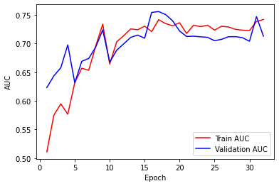
All features:

Med dropouts

All features: 0.82 (0.83)
Only one-hot: 0.86 (0.87)
Only energy terms: 0.77 (0.77)
One-hot and global energy terms: 0.83 (0.83)
One-hot and per-residue energy terms: 0.86
Only per-residue energy terms: 0.82
One-hot and total scores: 0.86
Only global energy terms: 0.67

 | Evaluation on all | Evaluation on pos+swapped | Evaluation on pos+10x
All features | 0.82 | 0.82 (0.83) | 0.83 (0.83)
Only one-hot | 0.86 | 0.90 (0.88) | 0.85 (0.85)
Only energy terms | 0.77
One-hot and global energy terms | 0.83
One-hot and per-residue energy terms | 0.86
Only per-residue energy terms | 0.82
One-hot and total scores | 0.86 | 0.89 | 0.85
Only global energy terms | 0.67
Only FoldX

All evaluated on pos+10x
 | All sequence | Without MHC | Without peptide | Without TCR
All features | 0.83 | 0.85 | 0.82 | 0.73
Only one-hot | 0.85 | 0.85 |  | 0.52 (everything negative)

Only first features (without MHC): 0.83
All features except the first one (without MHC): 0.84
4th feature also good performance
