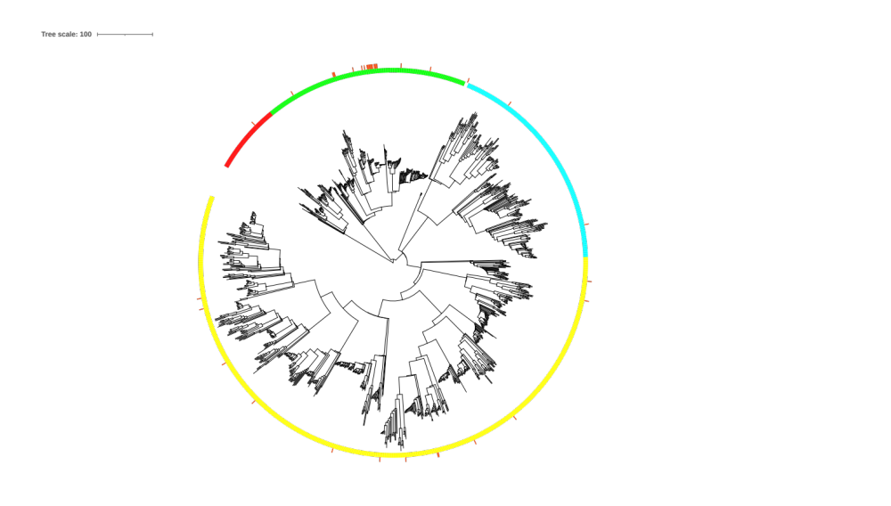
Supplementary Fig. 1. Aclust tree of representative O-Lig sequences. The four subfamilies are shown in red, green, turquoise, and yellow. Seed sequences are marked with a red bar.

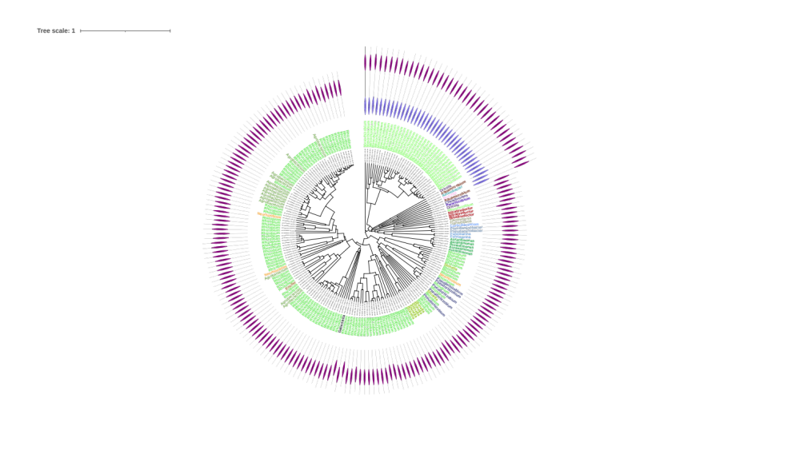
Supplementary Fig. 2. 210 representative sequences of the GTxx3 family including the taxonomic origin of the sequences and the domain modularity within the family, visualized using iTOL. The clustering is based on the pairwise BLAST similarity (coverage multiplied by identity) using the catalytic domain determined using pfam family (PF04932, Wzy_C). The domain modularity reveals members having an N-terminal GT25 domain (blue) in addition to the WadA domain (purple). Members with a GT25 domain are separated from those with only a single domain, suggestive of co-evolution of the two domains.

GTxx4:
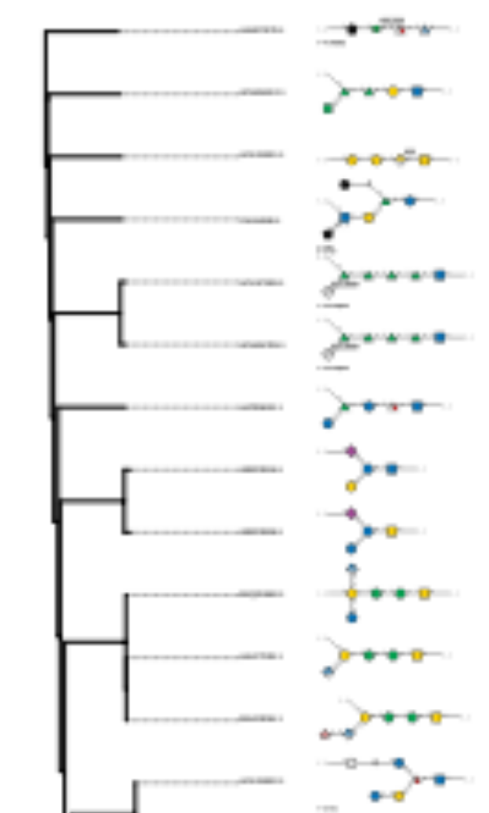
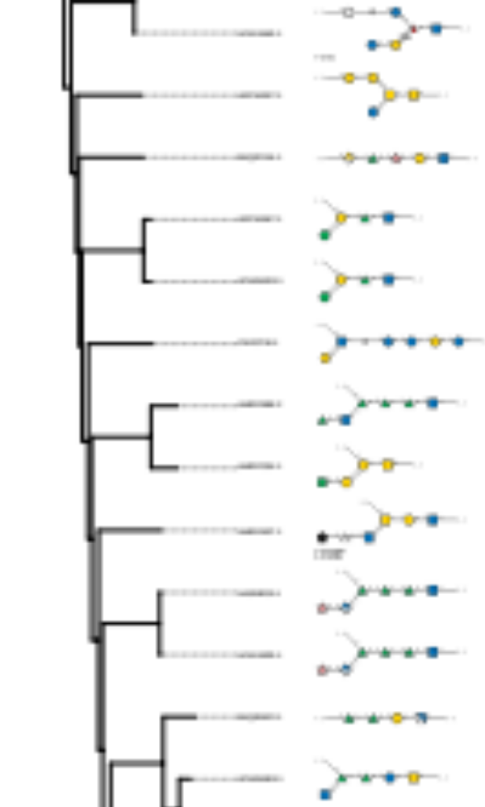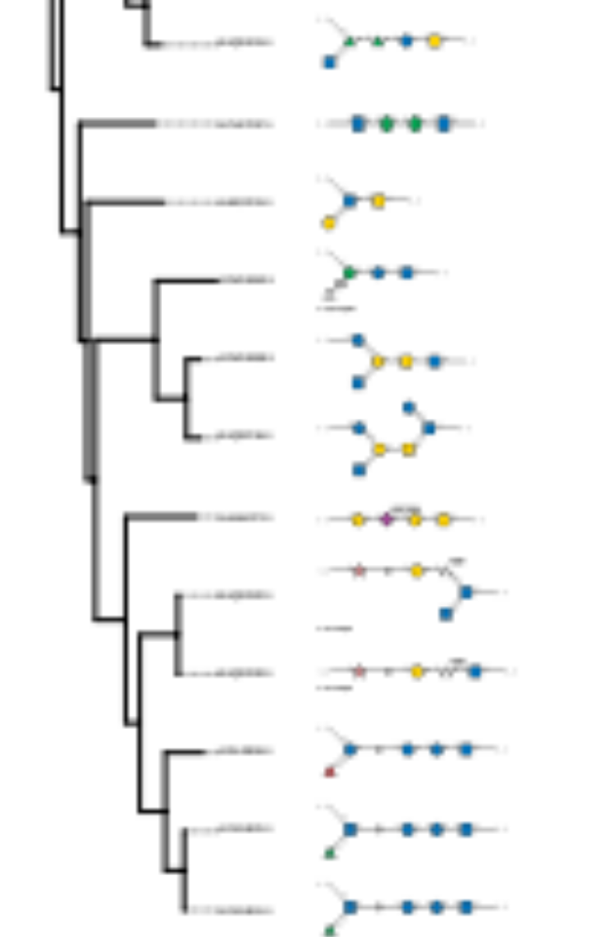

GTxx5:
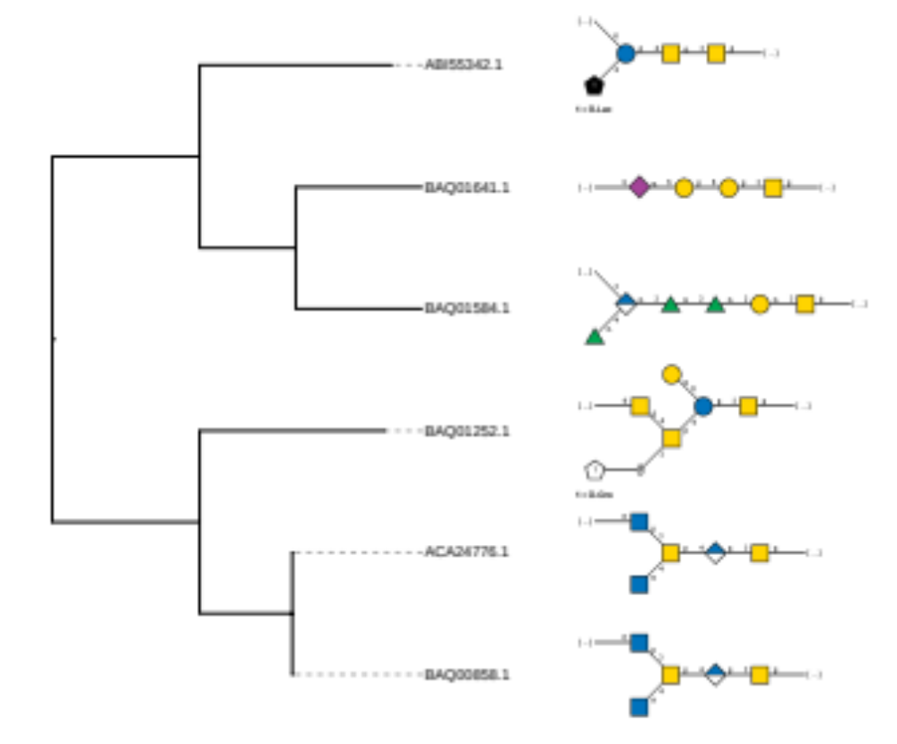

GTxx6:
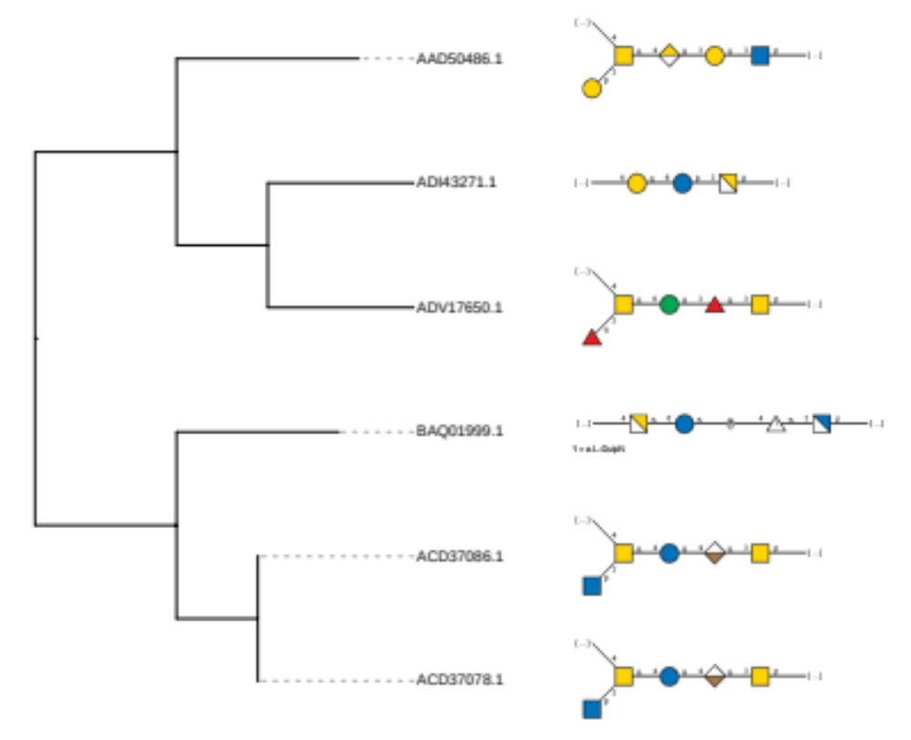

GTxx7:
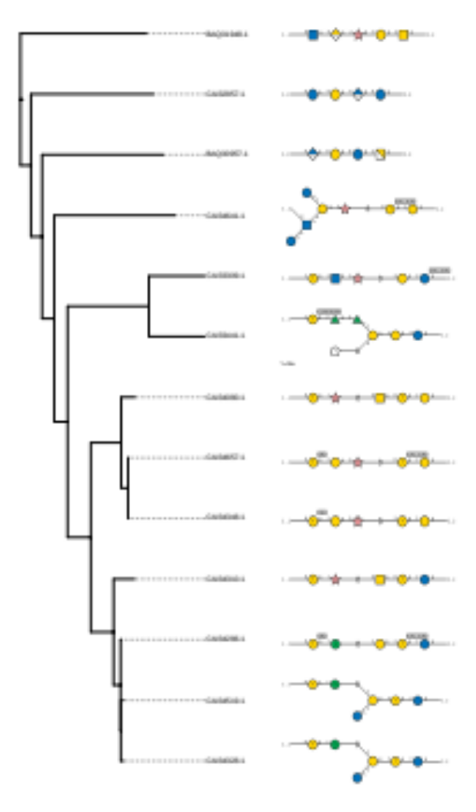

GTxx8:
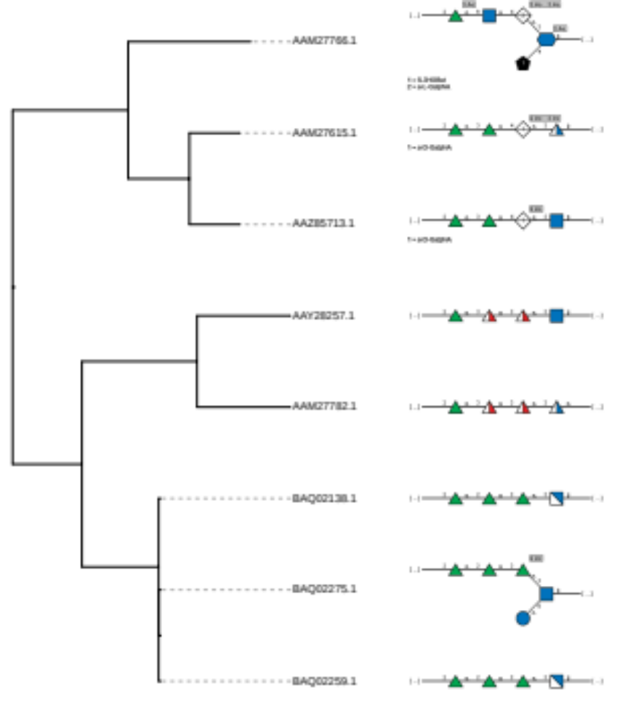

GTxx9:
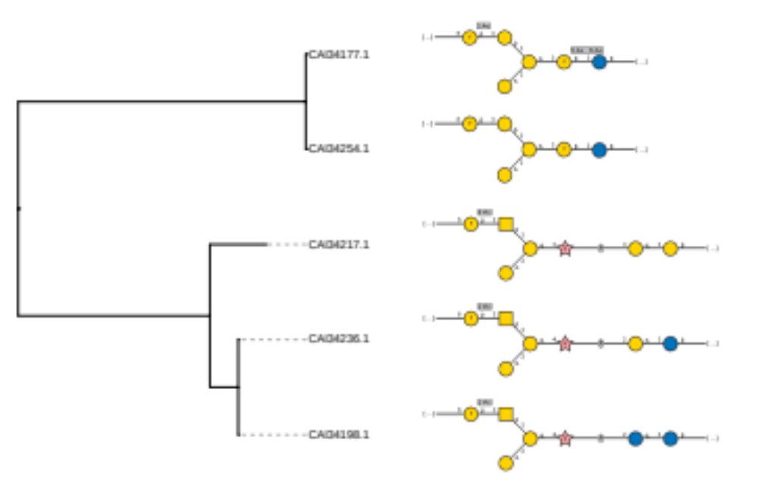

GTx10:
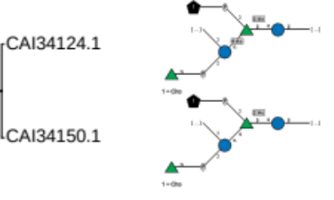

GTx11:
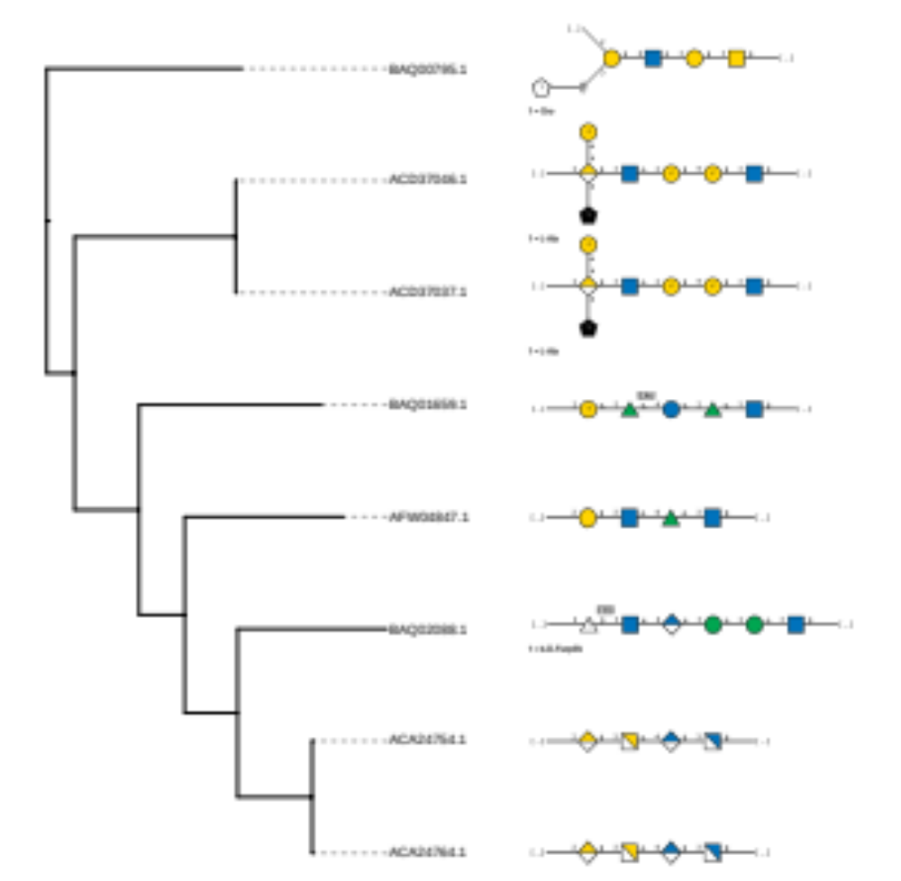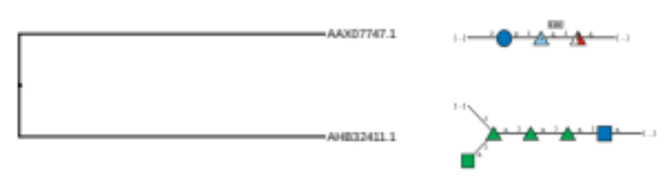

GTx12:
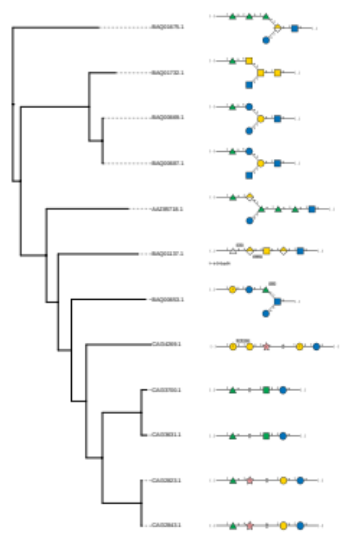

GTx13:
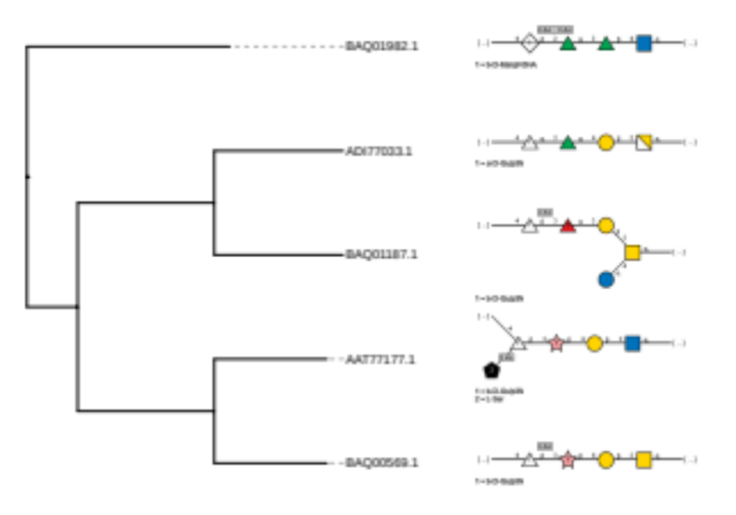
GTx14:
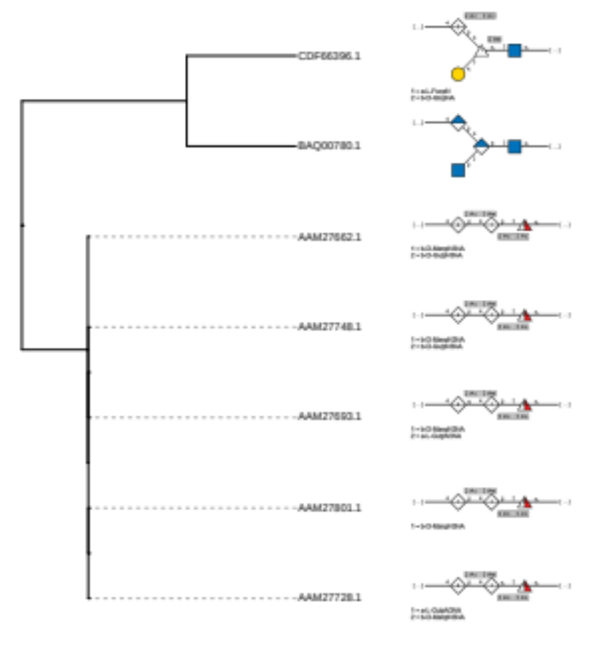
GTx15:
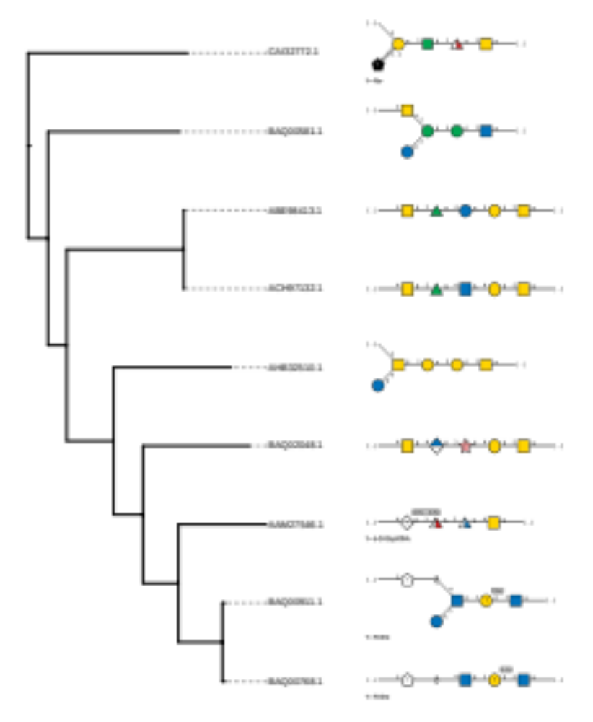

GTx16:
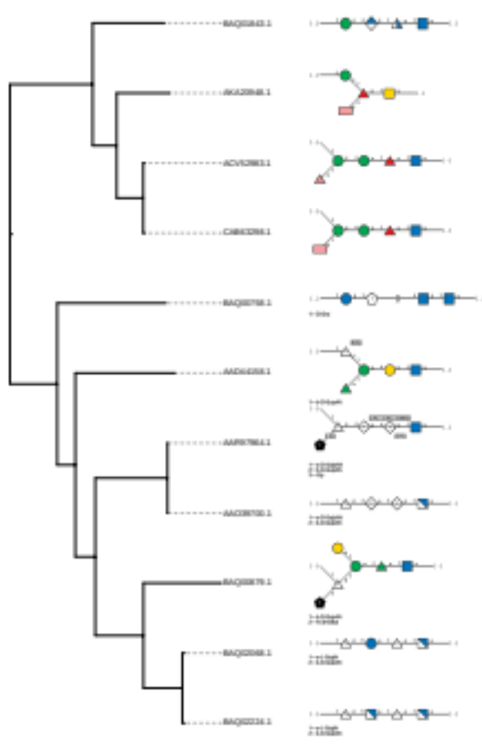
Supplementary Fig. 3. Phylogenetic trees of the BP-Pols in each family with structures of the corresponding sugar repeat units in SNFG format visualized using iTOL. The tree for GTxx4 is split in three pages due to its size.

Species | Accession number
Salmonella enterica | AAO71288.1
Salmonella enterica | AAV79366.1
Salmonella enterica | ACF62503.1
Salmonella enterica | ACF69468.1
Salmonella enterica | ACF92659.1
Salmonella enterica | CAR61594.1
Salmonella enterica | ACH77456.1
Salmonella enterica | CAR39498.1
Salmonella enterica | AAL22572.1
Vibrio cholerae | AAL76923.1
Taylorella equigenitalis | ADU91200.1
Haemophilus parainfluenzae | EGC72795.1
Aeromonas salmonicida | WP_005318160.1
Vibrio cholerae | AAL77359.1
Mycetohabitans rhizoxinica | CBW75858.1
Pectobacterium atrosepticum | CAG73082.1
Escherichia coli | AAB18599.1
Erwinia amylovora | CBA19033.1
Xenorhabdus bovienii | WP_012990589.1
Proteus mirabilis | CAR46213.1
Providencia rettgeri | EFE51464.1
Pseudomonas aeruginosa | AAG08384.1
Klebsiella pneumoniae | BAH65745.1
Vibrio cholerae | AAL77364.1
Leptospira borgpetersenii | WP_011670128.1
Escherichia coli | AAC69661.1
Escherichia coli | AAA24524.1
Salmonella enterica | AAA27206.1
Salmonella enterica | AAS22256.1
Salmonella enterica | NP_462613.1
Salmonella enterica | AAS22257.1
Escherichia coli | CAR10296.1
Escherichia coli | BAI33254.1
Escherichia coli | AAC69671.1
Escherichia coli | AAC69682.1
Cupriavidus metallidurans | WP_011517284.1
Escherichia coli | AAC69648.1

Supplementary Table 1. O-Lig seeds. List of seed sequences used for creation of the O-Lig family.

Species | Serotype | Accession number | CAZy family
Acinetobacter baumannii | O1 | AHB32215.1 | GTxx4
Acinetobacter baumannii | O2 | AHB32538.1
Acinetobacter baumannii | O3 | AHB32563.2 | GTx11
Acinetobacter baumannii | O4 | AHB32666.1
Acinetobacter baumannii | O5 | AHB32242.2
Acinetobacter baumannii | O6 | AHB32267.1
Acinetobacter baumannii | O7 | AHB32888.2 | GTxx4
Acinetobacter baumannii | O8 | AHB32311.1
Acinetobacter baumannii | O10 | AHB32411.1 | GTx12
Acinetobacter baumannii | O11 | AHB32510.1 | GTx16
Acinetobacter baumannii | O12 | AHB32774.1
Acinetobacter baumannii | O13 | AHB32386.1
Acinetobacter baumannii | O14 | AHB32687.1 | GTxx5
Acinetobacter baumannii | O15 | AHB32490.1 | GTx16
Acinetobacter baumannii | O17 | AHB32462.1 | GTxx4
Acinetobacter baumannii | O18 | AHB32334.1 | GTxx4
Acinetobacter baumannii | O19 | AHB32832.1
Acinetobacter baumannii | O20 | AHB32614.2
Acinetobacter baumannii | O21 | AHB32283.1 | GTxx4
Acinetobacter baumannii | O22 | AHB32438.2
Acinetobacter baumannii | O23 | AHB32637.1 | GTxx4
Acinetobacter baumannii | O24 | AHB32586.1
Acinetobacter baumannii | O25 | AHB32861.1 | GTxx4
Acinetobacter baumannii | O26 | AHB32799.1 | GTxx4
Acinetobacter baumannii | O27 | AHB32357.1
Streptococcus pneumoniae | 1 | CAI32705.1
Streptococcus pneumoniae | 2 | CAI32727.1
Streptococcus pneumoniae | 4 | CAI32772.1 | GTx16
Streptococcus pneumoniae | 5 | CAI32797.1
Streptococcus pneumoniae | 6A | CAI32823.1 | GTx13
Streptococcus pneumoniae | 6B | CAI32843.1 | GTx13
Streptococcus pneumoniae | 7A | CAI32867.1
Streptococcus pneumoniae | 7B | CAI32889.1
Streptococcus pneumoniae | 7C | CAI32910.1
Streptococcus pneumoniae | 7F | CAI32935.1
Streptococcus pneumoniae | 8 | CAI32957.1 | GTxx7
Streptococcus pneumoniae | 9A | CAI32973.1
Streptococcus pneumoniae | 9L | CAI32993.1
Streptococcus pneumoniae | 9N | CAI33011.1
Streptococcus pneumoniae | 9V | CAI33029.1
Streptococcus pneumoniae | 10F | CAI33105.1
Streptococcus pneumoniae | 10A | CAI33048.1
Streptococcus pneumoniae | 10B | CAI34733.1
Streptococcus pneumoniae | 10C | CAI33084.1
Streptococcus pneumoniae | 11F | CAI33207.1
Streptococcus pneumoniae | 11A | CAI33128.1
Streptococcus pneumoniae | 11B | CAI33149.1
Streptococcus pneumoniae | 11C | CAI33169.1
Streptococcus pneumoniae | 11D | CAI33188.1
Streptococcus pneumoniae | 12F | CAI33278.1
Streptococcus pneumoniae | 12A | CAI33226.1
Streptococcus pneumoniae | 12B | CAI33252.1
Streptococcus pneumoniae | 13 | CAI33309.1 | GTxx7
Streptococcus pneumoniae | 14 | CAI33324.1
Streptococcus pneumoniae | 15F | CAI33412.1
Streptococcus pneumoniae | 15A | CAI33343.1
Streptococcus pneumoniae | 15B | CAI33366.1
Streptococcus pneumoniae | 15C | CAI33389.1
Streptococcus pneumoniae | 16F | CAI33466.1
Streptococcus pneumoniae | 16A | CAI33441.1 | GTxx7
Streptococcus pneumoniae | 17F | CAI33515.1
Streptococcus pneumoniae | 17A | CAI33491.1
Streptococcus pneumoniae | 18F | CAI33610.1
Streptococcus pneumoniae | 18A | CAI33537.1
Streptococcus pneumoniae | 18B | CAI33561.1
Streptococcus pneumoniae | 18C | CAI33585.1
Streptococcus pneumoniae | 19F | CAI33700.1 | GTx13
Streptococcus pneumoniae | 19A | CAI33631.1 | GTx13
Streptococcus pneumoniae | 19B | CAI33652.1
Streptococcus pneumoniae | 19C | CAI33675.1
Streptococcus pneumoniae | 20 | CAI33718.1 | GTxx4
Streptococcus pneumoniae | 21 | CAI33745.1
Streptococcus pneumoniae | 22F | CAI33798.1
Streptococcus pneumoniae | 22A | CAI33774.1
Streptococcus pneumoniae | 23F | CAI33862.1
Streptococcus pneumoniae | 23A | CAI33817.1
Streptococcus pneumoniae | 23B | CAI33840.1
Streptococcus pneumoniae | 24F | CAI33941.1
Streptococcus pneumoniae | 24A | CAI33890.1
Streptococcus pneumoniae | 24B | CAI33915.1
Streptococcus pneumoniae | 25F | CAI33983.1 | GTx16
Streptococcus pneumoniae | 25A | CAI33966.2 | GTx16
Streptococcus pneumoniae | 27 | CAI34008.1 | GTxx4
Streptococcus pneumoniae | 28F | CAI34057.2
Streptococcus pneumoniae | 28A | CAI34032.1
Streptococcus pneumoniae | 29 | CAI34080.1 | GTxx7
Streptococcus pneumoniae | 31 | CAI34099.1
Streptococcus pneumoniae | 32F | CAI34150.1 | GTx10
Streptococcus pneumoniae | 32A | CAI34124.1 | GTx10
Streptococcus pneumoniae | 33F | CAI34254.1 | GTxx9
Streptococcus pneumoniae | 33A | CAI34177.1 | GTxx9
Streptococcus pneumoniae | 33B | CAI34198.1 | GTxx9
Streptococcus pneumoniae | 33C | CAI34217.1 | GTxx9
Streptococcus pneumoniae | 33D | CAI34236.1 | GTxx9
Streptococcus pneumoniae | 34 | CAI34269.1 | GTx13
Streptococcus pneumoniae | 35F | CAI34348.1 | GTxx7
Streptococcus pneumoniae | 35A | CAI34286.1 | GTxx7
Streptococcus pneumoniae | 35B | CAI34310.1 | GTxx7
Streptococcus pneumoniae | 35C | CAI34328.1 | GTxx7
Streptococcus pneumoniae | 36 | CAI34369.1 | GTxx7
Streptococcus pneumoniae | 38 | CAI34407.1 | GTx16
Streptococcus pneumoniae | 39 | CAI34436.1
Streptococcus pneumoniae | 40 | CAI34454.1
Streptococcus pneumoniae | 41F | CAI34498.1
Streptococcus pneumoniae | 41A | CAI34475.1
Streptococcus pneumoniae | 42 | CAI34519.1 | GTxx7
Streptococcus pneumoniae | 43 | CAI34544.1 | GTxx7
Streptococcus pneumoniae | 44 | CAI34753.1
Streptococcus pneumoniae | 45 | CAI34587.1
Streptococcus pneumoniae | 46 | CAI34613.1
Streptococcus pneumoniae | 47F | CAI34657.1 | GTxx7
Streptococcus pneumoniae | 47A | CAI34641.1 | GTxx7
Streptococcus pneumoniae | 48 | CAI34680.1 | GTx10
Yersinia pseudotuberculosis | O:1a | AAN23041.1
Yersinia pseudotuberculosis | O:1b | CAB63298.1 | GTx17
Yersinia pseudotuberculosis | O:1c | ADI59429.1
Yersinia pseudotuberculosis | O:2a | AAN23078.1
Yersinia pseudotuberculosis | O:2b | ADI59445.1
Yersinia pseudotuberculosis | O:2c | AKA20935.1
Yersinia pseudotuberculosis | O:3 | AKA20948.1 | GTx17
Yersinia pseudotuberculosis | O:4a | AKA20966.1
Yersinia pseudotuberculosis | O:4b | AAN23057.1
Yersinia pseudotuberculosis | O:5a | AKA20981.1
Yersinia pseudotuberculosis | O:5b | AKA20999.1
Yersinia pseudotuberculosis | O:6 | AEP25500.1
Yersinia pseudotuberculosis | O:7 | AEP25477.1
Yersinia pseudotuberculosis | O:8 | AKL88154.1
Yersinia pseudotuberculosis | O:9 | CDF66396.1 | GTx15
Yersinia pseudotuberculosis | O:10 | ADX97403.1
Yersinia pseudotuberculosis | O:11 | ACV52983.1 | GTx17
Yersinia pseudotuberculosis | O:12 | AFV46136.1 | GTxx4
Yersinia pseudotuberculosis | O:14 | ACV53000.1 | GTx17
Yersinia pseudotuberculosis | O:15 | CAX18360.1
Escherichia coli | O1 | ADC54929.1
Escherichia coli | O2 | ADC54941.1
Escherichia coli | O3 | ACH97152.1
Escherichia coli | O4 | AAT85653.1 | GTxx4
Escherichia coli | O5 | BAQ00569.1 | GTx14
Escherichia coli | O6 | BAQ00581.1 | GTx16
Escherichia coli | O7 | AAD44158.1 | GTx17
Escherichia coli | O10 | BAQ00622.1 | GTxx4
Escherichia coli | O11 | ADV17650.1 | GTxx6
Escherichia coli | O12 | BAQ00634.1
Escherichia coli | O13 | BAQ02138.1 | GTxx8
Escherichia coli | O15 | AAV74543.1
Escherichia coli | O16 | BAQ00653.1 | GTx13
Escherichia coli | O17 | BAQ02105.1
Escherichia coli | O18ab | BAQ00669.1 | GTx13
Escherichia coli | O18ac | BAQ00687.1 | GTx13
Escherichia coli | O19 | BAQ00705.1 | GTx13
Escherichia coli | O20 | BAQ00719.1
Escherichia coli | O21 | ACH97162.1
Escherichia coli | O22 | BAQ00736.1
Escherichia coli | O23 | BAQ00746.1 | GTxx4
Escherichia coli | O24 | ABB29906.1 | GTxx4
Escherichia coli | O25 | ADI43263.1
Escherichia coli | O26 | AAN60459.1
Escherichia coli | O27 | ADI43271.1 | GTxx6
Escherichia coli | O28ab | BAQ00758.1 | GTx17
Escherichia coli | O28ac | BAQ00768.1 | GTx16
Escherichia coli | O29 | ACA24852.1 | GTxx4
Escherichia coli | O30 | BAQ00780.1 | GTx15
Escherichia coli | O32 | ACD37058.1
Escherichia coli | O33 | BAQ00795.1 | GTx11
Escherichia coli | O34 | BAQ00812.1
Escherichia coli | O35 | ACV67289.1 | GTxx4
Escherichia coli | O36 | BAQ00830.1
Escherichia coli | O37 | BAQ00846.1
Escherichia coli | O38 | BAQ00858.1 | GTxx5
Escherichia coli | O39 | BAQ00879.1 | GTx17
Escherichia coli | O40 | ACD37117.1
Escherichia coli | O41 | BAQ00893.1
Escherichia coli | O42 | BAQ00911.1 | GTx16
Escherichia coli | O43 | BAQ00927.1
Escherichia coli | O44 | BAQ00945.1
Escherichia coli | O45 | AAX07747.1 | GTx12
Escherichia coli | O46 | BAQ00957.1 | GTxx7
Escherichia coli | O48 | BAQ00975.1
Escherichia coli | O49 | BAQ00994.1
Escherichia coli | O50 | BAQ01012.1
Escherichia coli | O51 | BAQ01024.1 | GTxx4
Escherichia coli | O53 | BAQ01043.1
Escherichia coli | O54 | BAQ02116.1 | GTxx4
Escherichia coli | O55 | AAL67557.1
Escherichia coli | O56 | ABB29916.1 | GTxx4
Escherichia coli | O58 | ACA24882.1
Escherichia coli | O59 | AAV74376.1
Escherichia coli | O61 | ADJ19217.1
Escherichia coli | O63 | BAQ01097.1
Escherichia coli | O64 | BAQ01114.1
Escherichia coli | O65 | BAQ01137.1 | GTx13
Escherichia coli | O66 | AAZ20761.1
Escherichia coli | O68 | BAQ01155.1
Escherichia coli | O69 | BAQ01169.1
Escherichia coli | O70 | BAQ01187.1 | GTx14
Escherichia coli | O71 | ADI77033.1 | GTx14
Escherichia coli | O73 | AAY23733.1
Escherichia coli | O74 | BAQ01207.1
Escherichia coli | O75 | ADC54967.1 | GTxx4
Escherichia coli | O76 | BAQ01218.1
Escherichia coli | O77 | BAQ02177.1
Escherichia coli | O78 | ACV67297.1 | GTxx4
Escherichia coli | O79 | ACA24739.1
Escherichia coli | O80 | BAQ01238.1
Escherichia coli | O81 | BAQ01252.1 | GTxx5
Escherichia coli | O82 | BAQ01266.1
Escherichia coli | O83 | BAQ01277.1
Escherichia coli | O84 | BAQ01293.1
Escherichia coli | O85 | ADC54974.1
Escherichia coli | O86 | AAO37717.1
Escherichia coli | O87 | ACA24901.1 | GTxx4
Escherichia coli | O88 | BAQ01317.1
Escherichia coli | O90 | BAQ01361.1
Escherichia coli | O91 | AAK60458.1
Escherichia coli | O93 | BAQ01386.1
Escherichia coli | O96 | BAQ01419.1
Escherichia coli | O98 | ABB04486.1
Escherichia coli | O100 | BAQ01456.1
Escherichia coli | O102 | BAQ01494.1
Escherichia coli | O103 | AAS73171.1
Escherichia coli | O104 | AAK64372.1 | GTxx4
Escherichia coli | O105 | ACA24829.1 | GTxx4
Escherichia coli | O106 | BAQ02189.1
Escherichia coli | O107 | ACH97132.1 | GTx16
Escherichia coli | O108 | BAQ01516.1
Escherichia coli | O109 | ADR74237.1
Escherichia coli | O110 | BAQ01533.1
Escherichia coli | O111 | AAD46730.1
Escherichia coli | O112ab | ACD37086.1 | GTxx6
Escherichia coli | O112ac | BAQ01545.1
Escherichia coli | O113 | AAD50486.1 | GTxx6
Escherichia coli | O114 | AAT77177.1 | GTx14
Escherichia coli | O115 | ADN43838.1
Escherichia coli | O116 | BAQ01563.1
Escherichia coli | O117 | ABE98413.1 | GTx16
Escherichia coli | O118 | BAQ02200.1 | GTxx4
Escherichia coli | O119 | ADB02825.1
Escherichia coli | O120 | BAQ01584.1 | GTxx5
Escherichia coli | O121 | AAO39700.1 | GTx17
Escherichia coli | O123 | BAQ02224.1 | GTx17
Escherichia coli | O124 | BAQ02241.1
Escherichia coli | O125 | BAQ01598.1
Escherichia coli | O126 | ABE98419.1
Escherichia coli | O127 | BAQ01623.1
Escherichia coli | O128 | AAO37701.1
Escherichia coli | O129 | BAQ02259.1 | GTxx8
Escherichia coli | O130 | ACD37157.1
Escherichia coli | O131 | BAQ01641.1 | GTxx5
Escherichia coli | O132 | BAQ01659.1 | GTx11
Escherichia coli | O133 | BAQ01675.1 | GTx13
Escherichia coli | O134 | BAQ01687.1
Escherichia coli | O135 | BAQ02275.1 | GTxx8
Escherichia coli | O136 | BAQ01702.1
Escherichia coli | O137 | BAQ02286.1
Escherichia coli | O138 | AAZ85713.1 | GTxx8
Escherichia coli | O139 | AAZ85718.1 | GTx13
Escherichia coli | O140 | BAQ01716.1
Escherichia coli | O141 | ABI98976.1
Escherichia coli | O142 | BAQ01732.1 | GTx13
Escherichia coli | O143 | ACA24764.1 | GTx11
Escherichia coli | O144 | BAQ01743.1 | GTxx5
Escherichia coli | O145 | AAV74530.1
Escherichia coli | O146 | ABE98437.1
Escherichia coli | O147 | ABI98986.1
Escherichia coli | O148 | ABA42232.1
Escherichia coli | O149 | ABI98966.1
Escherichia coli | O150 | ACA24803.1
Escherichia coli | O151 | BAQ02302.1 | GTxx4
Escherichia coli | O152 | ACA24821.1 | GTxx4
Escherichia coli | O153 | BAQ01759.1
Escherichia coli | O154 | BAQ01780.1
Escherichia coli | O155 | AAV74550.1
Escherichia coli | O156 | BAQ01793.1
Escherichia coli | O157 | AAC32340.1
Escherichia coli | O158 | ADN43871.1
Escherichia coli | O159 | ACA24890.1
Escherichia coli | O160 | BAQ01812.1
Escherichia coli | O161 | ADJ19203.1
Escherichia coli | O163 | BAQ01843.1 | GTx17
Escherichia coli | O164 | BAQ02323.1
Escherichia coli | O165 | ADN43883.1
Escherichia coli | O166 | ADC54957.1 | GTxx4
Escherichia coli | O167 | ACD37046.1 | GTx11
Escherichia coli | O168 | ACD36996.1
Escherichia coli | O169 | BAQ01860.1 | GTxx4
Escherichia coli | O170 | BAQ01878.1
Escherichia coli | O171 | BAQ01894.1
Escherichia coli | O172 | AAT28922.1
Escherichia coli | O173 | ADN43894.1 | GTxx4
Escherichia coli | O174 | BAQ01907.1
Escherichia coli | O175 | BAQ01917.1
Escherichia coli | O176 | BAQ01935.1
Escherichia coli | O177 | AAY28257.1 | GTxx8
Escherichia coli | O178 | BAQ01948.1 | GTxx7
Escherichia coli | O179 | BAQ01960.1
Escherichia coli | O180 | BAQ01982.1 | GTx14
Escherichia coli | O181 | BAQ01999.1 | GTxx6
Escherichia coli | O182 | BAQ02015.1
Escherichia coli | O183 | BAL03056.1 | GTxx4
Escherichia coli | O184 | BAQ02031.1
Escherichia coli | O185 | BAQ02048.1 | GTx16
Escherichia coli | O186 | BAQ02068.1 | GTx17
Escherichia coli | O187 | BAQ02088.1 | GTx11
Shigella boydii | 2 | ACD37126.1
Shigella boydii | 3 | ACD37037.1 | GTx11
Shigella boydii | 4 | ABB65530.1
Shigella boydii | 5 | AAL27327.1
Shigella boydii | 6 | AAL27339.1 | GTxx4
Shigella boydii | 7 | ACD37072.1
Shigella boydii | 8 | ACA24754.1 | GTx11
Shigella boydii | 9 | AAL27351.1
Shigella boydii | 11 | AAS98031.1 | GTxx4
Shigella boydii | 12 | ACD37026.1
Shigella boydii | 13 | AAR24270.1
Shigella boydii | 14 | ACD37051.1
Shigella boydii | 15 | ACD37078.1 | GTxx6
Shigella boydii | 16 | ABD19779.1
Shigella boydii | 17 | ABI55342.1 | GTxx5
Shigella flexneri | 6 | ABU80601.1
Shigella dysenteriae | 2 | ACD37006.1
Shigella dysenteriae | 3 | ACD37105.1
Shigella dysenteriae | 4 | ACD36984.1
Shigella dysenteriae | 5 | ACA24868.1
Shigella dysenteriae | 7 | AAR97964.1 | GTx17
Shigella dysenteriae | 8 | ACA24776.1 | GTxx5
Shigella dysenteriae | 9 | ACD37111.1
Shigella dysenteriae | 10 | ACA24912.1
Shigella dysenteriae | 11 | ACA24840.1 | GTxx4
Shigella dysenteriae | 12 | ACA24811.1 | GTxx4
Shigella dysenteriae | 13 | ACA24792.1
Pseudomonas aeruginosa | O1 | AAM27546.1 | GTx16
Pseudomonas aeruginosa | O2 | AAM27728.1 | GTx15
Pseudomonas aeruginosa | O3 | AAM27766.1 | GTxx8
Pseudomonas aeruginosa | O4 | AAM27782.1 | GTxx8
Pseudomonas aeruginosa | O5 | AAM27801.1 | GTx15
Pseudomonas aeruginosa | O9 | AAM27879.1 | GTxx4
Pseudomonas aeruginosa | O10 | AAM27560.1
Pseudomonas aeruginosa | O11 | AAM27574.1
Pseudomonas aeruginosa | O12 | AAM27595.1
Pseudomonas aeruginosa | O13 | AAM27615.1 | GTxx8
Pseudomonas aeruginosa | O15 | AAM27645.1 | GTxx8
Pseudomonas aeruginosa | O16 | AAM27662.1 | GTx15
Pseudomonas aeruginosa | O18 | AAM27693.1 | GTx15
Pseudomonas aeruginosa | O19 | AAM27711.1
Pseudomonas aeruginosa | O20 | AAM27748.1 | GTx15
Salmonella enterica | O11 | AFW04820.1 | GTxx4
Salmonella enterica | O21 | AFW04741.1
Salmonella enterica | O39 | AFW04696.1
Salmonella enterica | O40 | AFW04706.1 | GTx16
Salmonella enterica | O42 | AFW04812.1 | GTxx4
Salmonella enterica | O43 | AFW04802.1
Salmonella enterica | O44 | AFW04828.1
Salmonella enterica | O45 | AFW04716.1
Salmonella enterica | O47 | AFW04867.1 | GTxx4
Salmonella enterica | O48 | AFW04668.1
Salmonella enterica | O51 | AFW04888.1 | GTxx4
Salmonella enterica | O52 | AFW04790.1
Salmonella enterica | O53 | AFW04837.1
Salmonella enterica | O57 | AFW04883.1 | GTxx4
Salmonella enterica | O59 | AFW04847.1 | GTx11
Salmonella enterica | O60 | AFW04860.1 | GTxx4
Salmonella enterica | O61 | AFW04757.1
Salmonella enterica | O62 | AFW04785.1 | GTxx4
Salmonella enterica | O63 | AFW04735.1
Salmonella enterica | O65 | AFW04684.1

Supplementary Table 2. BP-Pol seed. List of seed sequences used to create the BP-Pol families.

