Analisis Copula Zero Inflated Regression

# Memanggil data

library(readxl)

## Warning: package 'readxl' was built under R version 4.1.3

# Memanggil Data  
data <- read_xlsx("D:/1. LECTURE/SEMESTER 7/KAPSEL 2/BABAK BARU/Data baru.xlsx")  
attach(data)  
summary(data)

## Y1 Y2 Y3 Y4   
## Min. :0.0000 Min. :0.0000 Min. :0.0000 Min. :0.0000   
## 1st Qu.:0.0000 1st Qu.:0.0000 1st Qu.:0.0000 1st Qu.:0.0000   
## Median :0.0000 Median :0.0000 Median :0.0000 Median :0.0000   
## Mean :0.2308 Mean :0.1282 Mean :0.2991 Mean :0.3162   
## 3rd Qu.:0.0000 3rd Qu.:0.0000 3rd Qu.:0.0000 3rd Qu.:1.0000   
## Max. :2.0000 Max. :2.0000 Max. :2.0000 Max. :2.0000   
## Y5 X11 X12 X13   
## Min. :0.0000 Min. : 0.000 Min. :0.000 Min. : 0.000   
## 1st Qu.:0.0000 1st Qu.: 1.000 1st Qu.:0.000 1st Qu.: 1.000   
## Median :0.0000 Median : 2.000 Median :0.000 Median : 2.000   
## Mean :0.1026 Mean : 2.359 Mean :0.641 Mean : 2.265   
## 3rd Qu.:0.0000 3rd Qu.: 3.000 3rd Qu.:1.000 3rd Qu.: 3.000   
## Max. :1.0000 Max. :23.000 Max. :6.000 Max. :15.000   
## X14 X15 X21 X22   
## Min. : 0.000 Min. :0.0000 Min. :4.302 Min. :4.050   
## 1st Qu.: 1.000 1st Qu.:0.0000 1st Qu.:6.100 1st Qu.:5.500   
## Median : 3.000 Median :1.0000 Median :6.400 Median :5.900   
## Mean : 3.496 Mean :0.9487 Mean :6.503 Mean :5.806   
## 3rd Qu.: 4.000 3rd Qu.:2.0000 3rd Qu.:6.900 3rd Qu.:6.350   
## Max. :15.000 Max. :7.0000 Max. :9.100 Max. :7.800   
## X23 X24 X25   
## Min. :4.000 Min. :4.483 Min. :4.000   
## 1st Qu.:6.350 1st Qu.:6.300 1st Qu.:5.500   
## Median :6.700 Median :6.610 Median :6.000   
## Mean :6.558 Mean :6.716 Mean :5.951   
## 3rd Qu.:7.000 3rd Qu.:7.200 3rd Qu.:6.510   
## Max. :8.500 Max. :8.300 Max. :8.150

# Eksplorasi Data

library(ggplot2)

## Warning: package 'ggplot2' was built under R version 4.1.3

vis_y1<-ggplot(data, aes(x=Y1)) +   
 geom_histogram(aes(fill=..count..), binwidth = 1)+  
 scale_fill_gradient("Count", low = "#dff9fb", high = "#95afc0")+ggtitle("Frekuensi Banyaknya Data 0 pada Y1 ")  
  
vis_y2<-ggplot(data, aes(x=Y2)) +   
 geom_histogram(aes(fill=..count..), binwidth = 1)+  
 scale_fill_gradient("Count", low = "white", high = "#f1c40f")+  
 ggtitle("Frekuensi Banyaknya Data 0 pada Y2")  
  
vis_y3<-ggplot(data, aes(x=Y3)) +   
 geom_histogram(aes(fill=..count..), binwidth = 1)+  
 scale_fill_gradient("Count", low = "white", high = "#10ac84")+  
 ggtitle("Frekuensi Banyaknya Data 0 pada Y1 (Bali)")  
  
vis_y4<-ggplot(data, aes(x=Y4)) +   
 geom_histogram(aes(fill=..count..), binwidth = 1)+  
 scale_fill_gradient("Count", low = "white", high = "#eb3b5a")+  
 ggtitle("Frekuensi Banyaknya Data 0 pada Y2 (Sulawesi)")  
  
vis_y5<-ggplot(data, aes(x=Y5)) +   
 geom_histogram(aes(fill=..count..), binwidth = 1)+  
 scale_fill_gradient("Count", low = "white", high = "#c44569")+  
 ggtitle("Frekuensi Banyaknya Data 0 pada Y3 (Papua)")  
  
  
vis_y1;vis_y2;vis_y3;vis_y4;vis_y5

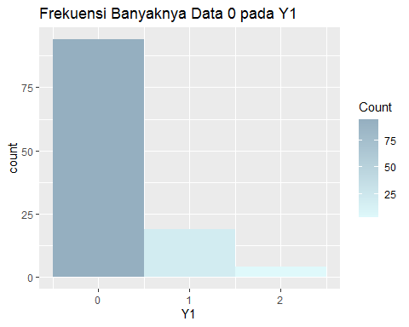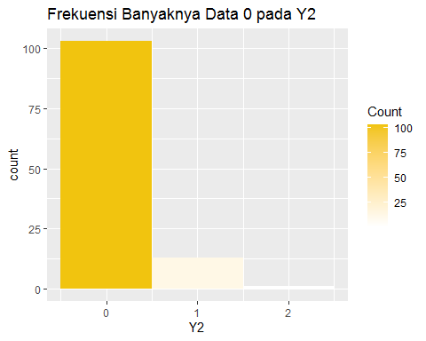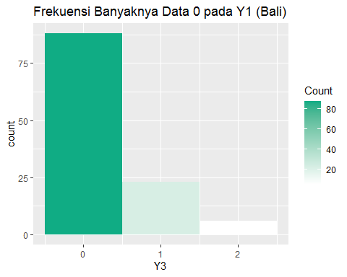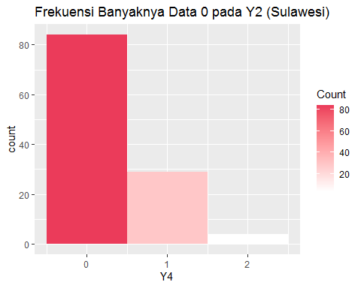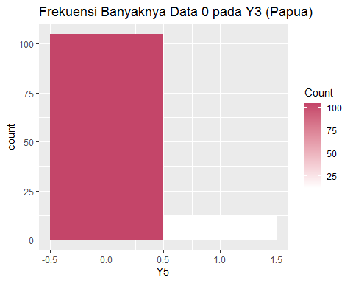

# Persiapan

model_Y1 <- glm(Y1~1, family=poisson(link="log"), data = data)   
  
model_Y2 <- glm(Y2~1, family=poisson(link="log"), data = data)   
  
model_Y3 <- glm(Y3~1, family=poisson(link="log"), data = data)   
  
model_Y4 <- glm(Y4~1, family=poisson(link="log"), data = data)   
  
model_Y5 <- glm(Y5~1, family=poisson(link="log"), data = data)

# Uji Overdispersi

library(AER)

## Warning: package 'AER' was built under R version 4.1.3

## Loading required package: car

## Warning: package 'car' was built under R version 4.1.3

## Loading required package: carData

## Warning: package 'carData' was built under R version 4.1.3

## Loading required package: lmtest

## Warning: package 'lmtest' was built under R version 4.1.3

## Loading required package: zoo

## Warning: package 'zoo' was built under R version 4.1.3

##   
## Attaching package: 'zoo'

## The following objects are masked from 'package:base':  
##   
## as.Date, as.Date.numeric

## Loading required package: sandwich

## Warning: package 'sandwich' was built under R version 4.1.3

## Loading required package: survival

dispersiontest(model_Y1, alternative="greater")

##   
## Overdispersion test  
##   
## data: model_Y1  
## z = 0.60367, p-value = 0.273  
## alternative hypothesis: true dispersion is greater than 1  
## sample estimates:  
## dispersion   
## 1.065527

dispersiontest(model_Y2, alternative="greater")

##   
## Overdispersion test  
##   
## data: model_Y2  
## z = 0.043949, p-value = 0.4825  
## alternative hypothesis: true dispersion is greater than 1  
## sample estimates:  
## dispersion   
## 1.005128

dispersiontest(model_Y3, alternative="greater")

##   
## Overdispersion test  
##   
## data: model_Y3  
## z = 0.45073, p-value = 0.3261  
## alternative hypothesis: true dispersion is greater than 1  
## sample estimates:  
## dispersion   
## 1.043712

dispersiontest(model_Y4, alternative="greater")

##   
## Overdispersion test  
##   
## data: model_Y4  
## z = -1.0757, p-value = 0.859  
## alternative hypothesis: true dispersion is greater than 1  
## sample estimates:  
## dispersion   
## 0.8999769

dispersiontest(model_Y5, alternative="greater")

##   
## Overdispersion test  
##   
## data: model_Y5  
## z = -1.8205, p-value = 0.9657  
## alternative hypothesis: true dispersion is greater than 1  
## sample estimates:  
## dispersion   
## 0.8974359

# Uji Excess Zero

library(vcdExtra)

## Warning: package 'vcdExtra' was built under R version 4.1.3

## Loading required package: vcd

## Warning: package 'vcd' was built under R version 4.1.3

## Loading required package: grid

## Loading required package: gnm

## Warning: package 'gnm' was built under R version 4.1.3

##   
## Attaching package: 'vcdExtra'

## The following object is masked from 'package:carData':  
##   
## Burt

zero.test(Y1)

## Score test for zero inflation  
##   
## Chi-square = 0.58122   
## df = 1  
## pvalue: 0.44583

zero.test(Y2)

## Score test for zero inflation  
##   
## Chi-square = 0.00789   
## df = 1  
## pvalue: 0.92924

zero.test(Y3)

## Score test for zero inflation  
##   
## Chi-square = 0.49028   
## df = 1  
## pvalue: 0.4838

zero.test(Y4)

## Score test for zero inflation  
##   
## Chi-square = 0.47272   
## df = 1  
## pvalue: 0.49174

zero.test(Y5)

## Score test for zero inflation  
##   
## Chi-square = 0.68205   
## df = 1  
## pvalue: 0.40888

# Scatter Plot

library(car)   
  
scatterplot(Y1,Y2)

## Warning in smoother(.x, .y, col = col[1], log.x = logged("x"), log.y =  
## logged("y"), : could not fit smooth

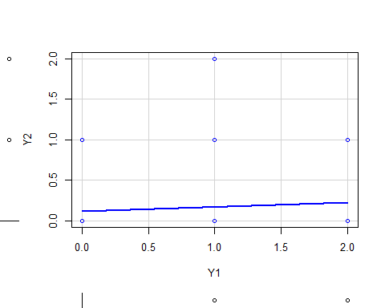

scatterplot(Y2,Y3)

## Warning in smoother(.x, .y, col = col[1], log.x = logged("x"), log.y =  
## logged("y"), : could not fit smooth

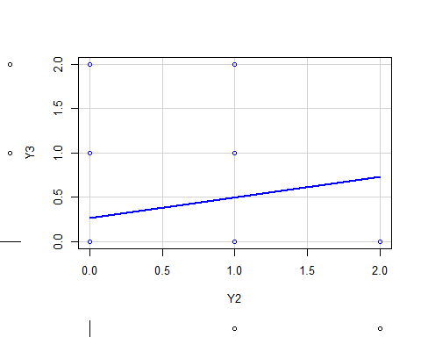

scatterplot(Y3,Y4)

## Warning in smoother(.x, .y, col = col[1], log.x = logged("x"), log.y =  
## logged("y"), : could not fit smooth

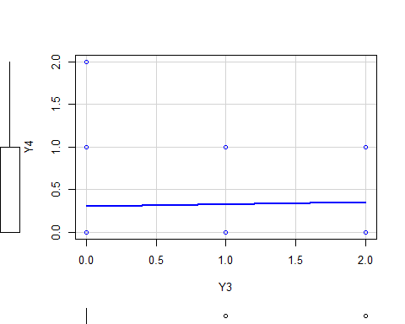

scatterplot(Y4,Y5)

## Warning in smoother(.x, .y, col = col[1], log.x = logged("x"), log.y =  
## logged("y"), : could not fit smooth

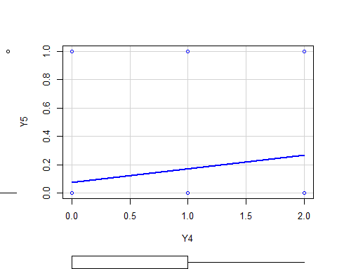

# Asosiasi Peubah Dependen

#Spearmen  
cor.test(Y1,Y2, method = "spearman")

## Warning in cor.test.default(Y1, Y2, method = "spearman"): Cannot compute exact  
## p-value with ties

##   
## Spearman's rank correlation rho  
##   
## data: Y1 and Y2  
## S = 259323, p-value = 0.7608  
## alternative hypothesis: true rho is not equal to 0  
## sample estimates:  
## rho   
## 0.02844632

cor.test(Y2,Y3, method = "spearman")

## Warning in cor.test.default(Y2, Y3, method = "spearman"): Cannot compute exact  
## p-value with ties

##   
## Spearman's rank correlation rho  
##   
## data: Y2 and Y3  
## S = 223842, p-value = 0.08217  
## alternative hypothesis: true rho is not equal to 0  
## sample estimates:  
## rho   
## 0.1613781

cor.test(Y3,Y4, method = "spearman")

## Warning in cor.test.default(Y3, Y4, method = "spearman"): Cannot compute exact  
## p-value with ties

##   
## Spearman's rank correlation rho  
##   
## data: Y3 and Y4  
## S = 257811, p-value = 0.715  
## alternative hypothesis: true rho is not equal to 0  
## sample estimates:  
## rho   
## 0.03411192

cor.test(Y4,Y5, method = "spearman")

## Warning in cor.test.default(Y4, Y5, method = "spearman"): Cannot compute exact  
## p-value with ties

##   
## Spearman's rank correlation rho  
##   
## data: Y4 and Y5  
## S = 222190, p-value = 0.07095  
## alternative hypothesis: true rho is not equal to 0  
## sample estimates:  
## rho   
## 0.167564

#Kendall tau  
cor.test(Y1,Y2, method = "kendall")

##   
## Kendall's rank correlation tau  
##   
## data: Y1 and Y2  
## z = 0.30378, p-value = 0.7613  
## alternative hypothesis: true tau is not equal to 0  
## sample estimates:  
## tau   
## 0.02770821

cor.test(Y2,Y3, method = "kendall")

##   
## Kendall's rank correlation tau  
##   
## data: Y2 and Y3  
## z = 1.7391, p-value = 0.08201  
## alternative hypothesis: true tau is not equal to 0  
## sample estimates:  
## tau   
## 0.1577055

cor.test(Y3,Y4, method = "kendall")

##   
## Kendall's rank correlation tau  
##   
## data: Y3 and Y4  
## z = 0.3719, p-value = 0.71  
## alternative hypothesis: true tau is not equal to 0  
## sample estimates:  
## tau   
## 0.03336631

cor.test(Y4,Y5, method = "kendall")

##   
## Kendall's rank correlation tau  
##   
## data: Y4 and Y5  
## z = 1.8047, p-value = 0.07112  
## alternative hypothesis: true tau is not equal to 0  
## sample estimates:  
## tau   
## 0.1651303

#Pearson  
cor.test(Y1,Y2, method = "pearson")

##   
## Pearson's product-moment correlation  
##   
## data: Y1 and Y2  
## t = 0.79433, df = 115, p-value = 0.4286  
## alternative hypothesis: true correlation is not equal to 0  
## 95 percent confidence interval:  
## -0.1091267 0.2520231  
## sample estimates:  
## cor   
## 0.07386967

cor.test(Y2,Y3, method = "pearson")

##   
## Pearson's product-moment correlation  
##   
## data: Y2 and Y3  
## t = 1.6235, df = 115, p-value = 0.1072  
## alternative hypothesis: true correlation is not equal to 0  
## 95 percent confidence interval:  
## -0.0327386 0.3224550  
## sample estimates:  
## cor   
## 0.149684

cor.test(Y3,Y4, method = "pearson")

##   
## Pearson's product-moment correlation  
##   
## data: Y3 and Y4  
## t = 0.28655, df = 115, p-value = 0.775  
## alternative hypothesis: true correlation is not equal to 0  
## 95 percent confidence interval:  
## -0.1555758 0.2072397  
## sample estimates:  
## cor   
## 0.02671159

cor.test(Y3,Y5, method = "pearson")

##   
## Pearson's product-moment correlation  
##   
## data: Y3 and Y5  
## t = 0.22186, df = 115, p-value = 0.8248  
## alternative hypothesis: true correlation is not equal to 0  
## 95 percent confidence interval:  
## -0.1614550 0.2014607  
## sample estimates:  
## cor   
## 0.0206842

# Pemodelan Univariate

## a. Bali - Sulawesi (Y3 - Y4)

#Bali - Sulawesi  
#Model  
model1.1 <- glm(Y3 ~ X13+X14, family=poisson(link="log"), data = data)   
model1.2 <- glm(Y4 ~ X13+X14, family=poisson(link="log"), data = data)   
model1.3 <- glm(Y3 ~ X23+X24, family=poisson(link="log"), data = data)   
model1.4 <- glm(Y4 ~ X23+X24, family=poisson(link="log"), data = data)   
  
model1.5 <- glm(Y3 ~ X13+X23, family=poisson(link="log"), data = data)   
model1.6 <- glm(Y4 ~ X13+X23, family=poisson(link="log"), data = data)   
model1.7 <- glm(Y3 ~ X14+X24, family=poisson(link="log"), data = data)   
model1.8 <- glm(Y4 ~ X14+X24, family=poisson(link="log"), data = data)   
  
model1.9 <- glm(Y3 ~ X13+X14+X23+X24, family=poisson(link="log"), data = data)   
model1.10 <- glm(Y4 ~ X13+X14+X23+X24, family=poisson(link="log"), data = data)

summary(model1.1);summary(model1.2)

##   
## Call:  
## glm(formula = Y3 ~ X13 + X14, family = poisson(link = "log"),   
## data = data)  
##   
## Deviance Residuals:   
## Min 1Q Median 3Q Max   
## -1.2510 -0.7278 -0.6302 -0.5072 2.4461   
##   
## Coefficients:  
## Estimate Std. Error z value Pr(>|z|)   
## (Intercept) -2.05069 0.34462 -5.951 2.67e-09 ***  
## X13 0.16908 0.05329 3.173 0.00151 **   
## X14 0.09600 0.04884 1.965 0.04936 *   
## ---  
## Signif. codes: 0 '***' 0.001 '**' 0.01 '*' 0.05 '.' 0.1 ' ' 1  
##   
## (Dispersion parameter for poisson family taken to be 1)  
##   
## Null deviance: 101.113 on 116 degrees of freedom  
## Residual deviance: 90.667 on 114 degrees of freedom  
## AIC: 158.35  
##   
## Number of Fisher Scoring iterations: 6

##   
## Call:  
## glm(formula = Y4 ~ X13 + X14, family = poisson(link = "log"),   
## data = data)  
##   
## Deviance Residuals:   
## Min 1Q Median 3Q Max   
## -1.0516 -0.7967 -0.7341 0.7749 2.1347   
##   
## Coefficients:  
## Estimate Std. Error z value Pr(>|z|)   
## (Intercept) -1.47520 0.31873 -4.628 3.68e-06 ***  
## X13 0.02504 0.08100 0.309 0.757   
## X14 0.06939 0.04899 1.416 0.157   
## ---  
## Signif. codes: 0 '***' 0.001 '**' 0.01 '*' 0.05 '.' 0.1 ' ' 1  
##   
## (Dispersion parameter for poisson family taken to be 1)  
##   
## Null deviance: 96.283 on 116 degrees of freedom  
## Residual deviance: 94.288 on 114 degrees of freedom  
## AIC: 168.74  
##   
## Number of Fisher Scoring iterations: 6

summary(model1.3);summary(model1.4)

##   
## Call:  
## glm(formula = Y3 ~ X23 + X24, family = poisson(link = "log"),   
## data = data)  
##   
## Deviance Residuals:   
## Min 1Q Median 3Q Max   
## -1.2720 -0.7811 -0.6646 -0.2340 2.3727   
##   
## Coefficients:  
## Estimate Std. Error z value Pr(>|z|)   
## (Intercept) -7.2392 2.3538 -3.076 0.00210 **  
## X23 0.7181 0.2427 2.958 0.00309 **  
## X24 0.1715 0.2598 0.660 0.50926   
## ---  
## Signif. codes: 0 '***' 0.001 '**' 0.01 '*' 0.05 '.' 0.1 ' ' 1  
##   
## (Dispersion parameter for poisson family taken to be 1)  
##   
## Null deviance: 101.113 on 116 degrees of freedom  
## Residual deviance: 90.685 on 114 degrees of freedom  
## AIC: 158.37  
##   
## Number of Fisher Scoring iterations: 6

##   
## Call:  
## glm(formula = Y4 ~ X23 + X24, family = poisson(link = "log"),   
## data = data)  
##   
## Deviance Residuals:   
## Min 1Q Median 3Q Max   
## -1.1597 -0.7548 -0.6318 0.5067 2.1176   
##   
## Coefficients:  
## Estimate Std. Error z value Pr(>|z|)   
## (Intercept) -6.98399 2.21626 -3.151 0.00163 **  
## X23 0.04112 0.18464 0.223 0.82375   
## X24 0.80707 0.25860 3.121 0.00180 **  
## ---  
## Signif. codes: 0 '***' 0.001 '**' 0.01 '*' 0.05 '.' 0.1 ' ' 1  
##   
## (Dispersion parameter for poisson family taken to be 1)  
##   
## Null deviance: 96.283 on 116 degrees of freedom  
## Residual deviance: 86.116 on 114 degrees of freedom  
## AIC: 160.57  
##   
## Number of Fisher Scoring iterations: 6

summary(model1.5);summary(model1.6)

##   
## Call:  
## glm(formula = Y3 ~ X13 + X23, family = poisson(link = "log"),   
## data = data)  
##   
## Deviance Residuals:   
## Min 1Q Median 3Q Max   
## -1.0860 -0.7766 -0.6734 -0.3130 2.2719   
##   
## Coefficients:  
## Estimate Std. Error z value Pr(>|z|)   
## (Intercept) -5.29597 1.82904 -2.895 0.00379 **  
## X13 0.08218 0.06142 1.338 0.18092   
## X23 0.56996 0.27528 2.071 0.03840 *   
## ---  
## Signif. codes: 0 '***' 0.001 '**' 0.01 '*' 0.05 '.' 0.1 ' ' 1  
##   
## (Dispersion parameter for poisson family taken to be 1)  
##   
## Null deviance: 101.113 on 116 degrees of freedom  
## Residual deviance: 89.538 on 114 degrees of freedom  
## AIC: 157.22  
##   
## Number of Fisher Scoring iterations: 6

##   
## Call:  
## glm(formula = Y4 ~ X13 + X23, family = poisson(link = "log"),   
## data = data)  
##   
## Deviance Residuals:   
## Min 1Q Median 3Q Max   
## -0.9769 -0.7914 -0.7785 0.9049 2.0391   
##   
## Coefficients:  
## Estimate Std. Error z value Pr(>|z|)  
## (Intercept) -1.238802 1.366333 -0.907 0.365  
## X13 0.032219 0.087529 0.368 0.713  
## X23 0.001883 0.220042 0.009 0.993  
##   
## (Dispersion parameter for poisson family taken to be 1)  
##   
## Null deviance: 96.283 on 116 degrees of freedom  
## Residual deviance: 96.109 on 114 degrees of freedom  
## AIC: 170.56  
##   
## Number of Fisher Scoring iterations: 6

summary(model1.7);summary(model1.8)

##   
## Call:  
## glm(formula = Y3 ~ X14 + X24, family = poisson(link = "log"),   
## data = data)  
##   
## Deviance Residuals:   
## Min 1Q Median 3Q Max   
## -1.1394 -0.7439 -0.6955 -0.6490 2.3253   
##   
## Coefficients:  
## Estimate Std. Error z value Pr(>|z|)   
## (Intercept) -1.18840 1.96813 -0.604 0.5460   
## X14 0.09945 0.05780 1.720 0.0853 .  
## X24 -0.06073 0.30791 -0.197 0.8436   
## ---  
## Signif. codes: 0 '***' 0.001 '**' 0.01 '*' 0.05 '.' 0.1 ' ' 1  
##   
## (Dispersion parameter for poisson family taken to be 1)  
##   
## Null deviance: 101.113 on 116 degrees of freedom  
## Residual deviance: 97.737 on 114 degrees of freedom  
## AIC: 165.42  
##   
## Number of Fisher Scoring iterations: 6

##   
## Call:  
## glm(formula = Y4 ~ X14 + X24, family = poisson(link = "log"),   
## data = data)  
##   
## Deviance Residuals:   
## Min 1Q Median 3Q Max   
## -1.1937 -0.7364 -0.6323 0.4864 2.0850   
##   
## Coefficients:  
## Estimate Std. Error z value Pr(>|z|)   
## (Intercept) -6.87679 1.94682 -3.532 0.000412 ***  
## X14 -0.01493 0.05959 -0.251 0.802169   
## X24 0.83914 0.28879 2.906 0.003664 **   
## ---  
## Signif. codes: 0 '***' 0.001 '**' 0.01 '*' 0.05 '.' 0.1 ' ' 1  
##   
## (Dispersion parameter for poisson family taken to be 1)  
##   
## Null deviance: 96.283 on 116 degrees of freedom  
## Residual deviance: 86.102 on 114 degrees of freedom  
## AIC: 160.56  
##   
## Number of Fisher Scoring iterations: 6

summary(model1.9);summary(model1.10)

##   
## Call:  
## glm(formula = Y3 ~ X13 + X14 + X23 + X24, family = poisson(link = "log"),   
## data = data)  
##   
## Deviance Residuals:   
## Min 1Q Median 3Q Max   
## -1.1484 -0.7491 -0.6366 -0.3077 2.4889   
##   
## Coefficients:  
## Estimate Std. Error z value Pr(>|z|)   
## (Intercept) -5.01556 2.83051 -1.772 0.0764 .  
## X13 0.10163 0.06496 1.564 0.1177   
## X14 0.07873 0.06121 1.286 0.1984   
## X23 0.49450 0.28305 1.747 0.0806 .  
## X24 -0.02048 0.32085 -0.064 0.9491   
## ---  
## Signif. codes: 0 '***' 0.001 '**' 0.01 '*' 0.05 '.' 0.1 ' ' 1  
##   
## (Dispersion parameter for poisson family taken to be 1)  
##   
## Null deviance: 101.113 on 116 degrees of freedom  
## Residual deviance: 87.437 on 112 degrees of freedom  
## AIC: 159.12  
##   
## Number of Fisher Scoring iterations: 6

##   
## Call:  
## glm(formula = Y4 ~ X13 + X14 + X23 + X24, family = poisson(link = "log"),   
## data = data)  
##   
## Deviance Residuals:   
## Min 1Q Median 3Q Max   
## -1.1791 -0.7450 -0.6288 0.4942 2.1565   
##   
## Coefficients:  
## Estimate Std. Error z value Pr(>|z|)   
## (Intercept) -7.26783 2.53754 -2.864 0.00418 **  
## X13 0.01009 0.09509 0.106 0.91549   
## X14 -0.01970 0.06254 -0.315 0.75277   
## X23 0.04722 0.21952 0.215 0.82969   
## X24 0.85005 0.29353 2.896 0.00378 **  
## ---  
## Signif. codes: 0 '***' 0.001 '**' 0.01 '*' 0.05 '.' 0.1 ' ' 1  
##   
## (Dispersion parameter for poisson family taken to be 1)  
##   
## Null deviance: 96.283 on 116 degrees of freedom  
## Residual deviance: 85.996 on 112 degrees of freedom  
## AIC: 164.45  
##   
## Number of Fisher Scoring iterations: 6

BIC(model1.1);BIC(model1.2);BIC(model1.3)

## [1] 166.6361

## [1] 177.0297

## [1] 166.6536

BIC(model1.4);BIC(model1.5);BIC(model1.6)

## [1] 168.8571

## [1] 165.5063

## [1] 178.8501

BIC(model1.7);BIC(model1.8);BIC(model1.9);BIC(model1.10)

## [1] 173.7054

## [1] 168.8436

## [1] 172.9304

## [1] 178.262

logLik(model1.1);logLik(model1.2);logLik(model1.3);logLik(model1.4)

## 'log Lik.' -76.17477 (df=3)

## 'log Lik.' -81.37159 (df=3)

## 'log Lik.' -76.18352 (df=3)

## 'log Lik.' -77.28527 (df=3)

logLik(model1.5);logLik(model1.6);logLik(model1.7);logLik(model1.8)

## 'log Lik.' -75.60989 (df=3)

## 'log Lik.' -82.28177 (df=3)

## 'log Lik.' -79.70943 (df=3)

## 'log Lik.' -77.27852 (df=3)

logLik(model1.9);logLik(model1.10)

## 'log Lik.' -74.55979 (df=5)

## 'log Lik.' -77.22558 (df=5)

## b. Sulawesi - Papua (Y4 - Y5)

model2.1 <- glm(Y4 ~ X14+X15, family=poisson(link="log"), data = data)   
model2.2 <- glm(Y5 ~ X14+X15, family=poisson(link="log"), data = data)   
model2.3 <- glm(Y4 ~ X24+X25, family=poisson(link="log"), data = data)   
model2.4 <- glm(Y5 ~ X24+X25, family=poisson(link="log"), data = data)   
  
model2.5 <- glm(Y4 ~ X14+X24, family=poisson(link="log"), data = data)   
model2.6 <- glm(Y5 ~ X14+X24, family=poisson(link="log"), data = data)   
model2.7 <- glm(Y4 ~ X15+X25, family=poisson(link="log"), data = data)   
model2.8 <- glm(Y5 ~ X15+X25, family=poisson(link="log"), data = data)   
  
model2.9 <- glm(Y4 ~ X14+X15+X24+X25, family=poisson(link="log"), data = data)   
model2.10 <- glm(Y5 ~ X14+X15+X24+X25, family=poisson(link="log"), data = data)

summary(model2.1);summary(model2.2)

##   
## Call:  
## glm(formula = Y4 ~ X14 + X15, family = poisson(link = "log"),   
## data = data)  
##   
## Deviance Residuals:   
## Min 1Q Median 3Q Max   
## -1.1749 -0.7913 -0.7242 0.7489 2.1715   
##   
## Coefficients:  
## Estimate Std. Error z value Pr(>|z|)   
## (Intercept) -1.48733 0.28149 -5.284 1.27e-07 ***  
## X14 0.06518 0.04983 1.308 0.191   
## X15 0.08363 0.11961 0.699 0.484   
## ---  
## Signif. codes: 0 '***' 0.001 '**' 0.01 '*' 0.05 '.' 0.1 ' ' 1  
##   
## (Dispersion parameter for poisson family taken to be 1)  
##   
## Null deviance: 96.283 on 116 degrees of freedom  
## Residual deviance: 93.923 on 114 degrees of freedom  
## AIC: 168.38  
##   
## Number of Fisher Scoring iterations: 6

##   
## Call:  
## glm(formula = Y5 ~ X14 + X15, family = poisson(link = "log"),   
## data = data)  
##   
## Deviance Residuals:   
## Min 1Q Median 3Q Max   
## -0.6482 -0.3995 -0.3141 -0.3131 1.7965   
##   
## Coefficients:  
## Estimate Std. Error z value Pr(>|z|)   
## (Intercept) -3.018481 0.519743 -5.808 6.34e-09 ***  
## X14 0.001539 0.098667 0.016 0.987559   
## X15 0.482483 0.130460 3.698 0.000217 ***  
## ---  
## Signif. codes: 0 '***' 0.001 '**' 0.01 '*' 0.05 '.' 0.1 ' ' 1  
##   
## (Dispersion parameter for poisson family taken to be 1)  
##   
## Null deviance: 54.654 on 116 degrees of freedom  
## Residual deviance: 44.309 on 114 degrees of freedom  
## AIC: 74.309  
##   
## Number of Fisher Scoring iterations: 6

summary(model2.3);summary(model2.4)

##   
## Call:  
## glm(formula = Y4 ~ X24 + X25, family = poisson(link = "log"),   
## data = data)  
##   
## Deviance Residuals:   
## Min 1Q Median 3Q Max   
## -1.2806 -0.7266 -0.6219 0.4490 2.1079   
##   
## Coefficients:  
## Estimate Std. Error z value Pr(>|z|)   
## (Intercept) -6.21404 2.06574 -3.008 0.00263 **  
## X24 0.81038 0.25747 3.148 0.00165 **  
## X25 -0.08794 0.17494 -0.503 0.61517   
## ---  
## Signif. codes: 0 '***' 0.001 '**' 0.01 '*' 0.05 '.' 0.1 ' ' 1  
##   
## (Dispersion parameter for poisson family taken to be 1)  
##   
## Null deviance: 96.283 on 116 degrees of freedom  
## Residual deviance: 85.913 on 114 degrees of freedom  
## AIC: 160.37  
##   
## Number of Fisher Scoring iterations: 6

##   
## Call:  
## glm(formula = Y5 ~ X24 + X25, family = poisson(link = "log"),   
## data = data)  
##   
## Deviance Residuals:   
## Min 1Q Median 3Q Max   
## -0.8749 -0.4628 -0.3624 -0.2711 2.3108   
##   
## Coefficients:  
## Estimate Std. Error z value Pr(>|z|)   
## (Intercept) -6.1184 3.4112 -1.794 0.0729 .  
## X24 -0.1886 0.4468 -0.422 0.6730   
## X25 0.8107 0.3315 2.445 0.0145 *  
## ---  
## Signif. codes: 0 '***' 0.001 '**' 0.01 '*' 0.05 '.' 0.1 ' ' 1  
##   
## (Dispersion parameter for poisson family taken to be 1)  
##   
## Null deviance: 54.654 on 116 degrees of freedom  
## Residual deviance: 48.222 on 114 degrees of freedom  
## AIC: 78.222  
##   
## Number of Fisher Scoring iterations: 6

summary(model2.5);summary(model2.6)

##   
## Call:  
## glm(formula = Y4 ~ X14 + X24, family = poisson(link = "log"),   
## data = data)  
##   
## Deviance Residuals:   
## Min 1Q Median 3Q Max   
## -1.1937 -0.7364 -0.6323 0.4864 2.0850   
##   
## Coefficients:  
## Estimate Std. Error z value Pr(>|z|)   
## (Intercept) -6.87679 1.94682 -3.532 0.000412 ***  
## X14 -0.01493 0.05959 -0.251 0.802169   
## X24 0.83914 0.28879 2.906 0.003664 **   
## ---  
## Signif. codes: 0 '***' 0.001 '**' 0.01 '*' 0.05 '.' 0.1 ' ' 1  
##   
## (Dispersion parameter for poisson family taken to be 1)  
##   
## Null deviance: 96.283 on 116 degrees of freedom  
## Residual deviance: 86.102 on 114 degrees of freedom  
## AIC: 160.56  
##   
## Number of Fisher Scoring iterations: 6

##   
## Call:  
## glm(formula = Y5 ~ X14 + X24, family = poisson(link = "log"),   
## data = data)  
##   
## Deviance Residuals:   
## Min 1Q Median 3Q Max   
## -0.6762 -0.4604 -0.4335 -0.4125 1.9109   
##   
## Coefficients:  
## Estimate Std. Error z value Pr(>|z|)  
## (Intercept) -0.69996 3.23449 -0.216 0.829  
## X14 0.09439 0.10428 0.905 0.365  
## X24 -0.28837 0.51559 -0.559 0.576  
##   
## (Dispersion parameter for poisson family taken to be 1)  
##   
## Null deviance: 54.654 on 116 degrees of freedom  
## Residual deviance: 53.894 on 114 degrees of freedom  
## AIC: 83.894  
##   
## Number of Fisher Scoring iterations: 6

summary(model2.7);summary(model2.8)

##   
## Call:  
## glm(formula = Y4 ~ X15 + X25, family = poisson(link = "log"),   
## data = data)  
##   
## Deviance Residuals:   
## Min 1Q Median 3Q Max   
## -0.9494 -0.8022 -0.7265 0.7497 2.2062   
##   
## Coefficients:  
## Estimate Std. Error z value Pr(>|z|)   
## (Intercept) 0.4928 1.3075 0.377 0.7062   
## X15 0.2783 0.1658 1.679 0.0932 .  
## X25 -0.3259 0.2426 -1.343 0.1792   
## ---  
## Signif. codes: 0 '***' 0.001 '**' 0.01 '*' 0.05 '.' 0.1 ' ' 1  
##   
## (Dispersion parameter for poisson family taken to be 1)  
##   
## Null deviance: 96.283 on 116 degrees of freedom  
## Residual deviance: 93.727 on 114 degrees of freedom  
## AIC: 168.18  
##   
## Number of Fisher Scoring iterations: 6

##   
## Call:  
## glm(formula = Y5 ~ X15 + X25, family = poisson(link = "log"),   
## data = data)  
##   
## Deviance Residuals:   
## Min 1Q Median 3Q Max   
## -0.6682 -0.4114 -0.3146 -0.3028 1.8649   
##   
## Coefficients:  
## Estimate Std. Error z value Pr(>|z|)   
## (Intercept) -3.49313 2.79240 -1.251 0.2110   
## X15 0.45216 0.21626 2.091 0.0365 *  
## X25 0.08382 0.48071 0.174 0.8616   
## ---  
## Signif. codes: 0 '***' 0.001 '**' 0.01 '*' 0.05 '.' 0.1 ' ' 1  
##   
## (Dispersion parameter for poisson family taken to be 1)  
##   
## Null deviance: 54.654 on 116 degrees of freedom  
## Residual deviance: 44.278 on 114 degrees of freedom  
## AIC: 74.278  
##   
## Number of Fisher Scoring iterations: 6

summary(model2.9);summary(model2.10)

##   
## Call:  
## glm(formula = Y4 ~ X14 + X15 + X24 + X25, family = poisson(link = "log"),   
## data = data)  
##   
## Deviance Residuals:   
## Min 1Q Median 3Q Max   
## -1.4211 -0.7381 -0.5954 0.4551 2.2163   
##   
## Coefficients:  
## Estimate Std. Error z value Pr(>|z|)   
## (Intercept) -4.90843 2.39732 -2.047 0.04061 *   
## X14 -0.01449 0.06110 -0.237 0.81258   
## X15 0.25231 0.16033 1.574 0.11556   
## X24 0.82596 0.28781 2.870 0.00411 **  
## X25 -0.36058 0.25324 -1.424 0.15449   
## ---  
## Signif. codes: 0 '***' 0.001 '**' 0.01 '*' 0.05 '.' 0.1 ' ' 1  
##   
## (Dispersion parameter for poisson family taken to be 1)  
##   
## Null deviance: 96.283 on 116 degrees of freedom  
## Residual deviance: 83.658 on 112 degrees of freedom  
## AIC: 162.11  
##   
## Number of Fisher Scoring iterations: 6

##   
## Call:  
## glm(formula = Y5 ~ X14 + X15 + X24 + X25, family = poisson(link = "log"),   
## data = data)  
##   
## Deviance Residuals:   
## Min 1Q Median 3Q Max   
## -0.7199 -0.4311 -0.3290 -0.2729 2.0547   
##   
## Coefficients:  
## Estimate Std. Error z value Pr(>|z|)   
## (Intercept) -0.45584 4.18380 -0.109 0.9132   
## X14 0.06687 0.11630 0.575 0.5653   
## X15 0.47971 0.22077 2.173 0.0298 *  
## X24 -0.50569 0.53441 -0.946 0.3440   
## X25 0.09076 0.48468 0.187 0.8515   
## ---  
## Signif. codes: 0 '***' 0.001 '**' 0.01 '*' 0.05 '.' 0.1 ' ' 1  
##   
## (Dispersion parameter for poisson family taken to be 1)  
##   
## Null deviance: 54.654 on 116 degrees of freedom  
## Residual deviance: 43.400 on 112 degrees of freedom  
## AIC: 77.4  
##   
## Number of Fisher Scoring iterations: 6

BIC(model2.1);BIC(model2.2);BIC(model2.3)

## [1] 176.6645

## [1] 82.59528

## [1] 168.6544

BIC(model2.4);BIC(model2.5);BIC(model2.6)

## [1] 86.50837

## [1] 168.8436

## [1] 92.18045

BIC(model2.7);BIC(model2.8);BIC(model2.9);BIC(model2.10)

## [1] 176.4685

## [1] 82.56502

## [1] 175.9239

## [1] 91.21052

logLik(model2.1);logLik(model2.2);logLik(model2.3);logLik(model2.4)

## 'log Lik.' -81.18901 (df=3)

## 'log Lik.' -34.15438 (df=3)

## 'log Lik.' -77.18394 (df=3)

## 'log Lik.' -36.11093 (df=3)

logLik(model2.5);logLik(model2.6);logLik(model2.7);logLik(model2.8)

## 'log Lik.' -77.27852 (df=3)

## 'log Lik.' -38.94697 (df=3)

## 'log Lik.' -81.091 (df=3)

## 'log Lik.' -34.13925 (df=3)

logLik(model2.9);logLik(model2.10)

## 'log Lik.' -76.05651 (df=5)

## 'log Lik.' -33.69982 (df=5)

# Mencari sebaran univariate Y

## Diskrit

library(fitdistrplus)

## Warning: package 'fitdistrplus' was built under R version 4.1.3

## Loading required package: MASS

## Warning: package 'MASS' was built under R version 4.1.3

Y1_coba1 <- fitdist(Y1, discrete = T, "pois")  
Y1_coba3 <- fitdist(Y1, discrete = T, "nbinom")  
Y1_coba4 <- fitdist(Y1, discrete = T, "geom")  
  
Y2_coba1 <- fitdist(Y2, discrete = T, "pois")  
Y2_coba3 <- fitdist(Y2, discrete = T, "nbinom")  
Y2_coba4 <- fitdist(Y2, discrete = T, "geom")  
  
Y3_coba1 <- fitdist(Y3, discrete = T, "pois")  
Y3_coba3 <- fitdist(Y3, discrete = T, "nbinom")  
Y3_coba4 <- fitdist(Y3, discrete = T, "geom")  
  
Y4_coba1 <- fitdist(Y4, discrete = T, "pois")  
Y4_coba3 <- fitdist(Y4, discrete = T, "nbinom")

## Warning in sqrt(diag(varcovar)): NaNs produced

## Warning in sqrt(1/diag(V)): NaNs produced

## Warning in cov2cor(varcovar): diag(.) had 0 or NA entries; non-finite result is  
## doubtful

Y4_coba4 <- fitdist(Y4, discrete = T, "geom")  
  
Y5_coba1 <- fitdist(Y5, discrete = T, "pois")  
Y5_coba3 <- fitdist(Y5, discrete = T, "nbinom")  
Y5_coba4 <- fitdist(Y5, discrete = T, "geom")

Y1_coba1$aic;Y1_coba1$bic;Y1_coba1$loglik; summary(Y1_coba1) #Poisson

## [1] 140.7274

## [1] 143.4896

## [1] -69.36369

## Fitting of the distribution ' pois ' by maximum likelihood   
## Parameters :   
## estimate Std. Error  
## lambda 0.2307692 0.04441073  
## Loglikelihood: -69.36369 AIC: 140.7274 BIC: 143.4896

Y1_coba3$aic;Y1_coba3$bic;Y1_coba3$loglik #nbinom

## [1] 142.4508

## [1] 147.9752

## [1] -69.22542

Y1_coba4$aic;Y1_coba4$bic;Y1_coba4$loglik #geom

## [1] 140.9823

## [1] 143.7445

## [1] -69.49117

Y2_coba1$aic;Y2_coba1$bic;Y2_coba1$loglik #Poisson

## [1] 95.01001

## [1] 97.77218

## [1] -46.505

Y2_coba3$aic;Y2_coba3$bic;Y2_coba3$loglik #nbinom

## [1] 97.00834

## [1] 102.5327

## [1] -46.50417

Y2_coba4$aic;Y2_coba4$bic;Y2_coba4$loglik #geom

## [1] 95.4695

## [1] 98.23167

## [1] -46.73475

Y3_coba1$aic;Y3_coba1$bic;Y3_coba1$loglik; summary(Y3_coba1) #Poisson

## [1] 164.7956

## [1] 167.5578

## [1] -81.39779

## Fitting of the distribution ' pois ' by maximum likelihood   
## Parameters :   
## estimate Std. Error  
## lambda 0.2991453 0.05056422  
## Loglikelihood: -81.39779 AIC: 164.7956 BIC: 167.5578

Y3_coba3$aic;Y3_coba3$bic;Y3_coba3$loglik; summary(Y3_coba3) #nbinom

## [1] 166.6608

## [1] 172.1851

## [1] -81.3304

## Fitting of the distribution ' nbinom ' by maximum likelihood   
## Parameters :   
## estimate Std. Error  
## size 5.2931456 15.48125425  
## mu 0.2991559 0.05197533  
## Loglikelihood: -81.3304 AIC: 166.6608 BIC: 172.1851   
## Correlation matrix:  
## size mu  
## size 1.000000e+00 -3.168976e-05  
## mu -3.168976e-05 1.000000e+00

Y3_coba4$aic;Y3_coba4$bic;Y3_coba4$loglik; summary(Y3_coba4) #geom

## [1] 166.0366

## [1] 168.7988

## [1] -82.01831

## Fitting of the distribution ' geom ' by maximum likelihood   
## Parameters :   
## estimate Std. Error  
## prob 0.7697368 0.0341472  
## Loglikelihood: -82.01831 AIC: 166.0366 BIC: 168.7988

Y4_coba1$aic;Y4_coba1$bic;Y4_coba1$loglik; summary(Y4_coba1) #Poisson

## [1] 166.7381

## [1] 169.5003

## [1] -82.36906

## Fitting of the distribution ' pois ' by maximum likelihood   
## Parameters :   
## estimate Std. Error  
## lambda 0.3162393 0.0519889  
## Loglikelihood: -82.36906 AIC: 166.7381 BIC: 169.5003

Y4_coba3$aic;Y4_coba3$bic;Y4_coba3$loglik; summary(Y4_coba3) #nbinom

## [1] 168.7383

## [1] 174.2627

## [1] -82.36916

## Fitting of the distribution ' nbinom ' by maximum likelihood   
## Parameters :   
## estimate Std. Error  
## size 2.305715e+04 NaN  
## mu 3.165089e-01 0.05203357  
## Loglikelihood: -82.36916 AIC: 168.7383 BIC: 174.2627   
## Correlation matrix:  
## size mu  
## size 1 NaN  
## mu NaN 1

Y4_coba4$aic;Y4_coba4$bic;Y4_coba4$loglik; summary(Y4_coba4) #geom

## [1] 171.8248

## [1] 174.5869

## [1] -84.91239

## Fitting of the distribution ' geom ' by maximum likelihood   
## Parameters :   
## estimate Std. Error  
## prob 0.7597403 0.03442761  
## Loglikelihood: -84.91239 AIC: 171.8248 BIC: 174.5869

Y5_coba1$aic;Y5_coba1$bic;Y5_coba1$loglik; summary(Y5_coba1) #Poisson

## [1] 80.65441

## [1] 83.41659

## [1] -39.32721

## Fitting of the distribution ' pois ' by maximum likelihood   
## Parameters :   
## estimate Std. Error  
## lambda 0.1025641 0.02960489  
## Loglikelihood: -39.32721 AIC: 80.65441 BIC: 83.41659

Y5_coba3$aic;Y5_coba3$bic;Y5_coba3$loglik; summary(Y5_coba3) #nbinom

## [1] 82.65442

## [1] 88.17876

## [1] -39.32721

## Fitting of the distribution ' nbinom ' by maximum likelihood   
## Parameters :   
## estimate Std. Error  
## size 7.319947e+05 90.57062957  
## mu 1.025711e-01 0.02960693  
## Loglikelihood: -39.32721 AIC: 82.65442 BIC: 88.17876   
## Correlation matrix:  
## size mu  
## size 1.000000e+00 4.763333e-09  
## mu 4.763333e-09 1.000000e+00

Y5_coba4$aic;Y5_coba4$bic;Y5_coba4$loglik; summary(Y5_coba4) #geom

## [1] 81.84514

## [1] 84.60731

## [1] -39.92257

## Fitting of the distribution ' geom ' by maximum likelihood   
## Parameters :   
## estimate Std. Error  
## prob 0.9069767 0.02557134  
## Loglikelihood: -39.92257 AIC: 81.84514 BIC: 84.60731

## Kontinu

Y1_kon1 <- fitdist(Y1, "norm")  
Y1_kon4 <- fitdist(Y1, "exp")  
Y1_kon6 <- fitdist(Y1, "logis")  
  
Y2_kon1 <- fitdist(Y2, "norm")  
Y2_kon4 <- fitdist(Y2, "exp")  
Y2_kon6 <- fitdist(Y2, "logis")  
  
Y3_kon1 <- fitdist(Y3, "norm")  
Y3_kon4 <- fitdist(Y3, "exp")  
Y3_kon6 <- fitdist(Y3, "logis")  
  
Y4_kon1 <- fitdist(Y4, "norm")  
Y4_kon4 <- fitdist(Y4, "exp")  
Y4_kon6 <- fitdist(Y4, "logis")  
  
Y5_kon1 <- fitdist(Y5, "norm")  
Y5_kon4 <- fitdist(Y5, "exp")  
Y5_kon6 <- fitdist(Y5, "logis")

Y1_kon1$aic;Y1_kon1$bic;Y1_kon1$loglik #Normal

## [1] 171.8961

## [1] 177.4205

## [1] -83.94806

Y1_kon4$aic;Y1_kon4$bic;Y1_kon4$loglik #Eksponensial

## [1] -107.1229

## [1] -104.3607

## [1] 54.56144

Y1_kon6$aic;Y1_kon6$bic;Y1_kon6$loglik #Logistik

## [1] 145.6542

## [1] 151.1785

## [1] -70.82709

Y2_kon1$aic;Y2_kon1$bic;Y2_kon1$loglik #Normal

## [1] 96.29761

## [1] 101.822

## [1] -46.1488

Y2_kon4$aic;Y2_kon4$bic;Y2_kon4$loglik #Eksponensial

## [1] -244.665

## [1] -241.9028

## [1] 123.3325

Y2_kon6$aic;Y2_kon6$bic;Y2_kon6$loglik #Logistik

## [1] 39.12195

## [1] 44.6463

## [1] -17.56098

Y3_kon1$aic;Y3_kon1$bic;Y3_kon1$loglik #Normal

## [1] 199.8387

## [1] 205.363

## [1] -97.91933

Y3_kon4$aic;Y3_kon4$bic;Y3_kon4$loglik #Eksponensial

## [1] -46.39725

## [1] -43.63508

## [1] 24.19863

Y3_kon6$aic;Y3_kon6$bic;Y3_kon6$loglik #Logistik

## [1] 185.5231

## [1] 191.0474

## [1] -90.76155

Y4_kon1$aic;Y4_kon1$bic;Y4_kon1$loglik #Normal

## [1] 189.0045

## [1] 194.5288

## [1] -92.50224

Y4_kon4$aic;Y4_kon4$bic;Y4_kon4$loglik #Eksponensial

## [1] -33.39391

## [1] -30.63174

## [1] 17.69695

Y4_kon6$aic;Y4_kon6$bic;Y4_kon6$loglik #Logsitik

## [1] 183.5513

## [1] 189.0756

## [1] -89.77563

Y5_kon1$aic;Y5_kon1$bic;Y5_kon1$loglik #Normal

## [1] 56.93036

## [1] 62.4547

## [1] -26.46518

Y5_kon4$aic;Y5_kon4$bic;Y5_kon4$loglik #Eksponensial

## [1] -296.8805

## [1] -294.1184

## [1] 149.4403

Y5_kon6$aic;Y5_kon6$bic;Y5_kon6$loglik #Logistik

## [1] -6.504071

## [1] -0.9797227

## [1] 5.252035

# Pemilihan Model Copula

library(VineCopula)

## Warning: package 'VineCopula' was built under R version 4.1.3

var_a <- pobs(Y3)   
var_b <- pobs(Y4)  
var_c <- pobs(Y5)  
  
selectedCopula1 <- BiCopSelect(var_a, var_b, familyset = 1) #Gaussian

## Warning in cor(x[(x[, 1] > 0) & (x[, 2] > 0), ]): the standard deviation is zero

## Warning in cor(x[(x[, 1] < 0) & (x[, 2] < 0), ]): the standard deviation is zero

selectedCopula2 <- BiCopSelect(var_a, var_b, familyset = 2) #student-t

## Warning in cor(x[(x[, 1] > 0) & (x[, 2] > 0), ]): the standard deviation is zero  
  
## Warning in cor(x[(x[, 1] > 0) & (x[, 2] > 0), ]): the standard deviation is zero

selectedCopula3 <- BiCopSelect(var_a, var_b, familyset = 3) #Clayton

## Warning in cor(x[(x[, 1] > 0) & (x[, 2] > 0), ]): the standard deviation is zero  
  
## Warning in cor(x[(x[, 1] > 0) & (x[, 2] > 0), ]): the standard deviation is zero

selectedCopula4 <- BiCopSelect(var_a, var_b, familyset = 4) #Gumbel

## Warning in cor(x[(x[, 1] > 0) & (x[, 2] > 0), ]): the standard deviation is zero  
  
## Warning in cor(x[(x[, 1] > 0) & (x[, 2] > 0), ]): the standard deviation is zero

selectedCopula5 <- BiCopSelect(var_a, var_b, familyset = 5) #Frank

## Warning in cor(x[(x[, 1] > 0) & (x[, 2] > 0), ]): the standard deviation is zero  
  
## Warning in cor(x[(x[, 1] > 0) & (x[, 2] > 0), ]): the standard deviation is zero

selectedCopula6 <- BiCopSelect(var_a, var_b, familyset = 6) #Survival Joe

## Warning in cor(x[(x[, 1] > 0) & (x[, 2] > 0), ]): the standard deviation is zero  
  
## Warning in cor(x[(x[, 1] > 0) & (x[, 2] > 0), ]): the standard deviation is zero

plot(selectedCopula1, main= "Gaussian Copula")

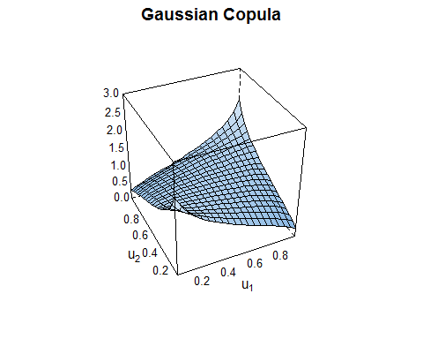

plot(selectedCopula2, main= "Student-t Copula")

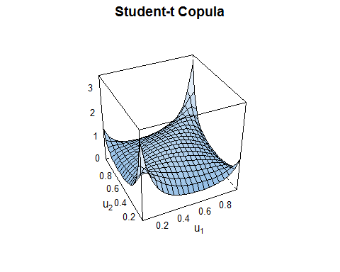

plot(selectedCopula3, main= "Clayton Copula")

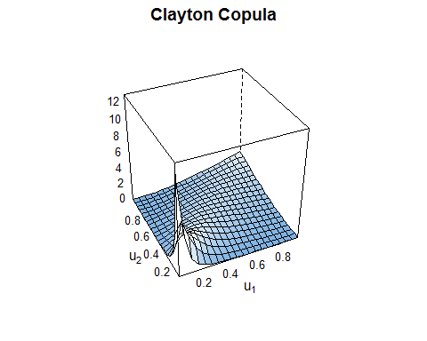

plot(selectedCopula4, main= "Gumbel Copula")

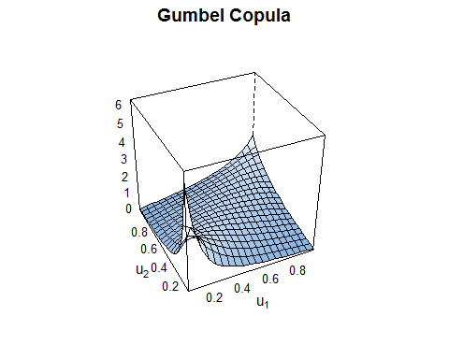

plot(selectedCopula5, main= "Frank Copula")

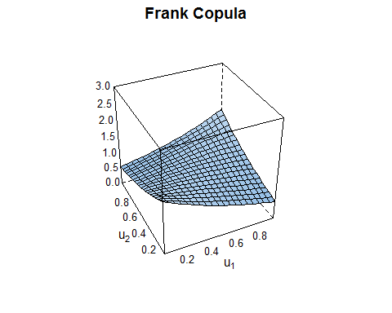

plot(selectedCopula6, main= "Joe Copula")

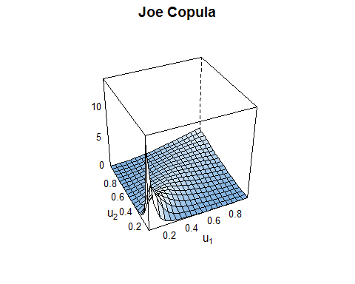

summary(selectedCopula1)

## Family  
## ------   
## No: 1  
## Name: Gaussian  
##   
## Parameter(s)  
## ------------  
## par: 0.34  
##   
## Dependence measures  
## -------------------  
## Kendall's tau: 0.22 (empirical = 0.03, p value = 0.59)  
## Upper TD: 0   
## Lower TD: 0   
##   
## Fit statistics  
## --------------  
## logLik: 0.72   
## AIC: 0.55   
## BIC: 3.32

summary(selectedCopula2)

## Family  
## ------   
## No: 2  
## Name: t  
##   
## Parameter(s)  
## ------------  
## par: 0.24  
## par2: 2  
## Dependence measures  
## -------------------  
## Kendall's tau: 0.15 (empirical = 0.03, p value = 0.59)  
## Upper TD: 0.27   
## Lower TD: 0.27   
##   
## Fit statistics  
## --------------  
## logLik: 4.91   
## AIC: -5.82   
## BIC: -0.29

summary(selectedCopula3)

## Family  
## ------   
## No: 3  
## Name: Clayton  
##   
## Parameter(s)  
## ------------  
## par: 2.1  
##   
## Dependence measures  
## -------------------  
## Kendall's tau: 0.51 (empirical = 0.03, p value = 0.59)  
## Upper TD: 0   
## Lower TD: 0.72   
##   
## Fit statistics  
## --------------  
## logLik: 15.45   
## AIC: -28.91   
## BIC: -26.14

summary(selectedCopula4)

## Family  
## ------   
## No: 14  
## Name: Survival Gumbel  
##   
## Parameter(s)  
## ------------  
## par: 1.65  
##   
## Dependence measures  
## -------------------  
## Kendall's tau: 0.39 (empirical = 0.03, p value = 0.59)  
## Upper TD: 0   
## Lower TD: 0.48   
##   
## Fit statistics  
## --------------  
## logLik: 7.72   
## AIC: -13.45   
## BIC: -10.69

summary(selectedCopula5)

## Family  
## ------   
## No: 5  
## Name: Frank  
##   
## Parameter(s)  
## ------------  
## par: 1.3  
##   
## Dependence measures  
## -------------------  
## Kendall's tau: 0.14 (empirical = 0.03, p value = 0.59)  
## Upper TD: 0   
## Lower TD: 0   
##   
## Fit statistics  
## --------------  
## logLik: 0.29   
## AIC: 1.43   
## BIC: 4.19

summary(selectedCopula6)

## Family  
## ------   
## No: 16  
## Name: Survival Joe  
##   
## Parameter(s)  
## ------------  
## par: 2.99  
##   
## Dependence measures  
## -------------------  
## Kendall's tau: 0.52 (empirical = 0.03, p value = 0.59)  
## Upper TD: 0   
## Lower TD: 0.74   
##   
## Fit statistics  
## --------------  
## logLik: 18.83   
## AIC: -35.66   
## BIC: -32.9

selected2Copula1 <- BiCopSelect(var_b, var_c, familyset = 1) #Gaussian

## Warning in cor(x[(x[, 1] > 0) & (x[, 2] > 0), ]): the standard deviation is zero  
  
## Warning in cor(x[(x[, 1] > 0) & (x[, 2] > 0), ]): the standard deviation is zero

selected2Copula2 <- BiCopSelect(var_b, var_c, familyset = 2) #student-t

## Warning in cor(x[(x[, 1] > 0) & (x[, 2] > 0), ]): the standard deviation is zero  
  
## Warning in cor(x[(x[, 1] > 0) & (x[, 2] > 0), ]): the standard deviation is zero

selected2Copula3 <- BiCopSelect(var_b, var_c, familyset = 3) #Clayton

## Warning in cor(x[(x[, 1] > 0) & (x[, 2] > 0), ]): the standard deviation is zero  
  
## Warning in cor(x[(x[, 1] > 0) & (x[, 2] > 0), ]): the standard deviation is zero

selected2Copula4 <- BiCopSelect(var_b, var_c, familyset = 4) #Gumbel

## Warning in cor(x[(x[, 1] > 0) & (x[, 2] > 0), ]): the standard deviation is zero  
  
## Warning in cor(x[(x[, 1] > 0) & (x[, 2] > 0), ]): the standard deviation is zero

selected2Copula5 <- BiCopSelect(var_b, var_c, familyset = 5) #Frank

## Warning in cor(x[(x[, 1] > 0) & (x[, 2] > 0), ]): the standard deviation is zero  
  
## Warning in cor(x[(x[, 1] > 0) & (x[, 2] > 0), ]): the standard deviation is zero

selected2Copula6 <- BiCopSelect(var_b, var_c, familyset = 6) #Survival Joe

## Warning in cor(x[(x[, 1] > 0) & (x[, 2] > 0), ]): the standard deviation is zero  
  
## Warning in cor(x[(x[, 1] > 0) & (x[, 2] > 0), ]): the standard deviation is zero

plot(selected2Copula1, main= "Gaussian Copula", col = "red")

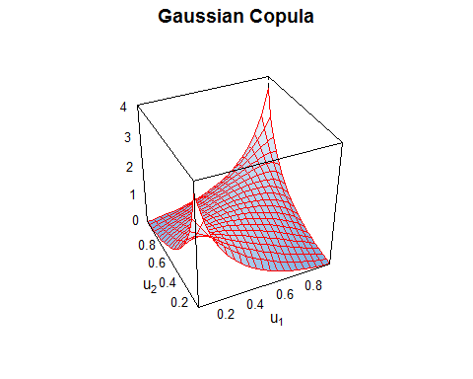

plot(selected2Copula2, main= "Student-t Copula", col = "red")

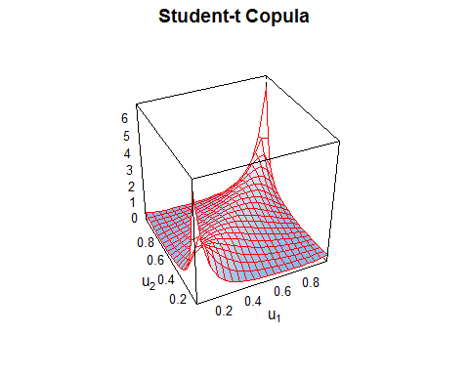

plot(selected2Copula3, main= "Clayton Copula", col = "red")

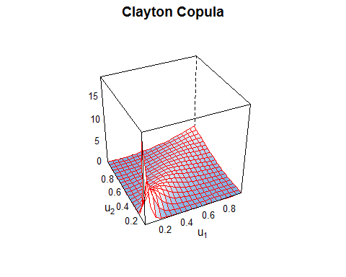

plot(selected2Copula4, main= "Gumbel Copula", col = "red")

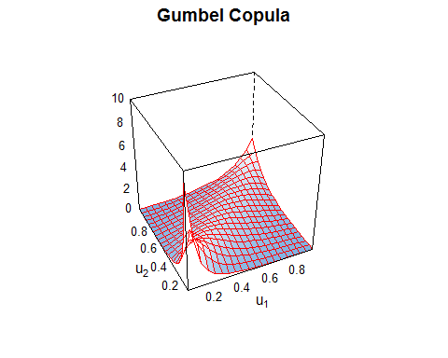

plot(selected2Copula5, main= "Frank Copula", col = "red")

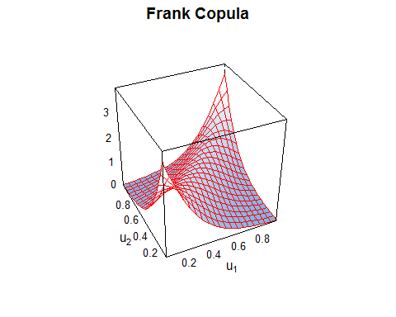

plot(selected2Copula6, main= "Joe Copula", col = "red")

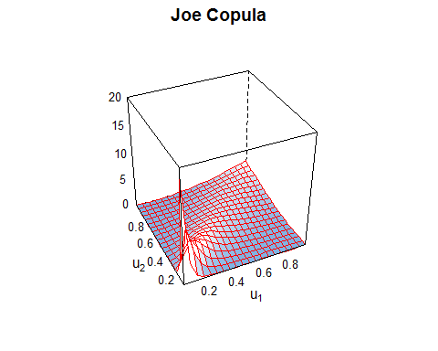

#=====================================================================  
selected2Copula1 <- BiCopSelect(var_b, var_c, familyset = 1) #Gaussian

## Warning in cor(x[(x[, 1] > 0) & (x[, 2] > 0), ]): the standard deviation is zero

## Warning in cor(x[(x[, 1] < 0) & (x[, 2] < 0), ]): the standard deviation is zero

selected2Copula2 <- BiCopSelect(var_b, var_c, familyset = 2) #Studnet-t

## Warning in cor(x[(x[, 1] > 0) & (x[, 2] > 0), ]): the standard deviation is zero  
  
## Warning in cor(x[(x[, 1] > 0) & (x[, 2] > 0), ]): the standard deviation is zero

selected2Copula3 <- BiCopSelect(var_b, var_c, familyset = 3) #Clayton

## Warning in cor(x[(x[, 1] > 0) & (x[, 2] > 0), ]): the standard deviation is zero  
  
## Warning in cor(x[(x[, 1] > 0) & (x[, 2] > 0), ]): the standard deviation is zero

selected2Copula4 <- BiCopSelect(var_b, var_c, familyset = 4) #Gumbel

## Warning in cor(x[(x[, 1] > 0) & (x[, 2] > 0), ]): the standard deviation is zero  
  
## Warning in cor(x[(x[, 1] > 0) & (x[, 2] > 0), ]): the standard deviation is zero

selected2Copula5 <- BiCopSelect(var_b, var_c, familyset = 5) #Frank

## Warning in cor(x[(x[, 1] > 0) & (x[, 2] > 0), ]): the standard deviation is zero  
  
## Warning in cor(x[(x[, 1] > 0) & (x[, 2] > 0), ]): the standard deviation is zero

selected2Copula6 <- BiCopSelect(var_b, var_c, familyset = 6) #Survival Joe

## Warning in cor(x[(x[, 1] > 0) & (x[, 2] > 0), ]): the standard deviation is zero  
  
## Warning in cor(x[(x[, 1] > 0) & (x[, 2] > 0), ]): the standard deviation is zero

plot(selected2Copula1)

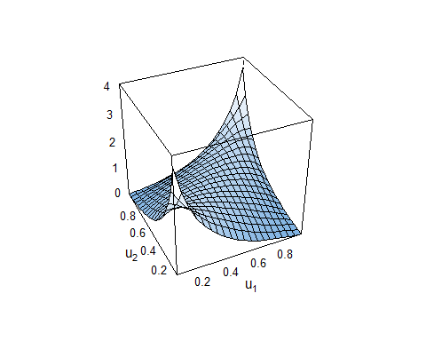

plot(selected2Copula2)

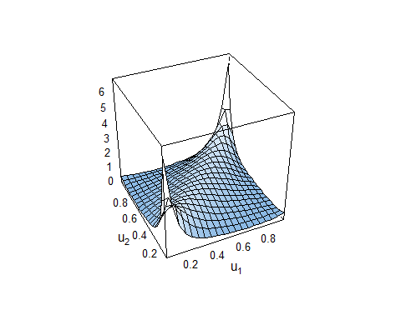

plot(selected2Copula3)

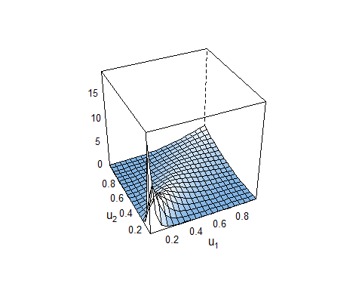

plot(selected2Copula4)

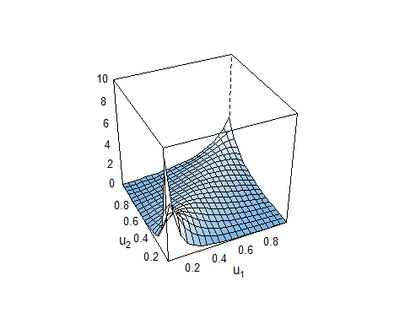

plot(selected2Copula5)

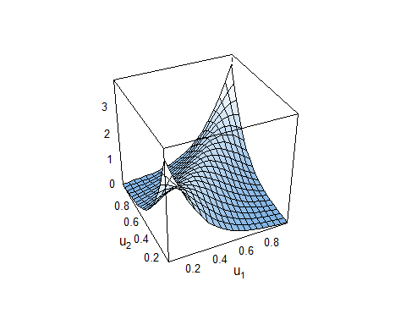

plot(selected2Copula6)

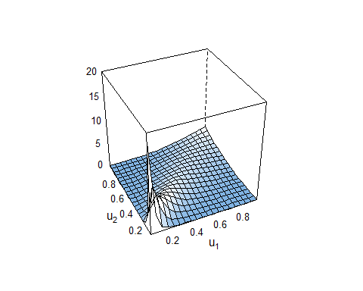

summary(selected2Copula1)

## Family  
## ------   
## No: 1  
## Name: Gaussian  
##   
## Parameter(s)  
## ------------  
## par: 0.62  
##   
## Dependence measures  
## -------------------  
## Kendall's tau: 0.43 (empirical = 0.17, p value < 0.01)  
## Upper TD: 0   
## Lower TD: 0   
##   
## Fit statistics  
## --------------  
## logLik: 8.43   
## AIC: -14.86   
## BIC: -12.1

summary(selected2Copula2)

## Family  
## ------   
## No: 2  
## Name: t  
##   
## Parameter(s)  
## ------------  
## par: 0.61  
## par2: 2  
## Dependence measures  
## -------------------  
## Kendall's tau: 0.42 (empirical = 0.17, p value < 0.01)  
## Upper TD: 0.46   
## Lower TD: 0.46   
##   
## Fit statistics  
## --------------  
## logLik: 14.27   
## AIC: -24.55   
## BIC: -19.02

summary(selected2Copula3)

## Family  
## ------   
## No: 3  
## Name: Clayton  
##   
## Parameter(s)  
## ------------  
## par: 3.15  
##   
## Dependence measures  
## -------------------  
## Kendall's tau: 0.61 (empirical = 0.17, p value < 0.01)  
## Upper TD: 0   
## Lower TD: 0.8   
##   
## Fit statistics  
## --------------  
## logLik: 31.83   
## AIC: -61.65   
## BIC: -58.89

summary(selected2Copula4)

## Family  
## ------   
## No: 14  
## Name: Survival Gumbel  
##   
## Parameter(s)  
## ------------  
## par: 2.19  
##   
## Dependence measures  
## -------------------  
## Kendall's tau: 0.54 (empirical = 0.17, p value < 0.01)  
## Upper TD: 0   
## Lower TD: 0.63   
##   
## Fit statistics  
## --------------  
## logLik: 20.34   
## AIC: -38.67   
## BIC: -35.91

summary(selected2Copula5)

## Family  
## ------   
## No: 5  
## Name: Frank  
##   
## Parameter(s)  
## ------------  
## par: 5.41  
##   
## Dependence measures  
## -------------------  
## Kendall's tau: 0.48 (empirical = 0.17, p value < 0.01)  
## Upper TD: 0   
## Lower TD: 0   
##   
## Fit statistics  
## --------------  
## logLik: 10.79   
## AIC: -19.58   
## BIC: -16.82

summary(selected2Copula6)

## Family  
## ------   
## No: 16  
## Name: Survival Joe  
##   
## Parameter(s)  
## ------------  
## par: 3.92  
##   
## Dependence measures  
## -------------------  
## Kendall's tau: 0.61 (empirical = 0.17, p value < 0.01)  
## Upper TD: 0   
## Lower TD: 0.81   
##   
## Fit statistics  
## --------------  
## logLik: 33.56   
## AIC: -65.12   
## BIC: -62.36

# Bivariat Copula

## a. Bali Sulawesi (Y3 - Y4)

m1 <- Y3 ~ X13+X14  
m2 <- Y4 ~ X13+X14  
  
m3 <- Y3 ~ X23+X24  
m4 <- Y4 ~ X23+X24  
  
m5 <- Y3 ~ X13+X23  
m6 <- Y4 ~ X13+X23  
  
m7 <- Y3 ~ X14+X24  
m8 <- Y4 ~ X14+X24  
  
m9 <- Y3 ~ X13+X14+X23+X24  
m10 <- Y4 ~ X13+X14+X23+X24

library(bizicount)

## Warning: package 'bizicount' was built under R version 4.1.3

cp1 <- bizicount(m1,m2,data,  
 cop = "frank",  
 margins = c("pois","pois"),  
 keep = T)   
cp2 <- bizicount(m3,m4,data,  
 cop = "frank",  
 margins = c("pois","pois"),  
 keep = T)

## Warning in bizicount(m3, m4, data, cop = "frank", margins = c("pois", "pois"), :  
## Convergence code 2 try adjusting stepmax. See '?nlm' Details --> Value --> Code  
## for more information.

cp3 <- bizicount(m5,m6,data,  
 cop = "frank",  
 margins = c("pois","pois"),  
 keep = T)   
cp4 <- bizicount(m7,m8,data,  
 cop = "frank",  
 margins = c("pois","pois"),  
 keep = T)

## Warning in bizicount(m7, m8, data, cop = "frank", margins = c("pois", "pois"), :  
## Convergence code 2 try adjusting stepmax. See '?nlm' Details --> Value --> Code  
## for more information.

cp5 <- bizicount(m9,m10,data,  
 cop = "frank",  
 margins = c("pois","pois"),  
 keep = T)

summary(cp1);cp1$aic;cp1$bic;cp1$loglik

## Call:  
## bizicount(fmla1 = m1, fmla2 = m2, data = data, cop = "frank",   
## margins = c("pois", "pois"), keep = T)  
##   
## =================================================   
## Count Model: Y3 |   
## -----------------   
##   
## Estimate Std. Err. Z value Pr(>|z|)   
## (Intercept) -2.050288 0.344434 -5.9526 2.639e-09 ***  
## X13 0.168832 0.053236 3.1714 0.001517 **   
## X14 0.096072 0.048829 1.9675 0.049122 *   
##   
## -------------------------------------------------   
## Estimate Std. Err. Z value Pr(>|z|)  
## dependence -0.13017 1.02842 -0.1266 0.8993  
## -------------------------------------------------   
##   
## Count Model: Y4 |   
## -----------------   
##   
## Estimate Std. Err. Z value Pr(>|z|)   
## (Intercept) -1.477182 0.318949 -4.6314 3.632e-06 ***  
## X13 0.025026 0.081021 0.3089 0.7574   
## X14 0.070030 0.049202 1.4233 0.1547   
## ---  
## Signif. codes: 0 '***' 0.001 '**' 0.01 '*' 0.05 '.' 0.1 ' ' 1  
##   
## =================================================

## [1] 329.0767

## [1] 319.9287

## [1] -157.5383

summary(cp2);cp2$aic;cp2$bic;cp2$loglik

## Call:  
## bizicount(fmla1 = m3, fmla2 = m4, data = data, cop = "frank",   
## margins = c("pois", "pois"), keep = T)  
##   
## =================================================   
## Count Model: Y3 |   
## -----------------   
##   
## Estimate Std. Err. Z value Pr(>|z|)   
## (Intercept) -7.24599 2.37015 -3.0572 0.002234 **  
## X23 0.71799 0.24260 2.9596 0.003081 **  
## X24 0.17255 0.26313 0.6558 0.511983   
##   
## -------------------------------------------------   
## Estimate Std. Err. Z value Pr(>|z|)  
## dependence -0.028862 1.099900 -0.0262 0.9791  
## -------------------------------------------------   
##   
## Count Model: Y4 |   
## -----------------   
##   
## Estimate Std. Err. Z value Pr(>|z|)   
## (Intercept) -6.984980 2.214158 -3.1547 0.001607 **  
## X23 0.041263 0.184644 0.2235 0.823166   
## X24 0.807100 0.258239 3.1254 0.001776 **  
## ---  
## Signif. codes: 0 '***' 0.001 '**' 0.01 '*' 0.05 '.' 0.1 ' ' 1  
##   
## =================================================

## [1] 320.9369

## [1] 311.7889

## [1] -153.4684

summary(cp3);cp3$aic;cp3$bic;cp3$loglik

## Call:  
## bizicount(fmla1 = m5, fmla2 = m6, data = data, cop = "frank",   
## margins = c("pois", "pois"), keep = T)  
##   
## =================================================   
## Count Model: Y3 |   
## -----------------   
##   
## Estimate Std. Err. Z value Pr(>|z|)   
## (Intercept) -5.311654 1.821524 -2.9160 0.003545 **  
## X13 0.083020 0.061376 1.3526 0.176170   
## X23 0.571867 0.273929 2.0876 0.036830 *   
##   
## -------------------------------------------------   
## Estimate Std. Err. Z value Pr(>|z|)  
## dependence 0.36518 1.00648 0.3628 0.7167  
## -------------------------------------------------   
##   
## Count Model: Y4 |   
## -----------------   
##   
## Estimate Std. Err. Z value Pr(>|z|)  
## (Intercept) -1.22470279 1.35699250 -0.9025 0.3668  
## X13 0.03233454 0.08750462 0.3695 0.7117  
## X23 -0.00051239 0.21858406 -0.0023 0.9981  
##   
## =================================================

## [1] 329.6511

## [1] 320.5031

## [1] -157.8255

summary(cp4);cp4$aic;cp4$bic;cp4$loglik

## Call:  
## bizicount(fmla1 = m7, fmla2 = m8, data = data, cop = "frank",   
## margins = c("pois", "pois"), keep = T)  
##   
## =================================================   
## Count Model: Y3 |   
## -----------------   
##   
## Estimate Std. Err. Z value Pr(>|z|)   
## (Intercept) -1.187913 1.963710 -0.6049 0.54522   
## X14 0.099318 0.057780 1.7189 0.08563 .  
## X24 -0.060749 0.307135 -0.1978 0.84321   
##   
## -------------------------------------------------   
## Estimate Std. Err. Z value Pr(>|z|)  
## dependence 0.058502 1.043114 0.0561 0.9553  
## -------------------------------------------------   
##   
## Count Model: Y4 |   
## -----------------   
##   
## Estimate Std. Err. Z value Pr(>|z|)   
## (Intercept) -6.877205 1.947121 -3.5320 0.0004124 ***  
## X14 -0.015096 0.059634 -0.2531 0.8001549   
## X24 0.839285 0.288757 2.9065 0.0036545 **   
## ---  
## Signif. codes: 0 '***' 0.001 '**' 0.01 '*' 0.05 '.' 0.1 ' ' 1  
##   
## =================================================

## [1] 327.9728

## [1] 318.8248

## [1] -156.9864

summary(cp5);cp5$aic;cp5$bic;cp5$loglik

## Call:  
## bizicount(fmla1 = m9, fmla2 = m10, data = data, cop = "frank",   
## margins = c("pois", "pois"), keep = T)  
##   
## =================================================   
## Count Model: Y3 |   
## -----------------   
##   
## Estimate Std. Err. Z value Pr(>|z|)   
## (Intercept) -5.005542 2.839766 -1.7627 0.07796 .  
## X13 0.101647 0.064922 1.5657 0.11742   
## X14 0.078780 0.061180 1.2877 0.19786   
## X23 0.494760 0.283028 1.7481 0.08045 .  
## X24 -0.022272 0.324027 -0.0687 0.94520   
##   
## -------------------------------------------------   
## Estimate Std. Err. Z value Pr(>|z|)  
## dependence 0.041746 1.147128 0.0364 0.971  
## -------------------------------------------------   
##   
## Count Model: Y4 |   
## -----------------   
##   
## Estimate Std. Err. Z value Pr(>|z|)   
## (Intercept) -7.268336 2.536318 -2.8657 0.004161 **  
## X13 0.010064 0.095038 0.1059 0.915668   
## X14 -0.019798 0.062533 -0.3166 0.751540   
## X23 0.047062 0.219292 0.2146 0.830074   
## X24 0.850315 0.293449 2.8977 0.003760 **  
## ---  
## Signif. codes: 0 '***' 0.001 '**' 0.01 '*' 0.05 '.' 0.1 ' ' 1  
##   
## =================================================

## [1] 325.5694

## [1] 311.194

## [1] -151.7847

## b. Sulawesi - Papua (Y4 - Y5)

n1 <- Y4 ~ X14+X15  
n2 <- Y5 ~ X14+X15   
  
n3 <- Y4 ~ X24+X25   
n4 <- Y5 ~ X24+X25   
  
n5 <- Y4 ~ X14+X24   
n6 <- Y5 ~ X14+X24  
  
n7 <- Y4 ~ X15+X25   
n8 <- Y5 ~ X15+X25   
  
n9 <- Y4 ~ X14+X15+X24+X25   
n10 <- Y5 ~ X14+X15+X24+X25

cop1 <- bizicount(n1,n2,data,  
 cop = "frank",  
 margins = c("pois","pois"),  
 keep = T)   
cop2 <- bizicount(n3,n4,data,  
 cop = "frank",  
 margins = c("pois","pois"),  
 keep = T)   
cop3 <- bizicount(n5,n6,data,  
 cop = "frank",  
 margins = c("pois","pois"),  
 keep = T)   
cop4 <- bizicount(n7,n8,data,  
 cop = "frank",  
 margins = c("pois","pois"),  
 keep = T)   
cop5 <- bizicount(n9,n10,data,  
 cop = "frank",  
 margins = c("pois","pois"),  
 keep = T)

summary(cop1);cop1$aic;cop1$bic;cop1$loglik

## Call:  
## bizicount(fmla1 = n1, fmla2 = n2, data = data, cop = "frank",   
## margins = c("pois", "pois"), keep = T)  
##   
## =================================================   
## Count Model: Y4 |   
## -----------------   
##   
## Estimate Std. Err. Z value Pr(>|z|)   
## (Intercept) -1.482126 0.282263 -5.2509 1.514e-07 ***  
## X14 0.065415 0.049906 1.3108 0.1899   
## X15 0.071199 0.124537 0.5717 0.5675   
##   
## -------------------------------------------------   
## Estimate Std. Err. Z value Pr(>|z|)  
## dependence 1.5867 1.5882 0.9991 0.3178  
## -------------------------------------------------   
##   
## Count Model: Y5 |   
## -----------------   
##   
## Estimate Std. Err. Z value Pr(>|z|)   
## (Intercept) -2.990909 0.526260 -5.6833 1.321e-08 ***  
## X14 0.014628 0.101605 0.1440 0.885528   
## X15 0.430793 0.137155 3.1409 0.001684 **   
## ---  
## Signif. codes: 0 '***' 0.001 '**' 0.01 '*' 0.05 '.' 0.1 ' ' 1  
##   
## =================================================

## [1] 243.642

## [1] 234.494

## [1] -114.821

summary(cop2);cop2$aic;cop2$bic;cop2$loglik

## Call:  
## bizicount(fmla1 = n3, fmla2 = n4, data = data, cop = "frank",   
## margins = c("pois", "pois"), keep = T)  
##   
## =================================================   
## Count Model: Y4 |   
## -----------------   
##   
## Estimate Std. Err. Z value Pr(>|z|)   
## (Intercept) -6.06719 1.99730 -3.0377 0.002384 **  
## X24 0.82052 0.25621 3.2025 0.001362 **  
## X25 -0.12566 0.17043 -0.7373 0.460944   
##   
## -------------------------------------------------   
## Estimate Std. Err. Z value Pr(>|z|)   
## dependence 3.7398 2.0843 1.7943 0.07277 .  
## -------------------------------------------------   
##   
## Count Model: Y5 |   
## -----------------   
##   
## Estimate Std. Err. Z value Pr(>|z|)   
## (Intercept) -6.941306 3.072428 -2.2592 0.02387 *   
## X24 -0.076261 0.374795 -0.2035 0.83877   
## X25 0.821682 0.318652 2.5786 0.00992 **  
## ---  
## Signif. codes: 0 '***' 0.001 '**' 0.01 '*' 0.05 '.' 0.1 ' ' 1  
##   
## =================================================

## [1] 235.7389

## [1] 226.5909

## [1] -110.8694

summary(cop3);cop3$aic;cop3$bic;cop3$loglik

## Call:  
## bizicount(fmla1 = n5, fmla2 = n6, data = data, cop = "frank",   
## margins = c("pois", "pois"), keep = T)  
##   
## =================================================   
## Count Model: Y4 |   
## -----------------   
##   
## Estimate Std. Err. Z value Pr(>|z|)   
## (Intercept) -6.7677696 1.9241870 -3.5172 0.0004361 ***  
## X14 -0.0086061 0.0598492 -0.1438 0.8856612   
## X24 0.8195898 0.2852899 2.8728 0.0040681 **   
##   
## -------------------------------------------------   
## Estimate Std. Err. Z value Pr(>|z|)  
## dependence 2.6669 1.6391 1.627 0.1037  
## -------------------------------------------------   
##   
## Count Model: Y5 |   
## -----------------   
##   
## Estimate Std. Err. Z value Pr(>|z|)  
## (Intercept) -1.114151 2.878259 -0.3871 0.6987  
## X14 0.093518 0.104163 0.8978 0.3693  
## X24 -0.227449 0.462044 -0.4923 0.6225  
##   
## =================================================

## [1] 243.1516

## [1] 234.0037

## [1] -114.5758

summary(cop4);cop4$aic;cop4$bic;cop4$loglik

## Call:  
## bizicount(fmla1 = n7, fmla2 = n8, data = data, cop = "frank",   
## margins = c("pois", "pois"), keep = T)  
##   
## =================================================   
## Count Model: Y4 |   
## -----------------   
##   
## Estimate Std. Err. Z value Pr(>|z|)  
## (Intercept) 0.33525 1.27420 0.2631 0.7925  
## X15 0.25386 0.16958 1.4970 0.1344  
## X25 -0.29680 0.23663 -1.2543 0.2097  
##   
## -------------------------------------------------   
## Estimate Std. Err. Z value Pr(>|z|)  
## dependence 1.7603 1.7589 1.0008 0.3169  
## -------------------------------------------------   
##   
## Count Model: Y5 |   
## -----------------   
##   
## Estimate Std. Err. Z value Pr(>|z|)  
## (Intercept) -4.03687 2.96960 -1.3594 0.1740  
## X15 0.37224 0.23373 1.5927 0.1112  
## X25 0.18967 0.51213 0.3704 0.7111  
##   
## =================================================

## [1] 243.3983

## [1] 234.2503

## [1] -114.6992

summary(cop5);cop5$aic;cop5$bic;cop5$loglik

## Call:  
## bizicount(fmla1 = n9, fmla2 = n10, data = data, cop = "frank",   
## margins = c("pois", "pois"), keep = T)  
##   
## =================================================   
## Count Model: Y4 |   
## -----------------   
##   
## Estimate Std. Err. Z value Pr(>|z|)   
## (Intercept) -4.7425892 2.2746705 -2.0850 0.037073 *   
## X14 -0.0064255 0.0604756 -0.1062 0.915384   
## X15 0.2537043 0.1606617 1.5791 0.114308   
## X24 0.8188000 0.2806038 2.9180 0.003523 **  
## X25 -0.3877905 0.2455546 -1.5792 0.114280   
##   
## -------------------------------------------------   
## Estimate Std. Err. Z value Pr(>|z|)  
## dependence 2.8845 2.2517 1.2811 0.2002  
## -------------------------------------------------   
##   
## Count Model: Y5 |   
## -----------------   
##   
## Estimate Std. Err. Z value Pr(>|z|)  
## (Intercept) -1.972659 4.195225 -0.4702 0.6382  
## X14 0.092459 0.117143 0.7893 0.4299  
## X15 0.357361 0.232425 1.5375 0.1242  
## X24 -0.418239 0.483341 -0.8653 0.3869  
## X25 0.252144 0.512108 0.4924 0.6225  
##   
## =================================================

## [1] 239.4107

## [1] 225.0353

## [1] -108.7053

# Bivariat Zero Inflated

## a. Bali - Sulawesi (Y3 - Y4)

z1 <- Y3 ~ X13+X14|X13+X14  
z2 <- Y4 ~ X13+X14|X13+X14  
  
z3 <- Y3 ~ X23+X24|X23+X24  
z4 <- Y4 ~ X23+X24|X23+X24  
  
z5 <- Y3 ~ X13+X23|X13+X23  
z6 <- Y4 ~ X13+X23|X13+X23  
  
z7 <- Y3 ~ X14+X24|X14+X24  
z8 <- Y4 ~ X14+X24|X14+X24  
  
z9 <- Y3 ~ X13+X14+X23+X24|X13+X14+X23+X24  
z10 <- Y4 ~ X13+X14+X23+X24|X13+X14+X23+X24

#Pemodelan ZIP  
cp.zi.1 <- bizicount(z1,z2,data,  
 cop = "frank",  
 margins = c("zip","zip"),  
 link.zi = c("logit", "logit"),  
 keep = T)

## Warning in bizicount(z1, z2, data, cop = "frank", margins = c("zip", "zip"), :  
## Convergence code 2 try adjusting stepmax. See '?nlm' Details --> Value --> Code  
## for more information.

cp.zi.2 <- bizicount(z3,z4,data,  
 cop = "frank",  
 margins = c("zip","zip"),  
 link.zi = c("probit", "probit"),  
 keep = T)

## Warning in bizicount(z3, z4, data, cop = "frank", margins = c("zip", "zip"), : nlm() was unable to obtain Hessian matrix, so numDeriv::hessian() was used in computing standard errors.  
## Consider reducing 'stepmax' option to nlm to prevent this.  
## See `?nlm` for more details on the 'stepmax' option.

## Warning: Hessian of loglik is not negative definite at convergence point;  
## convergence point is not a maximum.

cp.zi.3 <- bizicount(z5,z6,data,  
 cop = "frank",  
 margins = c("zip","zip"),  
 link.zi = c("probit", "probit"),  
 keep = T)

## Warning in bizicount(z5, z6, data, cop = "frank", margins = c("zip", "zip"), : nlm() was unable to obtain Hessian matrix, so numDeriv::hessian() was used in computing standard errors.  
## Consider reducing 'stepmax' option to nlm to prevent this.  
## See `?nlm` for more details on the 'stepmax' option.  
  
## Warning in bizicount(z5, z6, data, cop = "frank", margins = c("zip", "zip"), : Hessian of loglik is not negative definite at convergence point; convergence point is not a maximum.

## Warning in sqrt(diag(solve(hess.new, tol = tol))): NaNs produced

cp.zi.4 <- bizicount(z7,z8,data,  
 cop = "frank",  
 margins = c("zip","zip"),  
 link.zi = c("probit", "probit"),  
 keep = T)   
  
cp.zi.5 <- bizicount(z9,z10,data,  
 cop = "frank",  
 margins = c("zip","zip"),  
 link.zi = c("probit", "probit"),  
 keep = T)

## Warning: Hessian of loglik is not negative definite at convergence point;  
## convergence point is not a maximum.

summary(cp.zi.1);cp.zi.1$aic;cp.zi.1$bic;cp.zi.1$loglik

## Call:  
## bizicount(fmla1 = z1, fmla2 = z2, data = data, cop = "frank",   
## margins = c("zip", "zip"), link.zi = c("logit", "logit"),   
## keep = T)  
##   
## =================================================   
## Count Model: Y3 |   
## -----------------   
##   
## Estimate Std. Err. Z value Pr(>|z|)  
## (Intercept) -0.9113089 0.6947910 -1.3116 0.1896  
## X13 0.0982510 0.0665306 1.4768 0.1397  
## X14 -0.0031543 0.0747580 -0.0422 0.9663  
##   
## ++++++++++++++++++++++++   
## Zero Inflation: Y3 |   
## --------------------   
##   
## Estimate Std. Err. Z value Pr(>|z|)   
## (Intercept) 1.59082 1.14410 1.3905 0.16439   
## X13 -0.19873 0.19603 -1.0138 0.31069   
## X14 -0.46310 0.24549 -1.8864 0.05924 .  
##   
## -------------------------------------------------   
## Estimate Std. Err. Z value Pr(>|z|)  
## dependence -0.009675 1.078658 -0.009 0.9928  
## -------------------------------------------------   
##   
## Count Model: Y4 |   
## -----------------   
##   
## Estimate Std. Err. Z value Pr(>|z|)   
## (Intercept) -1.410893 0.344145 -4.0997 4.137e-05 ***  
## X13 0.066833 0.100101 0.6677 0.5044   
## X14 0.044737 0.053355 0.8385 0.4018   
##   
## ++++++++++++++++++++++++   
## Zero Inflation: Y4 |   
## --------------------   
##   
## Estimate Std. Err. Z value Pr(>|z|)  
## (Intercept) 9.2715 155.1531 0.0598 0.9523  
## X13 18.4832 48.9925 0.3773 0.7060  
## X14 -92.5362 78.7867 -1.1745 0.2402  
##   
## =================================================

## [1] 333.8598

## [1] 316.8707

## [1] -153.9299

summary(cp.zi.2);cp.zi.2$aic;cp.zi.2$bic;cp.zi.2$loglik

## Call:  
## bizicount(fmla1 = z3, fmla2 = z4, data = data, cop = "frank",   
## margins = c("zip", "zip"), link.zi = c("probit", "probit"),   
## keep = T)  
##   
## =================================================   
## Count Model: Y3 |   
## -----------------   
##   
## Estimate Std. Err. Z value Pr(>|z|)   
## (Intercept) -3.59088 3.11468 -1.1529 0.24896   
## X23 0.62134 0.24555 2.5305 0.01139 *  
## X24 -0.24386 0.34546 -0.7059 0.48025   
##   
## ++++++++++++++++++++++++   
## Zero Inflation: Y3 |   
## --------------------   
##   
## Estimate Std. Err. Z value Pr(>|z|)  
## (Intercept) 50.68551 35.80639 1.4155 0.1569  
## X23 -0.55393 0.69069 -0.8020 0.4226  
## X24 -7.71218 5.77316 -1.3359 0.1816  
##   
## -------------------------------------------------   
## Estimate Std. Err. Z value Pr(>|z|)  
## dependence 0.78449 1.20335 0.6519 0.5144  
## -------------------------------------------------   
##   
## Count Model: Y4 |   
## -----------------   
##   
## Estimate Std. Err. Z value Pr(>|z|)   
## (Intercept) -6.504189 2.181186 -2.9820 0.0028642 **   
## X23 -0.090247 0.196653 -0.4589 0.6462957   
## X24 0.866429 0.263080 3.2934 0.0009898 ***  
##   
## ++++++++++++++++++++++++   
## Zero Inflation: Y4 |   
## --------------------   
##   
## Estimate Std. Err. Z value Pr(>|z|)   
## (Intercept) -34.62437 96.72913 -0.358 0.7204   
## X23 -79.01256 0.78504 -100.648 <2e-16 ***  
## X24 47.70639 0.70822 67.361 <2e-16 ***  
## ---  
## Signif. codes: 0 '***' 0.001 '**' 0.01 '*' 0.05 '.' 0.1 ' ' 1  
##   
## =================================================

## [1] 325.2025

## [1] 308.2134

## [1] -149.6012

summary(cp.zi.3);cp.zi.3$aic;cp.zi.3$bic;cp.zi.3$loglik

## Call:  
## bizicount(fmla1 = z5, fmla2 = z6, data = data, cop = "frank",   
## margins = c("zip", "zip"), link.zi = c("probit", "probit"),   
## keep = T)  
##   
## =================================================   
## Count Model: Y3 |   
## -----------------   
##   
## Estimate Std. Err. Z value Pr(>|z|)   
## (Intercept) -5.311555 1.822267 -2.9148 0.003559 **  
## X13 0.083022 0.061423 1.3516 0.176493   
## X23 0.571852 0.274126 2.0861 0.036970 *   
##   
## ++++++++++++++++++++++++   
## Zero Inflation: Y3 |   
## --------------------   
##   
## Estimate Std. Err. Z value Pr(>|z|)  
## (Intercept) 1.72090 NaN NaN NaN  
## X13 0.37947 2841.74464 1e-04 0.9999  
## X23 -1.92639 NaN NaN NaN  
##   
## -------------------------------------------------   
## Estimate Std. Err. Z value Pr(>|z|)  
## dependence 0.36518 1.00647 0.3628 0.7167  
## -------------------------------------------------   
##   
## Count Model: Y4 |   
## -----------------   
##   
## Estimate Std. Err. Z value Pr(>|z|)  
## (Intercept) -1.22452978 1.35326877 -0.9049 0.3655  
## X13 0.03233924 0.08748603 0.3697 0.7116  
## X23 -0.00054052 0.21802931 -0.0025 0.9980  
##   
## ++++++++++++++++++++++++   
## Zero Inflation: Y4 |   
## --------------------   
##   
## Estimate Std. Err. Z value Pr(>|z|)  
## (Intercept) -0.82331 7517.15305 -1e-04 0.9999  
## X13 -0.77973 1383.76028 -6e-04 0.9996  
## X23 -1.16029 1914.95020 -6e-04 0.9995  
##   
## =================================================

## [1] 341.6511

## [1] 324.662

## [1] -157.8255

summary(cp.zi.4);cp.zi.4$aic;cp.zi.4$bic;cp.zi.4$loglik

## Call:  
## bizicount(fmla1 = z7, fmla2 = z8, data = data, cop = "frank",   
## margins = c("zip", "zip"), link.zi = c("probit", "probit"),   
## keep = T)  
##   
## =================================================   
## Count Model: Y3 |   
## -----------------   
##   
## Estimate Std. Err. Z value Pr(>|z|)   
## (Intercept) 4.781139 2.817784 1.6968 0.08974 .  
## X14 0.046855 0.071309 0.6571 0.51114   
## X24 -0.824996 0.422857 -1.9510 0.05106 .  
##   
## ++++++++++++++++++++++++   
## Zero Inflation: Y3 |   
## --------------------   
##   
## Estimate Std. Err. Z value Pr(>|z|)   
## (Intercept) 7.41367 4.97599 1.4899 0.13625   
## X14 -0.27794 0.14537 -1.9119 0.05589 .  
## X24 -1.03780 0.81572 -1.2722 0.20329   
##   
## -------------------------------------------------   
## Estimate Std. Err. Z value Pr(>|z|)  
## dependence 0.75707 1.19535 0.6333 0.5265  
## -------------------------------------------------   
##   
## Count Model: Y4 |   
## -----------------   
##   
## Estimate Std. Err. Z value Pr(>|z|)   
## (Intercept) -6.884856 1.948818 -3.5328 0.0004111 ***  
## X14 -0.018289 0.059250 -0.3087 0.7575655   
## X24 0.841548 0.288861 2.9133 0.0035759 **   
##   
## ++++++++++++++++++++++++   
## Zero Inflation: Y4 |   
## --------------------   
##   
## Estimate Std. Err. Z value Pr(>|z|)  
## (Intercept) 1.50466 830.06118 0.0018 0.9986  
## X14 0.45655 357.49546 0.0013 0.9990  
## X24 -1.70207 719.54143 -0.0024 0.9981  
##   
## =================================================

## [1] 331.4836

## [1] 314.4945

## [1] -152.7418

summary(cp.zi.5);cp.zi.5$aic;cp.zi.5$bic;cp.zi.5$loglik

## Call:  
## bizicount(fmla1 = z9, fmla2 = z10, data = data, cop = "frank",   
## margins = c("zip", "zip"), link.zi = c("probit", "probit"),   
## keep = T)  
##   
## =================================================   
## Count Model: Y3 |   
## -----------------   
##   
## Estimate Std. Err. Z value Pr(>|z|)  
## (Intercept) 0.374234 3.964079 0.0944 0.9248  
## X13 0.048142 0.070717 0.6808 0.4960  
## X14 0.045297 0.070860 0.6393 0.5227  
## X23 0.387773 0.297011 1.3056 0.1917  
## X24 -0.606760 0.428800 -1.4150 0.1571  
##   
## ++++++++++++++++++++++++   
## Zero Inflation: Y3 |   
## --------------------   
##   
## Estimate Std. Err. Z value Pr(>|z|)  
## (Intercept) 11.131357 9.466016 1.1759 0.2396  
## X13 -0.135268 0.151646 -0.8920 0.3724  
## X14 -0.252757 0.196734 -1.2848 0.1989  
## X23 -0.076503 0.471038 -0.1624 0.8710  
## X24 -1.548826 1.298524 -1.1928 0.2330  
##   
## -------------------------------------------------   
## Estimate Std. Err. Z value Pr(>|z|)  
## dependence 0.67873 1.24507 0.5451 0.5857  
## -------------------------------------------------   
##   
## Count Model: Y4 |   
## -----------------   
##   
## Estimate Std. Err. Z value Pr(>|z|)   
## (Intercept) -7.2341644 2.5288611 -2.8606 0.004228 **  
## X13 0.0091896 0.0948505 0.0969 0.922817   
## X14 -0.0217718 0.0620708 -0.3508 0.725770   
## X23 0.0426961 0.2173203 0.1965 0.844245   
## X24 0.8503782 0.2936986 2.8954 0.003787 **  
##   
## ++++++++++++++++++++++++   
## Zero Inflation: Y4 |   
## --------------------   
##   
## Estimate Std. Err. Z value Pr(>|z|)  
## (Intercept) 0.45954 1596.80623 0.0003 0.9998  
## X13 -3.05850 1788.58464 -0.0017 0.9986  
## X14 3.19384 549.91206 0.0058 0.9954  
## X23 -5.25391 476.50494 -0.0110 0.9912  
## X24 -1.20981 625.35349 -0.0019 0.9985  
##   
## =================================================

## [1] 340.516

## [1] 313.0721

## [1] -149.258