Exercise 3
Students ID: 212209993, 214453821
1. Introduction
In this exercise, the Bug1 and Bug2 navigation algorithm was implemented for the Pi-Puck robot using the ARGoS3 simulator.
The goal of the robot is to autonomously navigate in an unknown environment, avoid obstacles, reach a cyan target, and stop precisely at the target position.
The implementation follows the classical Bug1 algorithm as presented in class, with practical adaptations for the Pi-Puck sensors and differential-drive constraints.
2. System Overview
Sensors Used
- Positioning Sensor (m_pcPositioning)
Used to obtain the robot’s absolute position and orientation (yaw).
- Rangefinders (m_pcRangefinders)
Eight proximity sensors used for obstacle detection and wall following.
- Colored Blob Omnidirectional Camera (m_pcCamera)
Used only for visualization (target LED), not for navigation logic.
- System Sensor (m_pcSystem)
Used for timing/debugging.
Actuators Used
- Differential Drive (m_pcWheels)
Controls linear and angular motion.
- Colored LEDs (m_pcColoredLEDs)
Used to indicate the current behavior state.
3. State-Machine Design
The controller is implemented as a finite state machine with the following states:
- ALIGN
The robot rotates in place until its orientation is aligned with the target direction.
  - LEDs: Blue
  - Control: Angular feedback only
- GO_TO_GOAL
The robot moves straight toward the target using proportional angular correction.
  - LEDs: Blue
  - Control: Linear + angular feedback
- FOLLOW_BOUNDARY
Activated when an obstacle is detected.
The robot follows the obstacle boundary while memorizing the closest point to the target.
  - LEDs: Yellow
  - Control: Wall-following feedback using left and front-left sensors
- LEAVE_BOUNDARY
After completing a full loop around the obstacle, the robot returns to the best point, realigns toward the target, and detaches from the obstacle.
  - LEDs: Blue
  - Control: Angular alignment → straight motion
- FINISHED
The robot stops when it reaches the target.
  - LEDs: Green
  - Motion: Stop
4. Bug1 Algorithm Implementation Details
Obstacle Handling
- The robot detects obstacles using the front range sensors (indices 0, 1, and 7).
- Upon collision:
  - The current position is stored as the hit point
  - Boundary following begins
Boundary Following
- The robot follows the obstacle from the left side
- A target wall distance is maintained using proportional control
- During the first loop around the obstacle:
  - The robot continuously updates the best point, defined as the position with minimal distance to the target

Loop Completion Detection
- The robot detects loop completion by:
  - Leaving the hit point area
  - Returning close to the hit point afterward
- Once the loop is completed, the best point is frozen
Leaving the Obstacle
- The robot navigates back to the best point
- It then:
  - Rotates in place toward the target
  - Ensures the front is clear
  - Moves straight for a short distance
  - Forces re-alignment and returns to GO_TO_GOAL
This ensures a clean and deterministic detachment, avoiding random motion.
5. Feedback Control
Feedback control is used in both angular and linear components:
Angular Control
- Proportional controller based on yaw error:
$$ω=k⋅(θ_{target}-θ_{robot})$$
- Used in:
  - ALIGN
  - GO_TO_GOAL
  - LEAVE_BOUNDARY
Linear Control
- Speed is reduced as the robot approaches the target
- Speed is also reduced near corners and tight obstacle areas
Parameters
- Wheel speed: 5.0
- Obstacle threshold: 0.08
- Wall following distance: 0.15
- Angular gains tuned empirically for stability
6. LED Policy
The LED behavior strictly follows the assignment rules:
State | LED Color
Moving to target | Blue
Bypassing obstacle | Yellow
Target reached | Green
7. Pseudo Code
ALIGN:
rotate toward target until aligned
-> GO_TO_GOAL

GO_TO_GOAL:
move toward target
if obstacle detected:
store hit point
init best point
-> FOLLOW_BOUNDARY

FOLLOW_BOUNDARY:
follow obstacle boundary - left side
if closer to target than best:
update best point
if loop completed:
navigate to best point
-> LEAVE_BOUNDARY

LEAVE_BOUNDARY:
rotate toward target
ensure front is clear
move straight shortly
-> ALIGN

FINISHED:
Stop
8. Experimental Setup
- Arena size: 8m x 8m
- Obstacles: Rectangular static boxes
- Robot start: (-3.5, 3.5)
- Target: (3.5, -3.5) - cyan light
- Physics engine: dynamics2d
- Visualization: Bird’s-eye camera with trajectory tracking
Multiple arenas with different obstacle layouts were tested successfully.
9. Results and Success Report
Figure 1 – Bug1 Navigation Around a Single Obstacle
The figure shows the robot navigating toward the target, encountering a rectangular obstacle, and switching to boundary following mode. The robot circles the obstacle while maintaining a fixed distance from the wall and memorizes the closest point to the target. After completing the loop, it leaves the obstacle at the best point and proceeds directly to the target, where it stops successfully.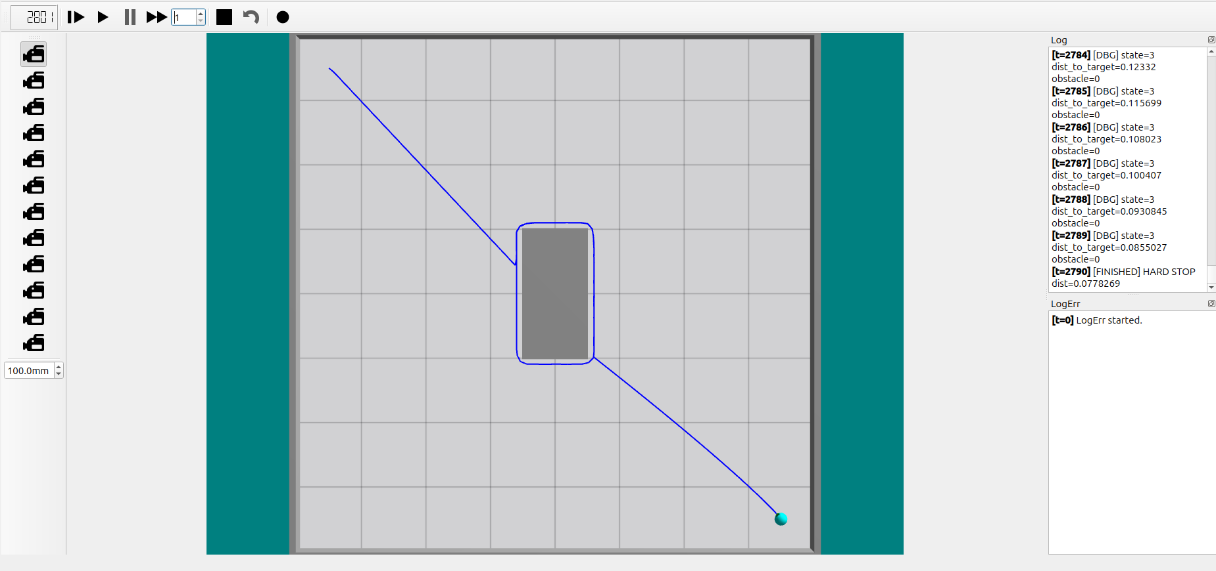

Figure 2 – Bug1 Navigation in a Complex Obstacle Layout
This figure demonstrates the robot operating in a more complex environment with multiple obstacle shapes. The robot follows the obstacle boundaries correctly, including sharp corners, completes a full loop, and detaches at the optimal point. The trajectory shows a clean transition back to goal-directed motion, ending with a precise stop at the target location.
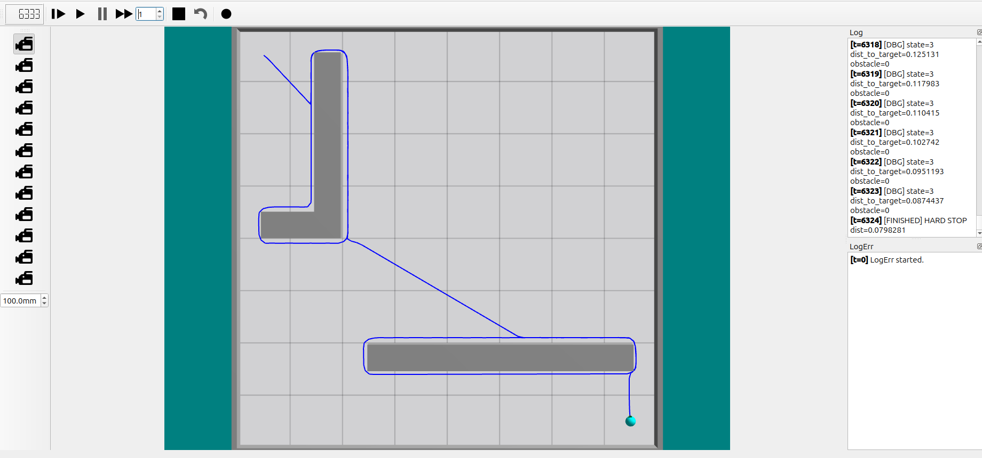

10. Conclusion
The Bug1 algorithm was implemented successfully using a structured state machine, feedback control, and proper memory of obstacle interaction points.
The robot reliably navigates around obstacles, selects the optimal leaving point, and reaches the target efficiently.
11. Bug2 Algorithm Implementation Details
While the Bug2 implementation shares the same sensor configuration, machine states (except leave boundary which is not necessary in bug2 logic), and low-level motion control (wall following logic) as the Bug1 algorithm described in Section 4, it introduces a fundamental change in the obstacle leaving condition based on the M-Line.
11.1. The M-Line Concept
The algorithm calculates a virtual line segment, the M-Line, connecting the robot's initial starting position and the target position.
In the code, this is implemented in the IsOnMLine function, which calculates the perpendicular distance of the robot from the line vector using the 2D cross-product area method. A tolerance corridor of 0.05m is used to determine if the robot is effectively "on" the line.
11.2. Obstacle Handling and Leave Condition
Unlike Bug1, which traverses the entire perimeter of the obstacle:
- Hit Point: When an obstacle is encountered, the robot records the distance to the target (m_fHitDist) and switches to FOLLOW_BOUNDARY.
- Wall Following: The robot follows the wall using the same P-controller logic as described in the Bug1 implementation (Section 4).
- Leave Condition: The robot does not complete a full loop. Instead, it evaluates the following condition at every step:
  - The robot intersects the M-Line.
  - The current distance to the target is strictly less than the distance at the Hit Point.
  - The path forward (towards the goal) is not blocked by an obstacle.
Once these conditions are met, the robot immediately transitions back to the ALIGN / GO_TO_GOAL state, effectively "short-cutting" the path.
12. Feedback Control
Feedback control is used in both angular and linear components:
$$ω=k⋅\left(θ_{target}- θ_{robot}\right)$$

- Angular Control: Proportional controller based on yaw error:
- Linear Control: Speed is reduced as the robot approaches the target, and near corners/tight obstacle areas.
- Parameters: Wheel speed: 5.0, Obstacle threshold: 0.08, Wall following distance: 0.15. Angular gains tuned empirically for stability.
13. LED Policy
The LED behavior strictly follows the assignment rules:
- Moving to target: Blue
- Bypassing obstacle: Yellow
- Target reached: Green
14. Pseudo Code
Shared Logic:
- ALIGN: Rotate toward target -> GO_TO_GOAL
- GO_TO_GOAL: Move toward target. If obstacle detected -> Store hit point -> FOLLOW_BOUNDARY
- FINISHED: Stop
Bug2 Specific:
- FOLLOW_BOUNDARY:
  - Follow obstacle boundary (left side).
  - Check if $IsOnMLine(current_pos)$ is TRUE AND $dist_to_target < hit_distance AND front_is_clear.$
  - THEN -> ALIGN (Switch immediately to goal seeking).

15. Experimental Setup
- Arena size: 8m x 8m
- Obstacles: Rectangular static boxes
- Robot start: (-3.5, 3.5)
- Target (scenario 1): (3.5, -3.5) - cyan light
- Target (scenario 2): (-3.5, -3.5) - cyan light
- Visualization: Bird’s-eye camera with trajectory tracking
16. Bug2 Results
Figure 3 – Bug2 Multi-Obstacle Traversal
The figure below demonstrates the efficiency of Bug2. The robot (blue line) encounters the first obstacle, follows the boundary until it intersects the M-Line closer to the target, and immediately leaves the wall. It repeats this process for the second obstacle, creating a "staircase" or zig-zag pattern along the line of sight.
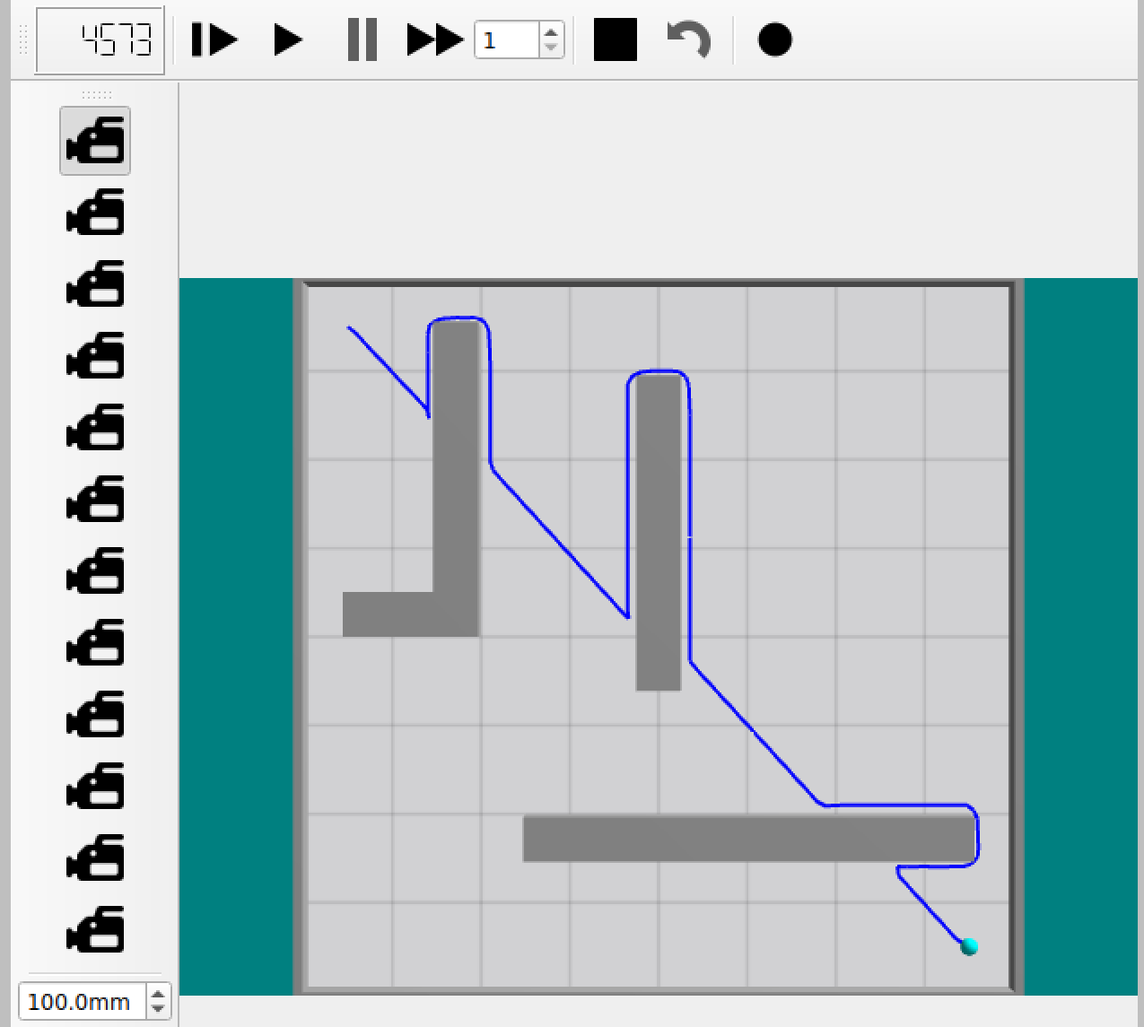
Figure 4 – Bug2 Complex "L" Shape
In this scenario, the robot encounters a concave L-shaped obstacle. It follows the interior and exterior walls. Unlike Bug1, it does not waste time circumnavigating the entire shape. Once it crosses the M-Line at a point closer to the target (at the bottom edge of the obstacle), it immediately detaches and proceeds to the goal.
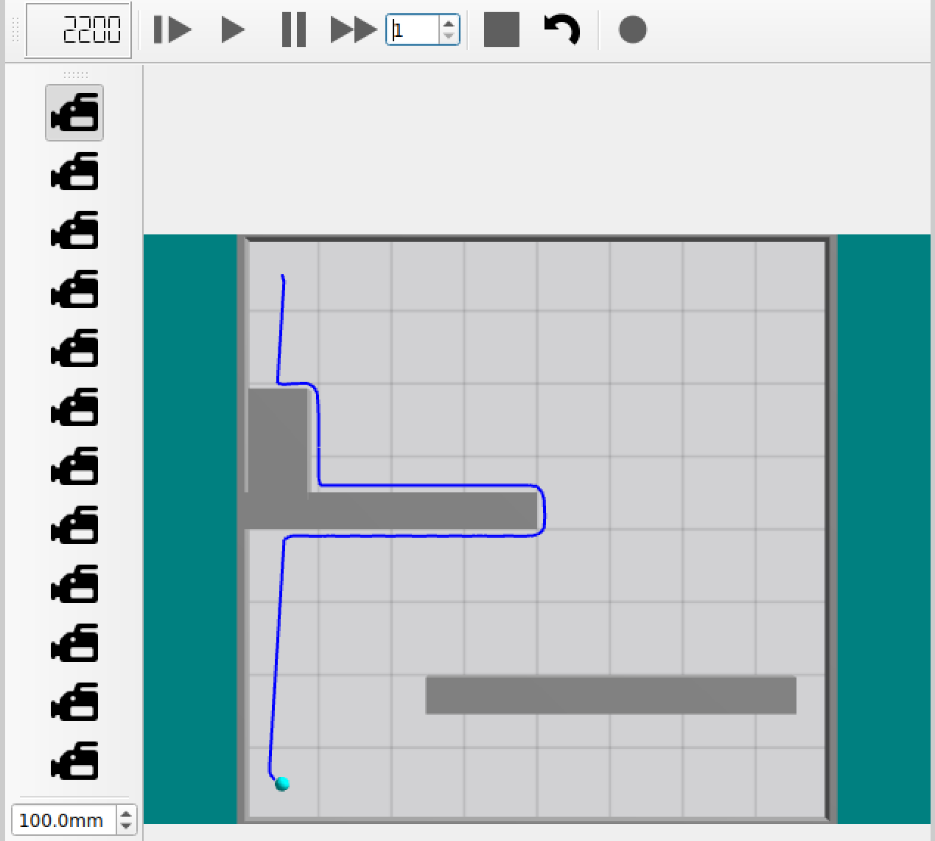
17. Conclusion
The Bug2 algorithms were implemented successfully using a structured state machine, feedback control, and proper memory of obstacle interaction points.
Bug2 optimizes the path by detaching as soon as the M-Line is crossed closer to the target.

