1. Create github repo from your github account. Copy the link from clone or download button

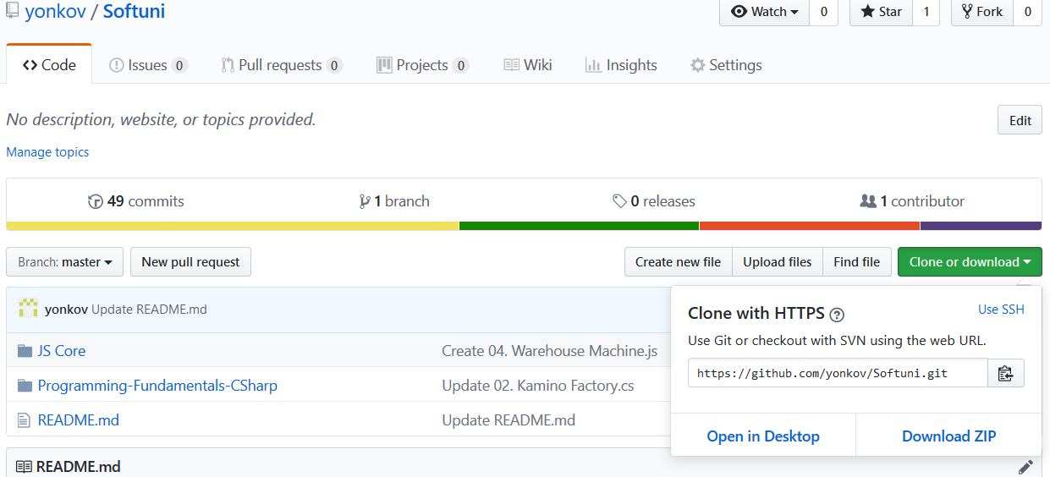

1. open terminal in any folder and type:

**git clone** [**https://github.com/yonkov/Softuni.git**](https://github.com/yonkov/Softuni.git)

1. Go to the folder, create a folder ReactJs Fundamentals/final-project and add your project inside it without the node modules
2. Commit to github:

git init

git add .

git commit -m "First commit"

git remote add origin [**https://github.com/yonkov/Softuni.git**](https://github.com/yonkov/Softuni.git)

git remote –v

git push -f origin master