A challenging goal in neuroscience is to be able to read out or decode, mental content from brain activity. recent functional magnetic resonance imaging (fMRI) studies have decoded orientation, position, and object category, from activity in the visual cortex. However, these studies typically used relatively simple stimuli (for example, gratings) or images drawn from fixed categories (for example, faces, houses), and decoding was based on previous measurements of brain activity evoked by those same stimuli or categories.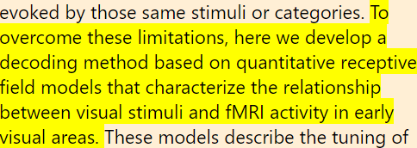

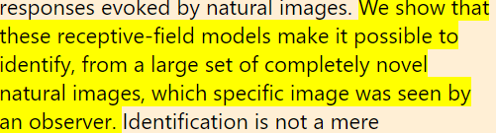

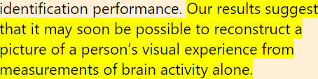

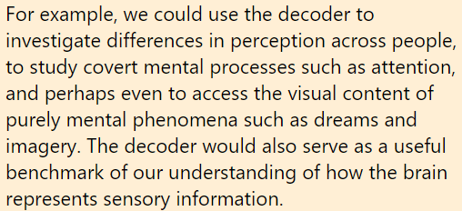

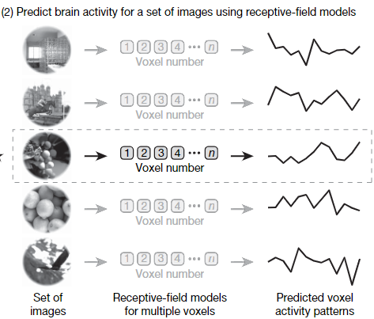

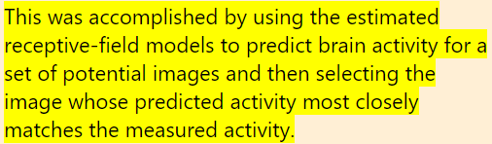

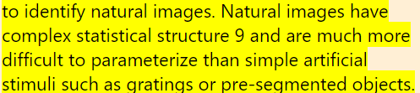

Reason: Because neural processing of visual stimuli is nonlinear, a decoder that can identify simple stimuli may fail when confronted with complex natural images.

The experiment consisted of two stages: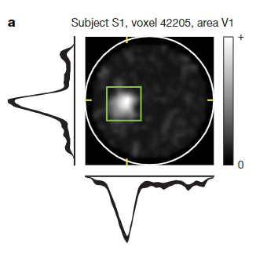

Stage_1:

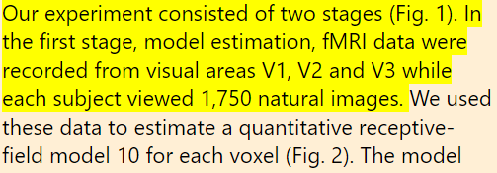

Stage_2

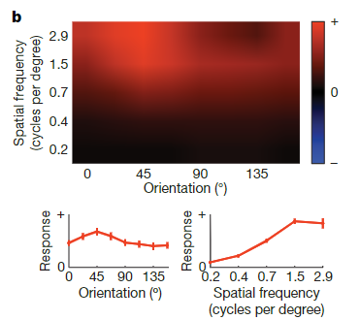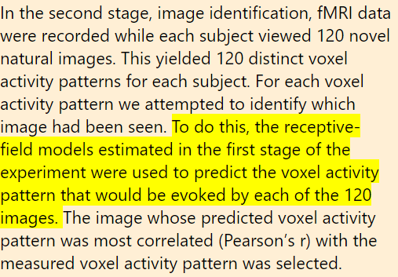

Result:

Note:

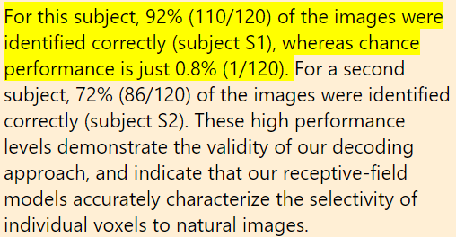

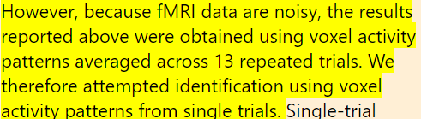

About FMRI:

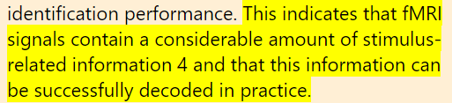

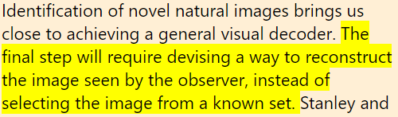

Alternative approaches:

