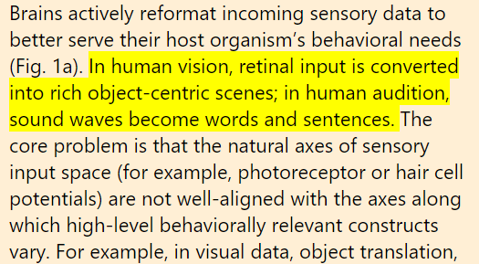

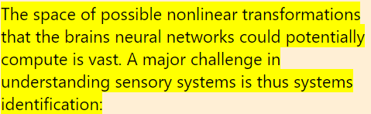

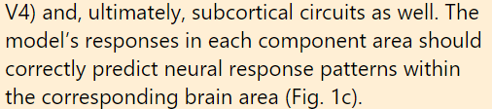

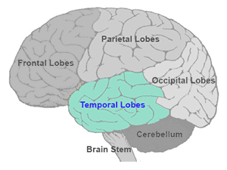

Temporal Lobe: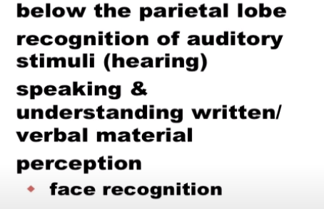

The temporal lobes sit behind the ears and are the second-largest lobe. They are most commonly associated with processing auditory information and with the encoding of memory. The temporal lobes are also believed to play an important role in processing affect/emotions, language, and certain aspects of visual perception.

The dominant temporal lobe, which is the left side in most people, is involved in understanding language and learning and remembering verbal information. The non-dominant lobe, which is typically the right temporal lobe, is involved in learning and remembering non-verbal information (e.g. visuospatial material and music).

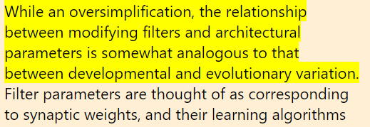

IT Cortex

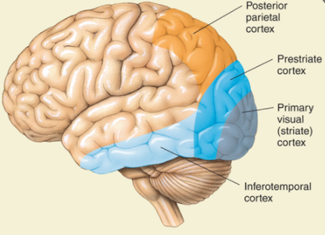

The Inferior Temporal Cortex receives information from the ventral stream, understandably so, as it is known to be a region essential in recognizing patterns, faces, and objects.[10]

Posterior Parietal Cortex

The posterior parietal cortex (the portion of the parietal neocortex posterior to the primary somatosensory cortex) plays an important role in planned movements, spatial reasoning, and attention.

The posterior parietal cortex receives input from a collection of sensory areas as well as a variety of other regions of the brain, and is thought to integrate that input to facilitate the execution of functions that require diverse information. It has been associated with a number of these functions, which are sometimes called "higher-order" functions; it is probably best known, however, for its role in attention.

The dorsal system is found in both [cerebral hemispheres](http://www.neuroscientificallychallenged.com/glossary/cerebral-hemispheres) and includes areas of the superior parietal lobule and intraparietal sulcus as well as a region of the [frontal cortex](http://www.neuroscientificallychallenged.com/glossary/frontal-lobe) that is involved in eye movements and visual perception known as the frontal eye field. The dorsal system is thought to be involved with what is known as "endogenous attention," which involves attention that is directed based on individual goals or desires. For example, if you are attempting to focus your attention to read this article, you are utilizing endogenous attention. The ventral system is found primarily in the right cerebral hemisphere and includes the area where the [temporal](http://www.neuroscientificallychallenged.com/glossary/temporal-lobe) and parietal lobes meet (the temporo-parietal junction), the intraparietal sulcus, and areas of the frontal cortex. The ventral system seems to be involved more in what is termed "exogenous attention," or attention that is directed towards external stimuli that are not being attended to by endogenous attentional processes. For example, if you were reading this article in a library and someone a few tables over shouted, breaking the complete silence of the room, you would suddenly and reflexively direct your attention to the person who shouted. This type of attention is not associated with your own goals or desires, and falls under the rubric of exogenous attention.

Early models of visual cortex in context A number of approaches have been taken to identify HCNN parameters that best match biological systems

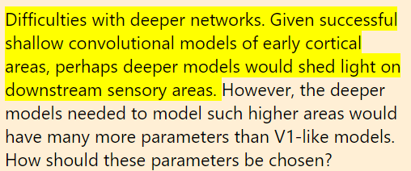

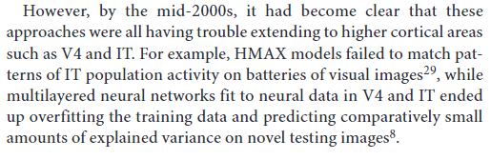

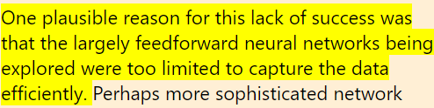

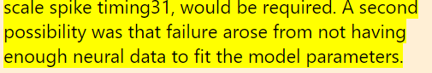

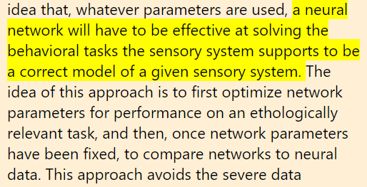

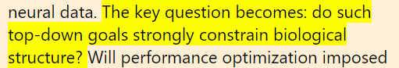

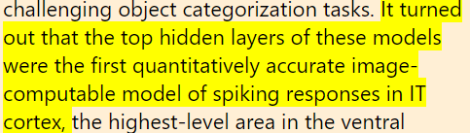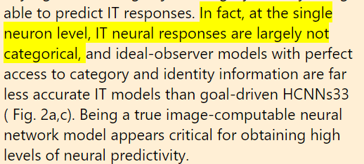

Important:

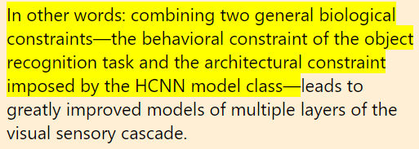

While we knew from prior work that neuronal population activity in inferior temporal cortex was likely to underlie visual object recognition, we did not have a predictive map that could accurately link that neural activity to object perception and behavior. The results from this study demonstrate that a particular map from particular aspects of IT population activity to behavior is highly accurate over all types of objects that were tested,” says James DiCarlo, head of MIT’s Department of Brain and Cognitive Sciences, a member of the McGovern Institute for Brain Research, and senior author of the study, which appears in the Journal of Neuroscience

Each of the 168 IT neurons and 128 V4 neurons fired in response to some objects but not others, creating a firing pattern that served as a distinctive signature for each object. By comparing these signatures, the researchers could analyze whether they correlated to humans’ ability to distinguish between two objects.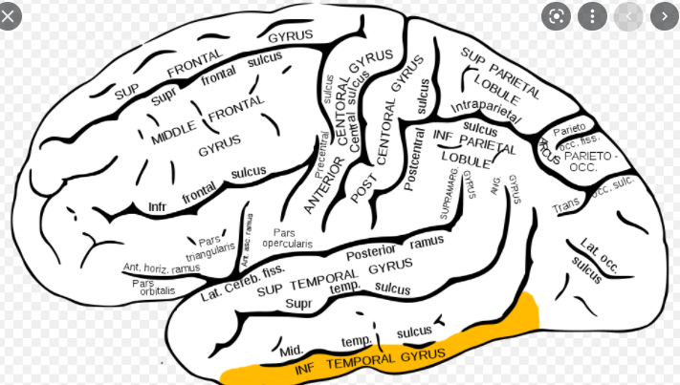

The researchers found that the firing patterns of IT neurons, but not V4 neurons, perfectly predicted the human performances they had seen. That is, when humans had trouble distinguishing two objects, the neural signatures for those objects were so similar as to be indistinguishable, and for pairs where humans succeeded, the patterns were very different.Nikolaus Kriegeskorte, a principal investigator at the Medical Research Council Cognition and Brain Sciences Unit in Cambridge, U.K., agrees that the study offers “crucial evidence supporting the idea that inferior temporal cortex contains the neuronal representations underlying human visual object recognition.”

<https://news.mit.edu/2014/computer-neural-networks-identify-objects-like-primate-brain-1218>

**How they ran the Experiment?**



