This is an example of a difference that we need to ignore…

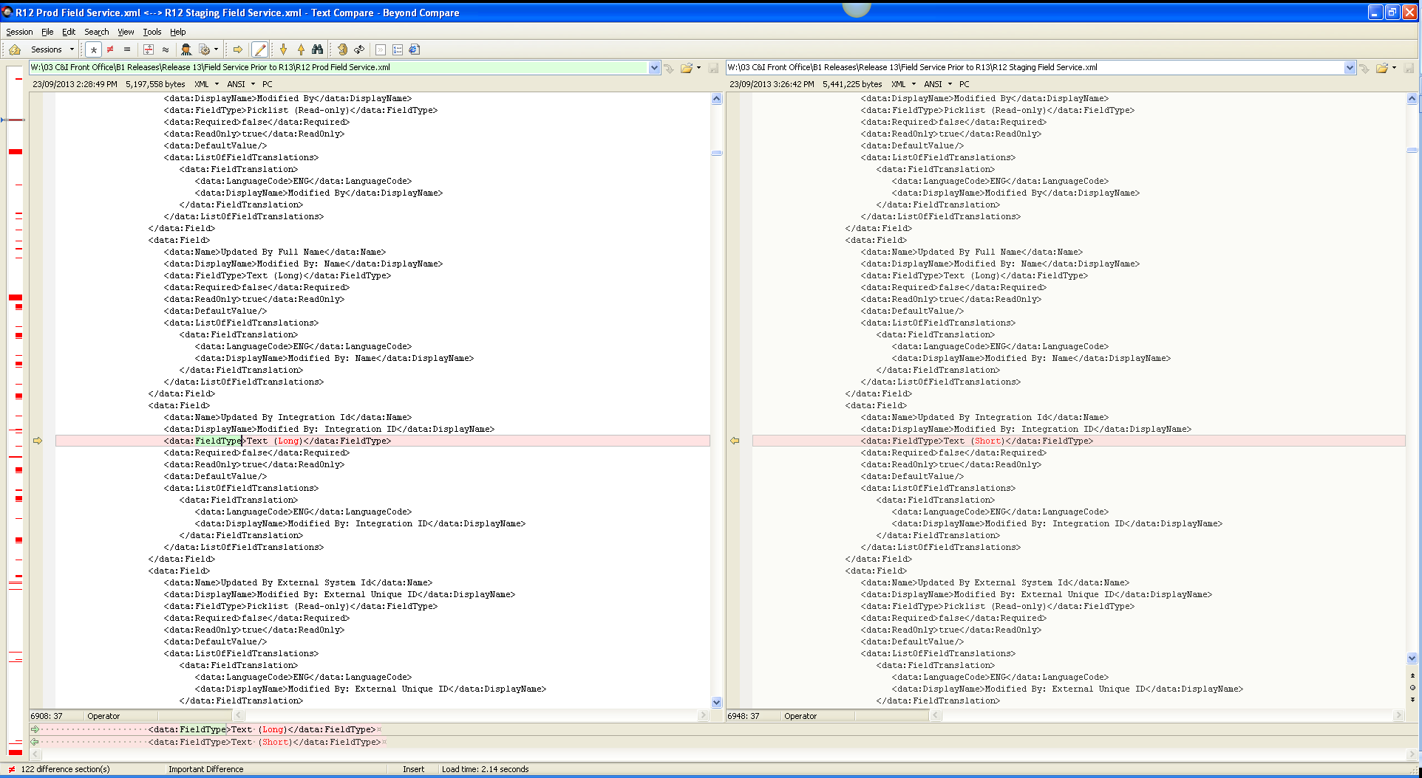

So in the above example for Object: CRMODLS_PlanOpportunities ignore the <Field> Element (and its children) that has a child of <Updated By First Name>

In addition it might be useful to ignore all children of a <FieldSet> where the <ObjectName> element equals a certain value, eg. :

<data:ObjectName>CustomObject9</data:ObjectName>

What we want to capture as a difference

We need to capture missing field definitions, or differences in field definitions.

For example, this is a field that exists in staging for the ObjectName: ‘Custom Object 3’ – but not in Prod (due to a upgrade to staging):

<data:Name>Address Id</data:Name>
<data:DisplayName>Address Id</data:DisplayName>
<data:FieldType>Picklist (Read-only)</data:FieldType>
<data:IntegrationTag>AddressId</data:IntegrationTag>
<data:GenericIntegrationTag>AddressId</data:GenericIntegrationTag>
<data:Required>false</data:Required>
<data:ReadOnly>false</data:ReadOnly>
<data:DefaultValue/>
<data:FieldValidation/>
<data:PostDefault>false</data:PostDefault>
<data:ValidationErrorMsg/>
<data:ListOfFieldTranslations>
<data:FieldTranslation>
<data:LanguageCode>ENG</data:LanguageCode>
<data:DisplayName>Address Id</data:DisplayName>
<data:ValidationErrorMsg/>
</data:FieldTranslation>
</data:ListOfFieldTranslations>
</data:Field>
<data:Field>

