Industrial Training Report
Bachelor of Computer Engineering
Peter Anderson z3293464
2/24/2012

Report on work experience with the CSIRO Wireless and Networking Technologies Laboratory .

Contents
I. Contents 2
II. Introduction 3
III. Projects 3
A. Integration of an IMU with a wireless tracking system 3
1. Hardware Environment 4
2. Software Environment 5
IV. Training 7
V. Relevance of Work Experience 9
VI. Conclusion 9

Introduction
This report outlines my work experience with the CSIRO (Commonwealth Science and Industrial Research Organisation) as a vacation scholar. The CSIRO aims to tackle significant scientific challenges that can benefit Australia, and to be a trusted scientific advisor to the Australian government. Between 28th November 2011 and 24th February 2012 I worked in the CSIRO ICT Centre at Marsfield NSW. The ICT Centre conducts research in information & computing technologies. It is one of the 15 research divisions of CSIRO that span fields as diverse as astrophysics, climate change, health, food and agriculture. The ICT Centre currently has around 250 research staff spread across six sites.
Within the ICT Centre, I was based in the Wireless and Networking Technologies Laboratory, which focuses on wireless communications and networks, sensor networks, imaging, antennas and propagation technologies to transform the wireless industry. My specific area of work was with the Positioning Team within the Wireless Laboratory. This team has developed a technology for high accuracy positioning and tracking called WASP (Wireless System for Ad-hoc Positioning).

Projects
During my time at CSIRO I worked on a single project for 12 weeks. I was responsible for developing an algorithm to integrate data from an IMU (Inertial Measurement Unit) with the existing WASP tracking system, as described below.

Integration of an IMU with a wireless tracking system
By way of background, WASP is a system for wireless positioning that time of arrival (TOA) based wireless ranging to provide position updates of mobile nodes based on the surveyed positions of stationary nodes. The systems exhibits high positioning accuracy, in the order of ~ 0.2m outdoors, and it also works indoors and underground. Current applications of the system include athlete tracking with the Australian Institute of Sport, and tracking of underground mine vehicles for safety and efficiency.
The motivation for integrating an IMU with WASP is to exploit the complementary nature of WASP and the IMU, noting that WASP positioning is stable in the long term but does not capture orientation or short term dynamics. In contrast, the IMU captures short term dynamics but suffer from medium and long-term drift. With the correct data fusion algorithm, a WASP + IMU system has the potential to improve the update rate for high dynamics applications (such as athlete tracking), to provide orientation estimation, and to improve the accuracy of WASP during periods of wireless signal loss, as shown in Table 1.
Table 1. Importance of WASP / IMU integration
 | WASP | WASP + IMU
Characteristics:
Update rate | ~ 10 Hz | 820 Hz
Accuracy | ~ 0.2 m | Potential improvement
Signal loss | Uncertainty grows rapidly | 5 - 10 seconds of stable positioning
Outputs:
Position | Yes | Yes
Velocity | No | Yes
Acceleration | No | Yes
Orientation | No | Yes

Hardware Environment
To complete the project, I worked with the existing WASP hardware, and the Analog Devices ADIS16405 IMU as illustrated in Figure 1. There are two versions of the WASP hardware, which differ in size and battery life but offer the same functionality. The IMU includes a 3-axis accelerometer, 3-axis gyroscope, and a 3-axis magnetometer, and had been previously mounted to the larger WASP unit and connected to the power supply.
During field trials, I collected sensor data from the IMU using a USB cable and a notebook computer, while simultaneously collecting WASP positioning data using the WASP wireless communication protocol. Field trials were conducted both indoors and outdoors with stationary sensors, sensors attached to people running and walking, and sensors mounted on mobile trolleys.

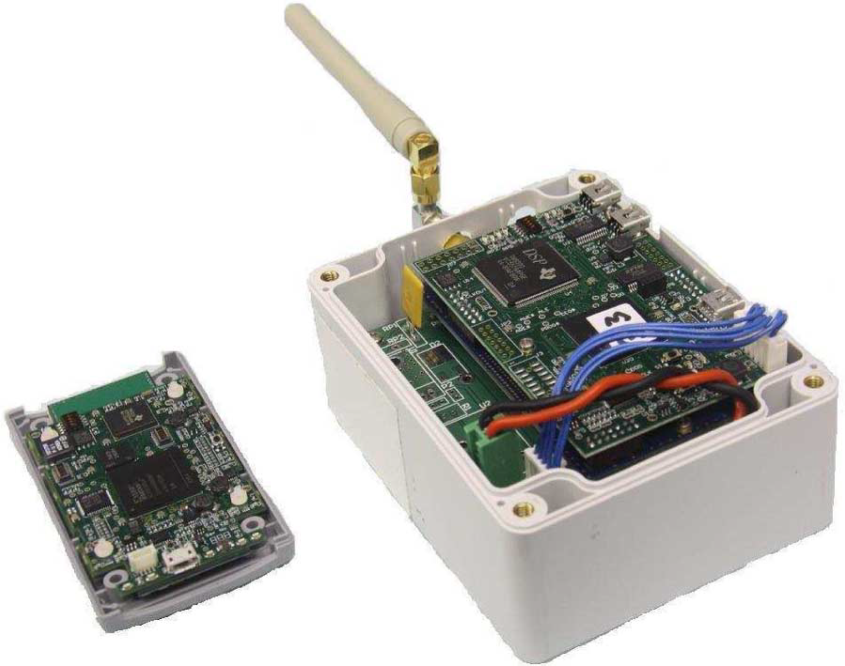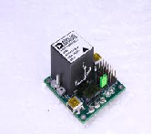
Figure 1. Left: Small WASP node (for athlete tracking). Middle: Large WASP node. Right: IMU sensor that was added to the large WASP node for field trials.

Software Environment
I used MATLAB to implement and test my filter algorithm to integrate the IMU sensor data and the WASP position data. During the process of implementing and testing the algorithm, and plotting outputs I wrote many thousands of lines of MATLAB code. A system overview of the final algorithm is included in Figure 2. There were a number of design choices to be made when designing the filter. In this case I used a dual error-state (indirect) Kalman filter, with errors in position, velocity and orientation and sensor biases as state variables, and observations of the position error calculated as the difference between the IMU calculated position and the WASP position. The main reasons I adopted this formulation were:
- There is no need to define a motion model, so the same filter can be used for both vehicle and pedestrian applications without modification;
- The output from the system is position, velocity, acceleration and orientation integrated directly from the error-compensated IMU. Since the filter is outside of the IMU output path, it can be run at lower update frequency than the IMU, whilst still preserving high dynamics output;
- Since orientation error angles should be small, the filter can be accurately linearised using small angle approximations.
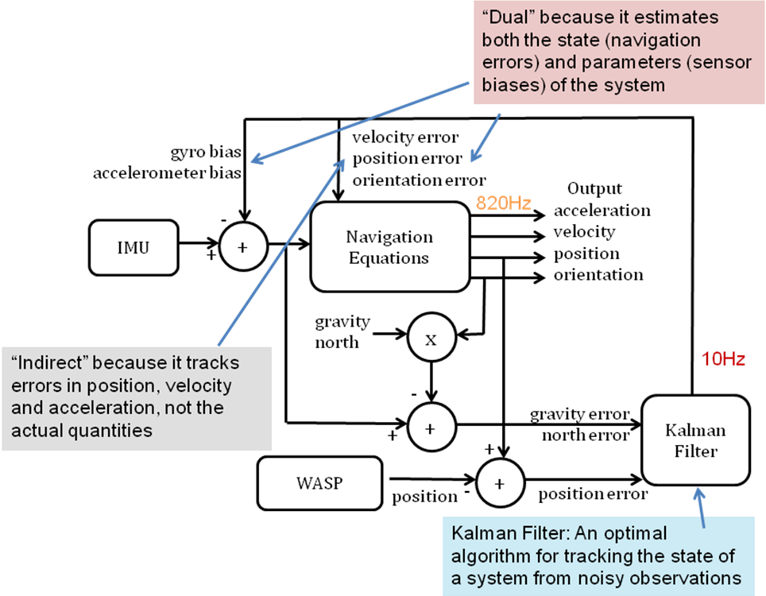
Figure 2. System diagram of the dual indirect Kalman filter I designed and implemented in MATLAB
Although Figure 2 provides a good overview of how the system was implemented in MATLAB, it doesn’t necessarily give a clear indication of how the system works. This is provided in Figure 3. As illustrated, the position updates from WASP are used to correct the high frequency velocity and position estimates calculated from the IMU, whilst simultaneously estimating the IMU accelerometer bias. At the same time, the accelerometer and magnetometer are used to correct the orientation calculated from the IMU gyroscope, and estimate its bias.
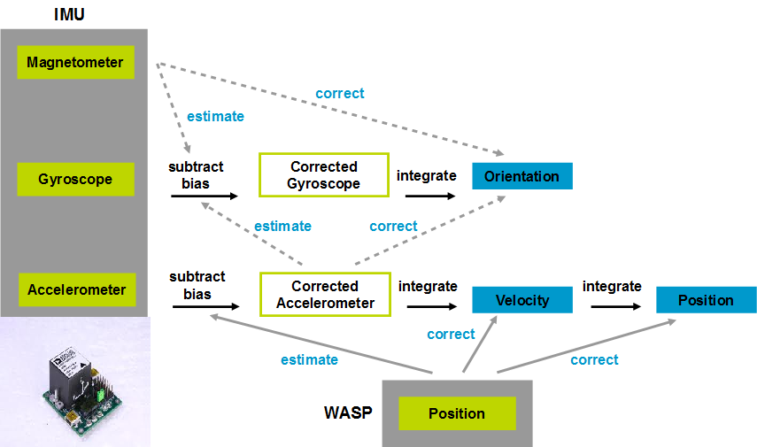
Figure 3. Functional overview of the WASP + IMU error correction process
To illustrate the results of the work, a sample of my MATLAB output from a 2 minute track of a person walking around an L-shaped concrete path is included in Figure 4. The figure illustrates that the WASP + IMU system with the new filter algorithm is capable of accurately tracking the position and orientation of the subject with an update rate of 820Hz, consistent with the goals of the project.

Training
During my time at CSIRO, we received several hours of formal presentation training in preparation for the CSIRO Big Day In. The Big Day In is a two day internal conference in which CSIRO vacation scholars from around Australia present the results of their summer research. At the conference I gave a 20 minute presentation on my work to an audience of other vacation scholars and CSIRO researchers. The training and the conference itself provided a valuable opportunity for development of presentation skills, particular in the presentation of scientific results at an academic conference.
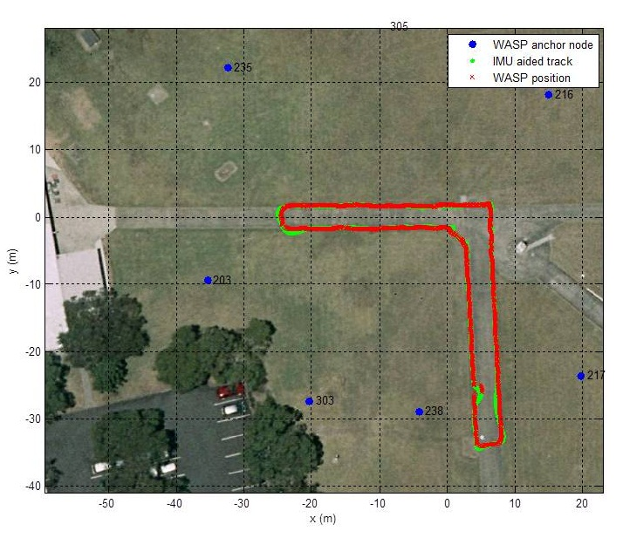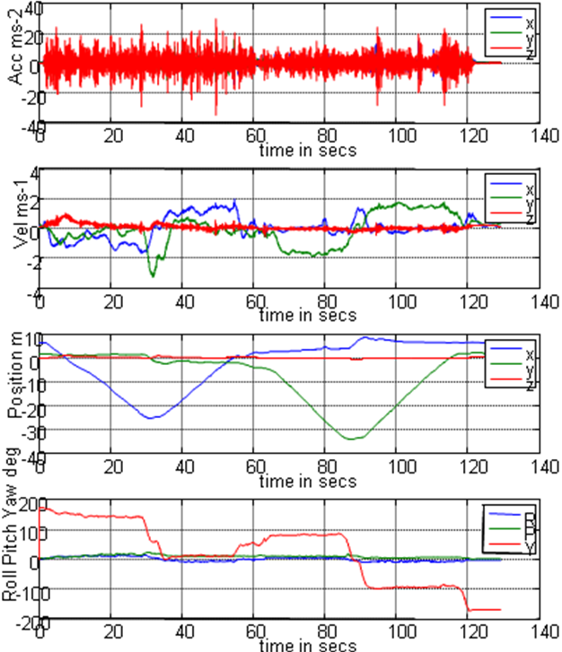
Figure 4. Typical output from a field trial of the WASP + IMU system using my filter algorithm developed in MATLAB
In terms of more informal training, during my work experience I was supervised and mentored by two CSIRO officers. Although my project was largely self-directed, my mentors provided a valuable sounding board for ideas and excellent advice on which direction to take the project. In addition, they directed me to a large number of academic papers relevant to the project I was undertaking, particularly in the area of IMU / GPS integration which is a related area. As such, a large amount of my training consisted of reading academic research and learning how to become familiar with a new field. Given the rapid pace of technological development, I believe this to be an important skill for all engineers.
It is worth noting that the WASP + IMU filter algorithm I developed is by far the most complex system I have ever designed, coded and debugged. Just understanding the problem and background literature took quite a few weeks. Each aspect of the system is by nature tightly coupled to most other aspects, so modular development was extremely difficult to achieve. Finally, the project required the application of techniques from academic literature to a unique proprietary system, and thus represented genuine original research with no guarantee of success. Due to all of these characteristics, I believe the experience of the project itself was an excellent training opportunity for me.

Relevance of Work Experience
In terms of my studies to date, CS3431 Robotic Software Architectures was most relevant to my work experience. This was the unit of study in which I was introduced to the use of the Kalman filter algorithm for navigation and tracking, which I used in my project. However, it would be fair to say that all of my computing studies were relevant, for example enabling me to quickly become familiar with MATLAB (which I hadn’t used very much), and to understand the design of the WASP unit as an embedded system in terms of FPGA’s, networking protocols, operating system etc.
With regard to my future career plans, my work experience has given me a good understanding of the nature of research and the work environment of CSIRO. As a partially government funded science organisation, I found the culture to be quite relaxed, unrushed, and work to be very self-directed. Although I have declined the offer of a CSIRO thesis topic in favour of a RoboCup thesis, I would definitely consider pursuing a PhD jointly supervised by CSIRO, either in the Wireless and Networking Laboratory or in the Computer Vision Laboratory based in Brisbane.

Conclusion
During my industrial training with CSIRO I was responsible for developing an algorithm to integrate IMU sensor data with an existing wireless positioning system. I achieve this goal, at the conclusion of my project I was able to demonstrate a system that offered higher update rates than the original system as well as accurate orientation tracking. Ultimately I hope that future versions of this algorithm will find their way into WASP units that are being deployed under contract to the mining industry and the AIS.
Overall I found the experience to be highly valuable. It enabled me to work for an extended period of time on a meaningful real world project, and gave me a good insight into the challenge and reward of undertaking research. I believe this experience provides a useful foundation for entering the work force or to undertake a PhD.

