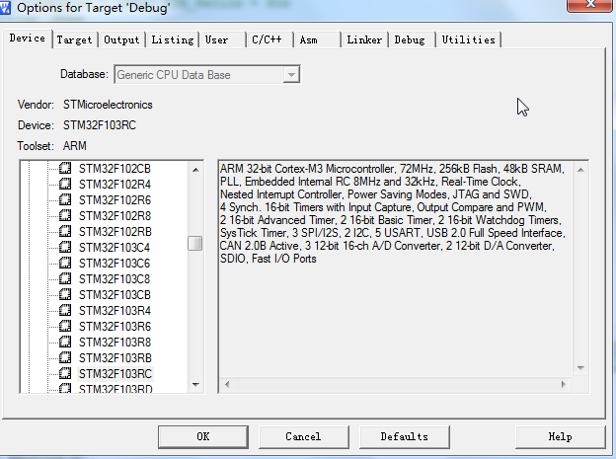

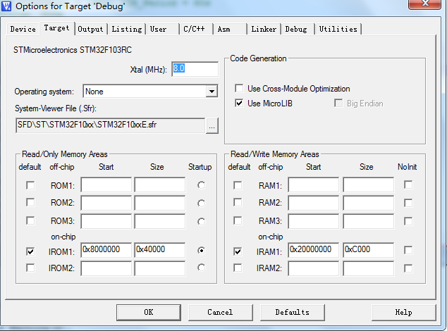

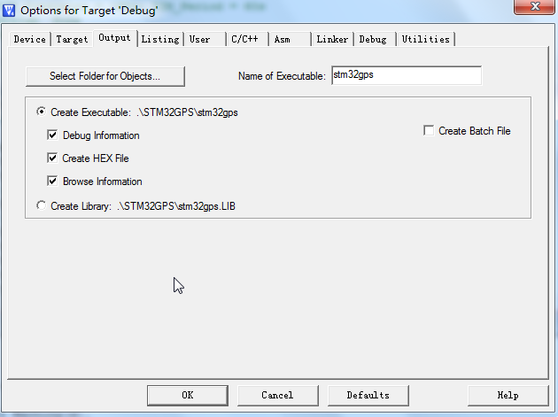

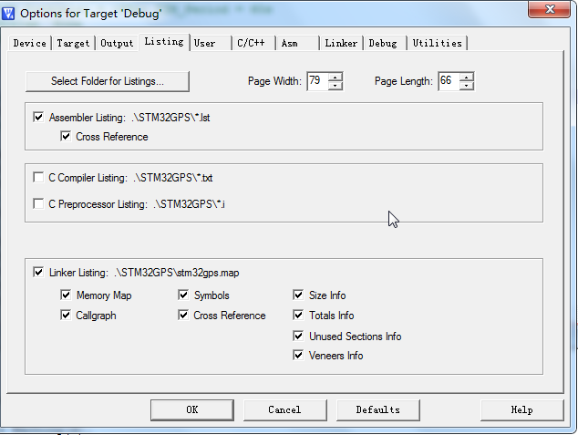

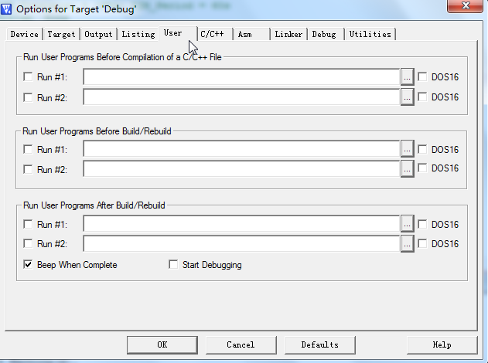

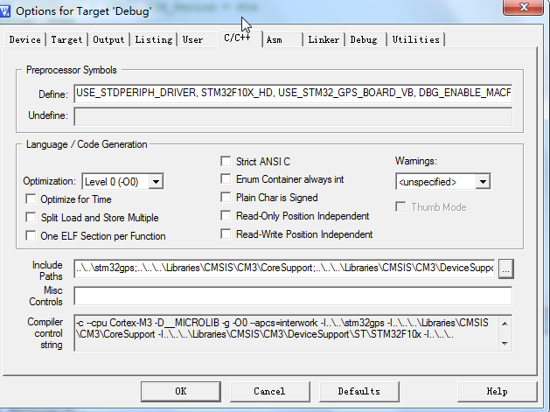

..\..\stm32gps;..\..\..\Libraries\CMSIS\CM3\CoreSupport;..\..\..\Libraries\CMSIS\CM3\DeviceSupport\ST\STM32F10x;..\..\..\Libraries\STM32F10x_StdPeriph_Driver\inc;..\..\..\Utilities\STM32_GPS;..\..\..\Utilities\STM32_GPS\STM32_GPS_BOARD_VA;..\..\..\Utilities\STM32_GPS\Common;..\..\..\Utilities\SIM800L;..\..\..\Utilities\SIM28M;..\..\..\Utilities\USART;..\..\..\Utilities

USE_STDPERIPH_DRIVER, STM32F10X_HD, USE_STM32_GPS_BOARD_VB, DBG_ENABLE_MACRO

