Alias

Developing a cross-platform application for creating personalised comics aimed for the Children and Youth Clinic at Haukeland University Hospital

Idar Antonsen Syslak

Master’s thesis in Software Engineering at

Department of Computing, Mathematics and Physics,

Western Norway University of Applied Sciences

Department of Informatics,

University of Bergen

December 2019



**Abstract**

To be written.

**Acknowledgements**

To be written.

**Contents**

|  |  |  |
| --- | --- | --- |
| **1 Introduction** | | **5** |
| 1.1 | About the thesis . . . . . . . . . . . . . . . . . . . . . . . . . . . . . . . . . . . . . . | 5 |
| 1.2 | Motivation . . . . . . . . . . . . . . . . . . . . . . . . . . . . . . . . . . . . . . . . . | 5 |
| 1.3 | Problem description . . . . . . . . . . . . . . . . . . . . . . . . . . . . . . . . . . . . | 5 |
| 1.4 | Research question and expected results . . . . . . . . . . . . . . . . . . . . . . . . . | 5 |
| 1.5 | Thesis outline . . . . . . . . . . . . . . . . . . . . . . . . . . . . . . . . . . . . . . . . | 6 |

|  |  |  |  |
| --- | --- | --- | --- |
| **2 Background** | |  | **7** |
| 2.1 | Terminology . . . . . . . . . . . . . . . . . . . . . . . . . . . . . . . . . . . . . . . . | | 7 |
| 2.2 | Preceding projects . . . . . . . . . . . . . . . . . . . . . . . . . . . . . . . . . . . . . | | 7 |
|  | 2.2.1 | Pictogram-me . . . . . . . . . . . . . . . . . . . . . . . . . . . . . . . . . . . | 7 |
|  | 2.2.2 | PictogramApp . . . . . . . . . . . . . . . . . . . . . . . . . . . . . . . . . . . | 8 |
| 2.3 | Initial direction . . . . . . . . . . . . . . . . . . . . . . . . . . . . . . . . . . . . . . . | | 8 |
| 2.4 | Related work . . . . . . . . . . . . . . . . . . . . . . . . . . . . . . . . . . . . . . . . | | 8 |
| 2.5 | Theoretical foundation . . . . . . . . . . . . . . . . . . . . . . . . . . . . . . . . . . . | | 9 |

|  |  |  |
| --- | --- | --- |
| **3 Methodology** | | **10** |
| 3.1 | Evaluation . . . . . . . . . . . . . . . . . . . . . . . . . . . . . . . . . . . . . . . . . . | 10 |
| 3.2 | Design process . . . . . . . . . . . . . . . . . . . . . . . . . . . . . . . . . . . . . . . | 10 |
| 3.3 | Interaction design . . . . . . . . . . . . . . . . . . . . . . . . . . . . . . . . . . . . . | 10 |
| 3.4 | Prototyping . . . . . . . . . . . . . . . . . . . . . . . . . . . . . . . . . . . . . . . . . | 11 |
|  | 3.4.1 Prototyping tools . . . . . . . . . . . . . . . . . . . . . . . . . . . . . . . . . . | 11 |

|  |  |  |  |
| --- | --- | --- | --- |
| **4 Planning the design** | | | **12** |
| 4.1 | Requirements . . . . . . . . . . . . . . . . . . . . . . . . . . . . . . . . . . . . . . . . | | 12 |
|  | 4.1.1 | Functional requirements . . . . . . . . . . . . . . . . . . . . . . . . . . . . . | 12 |
|  | 4.1.2 | Non-functional requirements . . . . . . . . . . . . . . . . . . . . . . . . . . . | 12 |
| 4.2 | Domain model . . . . . . . . . . . . . . . . . . . . . . . . . . . . . . . . . . . . . . . | | 12 |
| 4.3 | Target groups . . . . . . . . . . . . . . . . . . . . . . . . . . . . . . . . . . . . . . . . | | 13 |
| 4.4 | Use cases . . . . . . . . . . . . . . . . . . . . . . . . . . . . . . . . . . . . . . . . . . | | 13 |
| 4.5 | Inspiration . . . . . . . . . . . . . . . . . . . . . . . . . . . . . . . . . . . . . . . . . | | 13 |

|  |  |  |  |
| --- | --- | --- | --- |
| **5 Iterating the design** | | | **15** |
| 5.1 | Iteration 1: Paper prototype . . . . . . . . . . . . . . . . . . . . . . . . . . . . . . . . | | 15 |
|  | 5.1.1 | Considerations . . . . . . . . . . . . . . . . . . . . . . . . . . . . . . . . . . . | 15 |
|  | 5.1.2 | Analysis . . . . . . . . . . . . . . . . . . . . . . . . . . . . . . . . . . . . . . . | 17 |
| 5.2 | Iteration 2: Form study prototype . . . . . . . . . . . . . . . . . . . . . . . . . . . . . | | 17 |
|  | 5.2.1 | Analysis . . . . . . . . . . . . . . . . . . . . . . . . . . . . . . . . . . . . . . . | 17 |
| 5.3 | Iteration 3: Visual prototype . . . . . . . . . . . . . . . . . . . . . . . . . . . . . . . . | | 17 |
| 5.4 | Iteration 4: Interactive prototype . . . . . . . . . . . . . . . . . . . . . . . . . . . . . | | 17 |
| 5.5 | Iteration 5: UI experiments . . . . . . . . . . . . . . . . . . . . . . . . . . . . . . . . . | | 17 |

1

|  |  |  |  |  |
| --- | --- | --- | --- | --- |
|  | 5.6 | Iteration 6: Redesign . . . . . . . . . . . . . . . . . . . . . . . . . . . . . . . . . . . . | | 17 |
|  | 5.7 | Iteration 7: Final prototype . . . . . . . . . . . . . . . . . . . . . . . . . . . . . . . . . | | 17 |
|  |  | 5.7.1 | Analysis . . . . . . . . . . . . . . . . . . . . . . . . . . . . . . . . . . . . . . . | 17 |
| **6** | **Evaluation** | |  | **18** |
|  | 6.1 | The test group . . . . . . . . . . . . . . . . . . . . . . . . . . . . . . . . . . . . . . . | | 18 |
|  | 6.2 | Circumstances . . . . . . . . . . . . . . . . . . . . . . . . . . . . . . . . . . . . . . . | | 18 |
|  | 6.3 | Performing the evaluation . . . . . . . . . . . . . . . . . . . . . . . . . . . . . . . . . | | 18 |
|  | 6.4 | Results . . . . . . . . . . . . . . . . . . . . . . . . . . . . . . . . . . . . . . . . . . . | | 18 |
| **7** | **Application outline** | | | **19** |
|  | 7.1 | Implementation details . . . . . . . . . . . . . . . . . . . . . . . . . . . . . . . . . . | | 19 |
|  | 7.2 | Architecture . . . . . . . . . . . . . . . . . . . . . . . . . . . . . . . . . . . . . . . . . | | 19 |
|  |  | 7.2.1 | Backend . . . . . . . . . . . . . . . . . . . . . . . . . . . . . . . . . . . . . . | 19 |
|  |  | 7.2.2 | Frontend . . . . . . . . . . . . . . . . . . . . . . . . . . . . . . . . . . . . . . | 19 |
|  | 7.3 | Integration with existing systems . . . . . . . . . . . . . . . . . . . . . . . . . . . . . | | 19 |
|  | 7.4 | Anticipated challenges and feasibility . . . . . . . . . . . . . . . . . . . . . . . . . . . | | 19 |
|  |  | 7.4.1 | Projecting the avatar on the screen . . . . . . . . . . . . . . . . . . . . . . . . | 19 |
|  | 7.5 | Hando . . . . . . . . . . . . . . . . . . . . . . . . . . . . . . . . . . . . . . . . . . . | | 21 |
| **8** | **Tools and technology** | | | **22** |
|  | 8.1 | Choice of application setup . . . . . . . . . . . . . . . . . . . . . . . . . . . . . . . . | | 22 |
|  | 8.2 | Frameworks . . . . . . . . . . . . . . . . . . . . . . . . . . . . . . . . . . . . . . . . . | | 24 |
|  | 8.3 | Database system . . . . . . . . . . . . . . . . . . . . . . . . . . . . . . . . . . . . . . | | 25 |
|  | 8.4 | Storage . . . . . . . . . . . . . . . . . . . . . . . . . . . . . . . . . . . . . . . . . . . | | 25 |
| **9** | **Conclusion** | |  | **26** |
|  | 9.1 | Discussion . . . . . . . . . . . . . . . . . . . . . . . . . . . . . . . . . . . . . . . . . | | 26 |
|  | 9.2 | Validity . . . . . . . . . . . . . . . . . . . . . . . . . . . . . . . . . . . . . . . . . . . | | 26 |
|  | 9.3 | Concerns . . . . . . . . . . . . . . . . . . . . . . . . . . . . . . . . . . . . . . . . . . | | 26 |
|  | 9.4 | Further work . . . . . . . . . . . . . . . . . . . . . . . . . . . . . . . . . . . . . . . . | | 26 |
|  |  | 9.4.1 | Design and planning . . . . . . . . . . . . . . . . . . . . . . . . . . . . . . . . | 26 |
|  |  | 9.4.2 | Development . . . . . . . . . . . . . . . . . . . . . . . . . . . . . . . . . . . . | 26 |

2

**List of Figures**

|  |  |  |
| --- | --- | --- |
| 2.1 | PictoTheatre, shown at the 2016 RØST conference in Bergen . . . . . . . . . . . . . . | 8 |
| 2.2 | Screenshots from PictogramApp . . . . . . . . . . . . . . . . . . . . . . . . . . . . . | 9 |
| 3.1 | Interaction design lifecycle model . . . . . . . . . . . . . . . . . . . . . . . . . . . . . | 11 |
| 4.1 | Domain model . . . . . . . . . . . . . . . . . . . . . . . . . . . . . . . . . . . . . . . | 13 |
| 4.2 | General use case diagram . . . . . . . . . . . . . . . . . . . . . . . . . . . . . . . . . | 14 |
| 5.1 | Sketches of the first design . . . . . . . . . . . . . . . . . . . . . . . . . . . . . . . . . | 16 |
| 7.1 | Extended use case diagram . . . . . . . . . . . . . . . . . . . . . . . . . . . . . . . . | 20 |

3

**List of Tables**

|  |  |  |
| --- | --- | --- |
| 7.1 | Di erent ways to project an avatar on a screen . . . . . . . . . . . . . . . . . . . . . . | 20 |
| 8.1 | Web developer friendly frameworks for mobile application development . . . . . . . | 24 |

4

**Chapter 1**

**Introduction**

**1.1** **About the thesis**

This thesis describes an application development project that was held from August 2018 to Decem-ber 2019. The project supervisor (PSV), Carsten Helgesen, proposed the project as a continuation of a bachelor project from the spring of 2018. Both the master and bachelor projects aim to facilitate non-verbal communication and to visualise information and emotions.

Since the middle of 2018, the project has gained interest at the Children and Youth Clinic at Haukeland University Hospital. Ideas for the project were discussed during this period with senior consultant psychiatrist (SCP) Paul Joachim Thorsen.

**1.2** **Motivation**

Hvorfor, hvilken nytte det vil ha

**1.3** **Problem description**

Information that is handed out at most hospitals

Mange informasjonsbrosjyrer, ikke tilpasset

Age-appropriate interactive technology can be used to promote young children’s under-standing and to facilitate their situated participation in healthcare situations Stålberg et al., 2018

**1.4** **Research question and expected results**

Research question:

How can national guidelines (pakkeforløp) be made more personalised towards children and youth at hospitals?

At project completion, the desired result is a functional prototype that can be developed further on by Helse Vest IKT. Given the positive outcome of E-LAN (see 2.4), it is anticipated that the application will be used among children at the clinic.

5

Since the clinic has planned a bigger project involving the use of avatars and comics, the outcome of this project will become an indication of whether it is valuable to invest in it. This project will also provide useful knowledge that may come in handy for an eventual succeeding project.

**1.5** **Thesis outline**

The thesis is structured as follows: Chapter 2 describes relevant terminology and the theoretical foundation while giving an insight into preceding projects. The development process is detailed out in its entirety in Chapter 5. This development is then evaluated in Chapter 6 while Chapter 9 concludes the project. Finally, a discussion about further work is made in Chapter **??**.

6

**Chapter 2**

**Background**

**2.1** **Terminology**

A *pictogram* (also called a pictograph) is a simplified figure that resembles and represents a physical object. Pictograms are a common sight in a modern everyday life and are used to warn about dangers, to inform about functionality and to hint about specific characteristics. As such, they can be seen e.g. at tra ic signs, danger signs, public toilets and in computers. Naturally, pictograms vary in shapes and sizes, but they are ultimately designed in a way that make them easy to interpret and understand their symbolic meaning.

Given that the application will be used in a hospital setting, the associated terminology will be ex-tended to the application. A *procedure* is a sequence of steps separated from each other. Each *step* contains a background, an avatar and elements related to the procedure in the form of illustrations or pictures, and may feature interactive as well as non-interactive elements.

Story - scene Comic strip - panel Procedure - step

**2.2** **Preceding projects**

This project builds upon experience from a bachelor thesis named *PictogramApp* which was based on another project named *Pictogram-me*.

**2.2.1** **Pictogram-me**

Since 2011, associate professor in graphic design Linda Lien and professor in visual communication Ashley Booth have researched on creative usage of pictograms (figures which represent physical ob-jects, see 2.1). Their artistic research project, named *Pictogram-me*, experiments how pictograms can be used to express complex social messages (Lien and Booth, 2018). The aim is to illustrate challen-ging situations that people who have a di icult life may endure. Despite pictograms being flat and simplified, Lien and Booth wanted to show how pictograms also can visualise di icult topics and pro-mote empathy.

Pictogram-me presents a new set of pictograms that are designed for the purpose of the project. In addition, the project has resulted in various concepts including

* *PictoBooth*, a photo booth that translates the body and gestures into real life pictograms,
* *PictoFont*, a symbol typeface consisting of various pictograms, and

7

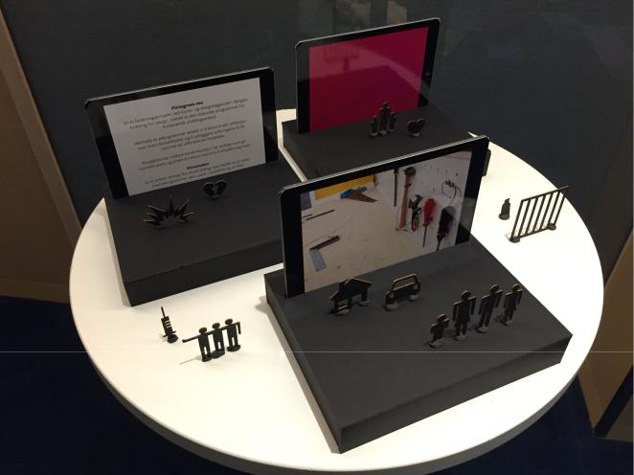

Figure 2.1: PictoTheatre, shown at the 2016 RØST conference in Bergen

* *PictoTheatre*, a small-scale theatre where pictograms can be arranged on a scene. A tablet canbe placed behind the scene and function as a background as illustrated in 2.1.

**2.2.2** **PictogramApp**

In 2017, the Western Norway University of Applied Sciences issued out a bachelor project in collabor-ation with Linda and Booth, with the purpose of creating a smartphone application. The application, which was later named *PictogramApp*, was meant to be a digital version of PictoTheatre where pic-tograms can be arranged on the screen and form visual messages in a mobile manner (Fure et al., 2017). The application allows users to place pictograms in context in order to create their own stories

– see figure 2.2. PictogramApp was targeted towards the Church City Mission, a voluntary organisa-tion which o ers help and services for people living near the street. A functional prototype of the application was released in June 2017.

**2.3 Initial direction**

The original intention was to create a communication tool aimed for people with autism-related dia-gnoses, but the project has taken a new direction since then.

**2.4** **Related work**

CYC has prior to this project experimented with di erent ways to engage their patients. Among these was an e-sport event named *E-LAN*, held in the end of October 2018. The purpose of this event was to connect gaming towards a healthy lifestyle and to let children and youth master various areas of interest. As a part of this initiative, an avatar generation system was created that let users create personal avatars which represent themselves. Each user would then carry their avatar in a name tag attached on their clothing. The so ware seems to run on Windows with support for a web client, and outputs two-dimensional portrait pictures.

Several applications and prototypes have been made that aim to provide information about and il-lustrate a child’s hospital stay. A notable example is *IACTA*, short for *Inter-Active Communication Tool* *for Activities*. This application ()...) (Stålberg et al., 2018).

Another example is an inpatient portal application named *MyChart Bedside*, developed by Epic Sys-

8

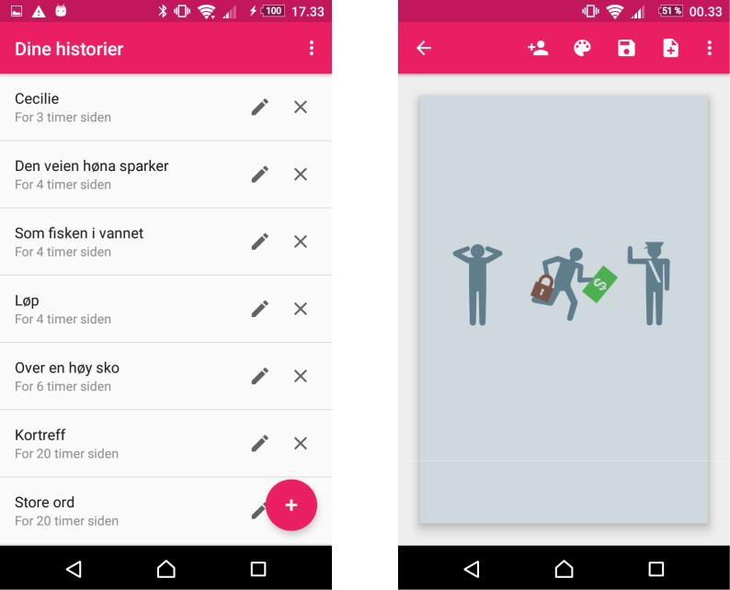

(a) List of stories (b) Scene editing

Figure 2.2: Screenshots from PictogramApp

tems Corporation. for tablet devices. A study conducted by Kelly et al. (2017) revealed that 90 percent of children’s parents were satisfied with the portal.

Bitmoji

Instruction videos used by Norwegian on their airplanes

**2.5** **Theoretical foundation**

The problem area was presented first and foremost by CYC. During meetings, Paul Thorsen stated that they wanted to improve the ways of which children were informed about upcoming procedures. Currently, the information that is given here is primarily textual and of varying interest for younger patients.

A number of search queries was performed on academic literature in order to confirm these state-ments and gain further insight in the problem area. Each query contained a set of the following keywords:

|  |  |  |  |  |  |
| --- | --- | --- | --- | --- | --- |
| • | Hospital | • | Informative | • | Cartoon |
| • | Patient | • | Interactive | • | Comics |
| • | Pediatric | • | Understanding | • | Illustrations |
| • | Children | • | Comprehension | • | Personalised |
| • | Information | • | Engage |  |  |

The queries yielded nine articles which form the theoretical foundation of this thesis.

9

**Chapter 3**

**Methodology**

This project functions as a pilot study in preparation for a bigger project held at the clinic. It is also a comparative study as it may possibly replace the current way of informing patients. This allows the clinic to run a small-scale project and see how the application compares to the existing system at an early stage with reduced investment and costs.

The development will focus on iterating over designs and prototypes in a user-centered manner. Po-tential users and stakeholders will be able to try out the design throughout various phases of its devel-opment. This user testing may consist of focus groups and uncontrolled experiments, and the gained experience can be applied in the next development stage. The testing will most likely be restricted to the internal group at first, but a designated test group may be created once the design evolves into prototypes.

**3.1** **Evaluation**

The final prototype will be evaluated by a usability test. A group of two to six users will be invited to test and evaluate the application. The users will quantitatively rate the systems by giving scores from one to five in areas such as "informing", "ease of use", "trustability" and "fun". The project is deemed to be valuable if the users find the application to be more informative and engaging than the current system.

**3.2** **Design process**

Iterative

For hver iterasjon - Hva er problemstillingen? - Hvilken tilnærming til løsningen skal prototypen ha?

* Hvordan er det levert? - Hvordan det er testet/testresultater
* Double Diamond approach: solve the right problem https://www.designcouncil.org.uk/news-opinion/design-process-what-double-Diamond Må utforske mye før man fokuserer inn på problemstilling - utforskningen er iterativ

**3.3** **Interaction design**

Preece et al. (2015) developed a lifecycle model for interaction design that could prove to be useful for this project. This model is shown in 3.1

10

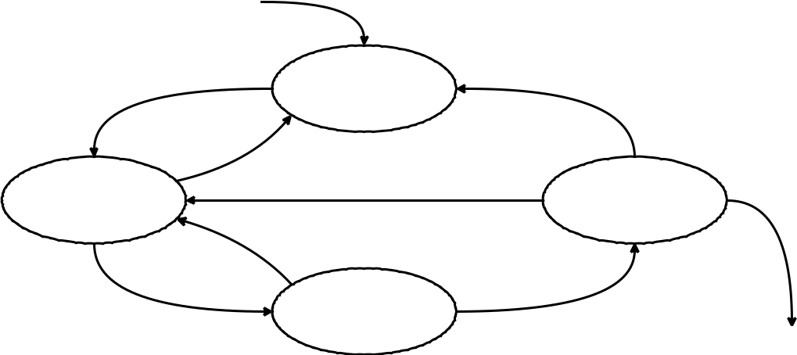

Establishing

requirements

|  |  |  |
| --- | --- | --- |
| Designing | Evaluating |  |
| alternatives |  |
|  |  |

Prototyping

Final product

Figure 3.1: Interaction design lifecycle model

**3.4** **Prototyping**

**3.4.1** **Prototyping tools**

* Pen and paper
* Marvel
* Figma

11

**Chapter 4**

**Planning the design**

This chapter deals with the initial planning of the design, where the most important factors are con-sidered.

**4.1** **Requirements**

The first step of the interaction design lifecycle is centered around establishing requirements. This involves having a dialog with the client, getting an idea of what they expect and correcting the re-quirements if they change. Preece et al. (2015) lists out two aims of a requirement activity:

One aim is to understand as much as possible about the users, their activities, and the context of that activity, so the system under development can support them in achieving their goals. Building on this, our second aim is to produce a set of stable requirements that form a sound basis to start designing.

The initial requirements were formed a er a meeting with SCP. These are divided into functional re-quirements which describe what the application should do, and non-functional requirements which tell something about constraints of the application and its development.

**4.1.1** **Functional requirements**

SCP wishes to have an application where the user can view personally targeted procedures. These will feature the user’s own personal avatar along with information about an upcoming procedure at the hospital. A erwards, the user should be able to rate their experience, and if possible, this rating should be reflected when the procedure is shown in retrospect.

**4.1.2** **Non-functional requirements**

The clinic expressed that they intend to use the application on larger screens akin to tablets.

**4.2** **Domain model**

Domain model is shown in figure 4.1.

12

|  |  |  |  |  |  |  |  |  |  |  |  |  |  |  |  |  |  |  |  |  |  |  |  |  |  |  |  |  |
| --- | --- | --- | --- | --- | --- | --- | --- | --- | --- | --- | --- | --- | --- | --- | --- | --- | --- | --- | --- | --- | --- | --- | --- | --- | --- | --- | --- | --- |
|  |  |  | **Hospital / Institution** | | | | |  |  |  |  |  | Uses ► | |  |  |  |  |  |  |  |  |  |  |  |  |  |  |
|  |  | **1** | **Sykehus / Institusjon** | | | | |  | **1** |  |  |  |  |  |  |  |  |  |  |  |  |  |  |  |  |  |
|  |  |  | + name | | |  |  |  |  |  |  |  |  |  |  |  |  |  |  |  |  |  |  |  |  |  |  |  |
|  |  |  |  | | |  |  |  |  |  |  |  |  |  |  |  |  |  |  |  |  |  |  |  |  |  |  |  |
|  |  |  |  |  | **1** |  |  |  |  |  |  |  |  |  |  |  |  |  |  |  |  |  |  |  |  |  |  |  |
|  |  |  |  |  |  |  |  |  |  |  |  |  |  |  |  |  | **\*** |  |  |  |  |  |  |  |  |  |  |  |
|  |  |  |  |  |  |  |  |  |  |  |  |  |  |  |  | **Guideline pathway** | |  |  |  |  |  |  |  |  |  |  |  |
|  |  |  |  |  |  |  |  |  |  |  |  |  |  |  |  | **Pakkeforløp** | |  | **1** | | Is made of ► | | |  |  |  |  |  |
|  |  |  |  |  |  |  |  |  |  |  |  |  |  |  |  |  |  |  |  |  |  |  |  |
|  |  |  |  |  |  |  |  | Is treated through ► | | | | | **\*** |  | + name |  |  |  |  |  |  |  |  |
|  |  |  |  |  |  |  |  |  |  |  |  |  |  |  |  |  |  |  |  |  |  |
|  |  |  | Is treated at ▲ | |  |  |  |  |  |  |  |  |  |  | + areas of interest | | |  |  |  |  |  |  |  | **\*** |  |  |  |
|  |  |  |  |  |  |  |  |  |  |  |  |  |  |  |  |  |  |  |  |  |  |  |
|  |  |  |  |  |  |  |  |  |  |  |  |  |  |  |  |  |  |  |  |  |  |  |  |  |  |
|  |  |  |  |  |  |  |  |  |  |  |  |  |  |  |  |  |  |  |  |  |  | **Phase** | | **1** |  |  |
|  |  |  |  |  |  |  |  |  |  |  |  |  |  |  |  |  |  |  |  |  |  |  |  |  |  |
|  |  |  |  |  |  |  |  |  |  |  |  |  |  |  |  |  |  |  |  |  |  |  |  | **Fase** | |  | Leads to ▼ |  |
|  |  |  |  |  |  |  |  |  |  |  |  |  |  |  |  |  |  |  |  |  |  |  |  |  |  |  |  |
|  |  |  |  |  |  |  |  |  |  |  |  |  |  |  |  |  |  |  |  |  |  | + name | |  |  |  |
|  |  |  |  |  |  |  |  |  |  |  |  |  |  |  |  |  |  |  |  |  |  |  |  |  |  |  |
|  |  |  |  |  |  |  |  |  |  |  |  |  |  |  |  |  |  |  |  |  |  |  |  | **\*** |  |  |
|  |  |  |  |  |  |  |  |  |  |  |  |  |  |  |  |  |  |  |  |  |  |  |  |  |  |  |  |
|  |  |  |  |  |  |  |  |  |  |  |  |  |  |  |  |  |  |  |  |  |  |  |  |  | **1** |  |  |  |
| Works at ▲ | |  |  |  |  |  |  |  |  |  | Gives ► | | **\*** |  |  | **Rating** | |  | **0..1** | | Applies to ► | | |  |  |  |  |
|  |  |  |  |  |  |  |  |  |  |  |  |  | Contains ▼ |  |  |  |
|  |  |  |  |  |  |  |  |  |  |  |  |  | **Vurdering** | |  |  |  |  |  |
|  |  |  |  |  | **\*** |  | **1** |  | **1** |  |  |  |  |  | + feelings | | |  |  |  |  |  | **1** |  | **\*** |  |  |  |
|  |  |  |  |  |  | **Patient** | |  |  |  |  |  |  |  |  |  |  |  |  |  |  |  |  | **Procedure** | |  |  |  |
|  |  | ◄ Is relative to | |  |  | **Pasient** | |  |  |  |  |  |  |  |  |  |  |  |  |  |  |  |  |  |  |  |
|  | **Relatives** |  |  |  |  |  |  |  |  |  |  |  |  |  |  |  |  |  |  |  |  | **Prosedyre** | |  |  |  |
|  |  |  |  |  |  |  |  |  |  |  |  |  |  |  |  |  |  |  |  |  |  |  |
|  | **Pårørende** |  |  | + name | |  |  |  |  |  |  |  |  |  |  |  |  |  |  |  |  |  |  |  |  |  |  |  |
|  |  |  |  |  |  |  |  |  |  |  |  |  |  |  |  |  |  |  | + name | |  |  |  |  |  |
|  |  |  |  | + age | |  |  |  |  |  |  |  |  |  |  |  |  |  |  |  |  |  |  |  |  |  |
|  |  |  |  |  |  |  |  |  |  |  |  |  |  |  |  |  |  |  |  |  |  |  |  |
|  |  |  |  |  |  |  |  |  |  |  |  |  |  |  |  |  |  |  |  |  |  |  |  |  |  |  |  |  |
|  |  |  |  |  |  |  | **\*** |  | **1** |  |  |  |  |  | **0..1** |  |  | **1** |  |  | **\*** | |  |  | **1** |  |  |  |
|  |  |  |  |  |  |  |  |  |  | Has a personal ► | | | | | **Avatar** | |  |  | Is displayed in ► | |  |  |  |  |  |  |
|  |  |  |  |  |  |  | Are treated by ▼ | | | | |  |  |  |  |  |  |  |  |  |  |  |  |  |  |  |
|  |  |  |  |  |  |  |  |  |  |  |  |  |  |  |  |  |  |  |  |  |  |  |  |
|  |  |  |  |  |  |  |  |  |  |  |  |  |  |  |  |  |  |  |  |  |  |  |  |
|  |  |  |  |  |  |  | **\*** |  |  |  |  |  |  |  |  |  |  |  |  |  |  |  |  |  |  |  |  |  |
|  |  |  |  |  |  | **Staﬀ** | |  |  |  |  |  |  |  |  |  |  |  |  |  |  |  |  |  |  |  |  |  |
|  |  |  |  |  |  | **Personale** | |  |  |  |  | Performs ► | | |  |  |  |  |  |  | Applies to ► | | |  |  |  |  |  |
|  |  |  | **\*** | + name | |  |  |  |  |  | **1** | **\*** | **Measurements** | | |  | **0..1** |  |  |  |  |  |
|  |  |  |  |  |  |  |  |  |  |  |  |  |  |  | **Målinger** |  |  |  |  |  |  |  |  |  |  |  |
|  |  |  |  | + contact information | | | |  |  |  |  |  |  |  |  |  |  |  |  |  |  |  |  |  |  |  |  |  |
|  |  |  |  |  |  |  |  |  |  |  |  |  |  |  |  |  |  |  |  |  |  |  |  |  |
|  |  |  |  | + profession | |  |  |  |  |  |  |  |  |  |  |  |  |  |  |  |  |  |  |  |  |  |  |  |
|  |  |  |  |  |  |  |  |  |  |  |  |  |  |  |  |  |  |  |  |  |  |  |  |  |  |  |  |  |



Figure 4.1: Domain model

**4.3** **Target groups**

As the requirements reveal, the application is intended for several users. It is therefore important to know who these users may be. For this project, these users are described in form of target groups.

The primary target group will be children and youth at the clinic with ages raging from 5 to 12. The content of the application must therefore be adapted to the target group and be suitable for their age.

The second target group will be the sta at the clinic. This includes physicians, practicioners, con-sultants, medical assistants and other people working with healthcare.

A third target group is relatives and parents of patients. This group is worth considering as they do have an influence for the patient’s stay. In fact, parents contribute to decision-making for most chil-dren.

An essential plan when it comes to the design of the application is to let children of the intended age group test it in various stages of its development. Their input is valuable since it can contribute to making the application age-appropriate (Stålberg et al., 2016).

**4.4** **Use cases**

Use cases are shown in figure 4.2.

**4.5** **Inspiration**

The PictogramApp application, of which the master project will primarily be based on, allows users to create their own *stories* consisting of an arbitrary number of *scenes*. These concepts can be applied to the new application, though they will be named as *procedures* and *steps* respectively.

13

**Patient**

|  |  |  |
| --- | --- | --- |
| **Register an account** | **Create a personal** |  |
| **avatar** |  |
|  |  |

|  |  |  |  |  |  |
| --- | --- | --- | --- | --- | --- |
| **Create a procedure** | | |  |  |  |
| **Assign procedure to user** | | | |  |  |
|  | **View a procedure** | |  |  |  |
| **Rate and comment a** | |  | **Publish** |  |  |
| **measurements for a** | | **Staﬀ** |  |
| **procedure** |  |  |
|  | **completed procedure** | |  |  |
|  |  |  |  |

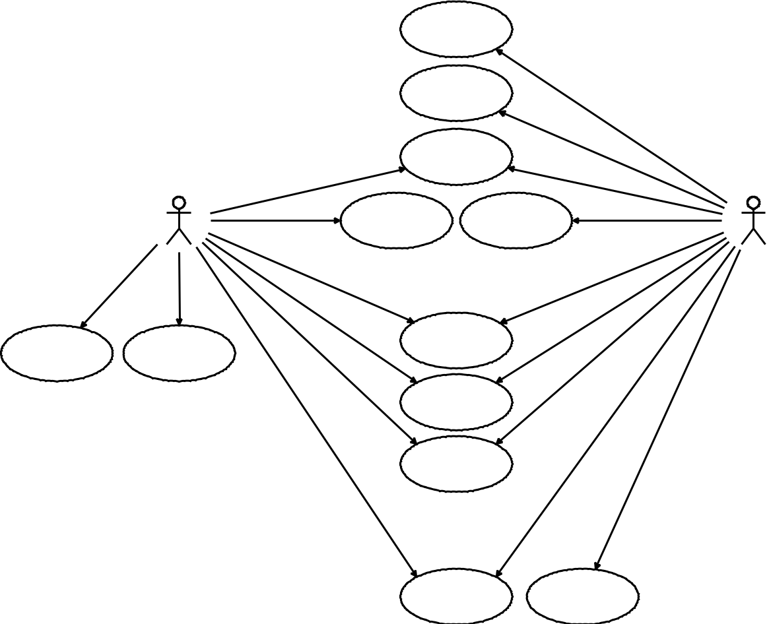

**View a list of**

**upcoming procedures**

**(timeline)**

**Customize order of**

**procedures**

**Choose the desired**

**path in a guideline**

**pathway**

**View epicrisis** **Publish epicrisis**

Figure 4.2: General use case diagram

14

**Chapter 5**

**Iterating the design**

**5.1** **Iteration 1: Paper prototype**

Some initial sketches were made during the first meeting with Paul Thorsen. Among others, they illustrated a list of procedures, a procedure in its entirety, rating the procedure and how the rating is reflected in the list of procedures. Selected sketches were used as a basis for the initial designing process.

The first design shows the user entering a procedure and evaluating it (see figure 5.1a), a common use case in this application. When viewing a procedure, its steps are shown in an horizontal, scrollable sequence of pictures. The user will be able to scroll across the whole procedure from le to right and to put each picture in focus, essentially becoming a step-to-step tutorial. This is a good way to get an overview of the procedure on its own, but it provides less interaction than if the user would, say, walk through the steps in a game-like approach. At the end of the procedure, the user is prompted to express their experience through use of smileys, a method proven to be quite successful (Stålberg et al., 2016). A more complicated system for rating procedures and experiences has been suggested but such a system is not within the scope of this application.

There are also several sketches showing how the procedure may be edited by an administrator (fig-ure 5.1b). Creating and modifying procedures on a tablet is one possibility, although not the only one, given the tablet requirement. Compared to PictogramApp, the interface is supposed to be more drag-and-drop oriented with possibilities to drag pages between each other. Another change is that elements must be clicked/tapped before they can be modified.

**5.1.1** **Considerations**

The scope of the application had been partially accounted for at this stage. It was clear that the ap-plication would be used to inform patients about upcoming procedures and let patients rate them a erwards. However, it was not known whether it was intended to be used during procedures and in context with a health professional.

Children at this age have most likely been made known to tablets and interactive devices, but the youngest children of the target group may not have su icient prior experience, either due to their age or health-related issues or a combination of both. Less experienced users should be able to learn how to use the application quickly regardless. It is therefore a good idea to consider ways to inform and possibly demonstrate the user about possible ways to interact with the application.

These initial ideas to the design will only give an indication of the final visual style of the application. Depending on the feedback of the test groups, the style should be one that the users feel more inter-esting. Some possible visual styles include a modern and minimal approach with focus on essential

15

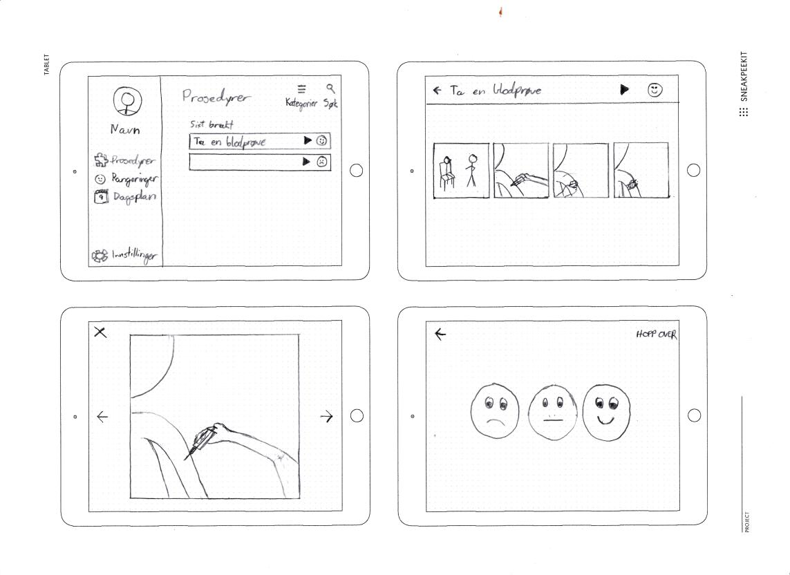

(a) Viewing a procedure

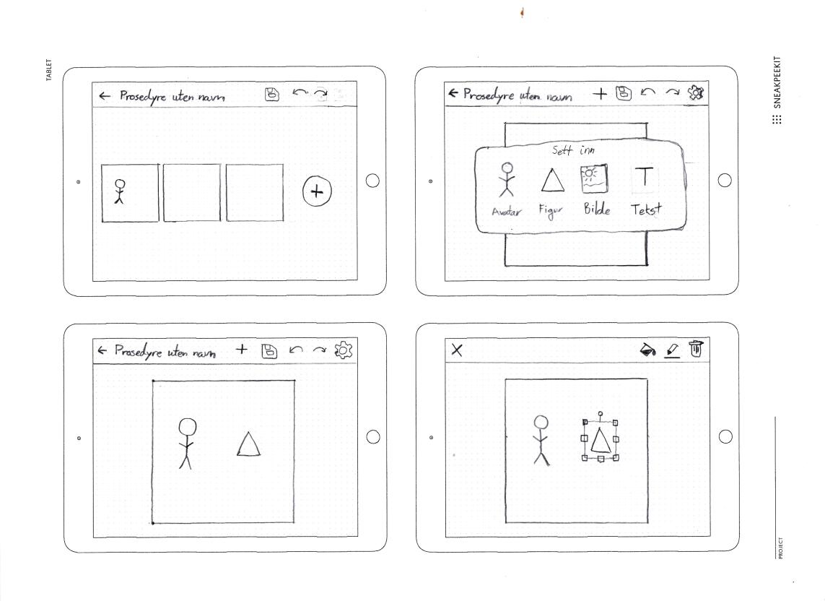

(b) Editing a procedure

Figure 5.1: Sketches of the first design

16

elements (similar to PictogramApp) and a more cartoonish, fun style with drawing-like pictures and an informal look. Regardless of what style is chosen, it should fit to the style of the avatars that are already made.

**5.1.2** **Analysis**

**5.2** **Iteration 2: Form study prototype**

**5.2.1** **Analysis**

**5.3** **Iteration 3: Visual prototype**

**5.4** **Iteration 4: Interactive prototype**

**5.5** **Iteration 5: UI experiments**

**5.6** **Iteration 6: Redesign**

**5.7** **Iteration 7: Final prototype**

**5.7.1** **Analysis**

When working on the final prototype, it was discovered that the design process did not consider every single case. One example is considering which emoji to display on a procedure a er rating it.

The idea is to show emojis that have a higher score than 50 %, and hide the others. If there is no rating, then a semi-transparent emoji is shown instead. Something that was not thought about was the fact that the user could rate every feeling below 50 %, resulting in no emojis being shown. It was therefore decided to reflect this situation with a neutral emoji. In that way, it symbolizes the fact that a rating has been given.

The design did also evolve during the prototyping process.

17

**Chapter 6**

**Evaluation**

Final prototype

**6.1** **The test group**

At the Children and Youth Clinic, a Youth Council has been set up to represent the younger patients at the hospital. (...) Together with SCP Thorsen, they form the test group for this evaluation.

**6.2** **Circumstances**

**6.3** **Performing the evaluation**

**6.4** **Results**

18

**Chapter 7**

**Application outline**

**7.1** **Implementation details**

An extended use case diagram is shown in figure 7.1.

Advanced domain model goes here

**7.2** **Architecture**

**7.2.1** **Backend**

**7.2.2** **Frontend**

**7.3** **Integration with existing systems**

Green figure

**7.4** **Anticipated challenges and feasibility**

The development tools chosen for an application should support the functionality of the application. The following subsections illustrate a few scenarios which the chosen development tools should sup-port.

**7.4.1** **Projecting the avatar on the screen**

Given that the avatar generation system only outputs images seen from the front view angle only, it will require additional work to make these look natural in a three-dimensional space. This has also been taken into consideration when deciding which tool to use for developing the application.

The avatar generation system created for E-LAN (from 2.4) can be used together with the application. This enables the user to view their avatar in procedures like they were participating themselves. The system does, however, only output portrait pictures in 2D and concerns were raised about whether these would look realistic in certain settings. For example, using a single 2D image, a person laying in the bed would look awkward unless viewed from above the bed. There are in fact multiple ap-proaches to this as seen in table 7.1.

It is shown that 2D images can be rotated in 3D pretty realistically. Rivers et al. (2010) carried out a pro-ject which showed that it is possible to view a figure from any angle when given three 2D projections of it.

19



**Relatives**



If minor



**Patient**

|  |  |  |  |  |  |
| --- | --- | --- | --- | --- | --- |
| Client application |  |  |  | Admin application |  |
| **Register / authenticate** |  | Avatar generator |  |  |  |
| **an account** |  |  |  |  |  |
| **Create a personal** | «include» | **Create an avatar** | «include» | **Create a generic** |  |
|  |  |  |
| **avatar** |  |  | **avatar** |  |
|  |  |  |  |
| **View a procedure** |  |  |  | **Create and modify a** |  |
|  |  |  | **procedure** |  |
|  |  |  |  |  |
| **Rate and comment a** |  |  |  | **Create and modify a** |  |
| **procedure** |  |  |  |  |
|  |  |  | **procedure template** |  |
|  |  |  |  |  |
| **View measurements** |  |  |  |  |  |
| **for a completed** |  |  |  | **Assign procedure to user** |  |
| **procedure** |  |  |  |  |
| **View a list of** |  |  |  |  |  |
| **upcoming procedures** |  |  |  | **Publish** |  |
|  |  |  |  |  |
|  |  | **Staﬀ** |  | **measurements for a** |  |
|  |  |  | **completed procedure** |  |
| **Customize order of** |  |  |  |  |  |
| **procedures** |  |  |  | **View ratings and** |  |
|  |  |  |  |  |
|  |  |  |  | **computed statistics** |  |
| **Choose the desired** |  |  |  |  |  |
| **path in a guideline** |  |  |  |  |  |
| **pathway** |  |  |  |  |  |
| **View epicrisis** |  |  |  | **Publish epicrisis** |  |

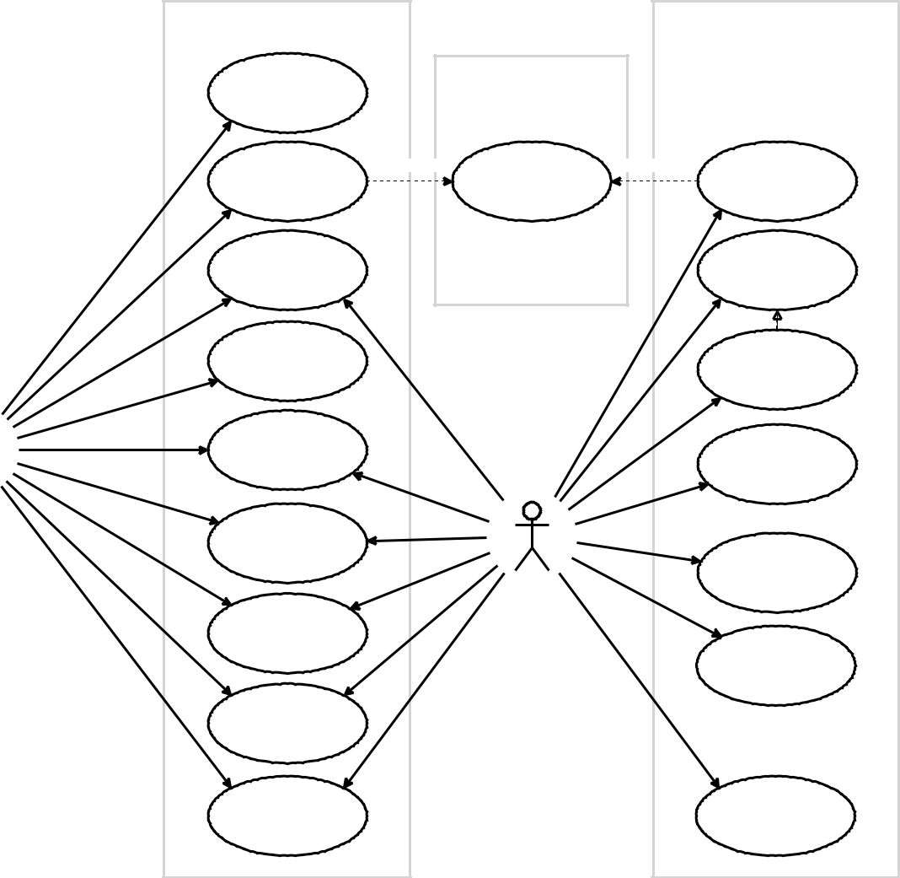

Figure 7.1: Extended use case diagram

|  |  |  |  |  |
| --- | --- | --- | --- | --- |
|  | **Realism** | **Processing** | **Ease of use** | **Additional** |
|  |  | **power** |  | **requirements** |
|  |  |  |  |  |
| **2D images** | Lowest | Lowest | Highest | None |
| **2D image sets with** | High | Low | High | Extra image sets |
| **various poses** |  |  |  |  |
| **2D images rotated** | Low | High | Low | So ware framework which |
| **in 3D** |  |  |  | supports 3D rotations |
| **3D models** | Highest | Highest | Lowest | New 3D models; a 3D |
|  |  |  |  | rendering engine; so ware |

framework which supports

3D rotations

Table 7.1: Di erent ways to project an avatar on a screen

20

Though, an alternative is to simply use such avatars in 2D-space.

The IACTA application shows that this can be used with similar e ect as a 3D-application (Stålberg et al., 2018).

**7.5 Hando**

The scope of this project involves minimal integration with existing healthcare and journal systems at Barneklinikken and Haukeland. Given that Helse Vest IKT monitors most of said systems, it would be sensible to develop an application that can be adapted, or even be developed further on, by them. It was pointed out that the developers of the avatar generation system used well-established web technologies such as HTML, CSS and JavaScript to develop it, and that similar technologies were preferred for the new application. This led to a new direction in choosing the most suitable so ware tools.

With this in mind, there were two main approaches remaining:

The first approach involves a mobile app and can be achieved in two ways; one way is to compile an application into native code. There are a number of frameworks which are able to transpile JavaScript into native applications, although the syntaxes may vary. Another way is to use *hybrid applications*, using HTML, CSS and JacaScript. These are typically built upon using a WebView, a browser instance that can be used by the application. Some frameworks o er their own JS-like language, providing additional methods and native functionality, which are compiled into traditional JavaScript.

The remaining approach is through web applications which run in web browsers. Lately there have been increasing interest in *Progressive Web Apps* (PWAs), which aim to make websites more app-like on mobile devices with o line access and push notifications. They do, however, require a website which is capable of serving HTTPS. PWAs is a relatively new kind of technology with increasing sup-port in both Android and iOS. Some browsers also support adding an app icon to the user’s app launcher, circumventing app stores in the process.

21

**Chapter 8**

**Tools and technology**

**8.1** **Choice of application setup**

Refer to 4.1

Requirements were not really present for this project; instead, there are various interests in how the application should be made and what it should result in.

To begin with, the Children and Youth Clinic indicated that this was intended for tablets with medium to large screens. Such tablets usually run a full-fledged operating system (OS) such as Windows or a mobile OS such as Android and iOS. There are no requirements regarding which operating systems the so ware should run on, but it seems that most of their tablets run Windows and Android operating systems.

As with most mobile applications, there is a choice between the following approaches:

* A *native application* is written in each operating system’s native languages. For Android this is Java, and Swi and Objective-C for iOS. Native applications can access all features which each OS may o er.
* Another native approach is to write the application in a di erent language and compile it to native code. The resulting app is then very alike a native one and has similar performance.
* A *hybrid application* encapsulates a web page into an app. Such apps use a browser instance to render elements, although without the search bar and tools of the browser. This approach of-fers functionality that you don’t get with web applications, but has usually worse performance compared to a native solution.
* A mobile *web application* is a responsive web page shown in the user’s web browser. These do not appear in app stores but function just like an ordinary web page. Lately there have been increasing interest in Progressive Web Apps (PWAs) which aim to provide mobile web pages with app-like behaviour and functionality such as push-notifications.

Due to the uncertainty in which operating systems that are in use (and will be used in the future), going for a cross-platform application is the most preferred.

Flutter is a relatively new framework

Dersom en Windows-løsning er ønskelig vil dette muligens kreve kunnskap om .NET, noe som ikke er blitt lært hittil. Det er flere måter å utvikle Windows 10-eksklusive applikasjoner på, men jeg har ikke gått i detalj gjennom disse ennå.

22

* - Xamarin (Microsoft)

2- C og F

3 - Stabilt og robust rammeverk

* - Kan utvikle for Windows 10 samtidig som for Android og iOS

5- Dårligere ytelse

6- Tidkrevende

7 - Flutter (Google)

8- Dart (C-lignende syntaks, kompilerer til JavaScript)

9- God ytelse

1. - Hot reload
2. - Ganske nytt; mangler erfaring som andre rammeverk har
3. - React Native (Facebook)
4. - HTML/CSS/JavaScript
5. - Bruker native UI-elementer
6. - Hot reload
7. - Kan gjenbruke kode for eventuell nettside
8. - Dårligere ytelse
9. - Relativt vanskelig åteste
10. - PhoneGap (Adobe) / Cordova (Apache)
11. - HTML/CSS/JavaScript
12. - Tradisjonelle web-rammeverk
13. - Delvis manglende støtte for native funksjonalitet
14. - Titanium
15. - JavaScript
16. -

Dersom vi lander på å utvikle for mobile operativsystemer vil det være naturlig å lage en multiplatform-applikasjon. Dersom ønskelig kan man etterpå se på en web-applikasjon eller en Windows desktop app.

Flutter har stort potensiale for utvikling av mobilapplikasjoner og ser ut til å passe oppgavebeskriv-elsen på en god måte. Dersom man ønsker å utvikle en og samme app både for Windows 10 og for Android/iOS vil Xamarin være et lovende alternativ.

Angående 3D-rotering av 2D-bilder kan dette oppnås enten ved å bruke en rekke bilder som er ferdig rotert, eller å faktisk rotere 2D-bilder i 3D. Xamarin har støtte for sistnevnte via SkiaSharp. Flutter støtter 3D-rotering også. Det ser ut til at React Native ikke har native støtte for dette, men det finnes trolig JavaScript-plugins som kan tilføye slik funksjonalitet.

Determining which approach to use requires paying attention to several factors: requirements, anti-cipated challenges and stakeholder interests among others. The requirements suggest using a cross-platform application primarily aimed for tablet devices, while Helse Vest IKT suggest using web tech-nologies when developing the application. General factors such as cost, ease of use, responsiveness, support for older devices and debugging also play a role.

When taking Helse Vest IKT’s opinion into account, there are basically two types of applications le to choose from.

Although only 2D images are currently supported, it seems reasonable to pick an approach that allow more extensive functionality if desired.

Given that both hybrid applications and Progressive Web Applications use web browsers (WebViews) to show content on the screen, their performances are assumed to be pretty comparable. The main di erence is how a hybrid application is dependent on an app store whereas a PWA is dependent on a website. In this case, a self-running application will require less server resources

23

|  |  |  |
| --- | --- | --- |
| **Framework** | **Functionality** | **Description** |
|  |  |  |
| Meteor | Native compiler | JavaScript |
| NativeScript | Native compiler | JavaScript |
| React Native | Native compiler | Mobile version of React. Supports hot reloading. |
|  |  | Focuses on Single Page Applications (SPAs) |
| Apache Cordova | App wrapper |  |
| Adobe PhoneGap | App wrapper |  |
| Ionic Capacitor | App wrapper |  |
| Angular | Navigation |  |
| Framework7 | Navigation & UI |  |
| Ionic | Navigation & UI |  |
| React (+ Flux) | Navigation & UI | JavaScript and JSX (HTML-like syntax represented as |
|  |  | JavaScript objects). Supports hot reloading |
| Vue.js | Navigation & UI |  |
| Bootstrap | UI |  |
| Onsen | UI |  |
| Polymer | UI |  |
| Semantic UI | UI |  |
|  |  |  |

Table 8.1: Web developer friendly frameworks for mobile application development

Based on the reflections above, a Progressive Web Application is considered to be less suitable for this project.

**8.2** **Frameworks**

Next to consider is frameworks. Frameworks allow developers to develop an application more e i-ciently by facilitating APIs, UI components, navigation, MVC patterns, utility methods or a combina-tion of these. Some frameworks can also help deploying the application to app stores.

Table 8.1 shows a few frameworks and what functionalities they o er.

The most common way to make a hybrid app is to use a Cordova-application. Apache Cordova is the original concept Adobe PhoneGap is an extension to Cordova and acts much the same with some additional features.

It is unknown which frameworks the web developers of Helse Vest IKT have used previously, if any. A

24

starting point is to assume that web developers have no or poor prior experience with frameworks. Any framework used for the project should therefore be easy to learn for any person skilled in HTML, CSS and JavaScript.

A framework worth explaining is React React Native is a mobile version of React, able to transpile code to both Android and iOS.

Is it too di icult for a web developer to learn React and its adjacent technologies? Learning React most likely requires learning JSX, Redux and Flux as well. Although

Supported functionalities What functionality do the frameworks facilitate?

**8.3** **Database system**

SQL vs NoSQL

**8.4** **Storage**

Lagringsmessig vil historier være serialiserte og kunne lagres i databaser. For å overføre historier kan de sendes i form av JSON-strenger som vil beskrive informasjon som

- Paneler - Antall paneler, evt. navn på disse - Størrelse på panel(er) - Piktogram/avatar - Plassering - Rotasjon - Størrelse - Om piktogrammet/avataren er speilvendt - Farge - Bakgrunn - Farge eller bilde

JSON kan også benyttes til å overføre kontoinformasjon, innstillinger og lignende. Bilder og pikto-grammer overføres som filer.

25

**Chapter 9**

**Conclusion**

Conclusion goes here

**9.1** **Discussion**

Arguments for why the conclusion is as such, what went right and what went wrong

**9.2** **Validity**

Arguments for the validity of this conclusion, that is, to which extent is it true and ’scientific’

**9.3** **Concerns**

Things to consider

**9.4 Further work**

**9.4.1** **Design and planning**

**9.4.2** **Development**

26

**Bibliography**

Fure, M., Spinnangr, N. and Syslak, I. (5th June 2017) **PictogramApp: Digital staging of pictograms**.

Bachelor’s thesis. Bergen: Western Norway University of Applied Sciences.

Kelly, M. M., Hoonakker, P. L. T. and Dean, S. M. (January 2017) Using an inpatient portal to engage families in pediatric hospital care. **Journal of the American Medical Informatics Association**, 24 (1) January, pp. 153–161.

Lien, L. H. and Booth, A. (19th January 2018) **Pictogram-me** [Internet]. Research Catalogue. Available at: [<https://www.researchcatalogue.net/view/157238/157386>](https://www.researchcatalogue.net/view/157238/157386) [Accessed 17th February 2018].

Preece, J., Rogers, Y. and Sharp, H. (2015) *Interaction design: beyond human-computer interaction*.

Fourth edition. Chichester: Wiley. 567 pp.

Rivers, A., Igarashi, T. and Durand, F. (26th July 2010) 2.5D cartoon models. **ACM Transactions on** **Graphics**, 29 (4) July, p. 1.

Stålberg, A., Sandberg, A., Larsson, T., Coyne, I. and Söderbäck, M. (January 2018) Curious, thoughtful and a irmative-Young children’s meanings of participation in healthcare situations when using an interactive communication tool. **Journal of Clinical Nursing**, 27 (1-2) January, pp. 235–246.

Stålberg, A., Sandberg, A., Söderbäck, M. and Larsson, T. (1st June 2016) The child’s perspective as a guiding principle: Young children as co-designers in the design of an interactive application meant to facilitate participation in healthcare situations. **Journal of Biomedical Informatics**, 61 June, pp. 149– 158.

27