Version 1.0

15/11/2018

**SMART HOME**

UNIVERSITY OF CAPE COAST, 2018

Presented by: Jerry & DAWUD

## OVERVIEW

### DEFINITION

A smart home is a residence that uses internet-connected devices to enable the remote monitoring and management of appliances and systems, such as lighting and heating.

### THE PROBLEM

Energy is mostly wasted at homes, offices and laboratories. As humans, we may not be able to manage energy efficiently due to forgetfulness.

Moreover, we wish we could switch on/off our lighting systems, appliances and other devices away from home.

These challenges have made it needful to develop a system to meet these needs.

### THE SOLUTION

Smart Home will allow users to control their lighting system, appliances and other devices.

Certain environmental readings such as temperature and humidity can be observed from the web app or phone app which may be useful in laboratories.

We seek to implement this solution as shown in the pictures below.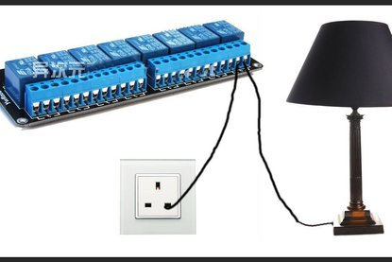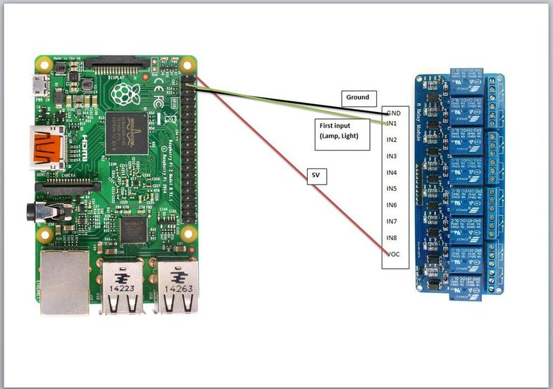

Figure 2: Relay connection with appliance

Figure 2: Relay connection with raspberry pi

<https://www.instructables.com/id/Raspberry-Pi-Home-Automation-Control-lights-comput/>

|  |  |
| --- | --- |
| HARDWARE RESOURCES | |
| NAME | **FUNCTION** |
| Raspberry Pi 3 | Micro-controller for sensors |
| Infrared sensor | Remote Controller |
| Relay Connector | Switching ON/OFF Appliances/Devices |
| Switch |  |
| Bulb |  |
| Copper wire | Circuit connections |
| Temperature & Humidity Sensor (DHT11) | Sensing temperature and humidity |

|  |  |
| --- | --- |
| Other (Technologies) Resources | |
| NAME | **FUNCTION** |
| Mqqt Protocol (Mosquito Broker) |  |
| Heroku | Hosting Web Server |
| Python3 | Embedded System Programming |
| Django | Web Server Implementation |
| React | Web Application Frontend |

## IMPLEMENTATION