Contents
Overview of Angular(Done) 3
What is Angular? 3
angular definition 3
Difference between AngularJS and Angular 3
Angular’s History 5
Angular Version Change 5
Advantages of Angular 5
What is Angular mainly used for? 6
In which scenario Angular is not a right choice ? 6
What is AOT compilation? What are the advantages of AOT? 6
Development Environment for Angular 6
Transpiling in Angular 7
Angular CLI 7
Chapter_03(Done) Key components of Angular 8
Modules in Angular 9
Decorators 10
class decorators 10
What are the class decorators in Angular? 10
field decorators 11
What are class field decorators? 11
(Chapter_04) Lifecycle hooks of angular 12
Difference between constructor and ngOnInit? 13
Data Model 13
How to create a Project in Angular 9(done) 17
Data Binding In angular(done partially) 23
Interpolation: Interpolation is a special syntax that Angular converts into property binding. It’s a convenient alternative to property binding. It is represented by double curly braces({{}}). The text between the braces is often the name of a component property. Angular replaces that name with the string value of the corresponding component property. For ex. 23
Property binding: Property and attribute are not same ,There are some differences ,they are given below: 24
Attribute 24
Property 24
HTML 24
DOM 24
Attribute value cannot change once they are initialized 24
Property values however can change. 24
Event binding: When a specific event (eg: click,change,keyup,mousemove etc) occurred in DOM and perform some action is known as Event binding. 25
Two-way data binding: [(ngModel)]=“value” 26
Attribute Binding in Angular 26
Class Binding 26
How to save record in SqlServer using Angular 9 and WebAPi Core 27
How to add MatDialog in angular9 33

Overview of Angular(Done)

What is Angular?

angular definition
Angular is an open-source, client side/ front-end web development framework based on Microsoft’s TypeScript. It is one of the most popular JavaScript frameworks that is mainly developed and maintained by Google. it easy to build applications with in web/mobile/desktop using Angular. Angular started as a SPA (Single-Page-Application) framework and now supports dynamic content based on different users through dependency injection. YouTubeTV is the most popular company that uses Angular. It integrates powerful features like
- declarative templates
- an end to end tooling
- dependency injection
- Modular approach
- Re-usable code
- Quick and easy development
- Unit testing
- Single Page Application development
- And various other best practices that smoothens the development path.

Difference between AngularJS and Angular

The first version of Angular was released in the year of 2010. Some people call this as AngularJS and some people call as Angular 1. But it is officially named as AngularJS.The Angular 2 was released in the year of 2016. The important point to note is that Angular 2 is not a simple upgrade of AngularJS. Angular 2 is completely rewritten from scratch and as a result, the ways we write in AngularJS and Angular 2 are completely different. The differences between them are given below :
AngularJS | Angular
Based on JavaScript | Based on TypeScript
Based on the MVC design pattern | Based on components, modules, and directives
Based on controllers and the View communicates using $scope | controller and $scope are completely gone
No support for mobile app | Supports mobile
Can’t build SEO friendly applications | SEO friendly applications can be easily created
Dependency Injection tokens can only be strings. Also, only the injector is present. | DI Tokens can be of any type, for example, strings or class. Angular follows a tree-hierarchy for injectors starting with the root injector, and a nozzle for each component henceforth.
No support or backward compatibility | Backward compatibility can be done without issues. Also, there is a lot of support documentation for the same.
Uses $routeprovider.when() for routing | Routing is done using @RouteConfig[()]
Requires specific ng directive for each of property, event, and image | For event binding, () is used and for image or property binding [] is used
No facility of Unit testing | Greater facility of Unit testing
Used ng-directive for binding an event, or a property | Used Expression for binding an event, or a property. property binding  is done using "[ ]" attribute and event binding is done using "( )"  attribute

Angular’s History
Time | Version
2010 | Angular Js
2016 | Angular 2
2016 Dec | Angular 4
2017 Nov | Angular 5
2018 May | Angular 6
2018 October | Angular 7
2019 May | Angular 8
2020 February | Angular 9
2020 June | Angular 10

Angular Version Change
Semantic Versioning:
Version:1.2.3

Major Minor Fix(Patch)
For example, version 7.2.11 indicates major version 7, minor version 2, and patch level 11.
Pacth: Increase when any bug fixes.
Minor : Increases when added feature that does not break any functionalities.
Major : Increases when break any functionality.

Advantages of Angular
A few of the major advantages of using Angular framework are listed below:
- It supports two-way data-binding
- It follows MVC pattern architecture
- It supports static template and Angular template
- You can add a custom directive
- It also supports RESTfull services
- Validations are supported
- Client and server communication is facilitated
- Support for dependency injection
- Has strong features like Event Handlers, Animation, etc.
- We can add custom animations, directives, and services.

What is Angular mainly used for?
Angular is typically used for the development of SPA which stands for Single Page Applications. Angular provides a set of ready-to-use modules that simplify the development of single page applications. Not only this, with features like built-in data streaming, type safety, and a modular CLI, Angular is regarded as a full-fledged web framework.

In which scenario Angular is not a right choice ?
Angular may not be the right fit in some scenario, For example, for short-term projects or light-weight websites that have more static content do not require a complex framework like Angular. Same way, apps that have a microservice design approach will find too many unused features if they use Angular since it is a complete solution. There is less flexibility with the developer to choose additional tools.

What is AOT compilation? What are the advantages of AOT?

Development Environment for Angular
- Node
- Npm
- Angular CLI
- Text Editro (VS Code)
Check Development Environment for Angular
To check Development Environment for Angular , check version of Node,NPM and angularcli.
Command for Check node version in cmd
Node –v
Command for Check npm version in cmd
Npm –v
Command for Check angular cli version in cmd
ng version

Transpiling in Angular
Transpiling is the process of converting the typescript into javascript (using Traceur, a JS compiler). Though typescript is used to write code in the Angular applications, the code is internally transpiled into javascript.

Angular CLI
CLI stand for Command Line Interface Angular CLI(Command Line Interface) is a command line interface to scaffold and build angular apps using nodejs style (commonJs) modules. You need to install using any one of the below npm command.
npm install @angular/cli@latest
npm install @angular/cli@9
Below are the list of few commands, which will come handy while creating angular projects
  - Creating New Project: ng new
  - Generating Components, Directives & Services: ng generate/g The different types of commands would be,
    - ng generate class my-new-class: add a class to your application
    - ng generate component my-new-component: add a component to your application
    - ng generate directive my-new-directive: add a directive to your application
    - ng generate enum my-new-enum: add an enum to your application
    - ng generate module my-new-module: add a module to your application
    - ng generate pipe my-new-pipe: add a pipe to your application
    - ng generate service my-new-service: add a service to your application
  - Running the Project: ng serve
  - Running the Project and open in browser : ng serve –o
  - Running the Project and open in browser with port number: ng serve --port 4563 -o

Chapter_03(Done)
Key components of Angular
The Angular has the following building blocks
- Modules : Modules are the combination of Component and Template.
- Component
- Template
- Directives(ch16):
- Data Model : The Data Model is one of the building block of Angular. It provides access to the data that the application requires; the details of how this is done and what that data looks like is left to the developer.
- Services: A service is used when a common functionality needs to be provided to various modules. Services allow for greater separation of concerns for your application and better modularity by allowing you to extract common functionality out of components.
- Dependency Injection : Dependency injection (DI), is an important application design pattern in which a class asks for dependencies from external sources rather than creating them itself. Angular comes with its own dependency injection framework for resolving dependencies( services or objects that a class needs to perform its function).So you can have your services depend on other services throughout your application

- Routing
- MetaData

Modules in Angular
The first building block of Angular application is the Module. Angular is Modular based application in nature. Angular is a collection of many individual modules. Every module represents the feature area of the application. Each and every module can be imported or exported. Modules are logical boundaries in your application and the application is divided into separate modules to separate the functionality of your application. For example
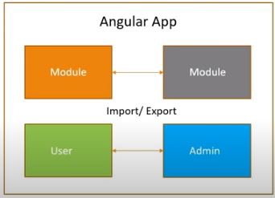

There are two types of Angular module: feature modules and the root module. Features modules are used to group related application functionality to make the application easier to manage.
The root module is used to describe the application to Angular. The description includes which feature modules are required to run the application, which custom features should be loaded, and the name of the root component. By convention the name of the root module is AppModule. Keep in mind, every application must contain a root module. Let’s take a look of app.module.ts root module declared with @NgModule decorator .
The NgModule decorator has five important(among all) options
- The imports option is used to import other dependent/feature modules. The BrowserModule is required by default for any web based angular application
- The declarations option is used to define components in the respective module. It tells Angular that it should load the root component.
- The bootstrap option tells Angular which Component to bootstrap in the application
- The providers option is used to configure set of injectable objects that are available in the injector of this module. Tells Angular about the shared objects used by the application. Such as register a service.
- The entryComponents option is a set of components dynamically loaded into the view. For example , when we display a popup dialog box according to user demand. We have to write component name in entryComponents which one used for popup dialog box.

Decorators

Introduction: Decorators are a design pattern that is used to separate modification or decoration of a class without modifying the original source code.
There are four types of decorators in Angular:
- Class Decorators
- Property Decorators
- Method Decorators
- Parameter Decorators

class decorators

What are the class decorators in Angular?
A class decorator is a decorator that appears immediately before a class definition, which declares the class to be of the given type, and provides metadata suitable to the type
The following list of decorators comes under class decorators,
- @Component()
- @Directive()
- @Pipe()
- @Injectable()
- @NgModule()

field decorators

What are class field decorators?
The class field decorators are the statements declared immediately before a field in a class definition that defines the type of that field. Some of the examples are: @input and @output,
@Input() myProperty;
@Output() myEvent = new EventEmitter();

@Injectable : The @Injectable decorator is used to tell Angular that this class will be used as a service, which allows other classes to access its functionality through a feature called dependency injection.

Dependency Injection :
Observable:
Directive :
Model Repository :

(Chapter_04)
Lifecycle hooks of angular
Angular application goes through an entire set of processes or has a lifecycle right from its initiation to the end of the application. The representation of lifecycle in pictorial representation as follows,
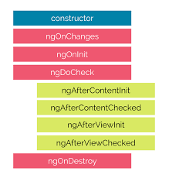
The description of each lifecycle method is as below,
- ngOnChanges: When the value of a data bound property changes, then this method is called.
- ngOnInit: This is called whenever the initialization of the directive/component after Angular first displays the data-bound properties happens.
- ngDoCheck: This is for the detection and to act on changes that Angular can't or won't detect on its own.
- ngAfterContentInit: This is called in response after Angular projects external content into the component's view.
- ngAfterContentChecked: This is called in response after Angular checks the content projected into the component.
- ngAfterViewInit: This is called in response after Angular initializes the component's views and child views.
- ngAfterViewChecked: This is called in response after Angular checks the component's views and child views.
- ngOnDestroy: This is the cleanup phase just before Angular destroys the directive/component.

Difference between constructor and ngOnInit?
TypeScript classes has a default method called constructor which is normally used for the initialization purpose. Whereas ngOnInit method is specific to Angular, especially used to define Angular bindings. Even though constructor getting called first, it is preferred to move all of your Angular bindings to ngOnInit method. In order to use ngOnInit, you need to implement OnInit interface as below,
export class App implements OnInit{
constructor(){
//called first time before the ngOnInit()
}

ngOnInit(){
//called after the constructor and called after the first ngOnChanges()
}
}
https://www.pluralsight.com/guides/defining-metadata-with-a-decorator-in-angular

Data Model
Data Model is one of the building block of Angular. The only requirement for the model is that it provides access to the data that the application requires. The model can be broken into three different parts.

• A class that describes the data in the model
• A data source that loads and saves data, typically to a server
• A repository that allows the data in the model to be manipulated

Model class: The model class describe the data that the application operate on it. TO create a model class in Angular application you have to write following command in terminal of Visual studio code.

ng g class Models/BlogsCategory --type=model
Above code will create two files in Models folder,one is blog-category.model.ts ,another one is blog-category.model.spec.ts. Second one for testing purpose.If you want to ignore Testing file you can write command the below one rather than above one.
ng g class Models/BlogsCategory --type=model --skipTests
This command will create only one file is blog-category.model.ts under Models folder .
Now put required properties in blog-category.model.ts file. Like below :
export class BlogsCategory {
constructor(public Id?:number,
public name?:string)
{

}
}
The BlogsCategory model class defines properties for a blogs identifier and the name of the blog. The properties are defined as optional constructor arguments, which is a useful approach if you are creating objects using an HTML form.

Creating the Data Source
The data source provides the application with the data. The most common type of data source uses HTTP to
request data from a web service. I add a data source class using following command :

ng g class Datasources/BlogsCategorySource --type=model --skipTests

The content of BlogsCategorySource class is :

export class BlogsCategorySource {
private data : BlogsCategory[];
constructor(){
this.data= new Array<BlogsCategory>(
new BlogsCategory( 1,"Technology"),
new BlogsCategory( 1,"Social"),
new BlogsCategory( 1,"Social Media"),
new BlogsCategory( 1,"Politics"),
new BlogsCategory( 1,"Religious"),
);

}
getBlogs():BlogsCategory[]{
return this.data;
}
}
Repository class
The final step to complete the simple model is to define a repository that will provide access to the data from the data source and allow it to be manipulated in the application. I added a repository for Blogscategory model class using following command
ng g class Repositories/BlogsCategoryRepo --type=model --skipTests

The structure of BlogsCategorRepo class is
import { BlogsCategorySource } from '../Datasources/blogs-category-source.model';
import { BlogsCategory } from '../Models/blogs-category.model';

export class BlogsCategoryRepo {
private ds: BlogsCategorySource;
private categorys:BlogsCategory[];
private locator= (b:BlogsCategory,id:number)=>b.Id==id;
constructor(){
this.ds=new BlogsCategorySource();
this.categorys=new Array<BlogsCategory>();
this.ds.getBlogs().forEach(c=>this.categorys.push(c));
}
getAll(): BlogsCategory[] {
return this.categorys;
}
getbyID(id: number): BlogsCategory {
return this.categorys.find(p => this.locator(p, id));
}
save(b: BlogsCategory) {
if (b.Id == 0 || b.Id == null) {
b.Id = this.generateID();
this.categorys.push(b);
} else {
let index = this.categorys
.findIndex(p => this.locator(p, b.Id));
this.categorys.splice(index, 1, b);
}
}
delete(id: number) {
let index = this.categorys.findIndex(p => this.locator(p, id));
if (index > -1) {
this.categorys.splice(index, 1);
}
}

private generateID(): number {
let candidate = 100;
while (this.getbyID(candidate) != null) {
candidate++;
}
return candidate;
}
}

The Model class defines a constructor that gets the initial data from the data source class and provides
access to it through a set of methods. These methods are typical of those defined by a repository and are
described in below :
Name | Description
getAll | This method returns an array containing all the Blogscategory objects in the model.
getbyID | This method returns a single BlogsCategory object based on its ID.
save | This method updates an existing blogscategory object or adds a new one to the model
delete | This method removes a blogscategory object from the model based on its ID.

We have created our model class.Now its time to implement these classes in component. So I create a component using following command :
ng g c Components/BlogCategory --skipTests
This command will create three file ,one for html template,one for typescript and other one for css.like below:
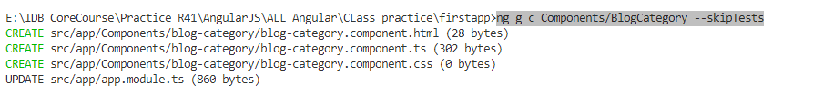
The structure of html class is
<div class="bg-info text-white m-2 p-2">
There are {{data.getAll().length}} products in the model
</div>

The structure of ts class is given below :
import { Component, OnInit } from '@angular/core';
import { BlogsCategory } from 'src/app/Models/blogs-category.model';
import { BlogsCategoryRepo } from 'src/app/Repositories/blogs-category-repo.model';

@Component({
selector: 'app-blog-category',
templateUrl: './blog-category.component.html',
styleUrls: ['./blog-category.component.css']
})
export class BlogCategoryComponent implements OnInit {

constructor() { }
public data ;
ngOnInit(): void {

this.data= new BlogsCategoryRepo();
console.log(this.data)
}

}
Now you have to configure routing for Blogscomponent in app-routing.modules ,that is given below

import { NgModule } from '@angular/core';
import { Routes, RouterModule } from '@angular/router';
import { BlogCategoryComponent } from './Components/blog-category/blog-category.component';

const routes: Routes = [
{path:"bCategory",component:BlogCategoryComponent},
];

@NgModule({
imports: [RouterModule.forRoot(routes)],
exports: [RouterModule]
})
export class AppRoutingModule { }

Now run the application using following command and you will see the output as like below
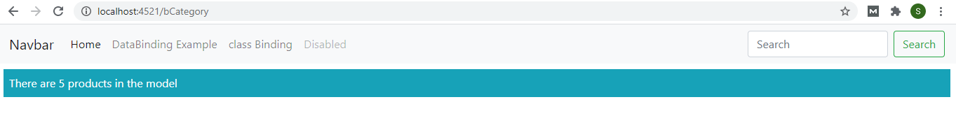

How to create a Project in Angular 9(done)
In this blog, I will show how to create a project in Angular 9. To set up a project, make sure you have installed nodejs. To ensure nodejs installation you can check version of nodejs using following command in command line ,Node –v, as below -
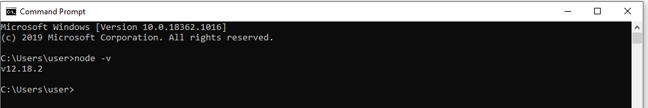
If you do not get version, you can download it from nodejs website , https://nodejs.org/en/
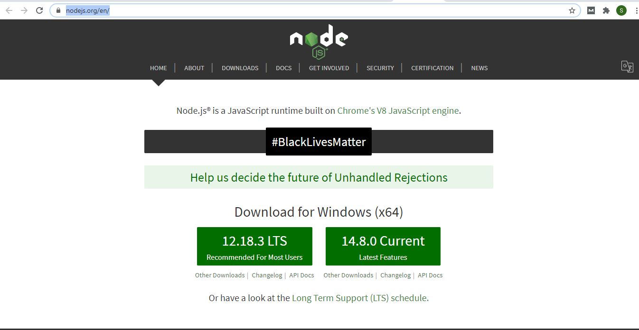
Once you installed nodejs ,you have to check NPM, To check npm write command npm –v in cmd,like below-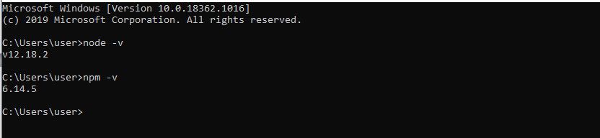
Now we have Node version 12 and npm version 6.
Now,you have to install Angular/Cli using following command in cmd.
Npm install -g @angular/cli@9 [For specific version]
If you skip version number it will install latest one. For example
Npm install -g @angular/cli
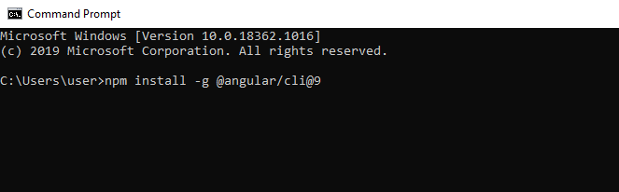
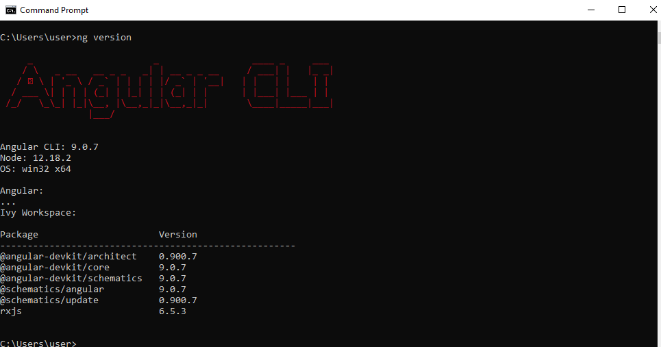
Here g stands for global. That means Angular/CLI will install globally. Once installation done check installed package details as shown
All required installation complete, now we can create project in Angular 9. To create project use following command
Ng new MyFirstApp .
like below
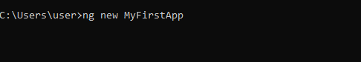
Here “MyFirstApp” is project name. You can choose as you wish. But it’s better to give project name that relevant with project .Once you run the command you will asked about routing ,as like below :

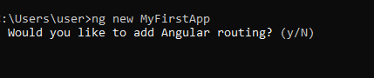
Press Y to add routing with your project. Next , you will asked to choice stylesheet type, press enter to default type CSS,
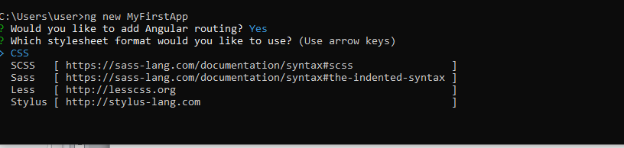
Other available types are Sass, Less and Stylus. You can use arrow key to select another one.
The Project MyFirstApp created successfully. It install all the required packages that is mandatory to run the project in angular9.Let’s switch to project directory using following command
Cd MyFirstApp ,like :
Now you can build project using following command
Ng serve
If you want to see the output in browser window along with build ,use the following command
Ng serve -o
If you want to see the output in specific port, you can write
Ng serve –port 4785 -o
Like below:
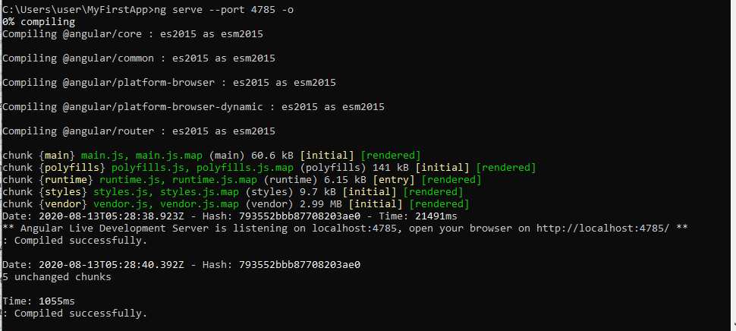
After successfully compilation you can see output in browser .like this :
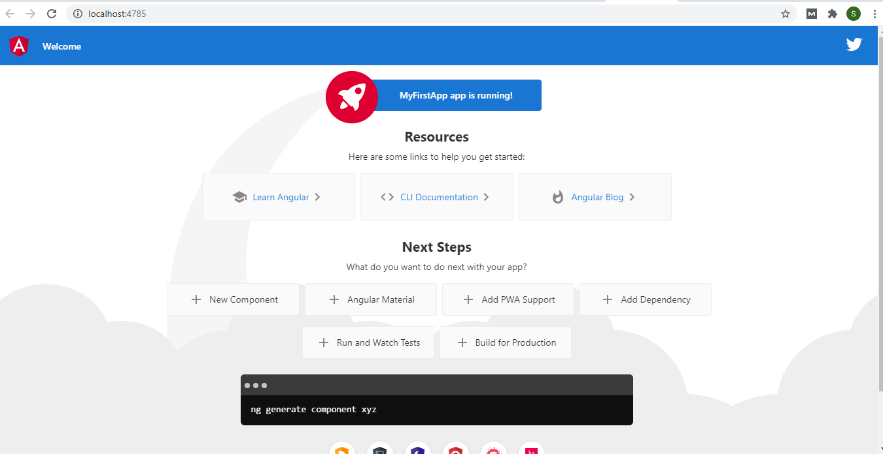
Congratulation’s, You successfully created your first project.
Angular development can be done with any programmer’s editor, from which there is an endless number
to choose. Some editors have enhanced support for working with Angular, including highlighting key terms
and good tool integration. If you don’t already have a preferred editor for web application development,
below I mention some popular options for you to consider.
Name | Desciption
Sublime Text | Sublime Text is a commercial cross-platform editor that has packages to support  most programming languages, frameworks, and platforms. Download from here http://www.sublimetext.com/
Atom | Atom is a free, open source, cross-platform editor that has a particular emphasis  on customization and extensibility. See atom.io for details.
Brackets | Brackets is a free open source editor developed by Adobe. See brackets.io for  details.
WebStorm | WebStorm is a paid-for cross-platform editor that integrates many tools so that you  don’t have to use the command line during development. See www.jetbrains.  com/webstorm for details.
Visual Studio Code | Visual Studio Code is a free, open source, cross-platform editor from Microsoft,  with an emphasis on extensibility. See code.visualstudio.com for details.
Visual Studio | Visual Studio is Microsoft’s flagship developer tool. There are free and commercial  editions available, and it comes with a wide range of additional tools that integrate  into the Microsoft ecosystem.

Data Binding In angular(done partially)

DataBinding is a core concept in Angular that allows communication between component and DOM element. There are four types of DataBinding .They are different in data following process.They are given below :

From the Component to the DOM

Interpolation: Interpolation is a special syntax that Angular converts into property binding. It’s a convenient alternative to property binding. It is represented by double curly braces({{}}). The text between the braces is often the name of a component property. Angular replaces that name with the string value of the corresponding component property. For ex.
{{title}}
This evaluates the title property of the component and display value of its in html page.

Property binding: Property and attribute are not same ,There are some differences ,they are given below:
Attribute | Property
HTML | DOM
Attribute value cannot change once they are initialized | Property values however can change.
We can clear understand the differences between attribute and property by following example.
Property binding:
<input type="text" id="sid" value="Shahanaj" />
Write following command in console of developer tools (press f12 in browser)
$("#sid").getAttribute('value')
Rertieve value: "Shahanaj"
$("#sid").value
Rertieve value: "Shahanaj"
After changing value in textbox from "Shahanaj" to : "Shahanaj Begum"
Execute this code again in console
$("#sid").value
Rertieve value: "Shahanaj Begum"
$("#sid").getAttribute('value')
Rertieve value: "Shahanaj" [Changed value can’t retrieve,that means attribute can’t changed after initialization]
With property binding, we can pass value from the component to the specified property, which can often be a simple html attribute. For property binding [ ] is used. [ ] this contain html attribute name and its value will be passed from component, such as
<input type="text" value="Shahanaj" [disabled]="isDisabled" />

In this example, the value of [disabled] property depends on isDisabled. isDisabled ‘s value define in component.For ex.

public isDisabled:boolean
this.isDisabled = false;

From the DOM to the Component

Event binding: When a specific event (eg: click,change,keyup,mousemove etc) occurred in DOM and perform some action is known as Event binding.
We can assign evnthandler or template statement in an event. To bind an event Parenthesis () is used. Inside parenthesis event name placed. For ex.
<input type="button" (click)="SomeAction()" value="Get" />
{{someAction}}

Component:
SomeAction (){
this.someAction= "Clicked event fired";
}
Output:
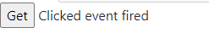
In this example ,we assign an event handler which is nothing but a method .which this event occurred its display output in browser.
To get event details
<button (click)="Someevent($event)" >Get event</button>
Method in TS file
Someevent (e){
this.someAction= e.type;
console.log(e)
}
Output in browser
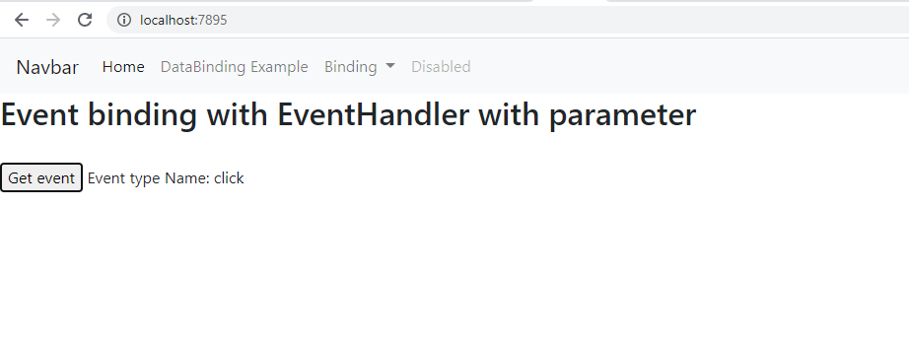
Template assignment
<input type="button" (click)="action='template displayed'" value="Get" />
{{action}}
When clicked it will display
template displayed

Two-way

Two-way data binding: [(ngModel)]=“value”
Using what’s called the banana in a box [()] syntax, two-way data binding allows to have the data flow both ways.
<input type="text" [(ngModel)]="uname" />
{{uname}}

Module: CommonModule,FormsModule

In this example, the uname data property is used as the value for the input, but if the user changes the value, the component property gets updated automatically to the new value.

Attribute Binding in Angular
Not all HTML element attributes have equivalent properties in the DOM API. For these situations, Angular provides the attribute
binding, which is used to set an attribute on the host element rather than setting the value of the JavaScript
object that represents it in the DOM. The attribute binding is applied by defining a target that prefixes the name of the attribute with attr.(the term attr, followed by a period)

Class Binding

How to save record in SqlServer using Angular 9 and WebAPi Core
Introduction
In this tutorial, I'm going to perform Save operations in an Angular 9 Web application step by step. The backend is a SQL Server database. A Web API Core is used to provide data connectivity between the database and the front end application. On the UI side, I will use the Angular Bootstrap theme to create a rich, interactive, and device-independent user experience.
I'm using Visual Studio Code as an editor tool to build my client application. If you don't have Visual studio code, download and install from here. And Visual Studio 2019 to create WEBAPI Project
Step1: Create a WebAPi Project
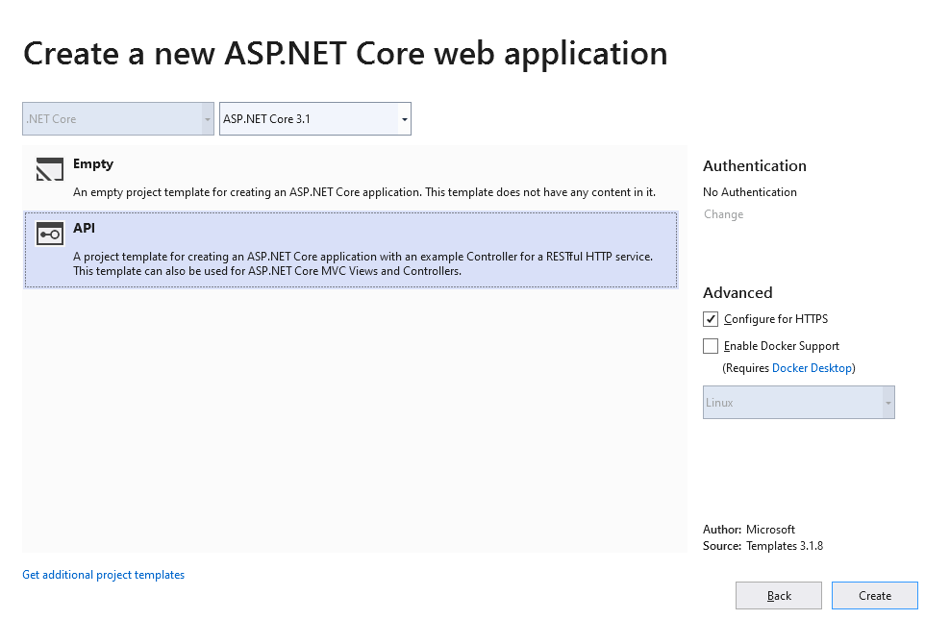
Open visual studio 🡪 select create New Project 🡪select ASP .net core WebApplication 🡪Click Next 🡪Write downProject Name in name box and browse location in which you want to save the project 🡪click Create button 🡪 select API from the template dialog box.Like below

Click Create button. Web Application Created.
Step 2: Create DataModel for CODE First Approach.
Right click on Project🡪Add🡪 New Folder🡪Write folder name as Models🡪Right click on Models Folder🡪Add🡪New Item🡪Select Class and Provide name as dbShop🡪 Click Add.
Now create EntityModel like this :
public class dbShop:DbContext
{
public dbShop(DbContextOptions<dbShop> db):base(db)
{

}
public DbSet<Category> Categories { get; set; }
}
public class Category
{
public int Id { get; set; }
public string Name { get; set; }
public string Description { get; set; }
public int ParentId { get; set; }

}
Step3:Provide connectionString in appsettings.json file.
{
"ConnectionStrings": {
"DefaultConnection": "Data Source=DESKTOP-NI6MTIN\\SQLEXPRESS;Initial Catalog=DbSHopNagular;Trusted_connection=true;"
},
Step4: Install package for CORS enable

RightClick Project Name 🡪 Manage Nuget Packages🡪write Microsoft.AspNetCore.Cors in search box 🡪 select Microsoft.AspNetCore.Cors🡪Click Install.

Step5: Register services in startup file.

public void ConfigureServices(IServiceCollection services)
{
services.AddDbContext<dbShop>(op=> {
op.UseSqlServer(Configuration.GetConnectionString("DefaultConnection"));
});
services.AddCors(o =>
{
o.AddPolicy("shop", s =>
{
s.AllowAnyHeader();
s.AllowAnyMethod();
s.AllowAnyOrigin();
});
});
}
Step 6: Run migration Command in Package Manager Console
Add-migration
Update-database
Step 7: Save Operation
Now, we will write code to perform SAVE operation.

Go to the Controller folder in our API Application and right click 🡪 Add 🡪 Controllers🡪
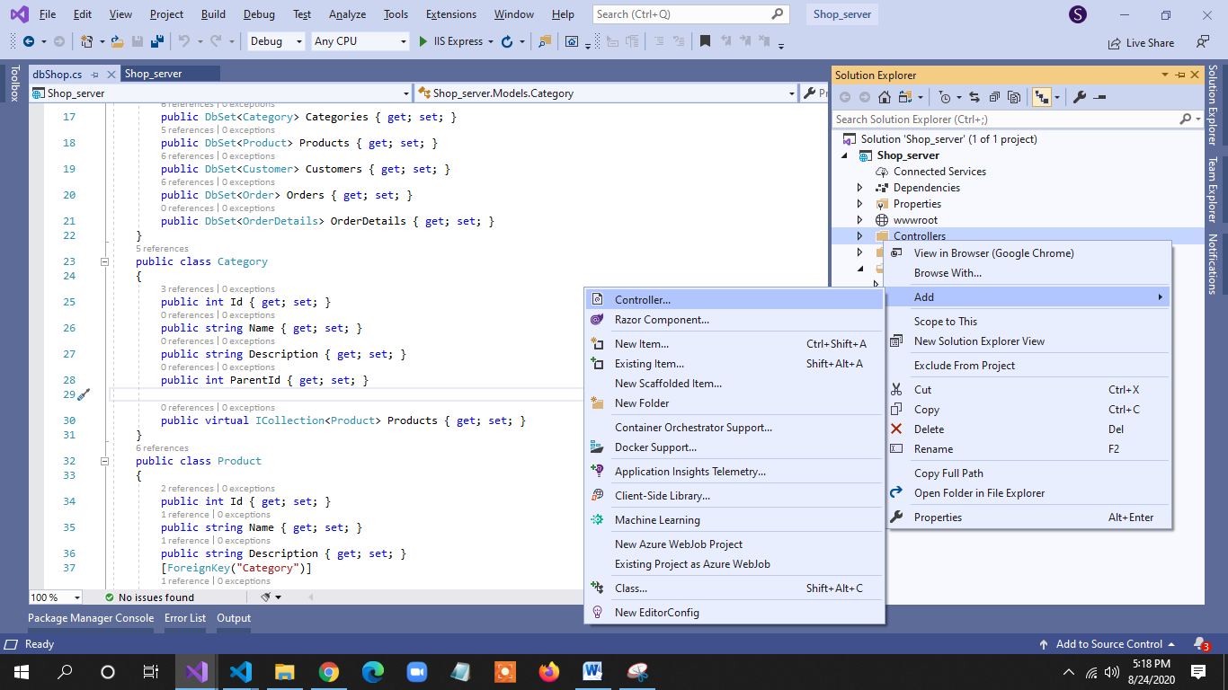

Then Select API Controller-Empty from ADD new Scaffolded Item Dialog box 🡪Add.
Now we go to controller class to write required code for save operation.
[Route("api/[controller]")]
[ApiController]
public class CategoriesController : ControllerBase
{
private readonly dbShop _context;

public CategoriesController(dbShop context)
{
_context = context;
}
[HttpPost]
public async Task<IActionResult> PostCategory([FromBody] Category category)
{
if (!ModelState.IsValid)
{
return BadRequest(ModelState);
}

_context.Categories.Add(category);
await _context.SaveChangesAsync();

return CreatedAtAction("GetCategory", new { id = category.Id }, category);
}
As you can see from the above code, it has functionality to add records to the table.
Now Build(ctrl+Shift+b) the application.

Step7: Create Client Side Application
Now, we create the Web application in Angular 9 that will consume Web API. The steps to create a new Project I describe here. Please see that article.
Now open visual studio code and navigate to Project folder.
Step 8: Create a model class
In terminal window write the below command
Ng g class Category –type=model –skipTests
Now, write all properties of the Category class related to an Ctaegory that matches with the database.
export class Category {
Id:number;
Name:string;
Description:string;
ParentId :number;
}
Step 9:Write WebApi url in Environment.ts for globally access.
export const environment = {
production: false,
apiUrl:"https://localhost:44307/api/",
};

Step 10 : Create a service for Remote data access
In terminal window write the below command
Ng g s CategorySrv --skipTests
Press enter. And you will see the service file created.
Now, open CategorySrv class and first import necessary class and libraries and then make calls to the WebAPI methods.
import { HttpClient } from '@angular/common/http';
import { environment } from 'src/environments/environment';
export class CategorySrvService {

constructor(private http:HttpClient) { }
saveOrUpdate(body){
return this.http.post(environment.apiUrl+"Categories",body);
}
Step 11: Create Component
Now I am going to create new component , Category. Write the following command in terminal window
Ng g c Category --skipTests
Press enter.
Step 12: Write Html for save operation
<form (submit)="save()">
<div>
<input type="text" name="Id" [(ngModel)]="category.Id" hidden />
<label for="Name">Name</label>
<input type="text" name="Name" [(ngModel)]="category.Name" />
</div>
<div>
<label for="Description">Description</label>
<input type="text" name="Description" [(ngModel)]="category.Description" />
</div>
<div>

<input type="checkbox" name="ParentID" [(ngModel)]="isSub" (change)="toggleChange($event)" /><label>Issub</label>
</div>
<div >
<label for="ParentId"> Parent Category</label>
<select [disabled]=!isSub [(ngModel)]="category.ParentId" name="ParentId" >

<option value="0"> Select Parent</option>
<option *ngFor="let category of categoryList"
[ngValue]="category.id" >
{{category.name}}
</option>
</select>
</div>
<div>
<input type="submit" [value]="btnsave" >
<!-- <input type="button" value="Save" (click)="save()" > -->
</div>
</form>

Step 13: Open category.component.ts file and write the below code.
export class CategoryComponent implements OnInit {
categoryList;
category:Category;
isSub:boolean =false;
btnsave="Save";
constructor(public cat:CategorySrvService
) { }

save(){
console.log(this.category)
this.cat.saveOrUpdate(this.category).subscribe(s=>{
console.log(s)
})
}
toggleChange(e){
console.log(e.target.checked)
this.isSub=e.target.checked;
}
}

Step 14 : Provide routing path in app-routing.module.ts
const routes: Routes = [
{path:"cat",component:CategoryComponent}
]
Step 15 : Provide link in app.component.html
<ul>
<li >
<a routerLink="cat" >Category</a>
</li>
<ul>
Step 16. Run

We have written all required code for our Save operations. Before running the application, first ensure save all from File menu.

Now, let's run the app and see how it works.

Open TERMINAL and write the following command to run the program.

ng serve -o

The output looks like the following image
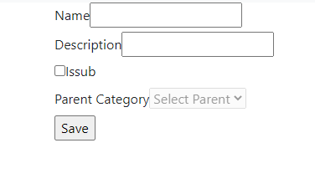
Provide information and click save button.
Thank you for reading my article.

How to add MatDialog in angular9
Step1 :
ng add @angular/material

npm i -save @angular/cdk
npm i --save @angular/animations
npm i --save hammerjs
ng g module Materials –flat
ng g c Components/orders/AddOrder --skipTests --flat --module=app.module --inline-style
step2: ng g c Components/orders/AddOrder --skipTests --flat --module=app.module --inline-style

Filter in Angular9

Search Filter in Angular 9

Step1: create filter using following command
ng g pipe cateName --skipTests --module=app.module
If more than one module in your project you have to specify module name using [--module=app.module] --module .
Step2:Write following code in cateName pipe
import { Pipe, PipeTransform } from '@angular/core';

@Pipe({
name: 'cateName'
})
export class CateNamePipe implements PipeTransform {

transform(value: any, args: string): [] {
if(args)
{
args=args.toLowerCase();
return value.filter(function(el:any){
console.log(el)
return el.Name.toLowerCase().indexOf(args)>-1

})
}
return value;
}

}
Step3: write following html
<input type="text" [(ngModel)]="queryString" id="search" placeholder="category name">

<table border="2">
<thead>
<tr>
<td>Name</td>
<td>Description</td>
<td>
<a routerLink="add" >Add</a>
</td>
</tr>
<tr *ngFor="let c of categoryList | cateName:queryString">
<td>
{{c.Name | uppercase}}
</td>
<td>
{{c.Description}}
</td>
<td>
<a routerLink="edit/{{c.Id}}" >
<i class="fa fa-pencil"></i>
Edit</a>||
<a (click)="delete(c.Id)">Delete</a>
</td>
</tr>
</thead>
</table>
Step4: Write following code in Component.ts file
import { Component, OnInit } from '@angular/core';
import { Category } from 'src/app/Models/category.model';
import { CategorySService } from 'src/app/Services/category-s.service';

@Component({
selector: 'app-categories',
templateUrl: './categories.component.html',
styleUrls: ['./categories.component.css']
})
export class CategoriesComponent implements OnInit {
categoryList;
queryString
constructor(public service:CategorySService) { }

ngOnInit(): void {
this.loadCategory();
}
loadCategory(){
this.service.getAll().subscribe(s=>{
this.categoryList=s;
})

}

}

Step5: Run application using following command
Ng serve –o

Display item according to user choice using Angular Slice Pipe

The SlicePipe is Angular CommonModule API. Slice pipe slices a given array or string into subsets. We need to provide start and end index. The SlicePipe uses slice keyword with pipe operator. The SlicePipe uses JavaScript API Array.prototype.slice() and String.prototype.slice() to perform its task. On this page we will provide slice pipe example using array and string expression separately. We will discuss start and end index taking positive and negative values both. Now find the complete example step-by-step.
Details : https://www.concretepage.com/angular-2/angular-2-slice-pipe-example

Step1: : Following code in ts file
import { Component, OnInit } from '@angular/core';
import { Category } from 'src/app/Models/category.model';
import { CategorySService } from 'src/app/Services/category-s.service';

@Component({
selector: 'app-categories',
templateUrl: './categories.component.html',
styleUrls: ['./categories.component.css']
})
export class CategoriesComponent implements OnInit {
categoryList;
itemCount;
queryString
constructor(public service:CategorySService) { }

ngOnInit(): void {
this.loadCategory();
}
loadCategory(){
this.service.getAll().subscribe(s=>{
this.categoryList=s;
})

}
delete(id){
this.service.deleteOrder(id).subscribe(s=>{
console.log(s)
})
}
}

Step2: Following code in Html file
<input type="text" [(ngModel)]="queryString" id="search" placeholder="category name">
<br>
<div>
<label>Number of items:</label>
<select [value]="itemCount || 1" (change)="itemCount=$event.target.value">
<option *ngFor="let item of categoryList; let i = index" [value]="i + 1">
{{i + 1}}
</option>
</select>
</div>
<br/>

<table border="2">
<thead>
<tr>
<td>Name</td>
<td>Description</td>
<td>
<a routerLink="add" >Add</a>
</td>
</tr>
<!-- <tr *ngFor="let c of categoryList | cateName:queryString" -->
<tr *ngFor="let c of categoryList | slice :0 : (itemCount ||1) | cateName:queryString">
<td>
{{c.Name | uppercase}}
</td>
<td>
{{c.Description}}
</td>
<td>
<a routerLink="edit/{{c.Id}}" >
<i class="fa fa-pencil"></i>
Edit</a>||
<a (click)="delete(c.Id)">Delete</a>
</td>
</tr>
</thead>
</table>

Date Pipe in Angular 9
Step1: Take date type value in different format ,like
dateObject: Date = new Date(2020, 1, 20);
dateString: string = "2020-02-20T00:00:00.000Z";
dateNumber: number = 1582156800000;
convert this object,string and number type value in date in following way

<div class="bg-info p-2 text-white">
<div>Date formatted from object: {{ dateObject | date :"shortDate"}}</div>
<div>Date formatted from string: {{ dateString | date:"mediumDate" }}</div>
<div>Date formatted from number: {{ dateNumber | date :"longDate"}}</div>
<div>Date formatted from number: {{ dateNumber | date :"shortDate"}}</div>

</div>

Calculate vat or Tax using custom pipe in Angular 9
Step1: Create pipe using following command
Ng g pipe Addtax
Step2 : Write following code in Addtax.pipe.ts file
import { Pipe, PipeTransform } from '@angular/core';

@Pipe({
name: 'addTax'
})
export class AddTaxPipe implements PipeTransform {
defaultRate: number = 10;
transform(value: any, rate?: any): number {
let valueNumber = Number.parseFloat(value);
let rateNumber = rate == undefined ?
this.defaultRate : Number.parseInt(rate);
return valueNumber - (valueNumber * (rateNumber / 100));
}

}

Step3: Implement AddTax pipe in Html file in following way
{{e.salary| addTax:(taxRate||0) | currency :"USD" : "symbol"}}

