10-16-19 exploratory analysis

Megan Beaudry

10/8/2019

# Exploratory Analysis

##Prelimnary Loading Load clean data

clean_water_quality_data <- readRDS("../../data/processed_data/clean_water_quality_data.rds")

Load libraries

library(ggplot2)  
library(ggthemes)  
library(RColorBrewer)  
library(dplyr)

##   
## Attaching package: 'dplyr'

## The following objects are masked from 'package:stats':  
##   
## filter, lag

## The following objects are masked from 'package:base':  
##   
## intersect, setdiff, setequal, union

##Exploratory Analysis - Summary Statistics

summary(clean_water_quality_data$Rainfall)

## Length Class Mode   
## 533 character character

summary(clean_water_quality_data$HF183)

## Min. 1st Qu. Median Mean 3rd Qu. Max.   
## 3.263 3.330 3.330 3.492 3.632 6.038

summary(clean_water_quality_data$HumM2)

## Min. 1st Qu. Median Mean 3rd Qu. Max.   
## 3.336 3.847 3.847 3.870 3.847 5.057

summary(clean_water_quality_data$CG01)

## Min. 1st Qu. Median Mean 3rd Qu. Max.   
## 3.109 3.109 3.109 3.125 3.109 4.871

summary(clean_water_quality_data$LeeSg)

## Min. 1st Qu. Median Mean 3rd Qu. Max.   
## 3.284 3.284 3.284 3.330 3.284 4.709

summary(clean_water_quality_data$Dog3)

## Min. 1st Qu. Median Mean 3rd Qu. Max.   
## 3.157 3.157 3.157 3.169 3.157 4.547

summary(clean_water_quality_data$MuBac)

## Min. 1st Qu. Median Mean 3rd Qu. Max.   
## 3.378 3.555 3.555 3.559 3.555 4.366

summary(clean_water_quality_data$Rum2Bac)

## Min. 1st Qu. Median Mean 3rd Qu. Max.   
## 3.255 3.457 3.457 3.464 3.457 5.231

summary(clean_water_quality_data$A_butlzeri_HSP60)

## Length Class Mode   
## 0 NULL NULL

summary(clean_water_quality_data$Salmonella_spp_InvA)

## Min. 1st Qu. Median Mean 3rd Qu. Max.   
## 3.171 3.171 3.171 3.173 3.171 3.472

summary(clean_water_quality_data$Campylobacter_spp_Van_Dkye)

## Min. 1st Qu. Median Mean 3rd Qu. Max.   
## 3.487 3.555 3.555 3.571 3.555 4.369

summary(clean_water_quality_data$Enterococcus_CCE)

## Min. 1st Qu. Median Mean 3rd Qu. Max. NA's   
## 0.6021 2.0774 2.4297 2.6199 2.8797 52.1365 2

summary(clean_water_quality_data$total_coliforms)

## Min. 1st Qu. Median Mean 3rd Qu. Max. NA's   
## 1.255 2.862 3.384 3.067 3.384 3.384 61

summary(clean_water_quality_data$E_coli)

## Min. 1st Qu. Median Mean 3rd Qu. Max. NA's   
## 0.0000 0.6021 1.2788 1.3119 1.8736 3.3837 3

summary(clean_water_quality_data$Enteroalert)

## Length Class Mode   
## 533 character character

summary(clean_water_quality_data$thermotolerant_coliforms)

## Min. 1st Qu. Median Mean 3rd Qu. Max. NA's   
## 0.0000 0.9542 1.3010 1.5138 2.0000 2.9375 1

##Exploratory Analysis - Temporal Trends

*Temporal Trends All Pond Comparison* Comparison with traditional water quality indicators and Arco. I am really unhappy with this figure. I need to brainstorm a better way to represent data

ggplot(clean_water_quality_data) +   
 geom_line(mapping = aes(x = Date_Sampled, y = A_butzleri_HSP60), color = "navy") +  
 geom_bar(mapping = aes(x = Date_Sampled, y = Enterococcus_CCE), color = "purple", stat = "identity") +   
 ylab("CCE")

## Warning: Removed 2 rows containing missing values (position_stack).

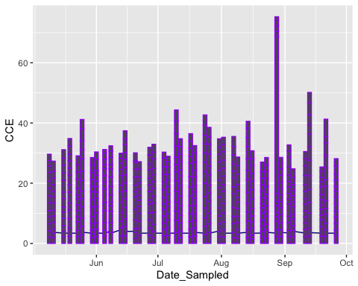

ggplot(clean_water_quality_data) +   
 geom_line(mapping = aes(x = Date_Sampled, y = A_butzleri_HSP60), color = "navy") +  
 ylab(expression("Log10_copies/100mL"))

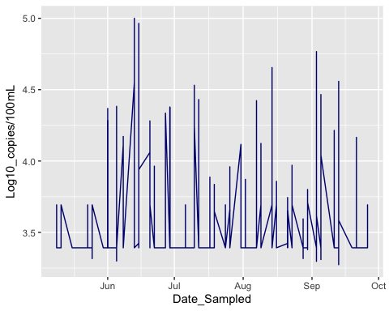

ggplot(clean_water_quality_data) +  
 geom_bar(mapping = aes(x = Date_Sampled, y = Enterococcus_CCE), color = "purple", stat = "identity") +   
 ylab("CCE")

## Warning: Removed 2 rows containing missing values (position_stack).

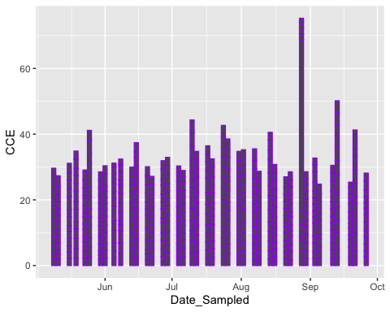

The temporal trends by pond of HF183, HumM2 & A. butzleri to see if there was a relationship between source and pathogen

All_Human_Arco <- ggplot(clean_water_quality_data) +  
 geom_line(mapping = aes(x = Date_Sampled, y = HF183), color = "dark green") +  
 geom_line(mapping = aes(x = Date_Sampled, y = HumM2), color = "purple") +  
 geom_line(mapping = aes(x = Date_Sampled, y = A_butzleri_HSP60), color = "navy") +  
 geom_point(mapping = aes(x = Date_Sampled, y = A_butzleri_HSP60), color = "navy") +  
 geom_point(mapping = aes(x = Date_Sampled, y = HF183), color = "dark green") +  
 geom_point(mapping = aes(x = Date_Sampled, y = HumM2), color = "purple") +  
 labs (x = "Date Sampled", y = "Log10 Copies/100mL") +  
 facet_wrap(~ Pond) +  
 geom_hline(yintercept = 3.67, colour = "dark green", linetype = "dotted") +  
 geom_hline(yintercept = 4.14, colour = "purple", linetype = "dotted") +   
 geom_hline(yintercept = 3.69, colour = "navy", linetype = "dotted") +  
 theme_bw()  
All_Human_Arco

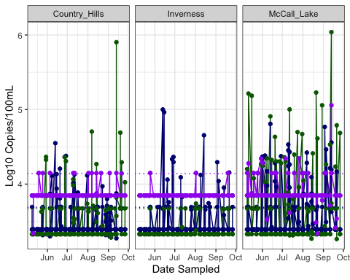

ggsave(filename = "../../results/All_Human_Arco.png",plot = All_Human_Arco)

## Saving 5 x 4 in image

All_rain_Arco <- ggplot(clean_water_quality_data) +  
 geom_line(mapping = aes(x = Date_Sampled, y = Rainfall), color = "dark green") +  
 geom_line(mapping = aes(x = Date_Sampled, y = A_butzleri_HSP60), color = "navy") +  
 labs (x = "Date Sampled", y = "Log10 Copies/100mL") +  
 facet_wrap(~ Pond) +  
 geom_hline(yintercept = 3.69, colour = "navy", linetype = "dotted") +  
 theme_bw()  
All_rain_Arco

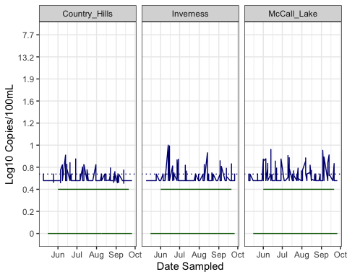

ggsave(filename = "../../results/All_rain_Arco.png",plot = All_rain_Arco)

## Saving 5 x 4 in image

*Temporal Trends grouped by Pond and Source* Temporal trend of each pond individually with pathogen and source

Part 1: Human and Arco

McCall_Human_Arco <- clean_water_quality_data %>%  
 filter(Pond == "McCall_Lake") %>%  
 ggplot() +  
 geom_line(mapping = aes(x = Date_Sampled, y = HF183), color = "dark green") +  
 geom_line(mapping = aes(x = Date_Sampled, y = HumM2), color = "purple") +  
 geom_line(mapping = aes(x = Date_Sampled, y = A_butzleri_HSP60), color = "navy") +  
 geom_hline(yintercept = 3.67, colour = "dark green", linetype = "dotted") +  
 geom_hline(yintercept = 4.14, colour = "purple", linetype = "dotted") +   
 geom_hline(yintercept = 3.69, colour = "navy", linetype = "dotted") +  
 geom_point(mapping = aes(x = Date_Sampled, y = A_butzleri_HSP60), color = "navy") +  
 geom_point(mapping = aes(x = Date_Sampled, y = HF183), color = "dark green") +  
 geom_point(mapping = aes(x = Date_Sampled, y = HumM2), color = "purple") +  
 labs (x = "Date Sampled", y = "Log10 Copies/100mL") +  
 theme_bw()  
McCall_Human_Arco

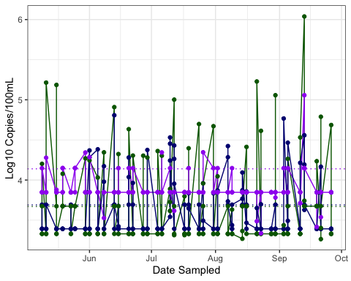

ggsave(filename = "../../results/McCall_Human_Arco.png",plot = McCall_Human_Arco)

## Saving 5 x 4 in image

All pathogens in McCall

McCall_Pathogens <- clean_water_quality_data %>%  
 filter(Pond == "McCall_Lake") %>%  
 ggplot() +  
 geom_line(mapping = aes(x = Date_Sampled, y = Campylobacter_spp_Van_Dkye), color = "dark green") +  
 geom_line(mapping = aes(x = Date_Sampled, y = Salmonella_spp_InvA), color = "purple") +  
 geom_line(mapping = aes(x = Date_Sampled, y = A_butzleri_HSP60), color = "navy") +  
 geom_hline(yintercept = 11.96, colour = "dark green", linetype = "dotted") +  
 geom_hline(yintercept = 4.14, colour = "purple", linetype = "dotted") +   
 geom_hline(yintercept = 3.69, colour = "navy", linetype = "dotted") +  
 geom_point(mapping = aes(x = Date_Sampled, y = A_butzleri_HSP60), color = "navy") +  
 geom_point(mapping = aes(x = Date_Sampled, y = Campylobacter_spp_Van_Dkye), color = "dark green") +  
 geom_point(mapping = aes(x = Date_Sampled, y = Salmonella_spp_InvA), color = "purple") +  
 labs (x = "Date Sampled", y = "Log10 Copies/100mL") +  
 theme_bw()  
McCall_Pathogens

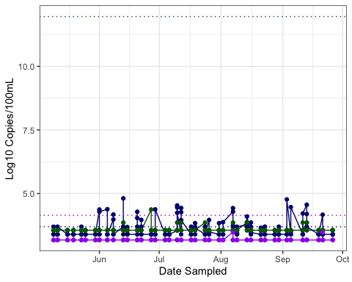

ggsave(filename = "../../results/McCall_Pathogens.png",plot = McCall_Pathogens)

## Saving 5 x 4 in image

Took out Salmonella because we didnt find any…However THIS graph looks horrible becasue the LOD for campy is so high compared to the others (i.e., 11 to 3.5 on average). I need to come up with a better to show this if i want to show it. It really is a negative result, as we did not find much Campylobacter spp. However, they are highly related bacteria so some kind of relationship would be nice to show…

McCall_Camp_Arco <- clean_water_quality_data %>%  
 filter(Pond == "McCall_Lake") %>%  
 ggplot() +  
 geom_line(mapping = aes(x = Date_Sampled, y = Campylobacter_spp_Van_Dkye), color = "dark green") +  
 geom_line(mapping = aes(x = Date_Sampled, y = A_butzleri_HSP60), color = "navy") +  
 geom_hline(yintercept = 11.96, colour = "dark green", linetype = "dotted") +  
 geom_hline(yintercept = 3.69, colour = "navy", linetype = "dotted") +  
 geom_point(mapping = aes(x = Date_Sampled, y = A_butzleri_HSP60), color = "navy") +  
 geom_point(mapping = aes(x = Date_Sampled, y = Campylobacter_spp_Van_Dkye), color = "dark green") +  
 labs (x = "Date Sampled", y = "Log10 Copies/100mL") +  
 theme_bw()  
McCall_Camp_Arco

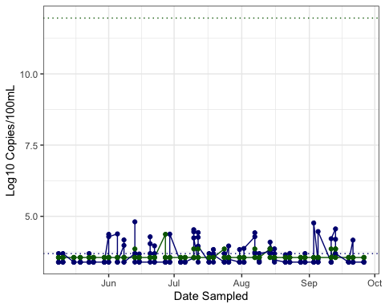

ggsave(filename = "../../results/McCall_Camp_arco.png",plot = McCall_Camp_Arco)

## Saving 5 x 4 in image

Country_Hills_Hum_Arco<- clean_water_quality_data %>%  
 filter(Pond == "Country_Hills") %>%  
 ggplot() +  
 geom_line(mapping = aes(x = Date_Sampled, y = HF183), color = "dark green") +  
 geom_line(mapping = aes(x = Date_Sampled, y = HumM2), color = "purple") +  
 geom_line(mapping = aes(x = Date_Sampled, y = A_butzleri_HSP60), color = "navy") +  
 geom_hline(yintercept = 3.67, colour = "dark green", linetype = "dotted") +  
 geom_hline(yintercept = 4.14, colour = "purple", linetype = "dotted") +   
 geom_hline(yintercept = 3.69, colour = "navy", linetype = "dotted") +  
 geom_point(mapping = aes(x = Date_Sampled, y = A_butzleri_HSP60), color = "navy") +  
 geom_point(mapping = aes(x = Date_Sampled, y = HF183), color = "dark green") +  
 geom_point(mapping = aes(x = Date_Sampled, y = HumM2), color = "purple") +  
 labs (x = "Date Sampled", y = "Log10 Copies/100mL") +  
 theme_bw()  
Country_Hills_Hum_Arco

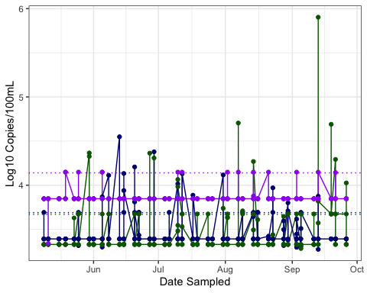

ggsave(filename = "../../results/Country_Hills_Hum_Arco.png",plot = Country_Hills_Hum_Arco)

## Saving 5 x 4 in image

Inverness_Hum_Arco <- clean_water_quality_data %>%  
 filter(Pond == "Inverness") %>%  
 ggplot() +  
 geom_line(mapping = aes(x = Date_Sampled, y = HF183), color = "dark green") +  
 geom_line(mapping = aes(x = Date_Sampled, y = HumM2), color = "purple") +  
 geom_line(mapping = aes(x = Date_Sampled, y = A_butzleri_HSP60), color = "navy") +  
 geom_hline(yintercept = 3.67, colour = "dark green", linetype = "dotted") +  
 geom_hline(yintercept = 4.14, colour = "purple", linetype = "dotted") +   
 geom_hline(yintercept = 3.69, colour = "navy", linetype = "dotted") +  
 geom_point(mapping = aes(x = Date_Sampled, y = A_butzleri_HSP60), color = "navy") +  
 geom_point(mapping = aes(x = Date_Sampled, y = HF183), color = "dark green") +  
 geom_point(mapping = aes(x = Date_Sampled, y = HumM2), color = "purple") +  
 labs (x = "Date Sampled", y = "Log10 Copies/100mL") +  
 theme_bw()  
Inverness_Hum_Arco

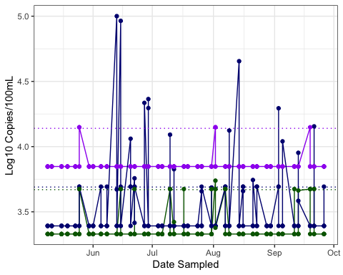

ggsave(filename = "../../results/Inverness_Hum_Arco.png",plot = Inverness_Hum_Arco)

## Saving 5 x 4 in image

Part 2: Birds and Arco

Inverness_Bird_Arco <- clean_water_quality_data %>%  
 filter(Pond == "Inverness") %>%  
 ggplot() +  
 geom_line(mapping = aes(x = Date_Sampled, y = CG01), color = "dark green") +  
 geom_line(mapping = aes(x = Date_Sampled, y = LeeSg), color = "purple") +  
 geom_line(mapping = aes(x = Date_Sampled, y = A_butzleri_HSP60), color = "navy") +  
 geom_hline(yintercept = 3.4, colour = "dark green", linetype = "dotted") +  
 geom_hline(yintercept = 3.58, colour = "purple", linetype = "dotted") +   
 geom_hline(yintercept = 3.69, colour = "navy", linetype = "dotted") +  
 geom_point(mapping = aes(x = Date_Sampled, y = A_butzleri_HSP60), color = "navy") +  
 geom_point(mapping = aes(x = Date_Sampled, y = CG01), color = "dark green") +  
 geom_point(mapping = aes(x = Date_Sampled, y = LeeSg), color = "purple") +  
 labs (x = "Date Sampled", y = "Log10 Copies/100mL") +  
 theme_bw()  
Inverness_Bird_Arco

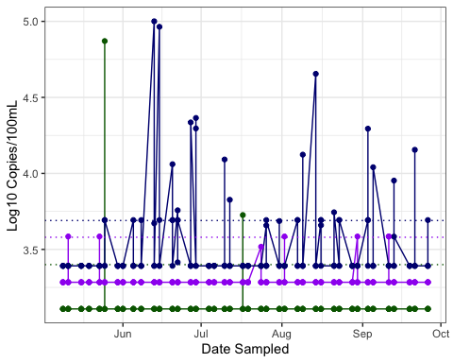

ggsave(filename = "../../results/Inverness_Bird_Arco.png",plot = Inverness_Bird_Arco)

## Saving 5 x 4 in image

McCall_Bird_Arco <- clean_water_quality_data %>%  
 filter(Pond == "McCall_Lake") %>%  
 ggplot() +  
 geom_line(mapping = aes(x = Date_Sampled, y = CG01), color = "dark green") +  
 geom_line(mapping = aes(x = Date_Sampled, y = LeeSg), color = "purple") +  
 geom_line(mapping = aes(x = Date_Sampled, y = A_butzleri_HSP60), color = "navy") +  
 geom_hline(yintercept = 3.4, colour = "dark green", linetype = "dotted") +  
 geom_hline(yintercept = 3.58, colour = "purple", linetype = "dotted") +   
 geom_hline(yintercept = 3.69, colour = "navy", linetype = "dotted") +  
 geom_point(mapping = aes(x = Date_Sampled, y = A_butzleri_HSP60), color = "navy") +  
 geom_point(mapping = aes(x = Date_Sampled, y = CG01), color = "dark green") +  
 geom_point(mapping = aes(x = Date_Sampled, y = LeeSg), color = "purple") +  
 labs (x = "Date Sampled", y = "Log10 Copies/100mL") +  
 theme_bw()  
McCall_Bird_Arco

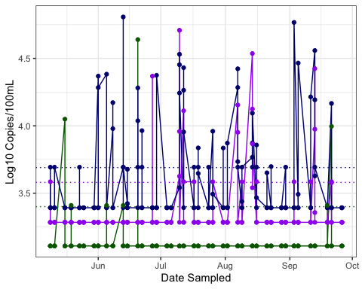

ggsave(filename = "../../results/McCall_Bird_Arco.png",plot = McCall_Bird_Arco)

## Saving 5 x 4 in image

Country_Hills_Bird_Arco <- clean_water_quality_data %>%  
 filter(Pond == "Country_Hills") %>%  
 ggplot() +  
 geom_line(mapping = aes(x = Date_Sampled, y = CG01), color = "dark green") +  
 geom_line(mapping = aes(x = Date_Sampled, y = LeeSg), color = "purple") +  
 geom_line(mapping = aes(x = Date_Sampled, y = A_butzleri_HSP60), color = "navy") +  
 geom_hline(yintercept = 3.4, colour = "dark green", linetype = "dotted") +  
 geom_hline(yintercept = 3.58, colour = "purple", linetype = "dotted") +   
 geom_hline(yintercept = 3.69, colour = "navy", linetype = "dotted") +  
 geom_point(mapping = aes(x = Date_Sampled, y = A_butzleri_HSP60), color = "navy") +  
 geom_point(mapping = aes(x = Date_Sampled, y = CG01), color = "dark green") +  
 geom_point(mapping = aes(x = Date_Sampled, y = LeeSg), color = "purple") +  
 labs (x = "Date Sampled", y = "Log10 Copies/100mL") +  
 theme_bw()  
Country_Hills_Bird_Arco

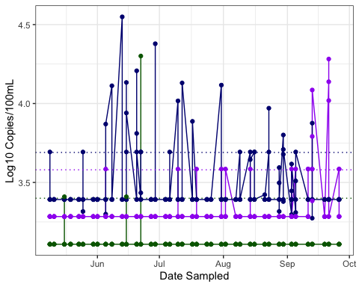

ggsave(filename = "../../results/Country_Hills_Bird_Arco.png", plot = Country_Hills_Bird_Arco)

## Saving 5 x 4 in image

*Temporal Trends One Marker Per Pond*

McCall_HF183 <- clean_water_quality_data %>%  
 filter(Pond == "McCall_Lake") %>%  
 ggplot() +  
 geom_line(mapping = aes(x = Date_Sampled, y = HF183), color = "dark green") +  
 geom_point(mapping = aes(x = Date_Sampled, y = HF183), color = "dark green") +   
 labs (x = "Date Sampled", y = "Log10 Copies/100mL") +  
 geom_hline(yintercept = 3.67, colour = "black", linetype = "dotted") +  
 theme_bw() +  
 scale_color_discrete(name = "Legend", labels = c("HF183", "LOD95"))  
McCall_HF183

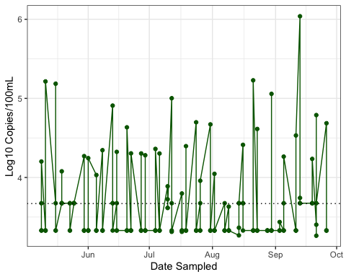

ggsave(filename = "../../results/McCall_HF183.png", plot = McCall_HF183)

## Saving 5 x 4 in image

##Exploratory Analysis - Box and Whisker Plots Boxplot of HF183 on all ponds

All_Box_HF183 <- ggplot(data = clean_water_quality_data, aes(x = "", y = HF183)) +   
 geom_boxplot() +  
 facet_wrap(~ Pond) +  
 theme_bw() +   
 labs (x = "HF183", y = "Log10 Copies/100mL")  
All_Box_HF183

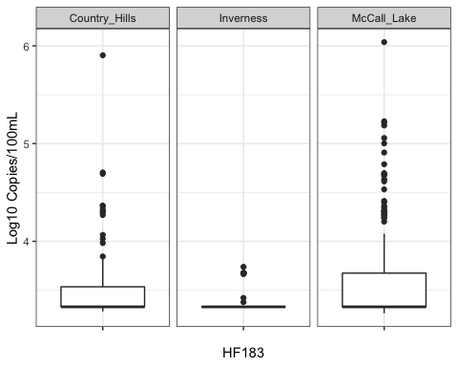

ggsave(filename = "../../results/All_Box_HF183.png", plot = All_Box_HF183)

## Saving 5 x 4 in image

Since McCall Lake has the most interesting data, lets look at the sampling sites within McCall Lake to see if one site has a higher median (is more contaminated)

McCall_bysite_box_HF183 <- clean_water_quality_data %>%  
 filter(Pond == "McCall_Lake") %>%  
 ggplot(aes(x = "", y = HF183)) +   
 geom_boxplot() +  
 coord_cartesian(ylim = c(0, 6)) +  
 facet_wrap(~ Sampling_Site) +  
 theme_bw() +  
 labs (x = "HF183", y = "Log10 Copies/100mL")  
McCall_bysite_box_HF183

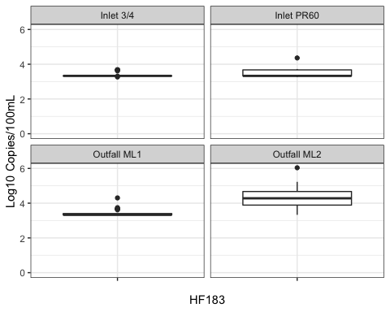

ggsave(filename = "../../results/McCall_bysite_box_HF183.png", plot = McCall_bysite_box_HF183)

## Saving 5 x 4 in image

##Explatory Analysis - Violin Plots The water quality data measured through molecular methods (i.e., Enterococcus CCE as determined by EPA Method 1611) would be best visualized using a violin plot

McCall_Enterococcus_CCE_Violin <- clean_water_quality_data %>%  
 filter(Pond == "McCall_Lake") %>%  
 ggplot(aes(x = "", y = Enterococcus_CCE)) +   
 geom_violin() +  
 geom_boxplot(width=0.1) +  
 coord_cartesian(ylim = c(0, 6)) +  
 facet_wrap(~ Sampling_Site) +  
 theme_bw() +  
 labs (x = "Enterococcus", y = "Log10 Copies/100mL")  
McCall_Enterococcus_CCE_Violin

## Warning: Removed 2 rows containing non-finite values (stat_ydensity).

## Warning: Removed 2 rows containing non-finite values (stat_boxplot).

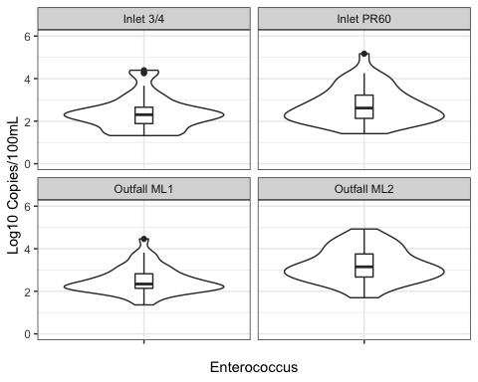

ggsave(filename = "../../results/McCall_Enterococcus_CCE_Violin.png", plot = McCall_Enterococcus_CCE_Violin)

## Saving 5 x 4 in image

## Warning: Removed 2 rows containing non-finite values (stat_ydensity).  
  
## Warning: Removed 2 rows containing non-finite values (stat_boxplot).

##Exploratory Analysis - Bar Charts How many samples are positive for shigatoxin 1

Shigatoxin1_bar <- clean_water_quality_data %>%  
 ggplot() +  
 geom_bar(aes(x = Shigatoxin_1), stat = "count", color = "magenta", fill = "white") +  
 labs(x = "Shiga Toxin 1", y = "Counts") +  
 theme(panel.background = element_rect(fill = "grey85"))  
Shigatoxin1_bar

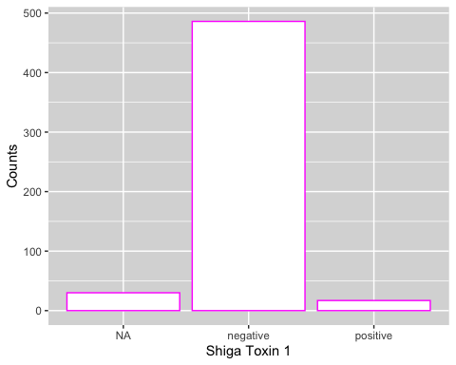

ggsave(filename = "../../results/Shigatoxin1_bar.png", plot = Shigatoxin1_bar)

## Saving 5 x 4 in image

How many samples are positive for shigatoxin 2

Shigatoxin2_bar <- clean_water_quality_data %>%  
 ggplot() +  
 geom_bar(aes(x = Shigatoxin_2), stat = "count", color = "yellow", fill = "white") +  
 labs(x = "Shiga Toxin 1", y = "Counts") +  
 theme(panel.background = element_rect(fill = "grey85"))  
Shigatoxin2_bar

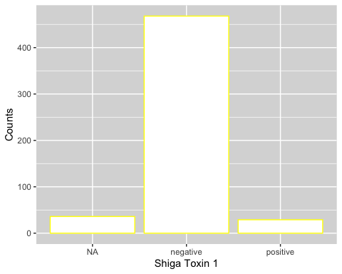

ggsave(filename = "../../results/Shigatoxin2_bar.png", plot = Shigatoxin2_bar)

## Saving 5 x 4 in image