Module: Machine Learning for Engineers
ASSESSMENT: ML-Based Visual Quality Inspection System

Claude Work Report

Section 1: Engineering Problem Definition
This project documents the work completed in defect_classification_stack on April 17, 2026 for an ML-based visual quality inspection task. The engineering problem is to inspect cup surfaces from a camera image and output a binary PASS/FAIL decision that could be used in an automated inspection cell.
- Engineering system: fixed-view camera, image preprocessing, classification model, final PASS/FAIL decision
- Input: one RGB image of a cup captured in a controlled inspection area
- Target output: PASS for non-defective cups and FAIL for defective cups
- Ground truth: manual labeling of visible surface condition into defective and non-defective classes
The problem is engineering-relevant because manual inspection is slow, inconsistent, and difficult to scale. A repeatable vision model can support faster rejection of visibly defective parts and create a consistent decision path for production screening. This report keeps the framing practical and cautious: it demonstrates a research-oriented inspection prototype rather than a fully validated factory deployment.
The model strategy was not to assume one architecture in advance. Instead, the work compared interpretable handcrafted-feature baselines, a rubric-aligned scratch CNN, optimiser studies, a tuned MLP, transfer-learning models, and a YOLO classification benchmark. This makes the final recommendation evidence-driven rather than preference-driven.

Section 2: Dataset Collection and Feature Representation
The workspace shows a cup-inspection dataset built from manually labeled camera images. The current raw folder at zeroq_cup_classification_scaffold/data/raw contains 87 defective images and 9 non-defective images. Those raw captures are the starting point, but the experiment results in this report were not all produced from the same downstream processed state. Augmentation, balancing, and later reruns created multiple dataset conditions inside the repository, so the report separates them explicitly.

2.1 Dataset states used in the workspace
Two different dataset states exist in the repository, and they should not be treated as the same experiment.

A. Balanced experiment snapshot used by the coherent iter1_*, iter2_*, and iter3_* runs
This dataset state is evidenced by defect_classification_stack/runs/data_balanced/dataset_metadata.json and matches the result files with class names defect and non_defect.
Split | Non-defect | Defect | Total
Train | 241 | 242 | 483
Validation | 35 | 34 | 69
Test | 69 | 69 | 138

This balanced snapshot is the authoritative basis for the main research progression in this report because it is the only dataset state that cleanly matches the iter1_*, iter2_mobilenet, and iter3_mobilenet_finetune result families.

B. Later processed rerun used by runs/sklearn_baseline
The current processed dataset under zeroq_cup_classification_scaffold/data/processed uses the class names defective and non_defective and is much more imbalanced.
Split | Non-defective | Defective | Total
Train | 248 | 2803 | 3051
Validation | 47 | 597 | 644
Test | 41 | 611 | 652

This later dataset state is important because it explains the apparently contradictory sklearn_baseline results: high accuracy but zero minority-class precision/recall/F1. Those rerun numbers do not belong in the same pooled comparison as the balanced iter1_* baseline results.

2.2 Raw and processed dataset locations
- Raw dataset path: zeroq_cup_classification_scaffold/data/raw
- Processed dataset path: zeroq_cup_classification_scaffold/data/processed
- Main research dataset snapshot evidence: defect_classification_stack/runs/data_balanced/dataset_metadata.json

2.3 Example PASS/FAIL samples
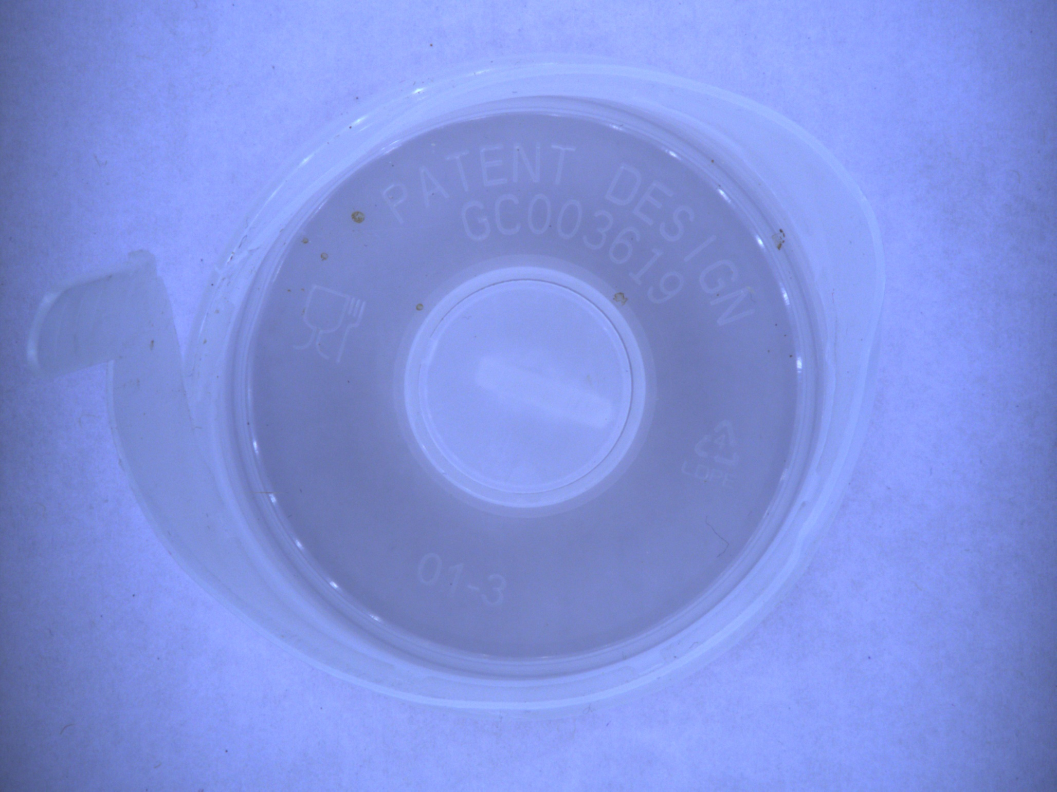
Figure 1. Example raw FAIL sample from the defective class.
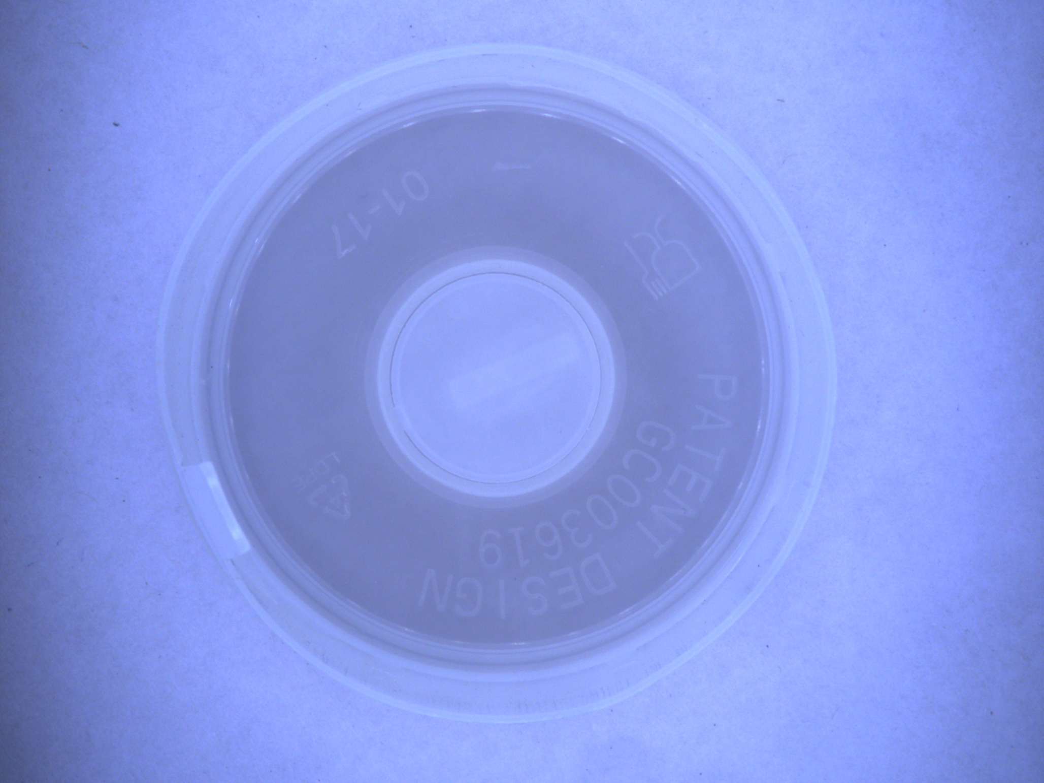
Figure 2. Example raw PASS sample from the non-defective class.

2.4 Feature representation and dimensionality
The codebase uses several feature representations depending on model family.
Model family | Representation | Dimensionality N | Interpretation
Classical HOG baselines | HOG on resized grayscale image | 8100 | Compact handcrafted texture/edge descriptor
Optimiser comparison MLP | HOG reduced with PCA | 20 | Very small feature vector used to make zero-order optimisation tractable
Scratch CNN / MobileNet | Raw RGB image | 224 x 224 x 3 = 150,528 | High-dimensional input learned directly from pixels
YOLO benchmark | Pretrained internal visual features | Internal | Feature extraction handled by pretrained backbone

The dimensionality matters for both model complexity and overfitting risk. HOG features are much smaller than raw-image tensors, so classical models are easier to train and interpret, but they may miss richer spatial structure. The PCA-reduced 20-dimensional input is intentionally tiny so Nelder-Mead can run on the same MLP architecture, but this also limits representational capacity. Raw-image CNN input is much richer, but it increases optimisation difficulty and overfitting risk when the dataset is small. This is exactly what appears in the results: the scratch CNN underperforms, while transfer learning with pretrained features improves performance substantially.
For the optimiser comparison, the PCA summary in runs/iter1_optimizer/pca_info.json shows 20 retained components and about 58.34% total explained variance. That makes the optimiser study computationally feasible, but it is a deliberately compressed representation rather than the highest-information input.

Section 3: Neural Network Design and Optimisation
This section is best read as a research progression rather than a single final model selected from the start.

3.1 Classical HOG baselines on the balanced experiment snapshot
The main classical baselines were produced in runs/iter1_sklearn.
Baseline model | Accuracy | Precision | Recall | F1
HOG + SVM | 0.8478 | 0.8000 | 0.9275 | 0.8591
HOG + sklearn MLP | 0.8406 | 0.7831 | 0.9420 | 0.8553

These models provide a useful reference point. They are simpler than the deep models, rely on handcrafted features, and give respectable binary classification performance on the balanced experiment split.

3.2 Scratch CNN activation-function sweep
The rubric-required fully connected CNN was implemented in train_cnn_activation_sweep.py. The architecture uses:
- input image tensor 224 x 224 x 3
- three convolutional hidden blocks with channel widths 32 -> 64 -> 128
- batch normalization, max pooling, and dropout in each block
- dense head 128 -> 128 -> 1
Five activation functions were compared: ReLU, ELU, GELU, SELU, and LeakyReLU.
Scratch CNN variant | Accuracy | Precision | Recall | F1
ELU | 0.5942 | 0.5520 | 1.0000 | 0.7113
ReLU | 0.6739 | 0.6500 | 0.7536 | 0.6980
LeakyReLU | 0.5435 | 0.5227 | 1.0000 | 0.6866
GELU | 0.5145 | 0.5074 | 1.0000 | 0.6732
SELU | 0.5145 | 0.5074 | 1.0000 | 0.6732

ELU produced the best F1 among the scratch CNN runs, while ReLU produced the best accuracy. Even so, the overall scratch-CNN performance stayed below the stronger classical and transfer-learning models, which suggests that training a CNN from scratch on this scale of data is not the most effective use of model capacity.
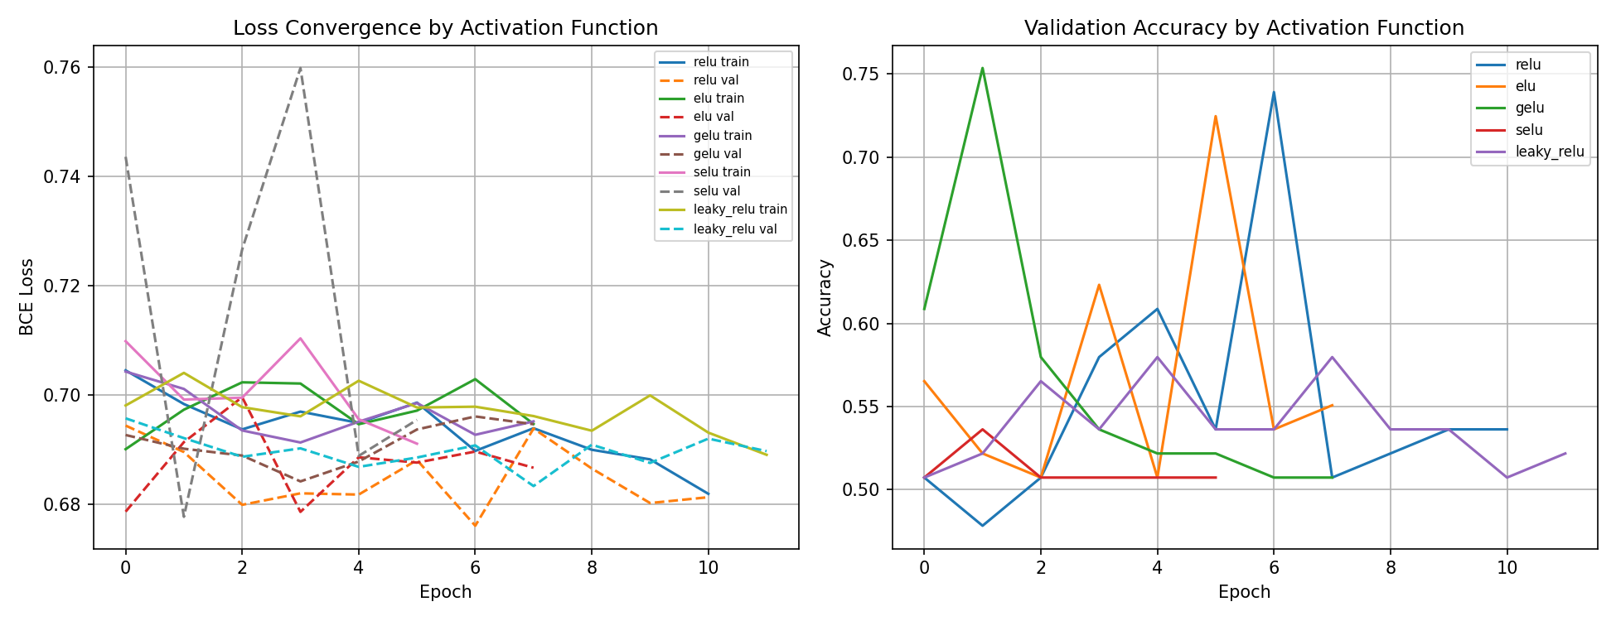
Figure 3. Convergence comparison for the scratch CNN activation sweep.

3.3 Optimiser comparison on the compact MLP
train_optimizer_comparison.py compared optimisers from three categories on the same small MLP with the architecture 20 -> 32 -> 16 -> 1.
- Zero-order: Nelder-Mead
- First-order: SGD and Adam
- Second-order: L-BFGS
Optimiser | Order | Accuracy | Precision | Recall | F1
Nelder-Mead | Zero-order | 0.4855 | 0.4915 | 0.8406 | 0.6203
SGD | First-order | 0.7826 | 0.7746 | 0.7971 | 0.7857
Adam | First-order | 0.8406 | 0.8406 | 0.8406 | 0.8406
L-BFGS | Second-order | 0.8188 | 0.8548 | 0.7681 | 0.8092

Adam gave the strongest overall result in this controlled optimiser study. L-BFGS was competitive and clearly stronger than Nelder-Mead, while the zero-order method struggled on this problem even after dimensionality reduction. This result supports the standard engineering intuition that gradient-based optimisation is more practical than derivative-free optimisation once the network still has a meaningful number of parameters.
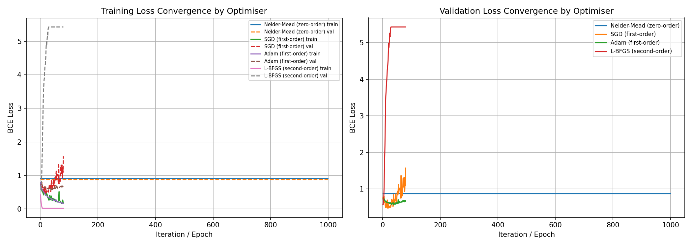
Figure 4. Training convergence across zero-order, first-order, and second-order optimisation methods.

3.4 PyTorch MLP random search
train_keras_mlp_random_search.py was repurposed into a PyTorch random-search experiment over hidden sizes, activation, dropout, and learning rate. The best stored hyperparameters were:
- hidden sizes: (256,)
- activation: elu
- dropout: 0.4
- learning rate: 0.001
The best random-search MLP reached:
- accuracy: 0.9420
- precision: 0.9178
- recall: 0.9710
- F1: 0.9437
This is a strong result because it beats both classical baselines and the scratch CNN without requiring transfer learning. It shows that careful tuning of a simpler network can still produce competitive performance on this task.

3.5 Transfer learning with MobileNetV2
train_cnn_pretrained.py introduced MobileNetV2 with a custom classification head and repeated the same five-activation comparison in two settings.

Frozen backbone
Frozen MobileNetV2 variant | Accuracy | Precision | Recall | F1
ELU | 0.8696 | 0.8228 | 0.9420 | 0.8784
GELU | 0.8696 | 0.8228 | 0.9420 | 0.8784
SELU | 0.8696 | 0.8228 | 0.9420 | 0.8784
LeakyReLU | 0.8696 | 0.8228 | 0.9420 | 0.8784
ReLU | 0.8623 | 0.8125 | 0.9420 | 0.8725

Fine-tuned backbone
Fine-tuned MobileNetV2 variant | Accuracy | Precision | Recall | F1
ELU | 0.9493 | 0.9079 | 1.0000 | 0.9517
LeakyReLU | 0.9420 | 0.8961 | 1.0000 | 0.9452
GELU | 0.9420 | 0.9296 | 0.9565 | 0.9429
SELU | 0.9348 | 0.8846 | 1.0000 | 0.9388
ReLU | 0.9275 | 0.8933 | 0.9710 | 0.9306

Fine-tuning clearly improved the transfer-learning model over the frozen setting. The best non-YOLO result in the new stack is mobilenet_elu, with 94.93% accuracy and 95.17% F1 on the balanced test set. Its saved classification report shows very strong class balance:
- defect: precision 1.0000, recall 0.8986, F1 0.9466
- non_defect: precision 0.9079, recall 1.0000, F1 0.9517
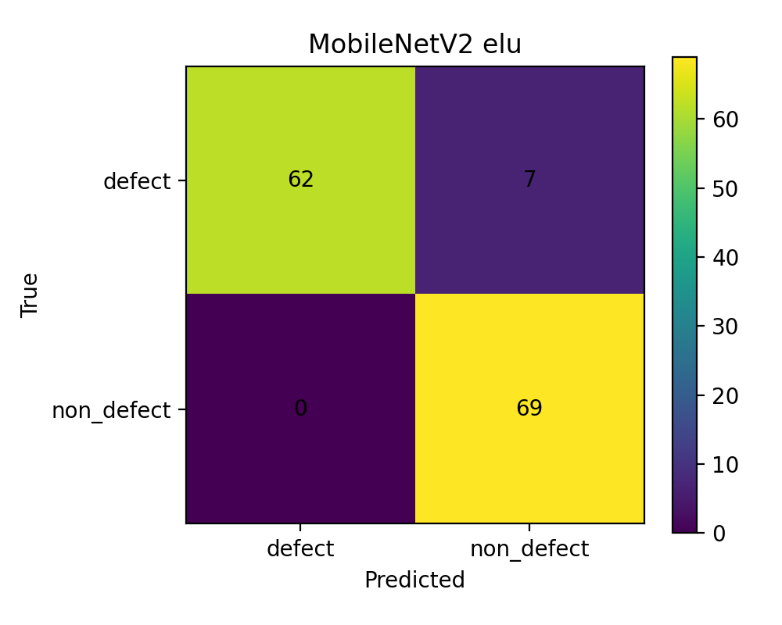
Figure 5. Confusion matrix for the strongest fully documented deep model in the new stack.

3.6 YOLO benchmark
train_yolo26_cls.py also evaluated a pretrained YOLO26n classification model. The stored summary reports:
- top-1 accuracy: 0.9855
- top-5 accuracy: 1.0000
- fitness: 0.9928
This is the strongest headline result in the available saved artefacts. However, the saved YOLO summary does not include the same full binary precision/recall/F1 report that exists for the other model families. In runs/final_report/all_results.csv, the aggregate script mirrors YOLO top-1 into the f1 column so that it can appear in the same ranking chart. That makes YOLO the strongest headline result, but it should be read as a stored top-1 benchmark rather than a directly equivalent per-class F1 report.

3.7 Aggregate ranking
The final aggregate comparison in runs/final_report/all_results.csv ranks the best saved experiments as follows:
Family | Best saved model | Main reported value | Notes
YOLO benchmark | yolo26n_cls | top-1 accuracy 0.9855 | strongest headline result, but not a full saved binary report
Fine-tuned transfer learning | mobilenet_elu | F1 0.9517 | best fully documented non-YOLO deep model
Tuned MLP | mlp_random_search | F1 0.9437 | strong result without transfer learning
Frozen transfer learning | mobilenet_elu | F1 0.8784 | good uplift over scratch CNN
Classical baseline | hog_svm | F1 0.8591 | best classical model on balanced snapshot
Optimiser study | optim_adam | F1 0.8406 | best optimiser comparison result
Scratch CNN | cnn_elu | F1 0.7113 | rubric-aligned CNN but weakest deep approach

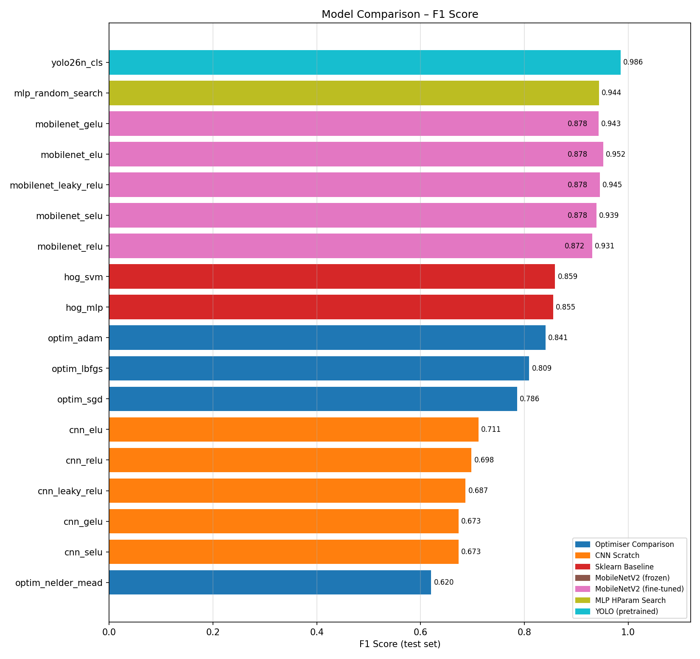
Figure 6. Consolidated ranking across the main saved model families.

Section 4: Baseline Comparison

4.1 Main classical baseline comparison aligned with the balanced experiment series
The classical baselines that should be used for direct comparison with the deep models are the iter1_sklearn results because they match the balanced defect/non_defect experiment family.
Model | Accuracy | Precision | Recall | F1 | Interpretation
HOG + SVM | 0.8478 | 0.8000 | 0.9275 | 0.8591 | strongest classical baseline
HOG + sklearn MLP | 0.8406 | 0.7831 | 0.9420 | 0.8553 | comparable but slightly below SVM

These baselines generalise reasonably well on the balanced test set and create a useful reference for the gains delivered by transfer learning and the tuned MLP.

4.2 Later inconsistent rerun in runs/sklearn_baseline
The repository also contains a later rerun of the sklearn baselines in runs/sklearn_baseline.
Later rerun model | Accuracy | Precision | Recall | F1 | Why this is misleading alone
HOG + SVM | 0.9371 | 0.0000 | 0.0000 | 0.0000 | high accuracy driven by majority class dominance
HOG + sklearn MLP | 0.9356 | 0.0000 | 0.0000 | 0.0000 | same issue; minority class is not being recovered

This inconsistency is explainable from the dataset state, not from the model family itself:
- iter1_* uses balanced defect/non_defect data with 69 / 69 test support
- sklearn_baseline uses defective/non_defective data with a heavily imbalanced test set of 611 defective / 41 non_defective
- the class names also changed between these dataset states
- therefore the rerun should be read as a separate dataset condition rather than a directly comparable baseline refresh
In practical terms, the later rerun shows why accuracy alone is not enough in quality-inspection work. A classifier can look strong on headline accuracy while still failing to recover the minority class correctly.

Section 5: Experimental Rigor

5.1 Train/validation/test split
The main coherent experiment series uses the balanced split recorded in runs/data_balanced/dataset_metadata.json:
- train: 241 non_defect / 242 defect
- validation: 35 non_defect / 34 defect
- test: 69 non_defect / 69 defect
This split is the cleanest basis for comparing model families because it prevents the large class imbalance seen in the later rerun from dominating the interpretation.

5.2 Cross-validation
train_cross_validation.py applied stratified 5-fold cross-validation to pooled train+validation data from the balanced experiment family and then kept the test set held out for final evaluation.
Cross-validation mean results from runs/iter1_crossval/cv_combined.csv:
Model | Mean train accuracy | Mean validation accuracy | Mean validation F1 | Mean overfit gap
HOG + SVM CV | 0.9769 | 0.7537 | 0.7804 | 0.2232
HOG + MLP CV | 0.9774 | 0.7900 | 0.8044 | 0.1874

These numbers show that both models fit the training folds strongly, but the validation scores drop noticeably, which indicates real overfitting pressure. The MLP baseline generalises slightly more consistently than the SVM in this cross-validation study because it has both higher mean validation accuracy/F1 and a smaller average overfit gap.
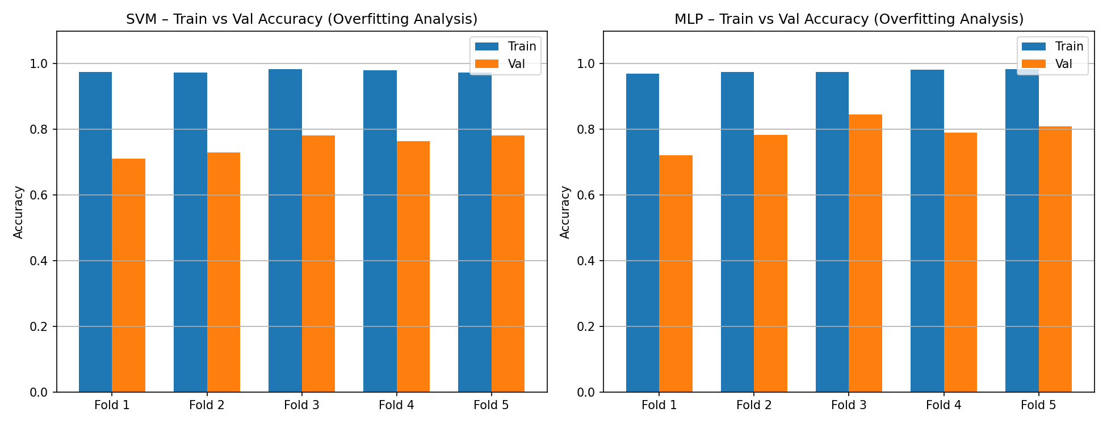
Figure 7. Train-versus-validation performance gap across folds.

5.3 Overfitting analysis
The overfitting evidence appears in three ways:
- the scratch CNN performs much worse than the stronger transfer-learning models, which suggests insufficient data for training a deep model from scratch
- cross-validation gaps remain non-trivial for both classical models
- transfer learning produces a large improvement over the scratch CNN, which is consistent with better prior feature reuse and lower effective data demand
Taken together, the experiments show that model capacity must be matched carefully to dataset scale. The most reliable improvement in this repo comes not from making the scratch network larger, but from using better features and better initialisation.

Live Demonstration Note
The current April 17 work is mainly model-development and evaluation work. Demonstration support scripts already exist in the older scaffold, especially:
- zeroq_cup_classification_scaffold/scripts/infer_yolo26_cls.py
- zeroq_cup_classification_scaffold/scripts/infer_yolo26_cls_stream.py
Those scripts are relevant for a future live demo, but the new stack documented here is primarily an experiment and comparison package. A stronger final submission would add direct evidence of the current capture setup, a short scripted demo path on unseen samples, and saved examples of live PASS/FAIL decisions.

Conclusion
Claude's work in defect_classification_stack should be understood as a structured research progression rather than a single isolated model run. The project now contains:
- classical HOG baselines for interpretability
- a rubric-aligned scratch CNN with activation comparisons
- a direct optimiser comparison covering zero-order, first-order, and second-order methods
- a tuned PyTorch MLP
- frozen and fine-tuned MobileNetV2 transfer-learning sweeps
- a YOLO classification benchmark
- a final aggregate ranking across saved results
The main conclusion is:
- strongest overall headline result: yolo26n_cls with stored top-1 accuracy 0.9855
- strongest fully documented non-YOLO model: fine-tuned mobilenet_elu with accuracy 0.9493 and F1 0.9517
- strongest classical baseline: hog_svm with F1 0.8591
For a final assessment submission, the best engineering recommendation is to present all of these experiments as a clear research progression and then advocate the best result at the end. If the emphasis is on the single strongest stored headline metric, that is YOLO. If the emphasis is on the strongest non-YOLO model with a fully saved binary classification report, that is fine-tuned MobileNetV2 with ELU.

