**Drops for Ceilings**



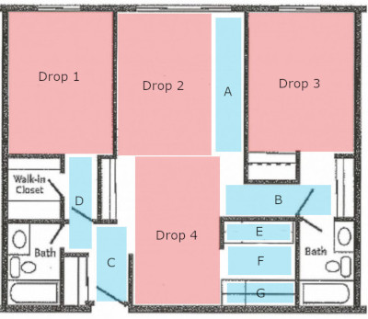

= Large Drops… Place them in the Livingroom, Bedrooms, and Dining Room.

= Small Drops… Place them in gaps where big drops don’t cover. Also on counters and kitchen floor!

= Equipment bag goes in Livingroom the about 12 feet away from the patio. Between drop 2 and 4.

Drops for Walls

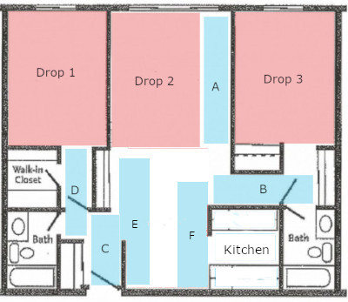

Hints:

* Remember: for ceiling always place small drops on kitchen counters and floor.
* Not all layouts are the same! Just make sure big drops cover large areas, and small drops “fill in the gaps” that big drops don’t cover.
* REMEMBER TO KICK THE DROPS UP AGAINST THE BASE!!!!