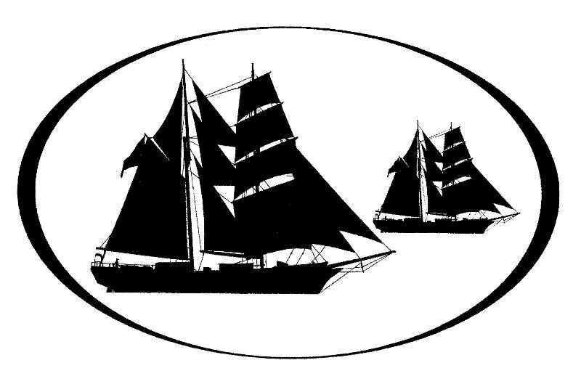
Los Angeles Maritime Institute
Physical Activity & Pre-Existing Condition

Release Form for Volunteers

I, _________________________________ release the Los Angeles Maritime Institute, its officers, employees, volunteers, and contractors from responsibility for personal injury or liability while engaged in the activities as a volunteer and participating in the operation of the institutes vessels and the execution of the TopSail Youth Program. I understand that this activity may require physical conditioning, and I certify that I am in appropriate physical condition to perform the duties for which I will volunteer. I understand that there is an element of risk in these activities and agree to follow all instructions, rules and regulations.

I also understand that I may participate without volunteering to climb the rig, go forward on the bow sprit or in any way leave the deck of the vessel.

Please list pre-existing conditions which may affect and or prohibit your participation in the required activities of the position you have accepted.

I further release the Los Angeles Maritime Institute, its officers, employees, volunteers, and contractors from the responsibility for these pre-existing conditions and should they be aggravated or re-injured in the course of executing the responsibilities for which I have committed to.

Volunteer:

______________________________________________________________________
Print Name Signature Date

