This Text Entry Method used Morse code technique. It includes four buttons, dot, dash, space, and enter. The project is built on breadboard. Once a set of dots and dashes are pressed, which means some letter or number. Press ENTER button to print the character on the screen. Type SPACE does not need to press ENTER again. The text entry device can print upper case letter A-Z, number 0-9, and space, total 37 characters. The reason this technique is chosen because it is easy to program. As well, it only requires few buttons.

Besides given library, the code includes a file called TextEntry.java. The TextEntry.java file runs the main code of checking button status and print corresponding characters. It includes functions dot(), dash(), enter(), type(). Dot function add a dot to the dash dot string, while dash function add a dash. Enter function will call type function to relate the string to a character, and print it out on screen. Following picture shows circuit (Arduino is used to replace PicoPro). Indicators are written on paperboard to help user type. And a Morse code is provided to help user decide what to type. Messy wires on the breadboard are grouped together for enclosure.

This project is very useful for beginners to learn with Arduino, and reflect well on lecture.

Video: YouTube: <https://youtu.be/Cc6CJ31Zt1o>

Code: GitHub: <https://github.com/idd-fall17/hw2-yusongxixi>

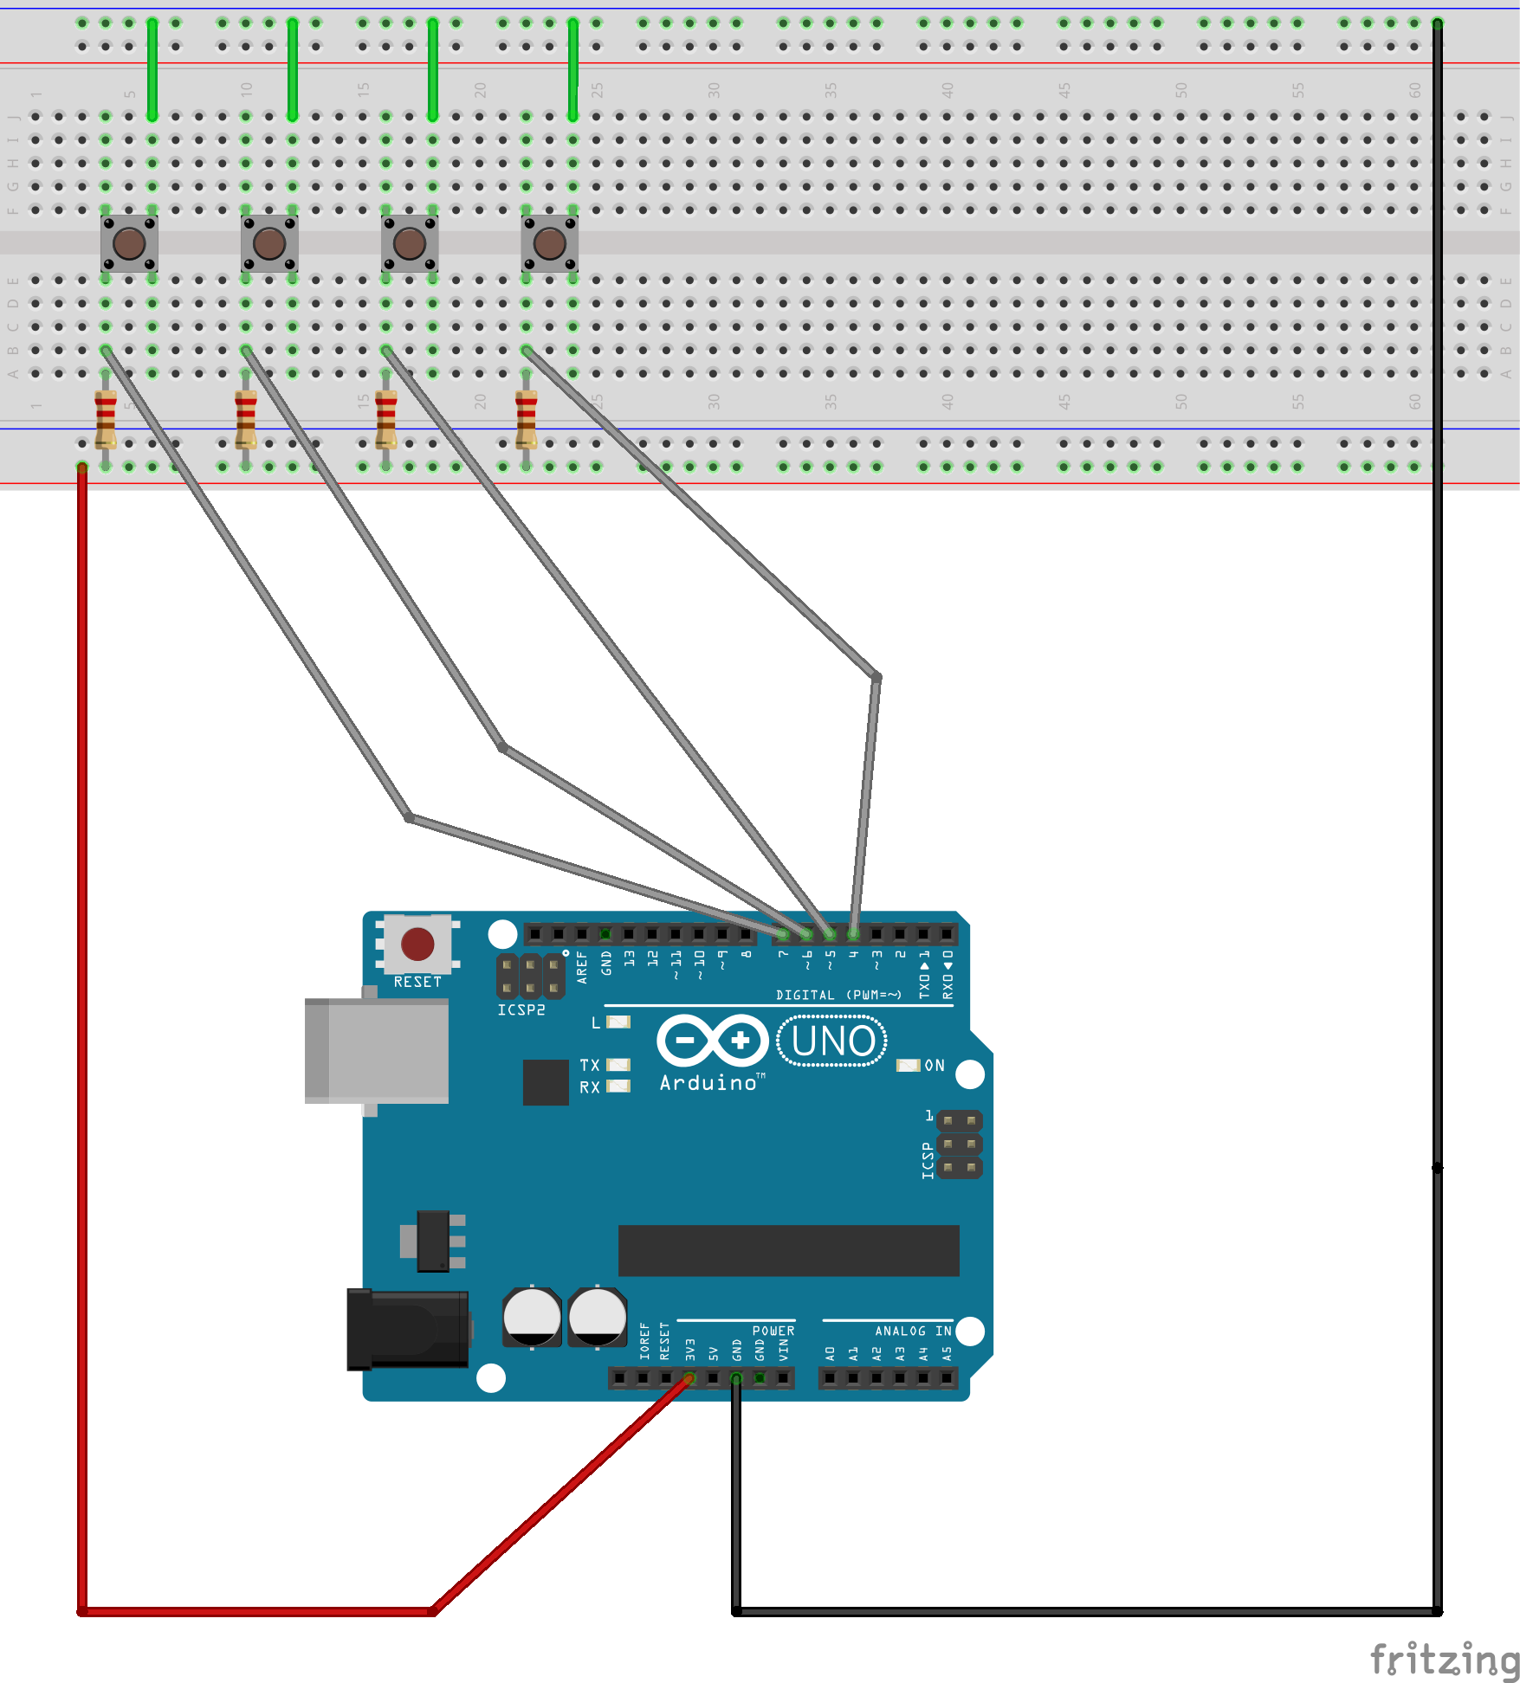

Figure : Circuit

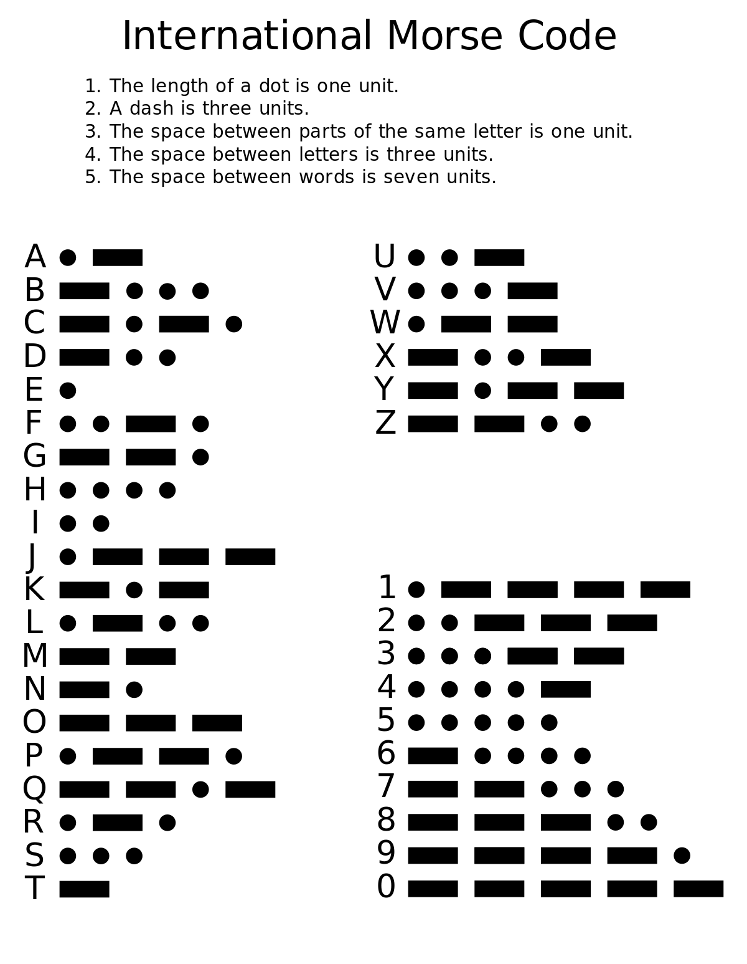

Figure : Morse Code

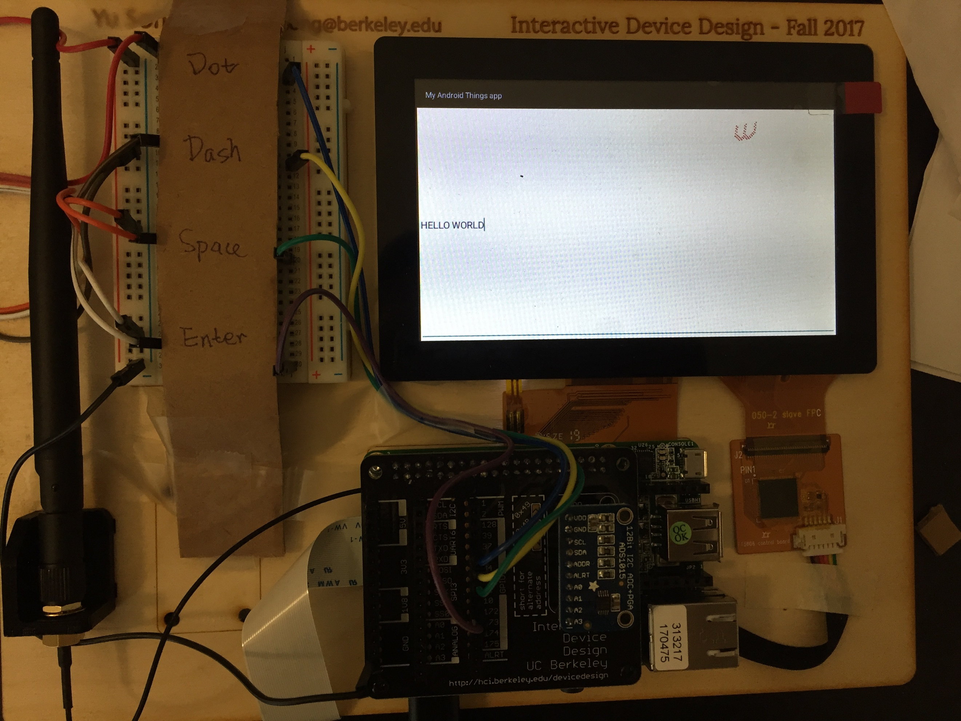

Figure : Device Outlook