Overview
BDGUI is a Linux program for displaying information about block devices in a GUI. It’s also possible to (temporary) mount devices with this program.
This program displays information about:

- Block devices like hard disks etc..
- Software raid
- iscsi disks
- fstab
- disk stats
- LVM

It has also has the following features
- It’s possible to change the columns and the order of the columns in the ‘disks’ tab page (settings=>fields)
- A notification is displayed when devices are added or removed or when devices are mounted or unmounted
- There is also an auto refresh of all information when a devices added, removed or mounted
- It’s possible to hide and show tab pages (“settings=>visible tabs” and “settings”=>”user defined tabs”
- It’s possible to define your own tab pages based data from the “Disk” tab page (setting=>user defined tabs”

Building BDGUI

This program can be build as follows:

For compiling Bdgui you need the following libraries and dev packages:
- gettext
- libblkid
- libudev
- When compiling for KDE4, the following libraries are also required:
  - libQtNetwork.so.4
  - libQtXml.so.4
  - libQtDBus.so.4
  - libQtGui.so.4
  - libQtSvg.so.4
  - libQtCore.so.4
  - qjson (version 0.8.1)
  - libkdeui.so.5
  - libkdecore.so.5
- When compile for KDE5, the following libraries are also required:
  - libKF5ConfigCore
  - libKF5CoreAddons
  - libKF5I18n
  - libQt5Core
  - libQt5Gui
  - libQt5Widgets

The program can be build as follows:
- goto the rood of bdgui source.:
- mkdir build
- cd build
- Configuration:
  - for kde5: cmake ..
  - for kde4: cmake -Dkde=4 -DQT_QMAKE_EXECUTABLE=<qmake 4 exec> ..
  - (For option -DQT_QMAKE_EXECUTABLE=<qmake 4 exec> see problem note)
- make
- sudo make install (if you want to install the program)
- running:
  - bdgui can be run directly from the “build” folder after make compleets.
  - Bdgui can be run as a normal user but when it is run as root more information is displayed.
Testing:
- Configure build for testing
  - cmake -D run_test=1 ..
- Compile sources:
  - make
- Run tests
  - make test
Problems:
- When Bdgui is not installed, ‘make test’ can fail testing appstream. This is cause by a bug in appstream cmake configuration.
This can be solved by:
  - Replace /usr/share/ECM/kde-modules/appstreamtest.cmake
by the latest version that can be downloaded here:
https://github.com/KDE/extra-cmake-modules/blob/master/kde-modules/appstreamtest.cmake
  - Install bdgui
  - create an empty install_matifest.txt in the build directory.
- If you get message 'Compile your code with -fPIC or -fPIE….' ,
Remove the contents of the build folder and run cmake again. This happens when the program is first build for kde5 and then for kde4 without cleaning the build directory.
- If you get an error message that "QT_QT_INCLUDE_DIR" is used in this project but not found, this happens when the wrong version of qmake is used.
This can be solved by adding -D QT_QMAKE_EXECUTABLE=<qmake executable> to the cmake command line.

Using the program

“Disks” tab page

Overview
The first tab page(on the left) contains a lot of information about all block devices on the system.
In general the following storage types are handles as block devices under Linux:

- Real block devices:
  - Physical disks
  - Removable disks like SD cards, CD,DVD etc..
- Virtual block devices
  - LVM devices
  - Linux Raid devices
  - ISCSI
  - Loop back
  - and some ram disks

Note: CIFS/SMB or NFS mounted shares are not handled through a devices and are therefor not visible in the “disk” tab page.

Changing the “Disks” tab page
It’s possible to change the fields and the order they display by the “settings”=>”Fields”. It’s also possible to define you’re own tab pages with the menu option “settings’=>”user defined tabs”.(see 3.2 Define your own tab pages).
This chapter is about the “Fields” dialog.
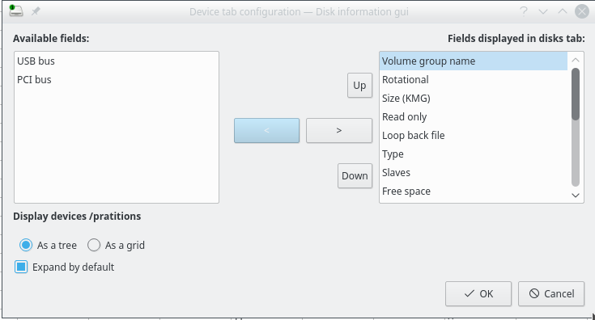
The “Fields” dialog can be used to changes to following settings:

- The fields that are displayed in the “Disks” tab page
- The order of fields
- Choose if the table is displayed as a tree of as a grid
- “Expand by default”, if the table is displayed as a tree

Define your own tab pages
It’s possible to define your own tab page based on the data from the “Disks” tab page. Those tab pages can be defined after selecting the “settings” menu and then “user defined tabs”. A dialog with an (empty) select list is displayed:
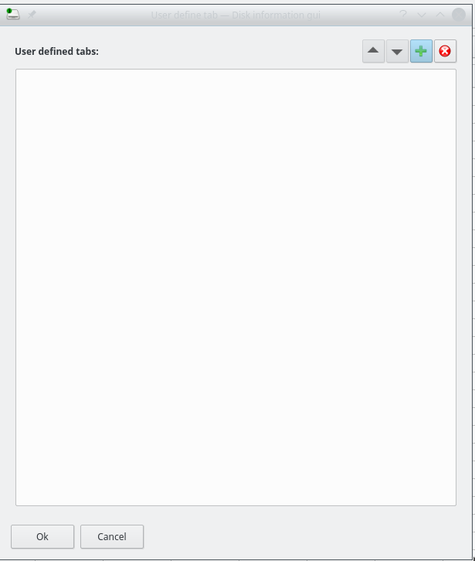

After pressing the “+” button you can enter the tab page label. It is possible to define a hot key by adding a & to the label name. If for example La&bel is entered, then after pressing alt-b the tab named “label” is displayed.

After pressing OK it’s possible to enter the field that are displayed on the tab page.
The dialog look like this:
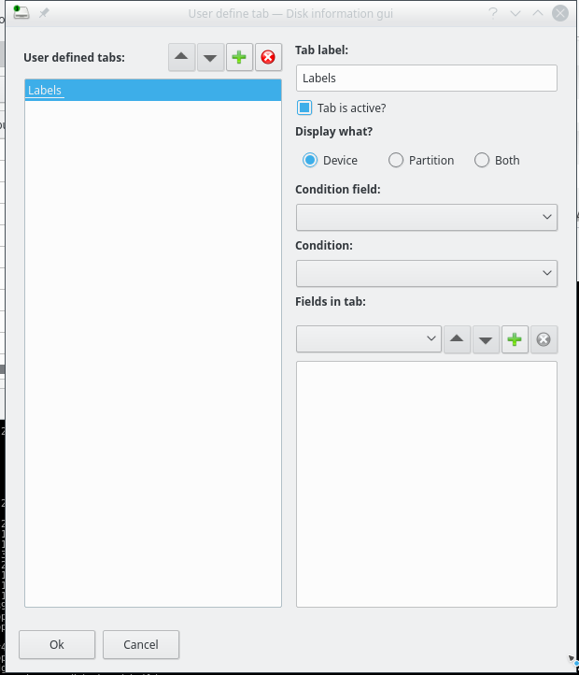
Label | The label of the tab page
Tab is active | When checked (by default) this tab is displayed
Display what | Choose what do display: Block devices only, partition or both
Condition Field  Condition | It is possible to filter the data from the “disks” device bu one field.  When left blank all data is shown
Fields in tab | Add the field you want to display tab

After pressing “Ok” the configuration is saved to disk

LVM
The “Disks” tab has some information about LVM devices. For those devices the “model” column contains the text “LVM device” and the column “lvm name” contains the lvm name of the device. This even works when the program is run as a normal user.
There is also a tab called “LVM”. This contains information about physical volumes, volume groups and logical volumes. This part of Bdgui contains information if:
- Bdgui is run as root
- LVM meta daemon is running
- and here is one or more LVM partition.

