1. **Study the data and analyze it carefully. Provide a monthly summary that include frequencies, describe the timings vs the customer flow over a working day and weekend day.**

**From the dataset it is clear that most of the sales occur in the morning and afternoon hours. The challenge however was to discern weekdays from weekends in order to map customer buying patterns based on the two.**

1. **Convert the data in a format that you can then use on WEKA (or any other ML toolkit) to enable you use the Apriori Algorithm for Association Analysis.**
2. **Identify the frequent itemsets by setting your own Support and Confidence values.**

**{Scone} -> {Toast, cake}**

**{Scone, bread} -> {Toast, cake}**

**{Scone} -> {Toast, Bread, cake}**

**{Scone, coffee} -> {Toast, cake}**

**{Scone} -> {Toast, coffee, cake}**

**{Scone, Bread} -> {Toast}**

**{Brownie} -> {Juice, Medialuna}**

**{Scone} -> {Toast, Bread}**

**{Scone, cake} -> { Toast}**

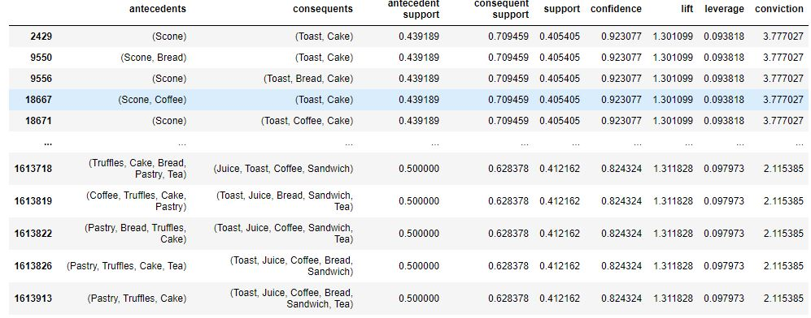

1. **Using this, generate frequent itemsets per month, working day vs weekend. What Association Rules do you find?**
2. **Is there a drift over the months?**