Title:

Comorbidities between specific learning disorders and psychopathology: a study with elementary school children in Germany

Abstract

Children with reading and/or spelling disorders have increased rates of behavioral and emotional problems and combinations of these. Some studies also find increased rates of attention-deficit-/hyperactivity disorder (ADHD), conduct disorder, anxiety disorder, and depression. However, the comorbidities of e.g. arithmetic disorders with ADHD, anxiety, and depression have been addressed only rarely. The current study explored the probability of children with specific learning disorders (SLD) in reading, spelling, and/or arithmetic to also have anxiety, depression, ADHD, and/or conduct disorder. The sample consisted of 3014 German children from grades 3 and 4 (mean age 9;9 years) who completed tests assessing reading, spelling as well as arithmetic achievement and intelligence via a web-based application. Psychopathology was assessed using questionnaires filled in by the parents. In children with a SLD we found high rates of anxiety (21%), depression (28%), ADHD (28%), and conduct disorder (22%). Children with SLD in multiple learning domains had a higher risk for psychopathology and had a broader spectrum of psychopathology than children with an isolated SLD. The results highlight the importance of screening for and diagnosing psychiatric comorbidities in children with SLD.

Keywords: specific learning disorder; ADHD; depression; anxiety; conduct disorder

Introduction

Children with specific learning disorders (SLD) do not only exhibit difficulties in reading, spelling, and/or arithmetic. They also often struggle with externalizing and internalizing problems such as attention deficits and hyperactivity, conduct problems, anxiety disorder, and depression. There is some evidence for the increased risk of symptoms and the diagnosis of attention-deficit-/hyperactivity disorder (ADHD) in children with reading and/or spelling disorder (Bäcker & Neuhäuser, 2003; Goldston et al., 2007; Kohn, Wyschkon, & Esser, 2013; Maughan & Carroll, 2006; Miranda, Jesús Presentación, Siegenthaler, Colomer, & Pinto, 2011; Sexton, Gelhorn, Bell, & Classi, 2012; Willcutt et al., 2013). In a representative German sample of 2nd and 3rd graders, a comorbid ADHD diagnosis was found in 17.2% (isolated reading disorder), 20.3% (isolated spelling disorder), and 22.2% (combined reading and spelling disorder) of subjects with SLD (Schuchardt, Fischbach, Balke-Melcher, & Mähler, 2015). In contrast, in a general population sample in Germany only 5% of the 7- to 10-year old children met the criteria for ADHD (Ravens-Sieberer et al., 2008); worldwide ADHD prevalence was estimated 3.5% (95% CI = 2.6%–4.5%) (Polanczyk, Salum, Sugaya, Caye, & Rohde, 2015). Girls with reading disorder mainly exhibit attentional deficits, while boys with reading disorder often additionally show symptoms of hyperactivity and impulsivity (Willcutt & Pennington, 2000).

Another frequently replicated result is the association between anxiety and dyslexia (Carroll, Maughan, Goodman, & Meltzer, 2005; Goldston et al., 2007; Willcutt et al., 2013). Carroll et al. (2005) showed that anxiety disorders were more than twice as prevalent in children with dyslexia compared to children without dyslexia. The relation between anxiety and dyslexia appears to be mostly domain-specific (Novita, 2016) and does not seem to be moderated by ADHD or inattention symptoms (Carroll et al., 2005; Goldston et al., 2007).

Results regarding the relationship between depression and dyslexia are ambiguous. While Goldston et al. (2007) report an association between the two disorders (seemingly moderated by symptoms of inattention), Carroll et al. (2005), Willcutt and Pennington (2000), and Bäcker and Neuhäuser (2003) did not find such an association. Finally, Willcutt et al. (2013) reported higher rates of depression in children and adolescents with reading difficulties, independent of the presence of ADHD.

Likewise, no conclusive statement can be made regarding the comorbidity of conduct disorders and dyslexia. Although some studies showed elevated symptoms of conduct disorders in dyslexic children and adolescents, this relationship is assumed to be moderated by the simultaneous occurrence of ADHD (Sexton et al., 2012; Willcutt & Pennington, 2000). This result is particularly apparent in boys (Willcutt & Pennington, 2000).

The co-occurrence of dyscalculia and mental disorders is still poorly investigated. Willcutt et al. (2013) reported that children and adolescents with dyscalculia were more likely to meet the criteria for ADHD, conduct disorders, anxiety disorder, and depression. However, the diagnosis of conduct disorder revealed to be fulfilled only by those children and adolescents with dyscalculia who also met the criteria for ADHD, indicating that the relationship between conduct disorder and dyscalculia is moderated by ADHD. A study investigating SLDs in representative school samples from 2nd to 6th grade in Brazil revealed an association between ADHD and dyscalculia (Fortes et al., 2016). In contrast, Schuchardt et al. (2015) did not find elevated rates of ADHD in children with dyscalculia. In a longitudinal study investigating the co-occurrence of internalizing symptoms (anxiety, depression), children and adolescents with dyscalculia generally exhibited higher symptom levels than control subjects, although in the normal range (Graefen, Kohn, Wyschkon, & Esser, 2015). Among the children with dyscalculia, boys received higher scores than girls on parent- and teacher-ratings of anxiety and depression symptoms, but not on self-ratings. However, on average, neither the experimental group nor the control group reached the clinical cut-off score for internalizing disorders (Graefen et al., 2015). Similar to research results in dyslexic children, the elevation of anxiety scores in subjects with dyscalculia might be domain-specific (Wu, Willcutt, Escovar, & Menon, 2014). On the other hand, the aforementioned Brazilian study found an association between anxiety disorders and dyscalculia in 2nd to 6th graders (Fortes et al., 2016).

Subjects with deficits in more than one domain of academic achievement exhibit more psychopathological symptoms (Fischbach, Schuchardt, Mähler, & Hasselhorn, 2010; Kohn et al., 2013; Martínez & Semrud-Clikeman, 2004; Willcutt et al., 2013). Thus, the worse children and adolescents perform academically, the more psychological distress they exhibit.

In the present study, we used a large non-clinical sample of 3rd and 4th grade children in Germany to shed more light upon the co-occurrence of different SLD subtypes and psychopathology. This is of great practical importance, as unidentified mental problems and mental disorders may impede treatment success in SLD. As opposed to earlier studies, we took into account various subtypes of SLD and various domains of psychopathology in one study. This makes it possible to study not only the comorbidity between the various types of SLD and psychopathology, but also the comorbidities between the different types of psychopathology in children with SLD.

We explore the occurrence of anxiety, depression, ADHD, and conduct disorder in children with an SLD in reading, spelling, arithmetic, or a combination of these. Additionally, we investigate to which extent the different psychopathologies co-occur within the different SLD groups. We hypothesize that children with reading and/or spelling and/or arithmetic disorder more often have depression, anxiety, ADHD, and conduct disorder than children without SLD; the more academic domains are affected, the higher the risk for more psychopathological symptoms. We further expect that the more academic domains affected by SLD, the higher the number of areas in which a child, on average, exhibits psychopathology.

# Materials and methods

# Recruitment

We invited families with 3rd and/or 4th grade children from the two German federal states Hesse (n = 25.000) and Bavaria (n = 27.734) to participate in this study. In Hesse, families were contacted through the Hessian Ministry of Culture. In Bavaria, we received the addresses of families with children aged between 8.8 and 10.8 years from local registration offices and sent invitation letters directly. The families were randomly chosen in a way that the population of selected families was approximately representative in terms of gender and age (Bavaria) respectively grade (Hesse).

Children and their parents were invited to download and use a web-based application to assess the academic skills and psychopathological profile of the children. The invitation letter included login information for this application, which interested families could use to complete the test battery autonomously within eight weeks. All participants (parents and children) gave informed consent. Study protocols outlining the recruiting procedures in Hesse and Bavaria were approved by the ethics committees of the University Hospital of the Ludwig-Maximilians-University Munich and the DIPF | Leibniz Institute for Research and Information in Education, Frankfurt am Main.

# Participants

A total of 4542 families started using the application which corresponds to a response rate of 8.6%. Reasons for non-participation were not requested. After applying all filtering and exclusion criteria, as described in section 2.3, the final sample consisted of 3014 children with a mean age of 9;9 years (SD = 7 months; range 8;1 to 11;8). The mean age for 3rd grade children was 9;3 years and for 4th grade 10;2 years. Table 1 displays the sample distribution with respect to gender, grade, state, as well as several indicators of representativeness. The sample is approximately equally distributed in terms of gender and grade. In both states, gender is roughly balanced per grade. Mothers with a high educational level, implying high SES, are overrepresented. The percentage of children with non-German nationality is lower than what would be expected based on demographic data (Statistisches Bundesamt, 2017a, 2017b). Native German speakers are slightly overrepresented with reference to an estimate of the population percentage (Eurobarometer, 2012).

# Drop-out and exclusion

For the current study, we excluded cases from the analyses for which the child did not complete all tests up to session four (678; 14.9%) or the parent did not complete all questionnaires (652; 14.4%).

The sample included 49 sibling pairs. To avoid statistical dependence in the sample, we randomly excluded the data of one sibling per pair. In addition, we excluded 81 (1.8%) cases because of an IQ of 70 or lower and 99 (2.2%) cases because the parents answered to an open question that the child had hearing or visual problems, neurological diseases, or chromosomal defects. In total, we excluded 1528 (33.6%) cases, resulting in the final study sample of 3014 children.

# Collection of data

We used a web-based application that was developed specifically for the present study by a software company. For this study all standardized psychometric tests and questionnaires were transformed from their paper-pencil versions to an online tablet/smartphone version and additionally embedded in a story frame around a magician to motivate children to do the tests. Using either a smartphone or tablet, participants worked on the tests and questionnaires independently at home. For the children tests and questionnaires were grouped into four sessions which had to be worked on for four days. There was one session for the assessment of parent (or other caregiver) ratings. The parental survey addressed, among other things, questions about family history, learning disorders in the family, and the child development. Children were asked to complete an optional fifth session[1] which included a newly developed spelling test (not reported in this manuscript). Each session lasted about 30 to 45 minutes, depending on how fast the child handled the tasks. The application was programmed such that it was not possible to complete more than one session per day. The participants were asked to complete the test battery within eight weeks after receiving the invitation.

# Measures

Reading achievement was assessed using an online version of the ‘Wuerzburger Silent Reading Test – Revised’ (WLLP-R; Schneider, Blanke, Faust, & Küspert, 2011; parallel-test reliability *r* = .93 for 3rd grade and *r* = .82 for 4th grade). Children were presented with a series of written words and were asked to select the corresponding image among four options within five minutes. To assess children’s spelling performance, the long versions of the ‘Weingarten spelling test for basic vocabulary’ (WRT) were administered online (WRT 3+ for 3rd graders; Birkel, 2007; parallel-test reliability *r* > .91, and WRT4+ for 4th graders; Birkel, 2007b; parallel-test reliability *r* > .90). Children had to fill in the blanks of missing words using the correct spelling without a time limit. Arithmetic achievement was assessed using the computer-assisted ‘CODY math test’ (CODY-M 2-4; Kuhn, Schwenk, Raddatz, Dobel, & Holling, 2017). The CODY-M 2-4 includes nine subtests focusing on basic number processing (counting, magnitude comparisons), complex number processing (number dictation, number line, domino count comparison, missing numbers), counting skills (addition, subtraction, multiplication, placeholder tasks), and visuo-spatial working memory (a matrix memory span task). All scholastic achievement tests used in the present study are recommended by the German evidence-based practical guidelines for diagnosis and treatment in reading and/or spelling disorder (Galuschka & Schulte-Körne, 2016) or dyscalculia (Deutsche Gesellschaft für Kinder- und Jugendpsychiatrie, Psychosomatik und Psychotherapie, 2018).

Nonverbal intellectual ability was assessed using the short version of the ‘Culture Fair Intelligence Test’ (CFT 20-R; Weiß, 2012; test reliability *r* = .92). Only three of the four subtests of the CFT 20-R were administered (sequences of drawing, classifications, matrices), because the fourth subtest could not be adapted to an online version. Because the fourth subtest contains fewer items than the other subtests, i.e., it contributes less to the total raw score, and is often too difficult for children in the age range of our study, the resulting IQ-scores nevertheless form a good approximation of the intelligence of the children. The parental survey started with a questionnaire about family and child background containing questions about parental educational level and work, ethnic background and language, developmental problems, psychopathology, and learning in the child as well as related interventions, and learning problems and psychopathology in the family. To assess children’s psychopathology, parents completed standardized rating scales for ADHD (FBB-ADHS; Cronbach’s α = .86–.94), conduct disorder (FBB-SSV; Cronbach’s α = .63-.93), and depression (FFB-DES; Cronbach’s α = .89) of the ‘Diagnostic System of Mental Disorders for Children and Adolescents – II’ (DISYPS-II; Döpfner, Görtz-Dorten, & Lehmkuhl, 2008). These parent rating scales are widely used in research and clinical practice. To assess anxiety, the German version of the ‘Screen for Child Anxiety Related Emotional Disorders’ (SCARED-D; Birmaher et al., 1997; Essau, Muris, & Ederer, 2002) was administered. The SCARED has a good internal consistency for the total anxiety score (Cronbach’s α = .91) and supported construct validity (e.g., *r =* .85 (*p* < .001) for the total scores of the ‘Spence Children’s Anxiety Scale’ (SCAS; Spence, 1997, 1998) and the SCARED).

# Data preparation

We used REDCap (Harris et al., 2009) for data management and R (R Core Team, 2018); version 3.5.0) for data analysis. Data and analysis code are available on the Open Science Framework (https://osf.io/9mxp2/) [dataset].

# Implausible data

As the participants used the web-based application autonomously, we were unable to directly monitor their behavior and assess the plausibility of the resulting data. Therefore, we applied five plausibility checks to the data, for which we determined the necessity and exact criteria based on the dataset itself.

Firstly, we checked whether the total time that a child worked on a specific test deviated from the set maximum time limit for this test by more than an acceptable tolerance limit. The tolerance limits were chosen on a test-by-test basis for positive and negative deviations, respectively: CFT 20-R (30 sec and 6 sec); CODY-M 2-4 (15 sec and 1 sec); WLLP-R (4 sec and 1 sec). Test results from children whose testing time exceeded these limits were considered implausible and excluded from further analysis.

Secondly, we checked whether a child selected the same answer alternative in the WLLP-R repetitively for an unrealistic number of times. Test results from children who exceeded 10 consecutive repetitions of the same answer alternative were considered implausible and excluded.

Thirdly, we checked whether a child responded unrealistically quickly, i.e., if it just typed a key instead of seriously working on the test. For each instrument, we first computed the median of the distribution of all single trial response times over all participants. For each response time in the left tail of this distribution (response times that are smaller, i.e., faster, than the median), we then computed the absolute deviation from the median and standardized it by dividing it by the median absolute deviation (MAD; i.e., the median of the absolute deviation from the median). We considered absolute deviations larger than three times the MAD as unrealistically quick and excluded test data from children who had implausibly fast response times for a certain percentage of all items of the respective tests. For most tests this criterion was set to 15%; for the CODY-M 2-4 subtests ‘missing number’ and ‘domino count comparison’, it was set to 30%. For the subtest ‘domino count comparison’, we additionally only considered test results as implausible if less than 70% of the items were answered accurately, because most of its items were very easy so that very fast reaction times were to be expected.

Fourthly, we checked whether participants seemed to have typed random letters instead of words when they had to fill in the blanks in the spelling tests WRT3+ and WRT4+. For each typed answer, we determined the similarity to its target word by computing the Jaro-Winkler distance (Jaro, 1989; Winkler, 1990). Answers with a Jaro-Winkler distance of more than .41 (.49 for the German word ‘Axt’) were considered as random typing. Test results from children who typed randomly for more than 15% of the items were considered implausible and excluded.

Fifthly, and finally, we excluded test results for the CFT 20-R and the CODY-M 2-4 if a participant did not complete all subtests.

In total, we excluded 540 (11.9%) cases because of implausible data. No data of parent questionnaires appeared to be implausible.

# Standardization

All diagnostic tests assessing children’s scholastic skills as well as psychopathology were normalized to the complete sample that used the web-based application. We decided to compute norms based on our own sample instead of using the norms from the norm sample of the original tests as a) the testing conditions in the web-based application deviated from the original tests (mostly paper-pencil versions), b) normalizing the tests to the same sample yields a higher degree of comparability between the test results, and c) our sample was considerably larger than the norm samples of the different tests, resulting in more precise norms.

The norms for the CFT 20-R, CODY-M 2-4, WRT 3+ and 4+, and WLLP-R were developed separately for the 3rd and 4th grade. For the SCARED-D and DISYPS-II, the norms were developed for girls and boys separately, which is in line with the norms of the original DISYPS-II.

Before normalizing children’s psychopathology to our sample, we compared the occurrence of psychopathology in our sample based on the norms from the original tests, to the results from the BELLA study (Ravens-Sieberer et al., 2008), a prevalence study of mental health problems in children and adolescents in Germany. The differences were mostly small and might be attributed to the different methods used to assess psychopathology in the two studies. However, the occurrence of conduct disorder was lower in our sample. As conduct disorder is more prevalent in children from families with a low SES background (Matthys & Lochman, 2017), this difference might be attributed to the overrepresentation of mothers with high educational level in our study.

# Classification of SLDs and psychopathology

To meet the SLD criteria according to the Diagnostic and Statistical Manual of Mental Disorders, 5th edition (DSM-5; American Psychiatric Association, 2013), below-average scores in one or more domains of academic achievement are required. As diagnostic threshold, the DSM-5 recommends 1.5 standard deviations (SD) below the expected score for chronological age/grade in a standardized test of scholastic skills. However, 1 SD may be used if other information indicates an elevated likelihood for SLD (e.g., clinical or qualitative information).

As criterion to classify children as having an SLD, we used a z-score of ≤ -1.5 in the respective standardized test of academic achievement. Furthermore, to ensure optimally distinct classifications, we classified children with a z-score of > -1 as not having an SLD and excluded children with a z-score of > -1.5 and ≤ -1. Since we did not assess other information indicating an elevated likelihood for SLD (as postulated by the DSM-5), we were not able to decide if these children have an SLD or not.

For the different analyses, we created four types of variables indicating SLD status. Firstly, to provide a comprehensive description of SLDs and their comorbidities, we created a categorical variable grouping children into eight categories that differentiated between isolated SLDs and all possible combinations of SLDs in the different domains. Children with z-scores of > -1 in all three domains (reading, spelling, arithmetic skills) were classified as having no disorder. Children with a z-score of ≤ -1.5 in one domain and z-scores of > - 1 in the other two domains were classified as having an isolated SLD in the respective domain. Likewise, children with z-scores of ≤ -1.5 in two domains and a z-score of > -1 in the third domain, or z-scores of ≤ -1.5 in all three domains, were classified as having specific combinations of comorbid SLDs in reading, writing, and/or arithmetic. Hence, children with a z-score of > -1.5 and ≤ -1 in at least one of the three learning domains were excluded when creating these variables, because these borderline scores mean it is relatively uncertain if a child has an SLD or not.

Secondly, for the inferential statistical analysis, we created four categorical variables that reflect SLD status more broadly. A first variable, “any SLD”, indicated whether a child had an SLD in any of the three domains or not. Children were classified as having any SLD if at least one of their reading, spelling, and/or arithmetic z-scores was ≤ -1.5, and as having no SLD if all three z-scores were > -1. Second, we created a variable “reading disorder” that categorized children as having any form (both isolated and non-isolated) of reading disorder, or not. The variable classified children as having an SLD in reading if their reading z-score was ≤ -1.5 and as having no SLD in reading if this z-score was > -1, independent from their test scores in the spelling and arithmetic domains. The variable thus does not only include children with an isolated reading disorder, but all children with a reading disorder, both isolated and not-isolated. The third and fourth variables were constructed in a similar way for “spelling disorder” and “arithmetic disorder”.

Thirdly, we created a count variable indicating the number of domains in which the child had an SLD (possible values: 0, 1, 2, or 3) as defined by the three variables indicating the existence of a specific SLD. For example, a child that was classified as having an SLD in reading and in spelling, but not in arithmetic, received a value of 2. Children who were not classified as having an SLD in reading, spelling, or arithmetic, but had a z-score between > -1.5 and ≤ -1 in at least one of the three domains, were excluded with respect to this variable.

Fourthly, based on the variable counting the number of affected domains, we created a categorical variable indicating whether a child had “no SLD” (number of SLDs = 0), an “isolated SLD” (number of SLDs = 1), or “comorbid SLDs” (number of SLDs > 1).

In line with the cut-off of more than 1 SD used in the original DISYPS-II, we classified children as fulfilling the cut-off score for each of the following disorders anxiety, depression, ADHD, or conduct disorder when they had a z-score of  1 in the respective questionnaire. Children with a z-score < 1 in all of the respective symptom questionnaires were classified as not exhibiting any psychopathology. We thus created a categorical variable for each area of psychopathology that indicated whether a child did or did not have the respective psychopathology. Based on these four variables, we created an additional variable indicating the number of areas in which the child fulfilled the cut-off score for a psychopathology (possible range: 0–4).

# Statistical analyses

We used descriptive statistics to compare the children in the different SLD-groups with regard to their test scores in the scholastic achievement tests and to the number and percentage of children with anxiety, depression, ADHD, and conduct disorder. To illustrate the overlap of the different psychopathologies in children with and without SLD, we used the visualization technique “UpSet” (Lex, Gehlenborg, Strobelt, Vuillemot, & Pfister, 2014). We first compared the overlap of the different psychopathologies between children who did not have an SLD with children who did. In a second step, we compared the overlap between the different SLDs.

We used one-sided Fisher’s exact tests to test whether the occurrence of psychopathology in the respective areas was significantly higher for children who had a certain SLD than for children who did not. We computed this test for each of the four areas of psychopathology and for the presence of SLD in general, as well as separately for reading, spelling, and arithmetic SLD. As a measure of effect size, we computed the odds ratio (OR) with 95% confidence intervals based on the adjusted inverse hyperbolic sine transformation procedure (with pseudo-frequencies ψ1 = 0.6 and ψ2 = 0.4; Fagerland & Newcombe, 2013).

To test the hypothesis that the more academic domains are affected, the higher the risk for psychopathology, we used a trend test based on the generalized linear model with logit link function (logistic regression) and the Wald test statistic (see Fagerland, Lydersen, & Laake, 2017). Additionally, we computed an estimate for the trend as OR and the associated 95% Wald confidence interval. For each of the four areas of psychopathology, we tested for a positive trend (i.e., one-sided test) in their occurrence over the levels no SLD, isolated SLD, and comorbid SLD. As post-hoc tests, we used one-sided Fisher’s exact tests comparing the levels no SLD vs. isolated SLD and isolated SLD vs. comorbid SLD.

To test the hypothesis that the number of psychopathological areas increases with the number of SLDs, we used a generalized linear model with log link function (Poisson regression), with the number of SLDs as predictor and the number of psychopathological areas as outcome variable.

For each of the hypotheses, we corrected for multiple testing by setting the false discovery rate (FDR) to .05 using the modified FDR procedure by Benjamini and Yekutieli (2001).

Results

# Descriptive statistics for the SLD groups

Table 2 shows the numbers of children that were categorized into each of the eight SLD groups and their average intelligence quotients (IQ; CFT-20R) as well as reading (WLLP-R), spelling (WRT), and arithmetic (Cody-M 2-4) T-scores. An isolated spelling disorder occurs in 47 cases (1.6%) within the sample; an isolated reading disorder in 55 cases (1.8%), and arithmetic disorder in 56 cases (1.9%). We refer to Table 2 for the numbers and percentages of children with the various forms of comorbid SLDs.

The average IQ is lower for children with an isolated arithmetic disorder than for children with an isolated reading or spelling disorder (M = 93.11 (95% CI = 90.06–96.15) vs. M = 101.73 (95% CI = 98.3–105.16) respectively M = 93.11 (95% CI = 90.06–96.15) vs. M = 98.3 (95% CI = 94.67–101.92)). The reading, spelling, and arithmetic T-scores reflect the criteria chosen in the grouping procedure.

# Numbers and percentages of children with psychopathology per SLD group

Table 3 shows the number and percentages of children in the eight SLD-groups that fulfill the chosen cut-off for anxiety, depression, conduct disorder, or ADHD. The individual group sizes are relatively small. Based on the descriptive statistics, the occurrence of psychopathology in all four areas seems higher in the 7 SLD groups than in the group of children without SLD. The only exception is the occurrence of conduct disorder in children with an isolated reading disorder. The occurrence of psychopathology seems to increase in children with SLDs in multiple areas. Remarkably high are the occurrence of depression in children with comorbid reading and spelling disorder (52%), of conduct disorder in children with comorbid reading and arithmetic disorder (42%), and of ADHD in children with combined spelling and arithmetic disorder (44%). For children classified as having any SLD, the occurrence of comorbid psychopathology are 21% (anxiety), 28% (depression), 28% (ADHD), and 22% (conduct disorder).

Figure 1 displays the number of areas with psychopathology for the more broadly defined groups of children with SLD: “any SLD” (n = 400), “reading disorder” (n = 177), “spelling disorder” (n = 182), and “arithmetic disorder” (n = 157). The percentage of children without any psychopathology is clearly lower in children with an SLD than in those without an SLD. While the percentage of children with psychopathology in a single area does not differ between children with and without SLD, the percentage of children with psychopathology in two or more areas is higher in the children who suffer from an SLD.

# Overlap in psychopathology within the SLD groups

Figure 2 illustrates this overlap between anxiety, depression, conduct disorder, and ADHD. In children without SLD, anxiety occurs most often, followed by conduct disorder. The graphs show that in children with SLD (note that there is overlap between these SLD-groups, because classification was done independent from the presence of a disorder in the other domains) there is a high degree of comorbidity between different psychopathologies. Within the group of children with any SLD, the highest rates occur for (1) ADHD only, (2) comorbid ADHD, depression, and conduct disorder, and (3) comorbidity of all four types of psychopathology. This last mentioned group is largest in cases of reading-related or arithmetic SLD as well. In children with spelling disorder, the largest group is formed by those with combined ADHD, depression, and conduct disorder, followed by the group with only ADHD. In children with reading disorder, depression occurs relatively frequently as well.

# Difference in psychopathology between children with and without SLD

Table 4 shows the results of the inferential statistical analysis of the association between SLD status and the presence of anxiety, depression, conduct disorder, and ADHD using Fisher’s exact tests. The occurrence of all four different psychopathologies is significantly higher in children with than without SLD (p<.01 for all types of psychopathology). The odds of having

ADHD are 3.67 (95% CI = 2.83–4.77) times higher if a child has an SLD. For depression, the odds are 3.33 (95% CI = 2.57–4.32) times higher, for anxiety 1.81 (95% CI = 1.38–2.38), and for conduct disorder 2.13 (95% CI = 1.63–2.8) times higher, compared to children without SLD.

When looking separately at reading, spelling, and arithmetic disorder, psychopathology is also elevated, except for anxiety in children with spelling disorder, which cannot be considered as significant after FDR correction. For all three SLDs, the highest ORs are found for ADHD and depression. The odds for Depression appear comparable between the three SLD-domains (range 2.93–3.44). ADHD appears more prevalent in children with arithmetic 3.7 (95% CI = 2.61–5.28) or spelling 3.81 (95% CI = 2.75–5.32) disorder than in children with reading disorder 2.23 (95% CI = 1.57–3.24).

Relationship between the number of SLDs and the risk for psychopathology

The risk for psychopathology increases with increasing number of SLDs. The trend tests show a significant positive trend for the rates of all four disorders (anxiety: z = 4.46, p < .001; depression: z = 9.76, p < .001; ADHD: z = 9.62, p < .001; conduct disorder: z = 5.45, p < .001) over the three levels “no SLD”, “isolated SLD”, and “comorbid SLD”. The estimates for the trend are similarly high for depression (OR = 2.52; 95%-CI = 2.09–3.03) and ADHD (OR = 2.51; 95%-CI = 2.08–3.03), indicating that the odds of having the specific psychopathology increase by a factor of 2.5 per level. The estimates for anxiety (OR = 1.57; 95%-CI = 1.29–1.91) and conduct disorder (OR = 1.73; 95%-CI = 1.42–2.1) are somewhat lower, indicating an increase in odds by around 50% per level.

The results of the post-hoc one-sided Fisher’s exact tests show that the occurrence of depression increases significantly over the three levels (no vs. isolated SLD: OR = 2.63, 95%-CI = 1.95–3.56, p < .001; isolated vs. comorbid SLD: OR = 2.33, 95%-CI = 1.45–3.74, p < .001). In contrast, for the other three types of psychopathology, the trend is mostly explained by a higher occurrence in children with an isolated SLD than in children without SLD (anxiety: OR = 1.65, 95%-CI = 1.21–2.27, p = .002; ADHD: OR = 3.3, 95%-CI = 2.47–4.45, p < .001; conduct disorder: OR = 1.99, 95%-CI = 1.47–2.72, p < .001). The increase in occurrence from isolated SLD to comorbid SLDs is not significant (anxiety: OR = 1.42, 95%-CI = 0.84–2.42, p = .13; ADHD: OR = 1.5, 95%-CI = 0.93–2.43, p = .069; conduct disorder: OR = 1.3, 95%-CI = 0.78–2.22, p = .201). Figure 3 illustrates the increase in occurrence of the psychopathological disorders with the number of SLDs.

Relationship between the number of SLDs and the number of psychopathologies

The Poisson regression model describing a child’s number of psychopathologies as a function of its number of SLDs shows a significant positive relationship between the two variables. The estimate for the intercept, exponentiated for ease of interpretation, is 0.45 (95-CI = 0.43–0.48, p < .001), which means that the predicted number of psychopathologies for a child without SLD is about 0.5. The (exponentiated) estimate for the slope is 1.66 (95-CI = 1.55–1.79, p < .001). This means that the predicted number of psychopathologies increases by 66% when the number of SLDs increases by 1.

Discussion

In the current study, we explored the occurrence of anxiety disorder, depression, ADHD, and conduct disorder in children with SLD in reading, spelling, and/or arithmetic skills. We further examined comorbidities between the different forms of psychopathology in children with SLD and differences in occurrence of psychopathology between children with an isolated SLD versus comorbid learning disorders.

The results show that children in the 3rd and 4th grade with SLD more often had psychiatric disorders than children with no SLD. For children with any SLD the occurrence rates are 21% (anxiety), 28% (depression), 28% (ADHD), and 22% (conduct disorder). ADHD is more prevalent in children with arithmetic or spelling disorder, compared to reading disorder. Conduct disorder is not associated with isolated reading disorder in our sample. Children who have SLD in multiple domains have both a higher risk of having a psychiatric disorder and on average a higher number of psychiatric disorders.

The higher risk of internalizing and externalizing problems in children with SLD is in line with the results of earlier studies (e.g. Willcutt et al., 2013). Whereas ADHD is often described as the most frequently occurring comorbidity in children with SLD (Sexton et al., 2012), we found similarly high comorbidity rates also for depression.

Earlier research (Willcutt & Pennington, 2000; Willcutt et al., 2013) found an impact of ADHD on the relationship between SLD and other psychopathologies. In our study, we found children with, e.g., conduct disorder both with and without comorbid ADHD, which means that ADHD does not always play a role in the comorbidity between SLD and conduct disorder, as suggested by former studies. However, as we did not explicitly study moderation, we cannot rule out the existence of a moderating effect over the whole group. Contrary to Schuchardt et al. (2015), we did find an increased occurrence of ADHD in children with arithmetic SLD. In fact, ADHD was more prevalent in children with isolated arithmetic disorder (25%) than in children with isolated reading disorder (16%) in our sample. The finding that SLD in multiple domains is related to higher rates of psychopathology is consistent with the results of previous research (Fischbach et al., 2010; Kohn et al., 2013; Martínez & Semrud-Clikeman, 2004; Willcutt et al., 2013).

A notable finding in our descriptive statistics was that children with an isolated arithmetic disorder, on average, have a lower IQ than children with an isolated reading or spelling disorder. This could be related to the fact that children with dyscalculia are known to have difficulties in visual-spatial processing (Mähler & Schuchardt, 2012; Simms, Clayton, Cragg, Gilmore, & Johnson, 2016) and executive functions (especially inhibition of information; Cragg & Gilmore, 2014; Deutsche Gesellschaft für Kinder- und Jugendpsychiatrie, Psychosomatik und Psychotherapie, 2018). The nonverbal intelligence test we used in this study, in significant part, draws upon these skills, which might have adversely affected the performance of children with dyscalculia.

# Limitations and directions for future research

Even though our study had a large overall sample, the classification into the various groups resulted in relatively small group sizes. In the subsequent inferential statistical analysis, we used more general, and thus larger, classifications of SLDs to ensure sufficient power.

Another limitation of our study is that mothers with a high educational level, which could hint at high SES, were overrepresented in the sample. Peterson and Pennington (2015) speculate that dyslexia might be more prevalent in children from low SES-families while underachievement in mathematics is more prevalent in children from low SES-families or from families belonging to linguistic or ethnic minority groups (Ramaa, 2014). With regard to psychopathology, low parental education has been shown to be related to higher degrees of anxiety and depression in children (Merz, Tottenham, & Noble, 2018; Okamura et al., 2016). Also, a low SES family background may constitute a risk factor for children to develop ADHD (Gould, Coventry, Olson, & Byrne, 2018; Morgan et al., 2016; Rowland et al., 2018; Russell, Ford, Williams, & Russell, 2016; Russell, Ford, Rosenberg, & Kelly, 2014) as well as conduct problems (Matthys & Lochman, 2017; Morgan et al., 2016). As SES seems related to both learning disorders and psychopathology, the overrepresentation of mothers with high educational background could have influenced the results. However, the comparability of our study to other studies investigating the relationship between SES and psychopathology/SLD is limited as SES can be assessed in different ways. We cannot examine if and to what extent SES influences our results, as we did not collect comprehensive demographic data regarding SES. To our knowledge, no research has yet been done on the influence of SES on the relationship between SLD and psychopathology, which we consider to be an important question for future research.

Another point to keep in mind when interpreting the results is the fact that we presented tests and questionnaires in a web-based app developed for this study. Although the content is the same as in the original paper-pencil-versions of the instruments, the validity of the online instruments and possible differences between writing and typing is still focus of ongoing research. Especially for the intelligence test the validity is still unclear, as the intelligence measure used in the online format is based on three out of the usual four subtests. On the other hand, the online format can be seen as a strength of the study as well. It has made it possible to reach a large sample size and to include the motivational concept.

Also, the standardized test results have been based on norms that we developed based on the sample of the current study. This means that the frequency of the SLDs and psychopathology in the total sample is not informative, as it is the pure consequence of the norming process. However, the research presented in this paper focuses on the comorbidity between SLDs and psychopathology, which can be well studied using norms based on the study sample.

The current study used cut-offs to classify children as having or not having a specific SLD or psychopathology. The choice of which cut-off to use may have influenced the presented results. To avoid this influence, future research could analyze the relation between SLDs and psychopathological symptoms in a continuous manner. In addition, the identification of subgroups of children with specific combinations of SLDs and psychopathology could be a topic for future research. Besides, because of its cross-sectional nature, this study cannot make assumptions about the causal mechanisms underlying the studied relationships. Future research using longitudinal designs is needed to identify the causal pathways leading to the comorbidities. More insights into the causal mechanisms could inform daily praxis to counteract and potentially prevent comorbidities from arising. The role of other potentially influencing factors like family factors (e.g., SES), social factors (e.g. the relationship with peers and mobbing), and child factors (e.g. the self-concept) should also be considered. In addition, because of the relatively high comorbidity rate not only with psychopathology, but also between different SLDs, a relevant question for future research would be if domain-specific or cross-domain learning interventions are more effective.

# Implications for practice

Knowledge about the comorbidity between SLDs and anxiety, depression, ADHD, and conduct disorder has important implications for the support of children with SLD in daily praxis. For example, the results of the current study mean that children who are suspected or known to have an SLD should especially be screened for symptoms of depression and ADHD. This is even more relevant when children have learning difficulties in multiple domains. Teachers need to be trained in noticing learning as well as psychopathological problems in children in an early stage, so that intervention can be started at an early stage to prevent more severe problems, both in terms of academic performance and psychological health. In addition, psychopathological problems should be taken into account when planning a learning intervention, because they might interfere with the effectiveness of the intervention, which is highest when optimally tailored to the child (Mascolo, Flanagan, & Alfonso, 2014).

To give an example, a depressive mood often manifests in feelings of inferiority, little self-efficacy and general listlessness. Children who are suffering from depression might not attend reading, spelling and arithmetic interventions as they have the feeling that they do not succeed anyway. Additionally, attending special trainings to ameliorate their scholastic achievement might cost depressed children more effort than normally developing children as they tend to draw back at home and avoid social interactions. On the other hand, earning bad marks in school due to their SLD may constitute a further mental burden and reinforce the depressive mood in the affected children. Special interventions addressed to children with both SLD and depression should focus on improving self-efficacy in general and particularly with regard to SLD. Dysfunctional thoughts concerning the poor performance in the area of the SLD should be explored and cognitively restructured.

With regard to ADHD, the lack of attention together with the increased impulsivity and hyperactivity might hinder the effectiveness of reading, spelling, and/or arithmetic interventions. Children with ADHD often have difficulties to focus on quiet activities, especially when they know that they are not good at them (e.g., in the area of their SLD). Positive reinforcement of the child is thus of great importance during special trainings directed towards improving scholastic achievement. Additionally, constant praising and appreciating the work of the children with ADHD is essential as these children primarily focus on positive feedback. Thus, the implementation of token systems in SLD interventions with ADHD children should be considered to reward the children for their progress.

In summary, in both depression and ADHD, the interaction of psychotherapeutic methods and SLD intervention is imperative. Parents and, if possible, teachers of the affected children should be involved in the interventions so that they can be adjusted as well as possible to the individual environment of the child.

Conclusions

Depression and ADHD, and to a lesser extent anxiety and conduct disorder, are elevated in children with SLD in reading, spelling, and/or arithmetic skills. In children with SLD in multiple learning domains both the chance of psychopathology and the number of psychopathological areas are higher than in children with an isolated SLD. These findings underline the relevance of detecting psychiatric comorbidities in children with SLD in order to provide the best possible support to affected children. Possibilities to implement psychotherapeutic methods in interventions for SLD are discussed.

References

American Psychiatric Association. (2013). *Diagnostic and Statistical Manual of Mental Disorders (DSM) 5*. Washington DC: American Psychiatric Association.

Bäcker, A., & Neuhäuser, G. (2003). Internalisierende und externalisierende Syndrome bei Lese- und Rechtschreibstörungen. *Praxis Der Kinderpsychologie Und Kinderpsychiatrie*, *52*, 329–337.

Benjamini, Y., & Yekutieli, D. (2001). The control of the false discovery rate in multiple testing under dependency. *The Annals of Statistics*, *29*(4), 1165–1188. https://doi.org/10.1214/aos/1013699998

Birkel, P. (2007a). *WRT 3+ Weingartener Grundwortschatz Rechtschreib-Test für dritte und vierte Klassen*. Göttingen: Hogrefe.

Birkel, P. (2007b). *WRT 4+ Weingartener Grundwortschatz Rechtschreib-Test für vierte und fünfte Klassen*. Göttingen: Hogrefe.

Birmaher, B., Khetarpal, S., Brent, D., Cully, M., Balach, L., Kaufman, J., & Neer, S. M. (1997). The Screen for Child Anxiety Related Emotional Disorders (SCARED): scale construction and psychometric characteristics. *Journal of the American Academy of Child and Adolescent Psychiatry*, *36*(4), 545–553. https://doi.org/10.1097/00004583-199704000-00018

Carroll, J. M., Maughan, B., Goodman, R., & Meltzer, H. (2005). Literacy difficulties and psychiatric disorders: evidence for comorbidity. *Journal of Child Psychology and Psychiatry, and Allied Disciplines*, *46*(5), 524–532. https://doi.org/10.1111/j.1469-7610.2004.00366.x

Cragg, L., & Gilmore, C. (2014). Skills underlying mathematics: The role of executive function in the development of mathematics proficiency. *Trends in Neuroscience and Education*, *3*(2), 63–68. https://doi.org/10.1016/j.tine.2013.12.001

Deutsche Gesellschaft für Kinder- und Jugendpsychiatrie, Psychosomatik und Psychotherapie. (2018, February 25). Diagnostik und Behandlung der Rechenstörung. Retrieved March 21, 2018, from http://www.awmf.org/uploads/tx_szleitlinien/028-046l_S3_Rechenst%C3%B6rung-2018-03_1.pdf

Döpfner, M., Görtz-Dorten, A., & Lehmkuhl, G. (2008). *DISYPS-II Diagnostik-System für psychische Störungen nach ICD-10 und DSM-IV für Kinder und Jugendliche - II*. Bern: Verlag Hans Huber.

Essau, C. A., Muris, P., & Ederer, E. M. (2002). Reliability and validity of the Spence Children’s Anxiety Scale and the Screen for Child Anxiety Related Emotional Disorders in German children. *Journal of Behavior Therapy and Experimental Psychiatry*, *33*(1), 1–18.

Fagerland, M., Lydersen, S., & Laake, P. (2017). *Statistical analysis of contingency tables*. London: Chapman and Hall.

Fagerland, M. W., & Newcombe, R. G. (2013). Confidence intervals for odds ratio and relative risk based on the inverse hyperbolic sine transformation. *Statistics in Medicine*, *32*(16), 2823–2836. https://doi.org/10.1002/sim.5714

Fischbach, A., Schuchardt, K., Mähler, C., & Hasselhorn, M. (2010). Zeigen Kinder mit schulischen Minderleistungen sozio-emotionale Auffälligkeiten? *Zeitschrift Für Entwicklungspsychologie Und Pädagogische Psychologie*, *42*(4), 201–210. https://doi.org/10.1026/0049-8637/a000025

Fortes, I. S., Paula, C. S., Oliveira, M. C., Bordin, I. A., de Jesus Mari, J., & Rohde, L. A. (2016). A cross-sectional study to assess the prevalence of DSM-5 specific learning disorders in representative school samples from the second to sixth grade in Brazil. *European Child & Adolescent Psychiatry*, *25*(2), 195–207. https://doi.org/10.1007/s00787-015-0708-2

Galuschka, K., & Schulte-Körne, G. (2016). The diagnosis and treatment of reading and/or spelling disorders in children and adolescents. *Deutsches Ärzteblatt International*, *113*(16), 279–286. https://doi.org/10.3238/arztebl.2016.0279

Goldston, D. B., Walsh, A., Mayfield Arnold, E., Reboussin, B., Sergent Daniel, S., Erkanli, A., … Wood, F. B. (2007). Reading problems, psychiatric disorders, and functional impairment from mid- to late adolescence. *Journal of the American Academy of Child and Adolescent Psychiatry*, *46*(1), 25–32. https://doi.org/10.1097/01.chi.0000242241.77302.f4

Gould, K. L., Coventry, W. L., Olson, R. K., & Byrne, B. (2018). Gene-environment interactions in ADHD: the roles of SES and chaos. *Journal of Abnormal Child Psychology*, *46*(2), 251–263. https://doi.org/10.1007/s10802-017-0268-7

Graefen, J., Kohn, J., Wyschkon, A., & Esser, G. (2015). Internalizing problems in children and adolescents with math disability. *Zeitschrift Für Psychologie*, *223*(2), 93–101. https://doi.org/10.1027/2151-2604/a000207

Harris, P. A., Taylor, R., Thielke, R., Payne, J., Gonzalez, N., & Conde, J. G. (2009). Research electronic data capture (REDCap)--a metadata-driven methodology and workflow process for providing translational research informatics support. *Journal of Biomedical Informatics*, *42*(2), 377–381. https://doi.org/10.1016/j.jbi.2008.08.010

Jaro, M. A. (1989). Advances in Record-Linkage Methodology as Applied to Matching the 1985 Census of Tampa, Florida. *Journal of the American Statistical Association*, *84*(406), 414–420. https://doi.org/10.1080/01621459.1989.10478785

Kohn, J., Wyschkon, A., & Esser, G. (2013). Psychische Auffälligkeiten bei Umschriebenen Entwicklungsstörungen: Gibt es Unterschiede zwischen Lese-Rechtschreib- und Rechenstörungen? *Lernen Und Lernstörungen*, *2*(1), 7–20. https://doi.org/10.1024/2235-0977/a000027

Kuhn, J.-T., Schwenk, C., Raddatz, J., Dobel, C., & Holling, H. (2017). *CODY-Mathetest Mathematiktest für die 2. bis 4. Klasse*. Düsseldorf: Kaasa Health.

Lex, A., Gehlenborg, N., Strobelt, H., Vuillemot, R., & Pfister, H. (2014). UpSet: visualization of intersecting sets. *IEEE Transactions on Visualization and Computer Graphics*, *20*(12), 1983–1992. https://doi.org/10.1109/TVCG.2014.2346248

Mähler, C., & Schuchardt, K. (2012). *Die Bedeutung der Funktionstüchtigkeit des Arbeitsgedächtnisses für Differenzialdiagnostik von Lernstörungen*. (M. Hasselhorn & C. Zoelch, Eds.). Göttingen: Hogrefe.

Martínez, R. S., & Semrud-Clikeman, M. (2004). Emotional adjustment and school functioning of young adolescents with multiple versus single learning disabilities. *Journal of Learning Disabilities*, *37*(5), 411–420. https://doi.org/10.1177/00222194040370050401

Mascolo, J. T., Flanagan, D. P., & Alfonso, V. C. (2014). *Essentials of planning, selecting, and tailoring interventions for unique learners. Essentials of psychological assessment.* Hoboken: John Wiley & Sons.

Matthys, W., & Lochman, J. E. (2017). *Oppositional defiant disorder and conduct disorder in childhood*. Hoboken: Wiley Blackwell.

Maughan, B., & Carroll, J. (2006). Literacy and mental disorders. *Current Opinion in Psychiatry*, *19*(4), 350–354. https://doi.org/10.1097/01.yco.0000228752.79990.41

Merz, E. C., Tottenham, N., & Noble, K. G. (2018). Socioeconomic status, amygdala volume, and internalizing symptoms in children and adolescents. *Journal of Clinical Child and Adolescent Psychology: The Official Journal for the Society of Clinical Child and Adolescent Psychology, American Psychological Association, Division 53*, *47*(2), 312–323. https://doi.org/10.1080/15374416.2017.1326122

Miranda, A., Jesús Presentación, M., Siegenthaler, R., Colomer, C., & Pinto, V. (2011). Comorbidity between attention deficit hyperactivity disorder and reading disabilities: Implications for assessment and treatment. *Advances in Learning and Behavioral Disabilities*, *24*, 171–211. https://doi.org/10.1108/S0735-004X(2011)0000024010

Morgan, P. L., Li, H., Cook, M., Farkas, G., Hillemeier, M. M., & Lin, Y. (2016). Which kindergarten children are at greatest risk for attention-deficit/hyperactivity and conduct disorder symptomatology as adolescents? *School Psychology Quarterly: The Official Journal of the Division of School Psychology, American Psychological Association*, *31*(1), 58–75. https://doi.org/10.1037/spq0000123

Novita, S. (2016). Secondary symptoms of dyslexia: a comparison of self-esteem and anxiety profiles of children with and without dyslexia. *European Journal of Special Needs Education*, *31*(2), 279–288. https://doi.org/10.1080/08856257.2015.1125694

Okamura, K. H., Ebesutani, C., Bloom, R., Higa-McMillan, C. K., Nakamura, B. J., & Chorpita, B. F. (2016). Differences in internalizing symptoms across specific ethnic minority groups: an analysis across Chinese American, Filipino American, Japanese American, Native Hawaiian, and white youth. *Journal of Child and Family Studies*, *25*(11), 3353–3366. https://doi.org/10.1007/s10826-016-0488-4

Peterson, R. L., & Pennington, B. F. (2015). Developmental dyslexia. *Annual Review of Clinical Psychology*, *11*, 283–307. https://doi.org/10.1146/annurev-clinpsy-032814-112842

Polanczyk, G. V., Salum, G. A., Sugaya, L. S., Caye, A., & Rohde, L. A. (2015). Annual research review: A meta-analysis of the worldwide prevalence of mental disorders in children and adolescents. *Journal of Child Psychology and Psychiatry, and Allied Disciplines*, *56*(3), 345–365. https://doi.org/10.1111/jcpp.12381

R Core Team. (2018). *R: A language and environment for statistical computing*. Vienna: R foundation for statistical computing. Retrieved from https://www.R-project.org/

Ramaa, S. (2014). *Arithmetic difficulties among socially disadvantages children and children with dyscalculia*. (S. Chinn, Ed.). Abingdon: Routledge.

Ravens-Sieberer, U., Wille, N., Erhart, M., Bettge, S., Wittchen, H.-U., Rothenberger, A., … BELLA study group. (2008). Prevalence of mental health problems among children and adolescents in Germany: results of the BELLA study within the National Health Interview and Examination Survey. *European Child & Adolescent Psychiatry*, *17 Suppl 1*, 22–33. https://doi.org/10.1007/s00787-008-1003-2

Rowland, A. S., Skipper, B. J., Rabiner, D. L., Qeadan, F., Campbell, R. A., Naftel, A. J., & Umbach, D. M. (2018). Attention-deficit/hyperactivity disorder (ADHD): Interaction between socioeconomic status and parental history of ADHD determines prevalence. *Journal of Child Psychology and Psychiatry, and Allied Disciplines*, *59*(3), 213–222. https://doi.org/10.1111/jcpp.12775

Russell, A. E., Ford, T., Williams, R., & Russell, G. (2016). The association between socioeconomic disadvantage and attention deficit/hyperactivity disorder (ADHD): a systematic review. *Child Psychiatry and Human Development*, *47*(3), 440–458. https://doi.org/10.1007/s10578-015-0578-3

Russell, G., Ford, T., Rosenberg, R., & Kelly, S. (2014). The association of attention deficit hyperactivity disorder with socioeconomic disadvantage: alternative explanations and evidence. *Journal of Child Psychology and Psychiatry, and Allied Disciplines*, *55*(5), 436–445. https://doi.org/10.1111/jcpp.12170

Schneider, W., Blanke, I., Faust, V., & Küspert, P. (2011). *WLLP-R Würzburger Leise Leseprobe*. Göttingen: Hogrefe.

Schuchardt, K., Fischbach, A., Balke-Melcher, C., & Mähler, C. (2015). Die Komorbidität von Lernschwierigkeiten mit ADHS-Symptomen im Grundschulalter. *Zeitschrift Für Kinder- Und Jugendpsychiatrie Und Psychotherapie*, *43*(3), 185–193. https://doi.org/10.1024/1422-4917/a000352

Sexton, C. C., Gelhorn, H. L., Bell, J. A., & Classi, P. M. (2012). The co-occurrence of reading disorder and ADHD: epidemiology, treatment, psychosocial impact, and economic burden. *Journal of Learning Disabilities*, *45*(6), 538–564. https://doi.org/10.1177/0022219411407772

Simms, V., Clayton, S., Cragg, L., Gilmore, C., & Johnson, S. (2016). Explaining the relationship between number line estimation and mathematical achievement: The role of visuomotor integration and visuospatial skills. *Journal of Experimental Child Psychology*, *145*, 22–33. https://doi.org/10.1016/j.jecp.2015.12.004

Spence, S. H. (1997). Structure of anxiety symptoms among children: a confirmatory factor-analytic study. *Journal of Abnormal Psychology*, *106*(2), 280–297.

Spence, S. H. (1998). A measure of anxiety symptoms among children. *Behaviour Research and Therapy*, *36*(5), 545–566.

Statistisches Bundesamt (2017a). *Bevölkerung und Erwerbstätigkeit Ausländische Bevölkerung Ergebnisse des Ausländerzentralregisters*. Wiesbaden: Statistisches Bundesamt.

Statistisches Bundesamt (2017b). *Bevölkerung und Erwerbstätigkeit Haushalte und Familien Ergebnisse des Mikrozensus*. Wiesbaden: Statistisches Bundesamt.

Weiß, R. (2012). *Grundintelligenztest Skala 2*. Göttingen: Hogrefe.

Willcutt, E. G., & Pennington, B. F. (2000). Psychiatric comorbidity in children and adolescents with reading disability. *Journal of Child Psychology and Psychiatry, and Allied Disciplines*, *41*(8), 1039–1048.

Willcutt, Erik G., Petrill, S. A., Wu, S., Boada, R., DeFries, J. C., Olson, R. K., & Pennington, B. F. (2013). Comorbidity between reading disability and math disability: Concurrent psychopathology, functional impairment, and neuropsychological functioning. *Journal of Learning Disabilities*, *46*(6), 500–516. https://doi.org/10.1177/0022219413477476

Winkler, W. E. (1990). String comparator metrics and enhanced decision rules in the Fellegi-Sunter model of record linkage, 354–359.

Wu, S. S., Willcutt, E. G., Escovar, E., & Menon, V. (2014). Mathematics achievement and anxiety and their relation to internalizing and externalizing behaviors. *Journal of Learning Disabilities*, *47*(6), 503–514. https://doi.org/10.1177/0022219412473154

Table 1

*Description and representativeness of the sample*

| variable | N (%) present study | % reference value (if applicable) | source |
| --- | --- | --- | --- |
| gender |  |  |  |
| *male* | 1570 (52.1%) |  |  |
| *female* | 1444 (47.9%) |  |  |
| grade |  |  |  |
| *3rd* | 1404 (46.6%) |  |  |
| *4th* | 1610 (53.4%) |  |  |
| state |  |  |  |
| *Hesse* | 636 (21.1%) |  |  |
| *Bavaria* | 2378 (78.9%) |  |  |
| mothers' education |  |  |  |
| *no degree/Hauptschule1* | 241 (8%) | 23.5 | Federal Office of Statistics, 2016 |
| *Realschule2* | 683 (22.7%) | 34.3 |
| *Gymnasium3* | 2090 (69.3%) | 42.9 |
| nationality |  |  |  |
| *German* | 2837 (94.1%) | 89.5 | Federal Office of Statistics, 2017a (p. 41), 2017b (p. 62) |
| *non-German* | 177 (5.9%) | 10.5 |

1 Hauptschule, five years of school after four years of elementary school.

2 Realschule, six years of school after four years of elementary school, terminating with a secondary-school level-I certificate.

3 Gymnasium, eight years of school after four years of elementary school, terminating with a general qualification for university entrance.

Table 2

*Numbers and percentages of children with different types of SLD and their average test scores*

| SLD group | freq. [%] | CFT | | WRT | | WLLP-R | | CODY | |
| --- | --- | --- | --- | --- | --- | --- | --- | --- | --- |
|  |  | (intelligence) | | (spelling) | | (reading) | | (arithmetic) | |
|  |  | [IQ] | | [T-score] | | [T-score] | | [T-score] | |
|  |  | M | SD | M | SD | M | SD | M | SD |
| no disorder | 2079 (69%) | 103.9 | 13.7 | 53.7 | 7.7 | 54 | 7.6 | 53.8 | 7.6 |
| isolated reading disorder | 55 (1.8%) | 101.7 | 12.7 | 49.7 | 6.8 | 32 | 2.1 | 49.7 | 6.5 |
| isolated spelling disorder | 47 (1.6%) | 98.3 | 12.4 | 31.9 | 2.2 | 48.2 | 5.6 | 51 | 8.1 |
| isolated arithmetic disorder | 56 (1.9%) | 93.1 | 11.4 | 48.9 | 7.1 | 47.7 | 6.4 | 31.9 | 2 |
| comorbid reading & spelling | 25 (0.8%) | 96.9 | 16.3 | 31 | 2.2 | 30.9 | 2.1 | 47.3 | 5.2 |
| comorbid reading & arithmetic | 12 (0.4%) | 92.6 | 10.1 | 45.1 | 4.1 | 32.8 | 2.2 | 31.3 | 2.3 |
| comorbid spelling & arithmetic | 16 (0.5%) | 89.5 | 11.1 | 33 | 2.1 | 46.6 | 4.2 | 30.4 | 2.1 |
| comorbid reading, spelling, & arithmetic | 17 (0.6%) | 88.9 | 10.3 | 30.6 | 2.1 | 30.7 | 2.2 | 30.9 | 1.6 |

Table 3

*Numbers and percentages of children with anxiety, depression, conduct disorder, and ADHD in children with different types of SLD*

| SLD group | ADHD | | anxiety | | conduct disorder | | depression | |
| --- | --- | --- | --- | --- | --- | --- | --- | --- |
|  | freq. (male/female) | | freq. (male/female) | | freq. (male/female) | | freq. (male/female) | |
|  | [%] | | [%] | | [%] | | [%] | |
|  | yes | no | yes | no | yes | no | yes | no |
| no disorder | 199 (113/86) | 1880 (958/922) | 263 (124/139) | 1816 (947/869) | 240 (136/104) | 1839 (935/904) | 215 (119/96) | 1864 (952/912) |
| [9.6%] | [90.4%] | [12.7%] | [87.3%] | [11.5%] | [88.5%] | [10.3%] | [89.7%] |
| isolated reading disorder | 9 (4/5) | 46 (32/14) | 9 (6/3) | 46 (30/16) | 2 (1/1) | 53 (35/18) | 10 (7/3) | 45 (29/16) |
| [16.4%] | [83.6%] | [16.4%] | [83.6%] | [3.6%] | [96.4%] | [18.2%] | [81.8%] |
| isolated spelling disorder | 11 (8/3) | 36 (26/10) | 8 (4/4) | 39 (30/9) | 11 (9/2) | 36 (25/11) | 8 (7/1) | 39 (27/12) |
| [23.4%] | [76.6%] | [17%] | [83%] | [23.4%] | [76.6%] | [17%] | [83%] |
| isolated arithmetic disorder | 14 (6/8) | 42 (17/25) | 11 (4/7) | 45 (19/26) | 12 (6/6) | 44 (17/27) | 13 (6/7) | 43 (17/26) |
| [25%] | [75%] | [19.6%] | [80.4%] | [21.4%] | [78.6%] | [23.2%] | [76.8%] |
| comorbid reading & spelling | 5 (4/1) | 20 (17/3) | 4 (2/2) | 21 (19/2) | 5 (5/0) | 20 (16/4) | 13 (11/2) | 12 (10/2) |
| [20%] | [80%] | [16%] | [84%] | [20%] | [80%] | [52%] | [48%] |
| comorbid reading & arithmetic | 3 (0/3) | 9 (4/5) | 3 (0/3) | 9 (4/5) | 5 (1/4) | 7 (3/4) | 4 (1/3) | 8 (3/5) |
| [25%] | [75%] | [25%] | [75%] | [41.7%] | [58.3%] | [33.3%] | [66.7%] |
| comorbid spelling & arithmetic | 7 (2/5) | 9 (4/5) | 4 (0/4) | 12 (6/6) | 5 (3/2) | 11 (3/8) | 6 (2/4) | 10 (4/6) |
| [43.8%] | [56.2%] | [25%] | [75%] | [31.2%] | [68.8%] | [37.5%] | [62.5%] |
| comorbid reading, spelling, & arithmetic | 7 (4/3) | 10 (6/4) | 5 (3/2) | 12 (7/5) | 4 (3/1) | 13 (7/6) | 6 (4/2) | 11 (6/5) |
| [41.2%] | [58.8%] | [29.4%] | [70.6%] | [23.5%] | [76.5%] | [35.3%] | [64.7%] |
| Total SLD (any disorder) | 112 (58/54) | 288 (174/114) | 83 (39/44) | 317 (193/124) | 87 (52/35) | 313 (180/133) | 111 (66/45) | 289 (166/123) |
| [28%] | [72%] | [20.8%] | [79.2%] | [21.8%] | [78.2%] | [27.8%] | [72.2%] |

Table 4

*Fisher’s exact test results for the difference in occurrence of anxiety, depression, conduct disorder, and ADHD between children with and without SLD*

| SLD | psychopathology | p | OR (95% CI) |
| --- | --- | --- | --- |
| any disorder | ADHD | < .001*\** | 3.67 (2.83-4.77) |
| anxiety | < .001*\** | 1.81 (1.38-2.38) |
| conduct disorder | < .001*\** | 2.13 (1.63-2.8) |
| depression | < .001*\** | 3.33 (2.57-4.32) |
| reading disorder | ADHD | < .001*\** | 2.23 (1.57-3.24) |
| anxiety | .007*\** | 1.66 (1.15-2.43) |
| conduct disorder | .013*\** | 1.62 (1.11-2.41) |
| depression | < .001*\** | 2.93 (2.1-4.15) |
| spelling disorder | ADHD | < .001*\** | 3.81 (2.75-5.32) |
| anxiety | .036 | 1.46 (1.01-2.17) |
| conduct disorder | < .001*\** | 2.53 (1.8-3.61) |
| depression | < .001*\** | 3.44 (2.48-4.82) |
| arithmetic disorder | ADHD | < .001*\** | 3.7 (2.61-5.28) |
| anxiety | < .001*\** | 2.26 (1.57-3.31) |
| conduct disorder | .001*\** | 1.94 (1.33-2.91) |
| depression | < .001*\** | 3.25 (2.29-4.65) |

* significant after FDR correction

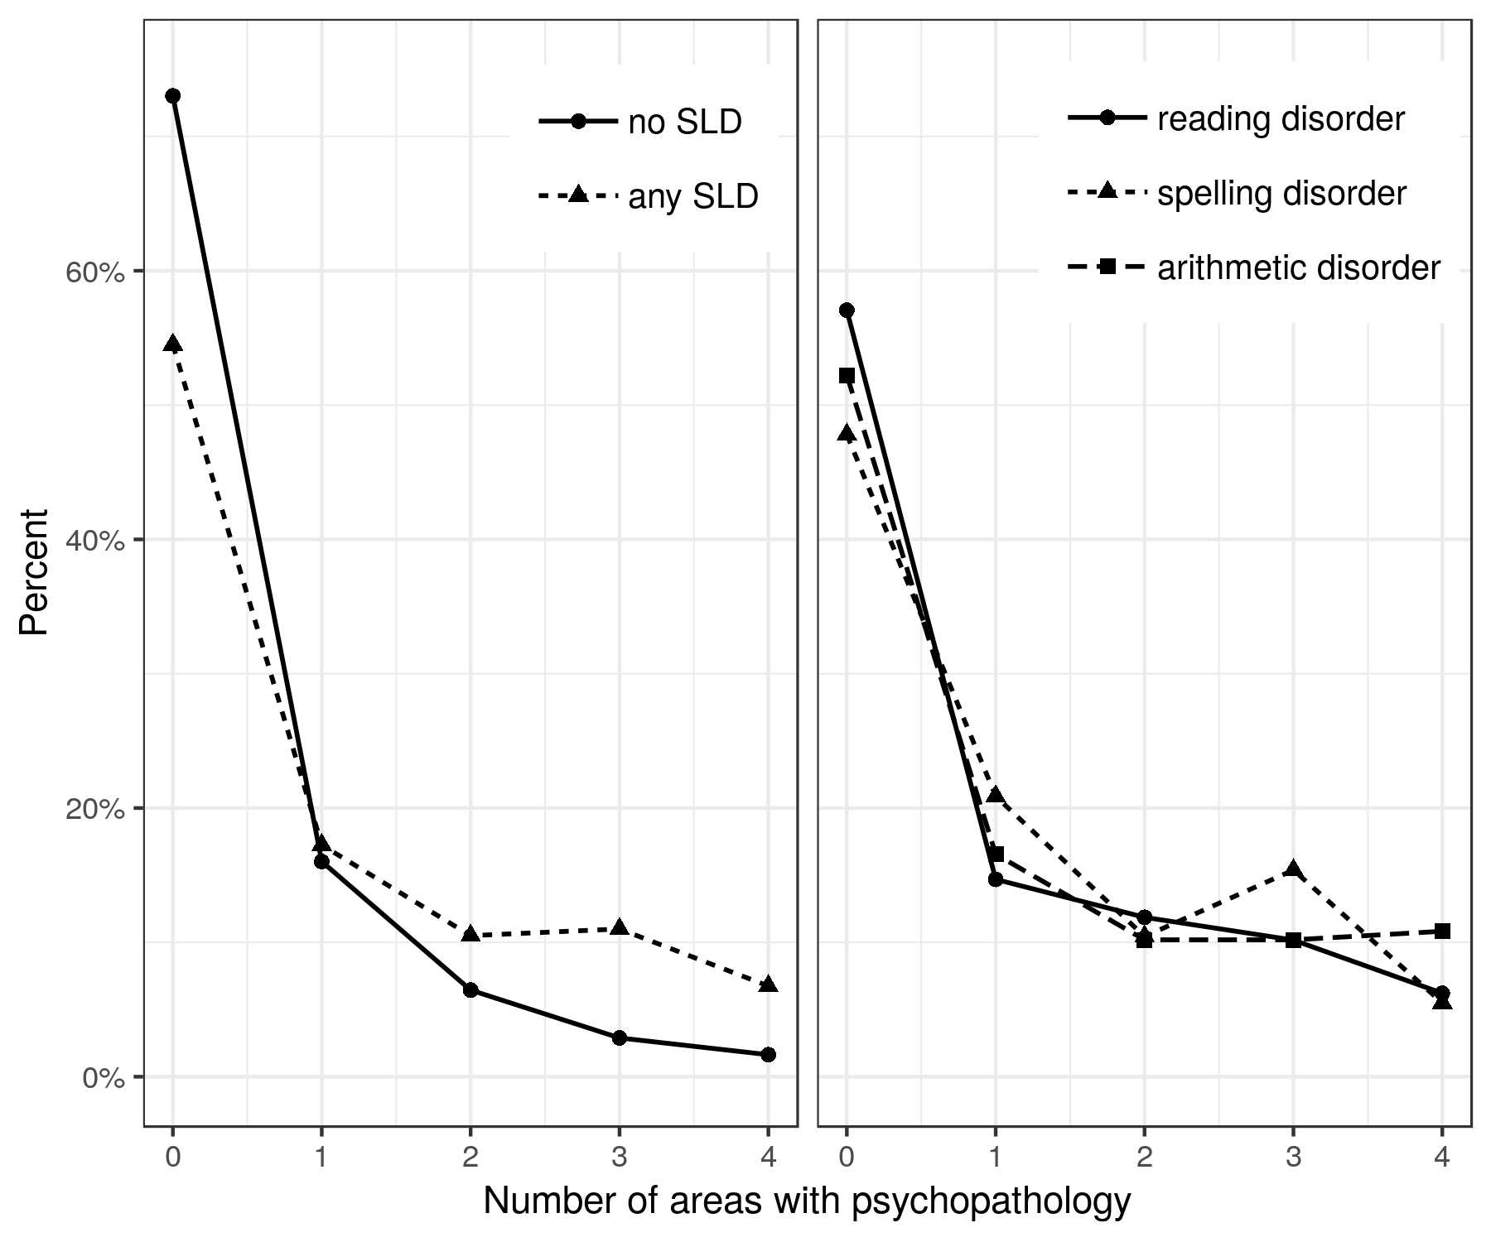

*Figure 1.* Number of areas affected by psychopathology in children with and without different subtypes of SLD.

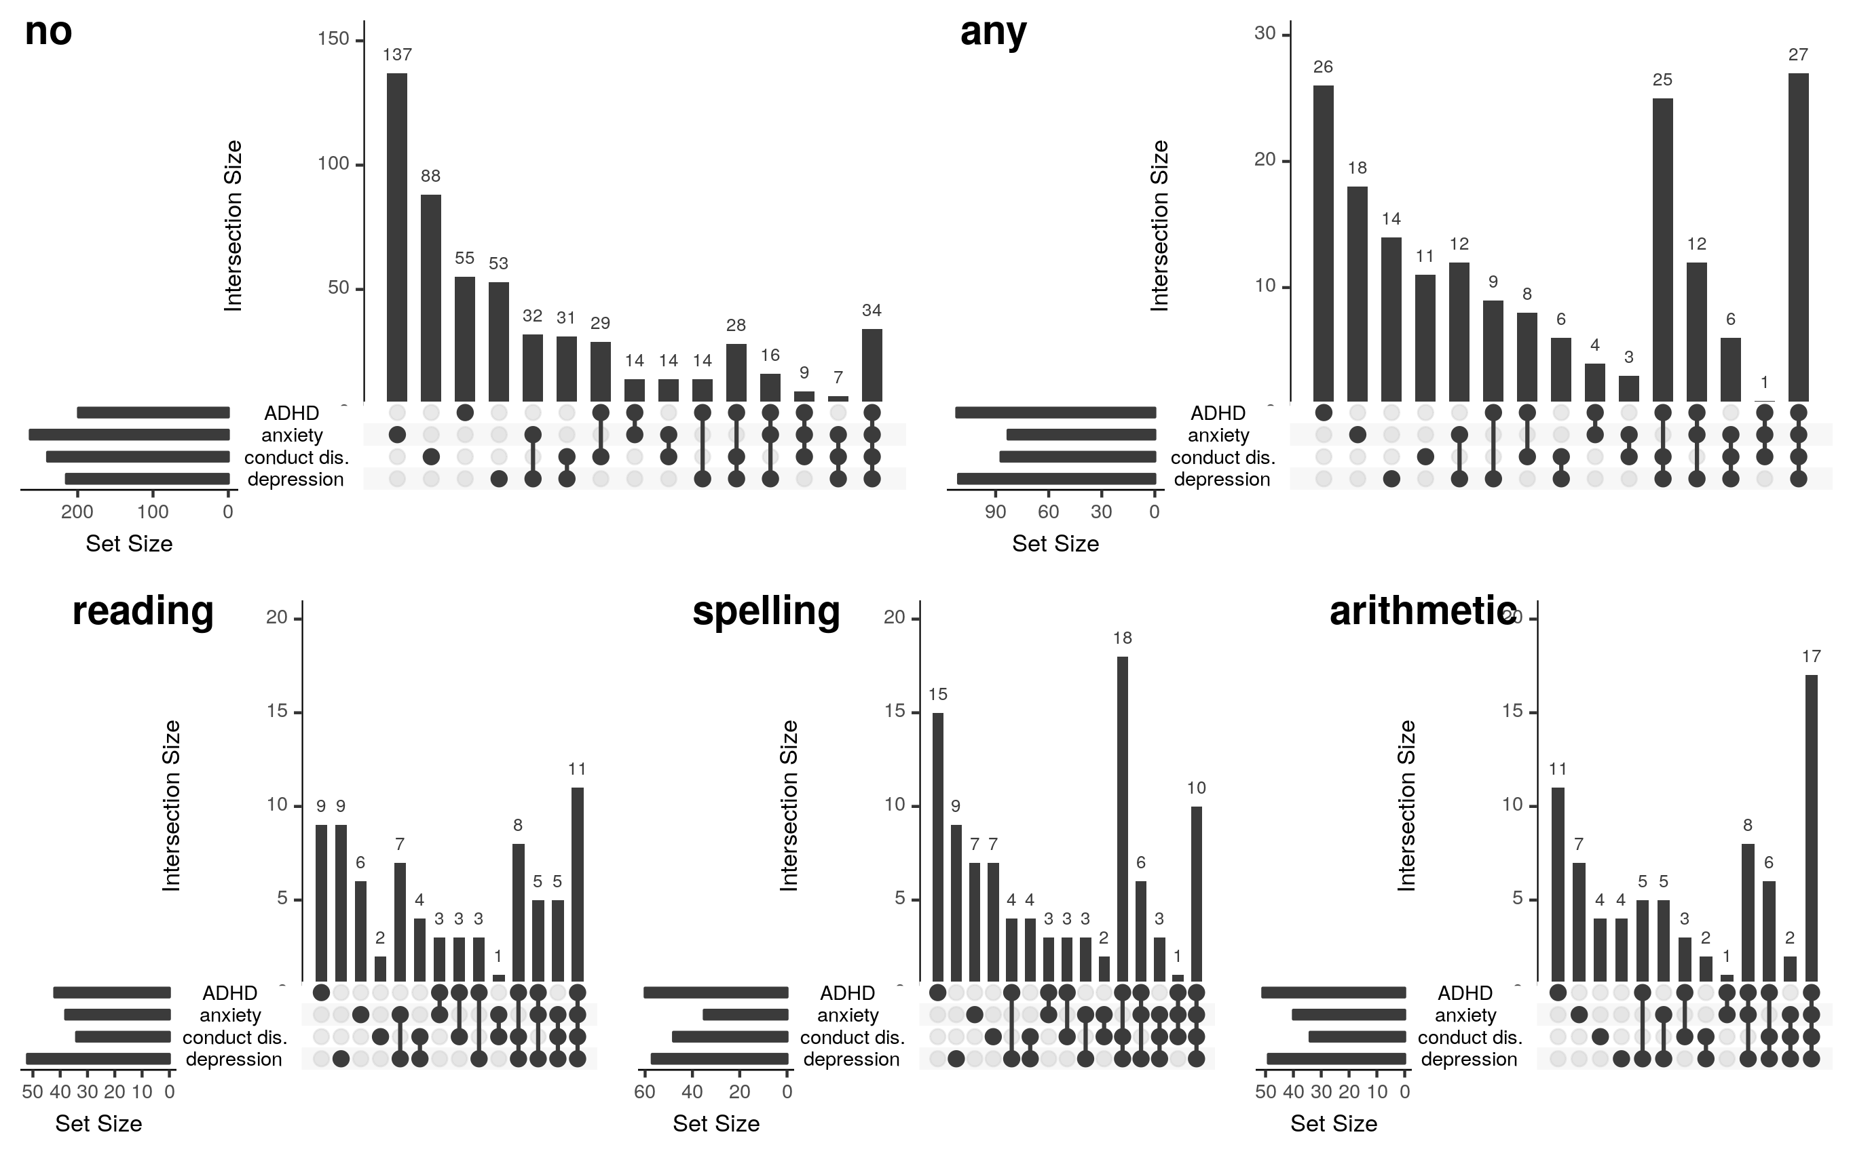

*Figure 2.* “UpSet” graphs visualizing the overlap between areas with psychopathology in children with no SLD, any SLD, reading disorder, spelling disorder, and arithmetic disorder. For each SLD group, the total number of children with the different psychopathologies (anxiety, depression, conduct disorder, and ADHD) is presented in the small horizontal graph on the left. In the graph on the right, the dots indicate the combinations of psychopathologies, and the bar above the respective dots indicates the number of children within this SLD-group affected by the respective psychopathologies. conduct dis. = conduct disorder.

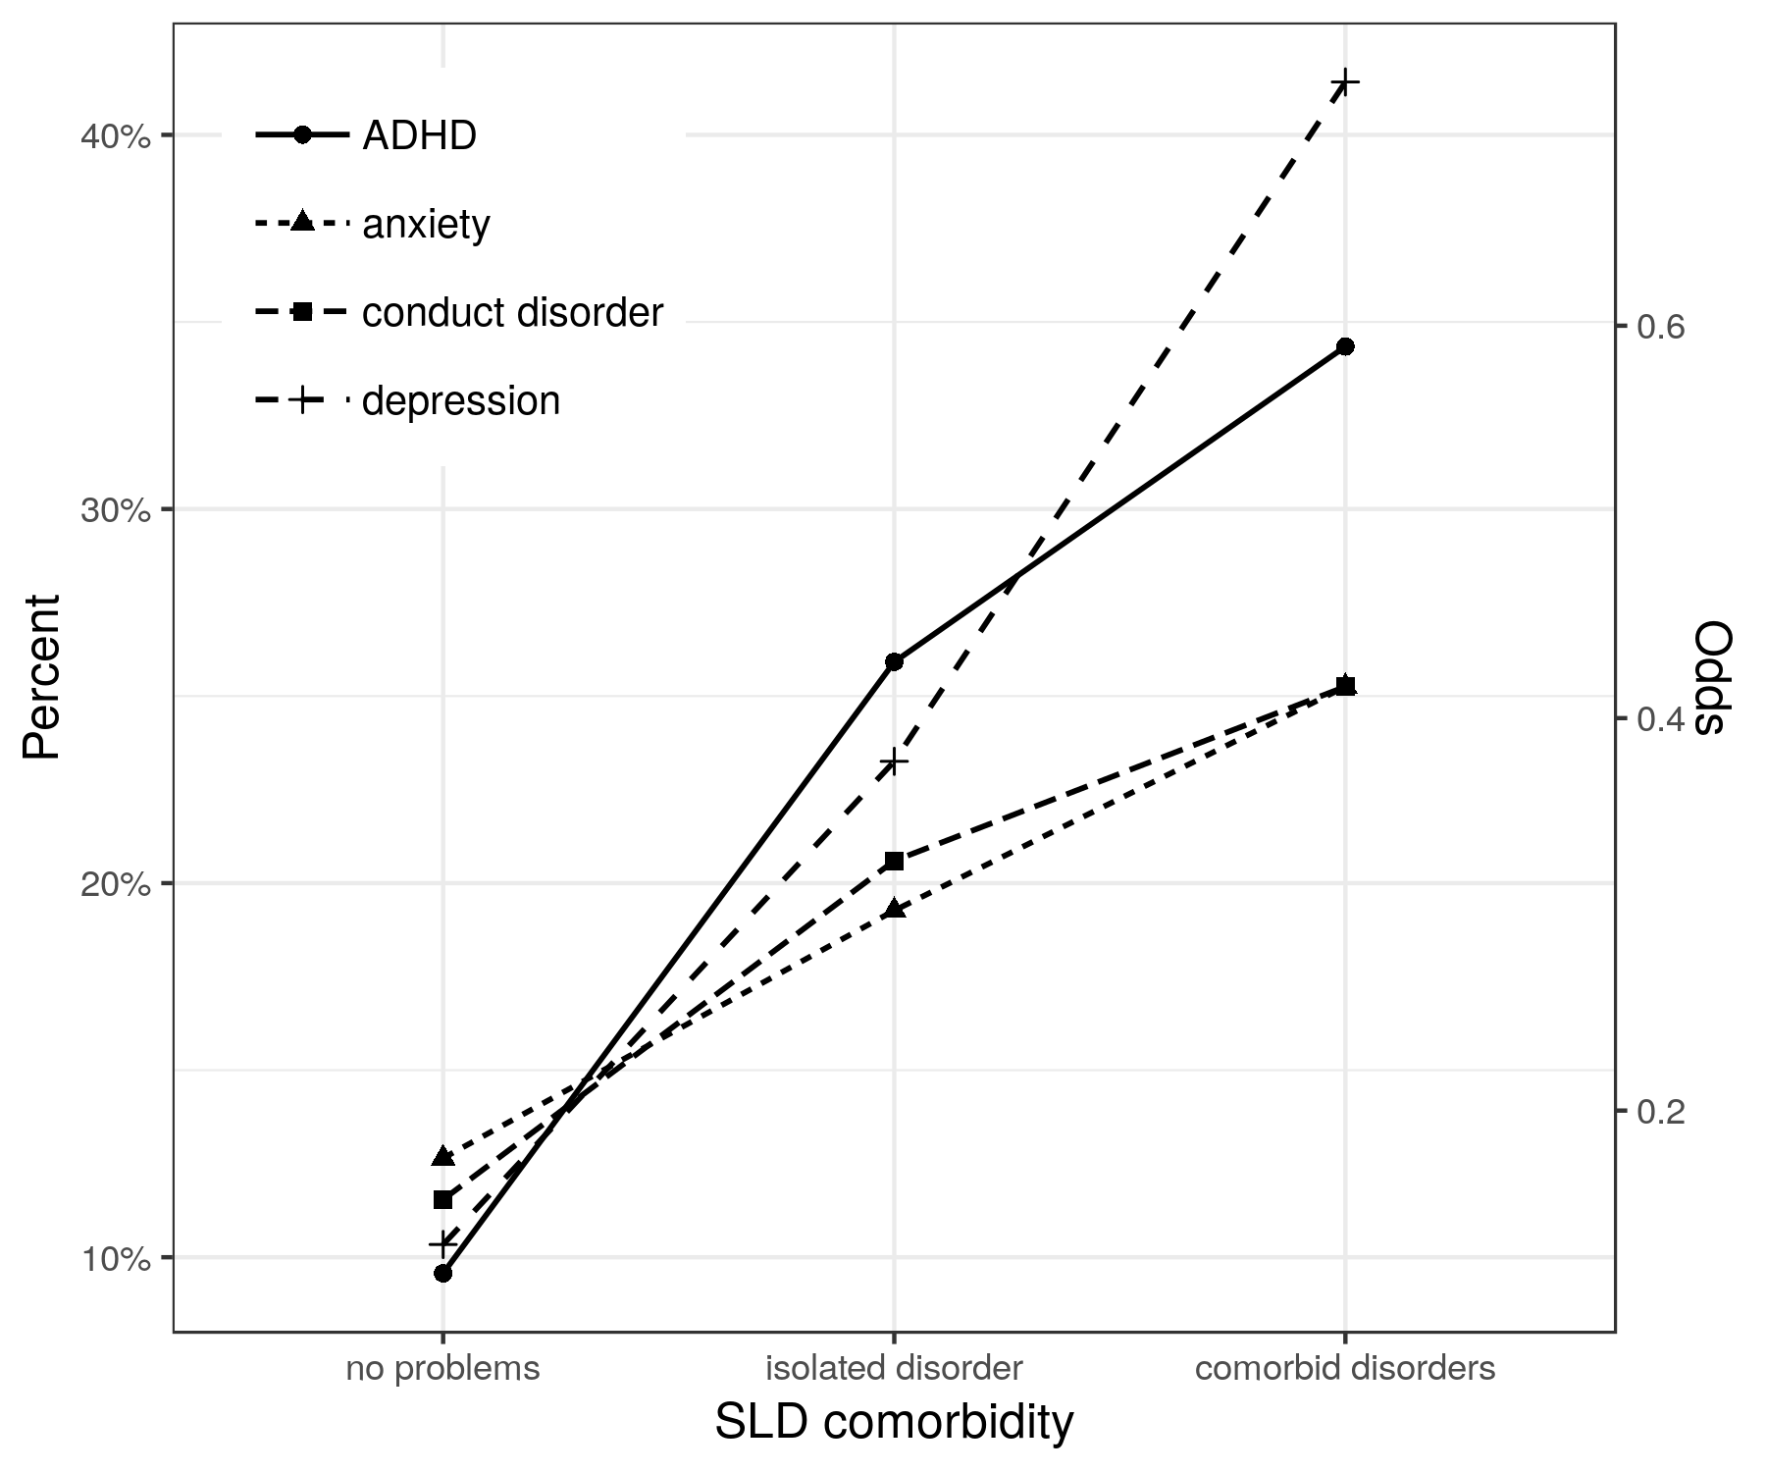

*Figure 3.* Trend in the prevalence of psychopathologies over the groups of children without an SLD, with an isolated SLD, and with comorbid SLDs.

1. “Optional” meant that children would get the reward (amazon.de voucher and participation in a lottery) also without completing this fifth day.