NOAA/NESDIS/NCDC Regional Climate Services
Pacific Region Action Plan
Overview
This document outlines on-going and planned priority activities that are designed to develop and deliver climate services to the Pacific region. The National Research Council defines climate services as “A mechanism to identify, produce, and deliver authoritative and timely information about climate variations and trends and their impacts on built, social-human, and natural systems on regional, national, and global scales to support decision making.” ¹ Such information is essential to many aspects of policy, planning, and decision-making, and the demand for it is growing.
This document draws heavily from the document Towards a Pacific Climate Information System (PaCIS) Plan for Regional Climate Services: A synopsis based on outcomes of the March 22-24, 2011 PaCIS Steering Committee Meeting.² The ‘PaCIS plan’ is based on outcomes of meetings that date back to initial discussions of Pacific climate services at a workshop held in conjunction with the 1999 Pacific Regional Environment Program’s (SPREP) meeting of the Pacific Regional Meteorological Services Directors (RMSD) through to a gathering of 22 PaCIS Steering Committee and working group members for an Implementation Plan Workshop in August 2010 and a meeting of the PaCIS Steering Committee and partners in March 2011. The outcomes of these meetings represent a synthesis of regional information needs from a variety of sources This includes a number of documents, papers and publications reflecting the results of regional workshops, surveys, research, etc. into the state of climate science, climate impacts, and user needs and capabilities.
This document places priority activities within a PaCIS programmatic framework that is itself consistent with a NOAA programmatic framework that brings together ongoing and future climate observations, operational forecasting services and climate projections, research, assessment, data management, outreach, and education – an integrated system of climate services. In so doing, it serves as a mechanism to guide integrated program planning and product development and thereby supports effective and efficient execution of NOAA's climate services strategy.
The Pacific Region³
The U.S. Pacific Islands region is vast, comprising more than 2000 islands spanning millions of square miles of ocean (Figure 1). The islands are isolated. The largest aggregate of land in this region, the Hawaiian Archipelago, is located nearly 2,400 miles from any continental land mass qualifying it as one of the most remote archipelagos on the globe. The islands support about 1.9 million people, a small number by comparison to the continental U.S., but their locations are strategic to U.S. defense and their biodiversity is important to the world. The islands vary from volcanic islands, islands of continental crust, atolls, and limestone islands, to islands of mixed geologic origin. The “high” volcanic island reaches nearly 14,000 feet, while some of the “low” atolls peak at only a few feet above present sea level. There is tremendous landscape diversity on these islands. Isolation and landscape diversity brings about some of the highest species endemism in the world, with several of the U.S. Pacific Islands considered marine biodiversity hotspots.
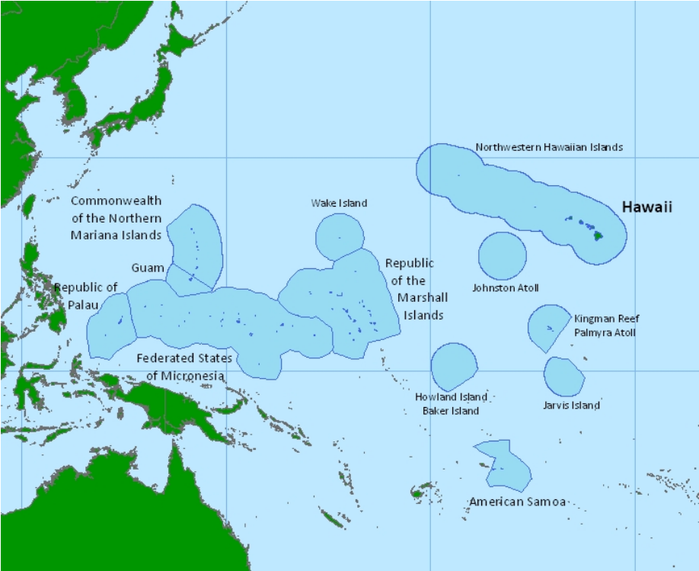

Figure 1. The U.S. Pacific Islands. In its broadest sense the U.S.Pacific Islands include: the State of Hawaii and the Northwestern Hawaiian Islands (Papahānaumokuākea); the Territories of Guam and American Samoa, and the Commonwealth of the Northern Mariana Islands; the Republic of Palau, Federated States of Micronesia (including the states of Chuuk, Kosrae, Pohnpei, and Yap) and the Republic of the Marshall Islands; and the islands of the Pacific Remote Island Areas. Shading indicates each island’s Exclusive Economic Zone (EEZ).

The Pacific Islands region includes demographically, culturally, and economically varied communities. At least 20 languages are spoken in the region. In general, Pacific Island cultures recognize the value and relevance of their cultural heritage and systems of traditional knowledge and customary law developed within their social, cultural, and natural contexts. There is an emphasis on long-term connection with lands and resources, with multigenerational attachment to places. Tourism figures prominently in the gross domestic product of most island jurisdictions. A large U.S. military presence makes the defense sector an important source of income. Natural resources are limited, with many communities relying on agriculture and ecosystems (such as coral reefs, open ocean, streams, and forests) for sustenance and revenue. Adaptive capacity in the region varies with the availability of socioeconomic and institutional resources. Typically, high islands support larger populations and infrastructure, which in turn attracts industry and allows the growth of different types of institutions.
The Pacific Islands are exposed to climate changes that affect every aspect of life. Ocean and island ecosystems are changing with warming air and ocean temperatures, shifting rainfall patterns, changing frequencies and intensities of storms and drought, decreasing base flow in streams, rising sea levels, and changing ocean chemistry. Fresh water supplies for natural systems, as well as communities and businesses are at risk. Food security is threatened through impacts on both agriculture and fisheries. Communities on low-lying atolls are particularly at risk and the built environment on all islands is at risk from coastal flooding and erosion. Loss of habitat for endangered species such as monk seals, sea turtles, and Laysan ducks is expected along with increased coral bleaching episodes, expansion of avian malaria to higher elevations, and changes in the distribution and survival of the areas’ marine biodiversity.
The PaCIS Programmatic Framework
PaCIS identifies a set of core capabilities that represent an ‘end-to-end’ system of products and services. They are grouped into three areas, with execution spanning local, regional, national, and international levels:
- Education, Outreach and User Information Needs
- Operational Climate Observations, Products, and Services
- Research and Assessment

Targeting products and services to unique user needs is accomplished through a program planning and implementation framework organized around three focus areas associated with climate issues critical to the region:
- Preserving Fresh Water Resources and Minimizing the Impacts of Drought
- Fostering Community Resilience to the Impacts of Sea Level Rise (SLR), Coastal Inundation, and Extreme Weather
- Sustaining Marine, Freshwater, and Terrestrial Ecosystems

Focusing on these areas integrates the core capabilities. It draws upon them in a way that supports more harmonized development and delivery of new or improved products and services that meet the needs of specific users. It serves to identify gaps in service delivery and opportunities for interagency resourcing and partnerships. Focusing on sub-regions within the Pacific is also relevant as it responds to differences that exist among the Pacific Islands in terms of climate drivers, issues, and institutional capacities. This provides for more precise targeting and delivery of products.
NOAA has established a program planning and implementation framework that corresponds closely to the above. NOAA recognizes as core capabilities: Integrated Services and Assessment; Observations and Monitoring; Predictions and Projections; and Research and Modeling. As societal challenge areas associated with climate issues critical to the nation, NOAA recognizes: Climate Impacts on Water Resources; Coasts and Climate Resilience; Changes in the Extremes of Weather and Climate; and Sustainability of Marine Ecosystems.
Placed within the PaCIS program planning and implementation framework are three broad categories of actions through which climate services in the Pacific region are developed and delivered.
Building a Network of Networks. No single agency, institution, or organization can provide all of the climate services that the region needs. What is required is an organizational framework and corresponding mechanisms that support sustained two-way dialogs among diverse science, service, and user communities via a ‘network of networks’ as a means to nurture essential partnerships, align complementary interests and activities, and thereby grow a regional culture of communication, coordination and collaboration.

A ‘pearl’ has been used as a metaphor to describe the myriad of networks comprised of communities of scientists, practitioners, and decision-makers intertwined across and through various levels from

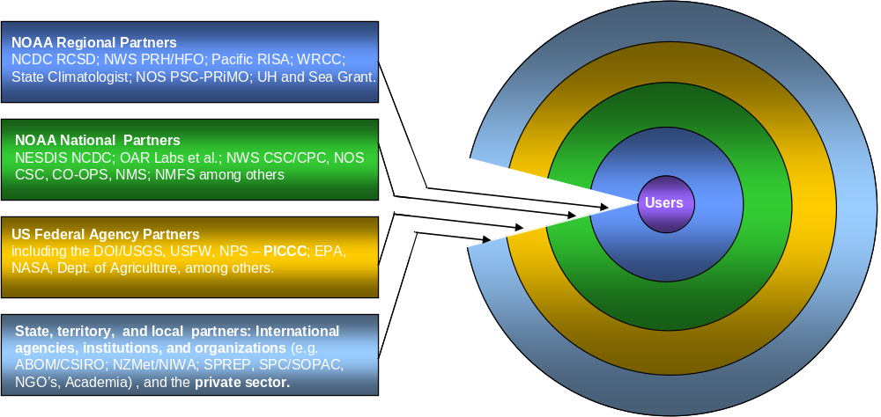

Figure 2. The NOAA Climate Services ‘Pearl’ in the Pacific. Depicted here is the ‘pearl’ specific to NOAA regional climate services in the Pacific. At the center are the users that drive the demand for climate services. Region-specific elements within NOAA and/or associated with NOAA that are actively engaged in climate science and services form an inner layer that wraps around the core. Progressing outward are layers composed of other regional and national elements of NOAA; regional and national elements of other federal agencies; and finally a broad range of non-federal, state, territory, local and international agencies, institutions, and organizations. Extending this metaphor to describe the networks of other agencies, institutions, and organizations -with each forming their own pearl- results in a ‘string of pearls’ that hold the expertise, experience, and perspective required to provide all of the climate services that the region needs. A complete list of regional partners can be found at http://www.pacificcis.org/.

national and international policy development and program planning to regional and local project development, implementation, and evaluation (Figure 2).

Conducting Assessments as a Sustained Process. The assessment process exemplifies the synergy between science and service. It frames the dialogs among the science, service, and user communities, and as such, is essential to guiding the development and evaluation of operational products, services, and research. An assessment process that incorporates current research and considers user requirements and user feedback by cultivating an approach grounded in the iterative ‘co-production of knowledge’ at multiple levels is required to ensure that science and services are appropriately and effectively brought to bear on relevant problems and questions.

Assembling and Advancing Core Capabilities to Develop and Deliver Products and Services Focused on Regional Issues. Making available a collection of information ranging from understanding and predicting climate variability and change to understanding climate impacts and informing adaptation is a fundamental element of climate services. It requires that emerging new science and associated capabilities are transmitted to policy and decision-makers, and conversely their needs (e.g., product content, format, and time frame) are conveyed back to scientists and practitioners. Further, it requires recognition of issues, partners, capabilities, and priorities in the region and orchestration of planning and implementation of a broad range of activities (synonymous with the core capabilities) in a way that ultimately results in operational products and services that meet the requirements of unique sets of decision-makers (i.e., reliable, relevant, timely, and easy to access and use: Figure 3).

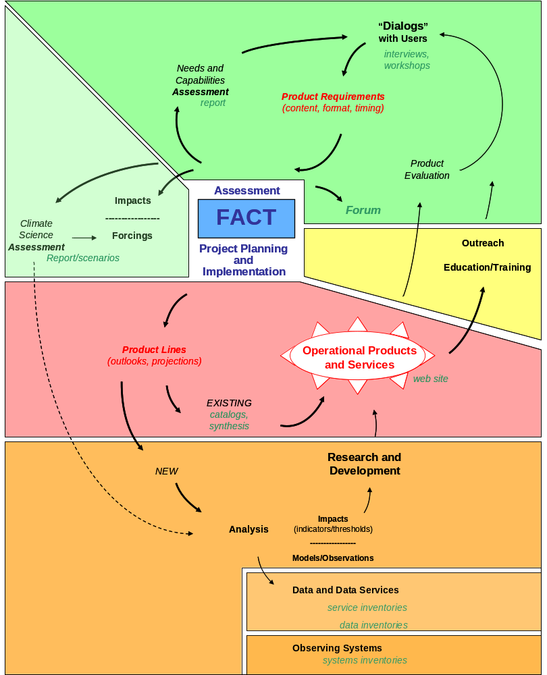

Figure 3. The PaCIS Climate Services Execution Architecture. The shaded areas encompass related sets of activities and outputs: Assessment (in green); Research and Development (in orange); Operational Products and Services (in red); and Outreach, Education and Training (in yellow). Note the relationships within and between them, as depicted by the arrows. Together they constitute an iterative process leading to the development and delivery of operational products and services. Also note the Focus Area Coordination Team (FACT, in blue) at the center of the diagram as the driver of the process. Each FACT will carry out a similar set of activities and generate comparable outputs; however the combinations of leaders and participants will differ for each FACT depending on the various agency, institution, and organizations mission, interests, and expertise.
Priority Actions

Efforts to identify and prioritize actions to further the development and delivery of climate services in the Pacific region are in their formative stages. These efforts will continue, evolving iteratively and involving extensive stakeholder engagement. Efforts to date suggest that, at a minimum, priority needs to be given to actions that: 1) fit well within the PaCIS mission; 2) are most feasible; and 3) have the greatest potential impacts. They also suggest that the actions outlined below are among the highest priority over the next 1-2 years. These priority actions are intended to:
- Improve access to and use of existing climate data products and services;
- Enhance our understanding of the climate system and its social and environmental impacts in a way that leads to the creation of new products and tools that can be used to guide and support decision-making;
- Expand the cadre of individuals skilled in understanding the science behind and consequences of a changing climate, and capable of making use of the technical capabilities at their disposal; and
- Broaden and strengthen strategic programs and partnerships across the Pacific.

Note that the NOAA Integrated Services and Assessment capability area encompasses activities in the first two PaCIS action areas described below. Activities associated with the other three NOAA capability areas fall into the third PaCIS action area described below.

Build a Network of Networks. Attention will be directed at establishing and maintaining an expanded PaCIS network. This will lay the groundwork needed to integrate activities and leverage resources. Specific activities in this action area include:
- The Pacific RCSD currently sits as the Chair of PaCIS, and in this role conducts a PaCIS Executive Council meeting and updates the Steering Committee every four months. The Pacific RCSD also serves a member of the Pacific Islands Climate Change Cooperative (PICCC) LCC Executive Council and sits on advisory, coordinating, and governing bodies including the NOAA Pacific Region Executive Board, the NOAA Sentinel Sites advisory group, and the Papahānaumokuākea Marine National Monument Climate Change Working Group, among others. As the types of activities related to facilitating communication, coordination, and collaboration constitute a significant component the RCSD’s mission, work in this area will undoubtedly continue and expand over the next 1-2 years.
- Particular attention will be given to continued development of the PaCIS Focus Area Coordination Teams (FACTs). The FACTs consist of a mix of and are led by different sets of agency, institution and organization representatives leading or overseeing projects and activities that fall within a given focus area and across capability areas. As such, the FACTs are the nexus between science and service and play a key role within PaCIS. This is evident in Figure 3, where the FACT (blue box) sits at the center of a hub of that need to be orchestrated in order to generate a focus area-related line of operational products and services that meet the requirements of unique sets of decision-makers. The FACTs have already made a significant contribution to regional assessment-related activities (see PIRCA below). Over the coming months, they will be directed towards evaluating the status of various science and services aspects of a respective focus area, conducting a gap analysis and subsequent alignment and program and project planning exercise across the core capability areas and, in the form of detailed work plans, identifying actions that can be taken to improve the situation. For example, the FACTs may identify specific projects and activities that represent ‘anchors’ in the context of the regional focus areas and that, as such, elements of other projects and activities can be tied to or built-upon. They may propose plans for joint action in response to requests from users or practitioners.

Conduct Assessments as a Sustained Process. Attention will be directed at employing the PaCIS network to continue efforts associated with an on-going, comprehensive, integrated assessment process. Specific activities in this action area include:
- The Pacific Islands Regional Climate Assessment (PIRCA) is a collaborative effort aimed at assessing the state of climate knowledge, impacts, and adaptive capacity in Hawaii and the U.S.-Affiliated Pacific Islands. Spearheaded by the Pacific RCSD along with representatives from the Pacific RISA and the USFW PICCC, and including representatives from across NOAA, other U.S. federal agencies, universities, as well as international participants from other national agencies and regional organizations, this effort led to the formulation of the technical report submitted to the USGCRP National Climate Assessment for Hawaii and the Pacific Islands. The technical report is currently in press. Over the coming months attention will be directed at distribution of information contained in the technical report, through presentations at workshops and other such events, as well as the development of sub-regional or focus area-related synthesis documents or other such materials as appropriate. Among other things, over the next year or two this information will be used to support education, outreach and trainings that include regionally-relevant and regionally-requested content (see below).
- As part of the PIRCA and in collaboration with PaCIS partners, particular attention will be given to convening and conducting climate impacts and indicators ‘caucuses’ in central, southern, and western sub-regions of the Pacific. At each event, resources managers, community planners and other decision makers; representatives of government ministries and other policy makers; regional meteorological service directors and other in-country communicators; as well as research scientists other subject matter experts, cultural practitioners, the press, and the general public will be brought together to share information on the state of knowledge as it pertains to climate change and associated impacts. These events will provide an opportunity to highlight the PIRCA technical report and use it as the foundation of an iterative dialog between the local experts, key decision makers, and scientists as a means to inform decision and policy-making and guide applied research and product development.
- Resources permitting, in a year or two an extensive round of product and trainings development based on and responsive to needs identified by the region and by individual use-sectors during the sub-regional caucuses will commence. These so-called ‘directed dialogs’ will bring users and providers together for a round of targeted and intensive in-country exchange of information. The dialogs will take the form of a suite of small group workshops and/or individual trainings directed at the application of focus area-related products or other topics of particular interest to different sets of decision-makers. The dialogs will also include a process for product evaluation as a means to identify refinements needed to make products more effective, as well as easier to access, understand, and use.

Assemble and Advance Core Capabilities to Develop and Deliver Products and Services Focused on Regional Issues. Through the FACTs attention will be directed at conducting projects and activities within and between the core capability areas that lead to the development and delivery of products and services that meet issue-specific needs. This will range from the packaging of existing primary level information centered on understanding and predicting climate variability and change to the creation of new value-added information targeted at understanding climate impacts and informing adaptation.

Specific activities in this action area that pertain to Predictions and Projections include:
- Developed in support of PaCIS by representatives of the NOAA NCDC working in the Pacific, pacificislandsclimate.org (“piko”) is a gateway to a broad range of information related to climate in the Pacific Islands. It includes summaries of programs, projects, and activities, as well as products and services. Formed through the collaboration of and contributions from the PaCIS family, it is serves as a shared resource for research scientists, service providers, and decision-makers. Resources permitting, work will continue on this regional web portal over the next 1-2 years. Areas targeted for future buildout include:
  - A web-based catalog of existing regional seasonal ‘outlooks’ and multi-decadal ‘scenarios’, which is already underway.
  - A web-based climatology atlas that integrates existing products describing historical ‘norms and storms’ of Essential Climate Variables such as air temperature, rainfall, and sea level.
  - A web-based inventory of/guide to existing regional data sets with an initial emphasis on rainfall, sea level, and sea surface temperature.
  - A web-based catalog of existing issue-related regional products, including climate change visualization and decision-support tools that can be used to assess impacts and evaluate adaptation options.
While these efforts are intended to address regional needs, they also represent part of a larger effort to prototype and build out an integrated regional web presence and, in so doing, contribute significantly to the creation of the climate.gov portal's regional section.
- Improvements to seasonal outlooks have been identified as high priority over the next 1-2 years. Building upon a considerable amount of information generated through the NWS PEAC Center and others, improvements take several forms.
  - Generation of a quarterly regional Climate Impacts and Outlook ‘one-pager’. Through a collaborative effort involving the NOAA NWS, NESIDS, OAR, NOS, and NMFS as well as the University of Hawaii and University of Guam, this outlook product is brings together climate event current impacts and projections into a concise, easy to digest format.
  - A synthesis of regional operational outlooks leading to the development of applications guidance with an initial emphasis on rainfall, sea level, and sea surface temperature.
  - Enhancement to outlooks, which includes working with NWS PEAC, the University of Hawaii, the University of Guam and other partners to build local capacity to document extremes impacts (e.g. fire and drought, stream flooding and landslides, coastal flooding and erosion) as a means to evaluate and improve seasonal forecasts.
  - Enhancements also include efforts to create an Integrated Water Level Service (IWLS) as part of regional climate-related sub-system demonstration project. In this regard, representatives from the Australian BOM an CSIRO, New Zealand NIWA and MetService, SOPAC, NOS CO-OPS and NWS PEAC among others are meeting monthly meeting monthly to formulate of a joint research plan to support the development and delivery of seasonal water level outlooks products that build upon, join, and enhance existing products. Resources permitting, innovative proof-of-concept products are anticipated within the next year.
  - Finally, work to improve outlooks incudes efforts to value-add and customize information to create outlooks that are more precisely targeted at the needs of specific users or sectors (e.g., outlooks for emergency managers, water resource planners, coral reef managers) and/or sub-regions.
- The development of multi-decadal scenarios, with an initial focus on waves and water levels has been identified as a high priority over the next 1-2 years (see below).
- Continuation of efforts started as part of the Pacific Storms Climatology Products program (http://www.pacificstormsclimatology.org/) to develop an integrated suite of products that delineate patterns and trends of storm frequency and intensity - "storminess"- within the Pacific region, resources permitting. These products will help users to explore how extreme events have been expressed historically and may be expected to be expressed in a changing climate.

Specific activities in this action area that pertain to Research and Modeling include:
- Carrying out a joint program of applied research leading to the development of guidance that outlines best practices and methodologies that can be used to formulate probabilistic estimates of extreme events under a changing climate for specific locations in the Pacific Islands (http://www.noaaideacenter.org/slr/). This includes the creation of innovative proof-of-concept products that can be used directly to support decision-making in areas ranging from area-wide vulnerability assessment related to climate adaptation planning and disaster risk reduction to site-specific analysis related to design and maintenance of facilities. It is anticipated these products will be available for NOAA Sentinel Site locations as well as those of interest to the DOD and USACE within the coming year. Attention will also be given to incorporating the results of the work into IT-based decision-support and visualization tools.
- Formulation of a joint research plan to support the development and delivery of seasonal water level outlooks products that build upon, join, and enhance existing products (noted above).
- Support for climate model down-scaling and coupled climate models towards the creation of a regional model ‘test bed’.

Specific activities in this action area that pertain to Observations and Monitoring include:
- Efforts to build local capacity to document extremes impacts (noted above).
- A survey and assessment of regional observing assets by ECV with an initial focus on rainfall and sea level, resources permittiing.
- Regional plans for the collection, management, recovery, and delivery of ‘climate quality’ data with an initial focus on rainfall and sea level, resources permitting.
- Identification of data that is ecologically and socially relevant with respect to diagnosing ‘climate sensitivity’ (i.e., so-called indicators and thresholds).

Other Considerations

The actions identified above are intended to meet the demand from decision-makers in the Pacific Islands for ‘actionable’ information needed to manage risks and support practical decision-making in the context of climate variability and change. Implementing these actions will require commitment to an iterative, nested, collaborative and participatory process of program planning and product development. Achieving the specific outputs identified here will require adequate fiscal and dedicated human resources. Leads for the multiple and complex actions that need to be carried out to achieve the outputs identified above will vary depending on respective mission, interests, and expertise. Effective coordination of activities among partners and stakeholders that includes a balancing of agency, institution, and organization portfolios will be required.

¹Restructuring Federal Climate Research to Meet the Challenges of Climate Change. The National Academies Press, Washington, DC, 13. 5NRC. V. Ramanathan (Chair), 2009.

²Towards a Pacific Climate Information System (PaCIS) Plan for Regional Climate Services: A synopsis based on outcomes of the March 22-24, 2011 PaCIS Steering Committee Meeting. December 2011.
(http://www.noaaclimatepacis.org/steering/PaCIS%20Synopsis_12.11%20FINAL.pdf from http://www.pacificcis.org/ )
³Hawaii and the Pacific Islands. Regional Chapter for the USGCRP National Climate Assessment, J. Leong and J.J. Marra, coordinating lead authors (in prep.)

