Report: Assessing MRP Implementation Feasibility at R.K. Engineering Co., Vadodara



PRESENTED BY- MARYAM KARTELA

DIVISION-SFI

SUBJECT-PRODUCTION AND OPERATIONS MANAGEMENT

ROLL NO-12

PRN-8021004361

FIRST YEAR MBA SEM-2 (2024-26)

PRESENTED TO-DR.AMIT PATEL

1. **INTRODUCTION**

Material Requirements Planning (MRP) is a foundational system utilized in manufacturing to effectively plan and manage production processes. Its core objective is to ensure that the necessary materials are available precisely when needed for production, thereby minimizing inventory holding costs and avoiding potential delays in the manufacturing schedule 1. By providing a structured approach to inventory control, production scheduling, and material procurement, MRP systems play a critical role in optimizing manufacturing operations. The adoption of such a system can be particularly significant for small and growing manufacturing enterprises, offering benefits such as enhanced operational efficiency, substantial cost reductions, and an overall improvement in customer service capabilities 2. For these businesses, which often operate with limited resources, the gains in efficiency and control provided by an MRP system can be instrumental in fostering sustainable growth and enhancing their competitive position.

This report aims to evaluate the potential for implementing an MRP system at a small manufacturing firm, R.K. Engineering Co., which is located in Vadodara, Gujarat. By analyzing the company's current operations and the inherent benefits of MRP, this assessment will determine the feasibility and potential impact of such an implementation. Furthermore, a tentative MRP flow diagram tailored to the firm's activities will be proposed, and an appropriate MRP model will be suggested for consideration.

# Company Profile: R.K. Engineering Co.

R.K. Engineering Co. is a manufacturer and exporter of food processing machines based in Vadodara, Gujarat, having been established in the year 2005 4. The company's primary business revolves around the production of a diverse range of machinery catering to the food processing sector. Their product portfolio includes essential equipment such as Noodles Making Machines, Pasta and Macaroni Making Machines, Chapati Making Machines, and Vermicelli Making Machines, alongside related machinery like Electric Steam Noodle Boilers and Noodles Dryer Machines 5. The variety of these machines suggests a multifaceted manufacturing process that likely involves the management of numerous components and sequential production stages, indicating a potential suitability for the structured approach offered by an MRP system.

Operating as both a manufacturer and exporter, R.K. Engineering Co. serves a market that extends beyond the local region 4. The company's approximate annual turnover, ranging between 40 Lakhs and 1.5 Crores, and its employee size, estimated to be between 11 and 25 individuals, classify it as a small-scale enterprise 4. Given its size, any proposed MRP system would ideally be scalable and cost-effective to ensure maximum benefit without imposing undue financial or operational strain.

# It can be reasonably inferred that the production of their machinery involves several key stages. These likely include the sourcing of raw materials such as metals and electronic components, various fabrication processes like cutting and welding, the assembly of individual parts into finished machines, and rigorous quality control measures to ensure the reliability and performance of their products . Understanding the general nature of these manufacturing activities is crucial for assessing the specific areas where an MRP system can provide the most significant improvements and efficiencies. 3 Current Manufacturing Activities Assessment

During my recent visit to R.K. Engineering Co. in Vadodara, I closely observed the day‐to‐day operations and gathered insights into how the firm manages its production processes. The detailed observations are as follows:

**Inventory Management:**  
• The company currently maintains its raw material and component records using manual methods. Employees rely on spreadsheets and handwritten logs to update inventory levels throughout the day.  
• During the visit, it became clear that updates to inventory were performed on a scheduled basis rather than in real time. This periodic updating sometimes resulted in discrepancies between actual stock levels and recorded figures.  
• I observed instances where delays in manual entries led to occasional stockouts in certain production lines, as well as periods of overstocking that tied up working capital. Such inefficiencies suggest that the system lacks the dynamic responsiveness needed to adjust to rapid changes in demand or supply.

**Production Scheduling and Workflow:**  
• Production planning appears to be reactive; orders are scheduled based on immediate customer demand rather than through a forecast-driven approach. Managers typically review available capacity at the start of each shift and then adjust the schedule accordingly.  
• Coordination between different manufacturing stages relies heavily on verbal communication and physical documentation. I noted that production orders and process updates were passed along manually, which sometimes caused delays and miscommunication between departments.  
• The absence of an integrated scheduling tool means that there is little visibility into capacity constraints or lead times, leading to unanticipated idle machine time and bottlenecks in the workflow.

**Procurement and Material Replenishment:**  
• Procurement activities are driven by immediate production needs. Without an automated system to predict and alert for material shortages, purchase orders are generated on a just-in-time basis.  
• This reactive approach to ordering often results in delayed deliveries, impacting production timelines. Moreover, without centralized data on material usage, negotiating better terms with suppliers or taking advantage of bulk-order discounts becomes challenging.  
• The manual process used for linking production schedules to material orders is time-consuming and increases the risk of errors, potentially affecting both cost efficiency and the overall smoothness of operations.

**Overall Observations:**  
The field visit revealed that while R.K. Engineering Co. has managed to sustain its its operations through these manual methods, the lack of a fully integrated Material Requirements Planning (MRP) system is evident. The reliance on spreadsheets and periodic manual updates creates gaps in real-time inventory control and production planning. These inefficiencies could be mitigated by adopting an MRP system that would provide:  
– Real-time tracking of inventory and material usage  
– Automated generation of production orders and purchase requests based on demand forecasts and current stock levels  
– Improved synchronization across production stages, thereby reducing downtime and minimizing errors in communication

Given these observations, it is clear that transitioning to a modern MRP system would not only streamline operations but also significantly enhance overall productivity and cost management at R.K. Engineering Co.

# 3 Potential Benefits of MRP Implementation for R.K. Engineering Co.

The implementation of an MRP system at R.K. Engineering Co. holds the potential for several significant benefits across its operations. One key advantage is improved inventory control. An MRP system can provide real-time visibility into the levels of all raw materials and components, track their movement throughout the production process, and optimize overall stock levels. This capability can substantially reduce the risk of both stockouts, which can halt production, and overstocking, which unnecessarily ties up financial resources 2. For a manufacturer of machinery with potentially numerous parts required for each product, having accurate and

up-to-date inventory data is crucial for ensuring timely production and maintaining cost efficiency.

.

Furthermore, an MRP system can significantly enhance production planning and scheduling. By automating the scheduling process based on factors such as customer demand, the availability of necessary materials, and existing production capacity, the company can achieve a more efficient production flow and provide more accurate lead time estimations to customers 1. This improved scheduling can lead to better utilization of production equipment and a reduction in downtime, both of which are vital for a small manufacturing firm aiming to maximize its output 10. The integration of these factors can also contribute to reduced lead times. With better inventory management and more efficient production planning, R.K. Engineering Co. can potentially shorten the time it takes to fulfill customer orders. This improvement can lead to increased customer satisfaction and provide a competitive edge in the market 2.

Procurement planning is another area that stands to benefit from MRP implementation. The system's ability to automatically generate purchase orders based on the identified material requirements allows for better planning of purchases. This proactive approach can potentially enable the company to negotiate more favorable terms with its suppliers and ensure a more consistent supply of necessary materials 2. Ultimately, these operational improvements can translate into better customer service. By providing more reliable delivery dates and demonstrating improved responsiveness to customer needs, R.K. Engineering Co. can build stronger customer relationships and enhance loyalty 12. Finally, the data-driven nature of MRP systems provides a significant advantage. The system generates valuable data and reports on various aspects of the business, including inventory levels, production performance, and procurement activities. This access to accurate and timely information empowers the company to make more informed decisions and continuously identify areas for operational improvement and optimization 2.

# Proposed MRP System and Tentative Flow Diagram

Considering the scale and operational characteristics of R.K. Engineering Co., particularly its potential as a make-to-order manufacturer of food processing machinery 1, a suitable MRP model would be either an **MRP I** system or a modern, cloud-based **MRP system specifically designed for small businesses** 3. Cloud-based MRP solutions often present a compelling option for small enterprises due to their inherent scalability, cost-effectiveness, and ease of use, which typically requires less extensive IT infrastructure 3. Furthermore, MRP I, focusing primarily on material requirements planning, addresses the fundamental need for any manufacturing company to effectively manage its material inputs 11.

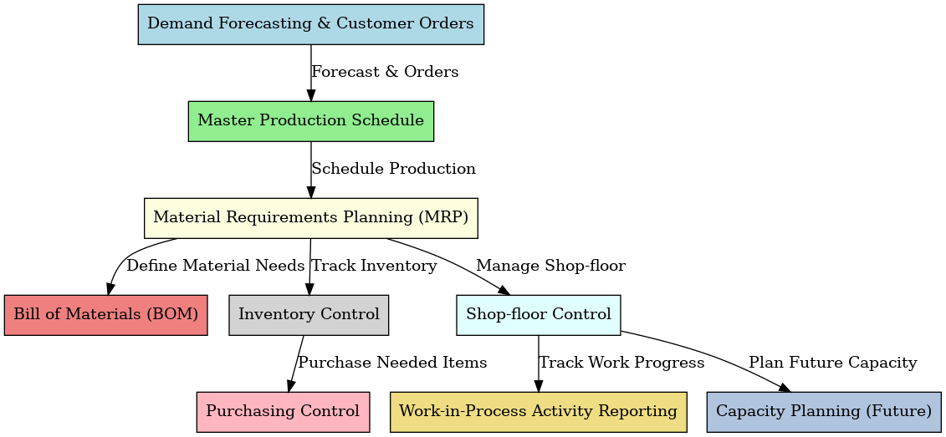 The tentative MRP flow diagram for R.K. Engineering Co. would encompass the following key stages:

* 1. **Demand Forecasting:** The process begins with the input of sales forecasts and actual customer orders into the MRP system. This provides the initial data regarding the demand for the company's food processing machines 1.
  2. **Bill of Materials (BOM):** For each type of food processing machine manufactured, a detailed Bill of Materials needs to be defined within the system. This BOM lists all the components and raw materials required to produce one unit of the finished product 1.

**Inventory Status:** The MRP system continuously tracks the current inventory levels of all raw materials and components held by R.K. Engineering Co. This real-time data is crucial for accurately calculating net material requirements 10.

1. **MRP Processing:** The core of the MRP system involves processing the demand data, the BOM information, and the current inventory status. The system calculates the net material requirements by comparing the total required materials (based on demand and BOMs) with the materials currently available in inventory. This calculation identifies any shortages that need to be addressed 1.
2. **Output Reports:** Based on the MRP processing, the system generates two primary types of output reports: purchase orders for the raw materials and components that need to be procured from suppliers, and production orders that detail the manufacturing activities required to produce the finished food processing machines 1.
3. **Capacity Planning (Future Consideration):** While not explicitly part of a basic MRP I system, it is important to note that for future optimization, R.K. Engineering Co. should consider integrating capacity planning into their system, potentially through an upgrade to an MRP II system. This would allow them to account for their production capacity when planning material requirements and production schedules.

# Comments and Conclusion

In summary, the analysis indicates that the implementation of an MRP system at R.K. Engineering Co. presents a significant opportunity to enhance their operational efficiency, achieve cost savings, and ultimately improve customer service. The potential benefits, including improved inventory control, enhanced production planning and scheduling, reduced lead times, and better procurement planning, align directly with the typical challenges faced by small manufacturing firms. Based on this assessment, it is concluded that implementing an MRP system is both feasible and highly beneficial for R.K. Engineering Co. The crucial factor for success will be selecting a system that is appropriately scaled to their current operations and possesses the capacity to support their future growth.

It is important to acknowledge that the implementation process may present certain challenges. These could include ensuring the accuracy of the initial data input into the system, overcoming potential resistance to change from employees who are accustomed to existing processes, and managing the initial investment of time and resources required for setup and training 13. To mitigate these challenges, R.K. Engineering Co. should prioritize data accuracy through comprehensive training and regular data audits, actively involve employees in the implementation process to foster buy-in, and consider a phased rollout of the system, starting with core modules such as inventory control and production planning.

To ensure a successful transition and maximize the benefits of an MRP system, the following specific recommendations are provided for R.K. Engineering Co.:

* Conduct a thorough and detailed analysis of their specific manufacturing processes, workflows, and data requirements to identify the most suitable MRP system.

raw materials and components held by R.K. Engineering Co. This real-time data is crucial for accurately calculating net material requirements 10.

1. **MRP Processing:** The core of the MRP system involves processing the demand data, the BOM information, and the current inventory status. The system calculates the net material requirements by comparing the total required materials (based on demand and BOMs) with the materials currently available in inventory. This calculation identifies any shortages that need to be addressed 1.
2. **Output Reports:** Based on the MRP processing, the system generates two primary types of output reports: purchase orders for the raw materials and components that need to be procured from suppliers, and production orders that detail the manufacturing activities required to produce the finished food processing machines 1.
3. **Capacity Planning (Future Consideration):** While not explicitly part of a basic MRP I system, it is important to note that for future optimization, R.K. Engineering Co. should consider integrating capacity planning into their system, potentially through an upgrade to an MRP II system. This would allow them to account for their production capacity when planning material requirements and production schedules.

SOME VISUALS