Final Project

**Your Name**:Jiwon Stella Mok **Your G Number**: G01096224

# Suppress dplyr summarise grouping warning messages  
options(dplyr.summarise.inform = FALSE)  
  
## Add R libraries here  
library(tidyverse)  
library(tidymodels)  
library(vip)  
library(discrim)  
  
# Load data  
loans_df <- read_rds("~/Desktop/MIS431 FINAL/loan_data.rds")

# Summary of Results

Write a summary of your overall findings and recommendations to the executives at the bank. Think of this section as your closing remarks of a presentation, where you summarize your key findings, model performance, and make recommendations to improve loan processes at the bank.

Your executive summary must be written in a business tone, with minimal grammatical errors, and should include the following sections:

1. An introduction where you explain the business problem and goals of your data analysis

* What problem(s) is this company trying to solve? Why are they important to their future success?
* Banks have experienced a large scale of default on customer loans through the years. To them, it has resulted in substantial loss from defaulting on loans, and it will be enable them to prevent further costs as the determinants become clear. Thereby, reducing such factors might lead the banks to reduce the default rates in the future; and in the end, they will be able to achieve more gains.
  + What was the goal of your analysis? What questions were you trying to answer and why do they matter? The primary goal of the analysis is to find the factors leading to loan default and develop a machine learning algorithms to predict the possibility of an applicants. The analysis will be based on the data of over 4,000 customers who are using loans from the National bank, and variables are used to find what ar driving to the loan default: i.interest rate, ii.debt-to-income ratio,iii.history of bankruptcy, iv.annual income, v. home ownership, vi. loan term.

1. Highlights and key findings from your Exploratory Data Analysis section
   * What were the interesting findings from your analysis and **why are they important for the business**?

Interestingly, among 6 variables, history of bankruptcy, debt-to-income ratio, and home ownership have insignificant influences on defaulting rate of loans. Thus, these three factors should be not be the consideration when banks approve the loan customers. On the other hand, loan interest rate, annual income, and loan term are the determinants showing the huge difference. Specifically, loan interest rate is shown to be higher to the people who default the loans. On top of that, the longer the loan term is, the higher default rate is based on the finding from comparing the difference between the 5 years loan and 3 years loan term. Finding three dominant factors to defaulting loans is important for the company since they can reduce the loss.

- This section is meant to **establish the need for your recommendations** in the following section

Related to three major factors, loan interest rate, annual income, and loan term, recommendation should be related to these three factors, not the history of bankruptcy, debt-to-income ratio, or home ownership. Such Recommendations will be helpful for bank to get more money back from customers and lower the default rate.

1. Your “best” classification model and an analysis of its performance
   * In this section you should talk about the expected error of your model on future data
     + To estimate future performance, you can use your model performance results on the **test data**
   * You should discuss at least one performance metric, such as an F1 or ROC AUC for your model. However, you must explain the results in an **intuitive, non-technical manner**. Your audience in this case are executives at a bank with limited knowledge of machine learning.

* In this analysis, three classification models are used: Logistic Regression Model, Random Forest Model, and LDA Model.Through Machine Learning modeling, three dominant factors are found, and ROC AUC is also used for the accuracy, 99%, 99%, and 97.6% are measured in logistic regression model, LDA model, and Random Forest model for each. It manifests that higher ROC AUC rate proves that it has more accurate result.Therefore, logistic regression model supports loan defaulting rate is greatly affected by installment, the amount of loan, interest rate, and loan term.

1. Your recommendations to the company on how to reduce loan default rates

First, bank should change the loan term from 5 years to 3 years. Based on the results from logistic regression model, the number of people with 5 years loan account for the second biggest part in defaulting on the loans. In statistics, 3 years loan has a half of defaulting rate, and thereby the it is recommend to reduce the loan term from 5 years to 3 years. It will not only reduce loan default rate but also encourage more customers to continuously loan the money.

Second, bank should loan the people who have higher annual income rate. In the data, it was noticeable that people with higher annual rate show more less default rate. Therefore, based on this result, banks should try to keep customers who are with higher annual income and higher the standard for the people who can be eligible for loan program.

Third, bank should reduce interest rate to lower the loan default rate since it is turned out as the most determining factor for the loan default rate. In summary table, 90% of customers who have not paid were using loan program at the interest rate higher than 10% while other customers with less interest rate were more likely to pay their money back to the bank. Default rate is 0 within the customers with the interest rate lower than 9%. If the bank is willing to focus on reducing loan defaulting rates, lower interest rate will result in significant difference.

1. Conclusion

Wrap up the report with concluding remarks by summarizing the results and your recommendations in two or three paragraphs.

In this report, six variables have been reviewed to see if each of them can be the determinant for loan default rate. The statistics given from the analysis will contribute to the banks’ gains in the future by reducing loan default rate. In analysis through classification model(logitic regression, Random Forest, and LDA), three factors leading to higher loan default rate are loan interest rate, annual income, and loan term. Based on the analysis, three recommendations have been made. First, company should lower the interest rate since interest rate is the biggest determinant. Second, bank should loan the people who have higher annual income rate since they are more likely to pay the money back. Third, bank should change to the short loan term from 5 years to 3 years. Since these recommendations are highly related to the biggest three factors, it will show the significant difference.

1. Appendix/Appendices

# Data Analysis [30 Points]

In this section, you must think of at least 6 relevant questions that explore the relationship between loan_default and the other variables in the loan_df data set. The goal of your analysis should be discovering which variables drive the differences between customers who do and do not default on their loans.

You must answer each question and provide supporting data summaries with either a summary data frame (using dplyr/tidyr) or a plot (using ggplot) or both.

In total, you must have a minimum of 3 plots (created with ggplot) and 3 summary data frames (created with dplyr) for the exploratory data analysis section. Among the plots you produce, you must have at least 3 different types (ex. box plot, bar chart, histogram, scatter plot, etc…)

See the example question below.

**Note**: To add an R code chunk to any section of your project, you can use the keyboard shortcut Ctrl + Alt + i or the insert button at the top of your R project template notebook file.

## Sample Question

**Are there differences in loan default rates by loan purpose?**

**Answer**: Yes, the data indicates that credit card and medical loans have significantly larger default rates than any other type of loan. In fact, both of these loan types have default rates at more than 50%. This is nearly two times the average default rate for all other loan types.

### Summary Table

loans_df %>%  
 group_by(loan_purpose) %>%   
 summarise(n_customers = n(),  
 customers_default = sum(loan_default == 'yes'),  
 default_percent = 100 * mean(loan_default == 'yes'))

## # A tibble: 5 × 4  
## loan_purpose n_customers customers_default default_percent  
## <fct> <int> <int> <dbl>  
## 1 debt_consolidation 1218 308 25.3  
## 2 credit_card 879 470 53.5  
## 3 medical 635 384 60.5  
## 4 small_business 853 221 25.9  
## 5 home_improvement 525 147 28

### Data Visulatization

default_rates <- loans_df %>%  
 group_by(loan_purpose) %>%   
 summarise(n_customers = n(),  
 customers_default = sum(loan_default == 'yes'),  
 default_percent = 100 * mean(loan_default == 'yes'))  
  
  
ggplot(data = default_rates, mapping = aes(x = loan_purpose, y = default_percent)) +  
 geom_bar(stat = 'identity', fill = '#006EA1', color = 'white') +  
 labs(title = 'Loan Default Rate by Purpose of Loan',  
 x = 'Loan Purpose',  
 y = 'Default Percentage') +  
 theme_light()

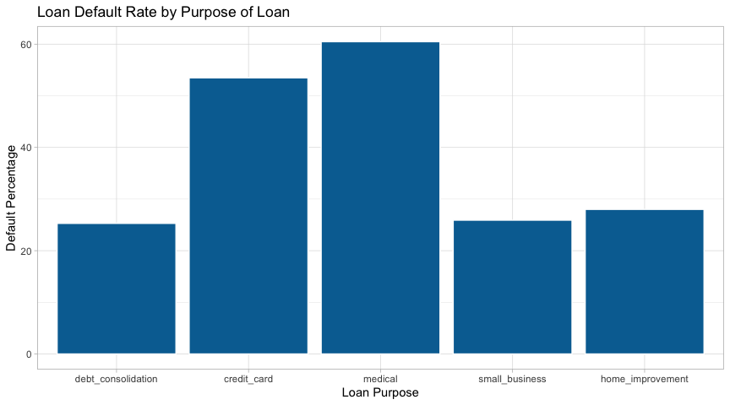

## Question 1

**Question**: Does higher interest rate result in higher loan default rate?

**Answer**: Yes. Higher interest rate is more likely to result in loan default rate based on the box plot below. The average interest rate among customers who default lone is 14.89 while people who do not default lone use the program at 9.34. It proves that higher interest rate is more likely to result in higher loan default rate. Among customers who have default loans, minimum interest rate is 9.75 and the highest interest rate is 20.00. Compared to them, customers who have not default loans show the far lower interest rate as 4.72 and 13.97 for minimum and maximum for each. Therefore, it shows that there is the clear relationship that higher interest rate leads to the higher defaulting loan rate to customers.

loans_df %>%  
 group_by(loan_default) %>%  
 summarize(minimum = min(interest_rate),  
 maximum = max(interest_rate),  
 standard_deviation = sd(interest_rate),  
 average = mean(interest_rate),  
 interestrate_over_10 = mean(interest_rate >= 10),  
 interestrate_less_9 = mean(interest_rate < 9))

## # A tibble: 2 × 7  
## loan_default minimum maximum standard_deviation average interestrate_over_10  
## <fct> <dbl> <dbl> <dbl> <dbl> <dbl>  
## 1 yes 9.75 20 3.00 14.9 0.978  
## 2 no 4.72 14.0 2.75 9.30 0.408  
## # … with 1 more variable: interestrate_less_9 <dbl>

ggplot(data = loans_df, mapping = aes(x = loan_default, y = interest_rate)) +  
 geom_boxplot(fill = 'pink') +  
 labs(title = 'Loan default rate by interest rate', x= "Loan default rate", y = "Interest Rate")

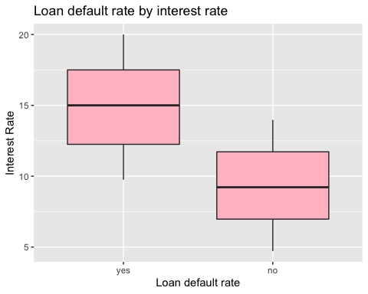

## Question 2

**Question**: Are customers with bankrutpcy history more likely to default the loans in the future? **Answer**: No. There is no significant difference in loan default rates. The data collected based on 486 customers, 41.76% of them have the history of bankruptcy. Among 3264, 36.6% of them do not default the loans, which is significant. Therefore, compared to other factors, the history of bankruptcy does not make the big difference in lowering loan default rate.

loans_df %>%  
 group_by(history_bankruptcy) %>%  
 summarise(n_customers = n(),  
 customers_default = sum(loan_default == 'yes'),  
 default_percent = 100 * mean(loan_default == 'yes'))

## # A tibble: 2 × 4  
## history_bankruptcy n_customers customers_default default_percent  
## <fct> <int> <int> <dbl>  
## 1 yes 486 203 41.8  
## 2 no 3624 1327 36.6

## Question 3

**Question**: Is short term loan period likely to default the loans in the future? **Answer**: Yes. It can be considered as one of the biggest determinants. Comparing three year to five years, default rate of five years is twice higher at 54.99%. Therefore, it makes the huge difference.

loans_df %>%  
 group_by(term) %>%  
 summarise(n_customers = n(),  
 customers_default = sum(loan_default == 'yes'),  
 default_percent = 100 * mean(loan_default == 'yes'))

## # A tibble: 2 × 4  
## term n_customers customers_default default_percent  
## <fct> <int> <int> <dbl>  
## 1 three_year 2588 693 26.8  
## 2 five_year 1522 837 55.0

## Question 4

**Question**: Is the current debt affecting to people when it comes to paying the money back? **Answer**: No. they do not have any relationship. debt-to-income ratio is appeared same in average rate as 22.47 and 18.59 for the number of people who have defaulted the loan who have not.

loans_df %>%  
 group_by(loan_default) %>%  
 summarise(n_customers = n(),  
 minimum = min(debt_to_income),  
 maximum = max(debt_to_income),  
 standard_deviation = sd(debt_to_income),  
 average = mean(debt_to_income))

## # A tibble: 2 × 6  
## loan_default n_customers minimum maximum standard_deviation average  
## <fct> <int> <dbl> <dbl> <dbl> <dbl>  
## 1 yes 1530 0 182. 12.7 22.5  
## 2 no 2580 0 438. 14.9 18.6

## Question 5

**Question**: Do people who have home are less likely to default loans? **Answer**: No. homeownership is not the factor of leading to defaulting loan. people who own their home show 37% of loan_default rate while people who rent the house show 42.79. The rate is slightly higher at 5%, which is significant.

default_rates <- loans_df %>%  
 group_by(homeownership) %>%   
 summarise(n_customers = n(),  
 customers_default = sum(loan_default == 'yes'),  
 default_percent = 100 * mean(loan_default == 'yes'))  
default_rates

## # A tibble: 3 × 4  
## homeownership n_customers customers_default default_percent  
## <fct> <int> <int> <dbl>  
## 1 mortgage 1937 628 32.4  
## 2 rent 1666 713 42.8  
## 3 own 507 189 37.3

ggplot(data = default_rates, mapping = aes(x = homeownership, y = default_percent)) +  
 geom_bar(color = "pink", stat = "identity") +  
 labs(title = 'Loan default rate by Homeownership', x= "Homeownership", y = "Default percentage")

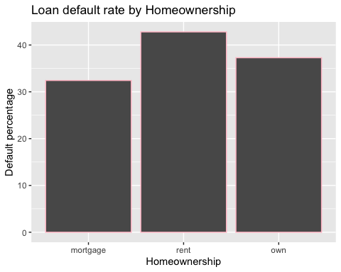

## Question 6

**Question**: Do people who have higher income are less likely to default the loans? **Answer**: Yes. Customers who default on their loans have lower income than customers who have not. From 100k, the proportion of customers who have not default on their loans is far higher than those who have not.

ggplot(data = loans_df, aes( x= annual_income, fill = loan_default)) +  
 geom_histogram(aes(y = ..density..), bins = 20) +  
 facet_wrap(~ loan_default, nrow =2) +   
 labs(title = "Annual income distribution by status",  
 x = "annual income(usd)",  
 y = "customers")

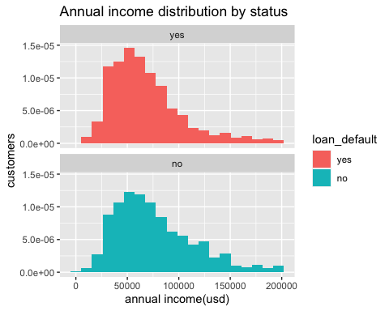

# Predictive Modeling [70 Points]

In this section of the project, you will fit **three classification algorithms** to predict the response variable,loan_default. You should use all of the other variables in the loans_df data as predictor variables for each model.

You must follow the machine learning steps below.

The data splitting and feature engineering steps should only be done once so that your models are using the same data and feature engineering steps for training.

* Split the loans_df data into a training and test set (remember to set your seed)
* Specify a feature engineering pipeline with the recipes package
  + You can include steps such as skewness transformation, dummy variable encoding or any other steps you find appropriate
* Specify a parsnip model object
  + You may choose from the following classification algorithms:
    - Logistic Regression
    - LDA
    - QDA
    - KNN
    - Decision Tree
    - Random Forest
* Package your recipe and model into a workflow
* Fit your workflow to the training data
  + If your model has hyperparameters:
    - Split the training data into 5 folds for 5-fold cross validation using vfold_cv (remember to set your seed)
    - Perform hyperparamter tuning with a random grid search using the grid_random() function
    - Hyperparameter tuning can take a significant amount of computing time. Be careful not to set the size argument of grid_random() too large. I recommend size = 10 or smaller.
    - Select the best model with select_best() and finalize your workflow
* Evaluate model performance on the test set by Select the best model with select_best() and calculating the area under the ROC curve on your test data

## Model 1

#Split the `loans_df` data into a training and test set   
set.seed(100)  
loan_split <- initial_split(loans_df, prop = 0.75, strata = loan_default)  
loan_training <- loan_split %>% training()  
loan_test <- loan_split %>% testing()  
  
#Specify a feature engineering pipeline with the `recipes` package  
recipes <- recipe(loan_default ~., data = loan_training) %>%  
 step_YeoJohnson(all_numeric(), -all_outcomes()) %>%  
 step_normalize(all_numeric(), -all_outcomes()) %>%  
 step_dummy(all_nominal(), -all_outcomes())  
  
recipes %>%  
 prep() %>%  
 bake(new_data = loan_training)

## # A tibble: 3,082 × 20  
## loan_amount installment interest_rate annual_income current_job_years  
## <dbl> <dbl> <dbl> <dbl> <dbl>  
## 1 1.17 1.42 -0.555 1.88 1.10   
## 2 -1.60 -1.68 -0.348 0.174 -0.399  
## 3 0.975 0.613 0.233 1.33 -0.124  
## 4 -1.21 -1.20 -0.844 0.119 -0.399  
## 5 1.87 1.45 -0.0186 0.119 -0.691  
## 6 0.0362 0.0786 0.0452 -0.844 1.10   
## 7 1.64 1.00 -1.07 2.22 1.10   
## 8 -1.12 -1.08 0.0452 -1.37 1.10   
## 9 -0.531 -0.524 -1.07 -0.181 1.10   
## 10 -1.04 -1.03 -0.148 -0.452 -0.691  
## # … with 3,072 more rows, and 15 more variables: debt_to_income <dbl>,  
## # total_credit_lines <dbl>, years_credit_history <dbl>, loan_default <fct>,  
## # loan_purpose_credit_card <dbl>, loan_purpose_medical <dbl>,  
## # loan_purpose_small_business <dbl>, loan_purpose_home_improvement <dbl>,  
## # application_type_joint <dbl>, term_five_year <dbl>,  
## # homeownership_rent <dbl>, homeownership_own <dbl>,  
## # missed_payment_2_yr_no <dbl>, history_bankruptcy_no <dbl>, …

#Specify a `parsnip` model object(Logistic Regression/LDA/QDA/KNN/Decision Tree/Random Forest)  
logistic_model <-logistic_reg() %>%  
 set_engine("glm") %>%  
 set_mode("classification")  
#Package your recipe and model into a workflow  
logistic_wf <- workflow() %>%  
 add_model(logistic_model)%>%  
 add_recipe(recipes)  
  
#Fit your workflow to the training data(5-fold cross validation using `vfold_cv`, grid search using the `grid_random()` ,Hyperparameter tuning can take a significant amount of computing time,Select the best model with `select_best()`, Select the best model with `select_best()`, calculating the area under the ROC curve)  
loan_folds <- vfold_cv(loan_training, v =5)  
logistic_fit <- logistic_wf %>%  
 last_fit(split = loan_split)  
  
logistic_result <- logistic_fit %>%  
 collect_predictions()  
#ROC Curve  
roc_curve(logistic_result, truth = loan_default, estimate = .pred_yes) %>% autoplot()

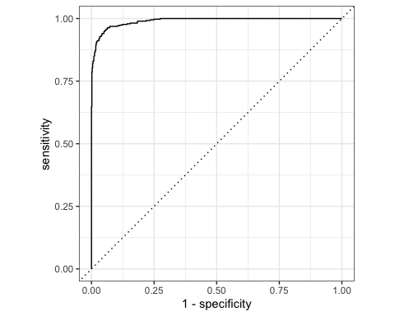

roc_auc(logistic_result, truth = loan_default, .pred_yes)

## # A tibble: 1 × 3  
## .metric .estimator .estimate  
## <chr> <chr> <dbl>  
## 1 roc_auc binary 0.990

model_1<- glm(loan_default ~., data = loan_training, family = binomial)  
tidy_model1 <- tidy(model_1)  
summary(tidy_model1)

## term estimate std.error statistic   
## Length:20 Min. :-7.340463 Min. :0.0000026 Min. :-19.2594   
## Class :character 1st Qu.:-0.579554 1st Qu.:0.0105427 1st Qu.: -4.4857   
## Mode :character Median :-0.121720 Median :0.2168513 Median : -1.1875   
## Mean :-0.055533 Mean :0.2071372 Mean : -2.3694   
## 3rd Qu.: 0.000267 3rd Qu.:0.2371219 3rd Qu.: 0.9784   
## Max. :11.606140 Max. :0.9606483 Max. : 17.1585   
## p.value   
## Min. :0.00000   
## 1st Qu.:0.00000   
## Median :0.01187   
## Mean :0.17616   
## 3rd Qu.:0.20944   
## Max. :0.95583

vip(model_1)

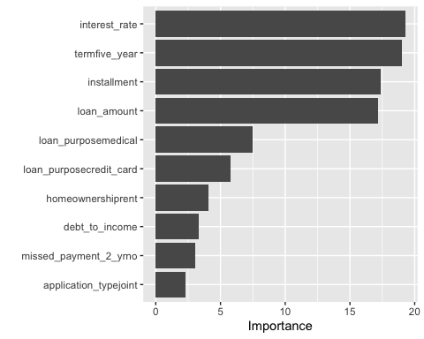

## Model 2

# Specify LDA Model  
LDA_model <- discrim_regularized(frac_common_cov = 1) %>%  
 set_engine('klaR') %>%  
 set_mode('classification')  
# Create a Workflow  
LDA_wf <- workflow() %>%  
 add_model(LDA_model) %>%  
 add_recipe(recipes)  
# Fit Model  
LDA_fit <- LDA_wf %>%  
 last_fit(split = loan_split)

## Warning: package 'klaR' was built under R version 4.1.2

# Collect Predictions  
LDA_results <- LDA_fit %>%  
 collect_predictions()  
# ROC Curve  
roc_curve(LDA_results, truth = loan_default, estimate = .pred_yes) %>%  
 autoplot()

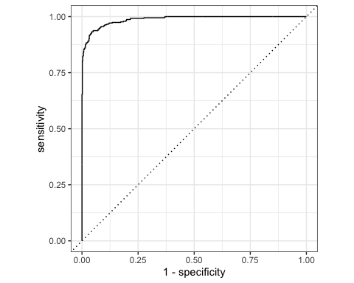

## Model 3

# Specify Random Forest Model  
rf_model <- rand_forest(mtry = tune(),  
 trees = tune(),  
 min_n = tune()) %>%  
 set_engine('ranger', importance = "impurity") %>%  
 set_mode('classification')  
# Create a Workflow  
rf_wf <- workflow() %>%  
 add_model(rf_model) %>%  
 add_recipe(recipes)  
# Hyperparameter Tuning  
set.seed(01174206)  
  
rf_grid <- grid_random(mtry() %>% range_set(c(2, 10)),  
 trees(),  
 min_n(),  
 size = 10)  
  
rf_tuning <- rf_wf %>%  
 tune_grid(resamples = loan_folds,  
 grid = rf_grid)  
# View the Best model  
best_rf <- rf_tuning %>%  
 select_best(metric = 'roc_auc')  
best_rf

## # A tibble: 1 × 4  
## mtry trees min_n .config   
## <int> <int> <int> <chr>   
## 1 10 1803 6 Preprocessor1_Model10

final_rf_workflow <- rf_wf %>%  
 finalize_workflow(best_rf)  
  
final_rf_workflow

## ══ Workflow ════════════════════════════════════════════════════════════════════  
## Preprocessor: Recipe  
## Model: rand_forest()  
##   
## ── Preprocessor ────────────────────────────────────────────────────────────────  
## 3 Recipe Steps  
##   
## • step_YeoJohnson()  
## • step_normalize()  
## • step_dummy()  
##   
## ── Model ───────────────────────────────────────────────────────────────────────  
## Random Forest Model Specification (classification)  
##   
## Main Arguments:  
## mtry = 10  
## trees = 1803  
## min_n = 6  
##   
## Engine-Specific Arguments:  
## importance = impurity  
##   
## Computational engine: ranger

# Fit the Model  
rf_wf_fit <- final_rf_workflow %>%  
 fit(data = loan_training)  
# Extract Trained Model  
rf_fit <- rf_wf_fit %>%  
 extract_fit_parsnip()  
  
vip(rf_fit)

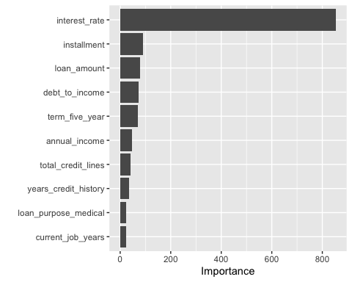

# Train and Evaluate with Last fit  
rf_last_fit <- final_rf_workflow %>%  
 last_fit(loan_split)  
# Accuracy and ROC AUC  
rf_last_fit %>% collect_metrics()

## # A tibble: 2 × 4  
## .metric .estimator .estimate .config   
## <chr> <chr> <dbl> <chr>   
## 1 accuracy binary 0.927 Preprocessor1_Model1  
## 2 roc_auc binary 0.981 Preprocessor1_Model1

# ROC Curve  
rf_last_fit %>% collect_predictions() %>%  
 roc_curve(truth = loan_default, estimate = .pred_yes) %>%  
 autoplot()

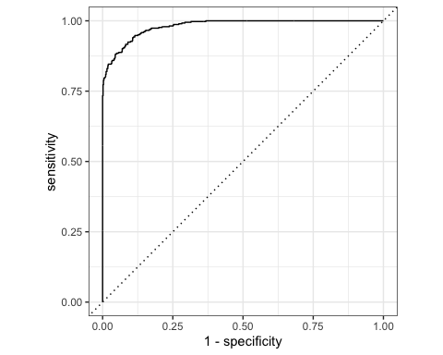

— End of the Project —