Tracing

# Tracing Bug Zero Charge

As bug that relates to zero charge being displayed while checking out can be observed in Check out use case, the method that display the message is tested first to check for error. And the error was trace as it progressed which can be seen in Hypothesis that is being tested.

# Hypothesis

## Hypothesis 1: There is problem in CheckoutCTL.roomIdEntered().

This hypothesis is tested by conducting unit test of the method that is responsible for displaying the charge of the service in CheckoutCTL class. The unit test shows that there is no problem within the method.

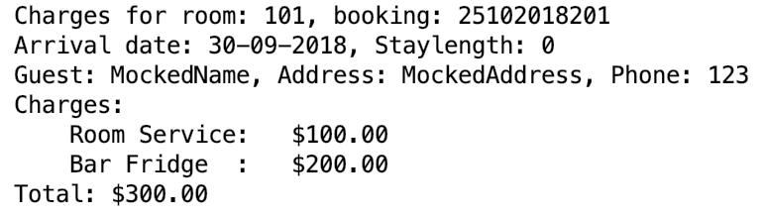

Figure: Method being executed properly when all external method call is mocked.

## Hypothesis 2: There is problem in RecordServiceCTL.serviceDetailsEntered().

This hypothesis is tested by conducting unit test of the method that is used to add charge of the service in RecordServiceCTL class. The unit test shows that there is no problem within the method.

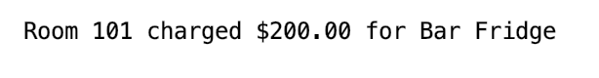

Figure: Method being executed properly when all external method call is mocked.

## Hypothesis 3: There is problem in Hotel.addServiceCharge().

This hypothesis is tested by conducting unit test of the method that is called when method serviceDetailsEntered() in RecordServiceCTL class is called. As this method call Hotel.addServiceCharge(), the unit test of the method shows that there is no problem within the method.

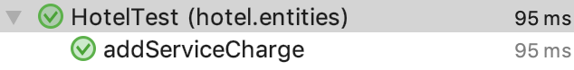

Figure: Method being executed without problem when all external method call is mocked.

## Hypothesis 4: There is problem in Booking.addServiceCharge().

This hypothesis is tested by conducting unit test of the method that is called when method addServiceCharge() in Hotel class is called. As this method call Booking.addServiceCharge(), the unit test of the method shows that there is problem in the method. By looking at the code there seems to be mistake made on naming parameter and variable used within the method. This test shows that the method is not working as expected. The variable declared in the parameter is not being used within the method due to spelling mistake made.



Figure: Method showing abnormal behaviour

# Debugging Log

As this hypothesis testing was carried out bottom up approach, the first source of problem was analysed, and the method call within the source method is studied.

|  |  |
| --- | --- |
| Hypothesis | Finding |
| Hypothesis 1 | The unit test shows that there is no problem within the method. |
| Hypothesis 2 | The unit test shows that there is no problem within the method. |
| Hypothesis 3 | The unit test shows that there is no problem within the method. |
| Hypothesis 4 | This test shows that the method is not working as expected. The variable declared in the parameter is not being used within the method due to spelling mistake made. |