Tracing

# Tracing Bug Charge Checked Out Room

As bug that relates to being able to add service charge to room that has already checked out, and by looking at the RecordServiceCTL , there appear to be problem on method that is supposed to remove the booking. And the error was trace as it progressed which can be seen in Hypothesis that is being tested.

# Hypothesis

## Hypothesis 1: There is problem in CheckoutCTL.creditDetailsEntered ().

This hypothesis is tested by conducting integration test of the method that is responsible for changing the state of the Booking. The integration test shows that there is problem in Hotel.checkout() method that is being called within the method.

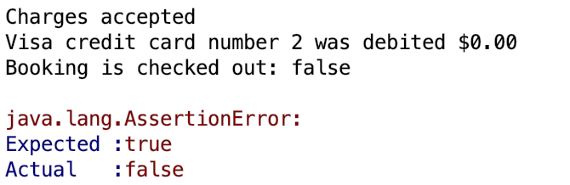

Figure: Method being executed showing error.

## Hypothesis 2: There is problem in Hotel.checkout().

This hypothesis is tested by conducting integration test of the method that is called in CheckoutCTL class responsible for error. The integration test shows that there is problem within the method. After looking at the use case, this method is supposed to remove the booking from the ‘activeBookingsByRoomId’ but never did.

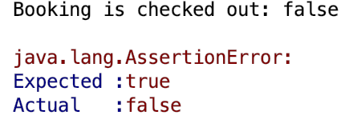

Figure: Method being executed showing error.

# Debugging Log

As this hypothesis testing was carried out bottom up approach, the first source of problem was analysed, and the method call within the source method is studied.

|  |  |
| --- | --- |
| Hypothesis | Finding |
| Hypothesis 1 | CheckoutCTL.creditDetailsEntered () showed an error in integration testing so there must be problem in method call that was made within this method which is Hotel.checkout(). |
| Hypothesis 2 | Hotel.checkout() showed an error in integration testing so there must be problem in method. After looking at the use case, this method is supposed to remove the booking from the ‘activeBookingsByRoomId’ but never did. |