# iDEALplugins.nl – Extension for Magento 2

## Installation

### Set up a TargetPay account

Before you can use the plugin, please sign up for a TargetPay account on [www.targetpay.com](http://www.targetpay.com/)

Use our promotional code YM3R2A for a special discount on the transaction costs. Currently iDEAL is offered for 44 eurocent per transaction, all-inclusive without monthly or setup fees.

Note that the plugin can be used in a live environment only after it has been completed with your details and is approved by their compliance department. This would normally take about one working day.

### Setting up

How to setup:

1. Extract the attachment zip into app/code

The path will be: app/code/Targetpay/Ideal or app/code/Targetpay/Mrcash, ...

2. Install new module using the following commands:

```

php bin/magento setup:upgrade

php bin/magento setup:di:compile

```

3. Clean cache

```

php bin/magento cache:flush

```

4. Delete static cached if needed

```

rm -rf var/* pub/*

```

5. Enable payment methods in Magento admin

Go to Store > Configuration > Sale > Payment methods

Newly installed methods will be there

Enable them and check/uncheck test mode for testing

More detailed installation instruction is available on https://www.idealplugins.nl/magento2#tab_install

### Troubleshooting

Please see the FAQ on <https://www.idealplugins.nl/magento2#tab_help>

## Configuration

Log into your administration panel and go to “Stores”, “Settings”, “Configuration”, “Sales” > “Payment Methods” to configure your extension.

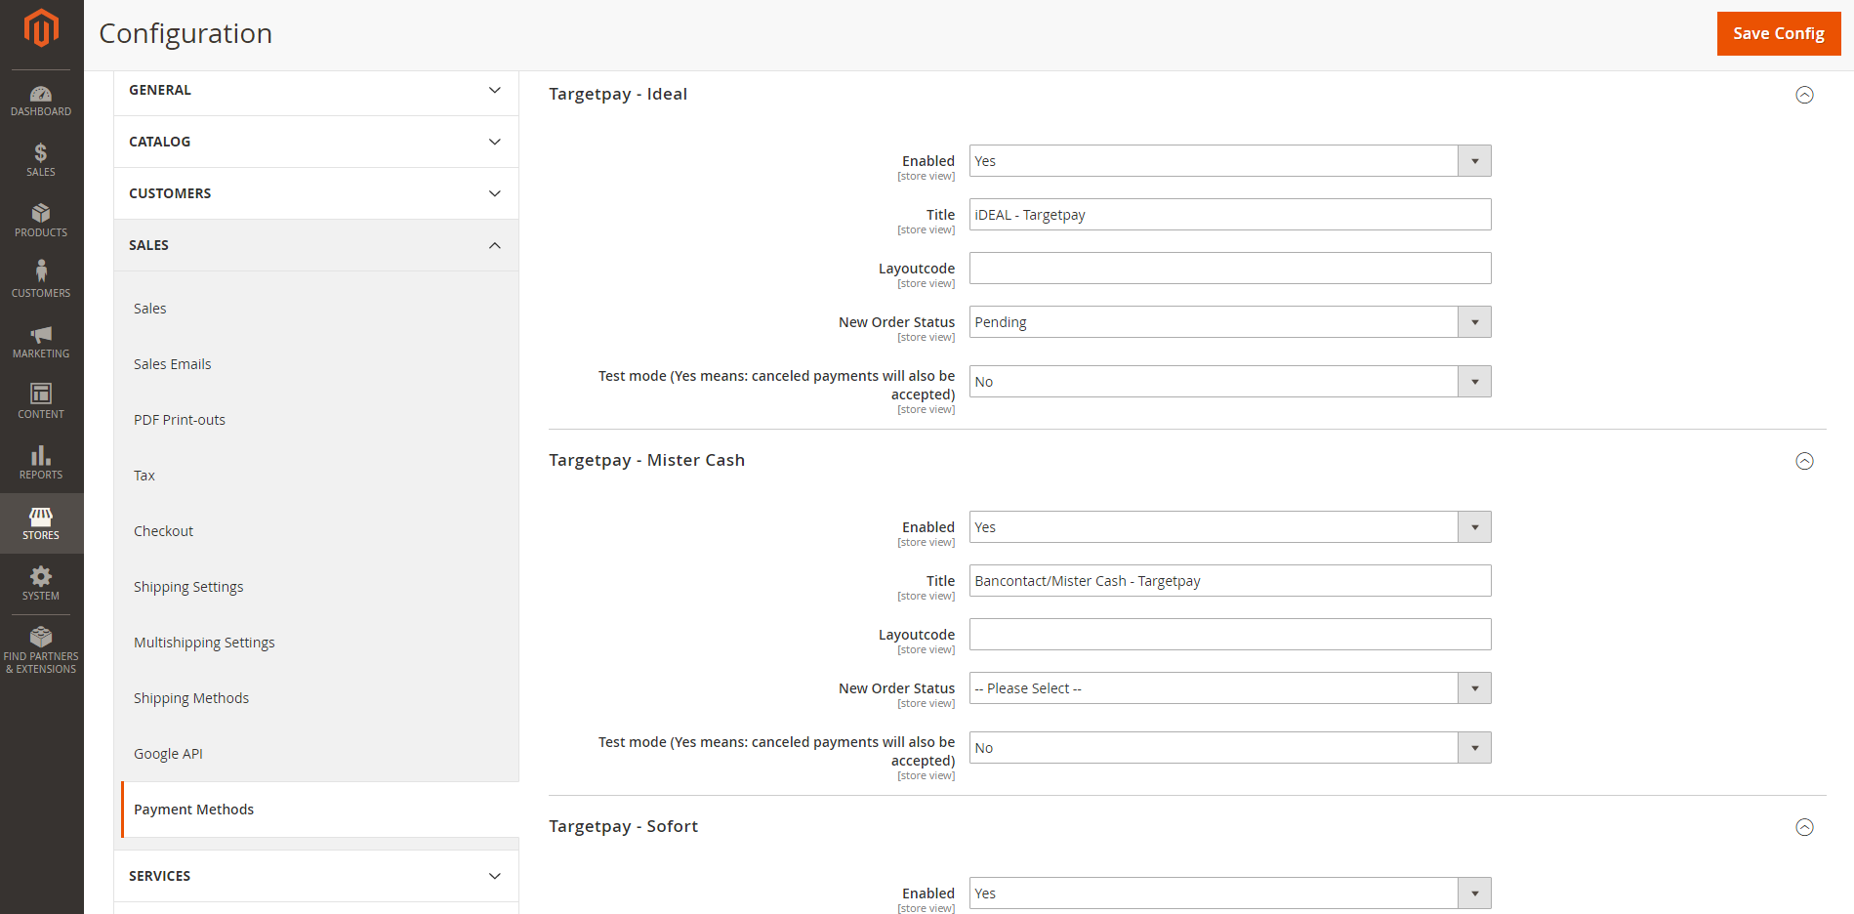

### Description of configuration fields

* **Enabled**: This will allow you to activate/deactivate the module.
* **Title**: Title shown on front-end area.
* **Layoutcode**: This is your account number supplied by TargetPay and is used for identification of your account.
* **New Order Status:** Status used for new orders placed using this plugin.
* **Test mode:** Enable or disable test mode. When test mode is enabled you can test the order process by canceling a transaction and the extension will mark it as successful.