2018级计算机科学与技术毕业实习实施方案



云客服背景、技术特点，项目系统架构，功能介绍



1. 云客服平台。
2. 系统架构与框架结构搭建，实现后台管理功能。
3. 云客服Web前端界面设计与交互实现，完成前台页面开发。
4. 前后端数据交互实现。
5. 高并发、集群、分布式、缓存策略

InteliJ IDEA安装

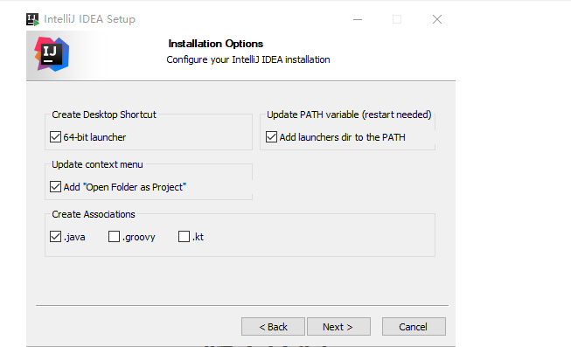

1.

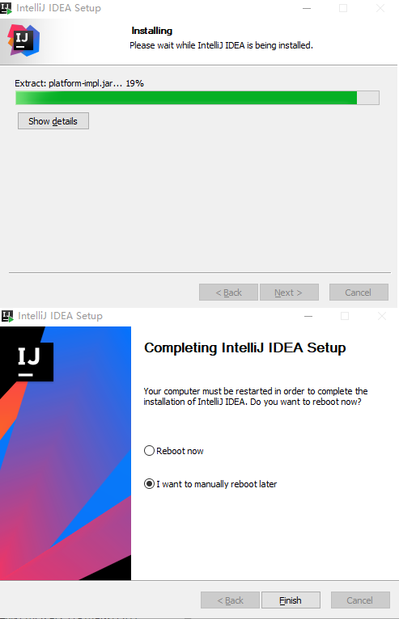

2.

3.

4. 不启动 idea, 复制jetbrains-agent.jar 到安装目录

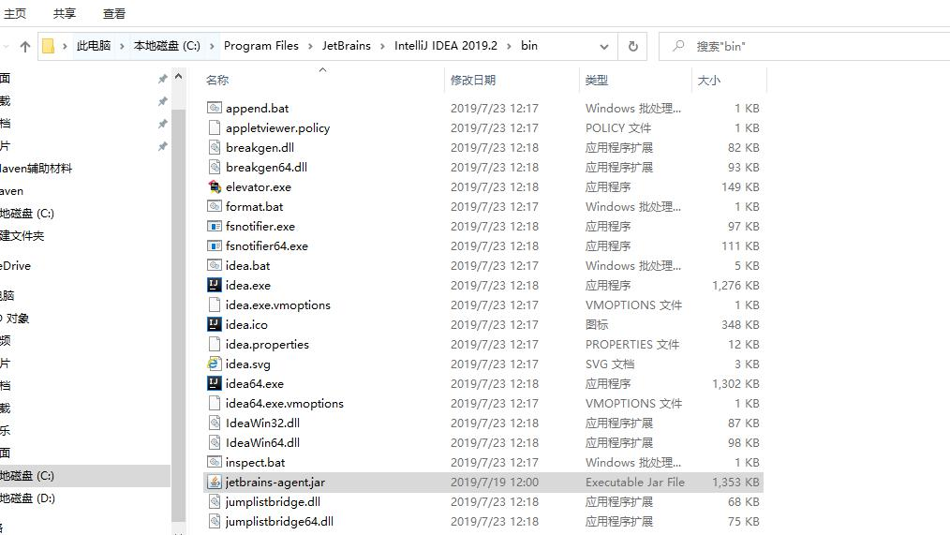

1. 然后在idea64.exe.vmoptions文件末尾加上 -javaagent:C:\Program Files\JetBrains\IntelliJ IDEA 2019.2\bin\jetbrains-agent.jar 这里改一下，对应你自己的路径

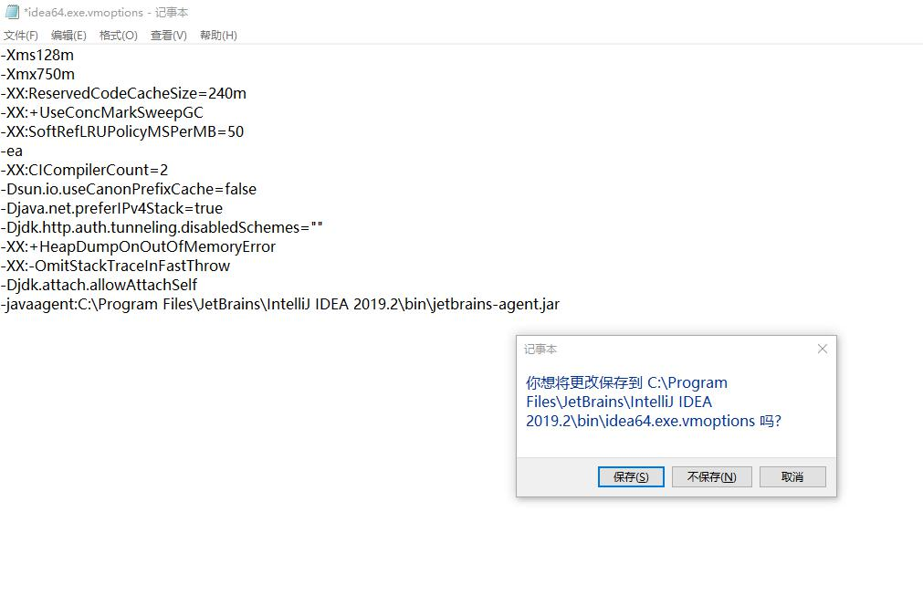

6. 运行IntelliJ IDEA 2019.2 x64

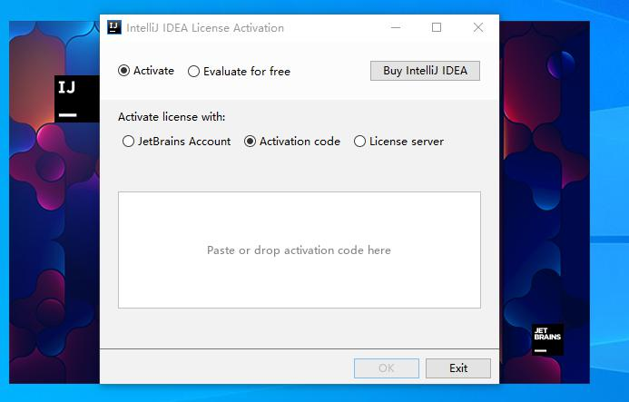

1. 输入注册码

MERYY2SM09-

eyJsaWNlbnNlSWQiOiJNRVJZWTJTTTA5IiwibGljZW5zZWVOYW1lIjoiRnFHdW1wIiwiYXNzaWduZWVOYW1lIjoiIiwiYXNz

aWduZWVFbWFpbCI6IiIsImxpY2Vuc2VSZXN0cmljdGlvbiI6IiIsImNoZWNrQ29uY3VycmVudFVzZSI6ZmFsc2UsInByb2R1

Y3RzIjpbeyJjb2RlIjoiSUkiLCJmYWxsYmFja0RhdGUiOiIyMDg5LTA3LTA3IiwicGFpZFVwVG8iOiIyMDg5LTA3LTA3In0s

eyJjb2RlIjoiQUMiLCJmYWxsYmFja0RhdGUiOiIyMDg5LTA3LTA3IiwicGFpZFVwVG8iOiIyMDg5LTA3LTA3In0seyJjb2Rl

IjoiRFBOIiwiZmFsbGJhY2tEYXRlIjoiMjA4OS0wNy0wNyIsInBhaWRVcFRvIjoiMjA4OS0wNy0wNyJ9LHsiY29kZSI6IlBT

IiwiZmFsbGJhY2tEYXRlIjoiMjA4OS0wNy0wNyIsInBhaWRVcFRvIjoiMjA4OS0wNy0wNyJ9LHsiY29kZSI6IkdPIiwiZmFs

bGJhY2tEYXRlIjoiMjA4OS0wNy0wNyIsInBhaWRVcFRvIjoiMjA4OS0wNy0wNyJ9LHsiY29kZSI6IkRNIiwiZmFsbGJhY2tE

YXRlIjoiMjA4OS0wNy0wNyIsInBhaWRVcFRvIjoiMjA4OS0wNy0wNyJ9LHsiY29kZSI6IkNMIiwiZmFsbGJhY2tEYXRlIjoi

MjA4OS0wNy0wNyIsInBhaWRVcFRvIjoiMjA4OS0wNy0wNyJ9LHsiY29kZSI6IlJTMCIsImZhbGxiYWNrRGF0ZSI6IjIwODkt

MDctMDciLCJwYWlkVXBUbyI6IjIwODktMDctMDcifSx7ImNvZGUiOiJSQyIsImZhbGxiYWNrRGF0ZSI6IjIwODktMDctMDci

LCJwYWlkVXBUbyI6IjIwODktMDctMDcifSx7ImNvZGUiOiJSRCIsImZhbGxiYWNrRGF0ZSI6IjIwODktMDctMDciLCJwYWlk

VXBUbyI6IjIwODktMDctMDcifSx7ImNvZGUiOiJQQyIsImZhbGxiYWNrRGF0ZSI6IjIwODktMDctMDciLCJwYWlkVXBUbyI6

IjIwODktMDctMDcifSx7ImNvZGUiOiJSTSIsImZhbGxiYWNrRGF0ZSI6IjIwODktMDctMDciLCJwYWlkVXBUbyI6IjIwODkt

MDctMDcifSx7ImNvZGUiOiJXUyIsImZhbGxiYWNrRGF0ZSI6IjIwODktMDctMDciLCJwYWlkVXBUbyI6IjIwODktMDctMDci

fSx7ImNvZGUiOiJEQiIsImZhbGxiYWNrRGF0ZSI6IjIwODktMDctMDciLCJwYWlkVXBUbyI6IjIwODktMDctMDcifSx7ImNv

ZGUiOiJEQyIsImZhbGxiYWNrRGF0ZSI6IjIwODktMDctMDciLCJwYWlkVXBUbyI6IjIwODktMDctMDcifSx7ImNvZGUiOiJS

U1UiLCJmYWxsYmFja0RhdGUiOiIyMDg5LTA3LTA3IiwicGFpZFVwVG8iOiIyMDg5LTA3LTA3In1dLCJoYXNoIjoiMTI3OTY4

NzcvMCIsImdyYWNlUGVyaW9kRGF5cyI6NywiYXV0b1Byb2xvbmdhdGVkIjpmYWxzZSwiaXNBdXRvUHJvbG9uZ2F0ZWQiOmZh

bHNlfQ==-

i6ySGpwlyxeDfJjDUa3I4a6G1iWhhvXKP4eP9sw3wGDGKoAnz+VNTwxTHe4T0ioaibUU2ts++TewhtmV1/MXkdo0E2yiAo4r

QZAp38KKGFfF9qXpOj5+3ylubo2FXmSmmm++bomgbT4RHEHQg+Oi++dJrhlzoTDg3ZMNNvDP9lC6LvwCrKxmiRbL34wOa+Nj

nUO8JLX3SCl0+PZA/TNp4Jl/F1G4yE6njPSUUjsNbNGiMI/T0JyJ4nYEdmPS34BRk/TzgxuNSWfARt3eBTj807f8RyLtfAFl

O04RoVsbRfgX6QAjgS3URiWf/u80t5fip5GHmrgpqB5F2liMLrfnfg==-

MIIElTCCAn2gAwIBAgIBCTANBgkqhkiG9w0BAQsFADAYMRYwFAYDVQQDDA1KZXRQcm9maWxlIENBMB4XDTE4MTEwMTEyMjk0

NloXDTIwMTEwMjEyMjk0NlowaDELMAkGA1UEBhMCQ1oxDjAMBgNVBAgMBU51c2xlMQ8wDQYDVQQHDAZQcmFndWUxGTAXBgNV

BAoMEEpldEJyYWlucyBzLnIuby4xHTAbBgNVBAMMFHByb2QzeS1mcm9tLTIwMTgxMTAxMIIBIjANBgkqhkiG9w0BAQEFAAOC

AQ8AMIIBCgKCAQEA5ndaik1GD0nyTdqkZgURQZGW+RGxCdBITPXIwpjhhaD0SXGa4XSZBEBoiPdY6XV6pOfUJeyfi9dXsY4M

mT0D+sKoST3rSw96xaf9FXPvOjn4prMTdj3Ji3CyQrGWeQU2nzYqFrp1QYNLAbaViHRKuJrYHI6GCvqCbJe0LQ8qqUiVMA9w

G/PQwScpNmTF9Kp2Iej+Z5OUxF33zzm+vg/nYV31HLF7fJUAplI/1nM+ZG8K+AXWgYKChtknl3sW9PCQa3a3imPL9GVToUNx

c0wcuTil8mqveWcSQCHYxsIaUajWLpFzoO2AhK4mfYBSStAqEjoXRTuj17mo8Q6M2SHOcwIDAQABo4GZMIGWMAkGA1UdEwQC

MAAwHQYDVR0OBBYEFGEpG9oZGcfLMGNBkY7SgHiMGgTcMEgGA1UdIwRBMD+AFKOetkhnQhI2Qb1t4Lm0oFKLl/GzoRykGjAY

MRYwFAYDVQQDDA1KZXRQcm9maWxlIENBggkA0myxg7KDeeEwEwYDVR0lBAwwCgYIKwYBBQUHAwEwCwYDVR0PBAQDAgWgMA0G

CSqGSIb3DQEBCwUAA4ICAQBonMu8oa3vmNAa4RQP8gPGlX3SQaA3WCRUAj6Zrlk8AesKV1YSkh5D2l+yUk6njysgzfr1bIR5

xF8eup5xXc4/G7NtVYRSMvrd6rfQcHOyK5UFJLm+8utmyMIDrZOzLQuTsT8NxFpbCVCfV5wNRu4rChrCuArYVGaKbmp9ymkw

1PU6+HoO5i2wU3ikTmRv8IRjrlSStyNzXpnPTwt7bja19ousk56r40SmlmC04GdDHErr0ei2UbjUua5kw71Qn9g02tL9fERI

2sSRjQrvPbn9INwRWl5+k05mlKekbtbu2ev2woJFZK4WEXAd/GaAdeZZdumv8T2idDFL7cAirJwcrbfpawPeXr52oKTPnXfi

0l5+g9Gnt/wfiXCrPElX6ycTR6iL3GC2VR4jTz6YatT4Ntz59/THOT7NJQhr6AyLkhhJCdkzE2cob/KouVp4ivV7Q3Fc6HX7

eepHAAF/DpxwgOrg9smX6coXLgfp0b1RU2u/tUNID04rpNxTMueTtrT8WSskqvaJd3RH8r7cnRj6Y2hltkja82HlpDURDxDT

Rvv+krbwMr26SB/40BjpMUrDRCeKuiBahC0DCoU/4+ze1l94wVUhdkCfL0GpJrMSCDEK+XEurU18Hb7WT+ThXbkdl6VpFdHs

RvqAnhR2g4b+Qzgidmuky5NUZVfEaZqV/g==

8. File-> New-> Project

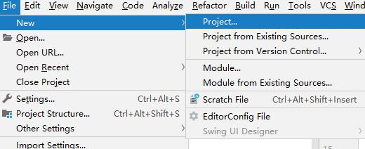

1. 使用模板创建maven项目：

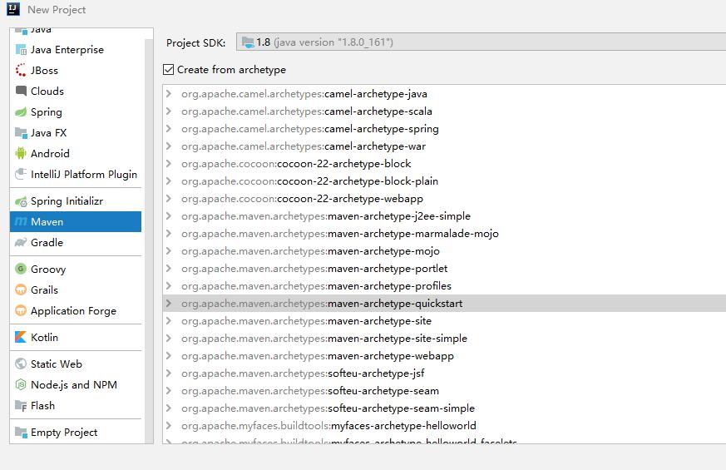

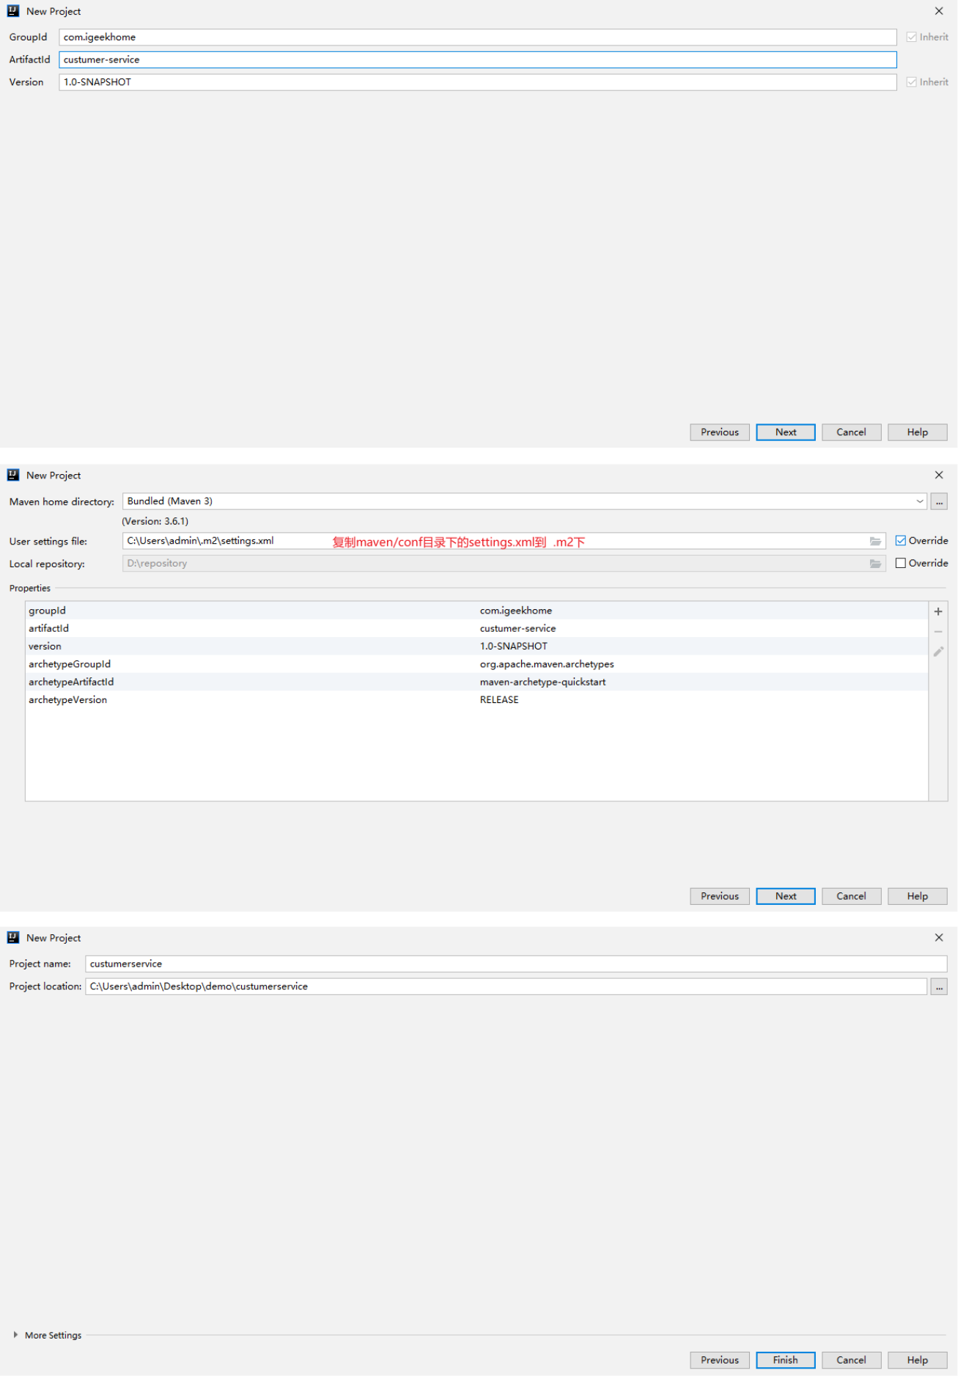

项目创建，完成。等待maven中远程仓库下载依赖。

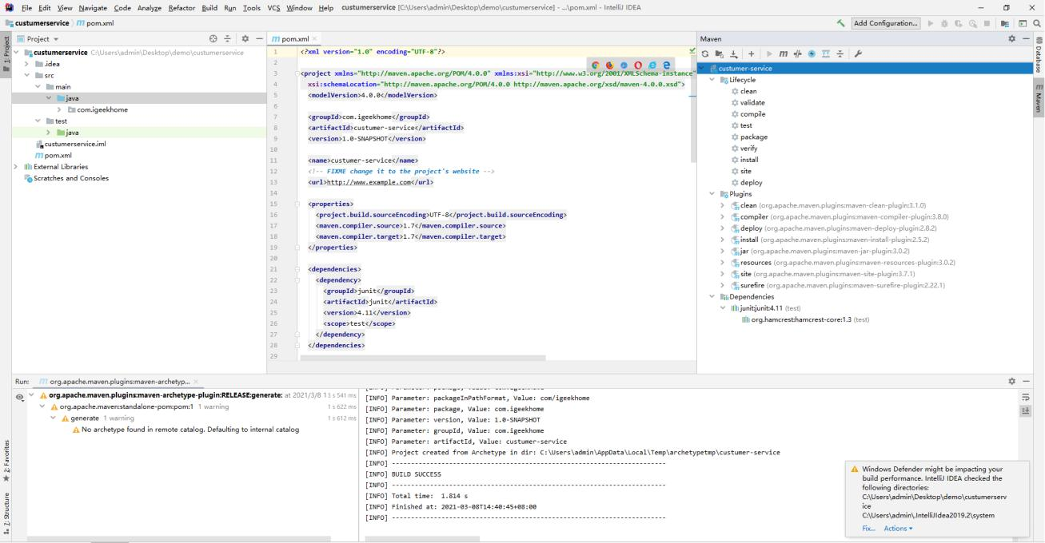

SVN/GIT版本控制



[Git](https://git-scm.com/) 是一个版本控制系统。版本控制是一种用于记录一个或多个文件内容变化，方便我们查阅特定版本修订情况的系统。Git 是分布式版本控制系统.

SVN、CVS等，它们是集中式版本控制系统.

[Gitee.com](https://gitee.com/) 是 OSCHINA.NET 推出的代码托管平台,支持 Git 和 SVN,提供免费的私有仓库托管。目前已有超过 600 万的开发者选择 Gitee。

[GitHub](https://github.com/)是一个面向开源及私有软件项目的托管平台，因为只支持Git作为唯一的版本库格式进行托管，故名GitHub。 GitHub于2008年4月10日正式上线，除了Git代码仓库托管及基本的Web管理界面以外，还提供了订阅、讨论组、文本渲染、在线文件编辑器、协作图谱（报表）、代码片段分享（Gist）等功能。目前，其注册用户已经超过350万，托管版本数量也是非常之多，其中不乏知名开源项目Ruby on Rails、jQuery、python等。

[GitLab](https://about.gitlab.com/)提供开源代码，支持企业自己用企业买的服务器搭建企业gitlab，供公司所有人使用的代码托管系统

Git安装



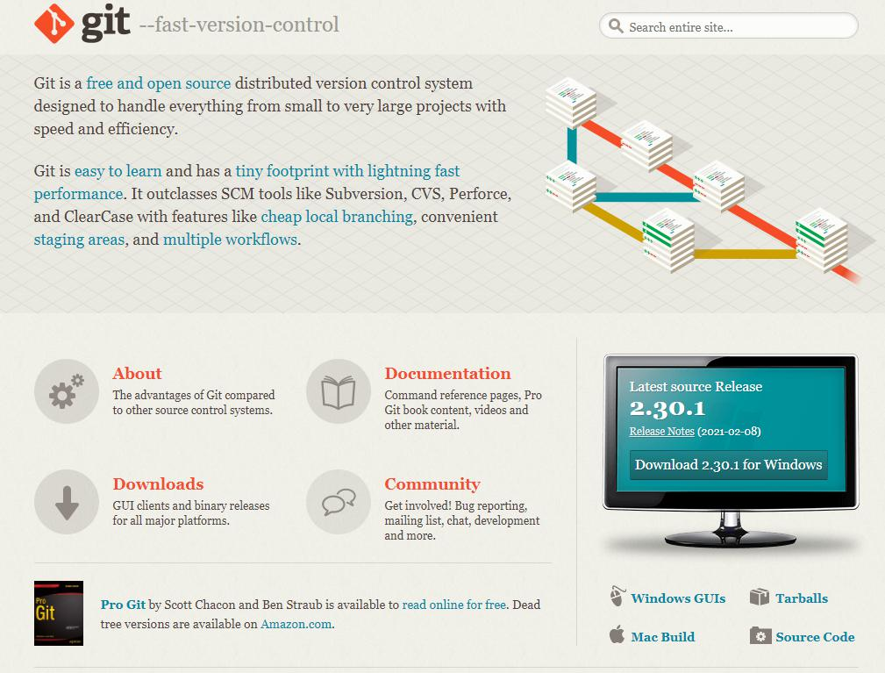

工作原理图

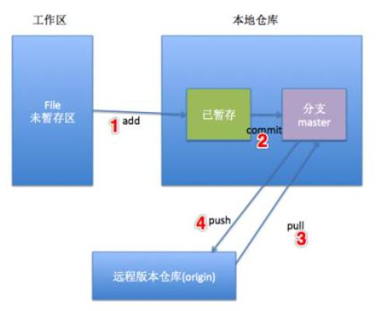

Idea添加配制Git

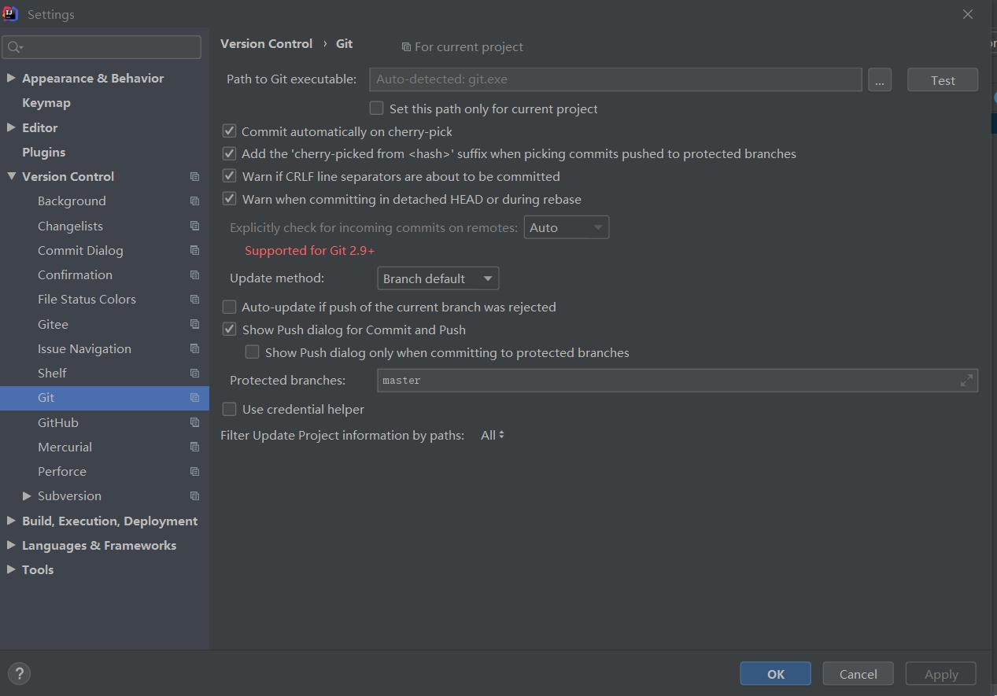

Idea添加Gitee插件

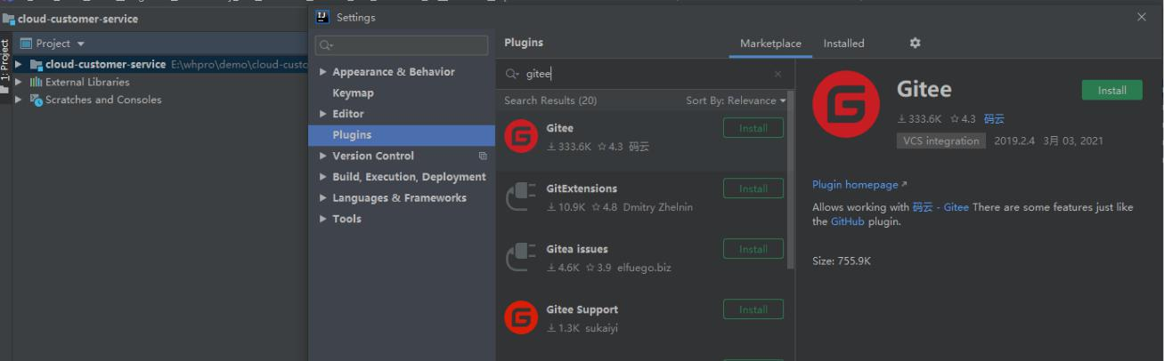

配制Gitee账号

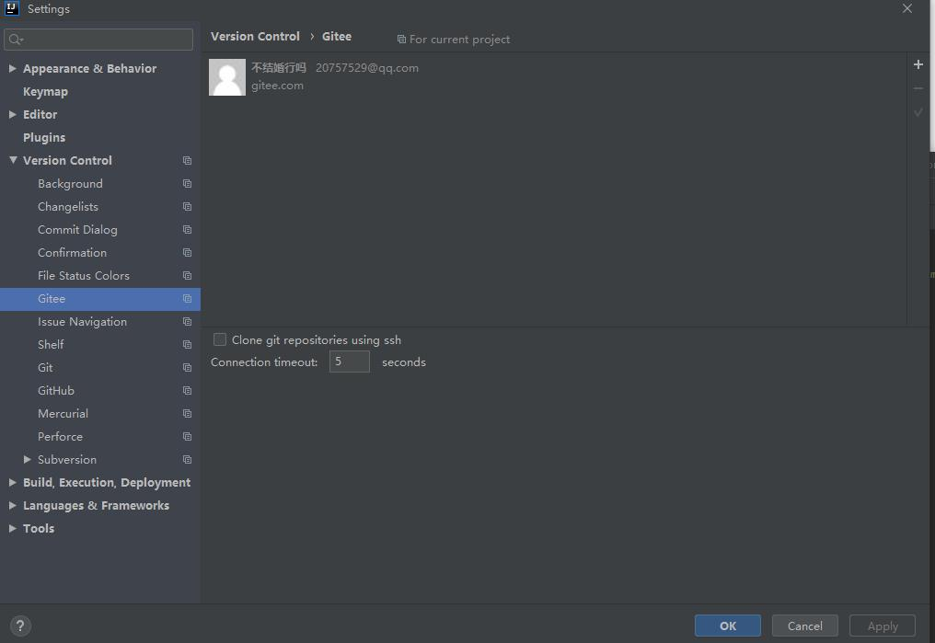

共享项目到Gitee

image-20210304024708530

