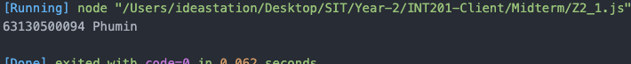2.1

**2.2**

2.3

2.4