**Requirement**

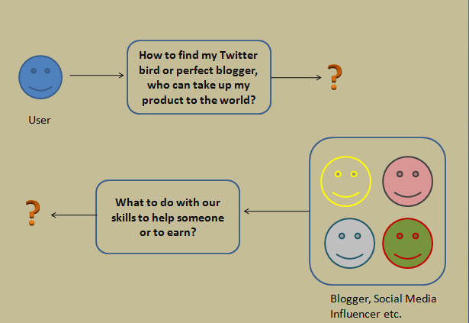

**Solution**

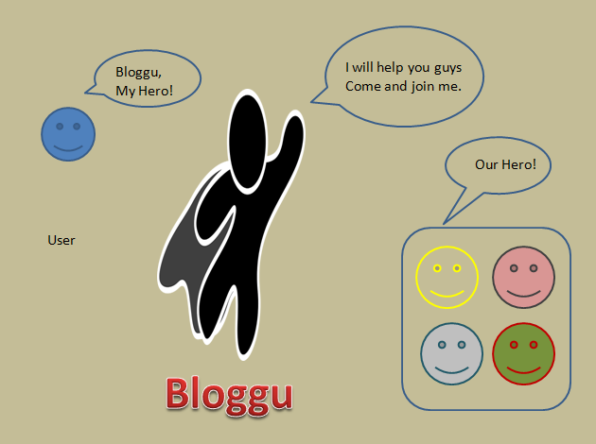

**User Registration**

Users will be people from across the world with some type product which they aspire to reach maximum number of people through to Web to market their product. They are intended to register themselves in Bloggu database.

**Registration Details Required**

TABLE: 1.0

|  |  |
| --- | --- |
| **Details** | **Data type** |
| Complete Name | VarChar |
| Email Id | Email |
| Contact | Integer |
| Password | Password |

**While Registering a user we will as minimum details as there in the above table 1.0, as the registering process should as simple as much possible.**

**User Account Details**

TABLE: 1.1

|  |  |  |
| --- | --- | --- |
| **Details** | **Data type** | **Required** |
| User ID | Alphanumeric | PK |
| Complete Name | VarChar | True |
| Email | VarChar | True |
| Contact | Integer | True |
| DOB | Date | True |
| Profile Picture | Image | False |
| Website Link | Link | True |
| Face book | Link | False |
| Twitter | Link | False |
| Business Type | VarChar | True |
| Address | VarChar | True |

**Service Provider**

Service Provider will be people from across the world who are really famous for their work in one or the other field of specialization. They are intended to register themselves in Bloggu database to receive assignment from Users to market their product through a Blog, Twitter tweet or by face book post etc.

**Registration Details Required**

TABLE: 2.0

|  |  |
| --- | --- |
| **Details** | **Data type** |
| Complete Name | VarChar |
| Email Id | Email |
| Contact | Integer |
| Password | Password |

**While Registering a user we will as minimum details as there in the above table 1.0, as the registering process should as simple as much possible.**

**Service Provider Account Details**

TABLE: 2.0

|  |  |  |
| --- | --- | --- |
| **Details** | **Data type** | **Required** |
| User ID | Alphanumeric | PK |
| Complete Name | VarChar | True |
| Email | VarChar | True |
| Contact | Integer | True |
| DOB | Date | True |
| Profile Picture | Image | False |
| Website Link | Link | True |
| Facebook | Link | False |
| Twitter | Link | False |
| Instagram | Link | False |
| Pin | Link | False |
| YouTube | Link | False |
| Other | Link | False |
| Specialization | VarChar | False |
| Address | VarChar | True |

**Address**

|  |  |  |
| --- | --- | --- |
| **Details** | Type | Required |
| Complete Address | VarChar | False |
| City | VarChar | True |
| Country | VarChar | True |

**Home Page for User**

Once user registration is complete the user can login to the home page with dashboard view.

Dashboard view will show highlight of several Service provider from all category in some chronological order, user will be privileged to view service provider highlight based on several category and search key.

These highlight about service provider will contain following details.

|  |
| --- |
| **Highlight of Service Provider at home page** |
| Profile Picture of Service Provider |
| Name of Service Provider |
| Summary |
| Offer Price |
| Followers |