**Week 1 Quiz - TOTAL POINTS 10**

Honor Code Signature: _____________________ Name & Number: _____________________

Your signature represents your promise that this quiz is solely your own work.

1. **Which of these terms best describes the type of AI used in today’s email spam filters, speech recognition, and other specific applications?**
   1. Artificial General Intelligence (AGI)
   2. Artificial Narrow Intelligence (ANI)
2. **What do you call the commonly used AI technology for learning input (A) to output (B) mappings?**
   1. Reinforcement learning
   2. Unsupervised learning
   3. Artificial General Intelligence
   4. Supervised learning
3. **You want to use supervised learning to build a speech recognition system. The figure above suggests that in order for a neural network (deep learning) to achieve the best performance, you would ideally use: (Select all that apply)**

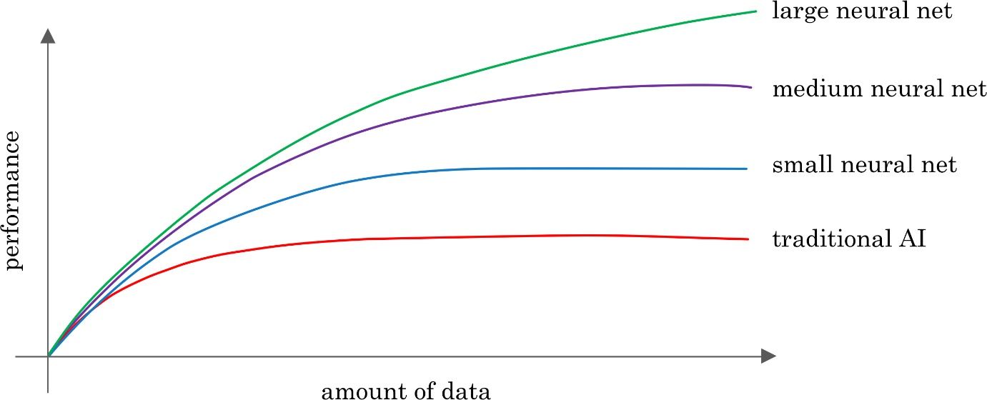

* 1. A large dataset (of audio files and the corresponding text transcript)
  2. A small dataset (of audio files and the corresponding text transcript)
  3. A large neural network
  4. A small neural network

1. **The only way to acquire data for a supervised learning algorithm is to manually label it. I.e., given the input A, to ask a human to provide B.**
   1. True
   2. False
2. **Which of these statements regarding data acquisition do you agree with?**
   1. **It** doesn’t matter how data is acquired. The more data, the better.
   2. It doesn’t help to give data to an AI team, because they can always produce whatever they need by themselves.
   3. Some types of data are more valuable than others; working with an AI team can help you figure out what data to acquire.
   4. Only structured data is valuable; AI cannot process unstructured data.
3. **You run a company that manufactures scooters. Which of the following are examples of unstructured data? (Select all that apply.)**
   1. The maximum speed of each of your scooters
   2. Audio files of the engine sound of your scooters
   3. The number of scooters sold per week over the past year
   4. Pictures of your scooters
4. **Suppose you run a website that sells cat food. Which of these might be a good result from a Data Science project? (Select all that apply.)**
   1. A neural network that closely mimics how cats’ brains work.
   2. A large dataset of images labeled as “Cat” and “Not Cat”
   3. A slide deck presenting a plan on how to modify pricing in order to improve sales.
   4. Insights into how to market cat food more effectively, depending on the breed of cat.
5. **Based on the terminology defined in Video 4, which of the following statements do you agree with? (Select all that apply.)**
   1. AI is a type of deep learning. (I.e., all AI algorithms are deep learning algorithms.)
   2. Deep learning is a type of machine learning.  (I.e., all deep learning algorithms are machine learning algorithms.)
   3. The terms “Deep learning” and “neural network” are used almost interchangeably.
   4. The terms “Machine learning” and “data science” are used almost interchangeably.
6. **Which of these do AI companies do well?**
   1. Strategic data acquisition
   2. Invest in unified data warehouses
   3. Spot automation opportunities
   4. All of the above
7. **Say you want to input a picture of a person’s face (A), and output whether or not they are smiling (B). Because this is a task that most humans can do in less than 1 second, supervised learning can probably learn this A-to-B mapping**
   1. True
   2. False