**DAY-3**

**1.IQR in R :**

Input:

# R program to calculate IQR value

# Defining vector

x <- c(5, 5, 8, 12, 15, 16)

# Print Interquartile range

print(IQR(x))

Output:

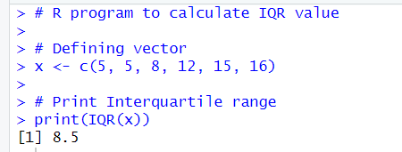

**2.Quartile in R**

Input:

# Sample data

data <- c(12, 25, 30, 42, 50, 58, 65, 73, 80, 92)

# Calculate quartiles

q1 <- quantile(data, 0.25)

q2 <- quantile(data, 0.5) # This is the median

q3 <- quantile(data, 0.75)

# Print quartiles

print(q1)

print(q2)

print(q3)

quantiles <- quantile(data, c(0.25, 0.5, 0.75))

print(quantiles)

Output:

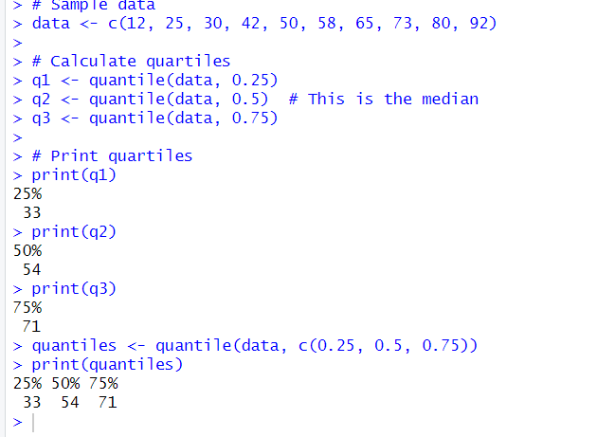

**3.Summary in R:**

Input:

# Example numeric vector

data <- c(12, 25, 30, 42, 50, 58, 65, 73, 80, 92)

# Generate summary statistics

summary(data)

Output:

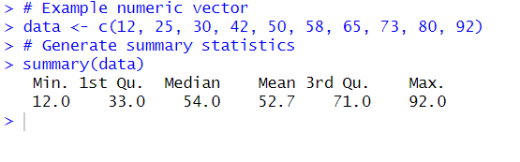

**4.Barplot:**

Input:

# Example data for grouped bar plot

categories <- c("A", "B", "C", "D")

values1 <- c(10, 20, 15, 30)

values2 <- c(5, 15, 10, 25)

# Create a grouped bar plot

barplot(rbind(values1, values2),

beside = TRUE,

names.arg = categories,

legend.text = c("Group 1", "Group 2"),

args.legend = list(x = "topright"),

main = "Grouped Bar Plot Example",

xlab = "Categories",

ylab = "Values",

col = c("blue", "green"))

Output:

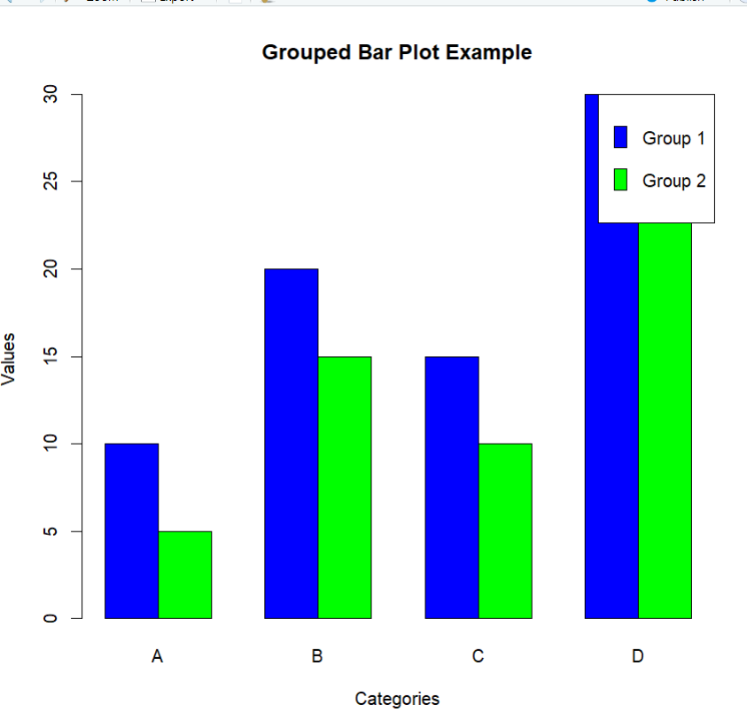

**Horizontal Barplot:**

Input:

# Example data

categories <- c("A", "B", "C", "D")

values <- c(10, 20, 15, 30)

# Create a horizontal bar plot

barplot(values, names.arg = categories,

main = "Horizontal Bar Plot Example",

xlab = "Values",

ylab = "Categories",

horiz = TRUE,

col = "blue")

Output:

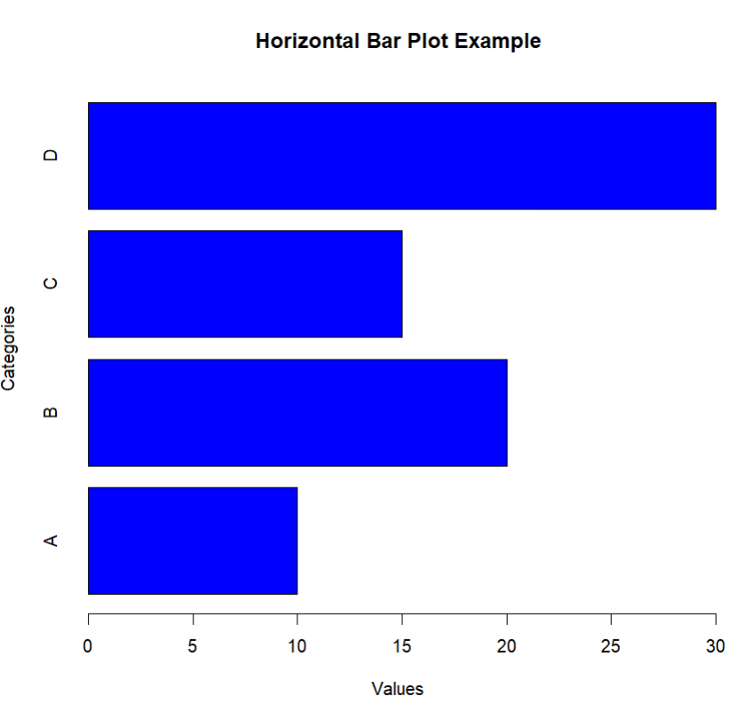

**5.Boxplot in R:**

Input:

# Example data for side-by-side boxplot

data1 <- c(25, 30, 40, 50, 55, 60, 70)

data2 <- c(15, 20, 30, 35, 50, 65, 75)

# Create a side-by-side boxplot

boxplot(data1, data2,

names = c("Data 1", "Data 2"),

main = "Side-by-Side Boxplot Example",

xlab = "Datasets",

ylab = "Values",

col = c("blue", "green"))

Output:

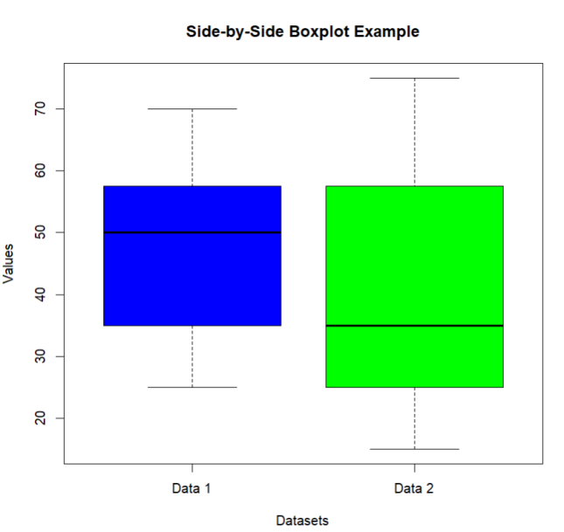

**6.Multiplication:**

Input:

x <- 5

y <- 3

result <- x * y

print(result)

Output:

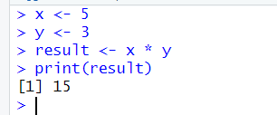

**7.Even or odd:**

Input:

# Check if a number is even or odd

number <- 7

if (number %% 2 == 0) {

print("Even")

} else {

print("Odd")

}

Output:

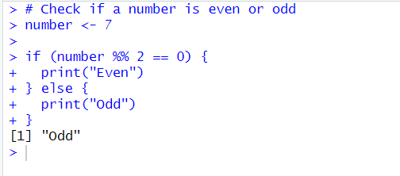

**8.Greater than three numbers:**

Input:

# Example numbers

numbers <- c(2, 5, 1, 8, 4, 6)

# Find and print numbers greater than 3 using if-else

for (num in numbers) {

if (num > 3) {

print(num)

}

}

Output:

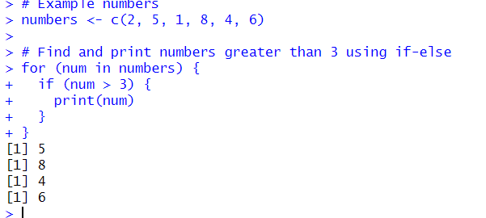

**9.Midrange in R:**

Input:

# Example data

data <- c(12, 25, 30, 42, 50, 58, 65, 73, 80, 92)

# Calculate the mid-range

mid_range <- (min(data) + max(data)) / 2

print(mid_range)

Output:

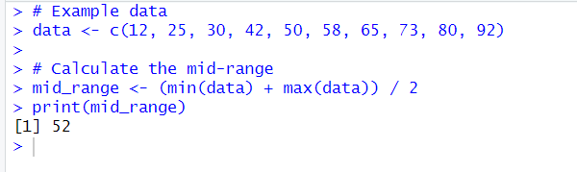

**10.Z-score Normalization:**

Input:

# Example data

data <- c(12, 25, 30, 42, 50, 58, 65, 73, 80, 92)

# Calculate mean and standard deviation

mean_data <- mean(data)

sd_data <- sd(data)

# Perform Z-score normalization

z_scores <- (data - mean_data) / sd_data

# Print the original data and the normalized data

print("Original Data:")

print(data)

print("Z-score Normalized Data:")

print(z_scores)

Output:

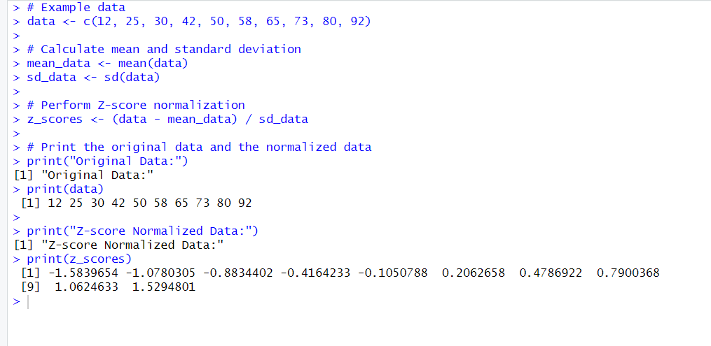

**11.Correlation in R:**

Input:

# Example data

variable1 <- c(12, 25, 30, 42, 50)

variable2 <- c(15, 28, 35, 45, 60)

# Calculate the correlation

correlation <- cor(variable1, variable2)

# Print the correlation

print(correlation)

Output:

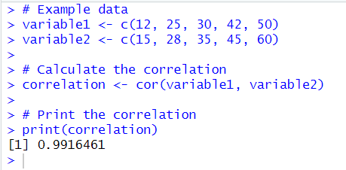

**12.Scatter plot:**

Input:

# Example data

variable1 <- c(12, 25, 30, 42, 50)

variable2 <- c(15, 28, 35, 45, 60)

# Create a scatterplot

plot(variable1, variable2,

main = "Scatterplot Example",

xlab = "Variable 1",

ylab = "Variable 2",

col = "blue",

pch = 16) # Use filled circles for points

Output:

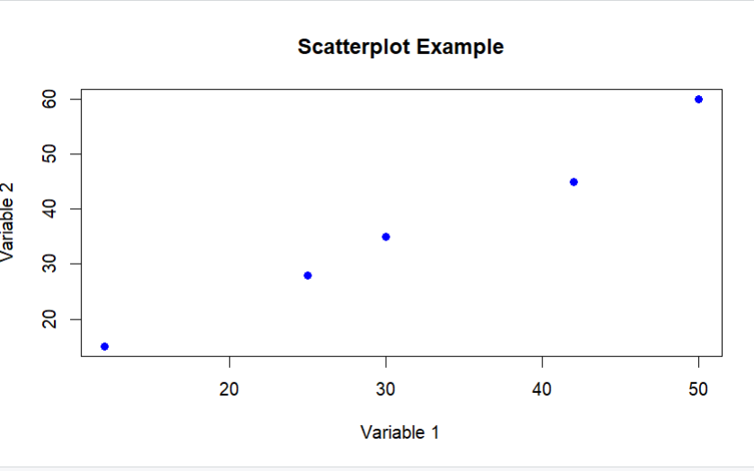

**13.Multiple regression in R:**

Input:

# Load the dataset

data(mtcars)

# Perform multiple regression

model <- lm(mpg ~ wt + hp + qsec, data = mtcars)

# Print summary of the regression model

summary(model)

Output:

