(SLOT -C) DATA WAREHOUSING AND DATA MINING FOR WHETHEAR FORECASTING

DAY-1

Q1. ADDITION

CODE🡪

num1=as.integer(readline (prompt = "Enter the num1:"))

num2=as.integer(readline (prompt = "Enter the num2:"))

sum=num1+num2

print(sum)

OUTPUT:

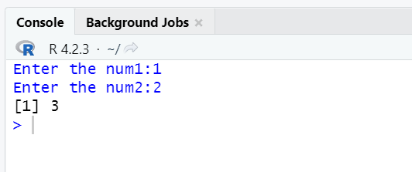

Q2.MEAN

CODE🡪

a<-c(150,174,138,186,128,136,171,163,152,131)

b<-mean(a)

print(b)

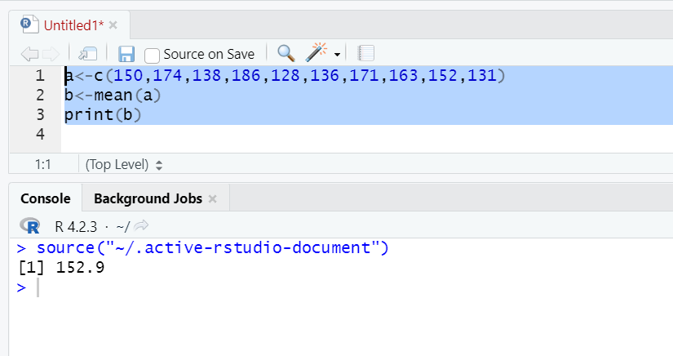

Q3. Bar plot

Code->

max.temp <- c(22, 27, 26, 24, 23, 26, 28)

barplot(max.temp)

barplot(max.temp,

main = "Maximum Temperatures in a Week",

xlab = "Degree Celsius",

ylab = "Day",

names.arg = c("Sun", "Mon", "Tue", "Wed", "Thu", "Fri", "Sat"),

col = "yellow",

horiz=TRUE)

Output:

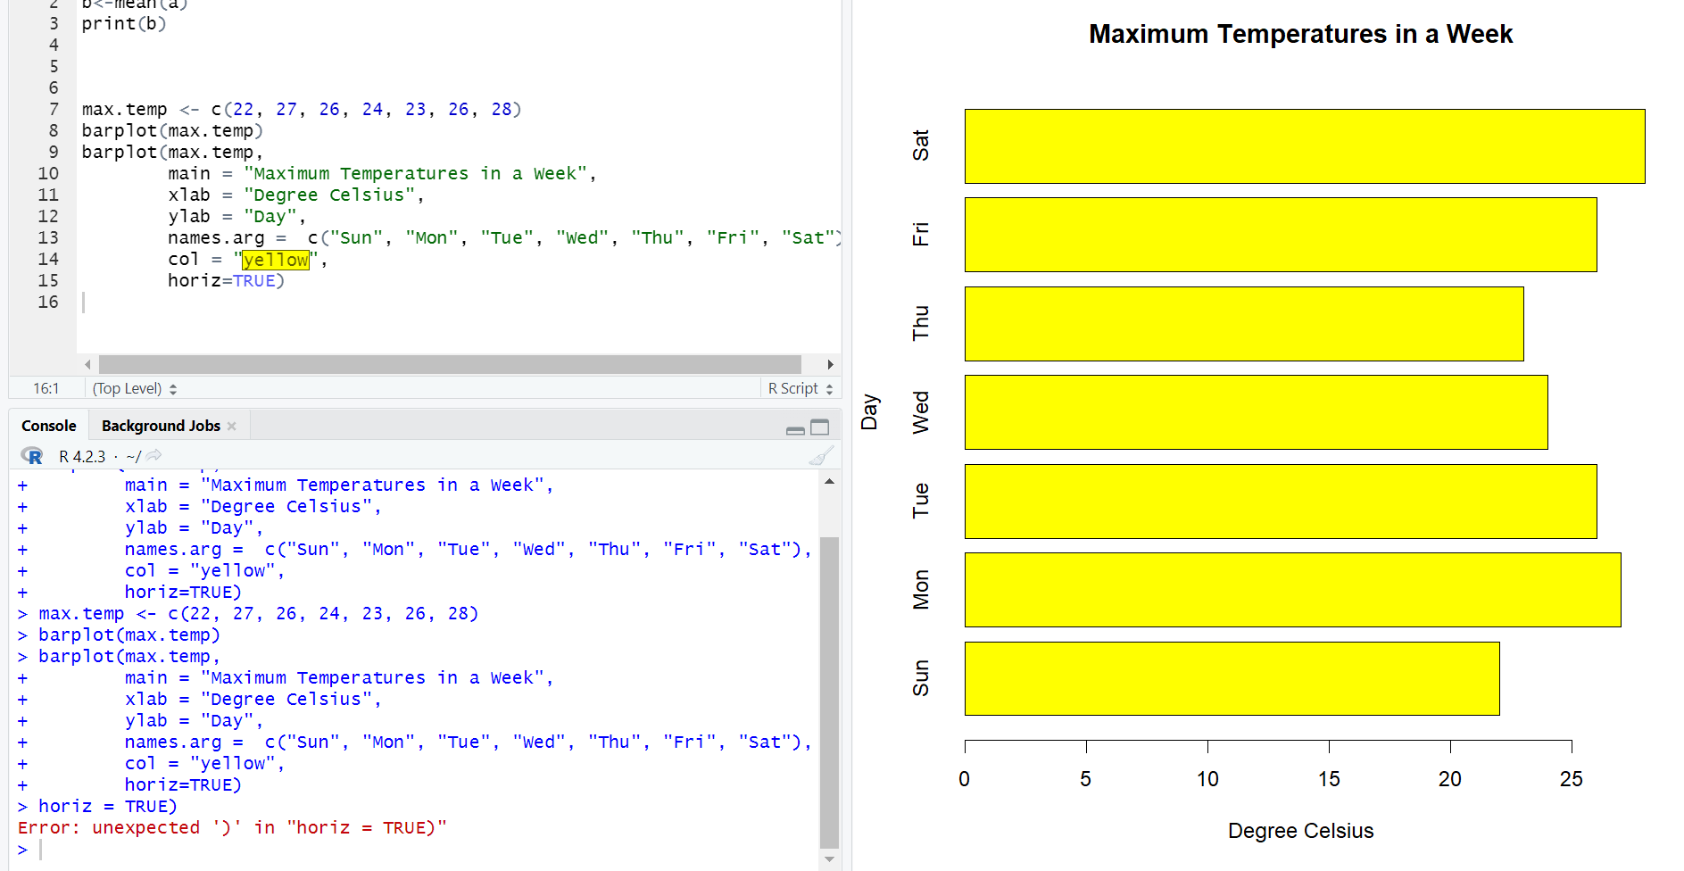

Q4. Box plot

Code->

a<-c(10,12,13,14,17,19,20,30,50,70,90,100)

boxplot(a,col="blue")

Output:

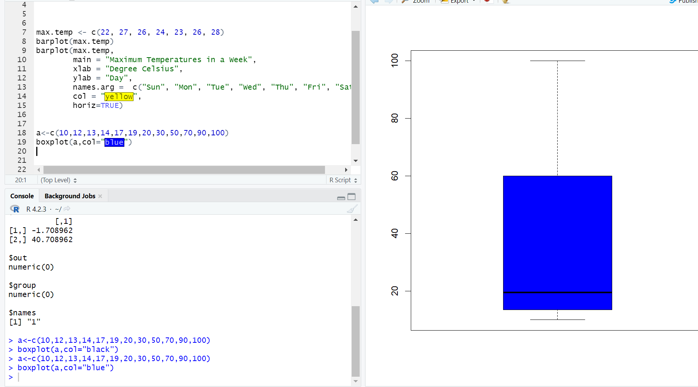

Q5. Division

Code->

a=readline(prompt = "Enter the number 1:")

b=readline (prompt = "Enter a number2:")

a=as.integer(a)

b=as.integer(b)

c=a/b

print(c)

output->

