**Git & GitHub**

**Task 1:**

**Demonstrate minimum 15 basic Git command with explanation and screenshot:**

1. These command sets the user’s name and email id respectively to be used with commit.

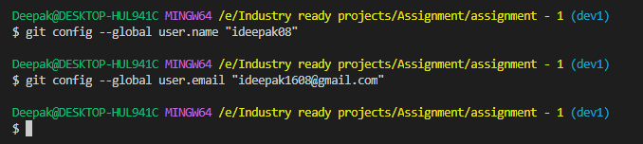

1. This command initialised the empty repository with name assignment1

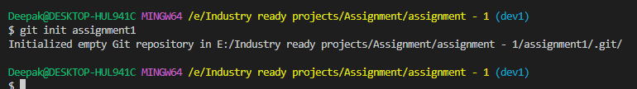

1. This command is used to make a copy of a repository locally from an existing URL

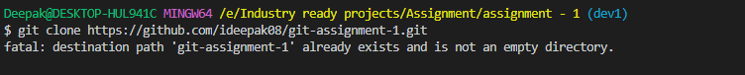

1. Git branch command show all the available branch and git checkout main command used to switched from dev1 branch to main branch.

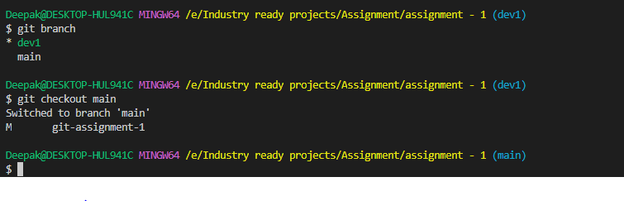

1. This command creates a new branch named dev2 and switch to it at the same time

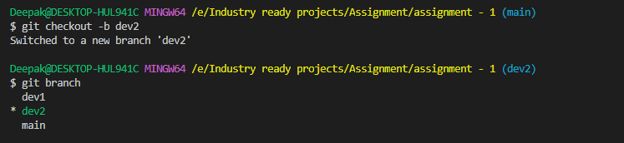

1. Command git add . is used to add more than one file to staging area while git add <file-name> is used to one file to staging area.

