



### Course: BCA-III

**MOOCS SEMINAR REPORT**

### Student ID: 20041299

### Name: Deepankar Sharma



**Google IT Automation with Python Professional Certificate**

**Using Python to Interact with the Operating System**

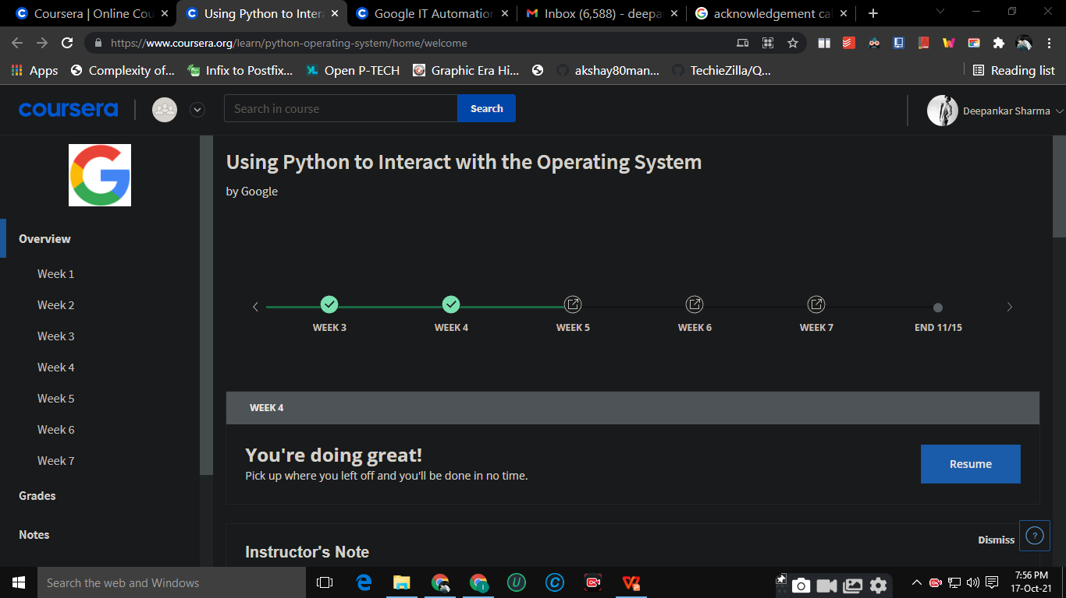

I take this opportunity to express my profound gratitude and deep regards to my teacher As. Prof. **Mayurika Joshi** **Ma’am**.

For their exemplary guidance, monitoring and constant encouragement throughout the course of this report. The blessing, help and guidance given by them time to time shall carry me a long way in the journey of life on which I am about to embark.

Lastly, I thank almighty, my parents and friends for their constant encouragement without which this project would not be possible.

**ACKNOWLEDGEMENT**



|  |  |
| --- | --- |
| **WEEK** | **NAME OF THE LESSON** |
| **WEEK 1** | Getting Your Python On |
| **WEEK 2** | Managing Files with Python |
| **WEEK 3** | Regular Expressions |
| **WEEK 4** | Managing Data and Processes |
| **WEEK 5** | Testing in Python |
| **WEEK 6** | Bash Scripting |
| **WEEK 7** | Final Project |

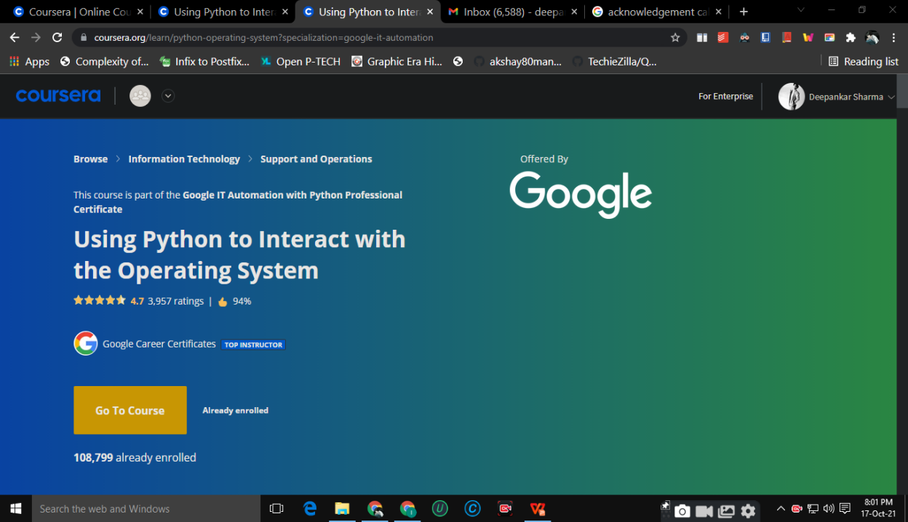



This course is designed to teach you the foundations in order to write simple programs in Python using the most common structures. No previous exposure to programming is needed. By the end of this course, you'll understand the benefits of programming in IT roles; be able to write simple programs using Python; figure out how the building blocks of programming fit together; and combine all of this knowledge to solve a complex programming problem. .

**Week 01: Getting Your Python On**

In this module, we learn about the different types of operating systems, and how we can get our python code ready to interact with the operating system. we learn about getting our environment set up and installing additional Python modules that help us along the way. we rundown interpreted versus compiled language, and how they differ from each other. we dive into the benefits of automation, and point out common pitfalls so we can avoid them. Finally, we learn about Qwiklabs, which be used for graded assessments.

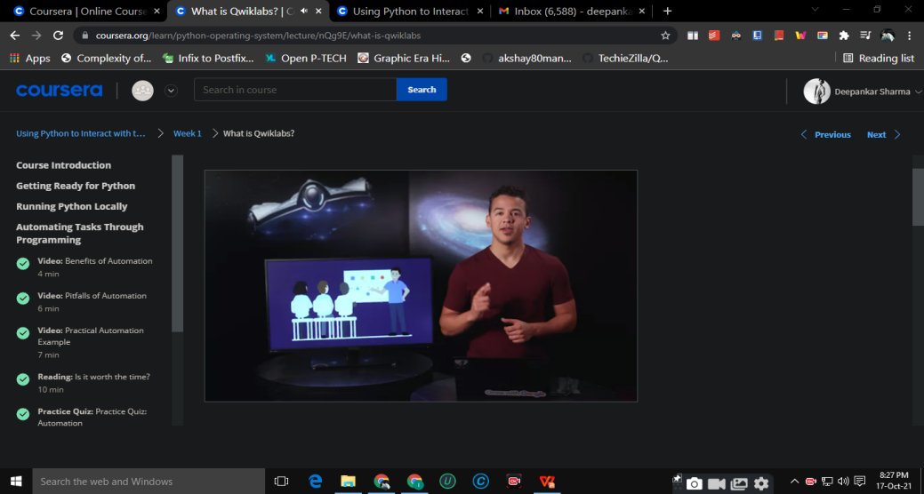

**Week 02: Managing Files with Python**

In this module, we learn about reading and writing to files and the commands that enable us to do this. we learn the importance of managing files and how we can navigate through different directories. we understand how to work with files and how there is a layer of abstraction between Python and the operating system. Finally, we dive into learning about CSV files and how to best utilize them.

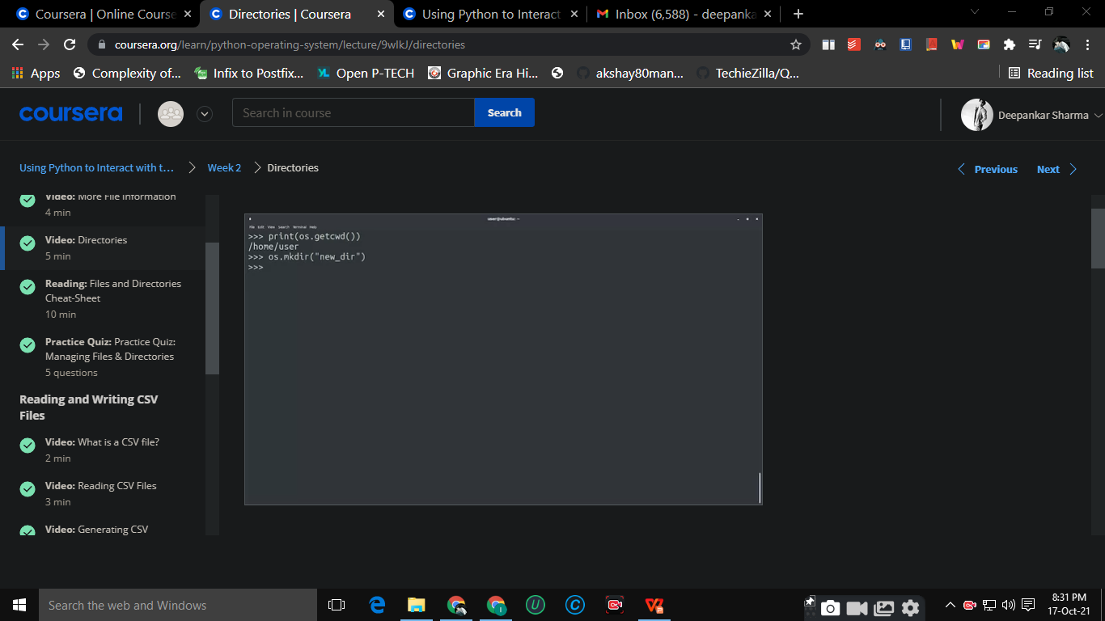

**Week 03: Regular Expressions**

In this module, we learn about what a regular expression is and why we would use one. we dive into the basics of regular expressions and give examples of wildcards, repetition qualifiers, escapare characters, and more. Next up, we explore advanced regular expressions and deep dive on repetition qualifiers. we tackle new exercises like capturing groups and extracting PIDs using regexes. Finally, we get a cheat sheet to serve as your go-to guide for regular expressions.

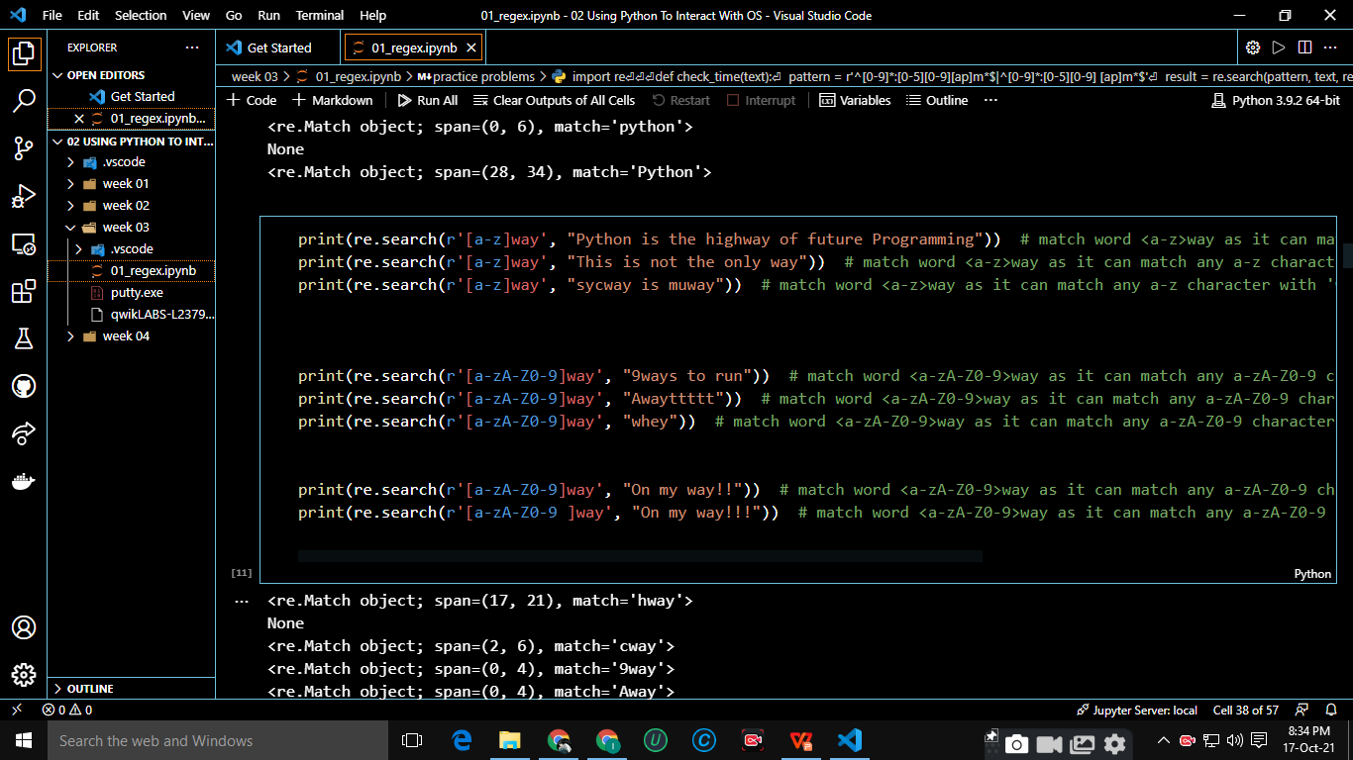

**Week 04: Managing Data and Processes**

In this module, we learn about reading and writing to data files based on an interaction with the user. Along the way, we dive into standard streams, environment variables, and command line arguments. Next, we jump into Python subprocesses, including system commands and how they can be used. we review how to obtain output from a system command, and dive into subprocess management, including how to check exit values and manipulate the normal versus error exit values. Finally, we rundown processing log files, and cover what a log file is, how to filter log files using regular expressions, and how to understand the output captured from log files.

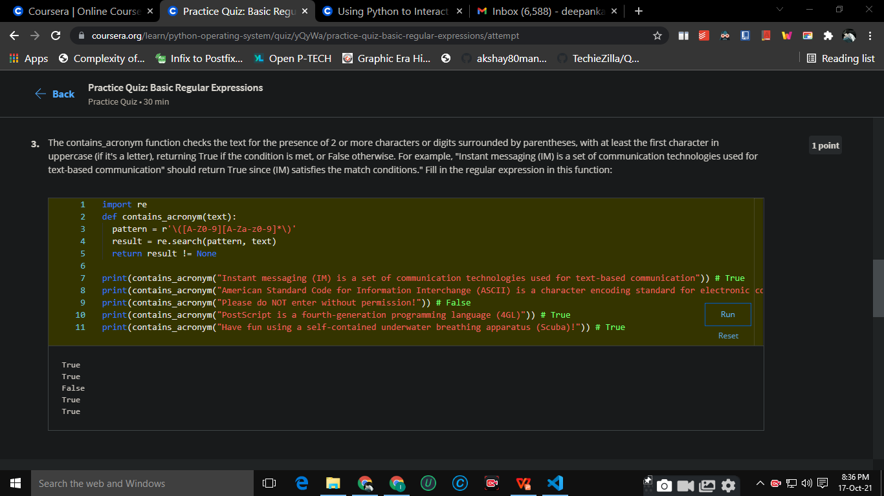

**Week 05: Testing in Python**

In this module, we learn how to create tests in Python. We’ll cover what testing is all about and dive into the differences between manual versus automated testing. Next, we’ll explore what unit tests are intended to do and how to write them. Then, we’ll learn about other test concepts like black box versus white box tests and how test-driven development can frame how you design and write your code. Finally, we learn about errors and exceptions, and how to combat them.

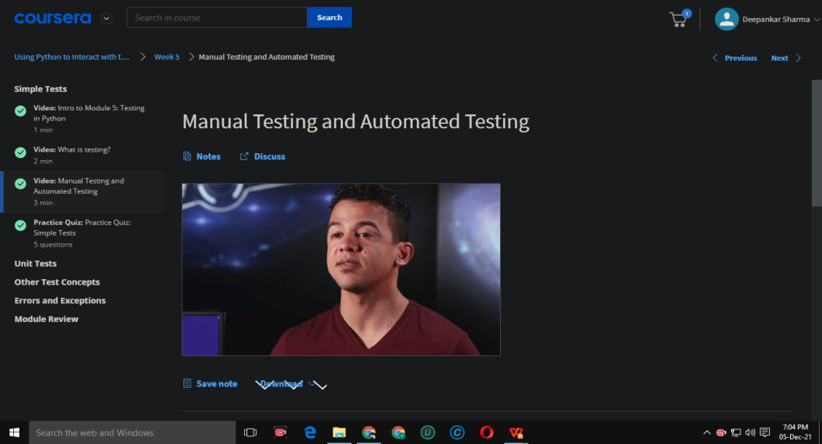

**Week 06: Bash Scripting**

In this module, we be exposed to what the Linux OS has to offer and we learn about Bash scripting. We’ll go over basic Linux commands and explore the many processes Linux has to offer, including a key concept called redirection. We’ll then deep dive into creating bash scripts using variables and globs. Finally, we’ll learn about advanced bash concepts and develop an understanding of when to use bash versus Python.

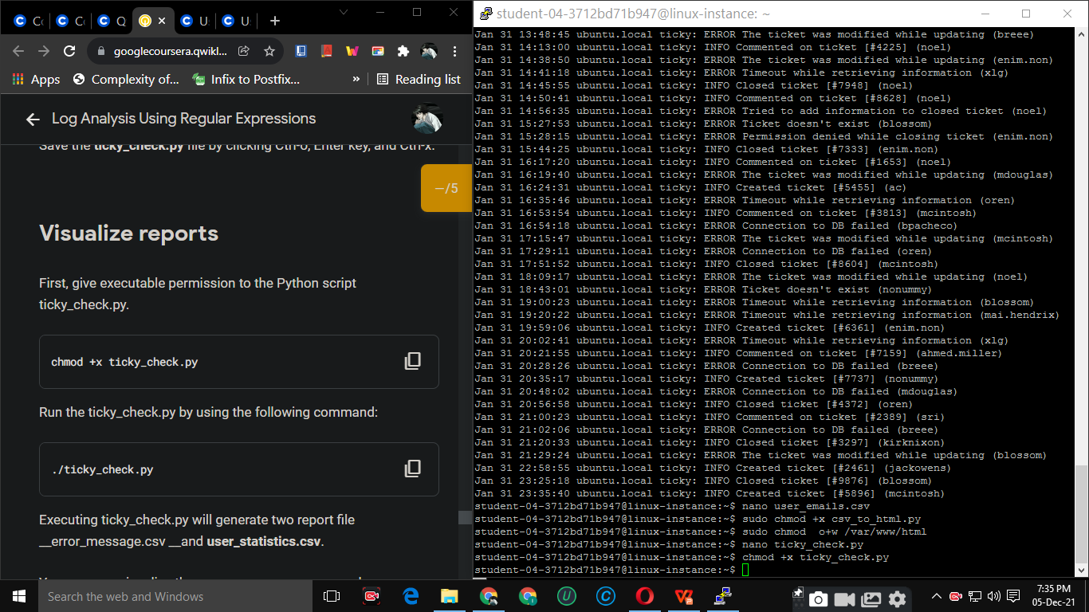

**Week 07: Final Project**

In this module, we put everything we’ve learned so far into action! we apply your scripting knowledge to tackle a challenging final project: writing a script that scans for a specific error in the log files. we are given a problem statement to understand the challenge, conduct some research to see what options are available, then begin planning how we intend to solve the problem. Lastly, we write the code to implement our solution!

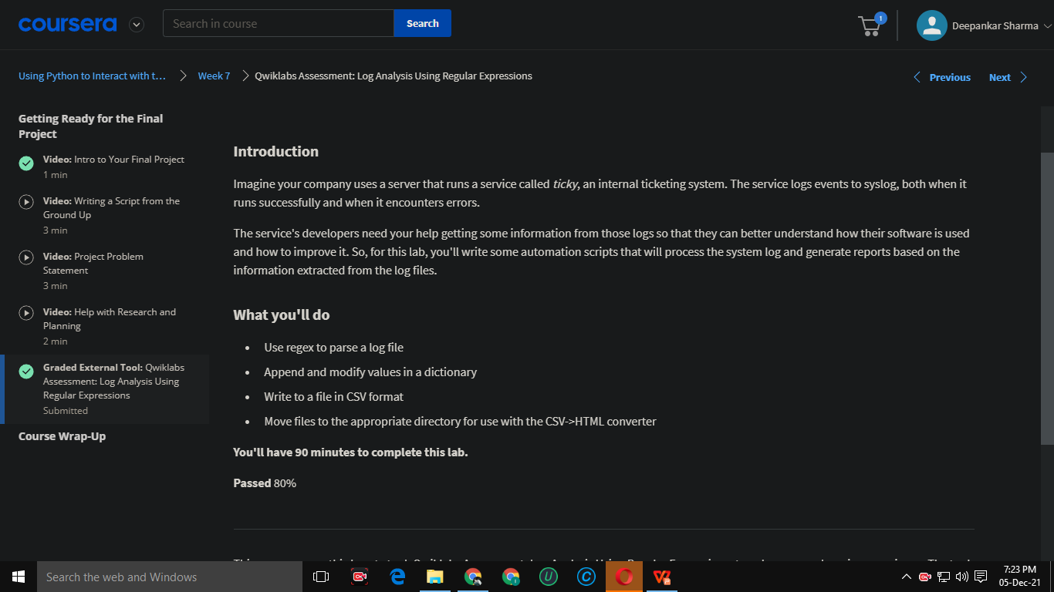

**Sneak Peek of the Next Course**

**Introduction to Git and Github !!!**

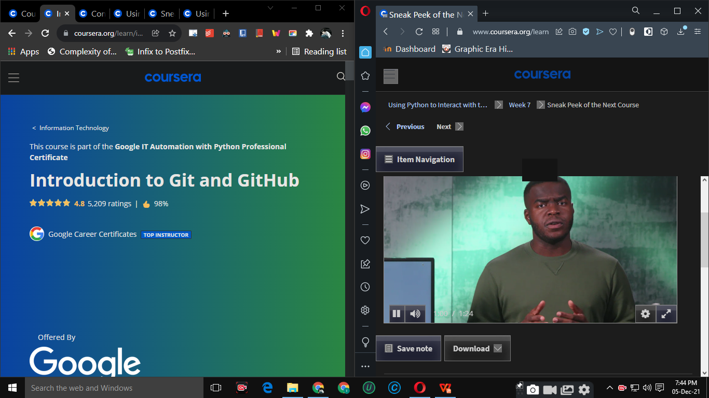

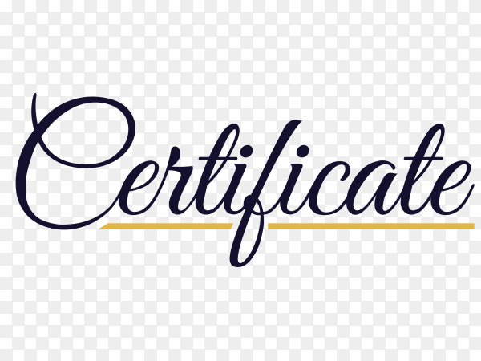

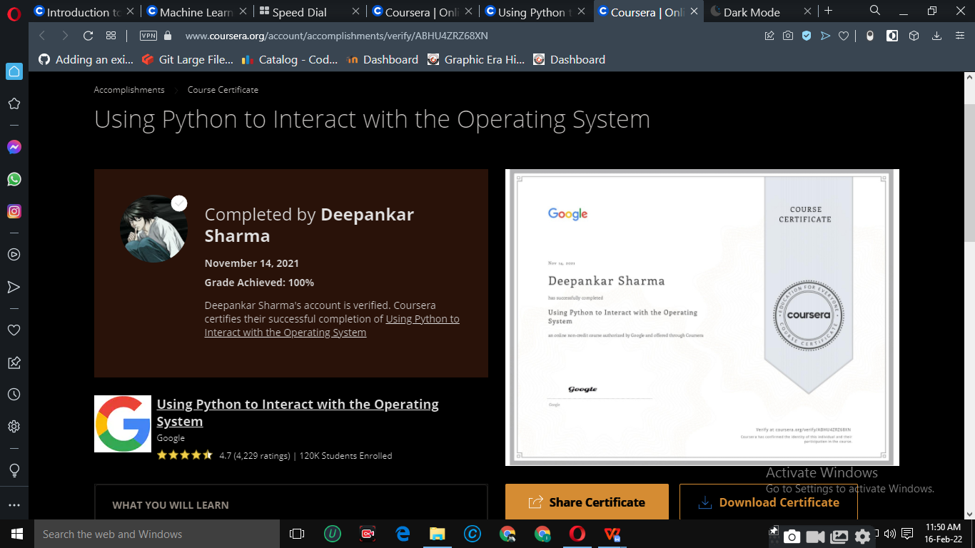



By the end of this course, I’m able to manipulate files and processes on your computer’s operating system. I also have learned about regular expressions -- a very powerful tool for processing text files -- and we get practice using the Linux command line on a virtual machine. And, this might feel like a stretch right now, but I also wrote a program that processes a bunch of errors in an actual log file and then generates a summary file. That’s a super useful skill for IT Specialists to know.

I also know how to set up my own developer environment in our machine. This is a key step in being able to write and deploy powerful automation tools.

Thank You !!!!