**Developing a Baby Health Care System using Artificial Intelligence and Reinforcement Learning**

Deepankar Sharma,

Student BCA,

Department of Computer Science and Engineering,

Graphic Era Hill University, Haldwani

[deepankarsharma.20041299@gehu.ac.in](mailto:DEEPANKARSHARMA.20041299@gehu.ac.in)

Sujata Negi Thakur,

Assistant Professor,

Department of Computer Science and Engineering,

Graphic Era Hill University, Haldwani

[sujatanegi@gehu.ac.in](mailto:sujatanegi@gehu.ac.in)

Manoj Kumar Singh,

Assistant Professor,

School of Computing,

Graphic Era Hill University, Bhimtal

[mthakur@gehu.ac.in](mailto:mthakur@gehu.ac.in)

Nidhi Joshi,

Assistant Professor,

Graphic Era Hill University, Dehradun

<nidhi345@gmail.com>

**Abstract:**

The lives of people is already getting busier everyday. In most families involving both parents working are prone to insufficient parenting, as small babies can’t exactly say what they want and parents might be too busy to figure it out. Usually most parents hire someone else to do the childcare of their babies in their working hours. This next person might be someone in family or someone on paid basis. But being human , a third person, being not a parent might not always be that much sensitive to your baby. Their minds maybe preoccupied. This usually leads to problems like separation anxiety, social isolation and increases the gap of misunderstanding between the working as well as single parents and their babies.

This paper presents an idea of how an effective baby healthcare system could be developed using Artificial Intelligence and Reinforcement Learning that will help to deal with these problems.

**Keywords:**

Artificial Intelligence , Reinforcement Learning, NLP, Computer Vision, Mood Detection Classifier, Recommendation System

**Introduction**

Having intelligent machines is a big demand for every sector of the society. Small babies don’t exactly express themselves in words so this system is focused on identifying their needs with the help of the existing AI technology around us. With such an advancement in fields of Computer Vision and Natural Language Processing, the tasks to be done have become very accurate.

1. **Working Of The Baby Healthcare System**

The idea is to develop a full-fledged AI automated application with a Mood Detection Classifier trained specially on datasets of small babies which can help you detect the current mood of the baby that whether they are happy/sad or they seem to be hungry. The app will also have another features like growth-vs-age mapping of various children that can help you track the growth of your child.

This app is supposed to be serving as a self-customized application which will learn to deal with specifically your child. It would be made flexible so that with time it’ll learn from habits of the specific children it’s serving to.

Another feature , the app will come with a community environment , where you can seek for advice from fellow parents/experts. Everyone knows some life hacks, so the users might will have possibly many many better options of childcare.

The application will also have various inbuilt melodies and songs as well as access to music applications or You Tube which it can play/recommend according to the mood of the child.

* 1. **The Mood Detection Classifier**

The Mood Detection Classifier would be the most important part of this application. It will use both Computer Vision as well as NLP to predict the mood of child at any point of time.

The visual inferences will be made by CNN part of this model, which will be trained with particularly over the dataset of images describing emotions of small babies essentially of the desired age group.

Whereas the Mood Classification using Voice of babies could be little trickier because premature babies can’t speak in words therefore we can’t perform sentiment analysis directly. Instead we’d need to perform Exploratory Data Analysis over the recorded voices and label the emotions based on the frequency and pitch of the sound of their cry and thereafter train the model.

* 1. **The Grow Monitoring Dashboard**

The growth monitoring dashboard would have various statistics and simplified data analysis describing the growth of the child as well as the comparison with the expected predicted growth at that age. This dashboard will also have lots of other fun facts and information about the personalized childcare suggestions for the user.

* 1. **The Recommendation Systems**

The overall system would contain various recommendation systems. For instance there would be a content based recommendation system that’ll help to identify the ‘genre’ for the babies, like what type of music and cartoons make them happy. Similarly another example would be to identify the food taste for babies we could use a collaborative filtering based recommendation system.

* 1. **The Reinforcement Learning Agent**

The Reinforcement Learning Agent is the most important part of this system. It will help the system to personalize according to the user(baby) it’s serving to.

It will smartly grow along with the child to customize itself accordingly. For example let’s take account of selecting a melody.

Suppose the user have three moods: “happy”, “sad” and “angry”. Now irrespective of these moods the agent would select a random melody at first and will observe the change in mood. If the user gets happy , that would be a positive reward otherwise a negative reward. Next time the agent would consider this melody into account before making any prediction.

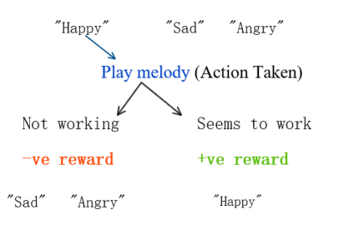

1. **Deployment**

The deployment of this system would involve the mobile application, server and a slave machine(robot).

The connection will start in three steps:

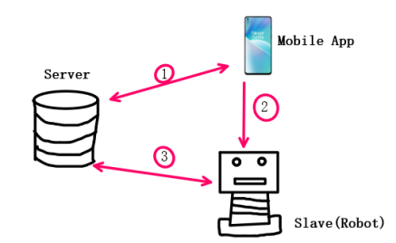

1. The handshake between the server and the mobile app with authentication.
2. The handshake between the slave and the mobile app with authentication.
3. Establishing a dedicated path between Slave and the Server.
   1. **Server**

The server would have all the processing power of the entire system. It’ll have the deployed ML models which will take live feed from the slave machine as an input and after processing that the actions will be sent back to the slave machine. The server will also redirect that live feed to the mobile app and will manage the notifications based on the processed predictions.

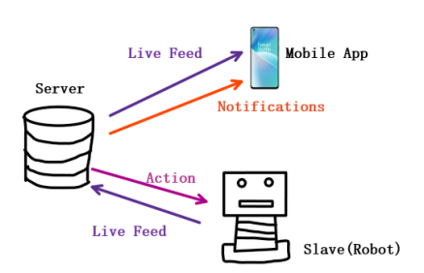

* 1. **The Mobile Application**

The mobile application wouldn’t have any internal processing. It will only act as a social media platform for community of parents as well as to display the live feed and the monitoring dashboard. It is only a display unit for users(parents).

* 1. **The Slave Machine (Robot)**

The Slave machine would essentially the device nearest to the user(baby). It’ll have sensors that will take input of the feed and will be sent to server for the processing. The slave would also perform the processed actions and would have small processing functionality within itself too.

1. **Conclusion**

This health care system is supposed to be one of it’s kind , because it’ll also learn from the habits of the children its serving to and call always be customized. This application will provide all effective tools at one place that will help parents with effective parenting. Besides if deployed in form of robots it can serve as a best buddy to many children.

**References**

1. Kulkarni, S.S., Reddy, N.P. & Hariharan, S. Facial expression (mood) recognition from facial images using committee neural networks. BioMed Eng OnLine 8, 16 (2009). <https://doi.org/10.1186/1475-925X-8-16>
2. <https://www.analyticsinsight.net/speech-emotion-recognition-ser-through-machine-learning/>
3. den Hengst, Floris et al. ‘Reinforcement Learning for Personalization: A Systematic Literature Review’. 1 Jan. 2020 : 107 – 147.
4. Chamishka, S., Madhavi, I., Nawaratne, R. et al. A voice-based real-time emotion detection technique using recurrent neural network empowered feature modelling. Multimed Tools Appl (2022). <https://doi.org/10.1007/s11042-022-13363-4>
5. H. Liu, N. Stoll, S. Junginger and K. Thurow, "A common wireless remote control system for mobile robots in laboratory," 2012 IEEE International Instrumentation and Measurement Technology Conference Proceedings, 2012, pp. 688-693, doi: 10.1109/I2MTC.2012.6229212.
6. Kumar Shastha, Tejas, Maria Kyrarini, and Axel Gräser. 2020. "Application of Reinforcement Learning to a Robotic Drinking Assistant" Robotics 9, no. 1: 1. https://doi.org/10.3390/robotics9010001