Having too many options also makes you misguided sometimes. The students these days face similar problem regarding their career paths and setting up their goals. The life of students is tough, there’s always some constant pressure from many dimensions like peer, family, teachers, etc. And the individuals start to loose clarity in their interests, arenas and eventually this leads to misguided goals.We can’t imagine the exposure of information a student gets these days, and having that much information works as a distraction most of the times.

**"What should I have to do in Life"?**

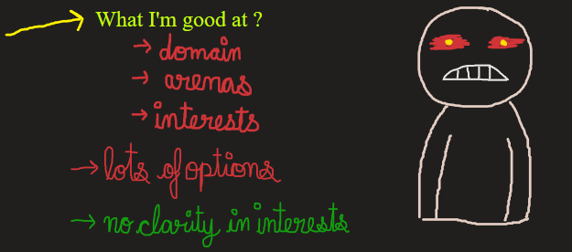

The idea is to develop an **AI Assistant cum Recommendation System Application** that will be serving as a self customized AI-Counsellor. The model would be made with advanced NLP so that Natural Conversation Interface would feel like very friendly environment to the users.

The Application would work on very simple algorithms like Regression, Classification , PCA , Recommendation Systems and Reinforcement Learning built on top of it. The input to the application would be lot of input features like: Interests, Subject-wise scores, Routine, Schedule per subject, social media usage , extra curricular activities etc.

Now applying PCA over this data would help to classify “Arena/Domain” interests of the user as well as calculate a numeric performance score of the user. A simple regression model would help to predict the future performance score on basis of a routine. Further more the application will help students to come up with a better time schedule , let them identify their strong domains and recommend them which areas they need to work on. Also the application will set up frequent goals for the students to provide them better guidance.

Now the application will be smart enough to customize itself according to student’s progress as if achieving certain goals leads to increase in performance score of student , it’ll yield a positive reward for the AI-assistant, otherwise negative.

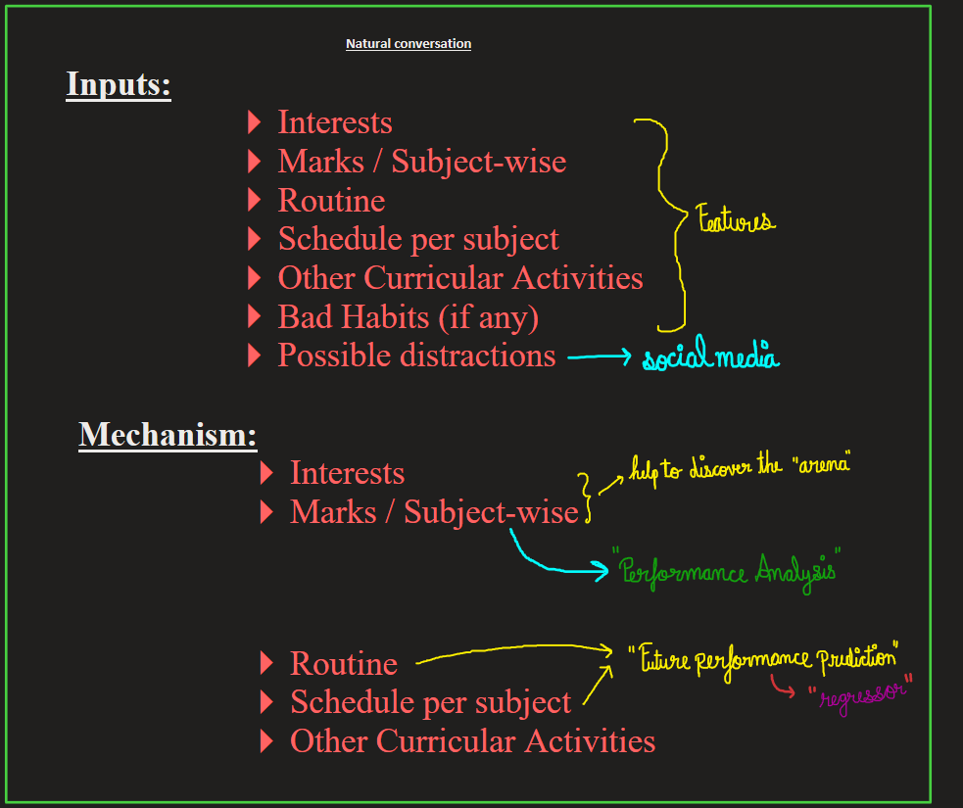

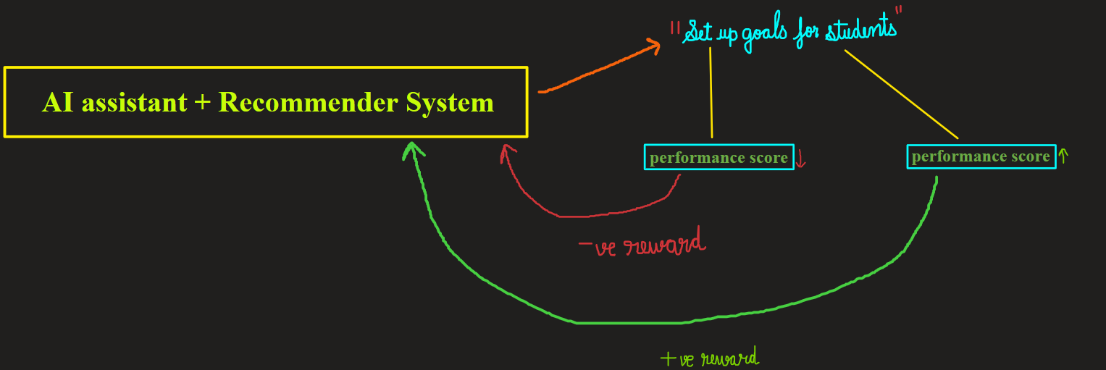

**Inputs:**

* Interests
* Marks / Subject-wise
* Routine
* Schedule per subject
* Other Curricular Activities
* Bad Habits (if any)
* Possible distractions
* ….……………

**Mechanism:**

* Interests
* Marks / Subject-wise

* Routine
* Schedule per subject
* Other Curricular Activities

**AI assistant + Recommender System**

CLASSIFY ARENAS

CALCULATE PERFORMANCE SCORE

PREDICT FUTURE PERFORMANCE SCORE

VS ROUTINE

Performance Score decreased

(negative reward)

Performance Score increased

(positive reward)

**SET UP GOALS FOR STUDENTS**

But being human , a person is always guided by his emotion and gut-instinct. But the story being told by data is very honest. This application exploits the power of data to make data driven decision making and identify the best possible actions to maximize the effective goal planning for students.