Name : Deepankar Sharma

Course: BCA

University Roll No: 2092014

Student Id : 20041299

Semester: 5

Date: December 26, 2022

**Practical 01: Hello World App**

**Objective:**  Create an Android Hello World App.

**XML**

<?xml version="1.0" encoding="utf-8"?>

<android.support.constraint.ConstraintLayout xmlns:android="http://schemas.android.com/apk/res/android"

xmlns:app="http://schemas.android.com/apk/res-auto"

xmlns:tools="http://schemas.android.com/tools"

android:layout_width="match_parent"

android:layout_height="match_parent"

tools:context=".MainActivity">

<TextView

android:layout_width="wrap_content"

android:layout_height="wrap_content"

android:text="Hello World!"

app:layout_constraintBottom_toBottomOf="parent"

app:layout_constraintEnd_toEndOf="parent"

app:layout_constraintStart_toStartOf="parent"

app:layout_constraintTop_toTopOf="parent" />

</android.support.constraint.ConstraintLayout>

**JAVA**

package com.example.practicalkimkbkc;

import android.support.v7.app.AppCompatActivity;

import android.os.Bundle;

public class MainActivity extends AppCompatActivity {

@Override

protected void onCreate(Bundle savedInstanceState) {

super.onCreate(savedInstanceState);

setContentView(R.layout.activity_main);

}

}

**Output:**

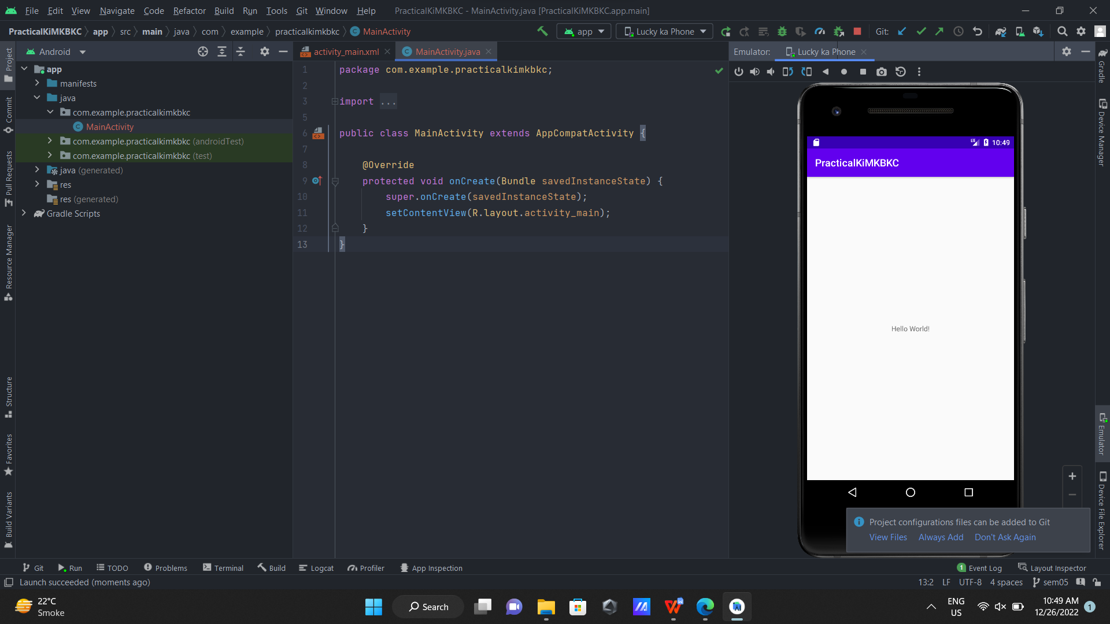

Name : Deepankar Sharma

Course: BCA

University Roll No: 2092014

Student Id : 20041299

Semester: 5

Date: September 12, 2022

**Practical 01: Unit Convertor App**

**Objective:**  Create an Android app to convert kilograms into pounds.

**XML CODE**

<?xml version="1.0" encoding="utf-8"?>

<androidx.constraintlayout.widget.ConstraintLayout xmlns:android="http://schemas.android.com/apk/res/android"

xmlns:app="http://schemas.android.com/apk/res-auto"

xmlns:tools="http://schemas.android.com/tools"

android:layout_width="match_parent"

android:layout_height="match_parent"

tools:context=".MainActivity">

<EditText

android:id="@+id/editTextTextPersonName"

android:layout_width="237dp"

android:layout_height="48dp"

android:layout_marginTop="116dp"

android:ems="10"

android:inputType="textPersonName"

android:text="0"

app:layout_constraintEnd_toEndOf="parent"

app:layout_constraintStart_toStartOf="parent"

app:layout_constraintTop_toTopOf="parent" />

<Button

android:id="@+id/button"

android:layout_width="wrap_content"

android:layout_height="wrap_content"

android:layout_marginTop="72dp"

android:shadowColor="#DC2828"

android:text="CONVERT"

android:textColor="#FAF6F6"

android:textStyle="bold"

app:layout_constraintBottom_toBottomOf="parent"

app:layout_constraintEnd_toEndOf="parent"

app:layout_constraintHorizontal_bias="0.498"

app:layout_constraintStart_toStartOf="parent"

app:layout_constraintTop_toTopOf="parent"

app:layout_constraintVertical_bias="0.343"

app:rippleColor="#E31A1A" />

<TextView

android:id="@+id/textView"

android:layout_width="wrap_content"

android:layout_height="wrap_content"

android:textColor="#0C0C0C"

android:textSize="20sp"

app:layout_constraintBottom_toTopOf="@+id/button"

app:layout_constraintEnd_toEndOf="parent"

app:layout_constraintHorizontal_bias="0.498"

app:layout_constraintStart_toStartOf="parent"

app:layout_constraintTop_toBottomOf="@+id/editTextTextPersonName"

app:layout_constraintVertical_bias="0.376" />

<TextView

android:id="@+id/textView2"

android:layout_width="325dp"

android:layout_height="31dp"

android:text="Enter the value in kilograms below"

android:textColor="#171414"

android:textSize="20sp"

android:textStyle="bold"

app:layout_constraintBottom_toTopOf="@+id/editTextTextPersonName"

app:layout_constraintEnd_toEndOf="parent"

app:layout_constraintStart_toStartOf="parent"

app:layout_constraintTop_toTopOf="parent"

app:layout_constraintVertical_bias="0.729"

tools:text="Enter the value in kilograms below" />

<ImageView

android:id="@+id/imageView"

android:layout_width="411dp"

android:layout_height="247dp"

app:layout_constraintBottom_toBottomOf="parent"

app:layout_constraintEnd_toEndOf="parent"

app:layout_constraintHorizontal_bias="0.0"

app:layout_constraintStart_toStartOf="parent"

app:layout_constraintTop_toBottomOf="@+id/editTextTextPersonName"

app:layout_constraintVertical_bias="0.721"

app:srcCompat="@drawable/img" />

</androidx.constraintlayout.widget.ConstraintLayout>

**JAVA CODE**

package com.example.unitconverter;

import androidx.appcompat.app.AppCompatActivity;

import android.os.Bundle;

import android.view.View;

import android.widget.Button;

import android.widget.EditText;

import android.widget.TextView;

import android.widget.Toast;

public class MainActivity extends AppCompatActivity {

private Button b;

private TextView tv;

private EditText et;

@Override

protected void onCreate(Bundle savedInstanceState) {

super.onCreate(savedInstanceState);

setContentView(R.layout.activity_main);

b= findViewById(R.id.button);

tv= findViewById(R.id.textView);

et= findViewById(R.id.editTextTextPersonName);

b.setOnClickListener(new View.OnClickListener() {

@Override

public void onClick(View view) {

Toast.makeText(MainActivity.this, "Converted Successfully !!!", Toast.LENGTH_SHORT).show();

String s= et.getText().toString();

int kg= Integer.parseInt(s);

double pound= kg*2.205;

tv.setText("The corresponding Pounds value is: "+ pound);

}

});

}

}

**Output:**

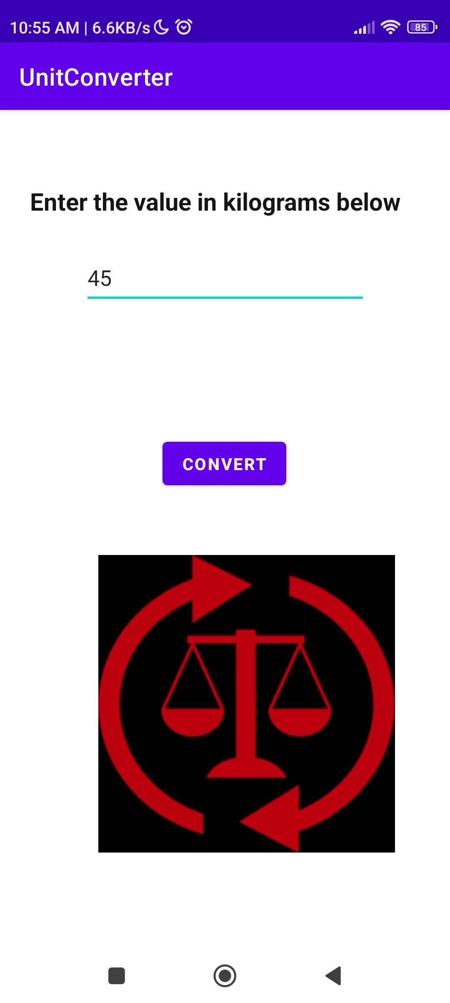

Name : Deepankar Sharma

Course: BCA

University Roll No: 2092014

Student Id : 20041299

Semester: 5

Date: September 12, 2022

**Practical 02: Scorecard App**

**Objective:**  Create an Android app which takes input marks of five subjects and calculates the percentage as output.

**XML CODE**

<?xml version="1.0" encoding="utf-8"?>

<android.support.constraint.ConstraintLayout xmlns:android="http://schemas.android.com/apk/res/android"

xmlns:app="http://schemas.android.com/apk/res-auto"

xmlns:tools="http://schemas.android.com/tools"

android:layout_width="match_parent"

android:layout_height="match_parent"

tools:context=".MainActivity">

<EditText

android:id="@+id/editTextNumberDecimal5"

android:layout_width="wrap_content"

android:layout_height="wrap_content"

android:layout_marginTop="28dp"

android:ems="10"

android:inputType="numberDecimal"

android:minHeight="48dp"

android:text="0"

app:layout_constraintEnd_toEndOf="parent"

app:layout_constraintHorizontal_bias="0.64"

app:layout_constraintStart_toEndOf="@+id/textView2"

app:layout_constraintTop_toBottomOf="@+id/editTextNumberDecimal4" />

<TextView

android:id="@+id/textView6"

android:layout_width="wrap_content"

android:layout_height="wrap_content"

android:layout_marginStart="36dp"

android:layout_marginTop="56dp"

android:text="DS ALGO"

app:layout_constraintStart_toStartOf="parent"

app:layout_constraintTop_toBottomOf="@+id/textView5" />

<EditText

android:id="@+id/editTextNumberDecimal4"

android:layout_width="wrap_content"

android:layout_height="wrap_content"

android:layout_marginTop="32dp"

android:ems="10"

android:inputType="numberDecimal"

android:minHeight="48dp"

android:text="0"

app:layout_constraintEnd_toEndOf="parent"

app:layout_constraintHorizontal_bias="0.64"

app:layout_constraintStart_toEndOf="@+id/textView2"

app:layout_constraintTop_toBottomOf="@+id/editTextNumberDecimal3" />

<TextView

android:id="@+id/textView5"

android:layout_width="wrap_content"

android:layout_height="wrap_content"

android:layout_marginStart="36dp"

android:layout_marginTop="52dp"

android:text="Python"

app:layout_constraintStart_toStartOf="parent"

app:layout_constraintTop_toBottomOf="@+id/textView4" />

<EditText

android:id="@+id/editTextNumberDecimal3"

android:layout_width="wrap_content"

android:layout_height="wrap_content"

android:layout_marginTop="32dp"

android:ems="10"

android:inputType="numberDecimal"

android:minHeight="48dp"

android:text="0"

app:layout_constraintEnd_toEndOf="parent"

app:layout_constraintHorizontal_bias="0.65"

app:layout_constraintStart_toEndOf="@+id/textView2"

app:layout_constraintTop_toBottomOf="@+id/editTextNumberDecimal2" />

<TextView

android:id="@+id/textView4"

android:layout_width="wrap_content"

android:layout_height="wrap_content"

android:layout_marginStart="40dp"

android:layout_marginTop="56dp"

android:text="CBNST"

app:layout_constraintStart_toStartOf="parent"

app:layout_constraintTop_toBottomOf="@+id/textView3" />

<EditText

android:id="@+id/editTextNumberDecimal2"

android:layout_width="wrap_content"

android:layout_height="wrap_content"

android:layout_marginTop="28dp"

android:ems="10"

android:inputType="numberDecimal"

android:minHeight="48dp"

android:text="0"

app:layout_constraintEnd_toEndOf="parent"

app:layout_constraintHorizontal_bias="0.64"

app:layout_constraintStart_toEndOf="@+id/textView2"

app:layout_constraintTop_toBottomOf="@+id/editTextNumberDecimal" />

<TextView

android:id="@+id/textView3"

android:layout_width="wrap_content"

android:layout_height="wrap_content"

android:layout_marginStart="40dp"

android:layout_marginTop="52dp"

android:text="Android"

app:layout_constraintStart_toStartOf="parent"

app:layout_constraintTop_toBottomOf="@+id/textView2" />

<TextView

android:id="@+id/textView"

android:layout_width="256dp"

android:layout_height="32dp"

android:text="Percentage Calculator"

android:textColor="#9C27B0"

android:textSize="24sp"

android:textStyle="bold"

app:layout_constraintBottom_toBottomOf="parent"

app:layout_constraintEnd_toEndOf="parent"

app:layout_constraintHorizontal_bias="0.496"

app:layout_constraintStart_toStartOf="parent"

app:layout_constraintTop_toTopOf="parent"

app:layout_constraintVertical_bias="0.061" />

<EditText

android:id="@+id/editTextNumberDecimal"

android:layout_width="wrap_content"

android:layout_height="wrap_content"

android:layout_marginTop="44dp"

android:ems="10"

android:inputType="numberDecimal"

android:minHeight="48dp"

android:text="0"

app:layout_constraintEnd_toEndOf="parent"

app:layout_constraintHorizontal_bias="0.656"

app:layout_constraintStart_toEndOf="@+id/textView2"

app:layout_constraintTop_toBottomOf="@+id/textView" />

<TextView

android:id="@+id/textView2"

android:layout_width="wrap_content"

android:layout_height="wrap_content"

android:layout_marginStart="40dp"

android:layout_marginTop="92dp"

android:text="Java"

app:layout_constraintStart_toStartOf="parent"

app:layout_constraintTop_toBottomOf="@+id/textView" />

<TextView

android:id="@+id/textView7"

android:layout_width="wrap_content"

android:layout_height="wrap_content"

android:textSize="34sp"

app:layout_constraintBottom_toBottomOf="parent"

app:layout_constraintEnd_toEndOf="parent"

app:layout_constraintHorizontal_bias="0.498"

app:layout_constraintStart_toStartOf="parent"

app:layout_constraintTop_toBottomOf="@+id/editTextNumberDecimal5"

app:layout_constraintVertical_bias="0.258" />

<Button

android:id="@+id/button"

android:layout_width="wrap_content"

android:layout_height="wrap_content"

android:text="Calculate Percentage"

android:textColor="#673AB7"

android:textColorHighlight="#4CAF50"

android:textColorHint="#EC1212"

android:textSize="24sp"

app:layout_constraintBottom_toBottomOf="parent"

app:layout_constraintEnd_toEndOf="parent"

app:layout_constraintStart_toStartOf="parent"

app:layout_constraintTop_toBottomOf="@+id/textView7"

app:layout_constraintVertical_bias="0.523" />

</android.support.constraint.ConstraintLayout>

**JAVA CODE**

package com.example.percentagecalculator;

import android.support.v7.app.AppCompatActivity;

import android.os.Bundle;

import android.view.View;

import android.widget.Button;

import android.widget.EditText;

import android.widget.TextView;

import android.widget.Toast;

public class MainActivity extends AppCompatActivity {

private Button b;

private EditText e1;

private EditText e2;

private EditText e3;

private EditText e4;

private EditText e5;

private TextView t1;

@Override

protected void onCreate(Bundle savedInstanceState) {

super.onCreate(savedInstanceState);

setContentView(R.layout.activity_main);

b= findViewById(R.id.button);

e1= findViewById(R.id.editTextNumberDecimal);

e2= findViewById(R.id.editTextNumberDecimal2);

e3= findViewById(R.id.editTextNumberDecimal3);

e4= findViewById(R.id.editTextNumberDecimal4);

e5= findViewById(R.id.editTextNumberDecimal5);

t1= findViewById(R.id.textView7);

b.setOnClickListener(new View.OnClickListener() {

@Override

public void onClick(View view) {

Toast.makeText(MainActivity.this,"Done!", Toast.LENGTH_SHORT).show();

String s1= e1.getText().toString();

String s2= e2.getText().toString();

String s3= e3.getText().toString();

String s4= e4.getText().toString();

String s5= e5.getText().toString();

double d1= Double.parseDouble(s1);

double d2= Double.parseDouble(s2);

double d3= Double.parseDouble(s3);

double d4= Double.parseDouble(s4);

double d5= Double.parseDouble(s5);

double sum= d1+d2+d3+d4+d5;

t1.setText("The percentage is: " + sum/5 );

}

});

}

}

**Output:**

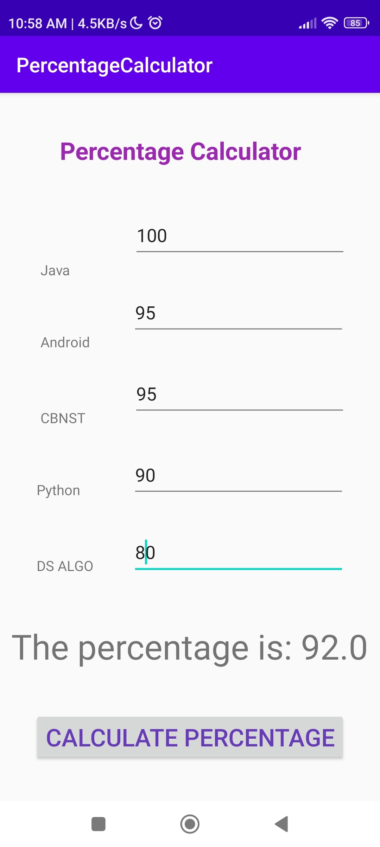

Name : Deepankar Sharma

Course: BCA

University Roll No: 2092014

Student Id : 20041299

Semester: 5

Date: December 26, 2022

**Practical 08: Media Player App**

**Objective:**  Create an Android app media player.

**XML CODE**

<?xml version="1.0" encoding="utf-8"?>

<android.support.constraint.ConstraintLayout xmlns:android="http://schemas.android.com/apk/res/android"

xmlns:app="http://schemas.android.com/apk/res-auto"

xmlns:tools="http://schemas.android.com/tools"

android:layout_width="match_parent"

android:layout_height="match_parent"

tools:context=".MainActivity">

<Button

android:id="@+id/button"

android:layout_width="match_parent"

android:layout_height="wrap_content"

android:text="@string/play"

app:layout_constraintBottom_toBottomOf="parent"

app:layout_constraintEnd_toEndOf="parent"

app:layout_constraintHorizontal_bias="0.439"

app:layout_constraintStart_toStartOf="parent"

app:layout_constraintTop_toTopOf="parent"

app:layout_constraintVertical_bias="0.004"

android:onClick="playVideo"/>

<VideoView

android:id="@+id/vv"

android:layout_width="match_parent"

android:layout_height="match_parent"

tools:layout_editor_absoluteX="-55dp"

tools:layout_editor_absoluteY="-16dp" />

</android.support.constraint.ConstraintLayout>

**JAVA CODE**

package com.example.kycmediaplayer;

import android.support.v7.app.AppCompatActivity;

import android.os.Bundle;

import android.view.View;

import android.widget.Button;

import android.widget.MediaController;

import android.widget.VideoView;

public class MainActivity extends AppCompatActivity {

Button b;

VideoView v;

MediaController mc;

@Override

protected void onCreate(Bundle savedInstanceState) {

super.onCreate(savedInstanceState);

setContentView(R.layout.activity_main);

b= findViewById(R.id.button);

v= findViewById(R.id.vv);

mc= new MediaController(this);

}

public void playVideo(View view){

String path= "android.resource://"+ getPackageName()+"/"+R.raw.video;

v.setMediaController(mc);

mc.setAnchorView(v);

v.setVideoPath(path);

v.start();

}

}

**Output:**

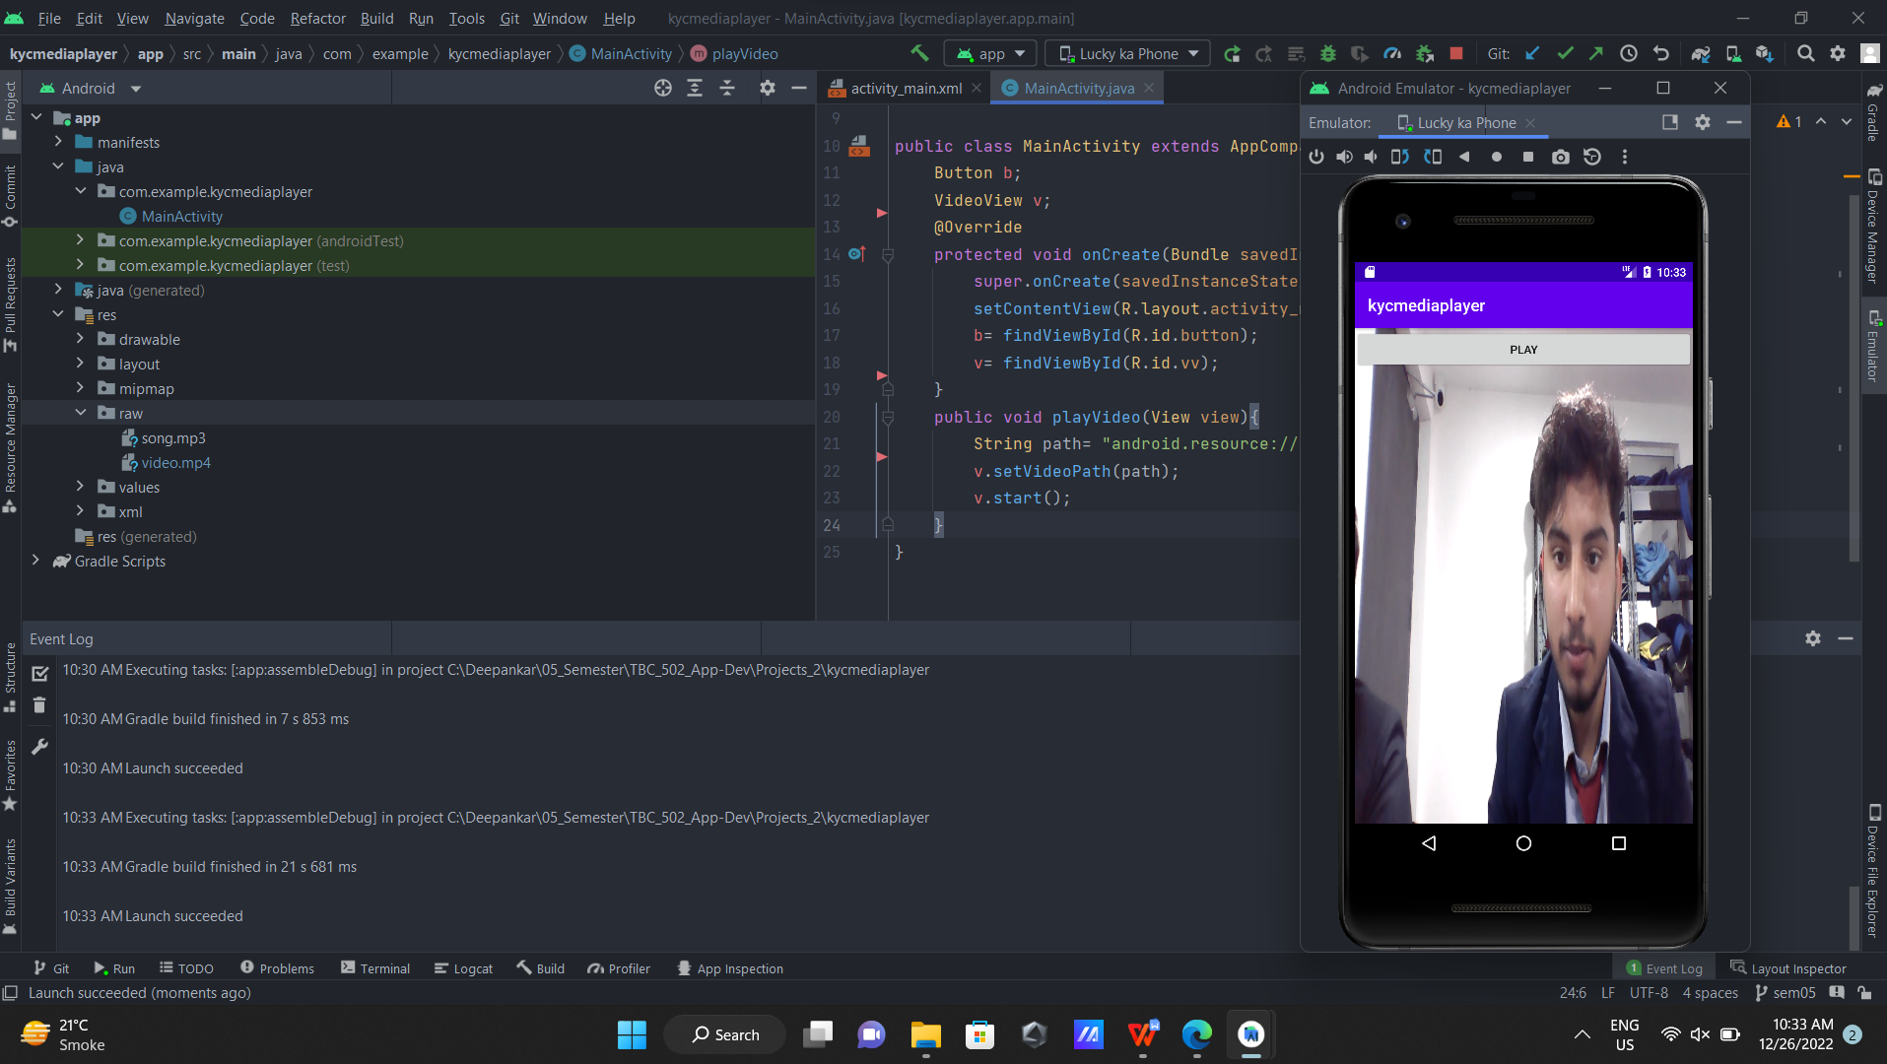

Name : Deepankar Sharma

Course: BCA

University Roll No: 2092014

Student Id : 20041299

Semester: 5

Date: December 26, 2022

**Practical 09: Setting Media Controllers App**

**Objective:**  Create an Android app media player and set the media controllers.

**XML CODE**

<?xml version="1.0" encoding="utf-8"?>

<android.support.constraint.ConstraintLayout xmlns:android="http://schemas.android.com/apk/res/android"

xmlns:app="http://schemas.android.com/apk/res-auto"

xmlns:tools="http://schemas.android.com/tools"

android:layout_width="match_parent"

android:layout_height="match_parent"

tools:context=".MainActivity">

<Button

android:id="@+id/button"

android:layout_width="match_parent"

android:layout_height="wrap_content"

android:text="@string/play"

app:layout_constraintBottom_toBottomOf="parent"

app:layout_constraintEnd_toEndOf="parent"

app:layout_constraintHorizontal_bias="0.439"

app:layout_constraintStart_toStartOf="parent"

app:layout_constraintTop_toTopOf="parent"

app:layout_constraintVertical_bias="0.004"

android:onClick="playVideo"/>

<VideoView

android:id="@+id/vv"

android:layout_width="match_parent"

android:layout_height="match_parent"

tools:layout_editor_absoluteX="-55dp"

tools:layout_editor_absoluteY="-16dp" />

</android.support.constraint.ConstraintLayout>

**JAVA CODE**

package com.example.kycmediaplayer;

import android.support.v7.app.AppCompatActivity;

import android.os.Bundle;

import android.view.View;

import android.widget.Button;

import android.widget.MediaController;

import android.widget.VideoView;

public class MainActivity extends AppCompatActivity {

Button b;

VideoView v;

MediaController mc;

@Override

protected void onCreate(Bundle savedInstanceState) {

super.onCreate(savedInstanceState);

setContentView(R.layout.activity_main);

b= findViewById(R.id.button);

v= findViewById(R.id.vv);

mc= new MediaController(this);

}

public void playVideo(View view){

String path= "android.resource://"+ getPackageName()+"/"+R.raw.video;

v.setMediaController(mc);

mc.setAnchorView(v);

v.setVideoPath(path);

v.start();

}

}

**Output:**

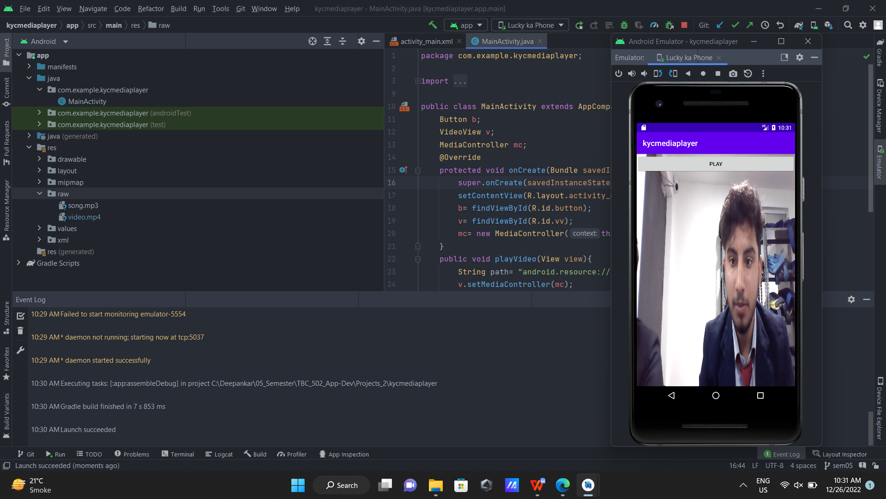

Name : Deepankar Sharma

Course: BCA

University Roll No: 2092014

Student Id : 20041299

Semester: 5

Date: December 26, 2022

**Practical 09: Intent App**

**Objective:**  Create an Android app to demonstrate intent.

**XML**

**Java**