A
MOOC based Seminar Report
On
Deep Neural Networks with PyTorch
Name of website registered: https://www.coursera.org

Submitted in partial fulfillment of the requirement Seminar for the Fifth Semester
BCA
By
Name of the Student: Deepankar Sharma
University Roll No: 2092014(14)

Under the Guidance of: Mrs. Manisha Koranga
Name of Faculty
Designation
Deptt. of CS&A

DEPARTMENT OF SCHOOL OF COMPUTING
GRAPHIC ERA HILL UNIVERSITY HALDWANI CAMPUS
BAREILLY ROAD, BERIPARAO, HALDWANI
DISTRICT- NAINITAL-263136
2022 - 2023


HALDWANI CAMPUS

THIS IS TO CERTIFY THAT MR. / MS. DEEPANKAR SHARMA HAS SATISFACTORILY PRESENTED MOOC BASED SEMINAR. THE COURSE OF THE MOOC REGISTRATION DEEP NEURAL NETWORKS WITH PYTORCH IN PARTIAL FULLFILLMENT OF THE SEMINAR PRESENTATION REQUIREMENT IN FIFTH SEMESTER OF BCA DEGREE COURSE PRESCRIBED BY GRAPHIC ERA HILL UNIVERSITY, HALDWANI CAMPUS DURING THE YEAR 2022- 2023.

Campus MOOC-Coordinator
Name

Signature

HALDWANI CAMPUS
Copy of confirmation Email of registration Received



HALDWANI CAMPUS
Copy of Course Completion Certificate Received



HALDWANI CAMPUS

Modules Attended
S. NO. | DATE | Details of Modules Attended | PAGE NO. | Signature
1 | 22-08-2022 | Introduction to PyTorch Tensors | 1
2 | 02-09-2022 | Image Processing with OpenCV and Pillow | 2
3 | 15-09-2022 | Machine Learning Image Classification | 3
4 | 27-10-2022 | Neural Networks and Deep Learning for Image Classification | 4
5 | 15-11-2022 | Object Detection | 5
6 | 28-11-2022 | Project Case: Not Quite a Self-Driving Car - Traffic Sign Classification | 6

ACKNOWLEDGEMENT

I take this opportunity to express my profound gratitude and deep regards to my teacher As. Prof. Manisha Koranga Ma’am.
For their exemplary guidance, monitoring and constant encouragement throughout the course of this report. The blessing, help and guidance given by them time to time shall carry me a long way in the journey of life on which I am about to embark.
Lastly, I thank almighty, my parents and friends for their constant encouragement without which this project would not be possible.

Name of Student
Deepankar Sharma
Email ID
DEEPANKARSHARMA.20041299@gehu.ac.in

MODULE- 1
(Introduction to PyTorch Tensors)
LEARNING OUTCOME:

- Introduction to PyTorch
PyTorch is a machine learning framework based on the Torch library, used for applications such as computer vision and natural language processing,originally developed by Meta AI and now part of the Linux Foundation umbrella. It is free and open-source software released under the modified BSD license.

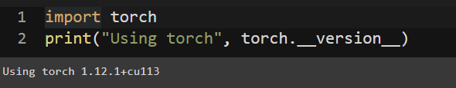

Tesla's development team uses PyTorch for its self-driving cars, including for features like Auto Pilot and Smart Summon.



- Rank 1 and Rank 2 Tensors in PyTorch

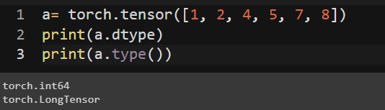

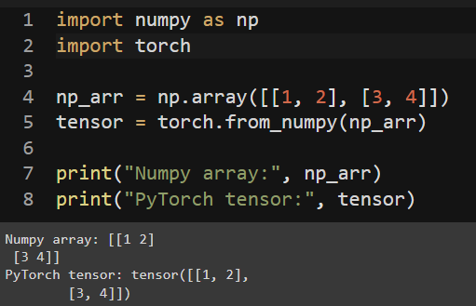

MODULE- 2
(Image Processing with OpenCV and Pillow)

OBJECTIVE OF LEARNING:
Image processing enhances images or extracts useful information from the image. In this module, we learnt the basics of image processing with Python libraries OpenCV and Pillow.

LEARNING OUTCOME:

- What Is A Digital Image
An image stored in binary form and divided into a matrix of pixels. Each pixel consists of a digital value of one or more bits, defined by the bit depth.

- Manipulating Images
OpenCV is a pre-built, open-source CPU-only library (package) that is widely used for computer vision, machine learning, and image processing applications. It supports a good variety of programming languages including Python.
Various image manipulation techniques supported are:
1. Resize Images · 2. Color to Gray · 3. Overlay Images · 4. Add Text · 5. Rotate

- Pixel Transformations
Transformation is a function. A function that maps one set to another set after performing some operations. The input would be an image and output would be an image too. And the system would perform some processing on the input image and gives its output as an processed image.

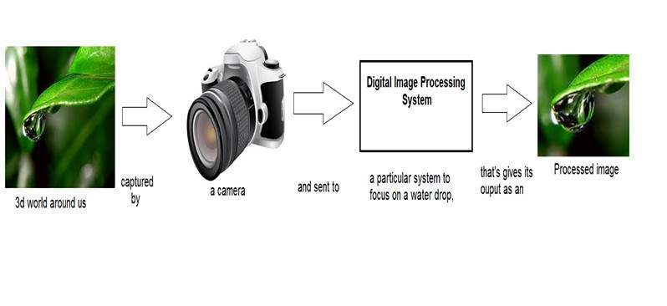
Now function applied inside this digital system that process an image and convert it into output can be called as transformation function.
As it shows transformation or relation, that how an image1 is converted to image2.

MODULE- 3
(Machine Learning Image Classification)

OBJECTIVE OF LEARNING:
In this module, we learnt about the different Machine learning classification Methods commonly used for Computer vision, including k nearest neighbours, Logistic regression, SoftMax Regression and Support Vector Machines. Finally, we learnt about Image features.

LEARNING OUTCOME:

- Image Classification
Image classification is a complex procedure which relies on different components. Here, some of the presented strategies, issues and additional prospects of image orders are addressed. The primary spotlight will be on cutting edge classification methods which are utilized for enhancing characterization precision.

- Image Classification with KNN
The k-Nearest Neighbor classifier is by far the most simple machine learning and image classification algorithm. In fact, it's so simple that it doesn't actually “learn” anything.

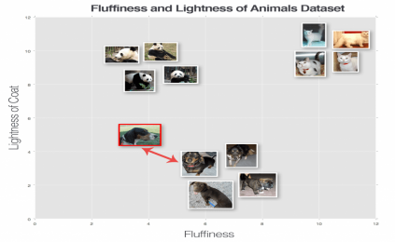

- Image Classification with SVMs
The main advantage of SVM is that it can be used for both classification and regression problems. SVM draws a decision boundary which is a hyperplane between any two classes in order to separate them or classify them. SVM also used in Object Detection and image classification.
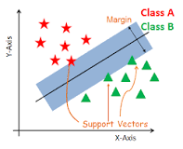
- Gradient Descent
Gradient descent (GD) is an iterative first-order optimisation algorithm used to find a local minimum/maximum of a given function. This method is commonly used in machine learning (ML) and deep learning(DL) to minimise a cost/loss function (e.g. in a linear regression).

MODULE- 4
(Neural Networks and Deep Learning for Image Classification)

OBJECTIVE OF LEARNING:
In this module, we learnt about Neural Networks, fully connected Neural Networks, and Convolutional Neural Network (CNN). We learnt about different components such as Layers and different types of activation functions such as ReLU. We also get to know the different CNN Architecture such as ResNet and LenNet.

LEARNING OUTCOME:
- Simple Neural Network for XOR
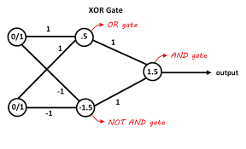
- Fully Connected Neural Network Architecture
Fully Connected (FC) The fully connected layer (FC) operates on a flattened input where each input is connected to all neurons. If present, FC layers are usually found towards the end of CNN architectures and can be used to optimize objectives such as class scores.
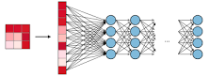

- Convolutional Networks
There are three types of layers in a convolutional neural network: convolutional layer, pooling layer, and fully connected layer. Each of these layers has different parameters that can be optimized and performs a different task on the input data.

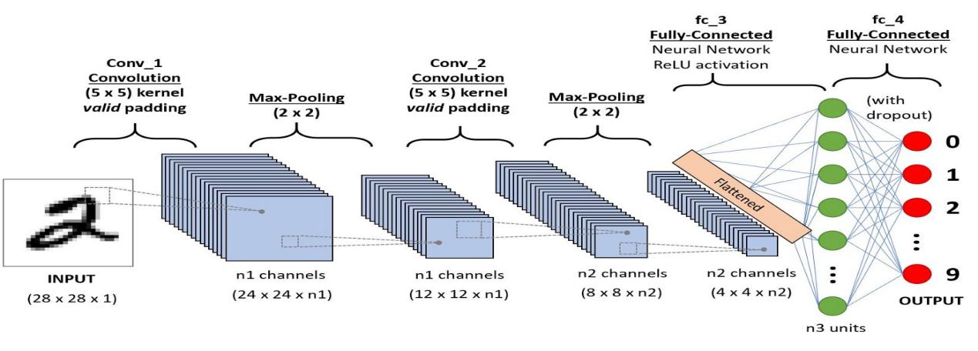
MODULE- 5
(Object Detection)

OBJECTIVE OF LEARNING:
In this module, we learnt about object detection with different methods. The first approach is using the Haar Cascade classifier, the second one is to use R-CNN and MobileNet.

LEARNING OUTCOME:
- Object Detection
Object detection is a computer vision technique for locating instances of objects in images or videos. Object detection algorithms typically leverage machine learning or deep learning to produce meaningful results.

- Object Detection with Haar Cascade Classifier
Haar cascade is an algorithm that can detect objects in images, irrespective of their scale in image and location. This algorithm is not so complex and can run in real-time. We can train a haar-cascade detector to detect various objects like cars, bikes, buildings, fruits, etc.

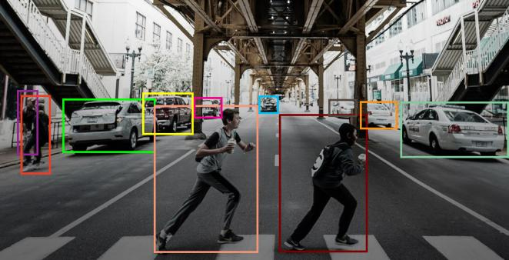

- Object Detection with Deep Learning
Deep learning-based object detection models typically have two parts. An encoder takes an image as input and runs it through a series of blocks and layers that learn to extract statistical features used to locate and label objects.

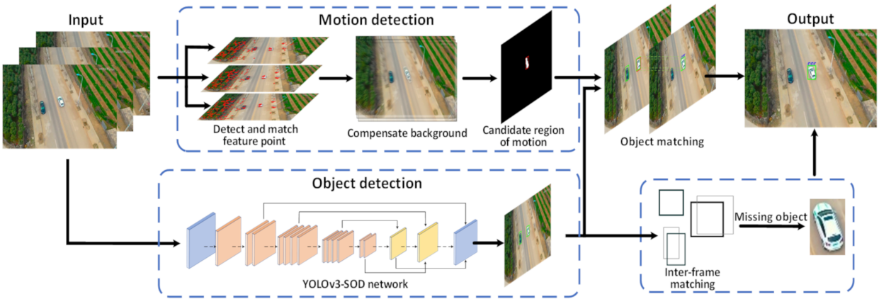

MODULE- 6
(Project Case: Not Quite a Self-Driving Car - Traffic Sign Classification)

OBJECTIVE OF LEARNING:
In the final week of this course, we build a computer vision app that we deployed on the cloud through Code Engine. For the project, we created a custom classifier, train it and test it on our own images.

LEARNING OUTCOME:
- Implementing all what learnt so far
- Project Overview
In this course, you learned how to train and use custom classifiers. For the project in this module, you will develop a new custom classifier using one of the classification methods you learnt and then deploy it as a web app using Code Engine. There are various advantages to deploying your classifier. First, you can share your classifier with anyone in the world. They simply need to enter the URL of your model into any web browser. Second, you can showcase your web app in your portfolio and your potential future employers can interact with your project.

- Project Scenario
You have been employed as a Junior Data Scientist by Jokwu, a self-driving car start-up in Capetown, South Africa. Jokwu has created the hardware and parts of the car, and they are beginning to create sensors; the next step is to have a working model that identifies traffic signs. The project and product team have decided to start with stop signs - is it a stop sign or not?
As a first step, you have been given a dataset and tasked with training a model that identifies the stop signs in an image. This will be integrated into a motion detector as a next step.

